James #160
Jesus Christ, is the true BREAD from heaven.

We can open in John 6 today and we will eventually go back into Hebrews chapter nine later.
We have recently begun to look deeper into the original temple items, that Moses was instructed to build and assemble and continually bring with the Exodus generation.
We noted the Golden lampstand and now we have noted the table of showbread;
/Heb 9:2 For a tabernacle was equipped, the outer sanctuary, in which were the lampstand, the table, and the sacred bread; this is called the Holy Place.

Exo 25:30 “And you shall set the bread of the Presence on the table before Me continually.\
The whole purpose of the table of showbread was a meaning that we are continually being fed by the WORD of God. It represented not only the 12 tribes of Israel, yet also many aspects of God’s divine plan and the very mind of Christ we know as Bible Doctrine.
REPEAT
It also spoke to the finished work of The Lord Jesus Christ and the completed canon of scripture we now have in front of us.
/The showbread was only available to be seen because of the golden lampstand of Jesus Christ. The analogy for the CA, pointed to a Believer filled by God the HS. For the Age of Israel, it meant a Believer in a position of priesthood had to digest the bread, as well as give forth what they learn from the bread (WORD). Only in the presence of God by the power of the HS do we learn the mind of Christ (Word/bread).\
The complete meaning of this table meant to be in the presence of God learning, growing and applying through obedience of our faith.

This section of John chapter six, is shortly after Jesus had already fed 5 thousand people with only two fish and five loaves of bread.
The next day, we can see the storm on the water and Jesus walked across the waters and calmed the storm.
A day later, Jesus was now in Capernaum and prepared to teach another lesson.
The crowd was curious as to how and when our LORD arrived ahead of them. HE now had a larger following after feeding the 5 thousand.
Many of them were still addressing Jesus as Rabbi, because they truly had not come to believe upon HIM as Lord and savior.
/Jhn 6:26 Jesus answered them and said, “Truly, truly (amēn amēn), I say to you, you seek Me, not because you saw signs, but because you ate some of the loaves and were filled.

From the original Hebrew, it carries the same meaning in several languages – truth is being told, believe upon this, this is a trustworthy statement so pay attention.\
AH-MAIN AH-MAIN, this is a point of doctrine, it is truth and it is factually, so pay attention.
The way Jesus answers this, is written in the aorist tense, meaning HE knew from eternity past these types of questions would surface in HIS earthly ministry.
/This was a large portion of Jewish followers who were there for the feeding of the five thousand. They were seeking more from Jesus, such as support and possibly a leader to overthrow Roman authority. They were thrilled with the miracles and the possibilities of the Jewish Messiah taking the crown, yet they were not truly born again and saved.\
There is an issue of wrong motivation here that often gets overlooked. Our Lord is going to handle them with grace and love.

Jhn 6:27 “Do not work for the food that perishes, but for the food that lasts for eternal life, which the Son of Man will give you, for on Him the Father, God, has set His seal.”
/The food they worked for and were focused upon (Greek present tense) was the food of the details of life, the food of political theater, the food of human viewpoint. Without salvation we are slaves to a system of corruption, a system controlled by Satan. Once we are born again, we are called to grow up spiritually. This happens by the means of the Word and Spirit (2 power options), that gives clarity and discernment.\
The Greek present tense, tells us this was an ongoing issue with these people.
Jhn 6:28 Therefore they said to Him, “What are we to do, so that we may accomplish the works of God?”
Notice they want to work for this, they are focused on flesh, human efforts or human solutions.
They use a plural term for works, effort that they can obtain favor from GOD.

Stop pursuing the things of this world that have no eternal value. TLJC is now going to present the truth that matters, the singular truth that determines where you spend eternity.
REPEAT
/Jhn 6:29 Jesus answered and said to them, “This is the work of God, that you believe in Him whom He has sent.”

SINGULAR work is found in Christ. HIS work is all that matters, we simply surrender ourselves to that truth!\
Faith is non-meritorious; it is not a work to believe the truth. To have a moment of time where you surrender your free will to the truth of Jesus Christ is not a works program.
Real faith has a target, that is the person and work of Jesus Christ. REPEAT
/Jhn 6:30 So they said to Him, “What then are You doing as a sign, so that we may see, and believe You? What work are You performing?

This is the crowd who ate the miracles of two fish and 5 loaves, many had witnessed several miracles or healings. Yet they do not believe this is the one and only MESSIAH.\
They seek more miracles, more healings and more proof.
This is no shock to a true Bel, we know that when Christ was performing miracles, it was no guarantee of faith in HIM.
Jhn 6:31 “Our fathers ate the manna in the wilderness; as it is written: ‘HE GAVE THEM BREAD OUT OF HEAVEN TO EAT.’”
/Jhn 6:32 Jesus then said to them, “Truly, truly, I say to you, it is not Moses who has given you the bread out of heaven, but it is My Father who gives you the true bread out of heaven.

Jesus Christ is the bread, it is HIS mind. THE WORD became flesh and dwelt among us. The manna from heaven, the showbread, the 5 loaves that fed thousands all point to Christ.\
Jhn 6:33 “For the bread of God is that which comes down out of heaven and gives life to the world.”
Jhn 6:34 Then they said to Him, “Lord, always give us this bread.”

/Jhn 6:35 Jesus said to them, “I am the bread of life; the one who comes to Me will not be hungry, and the one who believes in Me will never be thirsty.

The water of the word washing over us and the bread of life point to the focus of true spiritual power – THE WORD.\
Miracles and healings, signs and wonders do not save us.
They do not give us doctrine to learn and grow. The power of the WORD is the focus, it is where we have true sustenance in life, spiritual sustenance is only found in the WORD.
REPEAT
/Mat 4:4 But He answered and said, “It is written: ‘MAN SHALL NOT LIVE ON BREAD ALONE, BUT ON EVERY WORD THAT COMES OUT OF THE MOUTH OF GOD.'”

Deu 8:3 “And He humbled you and let you go hungry, and fed you with the manna which you did not know, nor did your fathers know, in order to make you understand that man shall not live on bread alone, but man shall live on everything that comes out of the mouth of the LORD.\

Notice what our LORD tells us;
Jhn 6:36 “But I said to you that you have indeed seen Me, and yet you do not believe.
They witnessed miracles and healings, they watched the MESSIAH they had been taught about their whole life, walk in front of them!
Yet most of them did not believe upon HIM.
Jhn 6:37 “Everything that the Father gives Me will come to Me, and the one who comes to Me I certainly will not cast out.
We can pivot back into Hebrews nine RF.

Eternal security…once saved always saved. Faith alone in Christ alone, is the first portion of the BREAD we need to digest.
Then we need to continually keep eating the word of GOD, eating the bread of life.
That is how we grow into maturity.
/Jesus proclaimed 7 ‘I AM’s’, in reference to analogies of spiritual sustenance of the WORD;
I am the bread of life (Jhn 6:35)
I am the light of the world (Jhn 8:12)
I am the door (Jhn 10:7-9)
I am the good shepherd (Jhn 10:11-14)

/I am the resurrection and the life (Jhn 11:25)
I am the way, and the truth, and the life (Jhn 14:6)
I am the true vine (Jhn 15:1-5)
Through HIS work and the WORD, we find truth, eternal life and spiritual maturity, there is no other way.\

Heb 9:2 For a tabernacle was equipped, the outer sanctuary, in which were the lampstand, the table, and the sacred bread; this is called the Holy Place.
We have now looked at the first room of the tabernacle, the HOLY Place.

We noted the golden lampstand and the table of showbread. Now we come to the entrance into the Holy of Holies;
Heb 9:3 Behind the second veil there was a tabernacle which is called the Most Holy Place,
Keep in mind, Hebrews is directed at a large majority of Jews who had been converted. Yet there were still many religious Jewish converts who insisted on rituals and falling backward into the shadows of Mosaic Law.
Hebrews covers the fact that we now live in the reality of the shadows of the Mosaic Law, it came to be fulfilled in the person and work of Jesus Christ.
/The second veil was hung on 4 pillars, it was blue, purple and scarlet, with cherub angels embroidered upon it. Four representing God’s balance and established work of creation, also HIS complete power of the natural and spiritual realm, it pointed to structure as well as balance – divine order.\
There are 4 gospels, 4 corners of the earth, four winds of heaven, the four rivers of Eden…etc.
Christ is represented as King, servant, Son of man and Son of God.
Blue, purple and scarlet point to Royality but also there was some white woven into this veil as well.
/The white pointed to the impeccable person of Christ. The Blue pointed to Deity, while the purple was the representation of the KING of kings. The scarlet referenced the finished work upon the Cross of Christ, the blood of the true savior. The Cherub angels pointed toward the heavens, yet also a reminder that the Cherub assigned to guard the throne in eternity past ignited a war!\
The table of incense was stationed almost at the entrance of the veil. Just outside the Holy of Holies.
/Heb 9:4 having a golden altar of incense and the ark of the covenant covered on all sides with gold, in which was a golden jar holding the manna, Aaron’s staff which budded, and the tablets of the covenant;

Exo 30:6 “You shall put this altar in front of the veil that is near the ark of the testimony, in front of the atoning cover that is over the ark of the testimony, where I will meet with you.\
There were several very specific instructions concerning this altar of incense. Exo 30:1-10 covers this in great detail.
/This was a picture of the doctrine of the Hypostatic Union and the victory of Christ after resurrection when HE sat down on the right side of the throne. The mix of wood and gold used in a unique fashion, pointed to the Hypostatic Union. The opposite of the brass altar in the courtyard, which pointed to judgment, this was about victory.\
The table of incense was of wood and gold but also a crown around the edge, it held fire, and incense.
It was 3 ft high and 18 inches in width, square width.
So, there were five articles in the structure of the golden altar:
/The golden altar of incense was made of wood (humanity of Christ), plated with gold (deity of Christ) — a picture of the hypostatic union; then three more articles: a crown, fire, and incense. The horns on this altar spoke to power and prayer as well as victory. The consistent burning of incense day and night, was to point to the fragrant aroma of satisfaction (propitiation) and victory. It was symbolic for prayer to align with the burning of incense.\
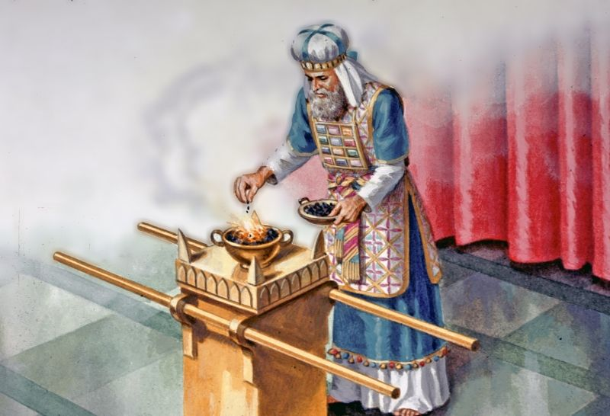

/Rev 5:8 When He had taken the scroll, the four living creatures and the twenty-four elders fell down before the Lamb, each one holding a harp and golden bowls full of incense, which are the prayers of the saints. (Rev 8:3-4) \
Our Lord Jesus Christ is always making intercession for us, we in turn, should be praying for others before our own needs.

Both the golden table of incense and the mercy seat, on top of the ark of the covenant, pointed to victory, as well as legal propitiation, highlighting the person and work of Jesus Christ.

/The fire of the incense represented judgement on the Cross. The crown containing that fire pointed to the validity of the work of Christ on the cross which is found in the resurrection, ascension, and session, the strategic victory of the angelic conflict. The crown was for the King of kings, which can only be placed upon the head of the one who sat down at the right hand of the throne in a victorious session. \

/ The brass altar in the courtyard emphasized salvation and how it was accomplished. The golden altar inside in front of the entrance to Holy of Holies, was symbolic of victory and how it was accomplished. The fire for the golden altar was from the brass altar. They carried coals in from the brass altar and put them in the crown which started the fire in the golden altar.\

Without the brass altar and its fire there would be no worship at the golden altar — meaning;
/Apart from the cross and salvation there is no effective worship or prayer mankind can bring forth on their own. You cannot ignore the brass altar (cross of Christ)! Prayer is useless until you believe upon Jesus Christ. There is no spirituality without our union with Christ.\

