**Friends of Sterling Forest**

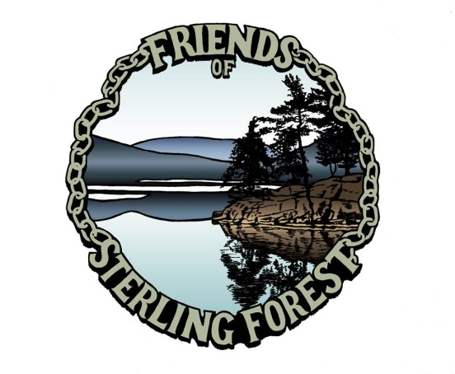

**116 Old Forge Road**

**Tuxedo, NY 10987**

You are invited to join the Friends of Sterling Forest, a non-profit organization established to preserve and protect the great legacy of natural resources and historical treasures of Sterling Forest State Park.

Each month the Friends host educational lectures, hikes and special events promoting the Park. The public is cordially invited to attend these events free of charge. In addition, the Friends work behind the scenes stabilizing, restoring and maintaining historic buildings and sites within the Park. Sites such as Southfields Furnace, Sterling Furnace and Sterling Forge, where the Great Chain across the Hudson was made, are in desperate need of attention. Your membership donation will enable the Friends to move forward with these important projects.

Doc Bayne, retired Sterling Forest State Park educator and President of the Friends, encourages everyone with an interest in history or the great outdoors to “Come join us and make a difference in your Park!”

-----------------------------------------------------------------------------------------------------------------------------------

Friends of Sterling Forest

Membership Application

Name ______________________________________________________ Phone ________________

Address_______________________________________________________________________________

_______________________________________________________________________________________

E-mail address ________________________________________________________________________

Please check one:

_______ $15.00 Individual _______ $10.00 Student (with valid ID)

_______ $25.00 Household (Persons living _______ $10.00 Senior (60+)

at the same address)

**Life Memberships:**

**_____$150.00 Adult**

**_____$250.00 Family**

**_____ $100.00 Senior**

Checks should be made payable to *Friends of Sterling Forest* & mailed to 116 Old Forge Road, Tuxedo, NY 10987. The F.S.F. is tax exempt under Section 501(c)(3) of the Internal Revenue Code. THANK YOU IN ADVANCE FOR YOUR SUPPORT!

www.friendsofsterlingforest.org / friendsofsterling@friendsofsterlingforest.org