**ONLINE SUNDAY SCHOOL**

**https://join.skype.com/dGIxUT2FsWyh**

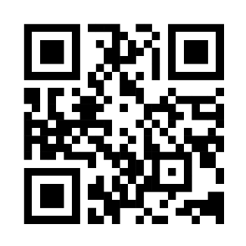

SUNDAY SCHOOL IS NOW AVAILABLE IN PERSON AND ONLINE FROM THE COMFORT OF YOUR HOME.

CHILDREN AND ADULTS WELCOME!

SUNDAY MORNINGS AT 10:45 – 11:30

ENTER THE LINK ABOVE IN YOUR BROWSER, SCAN QR CODE OR TEXT (718) 749-6170 TO HAVE THE LINK SENT TO YOU.

Mark 10:14 KJV

But when Jesus saw it, He was much displeased and said unto them, Suffer the little children to come unto me. and forbid them not for such is the kingdom of heaven.

Church Address: 89-53 Francis Lewis Boulevard, Queens, NY 11427

Mailing Address: 224-21 Merrick Boulevard, Box 1036, Springfield Gardens, NY 11413