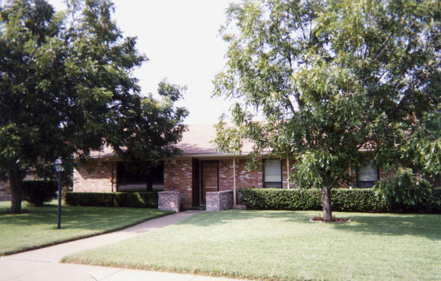
October 2005 Garden of the Month 6915 Racine Drive

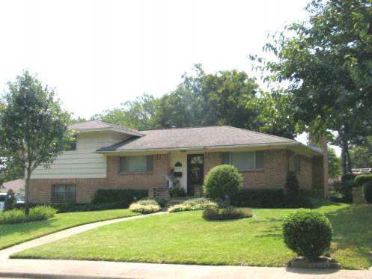
September 2005 Garden of the Month 910 Golden Trophy

