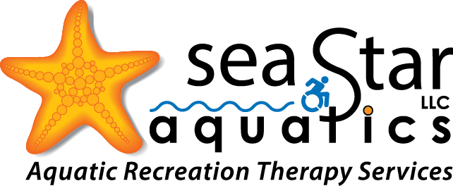

PO BOX 31938
SEATTLE, WA 98103
StacyAquatics@gmail.com
(206) 265-2436

Adaptive Aquatics and Aquatic Exercise Program

Parent/Guardian 1 Name: __________________________________________________

Phone:_________________________ E-Mail:___________________________________

Parent/Guardian 2 Name: __________________________________________________

Phone:_________________________ E-Mail:___________________________________

Billing Address:

Street:__________________________________________________________________

City:___________________________ State:________________ Zip Code:____________

Caregiver/Organization Name:______________________________________________

Phone:_________________________ E-Mail:___________________________________

Emergency Contact, if not listed above:

Name:_________________________ Phone:___________________________________

Relationship to Participant:_________________________________________________

Participant Information

Participant Name: _________________________________________________________

Date of Birth:_______________________________ Age:__________________________

Circle a Number to Indicate How Well the Participant Follows Directions:

1 2 3 4 5 6 7 8 9 10
Not Very Well Very Well

Please Describe the Participant’s Past Experience with Aquatic Exercise:

________________________________________________________________________

________________________________________________________________________

Please Describe the Participant’s Favorite Songs, Toys, Activities:

________________________________________________________________________

________________________________________________________________________

Please Circle the Participant’s Goals for Aquatic Exercise:

Swim Skills and Water Safety

Exercise

Swim Team

Other, Please Describe:_____________________________________________________

Medical Information

Diagnosis, if applicable:_____________________________________________________

Doctor (Optional):___________________________ Phone:________________________

Please Mark All APPLICABLE Boxes. Leave blank if none:
- Sensory Integration Needs
  - Sensory Seeker? YES NO
  - Sensory Avoider? YES NO
- Walks with walker
- Uses a manual wheelchair
  - Requires a 2-person transfer? YES NO
- Uses a power wheelchair
  - Requires a 2-person transfer? YES NO
- Hoyer Lift Transfer
- Verbal Ability:
  - Non-Verbal
    - Uses Picture Cards? YES NO
  - Minimally Verbal
    - Uses Picture Cards? YES NO
- Hearing Impairment
  - Hearing Aid Used? YES NO
  - Uses Picture Cards? YES NO
- Vision Impairment
  - Describe:____________________________________________________
- Seizure Disorder
  - Seizure Type:_________________________________________________
  - Date of Last Seizure:___________________________________________
  - Protocol:____________________________________________________

Please Mark All APPLICABLE Medical Concerns. Leave blank if none:
- Allergies
  - Describe:____________________________________________________
- Recent/Relevant Surgeries
  - Describe:____________________________________________________
- Medications
  - Describe:____________________________________________________

- Heart Conditions
  - Describe:____________________________________________________
  - Blood Pressure: LOW MEDIUM HIGH
- Asthma
  - Describe:__________________________________________________
  - Protocol:__________________________________________________
- Spinal Cord Injury
  - Describe:__________________________________________________
  - Level:_____________________________________________________

Additional Comments and Information:

________________________________________________________________________

Referred By:

________________________________________________________________________

MEDICAL RELEASE

I give my permission for “SEA STAR AQUATICS LLC” to review the medical charts and/or for you to give SEA STAR AQUATICS LLC medical information relating to the medical needs of: ________________________________________(participant’s name)

WAIVER OF LIABILITY

This agreement releases “SEA STAR AQUATICS LLC” from a liability relating to injury’s that might occur during aquatic exercise and adapted swim instruction and safety activities at Bellevue Aquatic Center. By signing this agreement, I agree to hold “SEA STAR AQUATICS LLC” entirely free from, liability, including financial responsibility for injuries, regardless of whether injuries are cause by negligence.

I also acknowledge the risks in Aquatic Exercise and Adapted Swim Instruction and Safety activities, such as drowning, physical injury, heart attack, stroke, chemical burns, seizures, brain injuries, blindness, asthma attacks, loss of hearing, rashes, spinal cord injuries. I acknowledge that I am participating voluntarily and that all risks have been made clear to me. Additionally, I do not have any conditions that will increase my likelihood of experiencing injuries while engaging in this activity
By signing below, I forfeit all the right to bring a suit against “SEA STAR AQUATICS LLC” for any reason. In return I will receive (Aquatic Exercise and Adapted Swimming Instruction and Safety. I will also make every effort to obey safety precautions as listed in writing at the “Bellevue Aquatic Center 601 143rd Ave NW.”
I________________________, fully understand and agree to the above terms.

Name of participant / parent or guardian
PRINT NAME_______________________________________________

SIGNATURE_________________________________________________DATE_________

