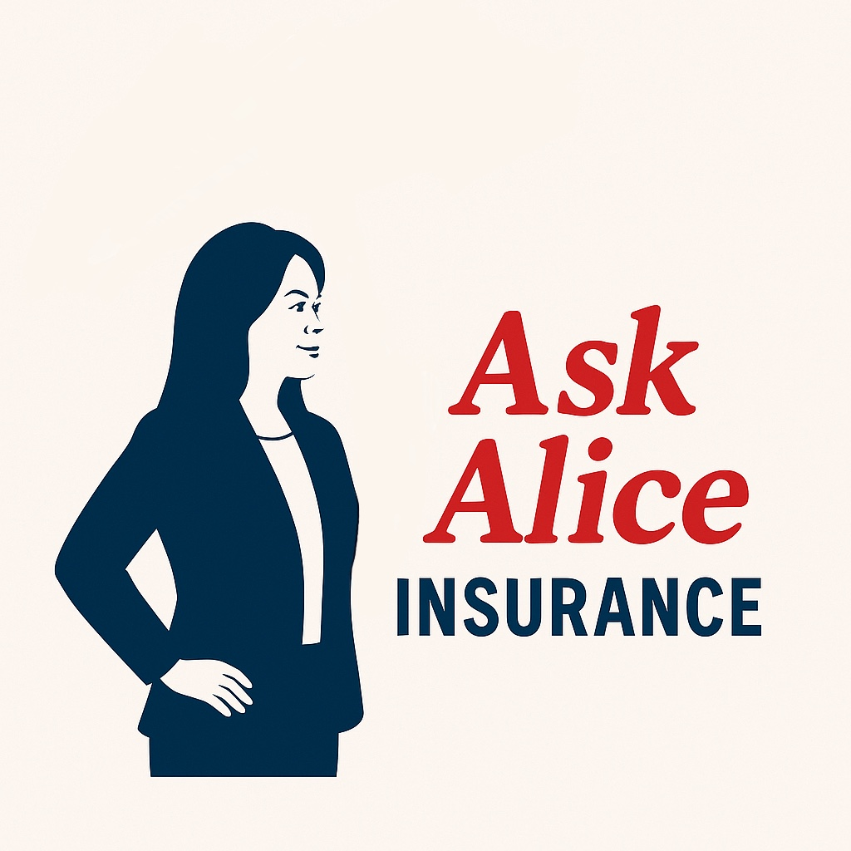 | 📞 +1 (909) 680-7009  📧 alice@askaliceinsurance.com  🌐 askaliceinsurance.com  📷 Instagram: @askaliceinsuranceagency  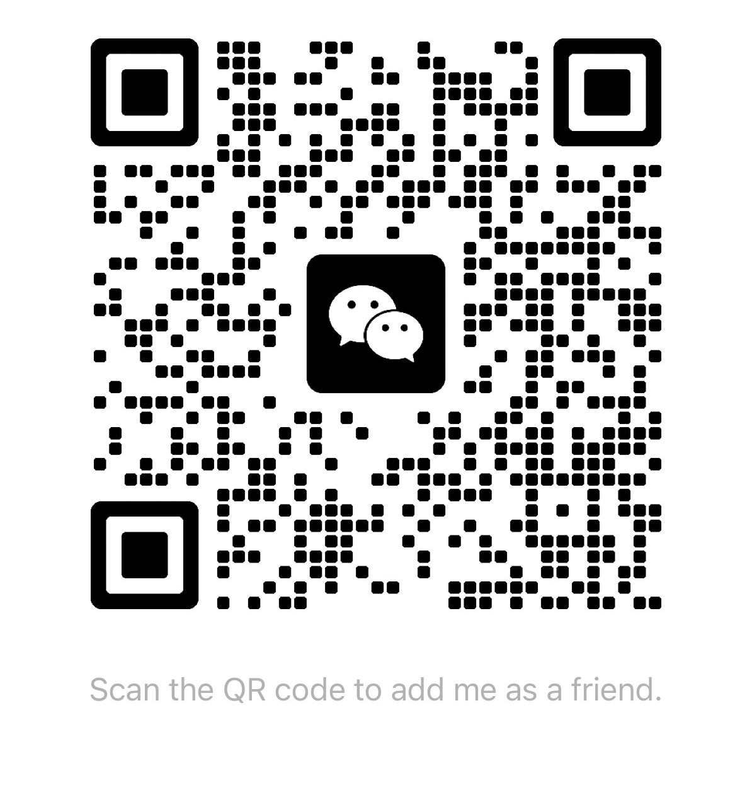  Scan to connect on WeChat  扫码加我微信

Ask Alice Insurance Agency, Inc.

Commercial Insurance Client Information Form / 商业保险客户信息收集表
To provide you with an accurate commercial insurance quote, please fill out the following information as completely as possible.
为便于我们为您提供准确的商业保险报价，请尽可能完整地提供以下信息。

1. Basic Information / 一、基本信息
□ Legal Business Name / 被保险人名称（公司全称）
□ Doing Business As (DBA) or operating name (if different) / 营业执照注册名称（如不同）
□ Business Entity Type (LLC / Corporation / Partnership / Sole Proprietor) / 企业类型
□ Year Established / 成立年份
□ Business Address / 营业地址
□ Contact Person Name / 联系人姓名
□ Phone / 电话
□ Email / 邮箱
□ Business Description (main products/services and service area) / 业务描述（主营业务及服务范围）

2. Insurance Requirements / 二、保险需求
□ Type(s) of Insurance Needed (e.g., General Liability, Commercial Property, Commercial Auto, etc.) / 保险类别（如：商业责任险、商业财产险、商业车险等）
□ Desired Coverage Start Date / 期望的保险起始日期
□ Required Coverage Limits (e.g., $1,000,000/$2,000,000) / 所需保险额度（如：$1,000,000/$2,000,000）
□ Do you have an existing policy? (If yes, please provide a copy) / 是否有现有保单（如有，请提供副本）

3. Premises and Assets Information / 三、场地及资产信息
□ Square Footage of Business Premises / 营业场所面积（平方英尺）
□ Building Construction Type (e.g., Steel, Masonry) / 建筑结构（例：钢结构、砖混）
□ Year Built / 建筑年份
□ Roof Type (e.g., Asphalt Shingle, Metal) / 屋顶类型（例：沥青瓦、金属）
□ Main Goods/Services Stored or Provided / 主要存放或经营的物品/服务类型
□ Do you store flammable/hazardous materials? (Yes/No, please specify if yes) / 是否存放易燃/易爆/危险品（是/否，如是请注明）
□ Fire/Burglar Alarm/Surveillance Systems (please specify) / 场所是否配备防火/防盗/监控系统（请说明）

4. Employees and Operations / 四、员工及运营信息
□ Number of Employees (Full-time / Part-time) / 员工人数（全职/兼职）
□ Total Annual Payroll / 年度工资总额
□ Business Hours / 营业时间
□ Any prior claims history? (If yes, please provide date and amount) / 是否有过理赔记录（如有，请说明理赔日期及金额）

5. Additional Notes / 五、其他信息
□ Additional remarks or special requirements / 额外备注或特殊需求

