Tuesday, February 21, 2023 at 6:00 pm
Minutes for the regular meeting of the Ponderosa Park Domestic Water Improvement District
Agenda
Call to order at 6:00 pm
Roll Call: AJ Adamkiewicz present, Jackie Wheeler present, Forrest Waymack present & Robert (Bob) McBurnie present.
6:01: Derek Rice, PhD, present
Full quorum.
Approve minutes of PPDWID board meeting on 1-17-2023: No Discussion or Corrections, Motion was made by AJ Adamkiewicz to accept the minutes. Second by Derek Rice, PhD
- Vote: Derek Rice, PhD yes, AJ Adamkiewicz yes, Jackie Wheeler yes, Forrest Waymack yes & Robert (Bob) McBurnie yes. Motion passed unanimous.
Financial update: Jackie Wheeler and all board members
- Begin working on 2024 budget with MA & C with Natalie, need to start as it needs to be finalized and published.
- Yavapai count account: $40,000.00 transferred to account, 4.5% interest.
- Insurance coverage: Jackie Wheeler: we were dropped/not renewed by Auto Owners on all the property due to fire danger. The only company that is willing to cover a water district, Liberty Mutual. The price was an increase of $2000.00. Any company that does work for the district must have a Certificate of Liability insurance or Workman’s comp, or license bonded & insured. Jackie will follow up with Natalie and make sure that she is aware of the cost increase for the budget.
- There may need to be a price increase, keep it smaller increase with Natalie’s feedback. Reference the financial report. Any increase would need to be included with the budget.
Operators & Maintenance report: Forrest Waymack, Jim Muylle’s written report, all board members
- Bacti-cloriform sample results negative. Chlorine 0.51mg/l average is low.
- Forrest is working with Fann staff on maintenance priorities. Still working on the locks. Better record keeping. Forrest will continue to follow up with Fann staff, hopes to have info to share next month.
- 15 nonpayment door hangers, Jackie will follow up with Natalie, for her to keep Jackie in the loop. There is a process in place. Payment plan is also available.
- More details are needed in the Fann MOR, Forrest will follow up.
- New meter install on Kaibab is complete, paid in full, with a refund to the customer.
- Thank you to Forrest for his personal time with the second well sounders repair.
- SUM is out of the picture on the meters and lids, we will need an estimate from Fann on the 10 meters and 80 lids. They are going to estimate on each meter. Lids may be done in mass at the Fann shop. A.J wanted to know if they should be left as is until there is an issue with the meter. Will follow up as Fann provides the estimates.
General Updates:
- ADWR 5-year plan completed by Bob. Bob has been waiting for a response, verbally been told that there were not any issues. There is a 1 year and a 5-year plan required. Jim Muylle completed/submitted the 1-year plan.
- MA&C, Natalie completed a financial census for US Census Bureau. First time this was required that we are aware of.
- Yavapai County records up to date. Resubmitted the paperwork for Forrest board appointment. No elections this year.
- 2022 Meetings and agendas are filed at the office, with the rest of the yearly files. May need to scan the files at some point in the future. Digital not required at this time, but will be coming in the future.
Next Month’s Agenda Items:
- Natalie Galgano-Pinkley plans to attend.
Call to close the meeting at 6:31 pm.
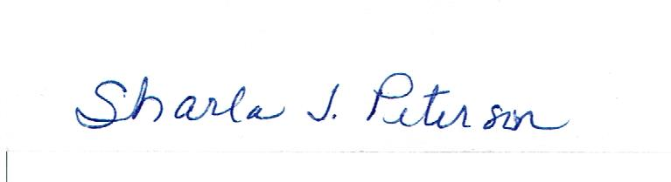
2-24-2023

