**Tuesday, March 21, 2023 at 6:00 pm**

**Agenda for the regular meeting of the Ponderosa Park Domestic Water Improvement District**

Pursuant to A.R.S. 38-431.01, 38-431.09, 38-431.02(H) This meeting is open to the public and the following topics and variables will be subject to board consideration/discussion/approval or other action. Agenda order may change for time/efficiency. The meeting will be held at 4619 South Deer Trail, Ponderosa Park, Prescott AZ. The board supports the CDC, state of AZ and Yavapai County guidelines for COVID-19 pandemic, please protect yourself as necessary.

Fann Environmental: Mike Young, Jim Muylle, Natalie Galgano-Pinkley and Recorder, Sharla Peterson, or a representative: may be called upon at any time to answer questions or give reports requested by the board.

**Agenda**

**Call to order**

**Roll Call:** Derek Rice, PhD, AJ Adamkiewicz, Jackie Wheeler, Forrest Waymack & Robert (Bob) McBurnie

**Approve minutes of PPDWID board meeting on 2-21-2023**: Discussion & Corrections, Motion, Second & **Vote**

**Financial update**: Natalie Galgano-Pinkley, Jackie Wheeler and all board members

* Monthly budget: Door hangers, nonpayment, shut off. New line item for credit card charges. Recover refund on improper charge for issuing credit cards. Fann charges: 8,720.41, normal. Thanks to Natalie for the water pumping graph. Derek: possible insurance coverage
* Annual Budget Discussion
  + 2023-2024 recommendations from MA&C
  + Potential minor changes of monthly rates, public notice/YCBS approval
  + Call to public for budget comments
  + Close call to public for budget comments

**Operators & Maintenance report**: Forrest Waymack, Jim Muylle’s written report, all board members

* Well Health, great due to moisture, 99%
* New call log for complaints
  + Required by ADEQ & ADWR that we log and keep records of all complaints
* ADEQ offered to reduce testing. Bacterial & chlorine, in the best interest of public, continue current testing
* Routine call outs for frozen pipes
* Forrest updates: Records, Pellet feeder, Booster station building, Meter installations
* Thanks to Forrest for grading/drainage on Indian Creek property
* Trash service, place can at garage?

**Misc. business**

* Smith property update: Bob
  + Pine Cone #1 & #2 well, main entry point under ADEQ
  + Recorded at Yavapai County office

**Future items:**

**Close the meeting**

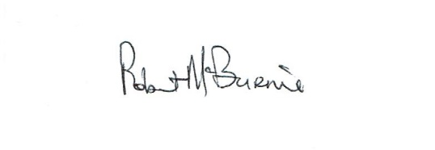

**Posted 3-17-2023**