**Tuesday, March 21, 2023 at 6:00 pm**

**Minutes for the regular meeting of the Ponderosa Park Domestic Water Improvement District**

**Agenda**

**Call to order at 6:01 pm**

**Roll Call:** Derek Rice, present PhD, AJ Adamkiewicz, absent Jackie Wheeler, present Forrest Waymack present & Robert (Bob) McBurnie present. Quorum of 4

**Approve minutes of PPDWID board meeting on 2-21-2023**: No discussion or corrections, Motion was made by Jackie to accept the minutes, Derek second the motion. **Vote:** Derek Rice, PhD, yes Jackie Wheeler, yes Forrest Waymack yes & Robert (Bob) McBurnie yes, motion passed unanimously.

**Financial update**: Natalie Galgano-Pinkley, Jackie Wheeler and all board members. Welcome Natalie to meeting

**Monthly Budget**: Six door hangers, zero no payment, zero shut off. Bob reported: Foothills Bank refunded the replacement charge of $105.00 for the credit cards. Fann charges are normal. Thanks to Natalie for the new water pumping graph. Derek update on possible insurance change: State Farm agent who is friend, underwriters said no coverage due to fire danger. New line item for credit card on the monthly report, changed from debit card to credit cards for minor purchases by board members. Audit: not able to find an auditor. The company in Phx. $6,500-$7,000.00 additionally $500-$1,000.00 for MA&C time to assist. Natalie will follow up to check on finding a quote & regulation requirement, financial review vs full audit.

**Annual Budget:** Yavapai County has a specific timeline for the budget.

Natalie has draft budget for board. Update to reflect the new Fann contract, tank maintenance, not much change. Natalie will follow up with numbers to reflect a small rate increase. Suggested board consider both base rate and consumption rate with increase/ more consumption. There is no disconnect fee on fee schedule. If more residents signed up for electronic billing the postage fee would be reduced, it also helps reduce late payments. Natalie, suggested that the contingency line item is on the low end.

Bob, water tank maintenance, keep contract, propose to increase this line item, estimate is coming for maintenance on the blending tank. Ask board to consider $2.00-4.00 increase on monthly charge. Arizona water resources is asking to get residents to conserve water with a surcharge for excessive use. What other changes would we want on the fee schedule.

Forrest would like to see this additional fee to help with maintenance cost on buildings/security. Add an additional paper in the water bill to notify of rate increase, cost would be low to do this. Add shut off /non payment fee needs to be added to fee schedule. No cost to sign up for electronic bill. Low-rate increase would help raise up the contingency line item to last years numbers.

Jackie like to consider also raising the rate on the consumption side. Complimented MA&C on the electronic account system.

Derek considering a large rate increase at the highest consumption. Would like to outreach to potential customers that would be affected by a rate change. Derek could post on water page and PP Facebook page. Asked about postal fee increase.

Call to the public on budget comments: none

Close call to the public on budget comments.

**Operators & Maintenance report:** Forrest and all board members

Forrest reported: Bob fixed the lights; Derek donated some chain that was used to lock tank valves. Bought new seat covers for Toyota. Estimate is coming from Jim, to remove the pellet feeder and redo room. Mike Young has found a solution with current telemetry system. Tank maintenance is being followed up. Natalie came up with new form for customer complaint log, that is required to be kept by the state. New forms for tracking purchases, filter changes and pumping data. Estimate for blending tank maintenance will be coming they are anxious to get the work done.

Jackie did not find a retention schedule for pumping data. Jackie will follow up with ADWR for retention schedule.

Natalie, rate charge question on a call out to customer, charge added to fee schedule. Customer will need to pay charges.

Thanks to Forrest for grading the empty lot near the garage and adding drainage.

Trash to be moved to garage, Bob will follow up with Patriot Disposal for pick up at garage at 4971 Indian Creek, Bob will be posting the garage address number.

**Misc. Business:** Bob and all board members

Well property: Most of the wells are in the Yavapai County right away, we were deeded the right of way. Two small parcels that were surrounded by private property. In the works, Smith family to quit deed property to PPDWID. Paid for title search this last year. Paperwork was submitted to Yavapai County, will be assigned a parcel number and maybe an address.

**Future Items**: Schedule changes for call out and nonpayment and budget

**Call to close the meeting at 7:01 pm**

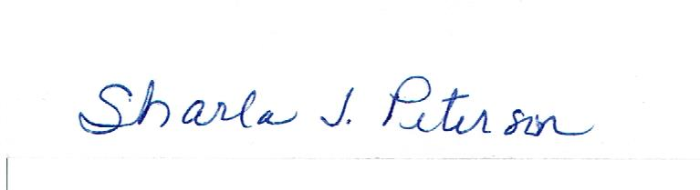

**Sharla Peterson, PPDWID recorder 3-24-2023**