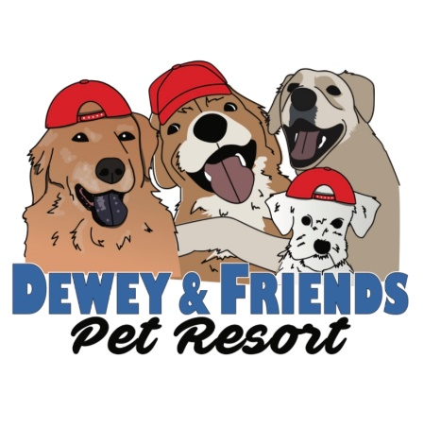
Medical Release Form

This is required from all Dewey & Friends Pet Resort participants receiving services.

First and foremost, the safety and wellbeing of your pet(s) is of the highest importance. Ensuring that your pet remains safe and well cared for is our first responsibility and as such we take it very seriously. We do our best to have our pet parents screen for pre-existing health conditions, but some factors may be beyond our control. In the event that a medical emergency arises while a pet is at our facility or participating in a service that we provide, it is imperative that we are immediately able to get them medical treatment at the closest available facility. We will call ahead to the veterinary offices in the closest proximity geographically to us to insure they can handle the emergency present. Your pet will be rushed to the closest available facility for treatment, and you will be notified. We notify the owner after we have secured a medical treatment center for the animal to avoid delays that may be caused by emotion on the part of the owner. Our goal is to get your pet medical attention as quickly as humanly possible, and any distractions may interfere with that process.
For this reason, it is a requirement to have our pet parents sign this form.
I understand that in the event of a medical emergency, Dewey & Friends Pet Resort,

at its sole discretion deems to need the immediate attention of licensed veterinarian. I authorize Dewey & Friends Pet Resort to seek medical attention at the closest available veterinary facility. I further agree that I am financially responsible for any medical treatment my pet(s) receives as a result of a medical emergency while attending services provided by Dewey & Friends Pet Resort.

Signature of owner: __________________________________ Date: ______________________
Printed Name: ____________________________

