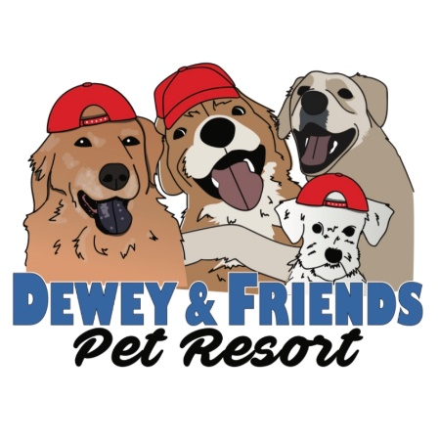
Pet Care Agreement

Your Name: _________________________________________
Address: ___________________________ City: ______________ State: _______ Zip: ________
Primary Phone ________________ Work Phone: ________________ Other: ________________
Email Address: _________________________ Spouse/Partner: __________________________
Dogs Name: _____________________ Age: ________ Breed: ____________________________
- I understand that Dewey & Friends Pet Resort has relied upon my representation that my dog is in good health and has not injured or shown aggression or threatening behavior to any person or dog in admitting my dog for services to their facility.
- I further understand that Dewey & Friends Pet Resort, their owners, staff, partners, and volunteers, will not be held liable, financially, or otherwise, for injuries to my dog, myself, or any property of mine while my dog is participating in services provided by Dewey & Friends Pet Resort. I hereby release Dewey & Friends Pet Resort of any liability of any kind arising from my dog’s participation in any, and all services provided by Dewey & Friends Pet Resort.
- I further understand and agree that any problems with my dog, behavioral, medical, or otherwise will be treated as deemed best by the staff of Dewey & Friends Pet Resort in their sole discretion, and in what they view as the best interest of the animal. I understand that I assume full financial responsibility and all liability for any, and all expenses involved in regard to the behavior and health of my dog.
- I further understand that there are risks and benefits associated with group socialization of dogs. I agree that the benefits outweigh the risks and that I accept the risk. I desire a socialized environment for my dog while attending services provided by Dewey & Friends Pet Resort and while in their care. I understand that while the socialization and play is closely and carefully monitored by Dewey & Friends Pet Resort’s staff to prevent injury, it is still possible that during the course of normal play my dog may receive minor nicks and scratches from roughhousing with other dogs. Any injuries to my dog that Dewey & Friends Pet Resort are aware of will be pointed out by staff upon pick-up.
- I understand by allowing my dog to participate in services offered by Dewey & Friends Pet Resort, I hereby agree to allow Dewey & Friends Pet Resort to take photographs or use images of my dog in print form or otherwise for publication and/or promotion.
- I further understand that I am solely responsible, financially, or otherwise, for any harm or damage caused by my dog while my dog is attending any services provided by Dewey & Friends Pet Resort; including but not limited to harming another dog that may require veterinary care, when my dog was the instigator.
- I understand that if my dog is not picked up in time or by a date specified in a separate agreement, I hereby authorize Dewey & Friends Pet Resort to take whatever action is deemed necessary for the continuing care of my dog. I will pay Dewey & Friends Pet Resort the cost of any such continuing care upon demand by Dewey & Friends Pet Resort. I understand that if I do not pick up my animal, Dewey & Friends Pet Resort will proceed according to the guidelines provided by the state of NH for abandonment of animal by owners. I also acknowledge that I will be fully responsible for all attorney’s fees and associated costs if I abandon my dog.

Signature of owner: __________________________________ Date: ______________________
Printed Name: ____________________________

