**RCG Consulting**

**Services**

Industrial Marketing

Health Check

Strategic Planning

**RCG Consulting Services**

**Brisbane Based**

[roderickgreen@bigpond.com](mailto:roderickgreen@bigpond.com)

PH 0404887143

ABN 65188656277

[www.rcgconsultingservices.com](http://www.rcgconsultingservices.com)

Version 12/06/2020

Index.

PG 4 Forward

PG 6 Marketing Check List

PG 8 Define Target market

PG 10 Unique Selling Proposition (USP) SWAT

PG 11 Perceptual Map

PG 16 Pricing Position Strategy

PG 23 Inventory

PG 27 APA Procedure

PG 31 Section 2

PG 33 Operational Procedures

PG 34 Inventory Matrix

PG 36 Stocking by Class

PG 40 Sales Procedure and Relationship

PG 46 Distribution

PG 49 Computer System

PG 53 KPI’s

PG 56 Initial Stocks

PG 57 Pricing

PG 70 Acronym Definitions

PG 71 Addendum 1 Pricing

PG 72 Addendum 2 Increase Order Size

PG 73 Addendum 3 Customer Retention

PG 75 Addendum 4 Logistics

PG 86 Addendum 5 Marketing Overview

PG 93 Budgeting, 5 Year Plan

PG 98 Analysis

PG 103 Addendum 6 Staff and Positions

PG 104 Addendum 7 New Vrs Used

PG 105 Addendum 8 Training

PG 106 Addendum 9 Operation

Index.

PG 107 Addendum 10 The Office

PG 109 Client Satisfaction Survey

PG 114 Work Flow Chart

PG 114 Relationships

PG 118 Final Synopsis

PG 118 Service exchange RM RB

PG 126 The Battle Map

PG 127 Fleet Operations

PG 129 B2B Marketing

PG 133 Marketing Through Operational Excellence

PG 136 Person to Person.

**Forward.**

**So! What is Industrial marketing? Personally I believe it to be an infinitely more interesting field than consumer marketing. A form of marketing that works with the basics, a process that does not follow fads, does not predispose to accept change for change sake, but accepts change when long term advantage can be proven. In this thesis I endeavour to pull together the elements, ideas, procedures that I have learnt and discovered during my 40 plus year career within the heavy mobile equipment industry and applying marketing theory. I wish I had been given much of this information and ideas early in my career, instead of learning and discovering the hard way.**

**Another purpose of this publication is to be a proactive resource,( Part 1 to be a working document) as a means to help a business consider aspects that may or may not pentane to their business situation, sometimes in point form sometimes with a longer narrative. The writing and style is based on a heavy and industrial position, and is also consistent with a multi franchise OEM leaning. I have also written for the operative in the equipment industry, and not the academic. I have tried to keep narrative simple using as few words as possible allowing the busy professional and Non Marketer to read quickly.**

**So let us Start!**

**Marketing books will expound the FACT that there 4P’s, Product Price Place Promotion.**

**“Please see Addendum 5. A General Marketing Overview.”**

**This I hold to be correct, although there is a desire to add more, this I believe is change for the sake of change.**

**Lets consider below, and put forward a check list of basic questions.**

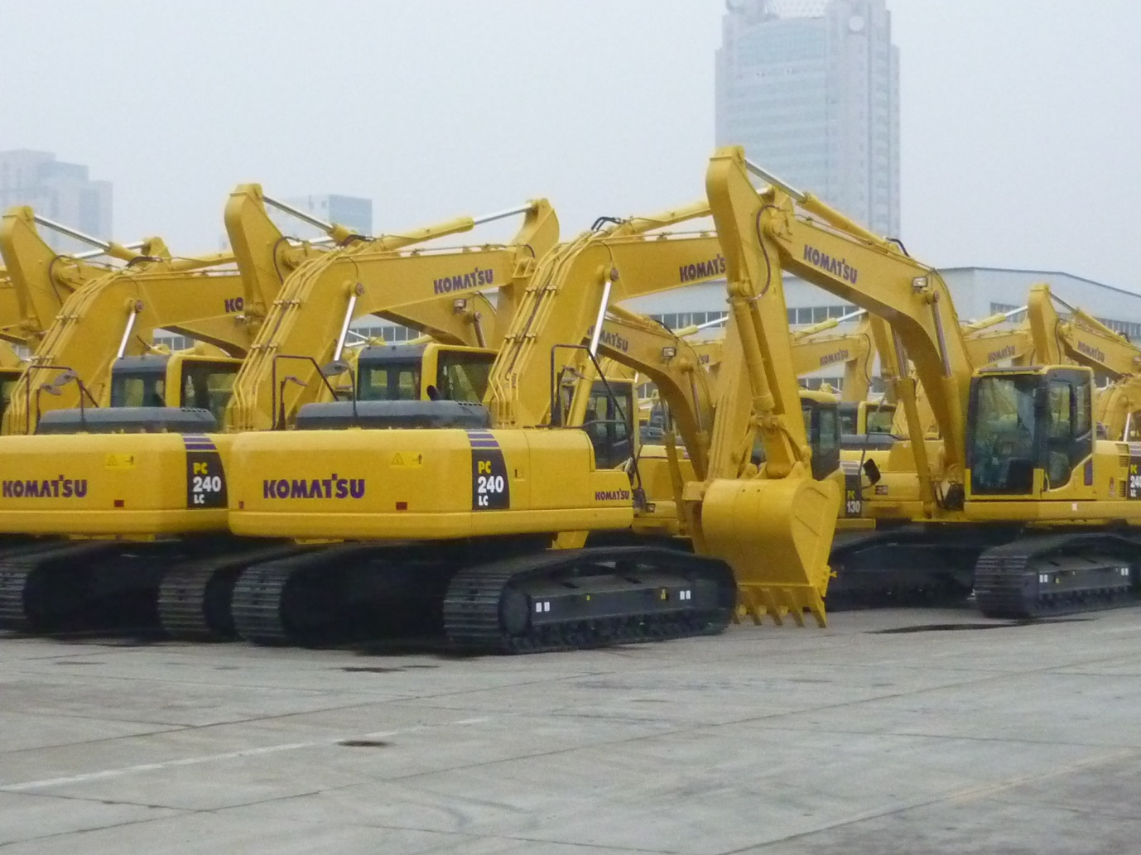

**Marketing Plan Checklist**

! Who is Your Customer?

! Why Choose Your Brand?

! Making the Sale?

! Reaching Your Customer?

! Growing Your Sales?

In short some of the basics you need to consider. As we move on through this thesis the above will be covered with a multitude of different points.

The procedure to move forward is to ask yourself questions, **Answer** **Honestly**, consider from different angles.

The use of this working document is to give a range of questions and analysis tools to be used. Be honest with yourself. Sit with another when using this document. To get the best results engage a person that is not part of your organisation thus having no preconceived ideas.(Industry experience is essential) After each section there is a space for notes, use it to document any relevant actions and ideas. 1/We will Start with Defining your target market, I have listed a number of suggestions that can be used. 2/ What is your Unique Selling Proposition.3/ You can undertake a SWOT analysis. 4/ Chose significant criteria, then undertake a Perceptual Map. Do one map to provide a base on how you believe you are perceived and or how you would like to be perceived. Then work with your clients on how they perceive you. Best to have an external party do this on your behalf. Will reduce the bias of extremes and provide a more honest assessment.

**You will only get out of this, what you put into it.**

Define Your Target Market.

Demographic & Psychographic Profile of Target Customers.

. Gender . Household Size . Nationality

. Age . Location . Language

. Generation . Occupation . Religion

. Income . Industry B2B . Machinery Owned

. Specialist Field . Education . Marital Status

. First World . 3rd World . Fleet Type and Size

. Purchasing Habits . Operational speciality (mining, Construction etc)

**. Psychographic Profile of Target Customers**

So what / who is your target market, can be a simple statement or a more defined narrative. Once you have defined your market, you need to consider the attributes that define them.

What attributes would frame your perfect customer.

What do they care strongly about?

What do they do for fun?

What media are they exposed to?

Are there things that disinterest them.

What manufacture do they consider to be best.

**Notes**

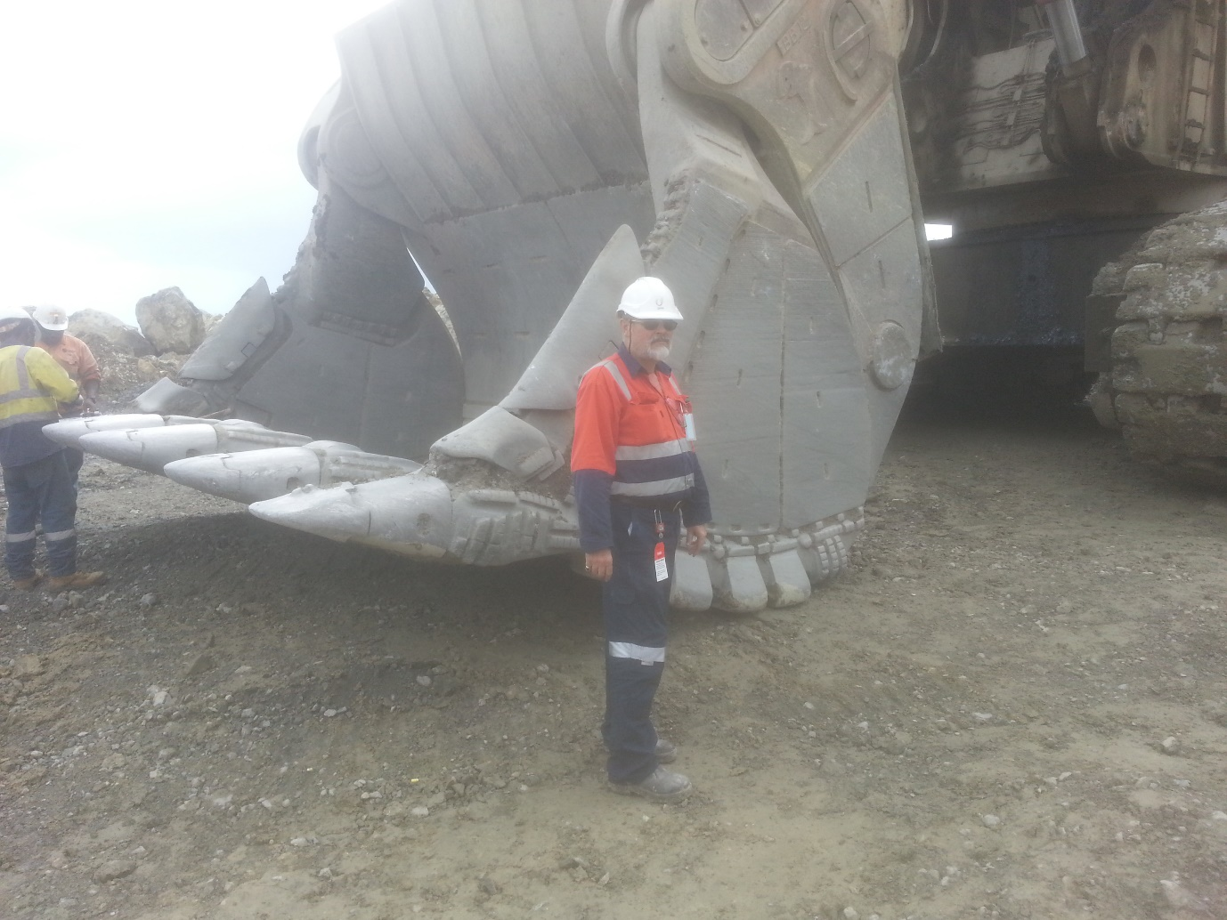

The author on site at Lihir Island. Inspecting an RH200 O&K Bucket.

Unique Selling Proposition (USP)

. Differentiation , What are the ways your brand stands out from the opposition. What attributes are uniquely yours? (Beyond pricing, IE safety, Options, location)

. Key Values. List any benefits that your products and services deliver to your clients, (current and future)

. Customer Response. How will the customer feel about their experience with your product.

.Customer Perception. How would you like your customer to think about your business. What does your product represent to your customer. (solving a problem, Less stressful life)

.External Relationships. Are there other products or services that customers buy or consume that are of a lesser or superior quality.

NB Use **SWOT** analysis, also a **Perceptual Map**

Swot Analysis

. Strengths

. Weakness

.Opportunities

.Threats

Perceptual Map. Your Perception

High Quality

Low Price High Price

Low Quality

How do you perceive your product, service and organisation?

Perceptual Map. Client Perception

High Quality

Low Price High Price

Low Quality

There will inevitably be a difference in perception within the market place, and to where you would like and believe your Company and products are positioned. There is a need for you to have an external party question you clients, regarding their beliefs and attitudes to your product and corporate position, this will allow for actual comparison of unbiased data. ( Best that person has industry knowledge)

A Perceptual map uses 2 different criteria arguments, with high and low values. The 2 different sets of data can be places on the same map, allowing for ease of view. You can also use a map to help prioritise your business activity, (High Value, Low Value / High Capital Investment, Low Capital Investment)

Distribution

**How does your customer get your product?**

**Direct Distribution** Do you use a retail location, Online sales, Direct Mail, Prepaid Delivery, Sales Representatives.

**Indirect Distribution** Do you sell via distributors, Partners , JV’s Agents, Dealers, Sub Dealers

NB Do you try a mixture of Direct and Indirect?

**Transport** Are you located in a Hub, or within receiving and delivery routes. Consideration, Air, Road, Sea, International , Domestic, Dangerous Goods Regulations, Customs Clearance, GST, Domestic/Local Charges, Rail, Postage.

To me product distribution is a necessary part of the marketing mix, and relates to, and has a bearing on each of the 4 P’s of marketing. (Product, Price, Place, Promotion) You can consider distribution as part of the tangible Product. Distribution can be included in the Price element of the mix, the on shelf price may be similar with your competitors, but your ability to provide to your product to a clients location at a lesser price will give you a price advantage and facilitate a purchase response.

You will need to consider how distribution relates to the mix and how it relates and affects your operation.

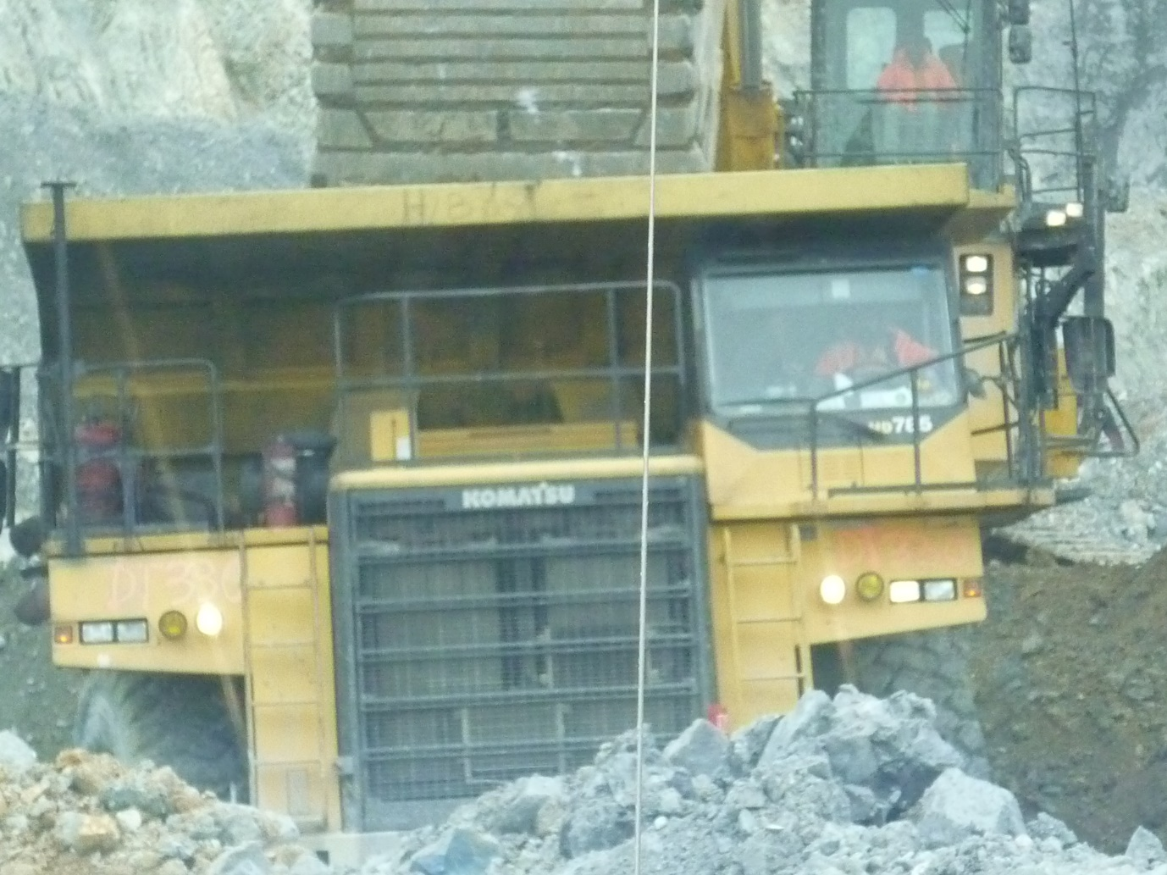

A Komatsu HD785-7 loading in the pit of a remote gold mine. These trucks were achieving in excess of 25000 hours before a full life rebuild.

**Pricing Position Strategy**

.What pricing do you charge for each of your products and services.

.How do these relate to your competitors?

. Do you consider the following.

Contact Pricing Indent Pricing Fleet Pricing

Price Matrix Bulk Pricing Free Offers

Trials Packaged Offers Discount Offers

Premium Offers Motivation to act. Sales Target Rebate

Commodity Code Product Group Cost Plus

Mark up % on AUC

Notes

See Addendum 1

Notes

**Increase the Order Size**

.What can be done to increase the size of an order?

Packages BOM Kits Up Sell

Cross Sell Bulk Pricing

The motivated sales person will always want to increase the size of each order. The more you can sell in each transaction is a cost effective means of increasing the bottom line.

Notes

See Addendum 2

**Customer Retention**

.How do you keep your customer coming back?

Regular Communication Loyalty Rebate

Product Training High Service Level

Market Pricing Credit Terms

.Post sale relationships

.Referral offers

**Do you consider PERSONAL SERVICE / CONTACT and RELATIONSHIP BUILDING as a primary task? Do you think a FACELESS integrated On Line service is better to the bottom line?**

Notes

See Addendum 3

**Normal Promotion**

Which of these do you do? Do you get any measured reaction?

Logo Business Cards Signage

Brochures Flyers Print Advertising

Stationary Catalogues Yellow Pages

Directories Gift Vouchers Packaging

Giveaways Uniforms Vehicle Signage

Trade Shows Sporting Teams Trade Publications

The above are shown, what we can call normal promotion, things that you will do and should do within the confines of normal business practice. Use as a check list against what you are currently doing. You may have others, this is by no means a definitive list.

Notes

**Digital Marketing/Social Media**

**Do you use any of the following, if so can you measure the results?**

Facebook Email Website

Twitter You Tube Linkedin

Paid Online Advertising Search Key words Contact Details

Get your Web Site to the top of the search!!!!!!!

What you do need to consider, “Is your target market a group that is Save and use Social Media?”

Notes

**Content Marketing**

.Newsletters

.Press Releases

.Customer Training

.Published Articles

.Speaking Opportunities

.Self Promote

.Seminars

.Customer Testimonials

.Public Relations

Content marketing takes a little extra effort, and some nonstandard thinking. It takes some effort to prepare articles for submission to trade journals, some OEM’s will have copy that can be used. Often there can be trade nights where you are able to present your brand and services. You can make as much out of Content Marketing as you are prepared to put in.

**Inventory**

**How do you plan your STOCKS.**

**. What do you believe your issues are.**

**.What product groups are you working with.**

**.What brand of inventory system do you use.**

**.Do you use an inventory class system (A,B,C).**

**.Can you analyse by usage.**

**. Do your stocks reflect vendor lead times.**

**.Do you do any supplier analysis /First Pick/BO**

**.What stocks do you hold.**

**.Genuine or aftermarket.**

**.Consumables, Filters, GET, Pins.**

**.Do you have any supplier Contracts.**

**.Do you run reorder reports based on usage, Min/Max. (calculated or manually set)**

**.Do you try to use dead stock in alternate applications.**

**.Do you do scheduled rebuilds, using BOM Kits.**

**.What maintenance do you do,(reclass, Min/Max update)**

**.Do you group your inventory by OEM Brand, and sub group IE Engine, Transmission, Driveline ETC.**

**.Centralization & Decentralization of inventory and process.**

**.Actions for removal of dead inventory.**

**.Reactive purchasing\Proactive Purchasing\Strategic Supply management.**

**.Formalizing supply chain, Supplier Partnerships, Strategic Alliances.**

**.Continuous identification of threats and opportunities in the firms supply environment.**

**.Does the ownership by group have active participation in the strategic inventory planning process.**

**.Receiving, issuing and stores process.**

**.Policy Manual.**

**.General stock & Expediting & Follow up.**

**Do you use OEM Part numbers, or System allocated numbers.**

**Notes**

**Actions**

After you have looked at your business and all elements of your operation, making notes in the spaces provided, you will need to take accountable action . I find the procedure on the next 4 pages as a means refining your conclusions, setting priorities , delegating tasks , setting completion dates and actual dates, and evaluating results.

There are many versions of this tool, I have set it to my personal liking. Groups will modify the format to suit their particular needs, this is the wise thing to do. The one rule is to follow through. Work to the target dates, don’t overload one person with deadlines. You will need a team leader to coordinate. Hold interim review meetings. They don’t have to be long. Try having the meeting with no table and chairs in the meeting room, the participants won’t want to stay too long.

|  |  |
| --- | --- |
| **APA Procedure Use By RCG** | |
| **Part 1 Analyse** | |
| 1 |  |
|  |  |
| 2 |  |
|  |  |
| 3 |  |
|  |  |
| 4 |  |
|  |  |
| 6 |  |
|  |  |
| 7 |  |
|  |  |
| 8 |  |
|  |  |
| 9 |  |
|  |  |
| 10 |  |
|  |  |
| 11 |  |
|  |  |
| 12 |  |
|  |  |
| 13 |  |
|  |  |
| 14 |  |
|  |  |
| 15 |  |
|  |  |
|  | Post prioritise from analysis to Page 2 Prioritise |

|  |  |
| --- | --- |
| **APA Procedure Use By RCG** | |
| **Part 2 Prioritise** | |
| 1 |  |
|  |  |
| 2 |  |
|  |  |
| 3 |  |
|  |  |
| 4 |  |
|  |  |
| 6 |  |
|  |  |
| 7 |  |
|  |  |
| 8 |  |
|  |  |
| 9 |  |
|  |  |
| 10 |  |
|  |  |
| 11 |  |
|  |  |
| 12 |  |
|  |  |
| 13 |  |
|  |  |
| 14 |  |
|  |  |
| 15 |  |
|  |  |
|  | Post prioritise from analysis to Page 3 Action |

|  |  |  |  |  |
| --- | --- | --- | --- | --- |
| **APA Procedure Use By RCG** | |  |  |  |
| **Part 3 Action** |  | | Target Date | Date Actual |
| 1 |  | |  |  |
|  |  | |  |  |
| 2 |  | |  |  |
|  |  | |  |  |
| 3 |  | |  |  |
|  |  | |  |  |
| 4 |  | |  |  |
|  |  | |  |  |
| 6 |  | |  |  |
|  |  | |  |  |
| 7 |  | |  |  |
|  |  | |  |  |
| 8 |  | |  |  |
|  |  | |  |  |
| 9 |  | |  |  |
|  |  | |  |  |
| 10 |  | |  |  |
|  |  | |  |  |
| 11 |  | |  |  |
|  |  | |  |  |
| 12 |  | |  |  |
|  |  | |  |  |
| 13 |  | |  |  |
|  |  | |  |  |
| 14 |  | |  |  |
|  |  | |  |  |
| 15 |  | |  |  |
|  |  | |  |  |
|  | Actions to include conclusion dates, and resources required to expedite the actions. | |  |  |

|  |  |
| --- | --- |
| **APA Procedure Use By RCG** | |
| Results Notes | |
|  |  |
|  |  |
|  |  |
|  |  |
|  |  |
|  |  |
|  |  |
|  |  |
|  |  |
|  |  |
|  |  |
|  |  |
|  |  |
|  |  |
|  |  |
|  |  |
|  |  |
|  |  |
|  |  |
|  |  |
|  |  |
|  |  |
|  |  |
|  |  |
|  |  |
|  |  |
|  |  |
|  |  |

**RCG Consulting**

**Services**

**Section 2**

**Equipment Spare Parts**

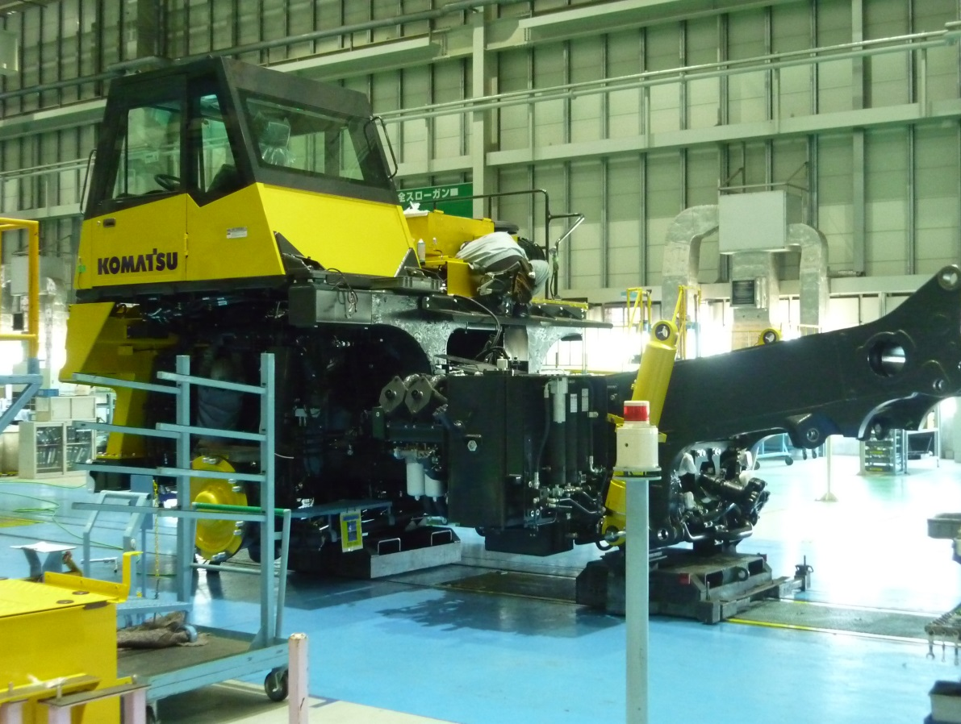

**By Roderick C Green FAMI**

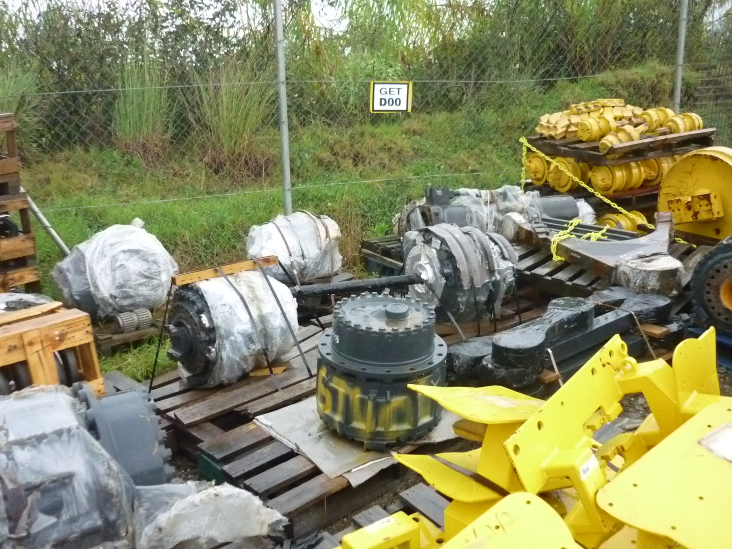

**Parts stock on a mine site. Not the way to store inventory. Note the truck final drives sitting out in the elements.**

**Spare Parts**

**Operational Procedures**

**Introduction**

What is the purpose of a spare parts department?

* To service the OEM Product, at an acceptable cost and generate profit.

* Run for profit, Run for service, Run for profit and service?

**Inventory**

Stock As directed by movement and preplanning must Push and Pull

SOH Stock on hand. Movement (demand) x lead time and safety.

EOQ Economic order Quantity. AMD x Lead time and safety stock-

Stock on hand and stock on order.

AMD Average monthly demand.

Stock Matrix A1 to Z4

New Stock Lines Hold in Matrix in a group that will come up for reorder.

Security Stock Stock no matter what demand and Obsolescence say.

Obsolescence How to calculate, remember corporate policy.

Average Costing. `Straight AUC or FIFO average? Page 97

Gross Turns, Sales at cost BY Inventory.

True Turns, Stock order purchases BY Inventory.

*Push and Pull. See glossary of terms page 97

|  |  |  |  |  |  |
| --- | --- | --- | --- | --- | --- |
| Inventory Matrix | | |  |  |  |
|  |  |  |  |  |  |
|  | **1** | **2** | **3** | **4** |  |
| **A** | **A1** | **A2** | **A3** | **A4** |  |
| B | **B1** | **B2** | **B3** | **B4** |  |
| C | **C1** | **C2** | **C3** | **C4** |  |
| D | **D1** | **D2** | **D3** | **D4** |  |
| E | **E1** | **E2** | **E3** | **E4** |  |
| G | **G1** | **G2** | **G3** | **G4** |  |
| V | **V1** | **V2** | **V3** | **V4** |  |
| W | **W1** | **W2** | **W3** | **W4** |  |
| X | **X1** | **X2** | **X3** | **X4** |  |
| Y | **Y1** | **Y2** | **Y3** | **Y4** |  |
| Z | **Z1** | **Z2** | **Z3** | **Z4** |  |
|  |  |  |  |  |  |
| A class, more than 10 movements per year. | | | | |  |
| B Class, 7 to 9 movements per year. | | | |  |  |
| C Class, 4 to 6 movements per year. | | | |  |  |
| D Class, 2 to 3 movements per year. | | | |  |  |
| E Class, 1 movement per year | | | |  |  |
| G Class Security stock. | | |  |  |  |
| V Class, movement 12 to 24 months. | | | | |  |
| W Class, movement 25 to 36 months. | | | | |  |
| X Class, movement 37 to 48 Months | | | |  |  |
| Y Class, 49 to 60 months. | | |  |  |  |
| Z Class, 61 months plus | | |  |  |  |
|  |  |  |  |  |  |
|  |  |  |  |  |  |
| 1 Class, 0.01 to 10.00 replacement cost. | | | | |  |
| 2 Class 10.01 to 200.00 replacement cost. | | | | |  |
| 3 Class, 200.001 to 1000.00 replacement cost. | | | | | |
| 4 Class, 1000.00 plus replacement cost. | | | | |  |
|  |  |  |  |  |  |
| Moving Stock | |  |  |  |  |
| Security Stock | |  |  |  |  |
| Dead Stock | |  |  |  |  |

The stock matrix is to be modelled on your specific needs. For example an “A” class item can be can be set a months of movement or individual movements. The numbers to be set after an analysis of lines and movement numbers. This is to say You may set A class as movement in 10 to 12 months. B class may be set as movement is 8-9 months of the year. You may set on individual movements. This will depend on a breakdown on movements by line item. Depending on your numbers A class may be 20 plus movements per year, B class could be 15 to 19 movements per year etc working it’s way down the matrix.

Other systems may not rely on a class system, and can work on the 80/20 principal. Working on your top 80% either by “ Quantity, Movements, Dollar Value”

|  |  |  |  |  |
| --- | --- | --- | --- | --- |
| **Inventory Stocking by Class** | | | |  |
|  |  |  |  |  |
|  | **1** | **2** | **3** | **4** |
| **A** | **A1** | **A2** | **A3** | **A4** |
| B | **B1** | **B2** | **B3** | **B4** |
| C | **C1** | **C2** | **C3** | **C4** |
| D | **D1** | **D2** | **D3** | **D4** |
| E | **E1** | **E2** | **E3** | **E4** |
| G | **G1** | **G2** | **G3** | **G4** |
| V | **V1** | **V2** | **V3** | **V4** |
| W | **W1** | **W2** | **W3** | **W4** |
| X | **X1** | **X2** | **X3** | **X4** |
| Y | **Y1** | **Y2** | **Y3** | **Y4** |
| Z | **Z1** | **Z2** | **Z3** | **Z4** |
|  |  |  |  |  |
|  |  |  |  |  |
|  | **Stock 3 Months** | |  |  |
|  | Stock 2 Months | |  |  |
|  | Stock nil |  |  |  |
|  | Stock 3 Months | |  |  |
|  | Stock to Quit Dead | |  |  |

The inventory matrix can be an invaluable aid in managing your inventory. If we consider the above matrix, A1 to C2, should be the area you concentrate on, with the plan to ensure you always have stock on hand. Helping with your first pick availability. C3 to D4, an area where you may have to make some value decisions depending on your inventory holding budget. E1 to E4 Possibly only move once a year so you won’t want to stock, Possibly too much money for too little return. It will also pay to analysis what percentage of your sales and movement in “E” class. IF 30% of line items sold come from the “E” class group, you can only then expect a first pick availability of 70%. This can often happen when your machine sales group, go out and sell 1 or 2 only of a specific model. My research has shown a machine population of 4 plus is the break even population for minimal stocking and profitability. G1 to G4 I would suggest you use as a group for holding what I would call “Security Stock”, stocks you may need to hold to for specific client of specific application, and should only be driven by demand, when the item is moving up the matrix . V1 to Z4 you would set in the following terms. “V” class no movement 12 to 24 months, “W” class no movement 25 to 36 months. “X” class no movement 36 to 48 months. “Y” class no movement 48 to 60 months. “Z” class no movement more than 60 months. This is ageing your inventory, you can look at write downs against your obsolesce reserve, give your sales team freedom to reduce the sell price. Consolidate in one location to free up warehouse space for moving stock.

**Marketing**

Goals Corporate goals, (Profit, Service, Both)

Plan Marketing plan

Product, Price, Place, Promotion.

Product Position Perceptual Map,

Market Segmentation. More by geographic and industry. (Not so much Demographic, physiographic)

Remember AIDA in the way you market to new business.(Attention Interest Desire Action)

What percentage of your total market are you getting, if not 100% what do you need to do??

**Warehouse**

What does a warehouse do? Hold and distribute stock! The speed and accuracy in which this is done, is a selling point.

**Design**, Fast moving picking area, Separation of inwards and outwards, Non Confirming. Shelving and binning for various size, High density draws and filing cabinets can provide vast space savings. Suitable bulk storage with easy forklift access.

**Materials Handling.** Forklift style (elect, gas, container masts). Reach trucks.

Primary objective must be customer service including accuracy.

Assistant Parts Manager to be warehouse supervisor.

Stock takes Full physical or Cyclic

Computer system. Must be friendly. Often computer systems are selected by accountants because it has a “Great General ledger System” the selection should commence with the operational side of the business, Inventory, Sales, New and Used Equipment, Workshop, Warehousing. An easy to use in depth Management information system, should also be available.

**Sales**

**Counter**

**End users coming to a parts counter need to be attended to by experienced and knowledgeable professionals. There is a growing trend today is to have computer input clerks as your front line personal. If the end user is unable to supply part numbers, the clerks are unable to take the sale any further. No opportunity to expand the sale, offer alternatives (if nil stock) no chance to develop helpful close relationships with the end user. This may be a cost saving and also forced due to the lack of experienced personal.**

**The Parts Interpreter discipline is renown for being under paid, with personal being the brunt of difficult clients, ( inventory, finance, service, issues). Often causing high turnover and burn out of staff.**

**In a more ideal world the Interpreter position should now be a transition position leading to Equipment sales, Parts or Warehouse Management, or further opportunity. The advantage with this is there can be an ongoing personal relationship with clients, also an ongoing relationship with company personal in other branches, that can lead to an informal relationship that aids in internal problem solving.**

**The supply of interpreters can come from many sources, warehouse, workshop, external. A further issue is that the counter or phone interpreters are never skilled in the basics of the trade, component identification, structure and function, basic engineering knowledge id of bolts and threads, measurement of bearings and seals, hose sizes, where you measure internal or external.**

**Phone**

**Dealerships will have a phone room, or their counter interpreters covering both duties. Larger companies will have a national call centre based most often in the same location as their head office, or in a location with a cost advantage. There are cost savings with call centres, but there is a loss of continuity and relationship between client and company,**

**Internet**

**Many OEM’s and increasingly Aftermarket dealers are actively trying to promote the usage of an online service for the purchase of spareparts, (looking up parts requited, placing orders follow up of Sales Orders) also for active access to parts manuals, and service information. This opens up a Pandora’s box. A reduction in the costs of parts interpreters, also placing any responsibility for selection of parts in the lap of the end user and not the dealer. It also can provide a restriction in the dissemination of proprietary data. While there are cost savings to be achieved( personal, and on costs). There is also a major down side, being the lack of personal relationships with your clients. There is also the lack of opportunity for the experienced parts interpreter to be able to offer options, that may reduce downtime.**

**Workshop**

**Workshops will make calls on a parts department, this needs to happen in a controlled manner. A system of manual or online requisitions needs to be in place, giving Job Number, quantity and part number. This can be charged directly to a warehouse picking ticket that is linked to WIP (work in progress). Backorders can then be handled in the same manner as a normal sales order. The Job Number can also dictate the Job Type, IE Warranty, Revenue, Retail, Assembly, New Equipment, Used Equipment, Reman/Rebuild. This can also predetermine the level of pricing. When dealing with your workshop, there are issues to be mindful of. Service Managers, will often over order to cover the lack of fault diagnosis, they will then try to return to stock. This is one of the major contributing factors to the creation of dead inventory. (every ones enemy) Service managers will also try to remove parts from a workshop job, to cover for overruns in labour. Never give inventory out without the Paperwork!!**

**New Equipment**

**The new equipment sales manager will often require items of inventory for many reasons. A new machine may need to be modified to suit the clients needs and job specifications, IE a new excavator or bulldozer may need to work in an application that requires a lower ground pressure, due to swampy and wet conditions. The need will be to retro fit wider track shoes. The Parts Manager and the New Equipment Sales Manager will then need to negotiate a settlement that will involve supply of wider shoes and the return of the existing narrow shoes.**

**Used Equipment**

**The used equipment manager will take delivery of pieces of used equipment that are in a range of conditions and levels of repair. He will need to calculate how much money to spend on a unit to put it into a saleable condition, but not spend too much money and make the unit too pricey to sell. Normally he would hope not to spend any money at all. Parts to used equipment will normally be charged on a used equipment Job Number through the workshop. The used equipment manager will sometimes provide consumable items as part of a deal, IE set of tracks or cutting edges. There will be a set pricing level agreed as a norm. Any special needs will be negotiated between the Parts Manager and the Used Equipment Manager.**

**Sales Reps/Product Support**

**One of the best tools the Parts Manager can have are his sales reps and product support reps. Within the equipment and industrial markets regular client visitation and inspection of machines is a proven means of not only supporting the product, but also selling Parts and Workshop Labour. To give an example, a client has a fleet of tracked machines , your Product support representative makes regular client visits. On these visits he measures the wear levels on the tracks of each of these machines. He is then able to prepare a report on each unit by serial number, hours worked etc. He includes the wear measurements ( Percentage worn) and can suggest a programme of track replacement based on hours worn and projected life in hours. Benefits to be arrived at, the client does not get any unexpected shocks, of down time . Undercarriage can be ordered on an indent basis, with the possibility of a cost saving to the end user, as you don’t have to hold inventory. The chance to also quote your workshop labour.**

**Sales/Supply contracts**

**When dealing with major end users, the means can differ from a small contractor, You may agree to hold and supply a basket of line items under certain agreed conditions. Some of this will be dealt with in the Contract Pricing section. You may agree to a certain level of supply, or to hold on the clients behalf a particular range of inventory, that would not normally be held under a demand based system. IE full sets of Hydraulic Pumps, or a particular style of G.E.T (Ground engaging tools/ Bucket teeth) IE High Impact Rock Teeth, or a High Penetration Tooth as opposed to the standard tooth.**

**Contract Pricing**

**A client that has a large package of your equipment( Fleet Owner)may well expect to enjoy a better level of parts pricing. This can be done by offering a discount, or a price level separate to the main price list in the system. Hopefully you will have a stagged matrix based on product group. Offering discounts can be a slippery slide and brings a discount mentality, what percentage of what starting price. Everyone can enjoy a discount off what inflated starting price? If you already competitively price your inventory, why discount? If you need to do special deals with large fleet customers, you could offer contract pricing by line item on a selected basket of line items. Remember this needs to be reviewed on a regular basis, possibly in line with OEM’s official price changes) ( Prices can move up and down, reflecting OEM price movement, forex movement) OEM’s will often reduce pricing down when they see certain line items are slowing in movement.**

**Sales programs**

**You may wish to offer sales programs, IE In conjunction with the Service Manager you may offer better pricing on filter kits when the servicing is done by your workshop or field service fitters. You can offer measurement of undercarriage as a service and quotation for replacement.( previously discussed) Above I have given 2 examples, and they can very on the industry you are servicing, Earthmoving , Truck, Agricultural. (Hay and harvest or tillage season, air bag replacement)**

**Bailment stock sales.**

**Bailment stocks, either from the OEM to you. Or you to the end user. This is a support service that may often happen. In brief you supply stocks to your client, or the OEM supplies stock to you without invoicing to you, or you invoicing your client. The advantage is that there can be critical stocks on site that don’t have to be paid for until used. Normally you would advise or be advised on a weekly basis what has been used, and then invoiced. Those stocks would then be replenished. This is the upside, and good in principal.**

**Having to agree on what has been used then invoiced. Regular stocktakes have to be done and agreed, the reconciliations signed off, and invoiced. Difficulties will occur involving a situations, IE when workshop fitters get involved and fit items as a test, finding it’s not the problem and put the goods back on the shelf, Ie Electrical items Alternators or starter motors, these goods are no longer new and possibly burnt out. Items taken and not charged out. Warranty items taken before approval is given. An agreement outlining invoicing, stocktaking, storage condition, needs to be set in place with both parties having a full understanding.**

**Retail VRS Wholesale**

**When you are a dealer, pricing to you will take place in a number of different ways. Different OEM’s will have different procedures. Often the OEM will issue a price list, possibly 2 or 3 times a year, with occasional updates. Your dealer price may be a billing rate of that price list. Your emergency billing rate may be 75% of list price and stock order rate of 65%of list price. That in simple terms means if you place an order on emergency basis, you receive a discount of 25% from the OEM list price, when you submit a stock order you will receive a 35% discount from the OEM list price. (as a general rule but not in every case this will happen. Percentages will differ) Often a stock order will be supplied on a CIF or freight free basis (cartage insurance freight), leaving you to deal with local charges and logistics. From here you will have to set your own list or sell price. You will set your price based on the commodity or product group, the more competitive the group the less a margin you will take. You may negotiate a more competitive buy price with the OEM on parts in these groups or selected parcel of line items. Items that are proprietary will normally maintain a higher margin. Your retail price needs to be set within the market expectations. When end users tender a new fleet of machines, trucks ETC, you will often be asked to price a basket of parts, both consumable and hard parts. If the hard parts selected are vastly more expensive than a competitors, it becomes hard to justify the purchase of your machines. ( although that item may never be used in the working life of the machine) When OEM’s produce a new price list, they have some tricks that you will need to be aware of. Often the OEM may claim that the have an overall price reduction of 2% , this will often mean a 5% reduction on expensive components that are never used, and a 2% increase on the consumable items. Before a new price list can be implemented an analysis needs to take place. If you are not mindful of this you will be increasing your consumable item price and end up losing business.**

**Should you operate as a retailer and wholesaler you attention to pricing is going to have to be more intense. If you set a retail price for your branch or branches the price that you then offer to your agents or dealers needs to be a price that allows them to maintain a commercial margin without being excessively more expensive than your locations, also any price reductions offered by your retail branches cannot be in conflict with your agents or dealers. This will often lead to a short term relationship with that agent. You can always sell to your agent at your full retail price and then give a monthly rebate as a percentage of purchases. The reverse also needs to be considered, the scenario is you supply a range bucket teeth to your agent at your list price less 25%. The agent then sells to the market at a discount of 10% and retaining only 16% gross margin for themselves. If your retail is acceptable to the market, all the agent is doing is damaging your reputation, reducing their profit, and causing friction between both parties. The subject of agents will be discussed further in the next section.**

**Distribution**

**Locations**

**How do you select locations for your branches, the logic behind the decisions will be many and varied, I will list in point form, and give some food for thought. The requirements will differ by industry type. The location for a tractor dealership will differ from those of a truck franchise. Remember that the perfect location can be more than your business plan can afford to pay.**

**Capital city and regional locations.**

**Locations located to support industry.**

**Do you need main road frontage.**

**Size of roads and turning access for heavy vehicles.**

**Cost of location either purchase or rental.**

**Legal restrictions and bylaws.**

**Storage considerations.**

**Proximity to target group.**

**Availability of suitable locations.**

**Cost to modify the location infrastructure.**

**Access to freight hubs (Air, Sea, Road)**

**Freight**

**Freight On/Prepaid. Allow customer to share better pricing.**

**You always need to consider the service element of providing freight and delivery to your clients. Often you may wish to take advantage of your freight buying power, to prepay the delivery freight and recharge on the invoice.**

**Channel Management**

**The term Channel Management is one of the buzz words liked by logistic consultants. It covers a wide range of activity and numerous disciplines. So what does it mean, its how do you manage the purchasing, sales and supply movement channels, and incorporates logistic management. If you have a manufacturing component to your business your goal is to have the component parts of your end product turn up, Just In Time (JIT) so scheduling purchasing and freight logistics will become part of channel management.**

**Agents**

**It’s popular to include agents in your product distribution mix. (part of channel management)What is the normal reason behind having agents? Where a company standalone branch cannot be justified, but there is a need to supply an increased level of service, to a group of users in that region. It’s necessary to have a Dealer or Agent agreement in place, outlining the duties and responsibilities of both parties. This should be as simple a document as possible, setting forth parts stocks and pricing, workshop facilities, warranty work and pricing, hourly charge out rates, what staff training you will provide to the agents staff. Do you expect your agent to make machine sales or just provide leads and have you sales people follow up, with a spotters fee paid to the agent. Do you put consignment stocks (parts and whole goods) at their location? A relationship that allows for a feeling of comfort when visiting each others locations, and a friendship and good working relationship between the staff of both parties is essential, if this arrangement is going to work. You also need to consider that the agents dealings with you is not necessarily their core business, and what they do for you is often a small adjunct to their operation. Often they are doing you a favour by allowing you representation in their region.**

**Company Branches**

**To discuss company branches we need to consider the structure that will best fit your companies needs, also the needs of the product and the needs of the end user. There is a cost/expense aspect. Can you afford to put duplicate facilities in each selected location, or do you have service branches supported by a main or head office. You could have different specialist activities in different branches, Possibly one location may have a track press, another may do engine rebuilds, and engine dyno, another may have a hydraulic rebuild and test facility, another branch may have fuel room. Or do you have all of this in your main branch and have the outlying branched send the work to a central rebuild in your head office. All company branches need to be able to stand alone financially to justify their existence. Centralisation is not always the best for providing the best service, and will always be a cost trade off.**

**Non sales stores/on site warehouse**

**You may wish to consider having a central warehouse that all subservient locations feed out of on a daily basis for EO basis. Consumable fast moving items (A,B,C, class) can be replenished on a weekly reorder based on demand and usage. Your central warehouse is only there to support the branches and does no retail sales. Or you could also have a sales group based there. Reorder is based on centralized demand and usage from the satellite branches and the demand and usage from any agents. You can set demand in 2 practical means.**

**1/ Take the demand up in the selling branch, then combine the sales from all locations for a national demand, and have a national and branch matrix class.**

**2/ You can set the system to calculate every branch transfer from the central warehouse to a branch, as a demand for the reorder calculation.**

**Each system will work, you need to decide what suits you best.**

**Computer**

**What is the purpose of a computer system?**

**To store, format and present data in a useable format.**

**Computer packages for the equipment dealership environment differ. With features, I have tried to list points to consider below. Proceed with caution as this will be a major capital investment. ASK FOR and DEMAND what you want and need.**

**Computer sales people and IT consultants and accountants believe they know more about your needs than you do. No one package ever gives you all that you need, so often it can be a cost trade off.**

**I have listed below points that you need to consider, and questions that you will need to ask, DON’T be pushed into taking what the IT people want to sell you……**

**Show stock, by branch, with AUC, List, Bin Location, SOO/Transit, Available/Dedicated. Options for supersessions and notes.**

**Stock movement, easy to view screen with costing’s.**

**Provide reports, Must have necessary reports, also ease to design others as requires.**

**ABC Class, full matrix A-Z 1-4 options to suit business.**

**Push and Pull, Systems tend to favour one or other, need to find correct balance.**

**IBT’s and Invoices, when does it take it from stock and when does it add it in .**

**Must be Average Demand (AMD) driven. Min/Max driven can also be included as an extra to calculate from, Min can be set a 1.5 months Max can be set at 3 months(depends on lead times). Option to reorder to Min or Max levels.**

**Could also be top Percentage of sales (items or sales) reorder on top 80% (lines or value).**

**Does it have the flexibility to cover the various vendor lead times and ordering procedures.**

**Costing methods. AUC, FIFO, FIFO Average. By location or company?**

**Stocktake system, WIP system and charge out to workshop.**

**How does it link to the GL?**

**Is it easy to use, easy to move from screen to screen.**

**Security levels? And personal access.**

**On line purchase orders, is there a provision to include manual P/O’s**

**User friendly paperwork (picking tickets/invoices)**

**Executive information system, is the data easily available or do you have to dig for it. Is it in a user friendly format.**

**Inventory class by movement or months of movement. (Bin Hits)**

**Ease of download into Excel or PDF file. Excel to give you the flexibility to massage data for analysis.**

**The ability to convert, IE Build , one item from a group of components.**

**The use of a Build of Materials (BOM) Kit system, Ask where the movement is taken up and how.**

**Can you import pricing and or pricelists, via the use of an external file such as excel.**

**Finance**

**Stock holding costs. What percentage of gross margin is necessary to cover this?**

**Absorption Rate. The percentage contribution of the profits from you parts and service departments to cover the Fixed Costs or your operation. Usually expressed as a percentage**!

**Budgeting ! Sales, Stock, Expenses, Capital Expenditure, Profit. Do you have a 5 year plan. ( As a guide only)**

**Stock Turns. (true gross)**

**Bank finance, overdraft.**

**Your gross margin needs to cover the following elements. 1/ All expenses, labour, rent, warehousing, etc, leaving enough margin to give the owners a suitable profit that more than covers what they may get by leaving the money in the bank, investing in shares and dividends.**

**KPI’S**

**First pick availability, expressed as a percentage, as high as the money you are prepared to invest. 80/20 principal.**

**Supplier availability (first pick, total order)Should monitor, IE 80% in 60 days. The lower there availability the more it affects you business.**

**Stock turn (True Turns or Gross Turns)(SO purchases by Inventory) (total inventory by sales)**

**Gross margin**

**Net Profit, Bottom line.(After expenses)**

**S/O VRS EO Ratio 80/20**

**Sales by Class (Analysis by company policy) Where are your sales coming from. If you get 90% from A to D Class, all well and good. If 50 % of sales are coming from E Class, not so good.**

**24 hour Availability, What percentage of client requirements can you supply within 24 hours, especially in an OEM situation.**

**Expenditure, Ensure your expenditure is within Budget.**

**Moving/Dead stock ratio**

**Absorption Rate (contribution % to total fixed costs, by parts and service), look for better than 80%.**

**Mechanical**

**Must have mechanical aptitude**

**Working knowledge of maintenance procedures and systems.**

**Also must have some understanding of client industries.**

**So many parts operations today rely on call centres, employing not much better than clerks, with ZERO product knowledge. You have the opportunity to present yourselves and much more professional, if your staff have product knowledge.**

**Regular training of your front line people is important.**

**An understanding of structure and function, how a machine works and what each component does.**

**Important to have a knowledge of General Engineering. Bolts/Threads, Tensile strength, hydraulics/ hose and fittings.**

**If the parts person is mechanically competent, gives an ability to make suggestions that will help the client and enhance the reputation of your franchise.**

**Genuine VRS Non Genuine**

**Quality differences. Sometimes Genuine and Non Genuine can come out of the same factory, as excess production, sometimes OEM’s repackage a specialist manufactures product, such as Fuel Injection, or Turbochargers. So strictly there is no difference. Other times they are direct copies, quality various, ranging from substandard to much better. You must consider the options, sometimes a cost trade off.**

**Price differences. Quality and price differences can come down to a cost trade off. May come down to dollar per hour. (Must factor in, change out, and down time)**

**Genuine and Non Genuine coming out of the same factory, often it can be selling the Over Run.**

**Same suppliers make for genuine and non genuine.**

**How to battle non genuine(quality, price, warranty)**

**Do you offer both? You can offer both options, quite common in the manufacturer of tools quite often offer a lesser brand at a lesser price. Caterpillar offer Classic parts for older machines.**

**Initial Stock**

**RSPL from the OEM (RSPL recommended spare parts list)(OEM original equipment manufacturer) will recommend stocking of parts for a given number of hours. These need to be treated with some caution, as some OEM’s will include too much and lead to dead stocks. You need to consider application and working conditions, and adjust your stocking accordingly, you may need more than the suggested Qty.**

**Service requests x unit Quantity. You can calculate consumable items such as filters and GET given quantity of machine units by projected hours worked per year/month.**

**Do it yourself from experience. If you are experienced you can pull together the data from the OEM’s RSPL’s and projected consumable by hours, and the working conditions, to come up with your own list. eg An excavator no matter the size 5ton or 500ton will always wear and fail in the same location. A bucket cylinder is more likely to be damaged than a boom cylinder.**

**Client requests. Clients may request you keep certain emergency items, this should be negotiated during the initial purchase of machines, and some restrictions need to be placed. A return to the OEM if not used within a period. Or if not used within a set period the end used to purchase items , at an agreed price level. Care has to be taken as this can lead to DEAD inventory. NB pricing structure should also be agreed at the initial purchase.**

**Pricing**

**Against the market**. Consider what the market is asking for a group of products, your price has to be competitive,

**Via Commodity code**. Filters, GET, Engine, Transmission. Different commodities to attract GP’s.

**By product group.** See above, but may differ if you use a franchise driven product group, IE Komatsu engine parts may attract a higher GP than Hitachi engine parts.

**Cost Plus.** Items that you bring in possibly on EO status may attract a cost plus percentage, that includes GP, Freight, Duty, Wharfage and handling.

**List Price.** Use the supplier list price, off which you receive a discount, then add percentage on to list for freight Etc.,

**Use price rules.** Put a percentage price rule against each line item, depending on competition, may cut across product group pricing. (Input on initial product master)

**Freight Forwarding**

**See Addendum 4**

**Sea! International or domestic. Often 3rd world countries don’t have a road system.**

**Air! International or domestic. Emergency or small amounts where it is not practical by sea.**

**Road! Express or general, Heavy Vehicle, Float Hire, Weight and height restrictions.**

**Courier! Same Day, Express same day, Point to point**

**Own delivery driver! General run to major clients.**

**International, BOL, Customs agent, Air weigh bill , Storage, Local Charges, Duty, GST, VAT. Remember input credits.**

**Conditions FOB, FIS, CIF. FAS,**

**Cubic VRS weight.**

**Delivery time often more important than price.**

**Foreign Exchange**

**See Addendum 4**

**Usually in USD. Most of the international trade is conducted in USD, though the EURO is also prominent. Regional trade may occur in the strongest currency IE PNG Solomon Islands, may trade in AUD**

**Always consider exchange movements. When you buy on credit with a lead time, the original exchange rate at time of purchase may move, either upwards or downwards. You may need to take forward cover or risk an exchange loss or gain. I further discuss in a later addendum.**

**Do you Prepay or take credit. Do you pay up front at time of order, or accept the risk involved with credit.**

**Do you take forward cover.**

**Rise and fall clause in contracts, and long term deals.**

**Pricing requires some 4X buffer. Do you have rise and fall clauses in any contracts.**

**Staff Structure & Positions**

**See Addendum 6**

**Parts Manager**

**Parts Supervisor**

**Interpreters**

**Sales Reps**

**Product Specialist/Technical Support/Training**

**EO Clerk/ Expediter/Purchasing**

**Inventory Clerk/Purchasing**

**Stock Controller/Purchasing**

**Warehouse Supervisor (can be assistant parts manager)**

**Store Man**

**Forklift Driver**

**New VRS Used Parts**

**See Addendum 7**

**Price difference**

**Cores for reman or service exchange**

**Deeper level of support**

**Purchase costs on the sale of the major components.**

**Training**

**See Addendum 8**

**Sales**

**Product**

**Mechanical**

**Management**

**Procedure**

**OH&S**

**Business Philosophy**

**A person must have a feel for the style of business or discipline**

**A plan has to be well communicated to the people that have to work with it.**

**Not to in depth as to scare people off and cause paralysis from analysis.**

**To remain flexible enough as to take advantage of other opportunities and work with change conditions.**

**Always achieve one positive thing each day.**

**Always have a written plan (does not have to be given to management), you need a guide to work to.**

**Service or Profit or balance of both.**

**! Short term Profit can lead to long term loss. People have long memories especially of they think that they have been price gouged.**

**Purchasing**

**See Addendum 4**

**Supplier performance. ( lead times, first pick, total supply)**

**Supplier pricing, SO, EO billing rated.**

**Import Duty and GST.**

**Emergency procurement, expedite, try to reduce timing, and costs.**

**Back order follow up.**

**Transport and Logistics**

OH&S

**Knowledge of relevant OH&S state policies.**

**Risk assessment**

**JSA’s (Job safety analysis)**

**Induction of new staff**

**Safety committee Tool box meetings.**

**Document all OH&S Meetings, Risk assessments and JSA’s**

**Safety boots, glasses clothing, vests.**

**Warehouse (forklifts, binning, lifting, )**

**\*ID the hazard**

**\*Assess and prioritize risks**

**\*Decide on control measures**

**\*Implement control measures**

**Monitor and review.**

**Short Point**

**Marketing**

**See Addendum 5**

**\*Data base marketing**

**\*By market segment**

**\*Product brochures**

**\*Advertising**

**\*Training Material**

**\*Special Offers**

**\*Push and Pull through the system**

**\*Marketable items**

**\*Dealer pricing**

**\*Market share**

**\*Dealer Budgets**

**\*Top moving line items, by Dollar, by Unit**

**\*Possible moving items by potential**

**\*What aftermarket is taking from you**

**\*Factory support**

**\*% GM for OEM and dealer**

**\*Other OEM and pricing competition**

**\*Distribution and service level**

**\*Dealer first pick**

**\*Website offers and access and development, pricing and placement of orders**

**\*Product position**

**\*Brand and dealer image**

**Operation**

**See Addendum 9**

**\*Stock VRS sales**

**\*Stock turns / True VRS Gross**

**\*Pick availability. Split and Non Split (By sales Order)**

**\*Franchises**

**\*Stock loss**

**\*Down time**

**\*Supply location**

**\*Contract pricing, supplier and customer**

**\*% Gross margin**

**\*Inventory/Computer systems**

**\*RSPL’s**

**\*Stock ageing**

**\*EO/SO ratio**

**\*Costing’s AUC, FIFO, FIFO average**

**\*Sales by inventory class**

**\*Moving/ Dead ratio**

**\*Retail pricing, Price rules/Market/Set list**

**\*Dealer/ OEM computer package, Parts/Warranty/Service information**

**Logistics**

**See Addendum 4**

**\*Freight, Air/Sea/Domestic/International/Road**

**\*Clearance/GST/Duty**

**\*Banking and Forex**

**\*Specific county requirements**

**\*Government Regulations, local officials**

**\*Warehouse & Dealership locations**

**\*Workshop locations, Major/Site**

**\*OH&S**

**\*Workshop tooling & training**

**\*Warehousing, binning, staff, systems, inwards, outwards, security, non-conforming**

**\*Service vehicles & field service & controls**

**\*Parts and machine delivery to end users**

**\*Loading and unloading of machinery**

**\*Yard control**

**\*Show room security & display**

**\*Materials handling equipment**

**Office**

**See Addendum 10**

**\*Payment of creditors.**

**\*Inventory pricing and receipting of goods**

**\*Pricing of service jobs**

**\*Process and follow up warranty claims.**

**\*Issue and follow up of accounts.**

**\*legal**

**\*Computer System maintenance.**

**\*GST payments**

**\*Personal, wages.**

|  |  |  |
| --- | --- | --- |
| **TLA** | **Definition** | **Industry** |
| FOB | Free on Board | Forwarding |
| CIF | Cartage Insurance Freight | Forwarding |
| UNF | Unified Fine or National Fine | Industrial |
| UNC | Unified Coarse or National Coarse | Industrial |
| BSP | British Standard Pipe | Industrial |
| JIC | Joint Industry Council | Industrial |
| GATT | General Agreement on tariff and trade | Forwarding |
| FAK | Freight All Kinds | Forwarding |
| FCL | Full Container Load | Forwarding |
| LCL | Less Than Container Load | Forwarding |
| FAS | Free Along Side | Forwarding |
| BOL | Bill of Lading | Forwarding |
| BSF | British Standard Fine | Industrial |
| SAE | Society of Automobile Engineers | Industrial |
| ORFS | O-ring Face Seal | Industrial |
| UNS | Unified Special | Industrial |
| ISO | International Organization for Standardization | Industrial |
| UNEF | Unified Extra Fine | Industrial |
| NPT | National Pipe Thread | Industrial |
| NPTF | National Pipe Thread Fuel | Industrial |
| BSW | British Standard Whitworth | Industrial |
| AF | Across the Flats | Industrial |
| BSPT | British Standard Pipe Taper | Industrial |
| JIS | Japanese Industrial Standard | Industrial |
| DIN | Deutsche Industrie Normen | Industrial |
| GAZ | Metric French GAZ | Industrial |
| BSPP | British Standard Pipe Parallel | Industrial |
| NPS | National Pipe Straight | Industrial |
| NPSM | National Pipe Straight Mechanical | Industrial |
| EXW | EX Works | Forwarding |
| FCA | Free Carrier | Forwarding |
| CPT | Cartage Paid To | Forwarding |
| CIP | Cartage and Insurance Paid to | Forwarding |
| DAT | Delivered at Terminal | Forwarding |
| DAP | Delivered at Place | Forwarding |
| DDP | Delivered Duty Paid | Forwarding |
| CRF | Cost and Freight | Forwarding |
| CIF | Cost Insurance Freight | Forwarding |
| DAF | Delivered at Frontier | Forwarding |
| DES | Delivered EX Ship | Forwarding |
| DEQ | Delivered X QUAY | Forwarding |
| DDU | Delivery Duty Paid | Forwarding |

Addendum 1 Pricing

A/ Contract Pricing. Individual prices by line item for a particular end user or account number. Popular use in wholesale or mining, where special item pricing is essential. Does your system allow multiple price lists linked to an account number?

B/Price Matrix. A price matrix can be set for an end user, a product type, a value level. IE items with a replacement of less than $5.00 could attract a higher mark up than items with a replacement cost of $10.00 or more.

C/ Trials. A special offer for testing. A chance for an end user to get a special price for the terms of a trial, could be used with G.E.T. (Ground Engaging Tools) or Undercarriage. Best to establish the full offer price before the trial starts.

D/Premium offers. Not necessarily an often used concept within the heavy market, though could be used IE selling oils giving away a container of grease if a drum of oil is purchased.

E/ Indent pricing. A price can be offered on a good that you purchase from your supplier or you manufacture. Your customer gives you a purchase order or pays up front before you order or manufacture. Does not affect your stocking, no inventory stocking costs. If a one off can affect demand.

F/ Bulk Pricing. The end user to enjoy a better price if they commit to a large one off purchase , or commit to a particular usage over a set period of time. Can work with indent purchasing.

G/ Packaged Offer. You can offer to construct rebuild kits for scheduled maintenance. BOM (Bill of materials) kits can be entered on to your computer system by machine type and serial number, can also work with indent pricing. NB Good to run this through a different warehouse from your normal operating warehouse, as it can affect your usage patterns.

H/ Motivation to act. Time constraints can be placed on specific offers. IE goods that can be seasonal, Harvest or tillage time, with the farming industry.

I/ Fleet Pricing. Price levels can be set if you are a fleet owner. This can be set on quantity of machines owned, Level A, Level B, etc.

J/ Free Offers. Buy one pellet of oil and get another drum free. Buy X amount of a certain product and get a free cap, or jacket or promotional item.

K/ Discount Offers. When you wish to push a particular product, you may wish to offer a particular discount, or you may offer a end user an across the board discount to obtain or hold their business.

L/ Sales Target Rebate. You may offer an end user a Target Purchase Rebate.IE spend X Amount in a month and you will be issued a rebate could be a set figure or a set percentage of their purchase. Could be sliding, the more purchased the bigger the rebate. This can be offered across the board or on selected products.

M/ Product Group Pricing. You may wish to set your pricing based on a particular product group, IE Filters, to retain one GP, while chassis parts may retain higher GP, transmission parts to have a higher GP than engine parts. This will be dependent on the competitive environment of your market.

Addendum 2

Increase the Order Size

A/ Packages, Do you offer packages of wearing items, GET, Filters, Undercarriage, supply the full package of a good across a fleet of machines, ie “Bucket Teeth and Cutting edges “

B/Kits, Rebuild kits for machine components or full machines, using the BOM element of your computer system. As better indent price may be offered.

C/ Up Sell. Can you offer a more expensive and better quality item, ie you may be able to offer a cutting edges made from a higher quality of steel, where they will get more hours, less change outs, less transactions for you.

D/ Cross Sell, Selling related items, that add value to an original purchase, Ie if you filters, can you also oils and fluids, to go with the filters.

E/ Bulk Pricing or packs, if fuel filters are required, possibly 2 per machine, you could offer a Pack Lot of Box Lot.

Addendum 3

Customer Retention

A/ Regular Communication. Do you send regular product information, Do your Product support reps visit regular basis, to assist with technical issues and advice. Do you have trade shows.

B/ Do you offer product and service training to your end users, if you can indoctrinate your end users staff with a preference for your product, you can get repeat business. Caterpillar was successful with this, many x CAT fitters ended up in positions where they became decision makers for the purchase spare parts or whole machines , and always recommended Caterpillar .

C/ Loyalty Rebate. Spend set amounts over an agreed period, month or year, and receive some form or rebate, Money, or Goods,

D/ Market Pricing. Do you follow market price, if you are an OEM distributor how hard do you compete on marketable items where the market is dictating a price, are you happy to get 10% of something, as opposed to 100% on nothing.

E/ Post sale Relationships. How much follow up do you do with the end used once the capital sale has been done,

F/ Referral offers, Do you offer your end user a bonus if they refer another potential / actual client to you.

G/ High Service levels. Do you ensure you hold necessary stocks of goods that your clients use on a regular basis. Is your first pick availability for spare parts at a expected level.

H/ Credit terms. Do you offer as settlement discount, if you invoice is paid before the due date, do you offer extended credit terms, as long as the end user follows agreed payments. IE big purchases such as undercarriage.

**Addendum 4**

**Logistics**

**A/ Freight , Air /Sea/Road, Domestic/International. Where do you start with this subject, a definition of what you need to achieve! “Timely cartage of inward and outward goods, to the desired location, giving the best cost trade off with reference to Pricing, Required Time Schedule, Safety and Integrity of the consignment, with all necessary paperwork and Proof of Delivery completed”**

**A/1 Airfreight. Normally the most expensive option to move your inventory and goods. There are many forwarders that offer a seamless service( TNT, DHL, Fedex) they will collect from your door or you suppliers door and deliver, further to this they will take care of the paperwork Air Weigh Bills and in the case of International air freight they will also provide a customs clearance service (inclusive of Duty and or GST). They will charge to provide this service, so be sure you have contracted rates, they will also charge on weight or cubic capacity, which ever is the greater.**

**A/2 Sea Freight . Normally the best option for moving large items, where road freight is not possible. The major issue in dealing with sea freight is to understand the acronym’s that drive this business. Many can be found in the general appendix the deals with terms and acronym’s. Though it will be beneficial to remind ourselves of the more popular terms.**

**FOB Free On Board**

**FAS Free Along Side**

**BOL Bill of Lading**

**FAK Freight of all Kinds**

**LCL Less than Container Load**

**CIF Cartage Insurance Freight**

**FCL Full Container Load**

**The above terms are the most commonly used and a knowledge of these is important as this is the only way the people involved in sea freight speak, if you don’t understand you are excluded from any conversation. I will now give a brief summary of each TLA.**

**FOB. Free on board. If you supplier quotes you a price FOB, this means they will incur all costs from their door (including packing) until the shipment is on the vessel . You will incur costs of the sea freight, local charges at your end, and transport from the wharf to your location.**

**FAS. Free Along Side. Similar to FOB, except you may incur some loading charges IE special cranes.**

**BOL. Bill of Lading. This is the document that serves a similar purpose to an Air Weigh Bill or Road Transport Consignment Note( Con Note). The exception this a legal document and without an original BOL you are unable to submit to customs to do clearance on your goods. It is also a proof of ownership for that consignment. Some customs agents and customs will now accept scanned and emailed copies, by prior arrangement. As a normal rule your shipping agent will give the BOL to your supplier to provide to you, often will have to be sent by airbag, as it is prudent to have your paperwork with your clearance agent well in advance, this will also include copies of the commercial invoice. There is also a system of express release where you surrender the BOL documents to the shipping company, and they will provide necessary title through to your clearance agent.**

**FAK. Freight All Kinds. When your shipment is too small to fill a container, your LCL shipment ( Less than Container Load ) will be put into a shared FAK consolidated container. To put this plainly you chosen forwarder will give your freight to a consolidator who will pack a FCL (Full Container Load). This has the benefit of you only being charged for the space you use, but many disadvantages, such as many of the following, Consolidators are less than gentle with the way they treat you freight, and will stack other shippers goods on top of yours, often causing damage, contamination can also occur, if paint or solvents have been packed in the container, the smell can reach each consignment in the container, especially if the container is stored on the ship in open sunlight. Should your ship run aground and a General Average is declared you will have trouble accessing your freight until all parties in the container have paid there Bond.**

**CIF. Cartage Insurance Freight. This is pretty much as it says. All costs are paid to your port. You have to pay Duty, GST, Local charges .**

**A/3 Road freight for the purpose of this paper, divides into 2 distinct groups, Express freight, General freight.**

**A/3/A. Express freight, being a situation where you have to move product from one location to another quickly. This can be further broken down to Local Domestic Courier (moving goods from your warehouse to your clients) (often same day)& an Overnight Express Service. (moving goods out of the range of the Courier) IE overnight Melbourne to Sydney, (Inwards your supplier to you) (Outwards You to your client) IE Melbourne to Bendigo.**

**The criteria for selection has to primarily service and delivery ability, with the second being price. Normally you would negotiate a contract price, per kilogram based on an possible annual usage, with delivery times as the major KPI.**

**A/3/B. General road freight. This is a situation where time is less important and cost is important. In this situation you may be consigning a 20tons of general freight from Melbourne to Brisbane, If it takes 5 Days or 7 Days It won’t often bother you, a situation may be receiving replacement stock for your inventory. (naturally the faster you can replace stocks, shortens your lead time equation, and reduces SOH) But you would not want to pay express freight costs as this would eat into margin.**

**A/4. International freight forwarding. (Sea or Air). This is a subject that will often scare people, for no other reason other than ignorance. The fact of the matter is the Freight Forwarder (Sea or Air) will do all the work for you. Possibly the biggest difference is that you will have to supply more than the normal number of commercial invoices. Attention to packing and cleanliness, is important. 1/ A more robust form of packing is important, as often these goods will incur more transhipping than domestic freight. 2/ Some countries will only accept goods on certified treated pallets. You forwarder will have to guide on this. 3/ Shipping of machinery can lead to problems with Bio Hazards, and Quarantine Services. If on inspection at the receiving end there is too much soil and plant matter the machine will be turned around, resulting in extensive extra freight charges. Often at the receiving port they can offer Quarantine cleaning services, but always to do it correctly right the first time.**

**General Points.**

**Most of the goods shipped are normally containerised 20ft and 40ft containers, either on FCL or LCL basis. One point to check, often is some small ports and 3rd world ports, there are wharfage and handling issues the Cranes, Forklifts, and side lifters may only accept 20ft containers, this is not as much of an issue as it once was, but it pays to check.**

**Items that are too high to fit into a standard or high top container can go on flat racks, which are basically a container base, and can be handled in a similar manner. Goods that are out of Gauge that is to say too wide or too long (wider than 8FT and longer than 20FT or 40FT) can be shipped at an extra out of Gauge cost.**

**When consigning a machine such as an excavator or truck. The costing is a cubic measurement charge. The measurement is done from the widest points on the machine, so remember to tuck in mirrors on arms or any other items that protrude as that is the point at which the measurement is taken.**

**B/ Customs clearance, GST, Duty.**

**To have your international freight shipments cleared, you will need a clearance agent to represent you, unless you have an In House logistics department with a licenced agent. The necessary documents have to be lodged by your agent with the countries customs department. Many countries have taken the step of charging GST as the goods come in, either by air or across the wharf, or even people hand carrying. The basic working procedure for GST is as follows. Upon a good arriving in a country the importer will pay the % GST as gazetted by the country, if the importer consumes the good, this goes no further, if the good is for resale, and a margin is taken up the procedure becomes a little more complicated, the GST paid at time of entry is then taken into your books as a tax input credit. Upon the sale of the item you collect the full amount of GST given the following scenario (goods at your cost of $100 on which you pay GST, for the sake of the example 10%. You now have an input tax credit on your book of $10. If you then resell for $150 plus GST of 10% you have a invoice price of $165, which consists of your sell price of $150 and GST of $15 . You then have to remit the difference between what you collect and what you paid at time of import which in this case is $5.00. ) It is the entity that consumes the good that is responsible for the full and final payment of GST. You as a business are a collector and also a prepaid subscriber to the Government. There are some countries that still run the duty code system, with different percentages applicable depending on the product group or classification of item.**

**C/ Banking and Forex**

**Forex, Foreign Exchange , If you are a company that imports goods, you will be exposed to the difficulties that are foreign exchange. This will have a bearing on the bottom line of your business. Currencies will fluctuate dependent on world events, balance of trade, actions of banks and Forex traders, Government activity, Pegging a currency as apposed to floating a currency.**

**You will need to consider the following.**

**1/ The timing differences, rates at time of order, rate on arrival and rate used for receipting.**

**2/ The rate at the point when you pay for the goods.**

**3/ How your computer system handles forex.**

**The bulk of world trade is done in USA Dollars (USD) though some is also done in Euro and some times in the currency of the country from which you are purchasing.**

**The following scenario will give you some points to ponder.**

**You buy Item A in USD from a manufacturing plant in Japan for $100 USD. You bring into Australia with an exchange rate, AUD to USD of .75 You will then have a cost of AUD 133.33 (leaving out freight and wharfage and handling). You recept in at that cost. What happens if you order for USD100, at a rate of .76 , you will have an order cost on your system of AUD131.58, when you receipt into stock at a rate of .75 AUD133.33, when you go to pay (given you are buying on credit). The rate has now moved to .74 AUD135.13 This will affect your margin which will now report a decreased profit. Also it will show a difference between your General Ledger Stock Account as what you actually pay should be the amount posted, and your Stock Sub Ledger, so in this case you will have a difference of AUD1.80 on that item. (given you will bring in a quantity of Item A, you will have to multiply the difference ,to get actual, and given you do this on multiple items the total variation for one shipment can be considerable.**

**Several options are taken to mitigate this problem.**

**Forward cover, Accountants will take forward cover against rise and fall on outstanding purchase orders ( lock in the currency rate) a good idea when it looks as though your currency is going to weaken against the currency you are purchasing in.**

**Currency variation account, accountants will have a “Currency variation account” where they will collect the negative and positive variations, as long as the account reconciles to a marginal variation there are few problems, if the variance is high on the positive side this can go to profit, and a review of the exchange practices needs to occur, you product may become too expensive, and you uncompetitive. If the variance is negative, you will be losing money, profit will be down, so a review of exchange practices will need to occur. (some Companies , Managers , will like to speculate , and make a little more profit on some deals)**

**Rise and Fall Clause, many contracts may include a rise and fall clause. If the currency moves more than a pre set percentage IE 3% up or down the pricing in the contract is moved to reflect. This is a means to be fair to both parties.**

**D/ Specific Country Requirements. I will list a few points on which you can ponder. There will be many others that you may have to face on an ongoing basis.**

**1/ Packing, some countries will have set requirements on the make up of any packaging, there may be a requirement of treated pallets that require the appropriate markings. Some packing may need to be recyclable and or have a percentage target.**

**2/ Where the clearance and GST has to be done. If you have a situation where the shipping may stop at many ports and you have freight for many ports , the country may have a rule that GST and clearance may have to be done at the first port. Some countries may allow transhipping under Bond, some don’t. It is important that you are appraised of these regulations (inwards and outwards). You clearance agents should be able to advise, if they are unable, change your agent.**

**3/ Shipment size. It’s of no use sending a 40ft container to a port where local transport can only handle 20ft containers. ( Often happens in smaller ports in 3rd world countries) It’s no use consigning a 4 metre hydraulic pipe that may fit in the cargo bins of a 767 Boeing or a A310 Airbus, when the only options for transhipping are a Twin Otter or a Kingair.**

**There are many different issues and you will need to take advice of your forwarders and local agents.**

**E/ Government regulations. Once again there are many, I will list a couple, to allow you to ponder. Regulations will differ between countries , and the interpretation will also differ.**

**1/ Packing, treated pallets, fumigation. You may fumigate your shipment in one country, and this may not be acceptable in the receiving country, as they have different standards, or it may be seen as a profit opportunity in the receiving country so you will be forced to do it again.**

**2/ Marking of the shipment, hazardous shipments, and identification, correct hazardous chemical stickers, and paperwork.**

**3/ Do you conform to the local quarantine regulations, IE the trade in used equipment, have you fully cleaned the piece of machinery to the receiving countries standards, if not the machine can be turned around and sent out again, costing you great expense, possibly you may need to deal with a quarantine cleaning bay service, to do any extra that is required. Once again many 3rd world countries won’t have this service, but there expected standard may well be less than other countries.**

**F/ Warehouse and Dealership Locations**

**1/ Access. You will always need ease of access, don’t have your business hidden away in back streets of industrial areas, you will need ease of access for your clients, and for inwards and outwards freight , room to move heavy freight Low Loaders, Tri Axle Trailers.**

**2/ Proximity of terminals for Air/Sea/ Road Freight, To keep down local domestic costs to a minimum. Also a close proximity to any of your suppliers distribution hubs are also and advantage.**

**3/ A central location for your main warehouse if you are distributing to any of your subordinate warehouses, and or your service locations and site warehouses.**

**4/ Do you have parts and service centres , some may hold parts inventory, some service centres may not hold stock and only urgently put stock from the central warehouse, using a system of in house drivers.**

**G/ Workshop Locations. There are times when location and set up must reflect the market and the aptitude of your workshop, apart from the general maintenance of the machinery you represent ( which can often be fixed in the field and or floating machines to your workshop). You may also provide specialist services such as but not limited to the following. Track press, Component rebuild, Full midlife rebuilds, Hydraulic cylinder rebuild, Hydraulic pump rebuilds. You may also have to offer testing such as engine dyno testing the rated HP output, or an Hydraulic Test bench for the testing of pump rebuilds. Many of these services will require proximity to the retail end of your target market.**

**Your workshop design will need to incorporate the following. A/ Lockable area for specialist tooling, if not locked and controlled expensive tooling will either totally disappear or be lost or damaged with zero responsibility being taken. B/ Administration to house the following functions, Invoicing, Warranty claims, Service programs, Recalls, Technical Services, Training, Library for technical publications, Lunch rooms.**

**Location allowing for Truck and float access, possibility of airports for the emergency delivery of spareparts . Also compliance to local government and land zoning regulations . (Example the use of a sand blasting machine, where the residue can drift into neighbouring business locations)**

**H/ In todays world OH&S is an increasing part of your business. This is a separate field and I don’t wish to go into depth, Consultants make a very good living advising business about the requirements. Best advise is to employ a consultant.**

**I/ Warehousing, this is a subject on which numerous books have been written, and numerous warehousing and logistics consultants make a very good living from. To discuss this subject I will touch in short form on points to consider. What is the function of a parts warehouse, A brief statement may go something along these lines “ A secure facility that allows for the organised storage, receiving and dispatch of goods and inventory in a timely and efficient and cost effective manner, with minimal loss and damage”. A/ A warehouse to be shaped and designed to the needs of your products, in the OEM equipment industry you will be dealing with line items that weigh many tons and use many cubic meters, to small screws that weigh almost zero, and take up little space. Your storage needs to reflect this, High density small item storage to heavy duty pallet racking, to a high density carousal. You may also need to consider a system in which the high volume lines are close to your picking area, and the slower moving items fanning out in order of usage. B/ Positions, you will no doubt have a number of positions, Warehouse Manager/supervisor, Leading hands, Pickers and packers, Forklift operators , Delivery drivers, some OEM’s may elect to have the Deputy Parts Manager fill the role of Warehouse manager, as part of the progression . C/ Systems. You will need to consider your systems, companies now run integrated “inventory, warehousing , accounting systems” Years ago it was much more disjointed, possibly some done manually. Your system should follow a seamless system that allows the full cycle to take place, “ picking ticket, picking and packing, dispatch, completing billing, invoice, movement data, stock reorder, receipting stocks” each of these routines will naturally break down into sub routines, IE Inwards stocks, check off, bin, check costing ,approve, receive in. As it is not always a perfect world, and stock does not always come in at the same time, you will need to consider how you effectively manage your customer backorders, and how it relates to the cycle above, How do you ensure the end user receives the backorders in the most cost effective manner IE they order 10 bolts, you only have 5 on hand, you have to then order the balance either from the OEM main warehouse or another of your branch locations? You get 3 from the OEM and 2 from another of your branches. The stocks arrives over a few days, do you hold and send the 10, and save the end user outwards freight, do you send the 5 and wait for the balance, you receive 2 from your other location, do you sent that 2? Another lot of outwards freight, the final balance of 3 arrive the next day, you send the 3, by this time the end user is paying 3 lots of outwards freight. Naturally you will never be correct unless you commutate with the end user.**

**J/ Delivery X Your Yard. There should always be some form of yard release paperwork, covering machines and bulky capital items. A system of spot checks also need to be carried out. I have seen attempted and have discovered major theft due to lack of yard control . Not hard when you have staff consorting with trucks coming and going from the yard, It’s not really noticeable if 2 pallets of track rollers are loaded instead of one. You also need to consider the locations for loading and unloading of different size and type of consignments. ( overhead gantry cranes, Container forklifts, space to move machines on and off transport floats, container loading docks) You also need to ensure your staff all have the necessary operator tickets .**

**K/ Service vehicles. I don’t intend to go too far into this, but you need to consider the range of service vehicles required for the application and range of work carried out, examples! Crane trucks, Utes/Vans, Forklifts, Mobile Cranes, Tyre Handlers , Troup Carriers.**

**L/ Show room, Parts and New machines. Some purpose built machinery dealerships now incorporate a large show room area that allows for the display of sizeable machines such as Prime Movers, Mid range wheel loaders, and up to 20 ton excavators. There is a split thought on having an internal machinery show room, those against claim it is a waste of internal space, I side with the other group and believe it is an aid in the display and selling of machines, an advantage when you have clients visiting the dealership. Parts show rooms. Some of your parts inventory is much more marketable than other groups, and a show room and display is an effective tool for marketing parts, Items such as ! Filters, GET, Oils, Seal Kits, Undercarriage all display well, you can also point out and market parts that fit other brands.**

**Addendum 5**

**A General Marketing Overview.**

**Statement 1/ Marketing plans are a live entity and evolve with the influence and or modification of external factors.**

**Statement 2/ Marketing integrates all the functions of business.**

**Statement 3/ Education can give you the vocabulary to talk the talk, but it’s always best to look behind the facade and see if there is any substance.**

**Statement 4/ Avoid and delete any functions that take you away from your goal.**

**It is essential that Marketing forms the central core of your business model, with all other disciplines radiating out from this point. In an ideal world there be no need for “selling” with the Marketing concept of having the Perfect PRODUCT at the Perfect PRICE in the Perfect PLACE with the Perfect PROMOTION. As we don’t live in the perfect world we have to adjust our position to reflect the situations. Many companies are product driven, if we take a company such as Komatsu, they are driven by engineers, with all other disciplines such as aftermarket support sales and service taking second place. As we are considering industrial marketing all marketing discussion will relate to this type of product.**

**Marketing holds at it’s centre the 4P’s (product price place promotion) with all actions relating back to these Elements. People involved in consumer style marketing tend to come up with new BUZZ words and trendy maximums that make them impossible to talk to, and also makes ordinary people sound a lot smarter than they actually are. In Industrial Marketing we will keep our communication simple with the absolute minimum of trendy words.**

**This overview will only go on for a small number of pages, many people have made a good living out of writing Marketing books, I personally have a library containing many of these including the related topics, (Buyer Behaviour , Marketing Research ETC) . If you are after a good book and wish to read further, I would suggest “Marketing in Australia” by Kotler Fitzroy Shaw and Chandler.**

**Let’s start with the 4P’s.**

**Product! This includes more than the item you are wanting to sell, IE if you are selling 20ton excavators ( in many cases you are selling the product from the OEM you represent, a product that their engineers have made with their best current design, and often made to a price.) From a Product marketing prospective you product needs to be considered more than the big piece of yellow metal , you are also selling your aftermarket support, staff training, The value of the product to make the end used more money, and or save them money, so you may also be selling loading cycle time, fuel efficacy, proximity to your service centres.**

**Price! Every Item has to have a price, your product needs to be positioned correctly, if you are a high quality product, you don’t price at a low end price. If you read back in this paper I go further into different pricing methods.**

**Place! This relates to how you make your products available to your end users, and will cover warehousing, distribution, supply chain management, location of available product, transport and logistics, much of this has been previously covered. A basic thought may be, It’s useless stocking a product in your Brisbane warehouse, if the retail market is in Perth, (unless all of your supply is by express post), With industrial products, direct supply is imperative .**

**Promotion! Different forms of promotion have been previously discussed, as we are working with industrial products a mass media blitz on TV, Radio, Papers, Facebook , is going to be a waste of money. With industrial products you are able to segment your target market to quite a narrow group, and target in your media advertising to that group, IE if you are promoting an earthing moving product you may select, The “Earthmovers and Excavators” magazine, or the truck market you may select the “Deals on Wheels” magazine. Football and Motor Racing may also hit that target market. Most industries have set trade publications , that are considered Bibles, and are good places to start. Industrial business is still done to a greater extent by human contact, with the active promotion face to face with the end user. This I hold to be one of the most important elements in Industrial marketing. Though there is a trend for spare parts to be sold online and through central call centres, while this may be a saving in personal, there is now the loss of growing a relationship. This I have previously discussed in previous pages. Many years ago while working at Komatsu in Melbourne, I had a client say to me, one of the reasons he continued to deal with Komatsu Melbourne was, when he came to the branch people found time to stop and say hello and have a quick chat, other brands and locations treated him as a number, although a little obtuse, this story, highlights that personal contact is an important element when marketing industrial product.**

**So we have has a quick look at the 4P’s . Text books will spend chapters on this, but let’s keep it simple, and take the line that we have to always relate our actions back to the 4P’s.**

**If we are going to be involved in the marketing of industrial products, we must have a plan. To develop a plan we must take a number of smaller steps before rushing to the plan, these steps will give the guidance and data that will influence the structure and nature of the plan.**

**1/ Situation Analysis / Market Research**

**2/ Segmentation**

**3/ Product Selection**

**4/ Market Economics**

**5/ Perceptual Map by Products**

**6/ Positioning, Pricing and Margins**

**7/Marketing Plan**

**8/ Self Review.**

**The above steps will give a guide as to the path you will need to follow to build a plan, it could be argued that some of the steps could be put into a different sequence, this I agree with, the sequence will often be driven by your current situation, and the style of product you are working with. You may often be able to carry out 2 of the steps at the same time, so a sequence can become blurred. The main caveat that has to be always thought of when doing this is, it must always relate back to the 4P’s. We can now consider and expand on each step.**

**1/ Situation Analysis/Market Research. As a Marketing Manager, you will most likely have an existing stable of products, that you have to work with, and this requires a modified thought process from new products. Analyse your current position with existing products, Do a Self Review, feed this back into your current Marketing Plan, you can chose from the remaining steps, which should really be part of your ongoing self review procress.**

**2/ Market segmentation. What is a market segment? A means of grouping like type individuals or products to allow you to manage as a whole. There is a bag of options, you can look into and pull out what is best for you. A segment will have sub segments. As we are dealing with Heavy Mobile Equipment in a OEM context, I will limit our discussion to this. You may decide to segment your market by Industry type, you may decide to consider the following.**

**\*General Contracting *Local Government**

**\*Mining *Forestry**

**\*Manufacturing *Quarrying**

**There are others but this will give you an idea.**

**You could segment by machine type.**

**\*Excavator *Bulldozer**

**\*Wheel loader *Dump Truck**

**\*Road Truck *Forklift**

**You may use subgroups such as the geographic region, or end users that use your brand of machinery, and those whose fleet is another manufacturer.**

**3/ Product Selection. To keep this simple and keeping to the main theme. In most cases, product selection will be determined by sales demand that is pulled through by your computer package by demand (a subject we cover in depth in other parts of this thesis). You are also able to push product through the system, this is where product selection will come into play. As a normal rule you would horizontally integrate . That is to say products that bear a relationship to your existing core business. Keeping to our main theme you may look at items such as Undercarriage to suit other makes, Ground Engaging Tools, Filtration products suiting other brands, Chains and tie down products. You always need to consider that other companies are trying to make an income from ancillary type products, so there will be price competition, another player in the market could further drive down price and margin. This possibly won’t fit in with your corporate profit expectations. You may consider products that coincide with services offered by your service department IE Fuel Room spare parts, Engine spare parts for the engine rebuild shop, or Wear Strips and GET for a bucket rebuild shop.**

**4/ Market Economics. I don’t propose to discuss Macro and Micro economic theory, if you wish to learn about it you will need to buy a book, or go and study the subject. For the purpose of this thesis, there are 6 relevant topics we can discuss.**

**A/ The action in each of your market segments. Forces, external domestic and International forces can differently impact each of your market segments. This can be a positive or negative impact and cause one sector to go up and another to go down. This may even out your sales, or increase your biggest segment and increase your total sales, or the inverse may also happen.**

**B/ Economy in General. As we all know the economies of countries heat up and cool down, this will have an effect on your sales and business. You will have to tighten you belts and hang on, don’t lose you assets such as your experienced staff.**

**C/ Government restrictions. Once again this is to bigger subject to fully address in this thesis, so I will mention points in general to give an idea. A Government may put a hold on logging in a certain region, this will affect your logging sector. The Government puts a hold on infrastructure projects, this will reduce your General Contracting and Quarrying sector. The Mines Department, puts a hold on the granting of prospecting leases, this will cause a future shortage in the development of mine sites.**

**D/ Public Belief. We live in a world of pressure groups, and Governments siding with these groups if there are a few votes on offer. I have no intention of discussing the rights and wrongs of their opinions, only considering the effects. The difficulties in opening and expanding current mine sites, for whatever reason, will cause a reduction in the market for capital equipment and as a knock on effect the market for spare parts.**

**E/ Fuel prices. A rise in the price of diesel fuel will have an affect on all of the market sectors. The more your client spends on fuel the less they can spend on maintenance, thus they will spend less on spare parts. The end user will be getting the same hourly rate no matter what the fuel price is. The knock on effect will cause a reduction in capital investment, as the end user will be trying to get a longer replacement cycle.**

**F/ Commodity Prices. It is necessary to watch the commodity prices that bear relation to your particular markets. The easiest commodity to discuss and make an example of is Gold. In the past 8 years the price of gold has fluctuated from highs of just over USD1800.00 per ounce to under USD1000.00 per oz. As I write this gold is sitting at USD1300.00 per ounce. It’s not hard to understand that mines will go hard when the price is high, money is spent on maintenance (including life rebuilds) and capital replacement, but what happens when the price is low? Expense cuts have to be made, to retain some viability of the mine site. Some mines are just viable at USD1250.00 per ounce, the price goes below USD1250, what do you do, put the mine into Care and Maintenance? Look for the best ore on their site, look for 6 grams per ton as apposed to the 4 grams per ton that is currently being putting through the mill. What happens to maintenance and capital replacement? I have seen mines where maintenance has been totally CUT in these periods. When the gold price does come back, the fleet has been totally destroyed with machines cannibalised for parts to keep other units going. But now there is less equipment than needed to take advantage of the increase in price, and what equipment that is left is in poor condition. Often no funds to buy new plant. You need to stay in contact, to protect any future business, while in down turn. Each commodity will have a different list of problems and that could occur. You need to watch, to allow for early action.**

**G/Perceptual maps. You may have noticed that I often refer to the use of perceptual maps. I find them to be a useful and easy to use tool. One picture worth 1000 words. You can plot your products, and competitors products, on a price vs quality access. This is a base that can used when trying to position your product.**

**H/ Positioning, Pricing, Margins. I cover a lot of this subject in other sections of this thesis. The first statement is, we need to remember is that “Profit is not a Dirty Word” A couple of points, You don’t position a quality product with a cheap price. People will often think that an item that is to cheap, is of an inferior quality. Conversely, because your product is of a high quality, you won’t sell if you set to high a premium when pricing.**

**I/ Marketing Plan. I’m not going to give a proforma on how you should set out a marketing plan. But some points that you will need to consider. The way you set out the plan is a personal thing, and will be dictated by the style of the products, the format of your company, where you products may be in the Life Cycle. Are you introducing new product and services.**

**The plan should consist of the following.**

**1/ An initial Statement. “XYZ Company plan to be the number One Provider of Heavy Mobile Plant and Equipment within 5Years” or similar.**

**2/ A listing of the products that you represent.**

**3/ A short synopsis on competition.**

**4/ A action plan by product, could be to introduce your product to the market, a sales increase, a relaunch. As much as possible list the steps that you plan, and some budget.**

**5/ Don’t make the document to big, I like the thought of keeping it in semi point form.**

**6/ What are your expected results, $ of sales, market share, Improve margin, Have your product accepted by the market.**

**7/ What tools you will require to action the plan.**

**8/ Remember this is a live document, conditions out of your control do change.**

**J/ Self Review. You need to review your actions in relation to the plan, and your corporate position relating to the plan. External factors change, your actions in relation to the plan change, you need to regularly review, given any new information or market conditions that may come to hand.**

**Budgeting**

**Budgeting is the fiscal plan and needs to be considered in line with your marketing plan. The budget that you will prepare will be broken into 2 distinct groups.**

**1/ Sales Budget**

**2/ Expense Budget.**

**The sales budget will consist of 3 elements. A/ Sales. B/ Cost of sales. C/ Gross margin. The budget is prepared well in advance of your fiscal year, and will no doubt go through your corporate approval process. Your budget should be achievable and not impossible. You may find companies GM’s will pad departments budgets to fill a shortfall in other areas, this short sighted act will have far reaching results, when the padded budget is not achieved. A demotivation for the department and staff when they unable to achieve the padded budget.**

**A worthwhile side effect of budget preparation is it can force a department manager to step back and look objectively at the business they are managing. Often a manager spends too much time working in the business not on the business.**

**A manager should always consider a 5 year plan. I have held that the benefits to be derived being that you are forced to consider future trends, and where you think the business will develop, you need to list the assumptions that you are using to base your plan on. It will also help you to consider the future resources required to meet your plan.**

**Year 1 of your 5 year plan will make up next year’s budget, years 2,3,4,5, are pie in the sky and can roll in as the basis for the following years 5 year plan. The future year’s budget always needs to be based on the previous year’s actual. More often than not a company will have more than one product range. Your budget must take this into account, it’s unlikely that each product group will afford you the same gross margin and this needs to be reflected in your budget and further in to your plan. Your budget may reflect your plan to increase your margin in one product group, or a plan to increase sales but reduce your margin, as part of your budget model you can explore if there is an overall advantage to be gained.**

**Variations to the budget, can be positive or negative. Management consider a large positive variation to be as bad as a negative variation. As a line manager you would always want to over achieve by a small amount if possible and or be very close. A large variation will be considered as bad budgeting, and will also result in a higher starting point for the future years budget.**

**You also have to budget for your departments expenses. This will consist of your operating expenses, ( wages, freight, tea coffee etc) also your Capital Expenditure ( Capex) This expenditure will provide the inputs, labour and needs (not stock) required to achieve your sales targets. Often Accountants and GM’s will try to prevent you from using the budgeted expenses. But still expect you to achieve the sales budget. Often accountants annual bonus will depend how they can reduce any expenditure. Preventing you accessing the capital requirements needed. This I have always found to be counter productive, driving sales down, and causing excessive frustration with what should be a motivated group of people. If the expense or capex has been budgeted for and it is in line with sales, the expenditure should be actioned.**

|  |  |  |  |  |  |  |  |  |
| --- | --- | --- | --- | --- | --- | --- | --- | --- |
| **Spare Parts Budget XXXX &5 Year Plan** | | | | | |  |  |  |
| **SALES** | **2000** |  |  |  | **2001** |  |  |  |
|  | **Oct** | **Nov** | **Dec** | **TOTAL** | **Jan** | **Feb** | **MAR** | **Apr** |
| **Fran1** |  |  |  | **0** | 1000 | 1000 | 1000 | 1000 |
| **Fran2** |  |  |  | **0** | 1000 | 1000 | 1000 | 1000 |
| **Fran3** |  |  |  | **0** | 1000 | 1000 | 1000 | 1000 |
| **Fran4** |  |  |  | **0** | 1000 | 1000 | 1000 | 1000 |
| **Fran5** |  |  |  | **0** | 1000 | 1000 | 1000 | 1000 |
| **Fran6** |  |  |  | **0** | 1000 | 1000 | 1000 | 1000 |
| **Fran7** |  |  |  | **0** | 1000 | 1000 | 1000 | 1000 |
| ***Total*** | ***0*** | ***0*** | ***0*** | ***0*** | ***7000*** | 7000 | 7000 | 7000 |
|  |  |  |  |  |  |  |  |  |
|  |  |  |  |  |  |  |  |  |
| **COST OF SALES** |  | **2000** |  |  | **2001** |  |  |  |
|  | **Oct** | **Nov** | **Dec** | **TOTAL** | **Jan** | **Feb** | **MAR** | **Apr** |
| **Fran1** | **0** | **0** | **0** | **0** | 641.4 | 641.4 | 641.4 | 641.4 |
| **Fran2** | **0** | **0** | **0** | **0** | 654 | 654 | 654 | 654 |
| **Fran3** | **0** | **0** | **0** | **0** | 645.6 | 645.6 | 645.6 | 645.6 |
| **Fran4** | **0** | **0** | **0** | **0** | 645 | 645 | 645 | 645 |
| **Fran5** | **0** | **0** | **0** | **0** | 624.2 | 624.2 | 624.2 | 624.2 |
| **Fran6** | **0** | **0** | **0** | **0** | 744.4 | 744.4 | 744.4 | 744.4 |
| **Fran7** | **0** | **0** | **0** | **0** | 640.2 | 640.2 | 640.2 | 640.2 |
| ***Total*** | ***0*** | ***0*** | ***0*** | ***0*** | 4594.8 | 4594.8 | 4594.8 | 4594.8 |
|  |  |  |  |  |  |  |  |  |
|  |  |  |  |  |  |  |  |  |
| **MARGIN** |  | **2000** |  |  | **2001** |  |  |  |
|  | **Oct** | **Nov** | **Dec** | **TOTAL** | **Jan** | **Feb** | **MAR** | **Apr** |
| **Fran1** | **0** | **0** | **0** | **0** | 358.6 | 358.6 | 358.6 | 358.6 |
| **Fran2** | **0** | **0** | **0** | **0** | 346 | 346 | 346 | 346 |
| **Fran3** | **0** | **0** | **0** | **0** | 354.4 | 354.4 | 354.4 | 354.4 |
| **Fran4** | **0** | **0** | **0** | **0** | 355 | 355 | 355 | 355 |
| **Fran5** | **0** | **0** | **0** | **0** | 375.8 | 375.8 | 375.8 | 375.8 |
| **Fran6** | **0** | **0** | **0** | **0** | 255.6 | 255.6 | 255.6 | 255.6 |
| **Fran7** | **0** | **0** | **0** | **0** | 359.8 | 359.8 | 359.8 | 359.8 |
| ***Total*** | ***0*** | ***0*** | ***0*** | ***0*** | 2405.2 | 2405.2 | 2405.2 | 2405.2 |
|  |  |  |  |  |  |  |  |  |
|  |  |  |  |  |  |  |  |  |
|  |  |  |  |  |  |  |  |  |
| **MARGIN PERCENTAGE %** |  |  |  |  | **TOTAL MARGIN%** |  |  |  |
|  | ***2000*** | ***2001*** |  |  |  |  |  |  |
| **Fran1** |  | 35.86% |  |  | ***2000*** | #DIV/0! |  |  |
| **Fran2** |  | 34.60% |  |  | ***2001*** | 34.36 |  |  |
| **Fran3** |  | 35.44% |  |  | ***2002*** | 34.36 |  |  |
| **Fran4** |  | 35.50% |  |  | ***2003*** | 34.36 |  |  |
| **Fran5** |  | 37.58% |  |  | ***2004*** | 33.93738 |  |  |
| **Fran6** |  | 25.56% |  |  | ***2005*** | 34.36 |  |  |
| **Fran7** |  | 35.98% |  |  |  |  |  |  |
|  |  |  |  |  |  |  |  |  |
|  |  |  |  |  |  |  |  |  |

|  |  |  |  |  |
| --- | --- | --- | --- | --- |
| **MARGIN PERCENTAGE** |  |  |  |  |
|  | 2002 | 2003 | 2004 | 2005 |
| Fran1 | 35.86% | 35.86% | 35.86% | 35.86% |
| Fran2 | 34.60% | 34.60% | 34.60% | 34.60% |
| Fran3 | 35.44% | 35.44% | 35.44% | 35.44% |
| Fran4 | 35.50% | 35.50% | 35.50% | 35.50% |
| Fran5 | 37.58% | 37.58% | 37.58% | 37.58% |
| Fran6 | 25.56% | 25.56% | 25.56% | 25.56% |
| Fran7 | 35.98% | 35.98% | 35.98% | 35.98% |
|  |  |  |  |  |

**You may wish to set up a budgeting spread sheet using some of the above. Set out a spread sheet by month for the following 5 years. Include the last months of the current fiscal year. By setting the formulas you can will only have to enter the budgeted margin as a percentage, by franchise, and dollar value sales by produce group, then rely on the formulas to calculate the other fields. You can run this as a model working with the numbers until satisfied.**



**When analysing your parts department the following style of spread sheet will be of an advantage. In this chart we are looking at a simple analysis sales and margin over the previous 12 months. Apart from this you need to consider things in a little more depth.**



**You will need to consider inventory on hand, and aged inventory on hand. What percentage of your inventory is in the moving inventory groups. What percentage is in the dead stock groups, and what are you doing about it’s reduction.**



**First pick availability, can be done in several ways, split and non split. As shown in the above spread sheet, number of total lines and percentage of lines filled. Very simple, a little more complicated, The number of complete invoices supplied in full. More complicated again partial and full supply of a line item. If you have an order placed on you for 10 bolts, you have only 7 on hand, can you count that a 70% fill rate. Remember to keep things as simple as possible.**

**Stock order efficiency, most text books would say that your stock order purchases should be between 70% and 80%. This would be dependent on the percentage of slow moving items that you have to procure.**

**Absorbiation rate, the percentage contribution by parts and service, to the fixed costs of the business. Experts will say 80% to 90%.**



**You need to be aware of the details of each of the franchises that you represent. Sales, Margin, GP% also the stocks you hold to service those sales.**



**You will also need to consider the total stocks you hold to service your total sales. Also doing this by franchise.**

**Addendum 6**

**Staff Structure & Positions**

**1/ Parts Manager. There are Parts Managers and Parts Managers. People may have the same title, but a structure of 2 people to 200 people. The small operation is often a career starting point, from which your career can move forward (often a very good product person) they are learning there trade. The PM that has a big operation, may have 10 branches 200 staff, sales in the millions, and becomes a full blown business manager, and often is not a product person. (a bonus if they are). A large PM will have a structure that the but not limited to the positions that will be described below.**

**A/ Parts Supervisor. This position will often be classed as the second in charge, and can be termed as the Assistant PM. In a large operation this position may also be the warehouse manager, and can be considered as a stepping stone and training for the top job.**

**B/ Interpreters, parts sales. The people filling this position will often come from many different disciplines, such as “ warehouse, workshop, other dealers, trainees, tech schools” there purpose is to service and interpret and sell to the end users. This is a career position that can lead to Parts Management, Sales machine and parts, possibly branch management.**

**C/ Sales Reps/Product Support Reps. With this position you will be visiting end users, selling spare parts and consumables, advising and recommending a forward plan for future plant maintenance. Advising Machinery sales of client future needs and sales leads. Often they will be paid on a retainer and commission. Though I would suggest that commission is only paid if sales go over a set budget. At times the sales are more down to what and how an interpreter handles the client on a daily basis, than the odd visit from the salesman. A sales rep can be tasked with introducing new product into his region, this can be measured, and commission paid on sales. Parts sales reps can often go on to become machine sales reps, or come back inside and continue of the career track to higher management.**

**D/ Product Specialist/Technical Support/Training. There is always need in your organisation to have an “Oracle” that is very product and technically knowledgeable . The go to person when technical issues are more than can be handled on the front line, often an older person that has the experience, but no longer has the patience for dealing with the end user on a daily basis. Training of front line staff needs to also be included in their remit.**

**E/ Emergency order clerk/ Expediter/ Purchasing. In smaller dealerships these duties will often fall to the interpreters, and is considered as part of following the client sale through, this is often a good thing as the client has one stable point for follow up, and can remove the possibility for the Duck Shove if things go wrong. In larger dealerships, these duties are segregated , with a specialist team in the background doing the purchasing, often this is a good thing as it can reduce the opportunity for skulduggery. I have worked with both situations, and would suggest that you have to determine which model you need to use based on your “ Size, Product Range, Staff Quality, OEM ordering procedures and order points, Volume of Business, Complexity of ordering procedures”**

**F/ inventory Clerk/Stock Control/Purchasing. This will cover the placing of Stock orders on the OEM’s. Based on your inventory and reorder parameters. Often your first pick availability will be reliant on how well this job is done. This should also include OEM follow up on outstanding purchase orders, and also producing reports on supplier performance, is percentage supply in days, weeks, months. So if your stock parameter is 3 months, and you are only getting 75% fill in 3.5 months you will have a problem, and it is this person duty to advise the Parts Manager of these facts and for the PM to decide on a course of action. This person or group will also need to be responsible for the receipting and costing of each shipment. I would suggest the PM looks over the cost sheets and signs off, before the final receipting takes place. (The final check as the PM is ultimately responsible for the final figures that are entered into the computer.**

**G/ Warehouse Supervisor. This position has the responsibility of ensuring that Goods that come in and Goods that go out, all happen correctly. Goods that come in do so under 2 distinct divisions, Emergency and Stock. Emergency parts come in and have to be distributed and dispatched as quickly as possible. (Goods received into stock, invoiced and sent to the end user) Stock orders have to be received, and binned into the correct location. The warehouse supervisor will have under his control storemen for picking packing etc. There will also be forklift drivers truck drivers, delivery drivers. Often this position can be the Assistant Parts Manager.**

**Addendum 7**

**New Vrs Used Parts**

**By using second hand parts you can often save money, not just on the cost of the item, but also on down time, especially if the spare part required, is of a slow moving nature. (get your machine going, reduce down time) You may have an older machine so the expense of keeping the machine going but may not warrant the expenditure of new parts, especially if it is a stand by machine. If dismantling a machine the dealer will use the rule of thumb that you need to get 2 to 3 times the value of the purchase price of the unit from the sale of the major components, leaving the balance to sell odd bits, the balance of the machine off to the scrap metal dealer.**

**By wrecking of machines it will afford you a higher level of client support, the odd bits brackets, wiring, valves etc. You also have the advantage of being able to take components, engines, transmissions, cylinders, and turn into service exchange, or rebuilt components. Offering a better level of support.**

**Addendum 8**

**Training**

**I am not going to discuss too much on training. This is a specific discipline and goes into most divisions of the industry. Training should cover Sales, Product, Mechanical, Management, Procedure, OH&S.**

**Often you will find in dealership training, Mechanical training goes to the workshop, and Product training will often go to the equipment sales people. The parts people often miss out. Often new machine models are released and the parts department is often the last to know.( I have worked with different OEM’s and this is often the case) This is a internal communication issue, and possibly shows a case for management training.**

**My last word on training, I believe product training is the most important, all staff need to undergo some level of product training. The more you know about your product, the flow through will show to your clients, and will usurp sales training to an extent.**

**Addendum 9**

**Operation**

**So much of this section has been covered in many of the other addendums, and point lists. So I will cover it again but where it has previously covered, in a smaller narrative.**

**\*Stock vrs Sales. There are many theories that people will hold. The old rule of thumb is that you should turn your full inventory 3 times (depending on how you calculate stock turn) at a gross margin of 33.3% or a mark up of 50%. If your stock is $100.00 With a 50% Mark up $50.00 , at 3 turns cost of sales is $300.00 Total sales $450.00, Gross Margin $150.00. This is all good and in a perfect world could happen, and some companies do make it happen. What has to be taken into account, Dead Stocks, Extended Lead Times, Client Support Packages, The PLC(product life cycle) of a machine and the stocks needed to support, The size of your operation. A Branch that works on a 1 week lead time for replacement stock and then daily EO’s can do much better than 3 turns. If you receive 80% fill rate in 3 months, you are going to have problems.**

**Addendum 10**

**The Office.**

Every dealership or business has to have an administration department, normally overseen by the company accountant. On page 67, I cover their general duties, as listed below. I don’t intend to expand excessively into this, but I will give some warning comment.

Many accountants like to hold on the funds in the bank account, and often hold back payments to valuable suppliers, this will cause operational problems, such as being put on no supply by your vendor. This will cause 2 separate and problematic issues. You will be unable to supply to your client as you are unable to purchase, it will also drive a wedge between you and your supplier, causing a loss of goodwill.

Computer system maintenance, often the Admin manager will have your computer system supplier do system updates, often without thought for specifically written changes and reports that you have in place. Naturally your system supplier will only be too happy to rewrite and modify afterwards at more expense. It is unfortunate but I have seen this occur on a number of occasions.

**\*Payment creditors.**

**\*Inventory pricing and receipting of goods**

**\*Pricing of service jobs**

**\*Process and follow up warranty claims.**

**\*Issue and follow up of accounts.**

**\*legal**

**\*Computer System maintenance.**

**\*GST payments**

**\*Personal, wages.**

**This is as far as I propose to go in this addendum, the other listed points don’t fit under a Marketing remit.**

**Glossary Of Terms**

1/ Push and Pull in terms of inventory movement. To Push inventory through the system is in simple terms, you go and buy product with no previous demand history, on belief that you can sell. You actively promote and sell this product, then in future let the pull function take over. To Pull product through the system, you allow demand history to be the basis of your reorder.

2/ Average costing. Spare parts will be normally use a straight average cost(AUC) That is to say total cost of that line item divided by the quantity on hand. Though some computer packages will use something called FIFO average. First In First Out. When you look at the costs you will see an AUC for the line, but when sold the computer will keep track of the items cost and then reduce the lines total cost by the actual cost FIFO cost of that item. To me this is an overly complicated and confusing system

**Client satisfaction surveys should be undertaken more of regularly, and should be used to gather quality information, I believe in an open format helps to provide lower bias. I have often viewed surveys that are undertaken to obtain a specific answer. To best try to obtain unbiased results, the survey needs to be undertaken by an independent researcher or consultant that has good industry knowledge. Below is a proforma survey that can be used, though can be modified to be more significant to product or industry format. I have included a perceptual map, a useful tool that can often provide more meaningful data than words, or numbers.**

**Client Satisfaction Survey**

**RCG Consulting Services**

Done For

Q1/How do you find contacting xxxxxxxxxxxxxxxxxxxxxxxx . Phone, email. Going to the branch?

A/

Q2/ Do you receive timely replies?

A/

Q3/ Do you think the staff you deal with take an active interest in your needs?

A/

Q4/ Do you prefer dealing with dealership personal, or web based sites and or central call houses?

A/

Q5/ Do you think suitable parts stocks are held by your supporting location?

A/

Q6/Do you think the lead time to supply your full order is satisfactory?

A/

Q7/ Do the dealers personal keep you informed on order status, if not would you like constant updates.

A/

Q8/Does the dealership staff have the product knowledge necessary to help with your requirements.

A/

Q9/ Do the dealership staff consider alternatives to help supply your full order?

A/

Q10/Do you receive timely transport for delivery of your orders. Does the dealer suggest transport or do use your preferred transport.

A/

Q11/ Is the quality of the spare parts supplied , at an expected level?

A/

Q12/Price, do you think parts prices charged are A/ Fair B/ Market Price C/ In line with Aftermarket D/ Overpriced

Q13/ Have you noticed a group of parts that may be expensive?

A/

Q14/ Do you think xxxxxxxxxxxxxxxxxxxxx understand your needs?

A/

Q15/ Does the dealership have any staff that go out of their way to take an interest provide a high level of service?

A/

Q16/ What improvements do you think the dealership can make to improve the service level.

A/

Perceptual Map. Client Perception

High Quality

Low High

Price Price

High Quality

How do you as a client view xxxxxxxxxxxxxxxxx, take into account price, service, availability, personality.

**Work Flow**

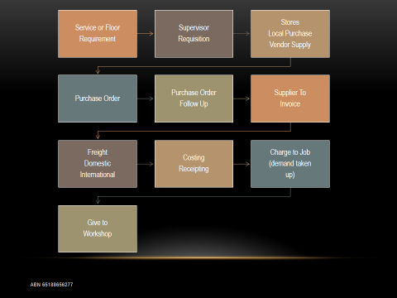

It pays to have a documented and structured work flow. The above(based on site warehouse being nil stock) gives a flow that will suit a mechanical workshop needing parts supply in a remote location. Machinery and job types are often located in remote areas, so its difficult to jump in a vehicle and drive to a dealer of vendor.

It pays to have a structured work flow especially if you are a multi location business, with staff moving from branch to branch.

**In Company Personal Relationships**

This particular subject, I intend to discuss the interaction between staff and the benefits that can be derived by having a good personal relationship. One of the situations that I will discuss, is no longer viable or possible, given OH&S and corporate liability. But I believe it warrants some examination if only to consider the positive benefits that were derived.

In the days before transactions were all done online, people actually spoke to each other and built relationships.

To highlight my opinion I will give some examples that will show the positive benefits.

A Few Beers After Work.

This no longer really happens, and most companies have banned alcohol and have random testing for drugs and alcohol, for OH&S reasons and also for corporate liability. But many years ago it was a regular occurrence for people to chip in and buy beer or bottles of wine, and sit around the office, workshop, lunch room, after work and have a drink. You would discuss all sorts of topics, from football to personal relationships, to holiday plans. The subject that always worked it’s way into conversation was Work, and what had happened during the day. All the niggly little issues would be discussed and sorted out, in a relaxed atmosphere, before they had a chance to fester and become a big problem. I always found this would create a much happier work place. People would get to know each other on a more personal level, this would in turn create informal and expedient ways of getting action and results.

Members of different departments would intermix, often job functions that would often come into conflict, during work hours, could build a friendly relationship that would permeate into the work place.

Little social groups would often form, often people from different departments, and levels of corporate position, often with a similar geographic location, would go to the football of the movies, or dinner or BBQ’s. This made for a much happier workplace. Often the friendships may carry over for years, and has the advantage of extending your group of contacts /network , that will be useful in future years. I was lucky enough to come from a time when this happened. Now 30 or 40 years later I am still in contact with many of my old work mates, even as our careers have moved in different directions, I can still pick up a phone and ask for assistance as they can of me.

As I have discussed previously in this thesis, the reliance on Online activity and dealing my well have some perceived advantages especially in labour savings. I have personally never liked this concept especially when used as the prime interface between you and your client. I believe it reduces and cheapens the PRODUCT element of the marketing mix. It will also reduce the advantage of In Company Personal Relationships. I will offer some examples to expand on my point.

In the days before online ordering, the checking of pricing , availability and placing of Inter Branch Transfers and orders . You would use the phone! ( Possibly place the order by fax) While not always the most efficient, the advantage was that you could build up a relationship with your other branches and suppliers, as could the branches and suppliers with you. When placing orders or IBT’s on line you do just that and hope for the best. (Hope they will follow any special delivery instructions you may request, especially if a 3rd party manages your warehouse) if you have the personal relationship you can request a Physical check of the stock, especially if urgent. You can request special attention for delivery that may be not standard. As they can to you, remember it’s always a two way street. Should you need to check measurements on a specific item, this can be done, try this if you have a 3rd party managing your warehouses.

A good relationship will also be a good means of sharing information such as any modifications to machines or the possibility of inter fitting spare parts, that will take the place of the actual part number. Helping to get your client mobile quickly.

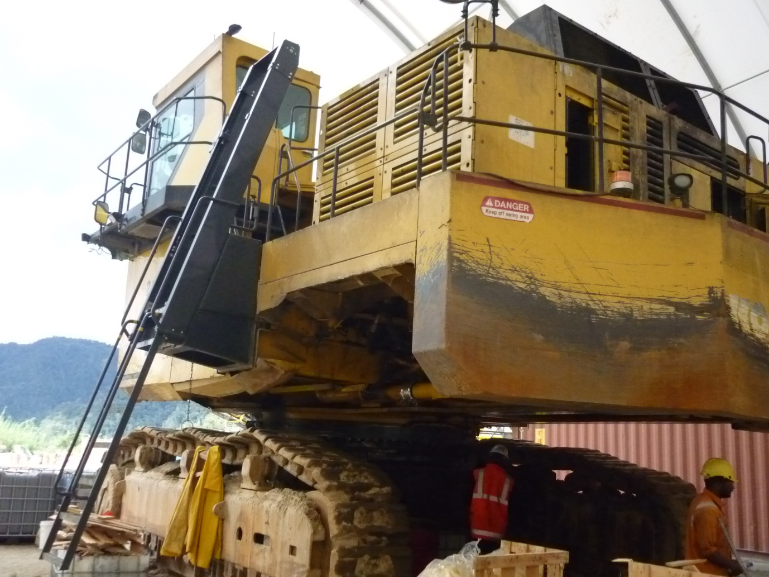

A Komatsu mining excavator receiving a midlife rebuild on a site workshop. Always good business if you can get into a rebuild schedule, and pre order the necessary inventory, on an indent basis. A good idea to supply the stocks through a rebuild warehouse, so the demand won’t impact your normal trading stocks.

**Final Synopsis**

**Let us try to pull together in as few words as possible, the central theme of this thesis. When I started off in my chosen industry more than 40 years ago. We were all product centred people and to an extent I have always remained to an extent partly that. As I grew in experience and position, I began to realise that there must be more to a business philosophy. It was then I discovered Marketing Theory and Principal. I was determined to learn more about it. I decided the best course of action was to go back and study marketing at night school. I soon discovered, that what the Marketing lectures were teaching was falling into line with the beliefs that I had previously formulated. I was able to spend years at college putting flesh around views already held.**

**I have remained to this day a Product and a Marketing Person. The main core being Industrial Marketing. I have held that there are 2 disciplines of marketing, Industrial and Consumer, both using the same marketing theory. I do hold the belief that it would be difficult but not impossible to move between the two. I remember a Marketing teacher talking about having empathy and feeling for the product that you a marketing. I do believe people have a flair and feeling for one or the other discipline. I know I would find it difficult to market men’s suits and clothing, though you can always use basic marketing theory, but I have no feeling for it.**

**People often talk about KISS “keep it simple stupid”. But the question should often be asked how often to people actually take notice, sometimes we all get to wound up in the “day to day” and don’t see what is actually going on, and take our eyes from the main goal, and stress about the little things. I have tried to take time to stand back and look from “Outside In” as apposed to “Inside Out”**

**I hold with the thought that there 2 general means of analysis. Data and feelings, as a marketing person you need to be able to engage the analytical side of your brain, and then be able to use our empathy and feeling for the product.**

**People and not computers, I have covered this on a number of occasions in the previous narrative. Often “Short Term Gain Giving Long Term Pain”. The issue is “you are not aware that you are receiving the pain”. I would like to put forward the postulate that if we went back to more human service, would we steal a march on our competitors? What would happen if we went back to driveway service in service stations? (True the operator want to get you into their shop, to market the products on the shelves) As a parts supplier have good experienced interpreters on the parts counter. Would this help with Capital sales?**

**The 4P’s Product, Price, Place, Promotion. To me the base of marketing theory, people do try to improve on by adding more P’s, but WHY, it is a means of overcomplicating what is essentially an basic and understandable process.( it’s popular to add People as the 5th P, I consider this to be part of Product)**

**Analyse, Take Action, Don’t be distracted, Always consider External Factors, Look at your Internal Assets, Follow your plan, Review your Plan. Don’t suffer from Paralysis from Analysis.**

Reman (RM) Rebuilt (RB)

Product Enquiry Service Exchange

Working Document

The purpose of this document is to create a working framework that can be implemented to construct Reman(RM) Rebuild(RB) service exchange system for the heavy mobile equipment industry.

The term Service Exchange is a general umbrella that covers Reman and Rebuilt, the general difference being that a Reman item is supplied by the OEM that you are representing, Rebuild will normally cover items that are rebuilt by your own workshop or sublet to an external rebuilder.

The advantages with an exchange component, are 2 fold, providing a customer service, with the product availability and a saving in machine down time( a component that is ready to go and not having to wait for a workshop rebuild). There is some cost saving, not having to purchase a New component. The downside to some end users, is components are repaired an as new condition, so may cost more than some contractors are often prepared to spend.(no such thing as a cheap rebuild).

1/ Product Enquiries can come in various ways, commonly a direct client enquiry, or a scheduled rebuild. During this stage you will confirm the correct part number or product code, by serial number.

2/ Check availability, Stock on hand in your or another company warehouse, or the OEM’s warehouse.

3/ Raise a quotation, clearly showing the core charge, the pre failure condition and terms. Time scale for return and inspections.

4/ Raise an invoice and despatch, at this time you take up the demand within inventory.

5/ The end user has 14 days to fit and return to your location.

6/ Your workshop will have 14 days to preform and inspection, or have the unit returned to the OEM for inspection.

7/ A report should be generated, listing the condition of the internals, such as the crankshaft in an engine. If worn beyond specification, it will need to be charged against the core charge.

8/ Finalize the invoicing and do a credit on the core charge. If the item is in a failure condition the end used gets zero core credit.

The Reman Rebuild Service Exchange Quality Circle

Possible Components

Engines Turbochargers Alternators

Starter Motors Fuel Pumps Cylinder Heads

Radiators

Transmissions Torque Converters Torqueflow Assemblies

Drop Boxes

Pumps & Hydraulic Motors

Main Hydraulic Transmission Scavenger Steering

Fan Motors Emergency Steering Swing Box Swing Motor

Backends Final Drives Travel Motors Differential Assy

Diff Centres Brake Clusters

General

Swing Circles Front Struts Rear Struts Drifters

Hydraulic Control Banks Hydraulic Cylinders

Cabins Track Frames

Major components such as an engine will need a different procedure from small items such as a starter motor. It will be up to you to make a decision on the cut off. Engines and transmissions and other major components need to be serialised to track hours in case of warranty issues.

Warranty. A statement of warranty should be provided with each component, a generic warranty will be provided later in this document.

A control document also needs to be provided with the sales invoice, it need to include sales invoice number , machine model , serial number machine, Serial number component, machine hours, date of change out, also a statement of terms, such as 14 days to remove replace and return, warranty voided if control document not correctly filled out.

You also need to track how many times you have turned over a component, a provision needs to be established for a write of each component.

Core deposits, need to be placed in a suspense account. Core credits are then taken out of this account, any uncredited amounts in this pool are used to recover non returned or units that damage is beyond tolerance and or post failure.

A warranty needs to be furnished in the paperwork for each sale/movement. See below a possible proforma warranty statement. Each companies needs may differ so the below form will need to be modified to suit your particular needs. Your company name will need to be fitted into the spaces provided, also your ABN or ACN

**Warranty**

**Rebuild and Exchange Components**

**XXXXXXX Company**

**This warranty applies to rebuilt and exchange components which are supplied and installed on XXXXXXX equipment supplied by xxxxxxxxx Company**

**XXXXXXXXXXXXXXXX Company warrants rebuild and exchange components sold by XXXXXXXXX to be free from defects in material and workmanship for a period of xx months, subject to the terms and conditions.**

**1/ The warranty for Reman and Rebuilt components shall be for xx months from the date of purchase.**

**2/ During the period of warranty, xxxxxxxxx company will provide any parts , new or rebuilt, and or workmanship to repair the failed component. Such items shall be provided without charge. This shall be done during normal work hours, xxxxxxxxxx company shall not be liable for removal and replacement of the component.**

**3/ Warranty shall not apply to consumable and electrical items. ( Such as Hoses, Bulbs, Belts, Tires, Filters, Cables, Brushes) Warranty will not also pertain to defects relating to improper use or existing conditions.(if component is used for a purpose for which it was not designed or incorrect fitment ) XXXXXXXXX Company will nor be responsible for any repairs or action taken not approved by XXXXXXXXX Company.**

**4/ This warranty supersedes any other warranties either written or verbal or implied.**

**XXXXXXXXXX Company shall not be responsible for any issues such as loss of income, or other damages resulting from the failure of the component.**

**Competitor Profile**

**The Battle Map**

**An in depth understanding of your opposition is a necessary tool. Consideration of the following points for investigation, given the structure and size of the business you are investigating.**

**1/ Origin and Background.**

**2/ Industry reputation.**

**3/ Corporate objectives and strategies.**

**4/ Market share.**

**5/ Major Products.**

**6/ Segment analysis and historic growth.**

**7/ Sales profiles.**

**8/ Corporate continuity.**

**9/ Recent Trends & Business Developments**

**10/ Analysis going back 5 years including the following.**

**Operating margin.**

**Net Margin.**

**Debt Ratio**

**Return on Equity**

**Return on Assets**

**Sales growth**

**Sales by segment**

**Total Sales**

**11/ Strategic Position**

**SWAT analysis**

**Strategic direction and management capability .**

**Expected performance.**

**What likely strategies would your competitor employ.**

**Where is your competitor vulnerable.**

**What will provoke the greatest retaliation from your competition.**

**12/ Prepare your Battle Map. (Can be part of marketing plan)**

**Fleet Operations**

**When coming in to a fleet situation the following points should be of consideration. Point form listing.**

**Mobile Fleet, and to an extent Fixed Plant. Can organise by plant number, or by group, IE Mobile plant, Crushes, Drills and then plant number.**

**A/ Model (fill model Is PC200LC-8)**

**B/ Serial Number**

**C/ Engine Number**

**D/ Hours**

**E/ Component Hours**

**F/ Modifications and any component serial numbers**

**G/ Rebuilds**

**H/ Build Date**

**I/ General Condition, Including any photo’s.**

**INVENTORY**

**A/ Machine Parts**

**B/ Crusher Parts**

**C/ Mill Parts**

**D/ Drill and Crusher Consumables**

**Warehouse stock levels, are they correct?**

**General Consumables?**

**Workshop Facilities**

**G.E.T. Teeth, Cutting Edges, Wear Plates**

**Conveyer parts and consumables.**

**Oils and Fuels**

**How does the parts stock relate to your current fleet.**

**Tooling and support vehicles.**

**History of any rebuilds done.**

**What if Any B.O.M. Kits**

**What parts suppliers and contracts and pricing.**

**What specialized stocks held by vendors at your request.**

**Has older S.O.H. been written down.**

**What is the age of the inventory, A.B.C. Class**

**Has your plant been written down.**

**Do you have the correct plant for your current plan.**

**Where can you get your rebuilds done?**

**Logistics, Australia, Asia, Europe**

**Airport/ Seaport. Duty, GST, International and Domestic freight.**

**Fleet and Inventory operating package. Requisitions and charge out paperwork.**

**Warehouse security.**

|  |  |
| --- | --- |
| ***RCG Consulting Services*** | |
| **ABN 65188656277 www.rcgconsultingservices.com** |  |
| **Email roderickgreen@bigpond.com Mob 0404887143** |  |
|  |  |

**B2B Marketing**

**RCG Consulting Services**

**B2B Marketing or Account Based Marketing shares similarities to what I have always thought of as Data Base or Industrial Marketing, (Trendy new names) differing from consumer or mass marketing. The use of client data bases and induvial segmentation, to build a Bond. As always anything that I write is aimed at an industrial level with an OEM (Original Equipment Manufacturer) dealer and product support slant. This can be transferred to other profiles, such as used equipment, or parts and service suppliers, and other like products.**

**How to Setup.**

**A/ Select a computer package**

**Many years ago we used a package called tracker, also Access Data Base, the main purpose is that you have something that is flexible allowing you to sort data by all fields. I now use Excel now, can be a bit basic, but allows for segmentation on all fields and allows for setting of fields by requirement, Most full service inventory, sales and accounting packages will allow you to download to excel, and this gives the advantage of being able to transfer data directly into your data base. Always edit your down loads.**

**B/ Use your debtors and potential clients.**

**To make a start you need to build a base data, you can start with the data already available within your business. Take your debtors listing, as a grouping of already trading clients, insert your necessary fields, contacts, (people, numbers, emails) previous 12 months sales. Don’t send contact pieces to accounting people, target your decision makers. Remember not every client has a trading account and or purchased with you. Input from your own sales sources is necessary. Consider sales call sheets & the buying of existing data , trade associations membership lists.**

**C/ Select the necessary data fields.**

**You will need to give thought to what fields you will require. If you are using Excel adding new fields is an easy process. “You will need to give thought to which product groups you select”, IE Engine, Hardware, Undercarriage, Drive Line Franchise, Product Group Subgroup, ETC Possibly download from your main package.**

**You also need include the normal admin type fields, once again possibly not all but a good start. You will always select dependent on your situation. Control number, Business Name, Account Number, Contact Name, Address, Contacts (Phone, email, address, Website) Industry Segment, Geographic Segment, Locations, Trade or End User, Contacts Position, Short space for personal notes, (Birthdays, Wife’s name, Football Team) Always be consistent with your data input, IE a Maintenance Manager should always be called exactly that.**

**Here I would like to talk further on market segmentation. Above I have listed a number of possible fields. I have always held that you need a major sort field that the data can wrap itself around. For our industry I would use the Industry segment, and you may utilize the following, Construction, Transport, Mining, Logistics, Forestry, Government, Trade, Quarrying. These of course can be broken down further, I would suggest you don’t go to far. You may find it helpful to go “Government Local” or “Mining Gold”**

**D/ Multi Location**

**Consider that clients often have more than one location and these locations have input into purchases;**

**E/ Start off with your top 10 or 20 clients, get the system working well with them, then embed the next group of smaller clients, keep on with this until you are complete.**

**G/ Product selection and product extension. Establish products already sold to the client then use to extend the product range. Often you will have other products that can go through the pipeline.**

**H/ Differentiation between Marketing and Sales. Sales are the tradesman that do up the nuts and bolts of marketing, also a path of MIS (marketing Information System). Marketing generates and provides the tools and environment for sales action.” Multi Chanel Marketing” is another of the buzz phrases often spoken about, and simply means how you relate with your customer, (Sales People Field, Sales People internal, Web Based Dealing giving stimulus response action, Person to Person by phone , direct mail or email, Media Advertising, Use of Activation codes to unlock pricing offers.**

**I/ Cycle of Business, Machines, Parts, Service. Sales feeding information to Marketing and in reverse, these departments receiving information and sales leads from marketing.**

**How often are machines replaced of purchased, when will replacement machines enter the purchase funnel. What group of spare parts are purchased from you. IE does your filter group not preform.**

**Most of the replacement machines are done on SMR hours not always on percentage write down on accounting periods. Your product support people should be feeding hours back to Marketing.**

**Service Reps and Sales People need to also be watching and listening and reporting back to Marketing on up coming projects, often companies will mobilize for projects that have been tendered, Purchases of plant will often be needed, and have to be included to the sales pipeline. (Machines /Parts/ Service)**

**J/ Data Strategy**

**Weekly meetings (Best as a start up meeting first thing Monday mornings) between Marketing, Sales, Spare Parts and Service. Review the previous weeks data and set priorities for the following week.**

**Working in with the cycle of business , PSR’s (Product Support Reps) Feeding data back to Marketing and data forwarding to sales, Data going to Rebuild, allowing scheduled rebuilds to be quoted.**

**K/ Plans and Personalization Action**

**This requires a knowledge of your clients work specialties, machine specifications, operational style, decision makers. You are unable to develop a personalized action plan, without this data.**

**Plans for top 10 or 20% of clients or business, Initial starting point. Always consider the 80/20 principle.**

**L/ Reporting and Measurement**

**Base level, (current sales) Budgets and Actual. You can also utilize the standard reports from your main package.**

**M/ Review and take action. Insist on lost sales reports, analyses and tabulation may lead to the discovery of ingrained weakness. Corrective action can be taken**

**Was budget achieved Yes/No, reasons. If yes why, if no why. What is driving the result. Economic conditions, Opposition product quality, price, service. The release of budget for capital works. An increase in the price of Gold.**

**Set future budgets, buy customer for machine purchase and parts and service. Consider the machine sales pipeline, separate by month, apply the current lead time, do you have sufficient inventory on hand or on order. Consider future projects, a buyer of opposition equipment may consider you, if your opposition does not have stock on hand.**

**ROMI (Return on Marketing Investment) is often spoken about. Put simply are your marketing efforts covering costs and producing increased profit. The other side of this is if you are not spending on Marketing are you going backwards. How much must you spend just to hold your position? The measurement of this is difficult to almost impossible, and some times you must rely on just Gut Feel. 3 often spoken about points of measurement are “ Revenue, Relationship, Reputation” Revenue being a tangible guide, Positive or Negative movement can and will impact Revenue.**

**N/ How to maintain relationship between your organization and your clients.**

**This is possibly the most important subject, so I have left to last. It is often said that “The Customer is never Wrong” This I don’t agree with. They are often wrong! and can try to play all sort of games to gain an advantage. “They must be allowed to Believe that they are Right” when wrong.**

**The question is how to manage the relationship. What works with one client may and often will differ from another. You have to ensure you consider all positions that are involved in buying decisions, neglecting the person that buys spare parts and favoring the person that person that organizes the service work will lead to problems and bad will, they may buy all the competitive products elsewhere or sit on invoices that are due for payment, there are many other situations that may play out.**

**There are many different ways to stay in contact I’m going to list in point form, you can choose from the list or come up with your own. Training on product and maintenance or operator training. Entertainment most people understand what is required. Rebates on parts and service against a budget or target. User Purchase Points, Spend to a level and receive points towards free gifts or merchandise, the more you spend the more points. Budgets and Targets, Internal Trade shows at the clients premises, present the advantages of your products, features and benefits. Know your clients personal interests and work in social interactions. Befriend on Facebook or Linkedin. Put on staff BBQ’s, Visits to local football matches. Organize client bus tours to job sites of interest. (Possibly a quarry with a new crusher. The quarry owner may also subsidize, as they will also be promoting their products to possible end users)**

**It is often said that Customer experience should be considered part of product differentiation. Possibly the use of a perceptual map as an aid in understanding custome perception.**

**There are 2 other points I will make as a separate Line.**

**NEVER USE THE WORD DISCOUNT.**

**ALWAYS FOLLOW UP AN ONLINE ENQUIRY WITH A PERSONAL RESPONSE “A PHONE CALL” NEVER RESPOND WITH AN ONLINE REPLY.**

**Marketing Through Operational**

**Excellence**

**To set you above the rest.**

**“ Take responsibility for the transaction you initiate, From enquiry to delivery”**

**This paper reflects a heavy industrial slant based on an OEM machinery dealer. The ideals and general grist is adaptable for any other like industry. As a procedure this attitude can be included in the Product and Promotion elements of the Marketing Mix. Operational Excellence is the most powerful tool for maintaining business and keeping repeat Capital business. I write mostly in point form, for ease of reading and often to make the point more thought provoking. Think about applying to your situation.**

**1/ Customer Service in the After Market. Product Support. This is the nub of this paper.**

**A; Who is your client?**

**B; Top 80%, By volume, Value, Sales.**

**C; Target those not yet clients.**

**D; Consider the Bottom 20% can you improve them.**

**E; Encourage the sharing of information between external sales people and internal sales and operational personal.**

**2/ Interaction with Clients.**

**A; Talk and get to know the person, always find time to stop, say hello and have a short chat.**

**B; Learn about them and their issues.**

**3/ Staff Attitude.**

**A; Good product training.**

**B: Fitters bad mouthing product. Often your fitters will badmouth product, they are sent to repair, This needs to be trained out of them, make them say good things about your brand.**

**C; Accounts departments being unresponsive. They can cause trouble by being small minded and not see the bigger picture.**

**4/ Always look for support alternatives.**

**A; There are mostly more than one solution to a machine down situation. You can use a ‘ Double Lip Seal, when a Single Lip Seal is Required’**

**5/ Workshop repairs done correctly and on time and at fair market price.**

**A; Ensure and sign off on work, no loading of hours. Most machine owners will always have a good idea on how long a mechanical job should take.**

**6/ Understanding your clients needs and recommending the best product.**

**A; Understand the industry in which your products are required.**

**B; A good working knowledge of industrial process.**

**C; Training should be given on the different market segments you operate in.**

**7/ Training and motivation ( All Departments)**

**A; Treat each department evenly, no use treating service (Maintenance) like super stars and Spare parts as inferior. Don’t want the whipping boy, syndrome.**

**8/ Working with subcontractors.**

**A; Warehouse, Transport, Ensuring transport companies can provide assistance and react when things go wrong. A direct line of interface needs to be established , official and unofficial. Problems often occur when you have 3rd party warehousing and dispatch.**

**9/ Flow and system and always able to provide the client with relevant information.**

**A; Do you have a documented consistent work flow, that is visible.**

**10/ Operating in difficult and remote locations.**

**A; A big advantage can be obtained by providing outstanding support in difficult and remote locations.**

**11/ Competitive environment.**

**A; How to standout in an even market, a lot of similar products, and level pricing.**

**12/ Continuity of customer service and responsibility.**

**A; All interactions handled in the same manner, with staff taking responsibility for each interaction they handle.**

**13/ Separation of responsibility.**

**A; The process of supply often requires many different hands, this required you to be able to look in and provide client information.**

**14/ Outline of work place.**

**A; Outline of functions I.e. Spare Parts, Service , Accounts.**

**15/ How Marketing can relate to the work place.**

**A; High level of service, all departments increased the value of your service to the end user.**

Dynamic Action

This is a People Industry

In the days of computer interface, the chances of dealing with a human are getting less, and reduces an important marketing opportunity. I would like to briefly touch on the following points to provoke some thought.

1/ Person to person to build relationships.

2/ Improve the service and customer satisfaction.

3/ Online may be cost effective in the short term.

4/ Central phone room, interpreters need to take ownership.

5/ A good interpreter provides more than parts they provide solutions.

6/ Companies going away from personal service causing severe client frustration.

7/ Good parts service can lead to machine sales.

8/ Only people can rebuild fractured relationships.

9/ When you build a relationship, you can gain further business that may have been going elsewhere.

10/ A company that takes a proactive steps towards personal contact will gain an advantage over there opposition.

In these days of doing most things online, the art of customer service is Gone, Some purchasing groups will like on line access, they miss out on the connection and the chance to network. I find it a contradiction that people will spend money and time to go to networking functions at expense, but will do as much as possible on line.

Many years ago while working at Komatsu in Melbourne, we had one particular customer, his opinion that most of the OEM’s are all much the same quality and service. He once told me that the reason he continued to buy Komatsu was when he came into the branch everyone found time to stop and say hello, and when he phoned he always got a helpful and friendly response. This incident happened many years ago and very much made sense to me, I have always done my best to bear this in mind throughout my career.