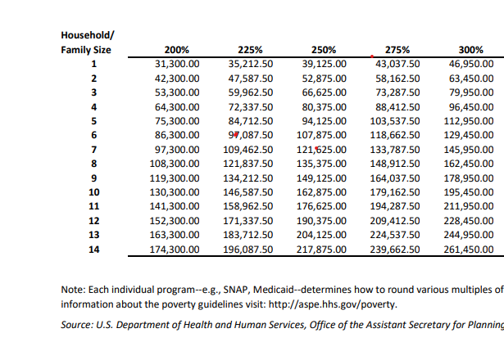
2025 Federal Poverty Guidelines

