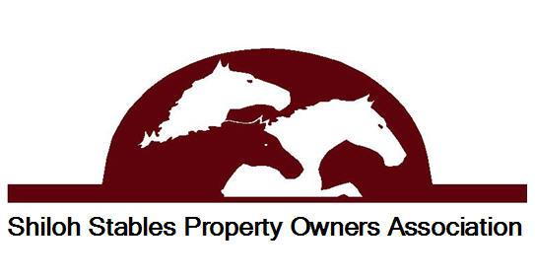

*673 Burch Cove Road • Hayesville, NC 28904*

[*www.sspoa.net*](http://www.sspoa.net)

SHILOH STABLES PROPERTY OWNERS ASSOCIATION

Finance Committee Meeting Minutes

November 4, 2021 – 10:00 AM

Present: Lynn Marqui, Marci Morales, Debbie Pringle, Tabitha Abrams

Location: Marci Morales’ home

Provided and Discussed were the actual income and expenses year to date October and projected thru December 2021 and a 2022 budget:

* There is one owner who is late on their dues. A lien has been filed on that property for the amount due to date.
* Additional and unbudgeted income of $1,000. came from receipt of a new construction impact fee on Fielder’s lot 82.
* Lynn talked with Rich Franklin regarding the 2022 road budget and he said his projections for road expenses for 2022 will be the same as 2021. No official budget was presented, or comments made for the remainder of 2021 road expenses.
* A budget for the entrance garden was provided by Leslie Wagner. That budget was discussed and approved at $1,000.00. Attached is the budget Leslie provided.
* Calcium Chloride was applied in 2021 and not budgeted so it was decided by Jim that that expense would be taken from reserves. The use of Calcium Chloride in 2022 was postponed per Jim as it is not yet decided if it will be used in 2022 and Jim advised that if it is used it will be taken out of reserves.
* Other Expenses for 2022 are expected to be approximately $339.00 higher than the 2021 budget due to some minor changes and cost increases. And, there were some minor reallocation of budget funds.
* It is projected that there will be a net income of $5,037. at the end of 2022.
* The cost of calcium chloride and Fiedler’s new road will reduce the projected net income for 2021 by approximately $5,000. thus, effecting the amount added to reserves.

Additional items discussed:

* Entrance mailbox unit and land. Jim provided purchase figures for the land ($2,500.) and 48-unit mailbox ($625.). Jim is working on obtaining a price to build the structure around the mailbox unit and gravel for the drive-off area. The committee all agreed that this is in the best interest of our community to proceed with the land purchase and mailbox unit construction.
* The committee suggests talking with the residents of Shepherd Farms and possibly others that use that area for their mailboxes to coordinate that change with them.
* The committee suggests that Shepherd Farms and Shiloh Ridge residents contribute to the use of the dumpsters or not be permitted to use them.
* It was brought to our attention that there has been a change of ownership of lots 74 & 75 that the association has not been notified of. Lot 74 Roberts to Hohensee and Lot 75 Stewart to Hohensee.
* It was brought up that there appears to be some roads, such as Philly, that are not maintained as the other roads are. The committee suggests that all roads be maintained the same, so all homeowners have good access to their property.
* The committee suggests additional speed limit signs and use of 4WD signs be purchased and installed thru out the community.
* The committee suggests keeping the HOA dues at the current $280. for 2022 but to advise homeowners that there is a projection that dues will increase to $300. per lot in 2023 due to the rise in material costs, freight and labor nationwide.
* Please see attached the projected 2022 budget submitted for the Boards approval.
* Please advise Rich and Leslie of their approved 2022 budgets amounts.