Energy Star
The Clear Choice for Quality, Comfort and Savings

The average American household spends more than 40 % of its energy budget on cooling and heating costs every year. Much of the budget goes to heating and cooling air that seeps out through the windows, doors, skylights and other gaps in a home’s envelope. ENERGY STAR qualified window products reduce heat loss and gain through these spaces, and reduce your energy cost by as much as 15%.

Energy Star qualified windows provide:
Energy Cost Savings
Keep the air you’ve paid to heat or cool where it belongs…in your home

Improved Comfort
Coating and quality construction keep your home warmer in the winter and cooler in the summer.

Reduce Fading
Reduce sun damage and fading by as much as 85%, keep your carpet, woodwork, furniture, artwork and interior wall paint protected.

ENERGY STAR qualified windows are twice as efficient as the typical windows produced only 10 years ago. New materials, coasting and design and construction features all mean a home ENERGY STAR qualified consumers use less energy and feels more comfortable all year around.
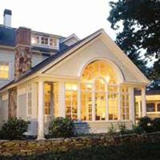
SolarBan 60
Solar Control Low – E Glass

Features and Benefits:

Cooler In The Summer
The total solar energy transmitted through SolarBan 60 (2) glass is almost 50% less than that transmitted by standard clear insulating glass.
- Lower SHGC numbers mean less summer heat
- Keep interiors cooler
- Helps reduce cooling energy costs

Transmits Visible Light / Appearance
The SolarBan 60 (2) window transmits almost 90 % as much desirable visible light as standard clear insulating glass.
- Provides exterior appearance similar to clear glass
- Provides glare control in bright, sunny climates

Fading Factors
While SolarBan 60 (2) glass blocks 79% of damaging UV energy, it also blocks other contributors to fading – in all, 24% better that standard clear insulating glass.
- Helps protect interior furnishings, fabrics and carpets from fading

Warmer In The Winter
The winter nighttime U – Value (insulating value) of SolarBan 60 (2) glass is almost 50% better than standard clear insulating glass.
- Lower U-values mean higher performance
- Reduces furnace heat loss
- Helps reduce heating energy costs

Glass Features

Optimal thermal design
Utilize Intercept Spacer System in all Architects Select
Systems. Developed by PPG, this superior thermal
barrier separates the two glass panes in every Insulated
Glass (I.G.) unit.

- Intercept’s unique one-piece, tin
plated steel U-channel design resists thermal transfer
through your windows and provides added structural
integrity to the entire system.
- Fill the interior chambers on the frame and sash with
polyurethane foam insulation. This creates a framing
system with an R-25 insulating value (not available on
all models).
Superior raw materials
Conduct unannounced tests on the vinyl components
used in every Architects Select window by American
Architectural Manufacturers Association (AAMA, an
independent trade organization of building product
manufacturers).

- Ensure that vinyl components exceed all industry
standards for impact resistance, dimensional stability,
and color fastness.
- Provide the features and options that discerning customers look
for in a replacement window. Architects Select
windows are built to the demanding standards of the
professionals whose reputation depends on them.
- They combine beauty and function and deliver
consistency, features, and style.
- Architects Select vinyl replacement windows meet the
needs of any customer, from the cost conscious
consumer to the high end homeowner. Built for
durability, designed for performance, and tested for
quality, Architects Select is the preferred choice for
remodeling professionals.

Test for quality and consistency
Monitor for quality and consistency in every step
of fabrication.

- Ensure that skilled craftsmen build every window
system as if it were their own.
- Combine professional craftsman approach with the
latest in computer-controlled manufacturing and a
revolutionary quality management system.
Results
- Deliver quality that is unmatched in the industry.

This thermograph or “heat picture” compares room side glass temperatures for an Intercept I.G. unit (right) and a conventional I.G. unit (left).
Yellow indicates warmer and blue indicates colder. Intercept I.G> glass temperatures are significantly higher, especially near the sash, resulting in higher comfort levels inside the home.
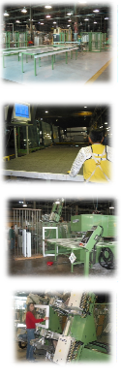
See the Difference

Chosen for consistency, features, and style, our new construction and replacement vinyl windows offer product to meet the needs of any customer.
From the cost conscious consumers to the high end homeowner, our window systems satisfy even the most discerning customer.
Our state-of-the-art technologies include computer-controlled glass cutting and four-point fusion welding to ensure that every corner is square and sealed against air and water infiltration.
Built for durability, designed for performance and tested for quality, we are the preferred choice for remodeling and new construction professionals.

5600 Series Double Hung
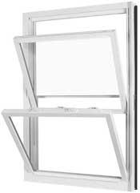

Sash and Frame:
- Miter cut fusion-welded sash and frame
- 70 mil thick vinyl extrusions
- 100% virgin vinyl-no regrind
- Higher concentration of titanium dioxide - gives a bright white appearance
- Available in White (standard) and Beige (optional)
- Sashes tilt in for easy cleaning
- Foam filled frame
Glazing:
- ¾ “ PPG intercept glass with warm edge spacer technology
- Exterior snaps - in glazing beads protect the glazing system perimeter
- Optional Low E / Argon Gas equals Energy Star rating for savings
Standard Features:
- Insulated glass
- Recessed tilt hardware
- Deluxe vent latches
- Head expander and sill angle
- Integral vinyl interlock
- Locking pivot bars
- Constant force balance
- 3 ¼” Jamb
- Aluminum reinforced lock rail
- Stainless steel constant force balance system which never needs adjusting
- Balance covers - hides balance system- cleaner, more refined style and look
- Meeting rail interlock mates the top and bottom sash when the window is closed reduces water and air infiltration
- Deluxe night latches
- Recessed tilt latches - easy to use and appealing to the eye
- Color - matched cam action lock and keeper
- Heavy - duty extruded locking half screen with fiberglass “memory mesh”
- Integral fully welded sloped sill utilizes an extended interior dam to reduce water backup across the sill
- Beveled exterior for curb appeal
- Window 28” or larger in exact height will have double locks

7100 Series Double Hung
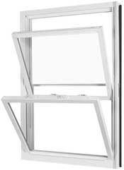

Sash and Frame:
- Miter cut fusion – welded sash and frame
- 70 mil thick vinyl extrusions
- 100 % virgin vinyl – no regrind
- Higher concentration of titanium dioxide – gives a bright white appearance
- Available in White (standard)and Beige, Earth Brown and Linen (optional)
- Sashes tilt in for easy cleaning
Glazing:
- 7/8” PPG Intercept glass with warm edge spacer technology
- Exterior snap – in glass beads protect the glazing system perimeter
- Optional Low-E / Argon Gas equals energy star rating for savings
Standard Features:
- Constant force balance
- Insulated glass
- Recessed tilt hardware
- Deluxe vent latches
- Head expander and sill angle
- Jamb adjustor clips
- 3 ¼” Jamb
- Aluminum reinforced lock rail
- Stainless steel constant force balance system which never needs adjusting
- Balance covers – hides balance system – cleaner, more defined style and look
- Triple interlocks at the head, meeting rails and sill
- Deluxe night latches
- Recessed tilt latches – easy control of tilt – in sashes
- Color – Matched extruded locking half screen with fiber glass memory mesh
- Beveled exterior for curb appeal
- Integral fully welded sloped sill utilizes an extended interior dam to reduce water back up across sill
- Window 28” or larger in exact height will have double locks

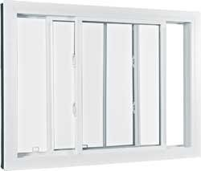

7100 Series Sliders

Sash and Frame:
- Miter cut fusion welded corners for superior structural integrity and prevention of air and water infiltration
- Sashes remove for easy cleaning
- Integral pull rail provides fingertip performance
- Rigid 70 mil thick vinyl
- Welded master frame and sash
Glazing:
- Insulated glass with intercept spacer system
- Exterior snap - in glazing beads protect the perimeter of the glazing system
Standard Features:
- Insulated glass
- Brass rollers
- Extruded fiberglass half screen
- 3 ¼ “ Jamb
- Windows 28” or larger in exact height will have double locks
- Aluminum reinforced lock rail
- Available in White (standard)and Beige, Earth Brown and Linen (optional)

7100 Series Picture Window
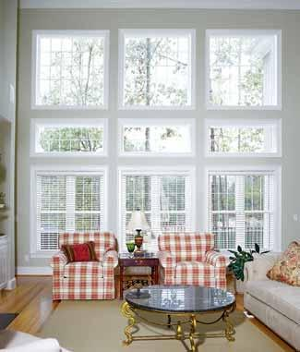

Sash and Frame:
- Miter - cut and fusion - welded for an air and watertight unit
- Optional foam filled frame
- Beveled exterior frame
- Rigid 70 mil vinyl
- Welded master frame
Glazing:
- Glazing with warm edge spacer system
Standard Features:
- Double strength insulated glass
- 3 ¼ “ Jamb
- Available in White (standard)and Beige, Earth Brown and Linen (optional)

7100 Series Deadlight
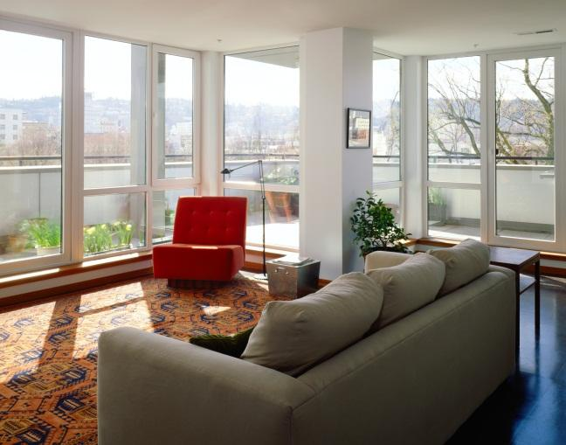

Sash and Frame:
- Rigid 70 mil vinyl
- Welded master frame
Standard Features:
- Double strength insulated glass
- Available in White (standard)and Beige, Earth Brown and Linen (optional)

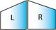
7100 Series Architectural Shapes
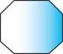

Sash and Frame:
- Miter cut fusion - welded corners for superior structural integrity and prevention of air and water infiltration
- Perimeter accessory grooves make mulling simple and secure
- DP50 Standard
Glazing:
- Glazing with warm edge spacer system
Standard Features:
- All welded
- Insulated glass
- Double strength glass
- Available in White (standard)and Beige, Earth Brown and Linen (optional)

4100 Series Hopper

Standard Features:
- Mechanical sash and frame
- Insulated glass
- Gasket frame corners
- Single lock
- Dual durometer glazing
- Tilt - in sash with roller arm
- Full screen
- 3 ¼” Jamb
- Available in White (standard)

7200 Series Casement
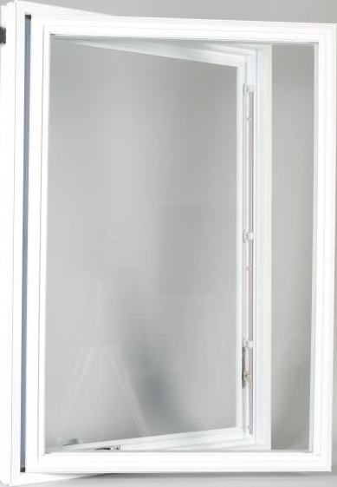
Standard Features:
- Rigid 70 mil vinyl
- Welded master frame and sash
- Full screen
- Insulated glass
- Multi - point locking system
- Premium color keyed hardware
- 3 ¼” Jamb
- Available in White (standard)and Beige and Linen (optional)

7200 Series Twin Casement

Standard Features:
- Rigid 70 mil vinyl
- Welded master frame and sash
- 2 Full screens
- Insulated glass
- Multi - point locking system
- Premium color keyed hardware
- 3 ¼” Jamb
- Available in White (standard)and Beige and Linen (optional)

7200 Series Triple Casement

Standard Layout: ¼, ½, ¼

Standard Layout:
1/3, 1/3, 1/3

Standard Features:
- Rigid 70 mil vinyl
- Welded master frame and sash
- 2 Full screens
- Insulated glass
- Multi - point locking system
- Premium color keyed hardware
- 3 ¼” Jamb
- Available in White (standard)and Beige and Linen (optional)

7200 Series Casement / Picture Window

Standard Features:
- Rigid 70 mil vinyl
- Welded master frame and sash
- Insulated glass
- 3 ¼” Jamb
- Available in White (standard)and Beige and Linen (optional)

7200 Series Awning Window

Standard Features:
- Rigid 70 mil vinyl
- Welded master frame and sash
- Insulated glass
- Dual lock
- Full fiberglass screen
- 3 ¼” Jamb
- Available in White (standard)and Beige and Linen (optional)

7200 Series Picture / Awning Window

Sash and Frame:
- Miter cut fusion - welded sash and frame
- 100% virgin vinyl - no regrind
Standard Features:
- Rigid 70 mil vinyl
- Welded master frame and sash
- Insulated glass
- Dual lock
- Full fiberglass screen
- 3 ¼” Jamb
- Available in White (standard)and Beige and Linen (optional)

7100 Series Double Hung Bay Window

Standard Features:
- Rigid 70 mil vinyl
- Welded master frame
- Insulated glass
- Half screens on double hung units
- 1” Birch veneer, head and seat
- 5 ½” Jambs fits a standard 4 9/16” wall
- Cable supported installed
- Fully assembled for easy on-site installation
- Available in White (standard)and Beige, Earth Brown and Linen (optional)
Layout:
- Bay windows available in 30 or 45 degree setups

7200 Series Casement Bay Window

Standard Features:
- Rigid 70 mil vinyl
- Welded master frame
- Insulated glass
- Full screens on casement units
- 1” Birch veneer, head and seat
- 5 ½” Jambs fits a standard 4 9/16” wall
- Multi – point locking systems on casements
- Premium color keyed hardware
- Cable supported installed
- Fully assembled for easy on-site installation
- Available in White (standard)and Beige and Linen (optional)
Layout:
- Bay windows available in 30 or 45 degree setups
- Bay windows available in 1/3, 1/3, 1/3 or ¼, ½, ¼ layout

7200 Series Casement Bow Window
Standard Features:
- Rigid 70 mil vinyl
- Welded master frame
- Insulated glass
- Full screens on operating units
- 1” Birch veneer, head and seat
- 5 ½” Jambs fits a standard 4 9/16” wall
- Multi – point locking systems
- Premium color keyed hardware
- Cable supported installed
- 10 Degree (standard)
- Fully assembled for easy on-site installation
- Available in White (standard)and Beige and Linen (optional)
Layout:
- Bay windows available in 10 or 15 degree setups
- Bow windows available in 3-6 lite units

8000 Series Garden Window

Standard Features:
- Slim line frame
- Multipoint locking system
- Optional built - in shelf
- Operating side lights
- Dual weather - stripping
- Fusion welded joints
- Available in White (standard)and Beige (optional)

4400 Series Patio Door
Standard Features:
- Fully welded and assembled
- Tempered insulated glass
- Integral nailing fin
- Color coordinated hardware
- DP30 Standard
- Keyed locks
- Available in White (standard)and Beige and Linen (optional)

4400 Series Patio Door Transom
Standard Features:
- All welded beveled exterior
- Integral nail fin
- Insulated glass
- 2 ¾” Jamb from nail fin back
- Double strengthen glass
- Available in White (standard)and Beige and Linen (optional)

4400 Series Patio Door Sidelite

Standard Features:
- All welded beveled exterior
- Integral nail fin
- Insulated glass
- 2 ¾” Jamb from nail fin back
- Available in White (standard)and Beige and Linen (optional)

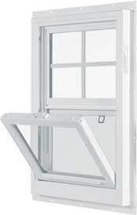

2300 Series Single Hung
Sash and Frame:
- Miter cut fusion - welded sash and frame
- 100% virgin vinyl- no regrind
- Higher concentration of titanium dioxide - gives a bright white appearance
- 2 - 7/8” Jamb depth with optional 4 - 9/16” wood extension jamb available
- Twin and triple units available in common frame
- 1” Pre - punched nail fin
- Sash tilts in for easy cleaning
Glazing:
- ¾ PPG intercept glass with warm edge spacer technology
- Exterior snap - in glazing beads protect the glazing system perimeter
- Optional Low-E/ Argon Equals Energy Star rating for service
Standard Features:
- Blocks and tackles balance system ensures smooth and effortless operation
- Weather sealed interlocks for improved performance
- Color-matched sweep lock
- Roll formed half screen with fiber glass ‘memory mesh”
- Brick mold exterior for pleasing aesthetics and curb appeal
- Integral lift rail provides fingertip performance
- Integral fully welded sloped sill utilizes extended interior dam leg to improve water control
- Sash tilts in for easy cleaning (bottom sash)
- Insulated glass
- Fiberglass half screen
- Water backup across sill
- Recessed J – channel for easy siding return
- 1 1/2 “ Jamb from nail fin back
- Aluminum reinforced lock and meeting rails
- Available in White (standard)and Beige (optional)
- Fin seal Weather-stripping
- DP-50 model Available
- Integral nailing fin

2300 Series Single Slider

Standard Features:
- Brick mold exterior
- Insulated glass
- Single sliding sash
- Welded master frame and sash
- Aluminum reinforced lock & meeting rails
- 1 ½” Jamb from nail fin back
- Integral J – channel
- Fiberglass half screen
- Brass rollers
- Integral nail fin
- Available in White (standard)and Beige (optional)

2300 Series 3 - Lite Slider
Standard Layout: ¼, ½, ¼

Standard Layout:
1/3, 1/3, 1/3
Standard Features:
- Brick mold exterior
- Welded master frame and sash
- Two sliding sashed
- Insulated glass
- Brass rollers
- Integral J – channel
- Integral nail fin
- Two (2) screens over moving sashes
- Aluminum reinforced lock & meeting rails
- 1 ½” Jamb from nail fin back
- Available in White (standard)and Beige (optional)

2300 Series Picture Window

Standard Features:
- Brick mold exterior
- Welded master frame and sash
- Two sliding sashed
- Insulated glass
- Brass rollers
- Integral J – channel
- Integral nail fin
- Two (2) screens over moving sashes
- Aluminum reinforced lock & meeting rails
- 1 ½” Jamb from nail fin back
- Available in White (standard)and Beige (optional)

2300 Series Transom

Standard Features:
- Brick mold exterior
- All welded beveled exterior
- Integral J – channel
- Integral nail fin
- Insulated glass
- 1 ½” Jamb from nail fin back
- Double strength glass
- Available in White (standard)and Beige (optional)

2300 Series Sidelite

Standard Features:
- Brick mold exterior
- All welded beveled exterior
- Integral J – channel
- Integral nail fin
- Insulated glass
- 1 ½” Jamb from nail fin back
- Double strength glass
- Available in White (standard)and Beige (optional)

2300 Series Architectural Shapes

Standard Features:
- All welded
- Insulated glass
- Integral nail fin
- Integral J – channel
- Double strength glass
- 1 ½” Jamb from nail fin back
- Available in White (standard)and Beige (optional)

2400 Series Double Hung
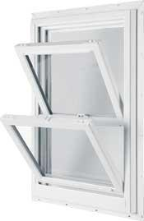

Sash and Frame:
- Miter cut fusion - welded sash and frame
- 100% virgin vinyl- no regrind
- Higher concentration of titanium dioxide - gives a bright white appearance
- 3- ¼” Jamb with optional 4 - 9/16” and 6- 9/16” wood extension jambs available
- 1” Pre - punctured nailing fin
- Sashes tilt for easy cleaning
Glazing:
- ¾” PPG intercept glass with warm edge spacer technology
- Exterior snap - in glazing beads protect the glazing system perimeter
- Optional Low-E/ Argon Equals Energy Star rating for savings
Standard Features:
- Block and tackle balance system ensures smooth and effortless operation
- Weather sealed interlock for improved performance
- Recessed tilt latch for easy control of tilt-in sash
- Cam lock and keeper system
- Brick mold exterior for pleasing aesthetics
- Integral lift rail for finger – tip operation
- Recessed “J” channel siding return
- Integral fully welded sloped sill utilizes an extended interior dam to reduce water backups across sill
- Insulated glass
- Full extruded fiberglass screen
- Integral J – channel
- Integral nailing fin
- 1 ½” Jamb from nail fin back
- Aluminum reinforced lock rail
- Available in White (standard)and Beige (optional)

2400 Series Picture Window

Standard Features:
- Brick mold exterior
- All welded beveled exterior
- Integral J – channel
- Integral nail fin
- Insulated glass
- Double strength glass
- 1 ½” Jamb from nail fin back
- Available in White (standard)and Beige (optional)

2400 Series Transom

Standard Features:
- Brick mold exterior
- All welded beveled exterior
- Integral J – channel
- Integral nail fin
- Insulated glass
- 1 ½” Jamb from nail fin back
- Double strength glass
- Available in White (standard)and Beige (optional)

2400 Series Sidelite

Standard Features:
- Brick mold exterior
- All welded beveled exterior
- Integral J – channel
- Integral nail fin
- Insulated glass
- 1 ½” Jamb from nail fin back
- Double strength glass
- Available in White (standard)and Beige (optional)

2400 Series Architectural Shapes

Standard Features:
- All welded
- Insulated glass
- Integral nail fin
- Integral J – channel
- Double strength glass
- 1 ½” Jamb from nail fin back
- Available in White (standard)and Beige (optional)

2200 Series Hinged Casement
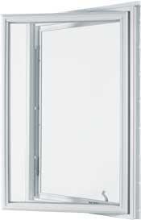

Standard Features:
- Rigid 70 mil vinyl
- Welded master frame and sash
- Full screen
- Insulated glass
- Multi – point locking screen
- Premium color keyed hardware
- 3 ¼” Jamb
- Integral nailing fin
- Available in White (standard)and Beige (optional)

2200 Series Twin & Triple Casement

Standard Features:
- Rigid 70 mil vinyl
- Welded master frame and sash
- 2 Full screens
- Insulated glass
- Multi – point locking system
- Premium color keyed hardware
- 3 ¼” Jamb
- Integral nailing fin
- Available in White (standard)and Beige (optional)

2200 Series Awning
Standard Features:
- Rigid 70 mil vinyl
- Welded master frame and sash
- Dual lock
- Full fiberglass screen
- Insulated glass
- 3 ¼” Jamb
- Integral nailing fin
- Available in White (standard)and Beige (optional)

2200 Series Picture / Awning Window

Standard Features:
- Rigid 70 mil vinyl
- Welded master frame and sash
- Insulated glass
- Dual lock
- Full fiberglass screen
- 3 ¼” Jamb
- Integral nailing fin
- Available in White (standard)and Beige (optional)

2200 Series Architectural Shapes

Standard Features:
- All welded
- Insulated glass
- Integral nail fin
- Integral J – channel
- Available in White (standard)and Beige (optional)

3500 Series Double Hung
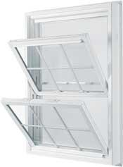

Sash and Frame:
- Miter cut fusion - welded sash and frame
- 70 mil thick vinyl extrusions
- 100% virgin vinyl- no regrind
- 4-9/16” jamb with optional 6-9/16” for 2x6 construction
- Higher concentration of titanium dioxide - gives a bright white appearance
- Available in White (Standard) and Beige (Optional)
- Sashes tilt in for easy cleaning
Glazing:
- ¾“ PPG intercept glass with warm edge spacer technology
- Exterior snap - in glazing beads protect the glazing system perimeter
- Optional Low-E/ Argon Equals Energy Star rating for savings
Standard Features:
- Balance covers- hides balance system-cleaner, more refined style and look
- Triple interlocks at the head, meeting rails and sill
- Recessed tilt latches- easy to use and appealing to the eye
- Color- matched cam action lock and keeper
- Integral fully welded sloped sill utilizes an extended interior dam to reduce water backup across sill
- Brick mold exterior for curb appeal
- Recessed “J” – Channel siding return
- Welded master frame and sash
- Integral nail fin
- Integral J – channel
- Tilt – in top and bottom sashes
- 4 9/16” Jamb depth
- Aluminum reinforced lock rail
- Insulated glass
- Extruded fiberglass full screen with “memory mesh”
- Deluxe vent latches
- Available in White (standard)and Beige (optional)

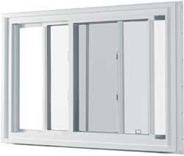
3500 Series Double Slider

Standard Features:
- Brick mold exterior
- Welded master frame and sash
- Insulated glass
- Integral J – channel
- Aluminum reinforced lock & meeting rails
- Integral nail fin
- Full extruded fiberglass screen
- 4 – 9/16” Jamb depth
- Available in White (standard)and Beige (optional)

3500 Series 3 - Lite Slider

Standard Features:
- Brick mold exterior
- Welded master frame and sash
- Three sliding sashes
- Insulated glass
- Brass rollers
- Integral J – channel
- Integral nail fin
- Two (2) screens over outer sashes
- 4 – 9/16” Jamb depth
- Aluminum reinforced lock & meeting rails
- Available in White (standard)and Beige (optional)

3500 Series Picture Window

Standard Features:
- Brick mold exterior
- All welded beveled exterior
- Integral J – channel
- Integral nail fin
- Insulated glass
- 4 – 9/16” Jamb depth
- Available in White (standard)and Beige (optional)

3500 Series Transom

Standard Features:
- Brick mold exterior
- All welded beveled exterior
- Integral J – channel
- Integral nail fin
- Insulated glass
- Double strength glass
- 1 ½” Jamb from nail fin back
- Available in White (standard)and Beige (optional)

3500 Series Sidelite

Standard Features:
- Brick mold exterior
- All welded beveled exterior
- Integral J – channel
- Integral nail fin
- Insulated glass
- Double strength glass
- 1 ½” Jamb from nail fin back
- Available in White (standard)and Beige (optional)

3500 Series Architectural Shapes

Standard Features:
- All welded 4 – 9/16” Jamb
- ¾” Insulated glass
- Integral nail fin
- Integral J – channel
- Double strength glass
- Available in White (standard)and Beige (optional)

Design-Pressure Performance Ratings:
REPLACEMENT

 |  |  | U-Value |  |  | SHGC with grids
Product  Series | D-P Rating | Size Tested | Clear | Low-E / Argon | Double Low-E/Argon | Low-E / Argon | Double Low-E/Argon
5600 DH | 35 | 44X60 | 0.48 | 0.29 | 0.26 | 0.38 | 0.263
7100 DH | 40 | 44X60 | 0.48 | 0.29 | 0.27 | 0.385 | 0.27
7100 PW | 45 | 48X72 | 0.46 | 0.25 | 0.21 | 0.39 | 0.28
7100 SL | 35 | 72X48 | 0.48 | 0.28 | 0.27 | 0.36 | 0.26
7200 CSMT/  AWN | 30 | 36X72 | 0.44 | 0.25 | 0.33 | 0.24 | 0.46

NEW CONSTRUCTION

 |  |  | U-Value |  |  | SHGC with grids
Product  Series | D-P Rating | Size Tested | Clear | Low-E / Argon | Double Low-E/Argon | Low-E / Argon | Double Low-E/Argon
2300 SH | 30 | 44X60 | 0.49 | 0.29 | 0.27 | 0.38 | 0.28
2300 SH | 50 | 44X60 | 0.49 | 0.29 | 0.27 | 0.38 | 0.28
2400 DH | 35 | 44X60 | 0.49 | 0.29 | 0.27 | 0.378 | 0.28
2200 CSMT | 30 | 36X72 | 0.44 | 0.25 | 0.24 | 0.33 | 0.24
3500 DH | 25 | 48X74 | 0.47 | 0.28 | 0.23 | 0.37 | 0.27
3500 SL | 20 | 72X60 | 0.46 | 0.28 | 0.25 | 0.35 | 0.26
3500 SL | 55 | 72X48 | 0.46 | 0.28 | 0.25 | 0.35 | 0.26
3500 PW | 50 | 73X72 | 0.47 | 0.27 | 0.224 | 0.41 | 0.30

Typical R-Value Frames
0.62 | Aluminum
1.04 | Thermally Broken Aluminum
2.14 | Aluminum Clad Wood
2.75 | Wood or Vinyl Clad Wood
3.25 | Standard Hollow Vinyl Frame
4.76 | Hollow Vinyl Multi-Chamber Frame
25.00 | Architect Select Foam Filled Vinyl

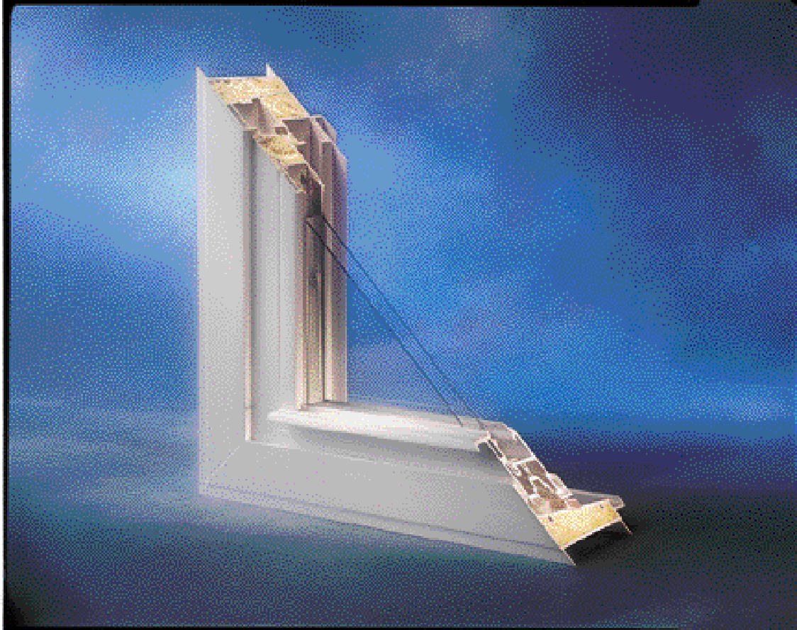
***R-VALUE IS A MEASURE OF THE MATERIAL QUALITIES AS AN INSULATOR. HIGHER VALUES DENOTE BETTER INSULATION***

