All Saints Lutheran Church, ELCA
421 SW 19th St. Blue Springs, Missouri 64015 816-229-3633
Pastor Sarah Pierce Spierce.aslcpastor@gmail.com
allsaintslc64015@gmail.com https://aslcbs.org/

Sunday, August 30, 2026

Fourteenth Sunday after Pentecost

You are absolutely invited into this sacred space. We welcome all who are seeking God’s love and grace. All Saints recognizes that we are all unique and beloved children of God. We celebrate and give thanks for the many diverse gifts that God has given us. We affirm the sacredness of people of all sexual orientations, gender identities, and gender expressions. We affirm the sacredness of all those who have experienced exclusion because of race, ability, age, or culture. We are committed to working towards anti-racism in ourselves and our community. We affirm the sacredness of all those who wrestle with addiction, physical or mental health, imprisonment, socio-economic circumstances, or anything that too often divides us. We believe that through our openness we all grow in our faith through Christ’s teaching to love one another as God loves us. We need each other and our sincere hope is by being in community together, we will experience God’s presence in new and real ways.

The offering plate is by the main door to the sanctuary for your convenience.

We practice open communion at All Saints Lutheran Church. What does that mean? It means that if you believe and trust that Christ offers his body and blood For You, you are welcome at the table. At All Saints, we believe that Christ invites all people to the feast. “Come to the banquet for all is now ready.”

**Stand as you are comfortable

Note: Bold Print: Congregational Statements

Prelude

Announcements

Decalogue (Ten Words)

Then God spoke all these words, and said, “I am God who brought you out of the land of Egypt, out of the house of bondage.
“Do not worship any gods except me!
“Do not make for yourselves any carved image or likeness of anything in heaven above or on the earth beneath or in the waters under the earth, and do not bow down to them or serve them! For I, your God, am a jealous God, and for the parents’ fault I punish the children, the grandchildren and the great-grandchildren of those who turn from me; but I show kindness to the thousandth generation of those who love me and heed my commandments.

“Do not utter the Name of God to misuse it, for God will not acquit anyone who utters God’s Name to misuse it!

“Remember the Sabbath day and keep it holy! For six days you will labor and do all your work, but the seventh day is a Sabbath for God. Do no work on that day, neither you nor your children, nor your workers – male or female – nor your animals, nor the foreigner who lives among you. For in the six days God made the heavens and the earth and the sea and all that they hold, but rested on the seventh day; this is why God has blessed the Sabbath day and made it sacred.

“Honor your mother and your father, so that you may have a long life in the land that God has given to you!
“No murdering!
“No adultery!
“No stealing!
“No giving false testimony against your neighbor!
“No desiring your neighbor’s house! No desiring your neighbor’s spouse, or worker – male or female – or ox, or donkey, or anything that belongs to your neighbor!”

** Confession and Forgiveness

The God that we worship is complex, multi-faceted, a single God made up of three Persons. When we try to understand the fullness of God, we fail. But God knows us and loves us and wants to be in relationship with us, so God is constantly finding new ways to be present with us. But sometimes, we fall short in our awareness. When that happens, we find that we have turned away from God to the idols of our own making.

Let us confess our sins together, as a community.

God of All the Cosmos,
Sometimes we try to make you small.
We try to put you in a box,
confine you to our way of understanding.
God, sometimes we misunderstand what you tell us.
Inspire us, Holy Spirit, to remember that you are beyond definition.
Help us to remember that you cannot be made small.
Help us to think deeply about who you are
and to respect and honor other people’s experiences of you.

Beloved in Christ, the God who walks beside you
is the same God who brings peace passing all understanding.
The Spirit who inspires your knowledge of the presence of God
is the same Spirit who moves over the waters of creation.
The Christ who hears your prayers
is the same Christ + who defeated death for the forgiveness of all sin, for all time.
Be at peace, for your sins are forgiven.

Amen.

**Entrance Hymn Blest Be the Tie That Binds ELW#656

**Greeting
The grace of our Lord Jesus Christ, the love of God,
and the communion of the Holy Spirit be with you all.
And also with you.

**Kyrie ELW 513
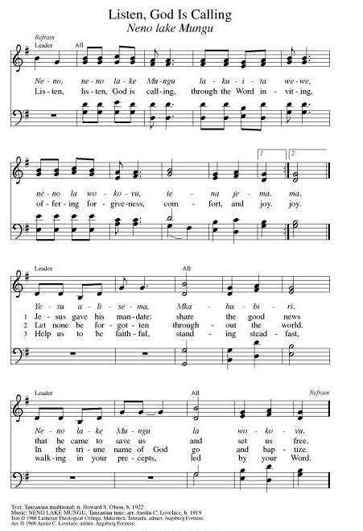

**Hymn of Praise ELW 866
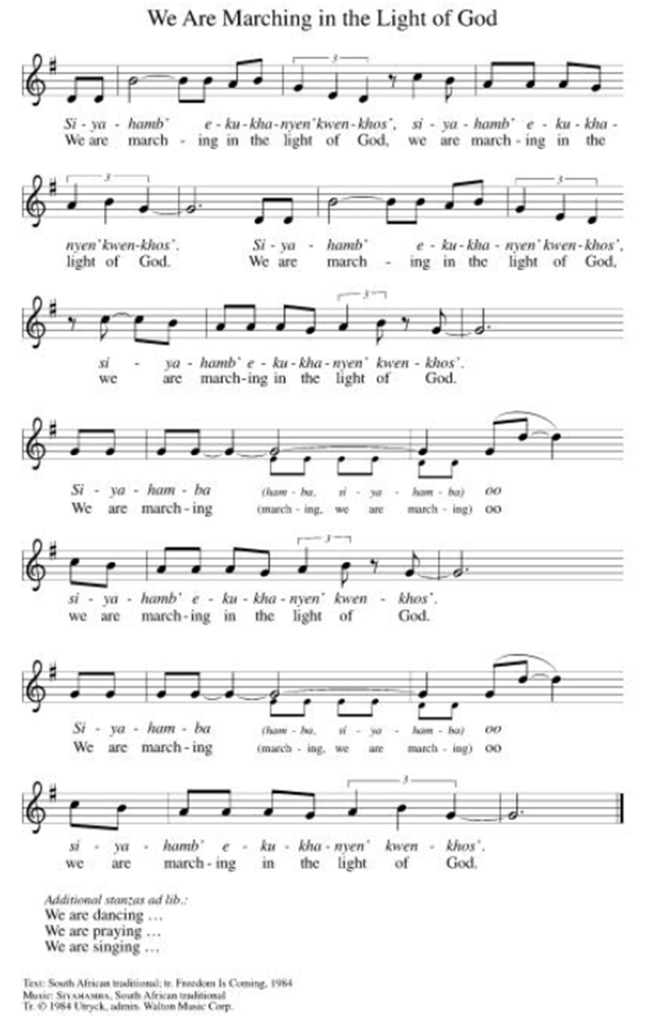

**Prayer of the Day
Good and loving God, you have freed us from sin and given us your Law to show us how to love our neighbors. Empower us to live into the freedom you have shown us in this word: that by keeping your word, we are caring for and honoring our neighbors and our community. We pray this in Jesus’ name. Amen.

Reading: Exodus 20:12-16

¹²[God said,] “Honor your mother and your father, so that you may have a long life in the land that God has given to you!
¹³“No murdering!
¹⁴“No adultery!
¹⁵“No stealing!
¹⁶No giving false testimony against your neighbor!”

Word of God, Word of Life
Thanks be to God

**Gospel Acclamation ELW 519
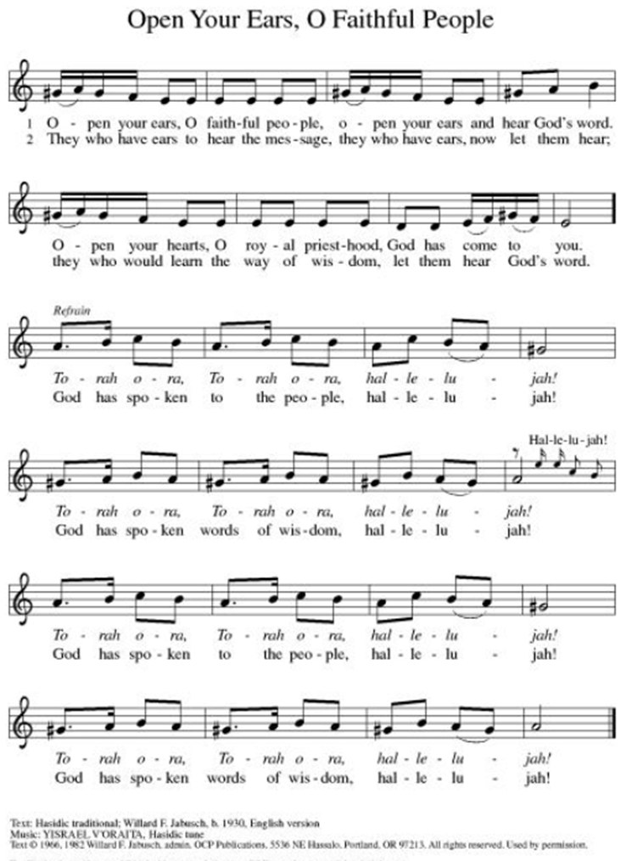
Announcement of the Gospel
Glory to you, O Lord.

Gospel: Matthew 22:34-40

³⁴When the Pharisees heard that Jesus had left the Sadducees speechless, they gathered together, ³⁵and one of them, an expert on the Law, attempted to trick Jesus with this question: ³⁶“Teacher, which commandment of the Law is the greatest?”

³⁷Jesus answered:
“’You must love the Most High God
with all your heart,
with all your soul and
with all your mind.’
³⁸“That is the greatest and first commandment. ³⁹The second is like it: ‘You must love your neighbor as yourself.’ ⁴⁰On these two commandments the whole Law is based – and the Prophets as well.”

The Gospel of the Lord.
Praise to you, O Christ.

Fifth Sunday Conversation
Hymn of the Day For the Beauty of the Earth ELW#879

**Affirmation of Faith – Immigrant’s Creed by Jose Luis Casal

I believe in Almighty God, who guided the people in exile and in exodus, the God of Joseph in Egypt and Daniel in Babylon, the God of foreigners and immigrants.

I believe in Jesus Christ, a displaced Galilean, who was born away from his people and his home, who fled his country with his parents when his life was in danger. When he returned to his own country he suffered under the oppression of Pontius Pilate, the servant of a foreign power. Jesus was persecuted, beaten, tortured, and unjustly condemned to death. But on the third day Jesus rose from the dead, not as a scorned foreigner but to offer us citizenship in God’s kingdom.

I believe in the Holy Spirit, the eternal immigrant from God’s kingdom among us, who speaks all languages, lives in all countries, and reunites all races.

I believe that the Church is the secure home for foreigners and for all believers. I believe that the communion of saints begins when we embrace all God’s people in all their diversity. I believe in forgiveness, which makes us all equal before God, and in reconciliation, which heals our brokenness. I believe that in the Resurrection God will unite us as one people in which all are distinct and all are alike at the same time. I believe in life eternal, in which no one will be foreigner but all will be citizens of the kingdom where God reigns forever and ever. Amen.

**Prayers of Intercession

Holy God, our prayers rise to you like the wings of a dove. We call upon your name, and we ask that you hear us.

For the church in every land, that its mission and ministry is anchored in the love of Christ. When threats or challenges arise, teach us to take up our cross and follow you in faith. Merciful God,
receive our prayer.
For the well-being of your creation, that all that lives and grows on the earth may thrive. Bring relief to areas ravaged by droughts, floods, fires, storms, and other disasters. Merciful God,
receive our prayer.
For the nations and all in authority, that they seek to live in peace with one another. Bless the work of international and diplomatic organizations and all who work to bring peace to a world scarred by violence. Merciful God,
receive our prayer.
For all those in need, that they be satisfied. Ensure all your children have safe access to food, water, shelter, and medical care. Bring healing to all who bear wounds in body, mind, and spirit especially for Monty & Marie, Paul, Helen, Linda, Kay, Becky H., Jim & Jan, Melian, Becky W., David, William & family, Judy, Peter & Carrie, Barbara & Donna, Brad & Chris, Drake, Bill & Sandy and the people of Spokane, Washington, Hawaii, Indonesia, El Salvador, Honduras, and Nicaragua. Merciful God,
receive our prayer.
For the congregation gathered here to serve you, that they remain strong in faith and united in purpose. Guide our committees, study groups, and other meetings toward honesty and humility, always seeking genuine love. Merciful God,
receive our prayer.
Pave a way to justice, drown the forces of oppression, bring peace on earth. Give leaders the will to turn from war and violence. Especially we pray for the people of Cuba, Venezuela, Iran, Sudan, Gaza, Israel, and Ukraine. When people must flee their homes, guide them to safety. Comfort those living with deep trauma, anxiety, or fear; all those who serve people in need, and accompany all those who care for people in harm’s way. We also lift up Jim’s grandson, Dylan, who is deployed, and Sharon’s great nephew, Taylor, who is serving in the military. Merciful God,
receive our prayer.
We pray for people who rise up against injustice. Bring courage and resilience to those who resist tyranny with their words and their bodies. Strengthen those who fight for justice in your name across the country, and around the world. Protect and sustain immigrants and refugees and all who work with them, that your kingdom, without borders and without walls, may truly come on earth as it is in heaven. We pray for all victims of gun violence or kidnapping. Embolden us to holy outrage and empower us to speak our truth of love and justice. Merciful God,
receive our prayer.
We lift up all who teach and all who learn. Thank you for teachers who share their knowledge and wisdom. Bless the students in our midst. Especially we remember Evie, in Elementary school; Addison, in high school; and Tyler and Zack, in college. Bless Janet and Carla as they teach merciful God.
For the faithful departed, that their witness continues to strengthen and guide the church. Renew our hope in your promises in this life and the life to come. Merciful God,
receive our prayer.

Good and loving God, we give everyone we have prayed for into your care. Amen.

** Sharing of the Peace

**Offering is brought forward

** Offertory Response ELW486

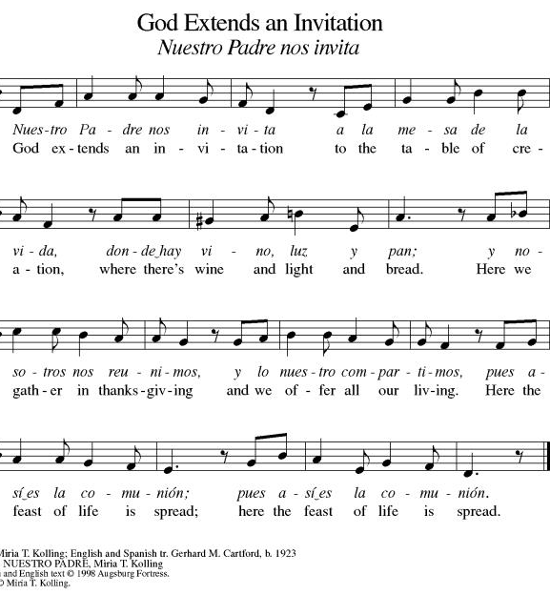

**Offertory Prayer
Jesus, all that we have and all that we are comes from you. Thank you for the gifts you have given us. Receive these gifts – our money, our service, our time – which we give in gratitude for all that we have received from you. Amen.

Dialogue
Christ is with you!
And also with you!
Lift up your hearts in joyful praise!
We lift them up to God in joy!

**Preface: We give thanks and praise to God...this hymn of praise:
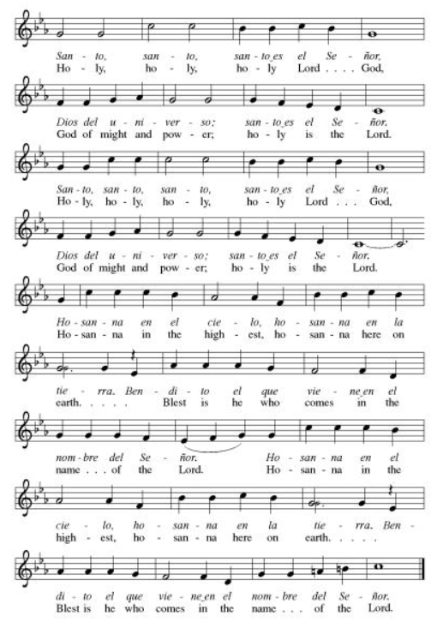
**Words of Institution

**LORD’S PRAYER
You are invited during this Pentecost season to pray whichever version feels most comfortable on your lips and in your soul. A separate sheet is available with alternate versions, should you be interested. Or, you are invited to use one of these:
Our Father in heaven, Our Father, who art in heaven,
hallowed be your name, hallowed be thy name,
your kingdom come, thy kingdom come,
your will be done, thy will be done,
on earth as in heaven. on earth as it is in heaven.
Give us today our daily bread. Give us this day our daily bread;
Forgive us our sins and forgive us our trespasses
as we forgive those as we forgive those
who sin against us. who trespass against us;
Save us from the time of trial and lead us not into temptation,
and deliver us from evil. but deliver us from evil.
For the kingdom, the power, For thine is the kingdom,
and the glory are yours, and the power, and the glory,
now and forever. Amen. forever and ever. Amen.

Invitation to Communion

Communion Hymn The King of Love My Shepherd Is ELW#502

**Sending Song ELW 535

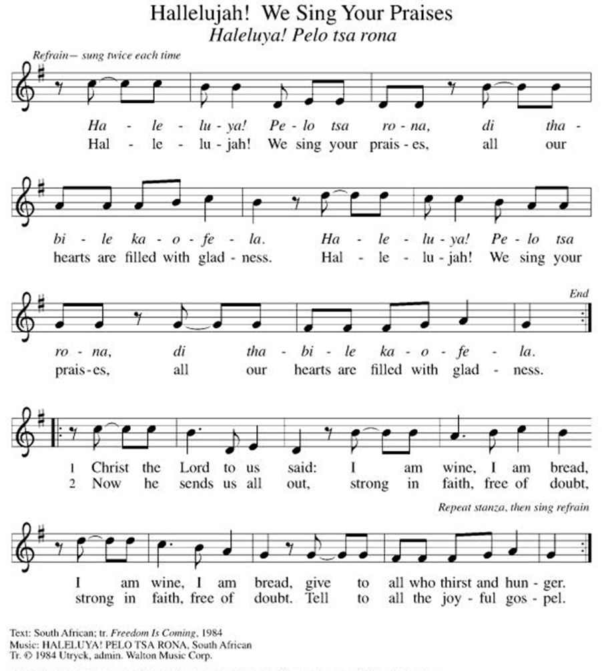

**Prayer After Communion
Holy God, you love us so much that you transformed an act of destruction into an act that gives new life. Thank you for the renewal we receive at your Table, as you send us out from this place into the world. Strengthen us for your service. In Jesus’ name we pray. Amen.

**Blessing

**Closing Hymn Shine, Jesus, Shine ELW#671

**Dismissal

Empowered by the Spirit, may you go in peace to share the gospel!
THANKS BE TO GOD!

+ + + + + +

Setting 07 and hymns from the Evangelical Lutheran Worship are under copyright and used with permission under One License #733618-A. Specific copyright information as listed in bulletin, the Prayers of Intercession are under copyright and are used with permission under Augsburg Fortress Liturgy License #SB155933. All other liturgy written by Sarah Pierce.

Weekly Attendance
Week of August 23:
24
******************************************************************************************

Next Week:
14th Sunday after Pentecost:
Exodus 20:17
Matthew 22:34-40

John 4:1-14
The color of the day is Green

Calendar of Events

Today
- Fifth Sunday Conversation

This Week
September 01 | Creative Friends 1:00 pm
September 02 | Council Meeting 6:30 pm

Upcoming Events

September 06 | Blessings of CSL
September 07 | Labor Day
September 08 | Creative Friends 1:00 pm
September 09 | Pastor Vacation September 9th -20th  Bell’s Practice 6:30 pm
September 13 | God’s Work. Our Hands.
September 16 | Bell’s Practice 6:30 pm
September 23 | Bell’s Practice 6:30 pm
September 27 | Celebration 5th year Anniversary of Pastor’s Ordination
September 30 | Bell’s Practice 6:30 pm
October 03 | Blessing of Animals
October 04 | Work Day
October 11 | Zoo after services
October 14 | Council Meeting 6:30 pm
October 25 | Reformation Sunday
November 01 | Healing for World, of the Nations,  All Saints Sunday,  Recognition of saints among us
November 11 | Council Meeting 6:30 pm
November 15 | Congregational Meeting
November 25 | Pie Night 7:00 pm
November 26  November 27 | Thanksgiving - Office Closed
December 19 | Council Meeting 6:30pm

SYNOD CONFIRMATION

As announced during the recent conference gatherings and synod assembly, the Central States Synod is putting together synod-wide confirmation. Details are in the works, but here are the basics. . .

  - Classes will run from September 3 through April 15. We will meet via Zoom from 6:30 – 7:45 pm on the 1st & 3rd Thursdays.
  - We will be on a two-year cycle. One year will be a Catechism year, and one will be a Bible year. We will be starting this fall with the Catechism year.
  - Anyone of any age can participate. (It's not just for students)
  - Each student will receive a Confirmation Kit containing items that will be used throughout the year.
  - There will be a weekly homework assignment.
  - Participants will be connected via GroupMe. Parents will need to give permission for this.
  - There will be some in-person retreats and/or camps offered along the way to connect in person with the other students.
  

As we prepare, we are hosting orientation meetings for parents, pastoral leaders, and students. We will talk about expectations, logistics, and answer your questions. If you are thinking of participating in the synod confirmation, please join us for one of two sessions, to be held on August 13 and August 20 at 6:30. Ask Pastor Sarah for the link or go to
https://www.css-elca.org/workshops#confirmation to register.

******************************************************************************************

Pastor Sarah Questions:

Questions for Reflection and Discussion

- The Decalogue is about freedom. What is freedom for? What can free people never do? Freedom is not about domination, where the powerful take what they want. It’s about respecting the rights and property of others, and helping them maintain and retain what’s theirs. It’s about being able to enter into a commitment. The commandments are what divinely-bestowed freedom looks and feels like.
- The 4th word: Honor your mother and your father, so that you may have a long life in the land that God has given to you! (In the Small Catechism, Luther writes: We are to fear and love God, so that we neither despise nor anger our parents and others in authority, but instead honor, serve, obey, love, and respect them.) In his commentary, “The Ten Commandments,” Patrick Miller writes about this commandment, “There is a further issue lurking in the background. A respected colleague wrote to me one time: ‘From my own experience and observation, no text has done more damage to abused children than the words, ‘Honor your father and your mother.’…I know that those words tormented me as a child, and I believe they have tormented others…From my…work with the Hebrew of Exodus 20, two facts are clear to me: the first is that honor is not a synonym for obedience and the second is that the Decalogue is not addressed to children.” I think this is an important point to make.
- The 5th Word: No murdering! (In the Small Catechism, Luther writes: We are to fear and love God, so that we neither endanger nor harm the lives of our neighbors, but instead help and support them in all of life’s needs.) In her book, “The Ten Commandments: Laws of the Heart,” Sister Joan Chittister asks if there can ever be such a thing as a “just” war when we no longer distinguish between combatants and noncombatants. I would ask, have we ever made such a distinction? Does this commandment make an exception for war? If so, when? Why?
- 6th Word: No adultery! (In the Small Catechism, Luther writes: We are to fear and love God, so that we lead pure and decent lives in word and dead, and each of us loves and honors their spouse.) This commandment is about commitment and intimacy. Sister Joan Chittister points out that adultery usually doesn’t destroy a relationship; instead, it’s usually a sign that the commitment and the intimacy are already gone from a relationship. The commandments are given to us so that we can love our neighbor; and one of the best ways we can love our neighbors (the ones not in our marriages) is by staying true to our commitments to our spouses. Miller writes that marriage is an act of creating moral space, where life is lived fully, in complexity, around the deepest of relationships. The only limit placed on this freedom is in terms of preserving this commitment, which in turn supports and preserves the family and the community.
- 7th Word: No stealing! (In the Small Catechism, Luther writes: We are to fear and love God, so that we neither take our neighbors’ money or property nor acquire them by using shoddy merchandise or crooked deals, but instead help them to improve and protect their property and income.) Food for thought: in 1980, the average US CEO made 42 times the average non-management worker. In 2024, the average US CEO made 281 times the average non-management worker. This commandment is about taking more than we need and wasting it. It’s about relationships, not things. It’s about holding onto our integrity.
- 8th Word: No giving false testimony against your neighbor! (In the Small Catechism, Luther writes: We are to fear and love God, so that we do not tell lies about our neighbors, betray or slander them, or destroy their reputations. Instead, we are to come to their defense, speak well of them, and interpret everything they do in the best possible light.) Lying harms both the one lied about and the liar. Both are hurt and diminished. If I tell a lie about you, not only is it possible that people will believe the bad thing that I said about you, but when (not if!) they discover that I’m the one who said it, they will lose trust in me. This is my favorite commandment, because of the second half of Luther’s explanation. I think this is foundational for every other commandment. If we keep this commandment, to interpret everything that our neighbors do in the best possible light, then we are better able to love God, keep the Sabbath, honor our parents, refrain from killing or harming, stay faithful to our spouses and have long and loving marriages, and refrain from stealing and coveting.

******************************************************************************************
BLUE SPRINGS COMMUNITY SERVICE LEAGUE is very appreciative of your continued support of your neighbor.

Birthdays
September 01-Sara Meyers

August 30
Altar Guild – Sara Meyers
Reader – Kent Deubner
Greeter – Donna Taylor
Usher-Paul Blixrud
Tech – Gary Antes

Prayer Requests
Monty & Marie Health Concerns (March 04)
Paul Health Concerns (May 31)
Mary Health Concerns (May 15)
James & Family Health Concerns (September 11)
William and Family Health Concerns (September 25)
Becky H Health Concerns (October 28)
David Health Concerns (November 18)
Becky W Health Concerns (November 18)
Judy Health Issues (December 16)
Kay (Sara’s cousin) Health Concerns (July 15)
Sharon Health Concerns (October 22)
Michael Health Concerns (October 22)
Peter and Carrie Health Concerns (November 26)
Melian Health Concerns (November 16)
RJ Health Concerns (November 17)
Barbara Health Concerns (December 30)
Helen Health Concerns (February 25)
Chris Health Concerns (June 09)
Drake Issues (August 11)
Bill & Sandy Health Issues (August 12)

Merciful God, your justice and mercy are without limits. Bring courage and resilience to those who resist tyranny with their words and their bodies. Strengthen those who fight for justice in your name across the country, and around the world.

Please pray for the people of Venezuela & Iran, Sudan, Gaza, Ukraine, Israel, Cuba, Iran and Palestine.
Please pray for the Homeless.
Please pray for legal & illegal immigrants & those seeking asylum or citizenship

