**All Saints Lutheran Church, ELCA**

**421 SW 19th St. Blue Springs, Missouri 64015 816-229-3633**

**Pastor Sarah Pierce** Spierce.aslcpastor@gmail.com

[allsaintslc64015@gmail.com](mailto:allsaintslc64015@gmail.com) <https://aslcbs.org/>

## Sunday, September 07, 2025

## Thirteenth Sunday after Pentecost

## *You are absolutely invited into this sacred space.  We welcome all who are seeking God’s love and grace.  All Saints recognizes that we are all unique and beloved children of God.  We celebrate and give thanks for the many diverse gifts that God has given us.  We affirm the sacredness of people of all sexual orientations, gender identities, and gender expressions.  We affirm the sacredness of all those who have experienced exclusion because of race, ability, age, or culture. We are committed to working towards anti-racism in ourselves and our community. We affirm the sacredness of all those who wrestle with addiction, physical or mental health, imprisonment, socio-economic circumstances, or anything that too often divides us.  We believe that through our openness we all grow in our faith through Christ’s teaching to love one another as God loves us.  We need each other and our sincere hope is by being in community together, we will experience God’s presence in new and real ways.*

*The offering plate is by the main door to the sanctuary for your convenience.*

*We practice open communion at All Saints Lutheran Church. What does that mean? It means that if you believe and trust that Christ offers his body and blood For You, you are welcome at the table. At All Saints, we believe that Christ invites all people to the feast. “Come to the banquet for all is now ready.”*

***\*\*Stand as you are comfortable***

***Prelude***

***Announcements***

**\*\* Confession and Forgiveness**

God who created the heavens, the earth, and all that exists, sometimes we feel small when we stand before you. But we trust that you see and hear us when we come to you.

Let us take a moment to draw near to God.

**Holy God,**

**You always listen to us when we pray.**

**Forgive us when we forget to center our lives around you.**

**Forgive us when we turn away, distracted by other things that delight or distress us.**

**Forgive us when we sin against you, scorning the promises you have made to us.**

**Help us remember that you are always the solid foundation on which we stand.**

**Remind us, your children, to turn back to you.**

Beloved children of God, the Spirit moves among us, bringing comfort and renewal. Our Creator, the Source of all that is good and holy, is making all things new. And in Jesus, our Savior +, we find the promise of forgiveness and mercy.

**Amen.**

***\*\*Entrance Hymn This is My Father’s World ELW #824***

***\*\*Greeting***

The grace of our Lord Jesus Christ, the love of God,

and the communion of the Holy Spirit be with you all.

**And also with you.**

**\*\*Kyrie**

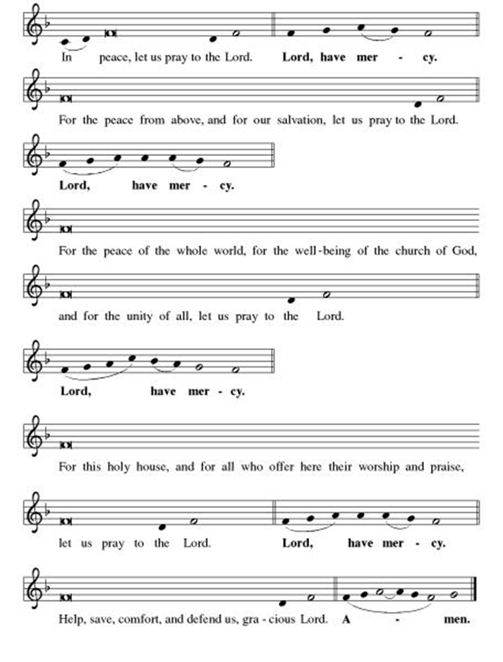

***\*\*This is the Feast***

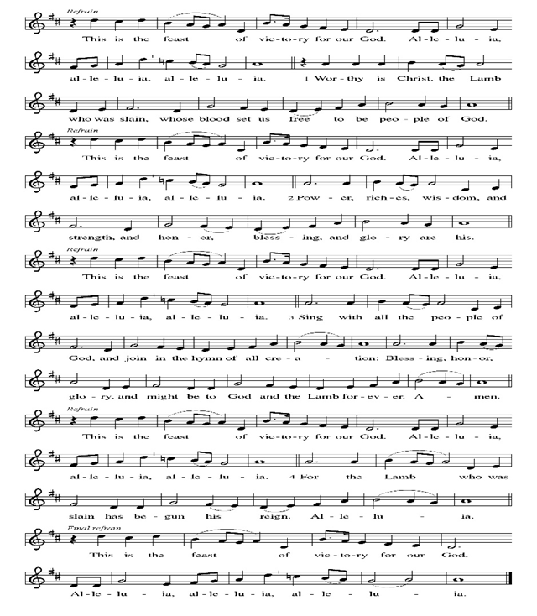

***\*\*Prayer of the Day***

**Creator God, all that you have created is good. Help us to protect and sustain your creation, to protect its boundaries and help it to thrive. Empower us to protect our own boundaries for our own flourishing. In Jesus’ name we pray. Amen.**

***Reading:*** **Genesis 1:1-2:4a**

1In the beginning

God created

the heavens

and the earth.

2But the earth became chaos and emptiness, and darkness came over the face of the Deep—yet the Spirit of God was brooding over the surface of the waters.

3Then God said, “Light: Be!” and light was. **4God saw that light was good**, and God separated light from darkness. 5God called the light “Day” and the darkness “Night.” Evening came, and morning followed—the first day.

6Then God said, “Now, make an expanse between the waters! Separate water from water!” So it was: 7God made the expanse and separated the water above the expanse from the water below it. 8God called the expanse “Sky.” Evening came, and morning followed—the second day.

9Then God said, “Waters under the sky: be gathered into one place! Dry ground: appear!” So it was. 10God called the dry ground “Earth” and the gathering of the waters “Sea.” **And God saw that this was good.** 11Then God said, “Earth: produce vegetation—plants that scatter their own seeds, and every kind of fruit tree that bears fruit with its own seed in it!” So it was: 12the earth brought forth every kind of plant that bears seed, and every kind of fruit tree on earth that bears fruit with its seed in it. **And God saw that this was good.**

13 Evening came, and morning followed—the third day.

14Then God said, “Now, let there be lights in the expanse of the sky! Separate day from night! Let them mark the signs and seasons, days and years, 15and serve as luminaries in the sky, shedding light on the earth.” So it was: 16God made the two great lights, the greater one to illumine the day, and a lesser to illumine the night. Then God made the stars as well, 17placing them in the expanse of the sky, to shed light on the earth, 18to govern both day and night, and separate light from darkness. **And God saw that this was good.** 19Evening came, and morning followed—the fourth day.

20God then said, “Waters: swarm with an abundance of living beings! Birds: fly above the earth in the open expanse of the sky!” And so it was: 21God created great sea monsters and all sorts of swimming creatures with which the waters are filled, and all kinds of birds. **God saw that this was good** 22and blessed them, saying, “Bear fruit, increase your numbers, and fill the waters of the seas! Birds, abound on the earth!”

23Evening came, and morning followed—the fifth day.

24Then God said, “Earth: bring forth all kinds of living soul—cattle, things that crawl, and wild animals of all kinds!” So it was: 25God made all kinds of wild animals, and cattle, and everything that crawls on the ground, **and God saw that this was good.**

26Then God said, “Let us make humankind in our image, to be like us. Let them be stewards of the fish in the sea, the birds of the air, the cattle, the wild animals, and everything that crawls on the ground.”

27Humankind was created as God’s reflection:

in the divine image God created them;

female and male, God made them.

28God blessed them and said, “Bear fruit, increase your numbers, and fill the earth—and be responsible for it! Watch over the fish of the sea, the birds of the air, and all the living things on the earth!” 29God then told them, “Look! I give you every seed-bearing plant on the face of the earth, and every tree whose fruit carries its seed inside itself: they will be your food; 30and to all the animals of the earth and the birds of the air and things that crawl on the ground—everything that has a living soul in it—I give all the green plants for food.” So it was. **31God looked at all of this creation, and proclaimed that this was good—very good.** Evening came, and morning followed—the sixth day.

2:1Thus the heavens and the earth and all their array were completed. 2On the seventh day God had finished all the work of creation, and so, on that seventh day, God rested. 3God blessed the seventh day and called it sacred, because on it God rested from all the work of creation. 4These are the generations of the heavens and the earth when they were created.

Word of God, Word of Life

**Thanks be to God**

***\*\*Gospel Acclamation***

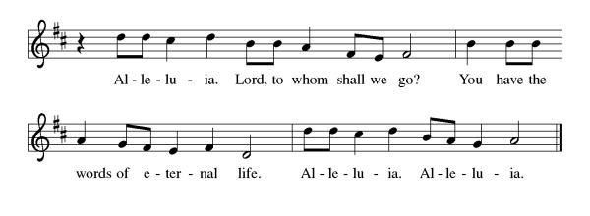

*Announcement of the Gospel*

**Glory to you, O Lord.**

***Gospel:* John 1:1-5**

1In the beginning

there was the Word;

the Word was in God’s presence,

and the Word was God.

2The Word was present to God

from the beginning.

3Through the Word

all things came into being,

and apart from the Word

nothing came into being

that has come into being.

4In the Word was life,

and that life was humanity’s light—

5a Light that shines in the darkness,

a Light that the darkness has never overtaken.

The Gospel of the Lord.

**Praise to you, O Christ.**

**Sermon  "Process of Creation”**

***Hymn of the Day* For the Beauty of the Earth ELW#879**

\*\***Affirmation of Faith – Immigrant’s Creed by Jose Luis Casal**

**I believe in Almighty God, who guided the people in exile and in exodus, the God of Joseph in Egypt and Daniel in Babylon, the God of foreigners and immigrants.**

**I believe in Jesus Christ, a displaced Galilean, who was born away from his people and his home, who fled his country with his parents when his life was in danger. When he returned to his own country he suffered under the oppression of Pontius Pilate, the servant of a foreign power. Jesus was persecuted, beaten, tortured, and unjustly condemned to death. But on the third day Jesus rose from the dead, not as a scorned foreigner but to offer us citizenship in God’s kingdom.**

**I believe in the Holy Spirit, the eternal immigrant from God’s kingdom among us, who speaks all languages, lives in all countries, and reunites all races.**

**I believe that the Church is the secure home for foreigners and for all believers. I believe that the communion of saints begins when we embrace all God’s people in all their diversity. I believe in forgiveness, which makes us all equal before God, and in reconciliation, which heals our brokenness. I believe that in the Resurrection God will unite us as one people in which all are distinct and all are alike at the same time. I believe in life eternal, in which no one will be foreigner but all will be citizens of the kingdom where God reigns forever and ever. Amen.**

***\*\*Prayers of Intercession***

**God of Love, hear the prayers that we lift before you. Hold close to you all those for whom we pray.**

We pray for the church to follow in your ways, that it may be a witness to your love for all people. Help us choose all that is life-giving and confront the forces of death. God of grace,

**receive our prayer.**

We pray for creation, that it may be cherished and nurtured. Sustain farmlands, animals, and waters; restore places affected by calamities; and shield coastlands from rising seas. God of grace,

**receive our prayer.**

We pray for those in authority. Grant them wisdom to govern justly and compassion to care for the marginalized. Equip them for actions that further the common good. God of grace,

**receive our prayer.**

We pray for those who are sick, hungry, unhoused, or lonely especially Monty, Paul, Linda, Betty F., Kay, family of Lisa, Becky H., Jim & Jan, Becky W., David, William and family, Helen, Larry, Jennifer, Otto, families in our community who endure hunger, and our beloved for whom death is near. Carry your people when grief is heavy, and lift burdens of shame and self-doubt. Bring honor to any who experience slander and evil intent or are discredited by others. Assure all who are afraid or experiencing great uncertainty that your promises are sure. Reassure them of your care in all times and places. Manifest your healing presence in their midst. May they find healing through your love and the care of those around them. Lead us to be your hands and feet in the world. God of grace,

**receive our prayer.**

We pray for this congregation, that we may be united in love and faith. Refresh our hearts in Christ, and deepen our support of one another. We pray that our sharing of faith may transform lives. God of grace,

**receive our prayer.**

Calm the fears of migrants and refugees who set out, not knowing where they go. Provide shelter, sustenance, protection from harm, and welcome. Bless the work of Global Refuge and other support and advocacy programs. God of grace,

**receive our prayer.**

We pray for the nations. Pave a way to justice, drown the forces of oppression, bring peace on earth. Give leaders the will to turn from war and violence. Especially we pray for the people of Gaza, Israel, and Ukraine, and for Jim’s grandson Dylan, who is deployed in Oman. When people must flee their homes, guide them to safety. Comfort those living with deep trauma, anxiety, or fear; all those who serve people in need, and accompany all those who care for people in harm’s way. God of grace,

**receive our prayer.**

We pray for people who rise up against injustice. Bring courage and resilience to those who resist tyranny with their words and their bodies. Strengthen those who fight for justice in your name across the country, and around the world. Protect and sustain immigrants and refugees and all who work with them, that your kingdom, without borders and without walls, may truly come on earth as it is in heaven. We pray for all victims of gun violence or kidnapping, especially those who are targeted out of hate or fear. Embolden us to holy outrage and empower us to speak our truth of love and justice, God of grace,

**receive our prayer.**

God of learning, we lift up all who teach and all who learn. Thank you for teachers who share their knowledge and wisdom. Bless the students in our midst. Especially we remember Evie, in kindergarten; Addison, in high school; and Tyler, Zach, Katie and Katy, in college. Bless Janet and Lisa as they teach. Hear us, God of grace,

**receive our prayer.**

We thank you for those who have died and now dwell with the saints. Surround them with your divine mercy, that they find peace and rest in your loving embrace. God of grace,

**receive our prayer.**

**Good and loving God, we give everyone we have prayed for into your care. Amen.**

*\*\** ***Sharing of the Peace***

### *\*\*Offering is brought forward*

### *\*\** *Offertory Response*

**Create in Me ELW#186**

### *\*\*Blessing of CSL Offering*

### *\*\*Offertory Prayer*

**Good and loving God, everything that we have and everything that we are comes from you. We respond in gratitude, offering up to you our gifts of our money, our time, and our talents. We dedicate these gifts to your service. In Jesus’ name we pray, amen.**

**\*\*Dialogue**

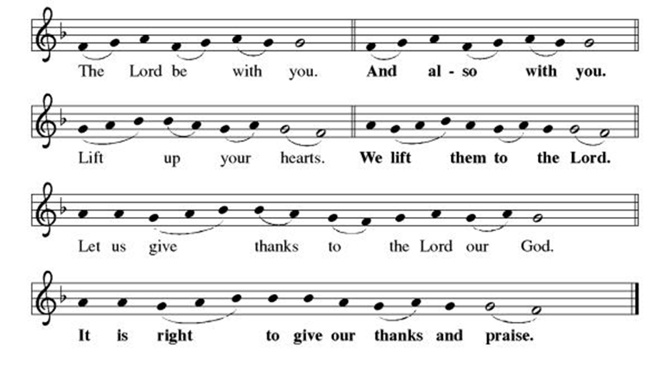

**\*\*Preface:** Since the earliest days of the covenant… this hymn of praise:

**\*\*Holy, Holy, Holy**

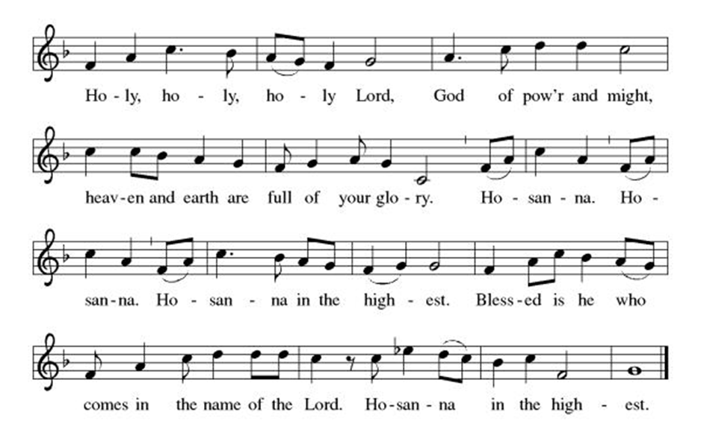

***\*\*Words of Institution***

**\*\*LORD’S PRAYER**

**Our Father, who art in heaven,**

**hallowed be thy name,**

**thy kingdom come,**

**thy will be done,**

**on earth as it is in heaven.**

**Give us this day our daily bread;**

**and forgive us our trespasses,**

**as we forgive those**

**who trespass against us;**

**and lead us not into temptation,**

**but deliver us from evil.**

**For thine is the kingdom,**

**and the power, and the glory,**

**forever and ever. Amen.**

***Invitation to Communion***

# ***Communion Hymn By Your Hand You Feed Your People ELW#469***

### *\*\*Sending Song*

### *Praise to you, O God of Mercy ELW#208*

### *\*\*Prayer After Communion*

**Abiding God, you call us then feed and nurture us. Now you send us out in the world you created with a purpose: to love our neighbors and care for those who need us. Strengthen us to do your work. In Jesus’ name we pray, Amen.**

### *\*\*Blessing*

***\*\*Closing Hymn******How Great Thou Art******ELW#856***

### 

### *\*\*Dismissal*

Go in peace to serve Christ and the world!

**THANKS BE TO GOD!**

### + + + + + +

*Setting 3 liturgy are under copyright and used with permission under One License #733618-A. Specific copyright information as listed in bulletin, the Prayers of Intercession are under copyright and are used with permission under Augsburg Fortress Liturgy License #SB155933. All other liturgy written by Sarah Pierce.*

*\*\*\*\*\*\*\*\*\*\*\*\*\*\*\*\*\*\*\*\*\*\*\*\*\*\*\*\*\*\*\*\*\*\*\*\*\*\*\*\*\*\*\*\*\*\*\*\*\*\*\*\*\*\*\*\*\*\*\*\*\*\*\*\*\*\*\*\*\*\*\*\*\*\*\*\*\*\*\*\*\*\*\*\*\*\*\*\*\*\*\*\*\*\*\*\*\*\*\*\*\*\*\*\*\*\*\**

**Weekly Attendance**

***Week of August 31***

***25***

*\*\*\*\*\*\*\*\*\*\*\*\*\*\*\*\*\*\*\*\*\*\*\*\*\*\*\*\*\*\*\*\*\*\*\*\*\*\*\*\*\*\*\*\*\*\*\*\*\*\*\*\*\*\*\*\*\*\*\*\*\*\*\*\*\*\*\*\*\*\*\*\*\*\*\*\*\*\*\*\*\*\*\*\*\*\*\*\*\*\**

**Calendar of Events**

***Today***

* ***God’s Work. Our Hands/Zoo after Worship***

***This Week***

|  |  |
| --- | --- |
| ***September 09*** | ***Creative Friends 1:00 pm*** |
| ***September 10*** | ***Handbell rehearsal 6:30 pm*** |
| ***September 13*** | ***Men’s Breakfast 8:00 am*** |

***Upcoming Events***

|  |  |
| --- | --- |
| ***September 14*** | ***Council Meeting after Worship*** |
| ***September 16*** | ***Creative Friends 1:00 pm*** |
| ***September 17- September 21*** | ***Pastor Sarah Vacation*** |
| ***September 23*** | ***Creative Friends 1:00 pm*** |
| ***September 22-23*** | ***Blue Springs Theatre 7:00 pm-9:00 pm*** |
| ***September 29-October 01*** | ***Blue Springs Theatre 7:00 pm-9:00 pm*** |
| ***September 28*** | ***Bishop Installation/Atonement Lutheran Church 5:00 pm Overland Park*** |
| ***September 30*** | ***Creative Friends 1:00 pm*** |
| ***October 04*** | ***Blessing of Animals TBA*** |
| ***October 12*** | ***Fall Work Day*** |
| ***October 15*** | ***Council Meeting 6:30 pm*** |
| ***November 05*** | ***Council Meeting 6:30 pm*** |
| ***November 16*** | ***Congregational Meeting*** |
| ***December 10*** | ***Council Meeting 6:30 pm*** |
| ***January 14, 2026*** | ***Council Meeting 6:30 pm*** |

****************************************************************************************

*You may recall that there has been an announcement in the bulletin over the past year directing you to Lutheran Immigration and Refugee Services (LIRS) if you wish to support the people of Ukraine. LIRS has changed its name to Global Refuge and can be found at* ***globalrefuge.org****. Although their name has changed, their mission remains the same: to assist and support refugees in the United States and around the world. Visit their website to see all the ways you can support this important work.*

**\*\*\*\*\*\*\*\*\*\*\*\*\*\*\*\*\*\*\*\*\*\*\*\*\*\*\*\*\*\*\*\*\*\*\*\*\*\*\*\*\*\*\*\*\*\*\*\*\*\*\*\*\*\*\*\*\*\*\*\*\*\*\*\*\*\*\*\*\*\*\*\*\*\*\*\*\*\*\*\*\*\*\*\*\*\*\*\*\***

**BLUE SPRINGS COMMUNITY SERVICE LEAGUE** *is very appreciative of your continued support of your neighbor.*

*\*\*\*\*\*\*\*\*\*\*\*\*\*\*\*\*\*\*\*\*\*\*\*\*\*\*\*\*\*\*\*\*\*\*\*\*\*\*\*\*\*\*\*\*\*\*\*\*\*\*\*\*\*\*\*\*\*\*\*\*\*\*\*\*\*\*\*\*\*\*\*\*\*\*\*\*\*\*\*\*\*\*\*\*\*\*\*\*\*\**

**Questions for Reflection and Discussion from Pastor Sarah**

1. Where did the sacredness of the number 7 come from, anyway? Ancient Mesopotamian astronomers knew of 7 “heavenly bodies:” the sun, the moon, Saturn, Venus, Jupiter, Mars, and Mercury – and they were all deified. Additionally, 7 was set apart a little: it is the only “non-regular” number under 10 because it’s not divisible by 2, 3, or 5. The even numbers are “sibling” numbers because they’re divisible by 2, and 3, 6, and 9 are the same because they’re divisible by 3; and 5 goes into all the round numbers (10, 20, etc.). So it stands on its own and acquired a unique sensibility because of that.
2. What does it mean to be made in God’s image? There are two words – one is translated “image” and comes from an unused root word meaning to shade; the first definition is a phantom or (figuratively) a likeness; the second definition is a representative figure or an idol. The second word is translated in our text “to be like us;” in other translations, it’s often “likeness.” The first definition of this word is to compare; the second definition is by implication to resemble or consider. So being made in God’s image probably doesn’t have anything to do with how we look. Beyond that, it’s open to interpretation. What do you think it means?
3. Look forward to John 1:1-5, to the coming of Jesus. We were created in God’s image, and God is committed enough to being in relationship to us that (regardless of what it means to be created in God’s image) God comes to earth in a form that not only LOOKS like us, but IS like us – as in human. That’s a pretty powerful statement of God’s desire for relationship with us.
4. There were a lot of creation stories that emerged around the same time and in the same area, in different religious traditions. All of the other Mesopotamian creation stories end with a temple (or sanctuary) being built. Our creation story in Genesis 1:1-2:4a ends with the Sabbath for God, which becomes encoded in law in the commandments, which we could call a sanctuary in time. It doesn’t matter where we are – we can take refuge in this particular sanctuary.

***\*\*\*\*\*\*\*\*\*\*\*\*\*\*\*\*\*\*\*\*\*\*\*\*\*\*\*\*\*\*\*\*\*\*\*\*\*\*\*\*\*\*\*\*\*\*\*\*\*\*\*\*\*\*\*\*\*\*\*\*\*\*\*\*\*\*\*\*\*\*\*\*\*\*\*\*\*\*\*\*\*\*\*\*\*\****

***Birthdays***

***September 07-Evie Soetmelk***

***Greeter –*** **September 07*-******Donna Taylor***

***Usher –* September 07*-Paul Blixrud***

***Altar Guild-* September 07-Mary Ann Gross**

***Reader-* September 07-Sara Meyers**

***Tech-* September 07*-Gary Antes***

**Prayer Requests**

***Monty Health Concerns (May 15)***

*Paul Health Concerns (May 31)*

*Mary Health Concerns (May 15)*

*James & Family Health Concerns (September 11)*

*Betty F (Sara’s friend) Health Concerns (July 15)*

*William and Family Health Concerns (September 25)*

*Becky H Health Concerns (October 28)*

*David Health Concerns (November 18)*

*Becky W Health Concerns (November 18)*

*Larry Health Issues (December 16)*

*Helen Health Issues (January 14)*

*Jennifer Health Concerns (February 27)*

*Otto Health Concerns (July 15)*

*Kay (Sara’s cousin) Health Concerns (**July 15)*

*Family of Lisa (September 03)*

***Merciful God, your justice and mercy are without limits. Bring courage and resilience to those who resist tyranny with their words and their bodies. Strengthen those who fight for justice in your name in Los Angeles, across the country, and around the world.***

***Please pray for the victims of the shooting at Annunciation Catholic School in Minneapolis.***

***Please pray for the people of Gaza, Ukraine, Israel, Iran and Palestine.***

***Please pray for the people of the Sudan.***

***Please pray for the Homeless.***

***Please pray for legal & illegal immigrants & those seeking asylum or citizenship.***