**All Saints Lutheran Church, ELCA**

**421 SW 19th St. Blue Springs, Missouri 64015 816-229-3633**

**Pastor Sarah Pierce** Spierce.aslcpastor@gmail.com

[allsaintslc64015@gmail.com](mailto:allsaintslc64015@gmail.com) <https://aslcbs.org/>

## Sunday, July 20, 2025

## Sixth Sunday after Pentecost

## *You are absolutely invited into this sacred space.  We welcome all who are seeking God’s love and grace.  All Saints recognizes that we are all unique and beloved children of God.  We celebrate and give thanks for the many diverse gifts that God has given us.  We affirm the sacredness of people of all sexual orientations, gender identities, and gender expressions.  We affirm the sacredness of all those who have experienced exclusion because of race, ability, age, or culture. We are committed to working towards anti-racism in ourselves and our community. We affirm the sacredness of all those who wrestle with addiction, physical or mental health, imprisonment, socio-economic circumstances, or anything that too often divides us.  We believe that through our openness we all grow in our faith through Christ’s teaching to love one another as God loves us.  We need each other and our sincere hope is by being in community together, we will experience God’s presence in new and real ways.*

*The offering plate is by the main door to the sanctuary for your convenience.*

*We practice open communion at All Saints Lutheran Church. What does that mean? It means that if you believe and trust that Christ offers his body and blood For You, you are welcome at the table. At All Saints, we believe that Christ invites all people to the feast. “Come to the banquet for all is now ready.”*

***\*\*Stand as you are comfortable***

***Prelude***

***Announcements***

**\*\* Confession and Forgiveness**

Siblings in Christ, as we gather in this place, let us confess our sins together in the ancient words of the people:

**O God, have mercy on me!**

**Because of your love and your great compassion, wipe away my faults;**

**wash me clean of my guilt;**

**purify me of my sin.**

**For I am aware of my faults,**

**and have my sin constantly in mind.**

**I sinned against you alone,**

**and did what is evil in your sight.**

**You are just when you pass sentence on me,**

**blameless when you give judgment.**

**I was born in sin, conceived in sin -**

**yet you want truth to live in my innermost being.**

**Teach me your wisdom!**

**Bless God, my soul!**

**All that is in me, bless God’s holy name!**

**Bless God, my soul,**

**and remember all God’s kindness!**

The One who forgives all your sins is the One who heals all your disease;

the One + who ransoms your life from the Pit is the One who crowns you with love and tenderness.

God’s love lasts from age to age for those who revere them,

as does God’s goodness to our children’s children,

and to those who cling to the faith of Christ.

**Amen.**

***\*\*Entrance Hymn Beautiful Savior ELW #838***

***\*\*Greeting***

The grace of our Lord Jesus Christ, the love of God,

and the communion of the Holy Spirit be with you all.

**And also with you.**

**\*\*Kyrie**

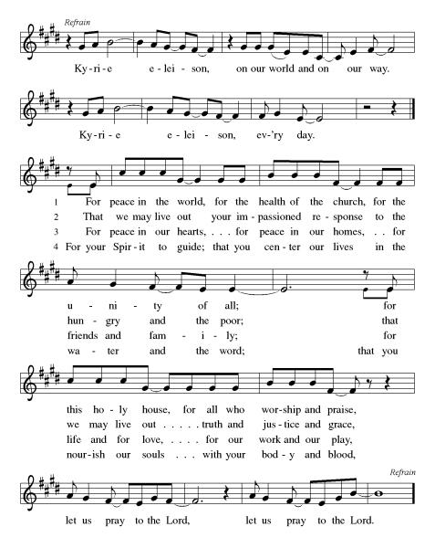

***\*\*Prayer of the Day***

**God of Grace, you call us to love and compassion – and also to notice and respond to injustice. Empower us to love all our neighbors as ourselves, even when the injustices seem too big for us to take on. Help us to remember that everything we do has an impact. In Jesus’ name we pray, Amen.**

***Reading:*** **Leviticus 19:1-2a, 33-34; 20:2b-5, 7-8, 22-24, 26**

1God told Moses 2to tell the entire Israelite community these things:

33Do not mistreat the foreigners who reside in your land. 34The foreigner who lives among you must be treated like one of your own. Love them as you love yourself, for you too were a foreigner in the land of Egypt. I am God.

20:2bAny of you Israelites, or any foreigners dwelling in Israel, who sacrifice your children to Molech, will be put to death. The people of the community must stone you to death. 3I will set my face against you and I will cut you off from my people. If you give your children to Molech you will defile my sanctuary and profane my holy Name. 4If you, as Israelites, ever close your eyes when a person gives a child to Molech, and you fail to carry out this law, 5I will set my face against you and your family. I will cut off from the community both the accused and all who make themselves idolators by following Molech.

7Consecrate yourselves and become holy, for I, your God, am holy. 8Keep my decrees and observe them, for it is I, your God, who makes you holy.

22You must keep my statutes and my laws and observe them so that the land that I am giving to you to dwell in will not vomit you out. 23Do not take on the customs of the nations whom I am driving out before you. They practiced all these things that I detest. 24Remember that I will give you possession of their land, a land flowing with milk and honey. I, your God, have made a clear separation between you and the other nations. 26 You must be holy to me as I, your God, am holy to you.

Word of God, Word of Life

**Thanks be to God**

***\*\*Gospel Acclamation***

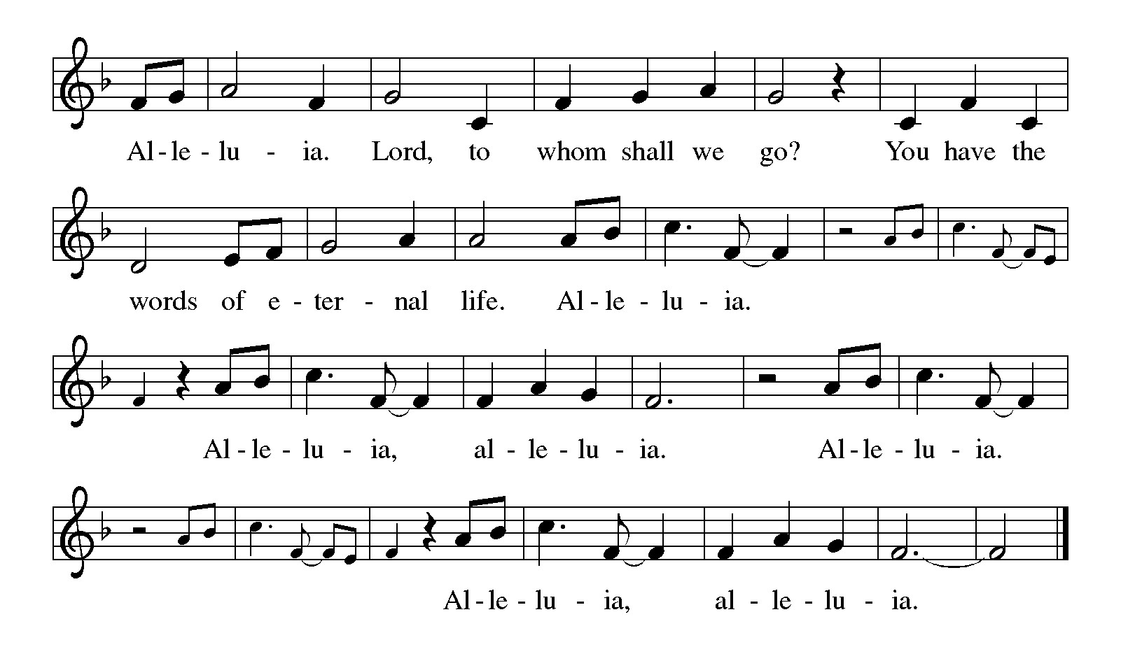

*Announcement of the Gospel*

**Glory to you, O Lord.**

***Gospel:* Matthew 6:19-21**

19[Jesus said,] “Don’t store up earthly treasures for yourselves, which moths and rust destroy and thieves can break in and steal. 20But store up treasures for yourselves in heaven, where neither moth nor rust can destroy them and thieves cannot break in and steal them. 21For where your treasure is, there will your heart be as well.”

The Gospel of the Lord.

**Praise to you, O Christ.**

**Sermon "Holiness Code 2"**

***Hymn of the Day* Children of the Heavenly Father ELW#781**

\*\***Affirmation of Faith – Immigrant’s Creed by Jose Luis Casal**

**I believe in Almighty God, who guided the people in exile and in exodus, the God of Joseph in Egypt and Daniel in Babylon, the God of foreigners and immigrants.**

**I believe in Jesus Christ, a displaced Galilean, who was born away from his people and his home, who fled his country with his parents when his life was in danger. When he returned to his own country he suffered under the oppression of Pontius Pilate, the servant of a foreign power. Jesus was persecuted, beaten, tortured, and unjustly condemned to death. But on the third day Jesus rose from the dead, not as a scorned foreigner but to offer us citizenship in God’s kingdom.**

**I believe in the Holy Spirit, the eternal immigrant from God’s kingdom among us, who speaks all languages, lives in all countries, and reunites all races.**

**I believe that the Church is the secure home for foreigners and for all believers. I believe that the communion of saints begins when we embrace all God’s people in all their diversity. I believe in forgiveness, which makes us all equal before God, and in reconciliation, which heals our brokenness. I believe that in the Resurrection God will unite us as one people in which all are distinct and all are alike at the same time. I believe in life eternal, in which no one will be foreigner but all will be citizens of the kingdom where God reigns forever and ever. Amen.**

***\*\*Prayers of Intercession***

Inspire your church, like Sarah and Mary, to listen with eager longing for your words of life. Equip biblical interpreters and teachers with faithful discernment, that your word may be more fully known. God of grace,

**hear our prayer.**

Every creature under heaven has been promised the hope of the gospel. From that promise, generate in humankind an eagerness to protect and care for creation. Bring healing to the earth with your words of life. God of grace,

**hear our prayer.**

Peel away the distractions, worries, and fears of all who govern the nations of the world. May your word of love and life dispel all other voices. Provide gracious hospitality in places where hostile forces hold sway. God of grace,

**hear our prayer.**

Speak your word of comfort to any who suffer pain, illness, grief, depression, or despair especially Monty, Paul, Linda, Betty F., Kay, Becky H., Jim & Jan, Becky W., David, William and family, Helen, Larry, Jennifer, Otto, families in our community who endure hunger, and our beloved for whom death is near. Carry your people when grief is heavy, and lift burdens of shame and self-doubt. Provide protection and aid to children who are unsafe and undernourished while on summer break. Bring honor to any who experience slander and evil intent or are discredited by others. God of grace,

**hear our prayer.**

Enliven and uphold all siblings in Christ who strive to provide hospitality and safe spaces where everyone, without exception, can receive and be transformed by your word of life. God of grace,

**hear our prayer.**

We pray for the nations. Pave a way to justice, drown the forces of oppression, bring peace on earth. Give leaders the will to turn from war and violence. Especially we pray for the people of Gaza, Israel, and Ukraine, and for Jim’s grandson Dylan, who is deployed in Oman. When people must flee their homes, guide them to safety. Comfort those living with deep trauma, anxiety, or fear; all those who serve people in need, and accompany all those who care in harm’s way.

God of grace,

**hear our prayer.**

Provide comfort to those whose loved ones have died in the Texas flood. Accompany the first responders and all who are searching for the missing. And may those who are waiting feel your presence and know they do not wait alone. God of grace,

**hear our prayer.**

We pray for people who rise up against injustice. Bring courage and resilience to those who resist tyranny with their words and their bodies. Strengthen those who fight for justice in your name across the country, and around the world. Protect and sustain immigrants and refugees and all who work with them, that your kingdom, without borders and without walls, may truly come on earth as it is in heaven. We pray for all victims of gun violence or kidnapping, especially those who are targeted out of hate or fear. Embolden us to holy outrage and empower us to speak our truth of love and justice, God of grace,

**hear our prayer.**

For all the saints who attended to your word, we give thanks. Open our ears to your voice until that day when we realize the promise of the gospel with all creation. God of grace,

**hear our prayer.**

**Good and loving God, we give everyone we have prayed for into your care. Amen.**

*\*\** ***Sharing of the Peace***

### *\*\*Offering is brought forward*

### *\*\** *Offertory Response*

**Create in Me ELW#186**

### *\*\*Offertory Prayer*

**Holy God, we return to you with thanks the first fruits of what you have given us: our time, our talents and interests, and our money. Use these gifts to your service and for your ministry in this place. We pray this in Jesus’ name. Amen.**

**Dialogue**

Thank you God, for you are good!

**Your love is everlasting!**

You alone perform such great marvels.

**Your love is everlasting!**

Your wisdom made the heavens.

**Your love is everlasting!**

You spread the land out over the waters.

**Your love is everlasting!**

You made the great lights:

**Your love is everlasting!**

The sun to govern the day, moon and stars to govern the night.

**Your love is everlasting!**

**\*\*Preface:** Since the earliest days of the covenant…this hymn of praise:

**\*\*Holy, Holy, Holy**

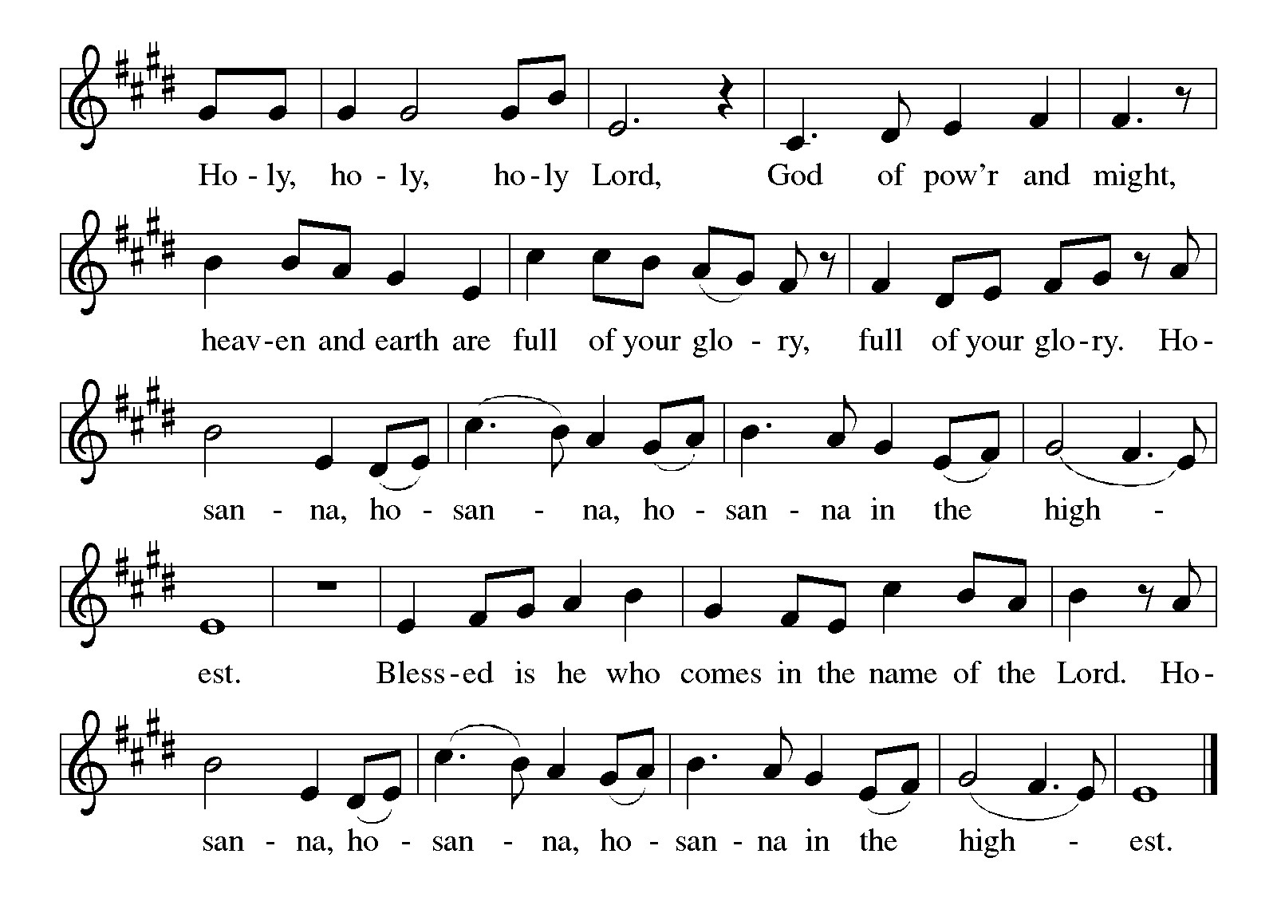

***\*\*Words of Institution***

**\*\*LORD’S PRAYER**

**Our Father, who art in heaven,**

**hallowed be thy name,**

**thy kingdom come,**

**thy will be done,**

**on earth as it is in heaven.**

**Give us this day our daily bread;**

**and forgive us our trespasses,**

**as we forgive those**

**who trespass against us;**

**and lead us not into temptation,**

**but deliver us from evil.**

**For thine is the kingdom,**

**and the power, and the glory,**

**forever and ever. Amen.**

***Invitation to Communion***

# ***Communion Hymn One Bread, One Body ELW#496***

### *\*\*Sending Song*

### *Praise to you, O God of Mercy ELW#208*

### *\*\*Prayer After Communion*

**Grafted onto the tree of faith and grounded in our baptisms, we have been fed by the Word and at the Table. Now send us out to share the joy of Christ with all whom we encounter. Amen.**

**\*\*Blessing of David**

### *\*\*Blessing*

### *\*\*Closing Hymn Go, My Children, with My Blessing ELW#*543

### 

### *\*\*Dismissal*

Go in peace to serve Christ and the world!

**THANKS BE TO GOD!**

### + + + + + +

*Setting 8 liturgy are under copyright and used with permission under One License #733618-A. Specific copyright information as listed in bulletin, the Prayers of Intercession are under copyright and are used with permission under Augsburg Fortress Liturgy License #SB155933. All other liturgy written by Sarah Pierce.*

*Confession and Forgiveness based on Psalm 51:1-6 and Psalm 103:104, 17-18 (adapted). Dialog based on Psalm 136:1, 4-8. Thanksgiving based on Psalm 100 (adapted). Benediction based on 1 Thessalonians 5:16-24 (adapted).*

**Weekly Attendance**

***Week of July 13***

***33***

*\*\*\*\*\*\*\*\*\*\*\*\*\*\*\*\*\*\*\*\*\*\*\*\*\*\*\*\*\*\*\*\*\*\*\*\*\*\*\*\*\*\*\*\*\*\*\*\*\*\*\*\*\*\*\*\*\*\*\*\*\*\*\*\*\*\*\*\*\*\*\*\*\*\*\*\*\*\*\*\*\*\*\*\*\*\*\*\*\*\**

**Calendar of Events**

***Today***

* ***Newsletter Deadline***
* ***David’s Last Sunday***

***This Week***

|  |  |
| --- | --- |
| ***July 22*** | ***Creative Friends 1:00 pm*** |
| ***July 22*** | ***BSCT Trivia Night 7:00 pm-9:00 pm Stations 7*** |
| ***July 26*** | ***Project Comfort 9:00 am-Noon*** |

***Upcoming Events***

|  |  |
| --- | --- |
| ***July 27*** | ***Coffee with Council*** |
| ***July 28 – Aug 03*** | ***Pastor Sarah’s Vacation*** |
| ***August 03*** | ***Blessing of CSL*** |
| ***August 05*** | ***Creative Friends 1:30 pm*** |
| ***August 09*** | ***Men’s Group Breakfast 8:00 am*** |
| ***August 09*** | ***BS Back to School Bingo 1:00 p -3:00 pm*** |
| ***August 10*** | ***Baptismal Birthdays*** |
| ***August 12*** | ***Creative Friends 1:30 pm*** |
| ***August 13*** | ***Council Meeting 6:30 pm*** |
| ***August 19*** | ***Creative Friends 1:30 pm*** |
| ***August 20*** | ***Newsletter Deadline*** |
| ***August 23*** | ***Project Comfort 9:00 am-Noon*** |
| ***August 26*** | ***Creative Friends 1:30 pm*** |
| ***August 31*** | ***Fifth Sunday Conversation*** |
| ***September 07*** | ***God’s Work. Our Hands*** |
| ***September 14*** | ***Council Meeting 6:30 pm after Worship*** |
| ***October 04*** | ***Blessing of Animals TBA*** |
|  |  |

****************************************************************************************

The book of Leviticus has kind of a bad reputation. We often think of it as being excessively rules-based, really strict, with regulations that don’t really apply to us any longer in our modern world. So much so that it seems like Leviticus has two purposes in modern Christianity – either to be ignored and set aside, or to have verses pulled out of context to be used to condemn others. But neither of those are a fair treatment of Leviticus. When we dive into it, we discover a text that we can wrestle with and learn from. A text that has much to teach us about faithfulness to God and to each other.

We will be exploring this book in a **7-part sermon series** this summer, starting on **Holy Trinity Sunday.**

* **July 27: Sabbath/Conclusion**

**\*\*\*\*\*\*\*\*\*\*\*\*\*\*\*\*\*\*\*\*\*\*\*\*\*\*\*\*\*\*\*\*\*\*\*\*\*\*\*\*\*\*\*\*\*\*\*\*\*\*\*\*\*\*\*\*\*\*\*\*\*\*\*\*\*\*\*\*\*\*\*\*\*\*\***

**“The New Colossus” by Emma Lazarus (1849-1887)**

Not like the brazen giant of Greek fame,  
With conquering limbs astride from land to land;  
Here at our sea-washed, sunset gates shall stand  
A mighty woman with a torch, whose flame  
Is the imprisoned lightning, and her name  
Mother of Exiles. From her beacon-hand  
Glows world-wide welcome; her mild eyes command  
The air-bridged harbor that twin cities frame.  
“Keep, ancient lands, your storied pomp!” cries she  
With silent lips. “Give me your tired, your poor,  
Your huddled masses yearning to breathe free,  
The wretched refuse of your teeming shore.  
Send these, the homeless, tempest-tost to me,  
I lift my lamp beside the golden door!”

*(poets.org)*

This poem was written by Lazarus in 1883 as part of the fund-raising efforts for a base for the Statue of Liberty. It is cast on a plaque that is mounted on the inside of the base of the statue. Lazarus was an activist and advocate for Jewish refugees fleeing from Russian pogroms in the 1800s, and wrote the poem as a way to express empathy for Russian Jewish refugees to the US.

The statue was intended to be a symbol of republican (anti-imperialist) values; however, Lazarus’ poem gave it a new purpose, turning it into a symbol of welcome for immigrants and refugees at the front door of the country. *(Wikipedia article on “The New Colossus”)*

*\*\*\*\*\*\*\*\*\*\*\*\*\*\*\*\*\*\*\*\*\*\*\*\*\*\*\*\*\*\*\*\*\*\*\*\*\*\*\*\*\*\*\*\*\*\*\*\*\*\*\*\*\*\*\*\*\*\*\*\*\*\*\*\*\*\*\*\*\*\*\*\*\*\*\*\*\*\*\*\*\*\*\*\*\*\*\*\*\**

*You may recall that there has been an announcement in the bulletin over the past year directing you to Lutheran Immigration and Refugee Services (LIRS) if you wish to support the people of Ukraine. LIRS has changed its name to Global Refuge and can be found at* ***globalrefuge.org****. Although their name has changed, their mission remains the same: to assist and support refugees in the United States and around the world. Visit their website to see all the ways you can support this important work.*

**\*\*\*\*\*\*\*\*\*\*\*\*\*\*\*\*\*\*\*\*\*\*\*\*\*\*\*\*\*\*\*\*\*\*\*\*\*\*\*\*\*\*\*\*\*\*\*\*\*\*\*\*\*\*\*\*\*\*\*\*\*\*\*\*\*\*\*\*\*\*\*\*\*\*\*\*\*\*\*\*\*\*\*\*\*\*\*\*\***

**BLUE SPRINGS COMMUNITY SERVICE LEAGUE** *is very appreciative of your continued support of your neighbor.*

*\*\*\*\*\*\*\*\*\*\*\*\*\*\*\*\*\*\*\*\*\*\*\*\*\*\*\*\*\*\*\*\*\*\*\*\*\*\*\*\*\*\*\*\*\*\*\*\*\*\*\*\*\*\*\*\*\*\*\*\*\*\*\*\*\*\*\*\*\*\*\*\*\*\*\*\*\*\*\*\*\*\*\*\*\*\*\*\*\*\**

**Questions for Reflection and Discussion**

1. If you’re curious about the other mentions of Molech in the Bible, here they are. There are two different mentions of Molech in Leviticus: a single verse in chapter 18 (verse 21) which also mentions the prohibition on sacrificing children, then this paragraph in chapter 20. Additionally, there are mentions in
   1. 1 Kings 11:7, when King Solomon is said to have introduced the cult of Molech, although some scholars think it’s a transcription error, referencing a different god;
   2. 2 Kings 23:10, when King Josiah destroys the place where the sacrifice happens;
   3. Jeremiah 32:35, in which the prophet condemns worship of Molech;
   4. Isaiah 30:33, which may be a reference to the king instead (the words are very similar in Hebrew); and
   5. Amos 5:26, a reference to idol-worship.
   6. Additionally, Stephen quotes the Amos verse in his sermon in Acts 7.
2. We are still in the Holiness Code this week. The center of the Holiness Code, perhaps of worship of God in general within Leviticus, is verse 19:2b: “You shall *become* holy, for I your God am holy” (italics my translation – many translations say “be”). What do these commands against child sacrifice and mistreatment of foreigners have to do with holiness? With love of neighbor?
3. At the end of our text for today, we see the mention of a “clear separation” between the Israelites and other nations, followed by the reiteration that they must be holy as God is holy. (The verse we skip has to do with making a “clear separation” between ceremonially clean and unclean animals and birds and references food purity, which we are skipping entirely.) There are other echoes of creation throughout Leviticus; is this another such echo, hearkening back to the separation of light and darkness, the waters above from the waters below, the land from the sea?
4. In one of the commentaries on Leviticus that I looked at for the section on Molech, the author excerpted a thought from Rabbi Joshua Heschel’s 1983 book “I Asked for Wonder.” Asked to reflect on Israel and reflecting on what we have learned from Jewish history, Rabbi Heschel wrote: “…if a man is not more than human then he is less than human. Judaism is an attempt to prove that in order to be a people we have to be more than a people. Israel was made to be a holy people.” Do those words have anything to say to us today?

***\*\*\*\*\*\*\*\*\*\*\*\*\*\*\*\*\*\*\*\*\*\*\*\*\*\*\*\*\*\*\*\*\*\*\*\*\*\*\*\*\*\*\*\*\*\*\*\*\*\*\*\*\*\*\*\*\*\*\*\*\*\*\*\*\*\*\*\*\*\*\*\*\*\*\*\*\*\*\*\*\*\*\*\*\*\****

***Birthdays***

***July 24 Judi Williams***

***Greeter –*** **July 20*-******Donna Taylor***

***Usher –* July 20*-Paul Blixrud***

***Altar Guild-* July 20- *Anne Lee & Paul Blixrud***

***Reader-* July 20-*Jim McDonald***

***Communion Assistant-July 20 -Sara Meyers***

***Tech-* July 20*-Gary Antes***

**Prayer Requests**

***Monty Health Concerns (May 15)***

*Paul Health Concerns (May 31)*

*Mary Health Concerns (May 15)*

*James & Family Health Concerns (September 11)*

*Betty F (Sara’s friend) Health Concerns (July 15)*

*William and Family Health Concerns (September 25)*

*Becky H Health Concerns (October 28)*

*David Health Concerns (November 18)*

*Becky W Health Concerns (November 18)*

*Larry Health Issues (December 16)*

*Helen Health Issues (January 14)*

*Jennifer Health Concerns (February 27)*

*Otto Health Concerns (July 15)*

*Kay (Sara’s cousin) Health Concerns (July 15)*

*Jim & Jan Health Concerns (July 15)*

***Merciful God, your justice and mercy are without limits. Bring courage and resilience to those who resist tyranny with their words and their bodies. Strengthen those who fight for justice in your name in Los Angeles, across the country, and around the world.***

***Please pray for the people of Gaza, Ukraine, Israel, and Palestine.***

***Please pray for the people of the Sudan.***

***Please pray for the Homeless.***

***Please pray for legal & illegal immigrants & those seeking asylum or citizenship.***