**All Saints Lutheran Church, ELCA**

**421 SW 19th St. Blue Springs, Missouri 64015 816-229-3633**

**Pastor Sarah Pierce** Spierce.aslcpastor@gmail.com

[allsaintslc64015@gmail.com](mailto:allsaintslc64015@gmail.com) <https://aslcbs.org/>

## Sunday, July 13, 2025

## Fifth Sunday after Pentecost

## *You are absolutely invited into this sacred space.  We welcome all who are seeking God’s love and grace.  All Saints recognizes that we are all unique and beloved children of God.  We celebrate and give thanks for the many diverse gifts that God has given us.  We affirm the sacredness of people of all sexual orientations, gender identities, and gender expressions.  We affirm the sacredness of all those who have experienced exclusion because of race, ability, age, or culture. We are committed to working towards anti-racism in ourselves and our community. We affirm the sacredness of all those who wrestle with addiction, physical or mental health, imprisonment, socio-economic circumstances, or anything that too often divides us.  We believe that through our openness we all grow in our faith through Christ’s teaching to love one another as God loves us.  We need each other and our sincere hope is by being in community together, we will experience God’s presence in new and real ways.*

*The offering plate is by the main door to the sanctuary for your convenience.*

*We practice open communion at All Saints Lutheran Church. What does that mean? It means that if you believe and trust that Christ offers his body and blood For You, you are welcome at the table. At All Saints, we believe that Christ invites all people to the feast. “Come to the banquet for all is now ready.”*

***\*\*Stand as you are comfortable***

***Prelude***

***Announcements***

### *Baptismal Birthdays*

**\*\* Confession and Forgiveness**

Siblings in Christ, as we gather in this place, let us confess our sins together in the ancient words of the people:

**O God, have mercy on me!**

**Because of your love and your great compassion, wipe away my faults;**

**wash me clean of my guilt;**

**purify me of my sin.**

**For I am aware of my faults,**

**and have my sin constantly in mind.**

**I sinned against you alone,**

**and did what is evil in your sight.**

**You are just when you pass sentence on me,**

**blameless when you give judgment.**

**I was born in sin, conceived in sin -**

**yet you want truth to live in my innermost being.**

**Teach me your wisdom!**

**Bless God, my soul!**

**All that is in me, bless God’s holy name!**

**Bless God, my soul,**

**and remember all God’s kindness!**

The One who forgives all your sins is the One who heals all your disease;

the One + who ransoms your life from the Pit is the One who crowns you with love and tenderness.

God’s love lasts from age to age for those who revere them,

as does God’s goodness to our children’s children,

and to those who cling to the faith of Christ.

**Amen.**

***\*\*Entrance Hymn Come, All You People ELW #819***

***\*\*Greeting***

The grace of our Lord Jesus Christ, the love of God,

and the communion of the Holy Spirit be with you all.

**And also with you.**

**\*\*Kyrie**

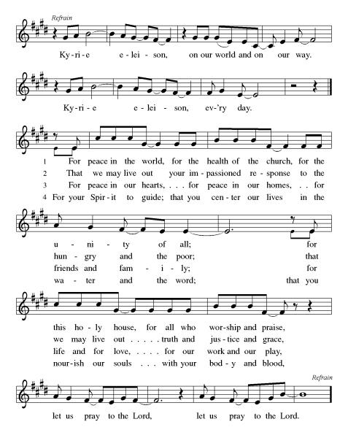

***\*\*Prayer of the Day***

**Loving God, you show us how to become holy. During the difficult in-between times, when it is easier to go backwards or go off the path, send your Spirit to guide and empower us to love our neighbors as Jesus loves us: with grace and compassion, and with all that we are. Amen.**

***Reading:*** **Leviticus 18:1-5, 24, 28-30; 19:2b-18**

18:1God told Moses 2to tell this to the Israelites:

I am your God. 3You must not do what is done in Egypt, where you once dwelled, nor may you do what is done in Canaan, where I am leading you. You must not take up their customs. 4Rather, you must observe my statutes and follow my laws faithfully; I am your God. 5Observe my statutes and my laws: If you do them, you will live because of them. I am your God.

24Do not make yourself unclean in any of these ways, for it is with such practices that the nations I am driving out before you make themselves ceremonially unclean. 28The land will vomit you out if you make it unclean, just as it did the nation that was before you. 29Any who practice these detestable acts will be cut off from their people. 30Honor my commandment to abandon all of these detestable acts that were committed before your time. Do not make yourselves ceremonially unclean with them: I am God.

19:2bBe holy, for I, your God, am holy.

3Each one of you must revere your parents. You must keep my sabbaths. I am your God. 4Do not turn to idols or cast metal images of gods for yourself. I am your God.

5When you offer a fellowship sacrifice to God, you must offer it in such a way that is acceptable on your behalf. 6You must eat it on the same day you offer it, or the next day; anything left after that must be burned. 7If it is eaten on the third day, it is tainted meat, and it is not acceptable. 8If you eat it on the third day you must assume guilt, for you desecrated what is holy to your God; you must be cut off from your people.

9When you reap the harvest from your fields, do not cut the grain to the very edges of the field, or gather in all the gleanings. 10Nor are you to completely strip your vines or pick up the fallen fruit. Leave the extra grain and fruit for poor people and foreigners to gather for themselves. I am your God.

11Do not steal. Do not lie. Do not cheat your neighbor. 12Do not swear by my Name with the intent to deceive, for if you do, you profane my Name. I am your God. 13Do not oppress your neighbors or rob them. Do not hold back the hired hand’s wages until the next day. 14Do not insult deaf people, or put obstacles in the way of blind people. Revere your God.

15Do not be corrupt in administering justice. Do not show partiality to the poor or give honor to the great. Judge your neighbor with fairness. 16Do not go about slandering others.

Do not profit by the blood of your neighbor. I am your God. 17Do not nurse hatred for a neighbor. If you are angry with your neighbor, speak frankly about it, to avoid storing up ill feelings. 18Never seek revenge or hold a grudge toward your relatives. You must love your neighbor as yourself. I am your God.

Word of God, Word of Life

**Thanks be to God**

***\*\*Gospel Acclamation***

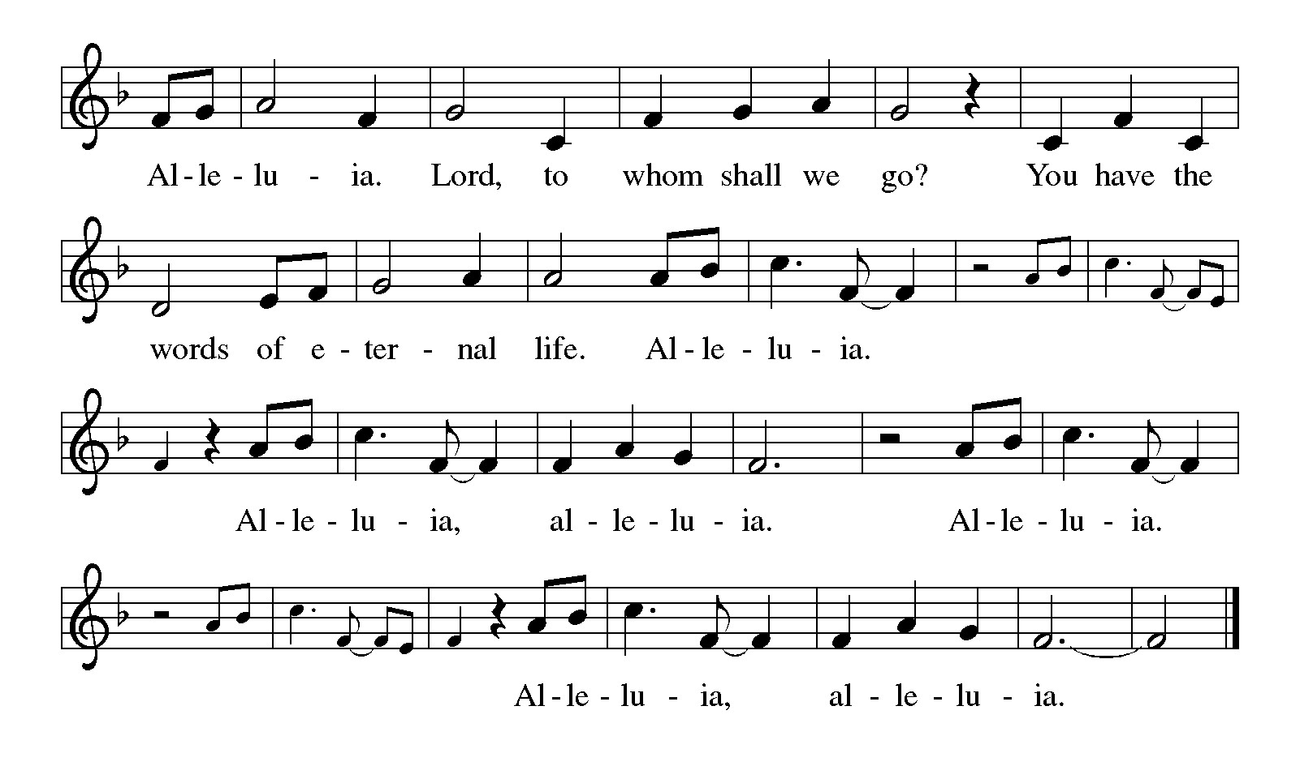

*Announcement of the Gospel*

**Glory to you, O Lord.**

***Gospel:* Luke 18:9-14**

9Jesus spoke this parable addressed to those who believed in their own self-righteousness while holding everyone else in contempt: 10 “Two people went up to the Temple to pray; one was a Pharisee, the other a tax collector. 11The Pharisee stood and prayed like this: ‘I give you thanks, O God, that I’m not like the others – greedy, crooked, adulterous – or even like this tax collector. 12I fast twice a week. I pay tithes on everything I earn.’

13 “The other one, however, kept a distance, not even daring to look up to heaven. In real humility, all the tax collector said was, ‘O God, be merciful to me, a sinner.’ 14Believe me, the tax collector went home from the Temple right with God, while the Pharisee didn’t. For those who exalt themselves will be humbled, while those who humble themselves will be exalted.”

The Gospel of the Lord.

**Praise to you, O Christ.**

**Sermon Holiness Code 1**

***Hymn of the Day* Spread, Oh Spread, Almighty Word ELW#663**

**INSTALLATION OF Church Council**

\*\***Affirmation of Faith – Immigrant’s Creed by Jose Luis Casal**

**I believe in Almighty God, who guided the people in exile and in exodus, the God of Joseph in Egypt and Daniel in Babylon, the God of foreigners and immigrants.**

**I believe in Jesus Christ, a displaced Galilean, who was born away from his people and his home, who fled his country with his parents when his life was in danger. When he returned to his own country he suffered under the oppression of Pontius Pilate, the servant of a foreign power. Jesus was persecuted, beaten, tortured, and unjustly condemned to death. But on the third day Jesus rose from the dead, not as a scorned foreigner but to offer us citizenship in God’s kingdom.**

**I believe in the Holy Spirit, the eternal immigrant from God’s kingdom among us, who speaks all languages, lives in all countries, and reunites all races.**

**I believe that the Church is the secure home for foreigners and for all believers. I believe that the communion of saints begins when we embrace all God’s people in all their diversity. I believe in forgiveness, which makes us all equal before God, and in reconciliation, which heals our brokenness. I believe that in the Resurrection God will unite us as one people in which all are distinct and all are alike at the same time. I believe in life eternal, in which no one will be foreigner but all will be citizens of the kingdom where God reigns forever and ever. Amen.**

***\*\*Prayers of Intercession***

Saving God, awaken your church to your truth as it follows your path of love. Encourage pastors, deacons, teachers, and seminarians, and lead them as they seek to learn your ways. Empower and strengthen Church Council Members and all church leadership to do your work. God of grace,

**hear our prayer.**

Prosper the harvests of fruit-bearing bushes, trees, and plants. Uphold farmers and farm workers as they labor through summer days, and bring relief to lands that are parched with heat. God of grace,

**hear our prayer.**

Instill in leaders of the world a strong love for their neighbors. Compel them to govern with equity and to give aid and protection to people who are vulnerable, especially strangers, migrants, and asylum seekers. God of grace,

**hear our prayer.**

Draw near to people in need of help, comfort, and healing especially Monty, Paul, Linda, Betty F, Carla, Becky H., Becky W., David, William and family, Helen, Larry, Stephen, Jennifer, Otto, families in our community who endure hunger, and our beloved for whom death is near. Carry your people when grief is heavy, and lift burdens of shame and self-doubt. Provide protection and aid to children who are unsafe and undernourished while on summer break. God of grace,

**hear our prayer.**

Go with all who travel, and protect them from harm. Put in their paths people who offer aid. We pray especially for the safety of first responders. God of grace,

**hear our prayer.**

We pray for the nations. Pave a way to justice, drown the forces of oppression, bring peace on earth. Give leaders the will to turn from war and violence. Especially we pray for the people of Gaza, Israel, Iran, and Ukraine. When people must flee their homes, guide them to safety. Comfort those living with deep trauma, anxiety, or fear; all those who serve people in need, and accompany all those who care in harm’s way.

God of grace,

**hear our prayer.**

Provide comfort to those whose loved ones have died in the Texas flood. Accompany the first responders and all who are searching for the missing. And may those who are waiting feel your presence and know they do not wait alone. God of grace,

**hear our prayer.**

We pray for people who rise up against injustice. Bring courage and resilience to those who resist tyranny with their words and their bodies. Strengthen those who fight for justice in your name across the country, and around the world. Protect and sustain immigrants and refugees and all who work with them, that your kingdom, without borders and without walls, may truly come on earth as it is in heaven. We pray for all victims of gun violence or kidnapping, especially those who are targeted out of hate or fear. Embolden us to holy outrage and empower us to speak our truth of love and justice, God of grace,

**hear our prayer.**

We give you thanks for all who have gone before us and have made your love known. Help us to follow their witness as we await our share in the inheritance of the saints. God of grace,

**hear our prayer.**

**Good and loving God, we give everyone we have prayed for into your care. Amen.**

*\*\** ***Sharing of the Peace***

### *\*\*Offering is brought forward*

### *\*\** *Offertory Response*

**Create in Me ELW#186**

### *\*\*Offertory Prayer*

**Holy God, we return to you with thanks the first fruits of what you have given us: our time, our talents and interests, and our money. Use these gifts to your service and for your ministry in this place. We pray this in Jesus’ name. Amen.**

**Dialogue**

Thank you God, for you are good!

**Your love is everlasting!**

You alone perform such great marvels.

**Your love is everlasting!**

Your wisdom made the heavens.

**Your love is everlasting!**

You spread the land out over the waters.

**Your love is everlasting!**

You made the great lights:

**Your love is everlasting!**

The sun to govern the day, moon and stars to govern the night.

**Your love is everlasting!**

**\*\*Preface:** Since the earliest days of the covenant…this hymn of praise:

**\*\*Holy, Holy, Holy**

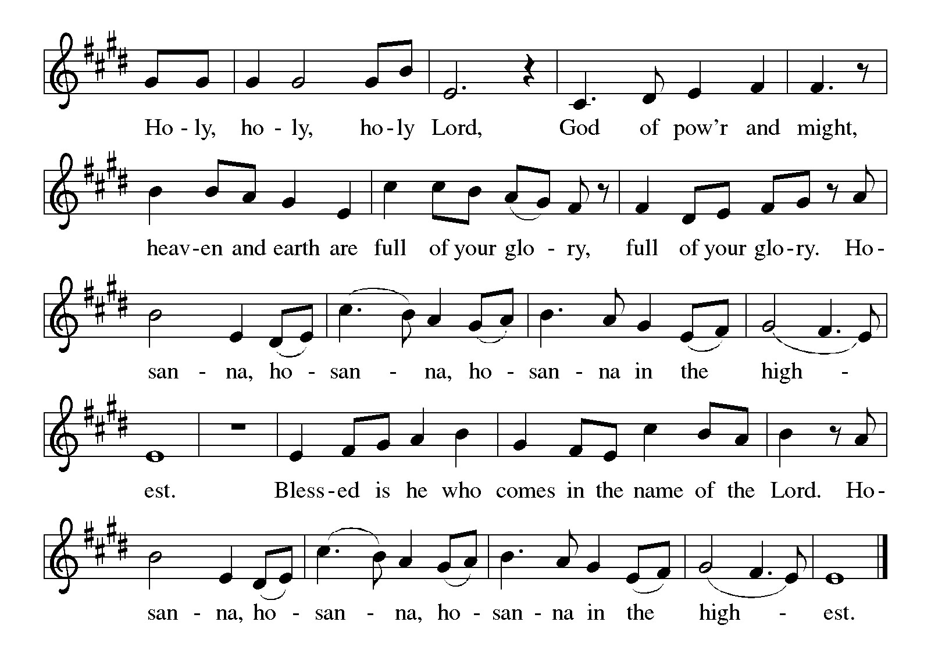

***\*\*Words of Institution***

**\*\*LORD’S PRAYER**

**Our Father, who art in heaven,**

**hallowed be thy name,**

**thy kingdom come,**

**thy will be done,**

**on earth as it is in heaven.**

**Give us this day our daily bread;**

**and forgive us our trespasses,**

**as we forgive those**

**who trespass against us;**

**and lead us not into temptation,**

**but deliver us from evil.**

**For thine is the kingdom,**

**and the power, and the glory,**

**forever and ever. Amen.**

***Invitation to Communion***

# ***Communion Hymn Wash, O God, Our Sons and Daughters ELW#445***

### *\*\*Sending Song*

### *Praise to you, O God of Mercy ELW#208*

### *\*\*Prayer After Communion*

**Grafted onto the tree of faith and grounded in our baptisms, we have been fed by the Word and at the Table. Now send us out to share the joy of Christ with all whom we encounter. Amen.**

### *\*\*Blessing*

### *\*\*Closing Hymn Let Us Talents and Tongues Employ ELW#*674

### 

### *\*\*Dismissal*

Go in peace to serve Christ and the world!

**THANKS BE TO GOD!**

### + + + + + +

*Setting 8 liturgy are under copyright and used with permission under One License #733618-A. Specific copyright information as listed in bulletin, the Prayers of Intercession are under copyright and are used with permission under Augsburg Fortress Liturgy License #SB155933. All other liturgy written by Sarah Pierce.*

*Confession and Forgiveness based on Psalm 51:1-6 and Psalm 103:104, 17-18 (adapted). Dialog based on Psalm 136:1, 4-8. Thanksgiving based on Psalm 100 (adapted). Benediction based on 1 Thessalonians 5:16-24 (adapted).*

**Weekly Attendance**

***Week of July 06***

***24***

*\*\*\*\*\*\*\*\*\*\*\*\*\*\*\*\*\*\*\*\*\*\*\*\*\*\*\*\*\*\*\*\*\*\*\*\*\*\*\*\*\*\*\*\*\*\*\*\*\*\*\*\*\*\*\*\*\*\*\*\*\*\*\*\*\*\*\*\*\*\*\*\*\*\*\*\*\*\*\*\*\*\*\*\*\*\*\*\*\*\**

**Calendar of Events**

***Today***

* ***Adult Bible Study***
* ***Baptismal Birthdays***
* ***Installation of Church Council/Ice Cream Social after Worship/Photo OP***

***This Week***

|  |  |
| --- | --- |
| ***July 15*** | ***Creative Friends 1:00 pm*** |
| ***July 16*** | ***Council Meeting 6:30 pm*** |

***Upcoming Events***

|  |  |
| --- | --- |
| ***July 20*** | ***David’s last Sunday*** |
| ***July 22*** | ***Creative Friends 1:00 pm*** |
| ***July 22*** | ***BSCT Trivia Night 7:00 pm-9:00 pm Stations 7*** |
| ***July 26*** | ***Project Comfort 9:00 am-Noon*** |
| ***July 27*** | ***Coffee with Council*** |
| ***July 28 – Aug 03*** | ***Pastor Sarah’s Vacation*** |
| ***August 09*** | ***BS Back to School Bingo 1:00 p -3:00 pm*** |
| ***August 13*** | ***Council Meeting 6:30 pm*** |
| ***September 07*** | ***God’s Work. Our Hands*** |
| ***September 14*** | ***Council Meeting 6:30 pm after Worship*** |
| ***September 28*** | ***Installation of Bishop Donna Simon at Atonement Lutheran Church 5:00 pm*** |
| ***October 04*** | ***Blessing of Animals TBA*** |
|  |  |

****************************************************************************************

The book of Leviticus has kind of a bad reputation. We often think of it as being excessively rules-based, really strict, with regulations that don’t really apply to us any longer in our modern world. So much so that it seems like Leviticus has two purposes in modern Christianity – either to be ignored and set aside, or to have verses pulled out of context to be used to condemn others. But neither of those are a fair treatment of Leviticus. When we dive into it, we discover a text that we can wrestle with and learn from. A text that has much to teach us about faithfulness to God and to each other.

We will be exploring this book in a **7-part sermon series** this summer, starting on **Holy Trinity Sunday.**

* **July 20: Holiness Code part 2**
* **July 27: Sabbath/Conclusion**

**\*\*\*\*\*\*\*\*\*\*\*\*\*\*\*\*\*\*\*\*\*\*\*\*\*\*\*\*\*\*\*\*\*\*\*\*\*\*\*\*\*\*\*\*\*\*\*\*\*\*\*\*\*\*\*\*\*\*\*\*\*\*\*\*\*\*\*\*\*\*\*\*\*\*\***

***David Fast’s last Sunday with us will be July 20. Join us after worship as we celebrate him and wish him well in Hutchinson!***

***\*\*\*\*\*\*\*\*\*\*\*\*\*\*\*\*\*\*\*\*\*\*\*\*\*\*\*\*\*\*\*\*\*\*\*\*\*\*\*\*\*\*\*\*\*\*\*\*\*\*\*\*\*\*\*\*\*\*\*\*\*\*\*\*\*\*\*\*\*\*\*\*\*\*\****

**“The New Colossus” by Emma Lazarus (1849-1887)**

Not like the brazen giant of Greek fame,  
With conquering limbs astride from land to land;  
Here at our sea-washed, sunset gates shall stand  
A mighty woman with a torch, whose flame  
Is the imprisoned lightning, and her name  
Mother of Exiles. From her beacon-hand  
Glows world-wide welcome; her mild eyes command  
The air-bridged harbor that twin cities frame.  
“Keep, ancient lands, your storied pomp!” cries she  
With silent lips. “Give me your tired, your poor,  
Your huddled masses yearning to breathe free,  
The wretched refuse of your teeming shore.  
Send these, the homeless, tempest-tost to me,  
I lift my lamp beside the golden door!”

*(poets.org)*

This poem was written by Lazarus in 1883 as part of the fund-raising efforts for a base for the Statue of Liberty. It is cast on a plaque that is mounted on the inside of the base of the statue. Lazarus was an activist and advocate for Jewish refugees fleeing from Russian pogroms in the 1800s, and wrote the poem as a way to express empathy for Russian Jewish refugees to the US.

The statue was intended to be a symbol of republican (anti-imperialist) values; however, Lazarus’ poem gave it a new purpose, turning it into a symbol of welcome for immigrants and refugees at the front door of the country. *(Wikipedia article on “The New Colossus”)*

*\*\*\*\*\*\*\*\*\*\*\*\*\*\*\*\*\*\*\*\*\*\*\*\*\*\*\*\*\*\*\*\*\*\*\*\*\*\*\*\*\*\*\*\*\*\*\*\*\*\*\*\*\*\*\*\*\*\*\*\*\*\*\*\*\*\*\*\*\*\*\*\*\*\*\*\*\*\*\*\*\*\*\*\*\*\*\*\*\**

*You may recall that there has been an announcement in the bulletin over the past year directing you to Lutheran Immigration and Refugee Services (LIRS) if you wish to support the people of Ukraine. LIRS has changed its name to Global Refuge and can be found at* ***globalrefuge.org****. Although their name has changed, their mission remains the same: to assist and support refugees in the United States and around the world. Visit their website to see all the ways you can support this important work.*

**\*\*\*\*\*\*\*\*\*\*\*\*\*\*\*\*\*\*\*\*\*\*\*\*\*\*\*\*\*\*\*\*\*\*\*\*\*\*\*\*\*\*\*\*\*\*\*\*\*\*\*\*\*\*\*\*\*\*\*\*\*\*\*\*\*\*\*\*\*\*\*\*\*\*\*\*\*\*\*\*\*\*\*\*\*\*\*\*\***

**BLUE SPRINGS COMMUNITY SERVICE LEAGUE** *is very appreciative of your continued support of your neighbor.*

*\*\*\*\*\*\*\*\*\*\*\*\*\*\*\*\*\*\*\*\*\*\*\*\*\*\*\*\*\*\*\*\*\*\*\*\*\*\*\*\*\*\*\*\*\*\*\*\*\*\*\*\*\*\*\*\*\*\*\*\*\*\*\*\*\*\*\*\*\*\*\*\*\*\*\*\*\*\*\*\*\*\*\*\*\*\*\*\*\*\**

**Questions for Reflection and Discussion**

1. If you WANT to read those verses in chapter 18 (that include the so-called “clobber verse”), they’re verses 6-23. But I’ll warn you – the other reason we didn’t include them is that they made me a little queasy. I decided I could talk about them plenty without having to have anyone read them. I think they’re less distracting that way. Spoiler alert: we’ll be skipping their parallel verses in chapter 20 next week, too.
2. Do we understand holiness as central to our understanding of God? If not, why not? Where did it get lost along the way?
3. I kind of skip over any mention of sin in this sermon, because I was focused on other things. But it’s clear from the verses at the end of chapter 18 that sin has the capacity to defile the land. It’s deeply tied to creation. For a little greater context, if one person sins or becomes unholy per these chapters, they’re driven from the community; if the whole community sins, the land will vomit them out. That’s kind of a graphic image, but how do we see this being played out with the Babylonian exile? Do we see it at all today?
4. There are so many words for “neighbor” in our verses from chapter 19: poor, foreigners, neighbor, hired hands, deaf people, blind people, the poor (again)/the great, others, and finally neighbor (again several times). What does this say to us about our neighbors, and how we are to treat them? What does the behavior that God instructs us to have in these verses tell us about loving our neighbor?
5. There’s a great thought – not original to me – about loving our neighbor as ourself: because we are made in the likeness of God, if we devalue each other, we are devaluing God. When we do this, we are essentially saying that God made a mistake in creating humanity. How does this change or deepen your understanding of loving your neighbor as yourself?

***\*\*\*\*\*\*\*\*\*\*\*\*\*\*\*\*\*\*\*\*\*\*\*\*\*\*\*\*\*\*\*\*\*\*\*\*\*\*\*\*\*\*\*\*\*\*\*\*\*\*\*\*\*\*\*\*\*\*\*\*\*\*\*\*\*\*\*\*\*\*\*\*\*\*\*\*\*\*\*\*\*\*\*\*\*\****

***Birthdays***

***July 13 Kimberly Bradshaw***

***July 13 Pastor Sarah Pierce***

***July 18 Becky Wilson***

***Greeter –*** **July 13*-******Donna Taylor***

***Usher –* July 13*-Paul Blixrud***

***Altar Guild-* July 13- *Sara Meyers***

***Tech-* July13*-Gary Antes***

**Prayer Requests**

***Monty Health Concerns (May 15)***

*Paul Health Concerns (May 31)*

*Mary Health Concerns (May 15)*

*Carla (Pr. George’s wife) Health Concerns (June 26)*

*James & Family Health Concerns (September 11)*

*Betty F (Sara’s friend) Health Concerns (September 23)*

*William and Family Health Concerns (September 25)*

*Becky H Health Concerns (October 28)*

*David Health Concerns (November 18)*

*Becky W Health Concerns (November 18)*

*Larry Health Issues (December 16)*

*Helen Health Issues (January 14)*

*Stephen Health Concerns (February 27)*

*Jennifer Health Concerns (February 27)*

*Otto Health Concerns (April 23)*

***Merciful God, your justice and mercy are without limits. Bring courage and resilience to those who resist tyranny with their words and their bodies. Strengthen those who fight for justice in your name in Los Angeles, across the country, and around the world.***

***Please pray for the people of Gaza, Ukraine, Israel, Iran and Palestine.***

***Please pray for the people of the Sudan.***

***Please pray for the Homeless.***

***Please pray for legal & illegal immigrants & those seeking asylum or citizenship.***