All Saints Lutheran Church, ELCA
421 SW 19th St. Blue Springs, Missouri 64015 816-229-3633
Pastor Sarah Pierce Spierce.aslcpastor@gmail.com
allsaintslc64015@gmail.com https://aslcbs.org/

Sunday, May 03, 2026

Fifth Sunday after Easter

You are absolutely invited into this sacred space. We welcome all who are seeking God’s love and grace. All Saints recognizes that we are all unique and beloved children of God. We celebrate and give thanks for the many diverse gifts that God has given us. We affirm the sacredness of people of all sexual orientations, gender identities, and gender expressions. We affirm the sacredness of all those who have experienced exclusion because of race, ability, age, or culture. We are committed to working towards anti-racism in ourselves and our community. We affirm the sacredness of all those who wrestle with addiction, physical or mental health, imprisonment, socio-economic circumstances, or anything that too often divides us. We believe that through our openness we all grow in our faith through Christ’s teaching to love one another as God loves us. We need each other and our sincere hope is by being in community together, we will experience God’s presence in new and real ways.

The offering plate is by the main door to the sanctuary for your convenience.

We practice open communion at All Saints Lutheran Church. What does that mean? It means that if you believe and trust that Christ offers his body and blood For You, you are welcome at the table. At All Saints, we believe that Christ invites all people to the feast. “Come to the banquet for all is now ready.”

**Stand as you are comfortable

Prelude

Announcements

**Thanksgiving for Baptism
Blessed be the Holy Trinity: the God who creates us and all that exists, the Risen One + in whom we are set free from sin, and the Spirit who strengthens and enlightens us with her gifts.
Amen.

Alleluia! Christ is risen!

Christ is risen indeed! Alleluia!

We are joined to Christ in the waters of our baptism, made part of God’s holy family that extends to every time and every place. Through our baptisms, we are given new birth each day, and through the Word and the Meal we receive new life in abundance.

Let us give thanks for the saving gift of our baptism.

Holy God, in our baptism you reached out your saving hand to give to us the gift of new life in you. You are the river of life, the source of all renewal and all joy.

We are blessed by your gift of holy water: oceans and lakes, rivers and streams.
We are blessed by your gift of the holy water which cleans and sustains our bodies.
We are blessed by your gift of holy water: rain and clouds, puddles and pools.
We are blessed by your gift of the holy water which nourishes flowerbeds and fields, and sustains all of creation.

We thank you for the gift of our holy baptism into Christ’s death and resurrection.
Wash away all our sin in your holy water.
Empower and encourage us to share the good news of the empty tomb.
Help us find the courage to speak and act toward justice for all your children.

Refresh us and the world through this holy and living water.
Where there is drought, bring rain and renewal.
Where there is doubt and despair, bring hope.
Where war and chaos thrive, bring the promise of peace.
We ask all these things through Christ, the Risen One,
who reigns with you and the Spirit forever.
Amen.

**Entrance Hymn Children of the Heavenly Father ELW#781

**Greeting
The grace of our Lord Jesus Christ, the love of God,
and the communion of the Holy Spirit be with you all.
And also with you.

**Kyrie
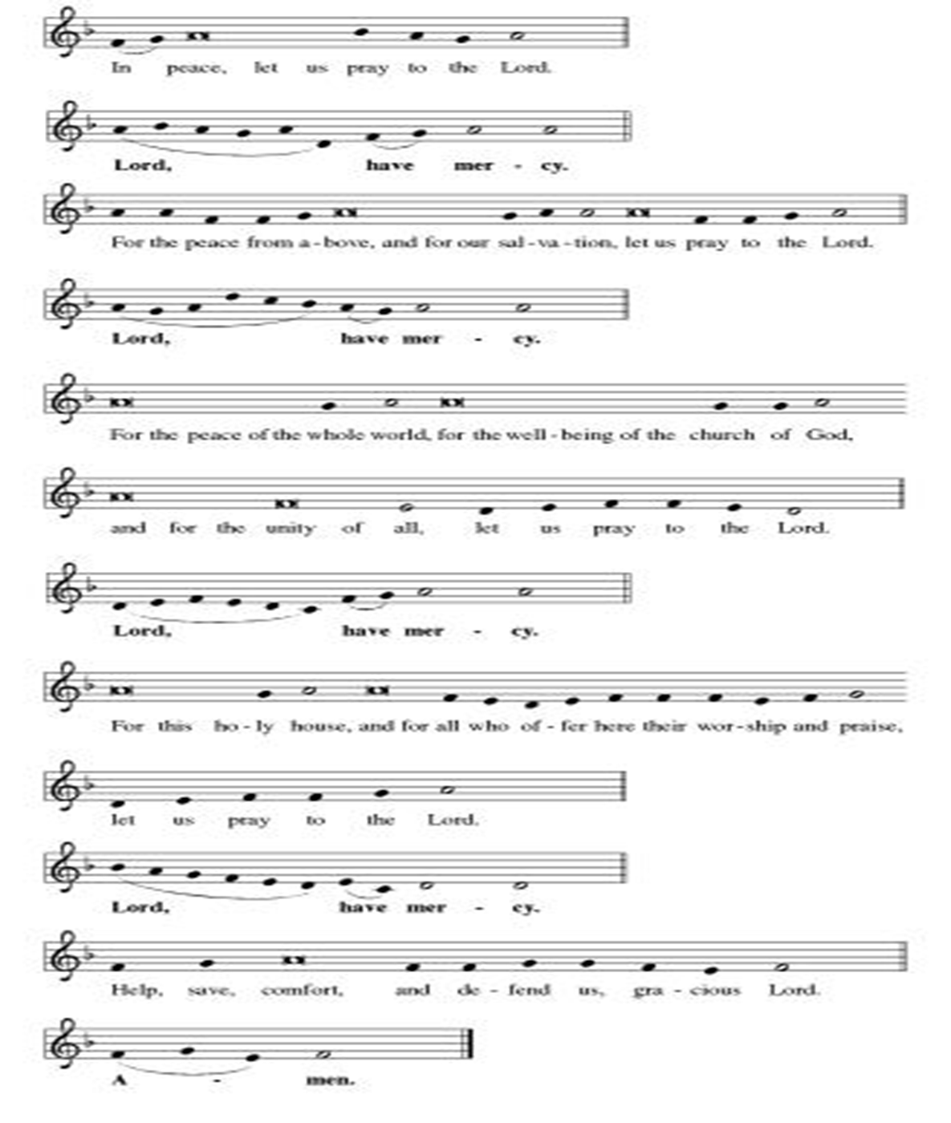
**Hymn of Praise
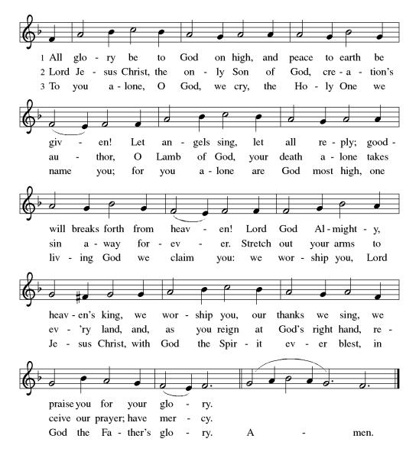
**Prayer of the Day
Loving God, you are always near to your people. Help us to sense your presence and be transformed by your good news, wherever and however we encounter it. Empower us to practice humility in our evangelism. We pray this in Jesus’ name. Amen.

Reading: Acts 17:16-34a

¹⁶As Paul waited for them in Athens, his spirit was revolted at the sight of the city given over to idols. ¹⁷So he debated in the Jewish synagogue with both the Jews and the God-fearing Greeks who worshiped there, and every day spoke in the marketplace to whomever came along. ¹⁸Even some Epicurean and Stoic philosophers argued with him. Some said, “What is this chatterbox trying to say?” Others said, “He seems to be a promoter of foreign gods,” because he was preaching about “Jesus” and “the Resurrection.”

¹⁹They invited Paul to accompany them to the Council of the Areopagus and said, “Let us learn of this new teaching you describe. ²⁰You bring some strange notions to our ears, and we would like to know the meaning of all this.” ²¹The Athenians and the foreigners living there loved talking about and listening to the latest ideas whenever they could.
²²Then Paul stood up before the council of the Areopagus and delivered this address: “Citizens of Athens, I note that in every respect you are scrupulously religious. ²³As I walked about looking at your shrines, I even discovered an altar inscribed, ‘To an Unknown God.’ Now, what you are worshiping in ignorance I intend to make known to you.

²⁴“For the God who made the world and all that is in it, the Sovereign of heaven and earth, doesn’t live in sanctuaries made by human hands, ²⁵and isn’t served by humans, as if in need of anything. No! God is the One who gives everyone life, breath—everything. ²⁶From one person God created all of humankind to inhabit the entire earth, and set the time for each nation to exist and the exact place where each nation should dwell. ²⁷God did this so that human beings would seek, reach out for, and perhaps find the One who is not really far from any of us—²⁸the One in whom we live and move and have our being. As one of your poets has put it, ‘We too are God’s children.’

²⁹“If we are in fact children of God, then it’s inexcusable to think that the Divine Nature is like an image of gold, silver or stone—an image formed by the art and thought of mortals. ³⁰God, who overlooked such ignorance in the past, now commands all people everywhere to reform their lives. ³¹For a day has been set when the whole world will be judged with justice. And this judge, who is a human being, has already been appointed. God has given proof of all of this by raising this judge from the dead.”

³²When they heard about the resurrection of the dead, some sneered, while others said, “We must hear you on this topic some other time.” ³³At that, Paul left the council. ³⁴A few women and men joined Paul and believed.

Word of God, Word of Life
Thanks be to God

**Gospel Acclamation
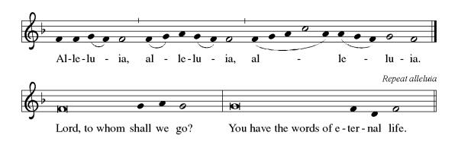
Announcement of the Gospel
Glory to you, O Lord.

Gospel: John 1:16-18

¹⁶Of this One’s fullness
we’ve all had a share—
gift on top of gift.
¹⁷For while the Law was given through Moses,
the Gift—and the Truth—came through Jesus Christ.
¹⁸No one has ever seen God;
it is the Only Begotten,
ever at Abba’s side,
who has revealed God to us.

The Gospel of the Lord.
Praise to you, O Christ.

Sermon Paul and Phil (No, Not Blixrud, Gross)

Hymn of the Day This Is My Father’s World ELW#824

**Affirmation of Faith – Immigrant’s Creed by Jose Luis Casal

I believe in Almighty God, who guided the people in exile and in exodus, the God of Joseph in Egypt and Daniel in Babylon, the God of foreigners and immigrants.

I believe in Jesus Christ, a displaced Galilean, who was born away from his people and his home, who fled his country with his parents when his life was in danger. When he returned to his own country he suffered under the oppression of Pontius Pilate, the servant of a foreign power. Jesus was persecuted, beaten, tortured, and unjustly condemned to death. But on the third day Jesus rose from the dead, not as a scorned foreigner but to offer us citizenship in God’s kingdom.

I believe in the Holy Spirit, the eternal immigrant from God’s kingdom among us, who speaks all languages, lives in all countries, and reunites all races.

I believe that the Church is the secure home for foreigners and for all believers. I believe that the communion of saints begins when we embrace all God’s people in all their diversity. I believe in forgiveness, which makes us all equal before God, and in reconciliation, which heals our brokenness. I believe that in the Resurrection God will unite us as one people in which all are distinct and all are alike at the same time. I believe in life eternal, in which no one will be foreigner but all will be citizens of the kingdom where God reigns forever and ever. Amen.

**Prayers of Intercession

God of Love, hear the prayers that we lift before you. Hold close to you all those for whom we pray.

God of glory, you have built your church on Christ the cornerstone. Inspire lay leaders, deacons, pastors, and bishops to proclaim forgiveness and your steadfast love to all whom they encounter. Merciful God,
receive our prayer.
God of majesty, you bring forth plants and animals, skies and seas, mountains and valleys. Protect all you have made from the ravages of pollution and climate disaster. Merciful God,
receive our prayer.
God of mercy, you intend governments and social service agencies to be instruments of peace and justice. Guide political leaders and organizations to be agents of compassion, and raise up advocates for those who seek refuge and assistance. Merciful God,
receive our prayer.
God of well-being, you soothe those in distress, console all who grieve, provide for any in need, and comfort those who are sick especially Monty & Marie, Paul, Helen, Linda, Betty F., Kay, Becky H., Jim & Jan, Melian, Becky W., David, Val, William & family, Judy, Peter & Carrie, Barbara & Donna, Lorey, families in our community who endure hunger, and our beloved for whom death is near. Strengthen the weary, give courage to the despairing, and comfort the dying. Instill caregivers with a sense of purpose to be your healing hands in this world. Merciful God,
receive our prayer.
God of community, you call us together as your people for mutual support and to witness to your love in the world. Make your presence known among those unable to attend worship today. Merciful God,
receive our prayer.
Pave a way to justice, drown the forces of oppression, bring peace on earth. Give leaders the will to turn from war and violence. Especially we pray for the people of Cuba & Venezuela, Iran, Sudan, Gaza, Israel, and Ukraine. When people must flee their homes, guide them to safety. Comfort those living with deep trauma, anxiety, or fear; all those who serve people in need, and accompany all those who care for people in harm’s way. We also lift up Jim’s grandson Dylan, who is deployed, and Sharon’s great nephew, Taylor, who is deployed in the Middle East. Merciful God,
receive our prayer.
We pray for people who rise up against injustice. Bring courage and resilience to those who resist tyranny with their words and their bodies. Strengthen those who fight for justice in your name across the country, and around the world. Protect and sustain immigrants and refugees and all who work with them, that your kingdom, without borders and without walls, may truly come on earth as it is in heaven. We pray for all victims of gun violence or kidnapping, especially those who are targeted out of hate or fear. Embolden us to holy outrage and empower us to speak our truth of love and justice. Merciful God,
receive our prayer.
We lift up all who teach and all who learn. Thank you for teachers who share their knowledge and wisdom. Bless the students in our midst. Especially we remember Evie, in kindergarten; Addison, in high school; and Tyler, Zach, Katie and Katy, in college. Bless Janet, Carla, and Lisa as they teach. Merciful God,
receive our prayer.
God of eternal life, you have prepared dwelling places for your people, so that we are never separated from you. We give you thanks for the faithful departed who witnessed to your mighty acts in word and deed. Merciful God,
receive our prayer.

Good and loving God, we give everyone we have prayed for into your care. Amen.

** Sharing of the Peace

**Offering is brought forward

** Offertory Response

Let Us Talents and Tongues Employ (Refrain Only) ELW#674

Blessings of CSL

**Offertory Prayer

Good and loving God, all you have created is good. Help us to be generous with that which you have first given us, so that we can respond to those who hunger in any way. As we gather now at your Table, prepare us to go out and proclaim Christ’s resurrection through what we say and do. Amen.

Dialogue
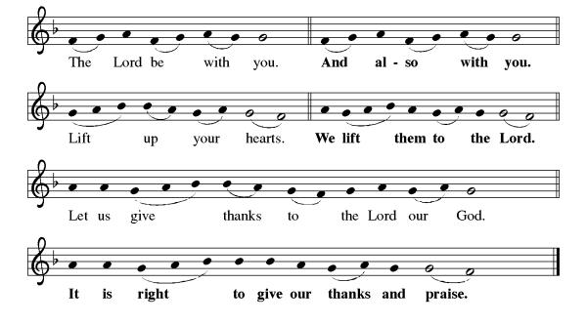
**Preface: As we celebrate Christ’s resurrection from the dead… this hymn of praise:
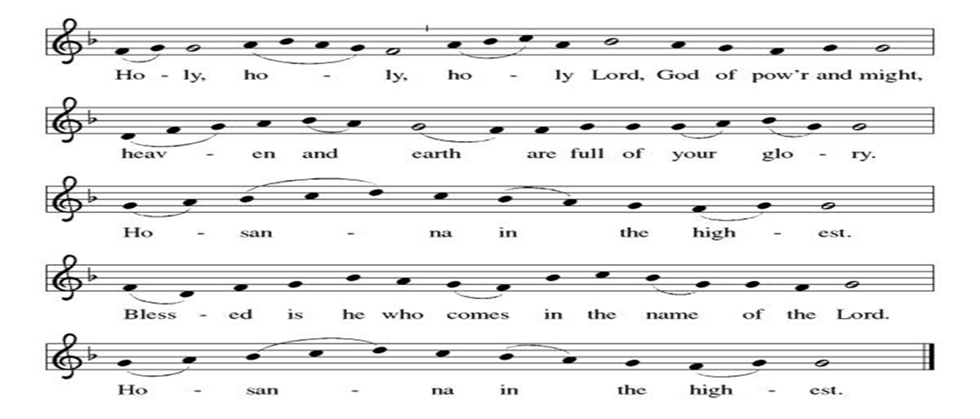
**Words of Institution

**LORD’S PRAYER
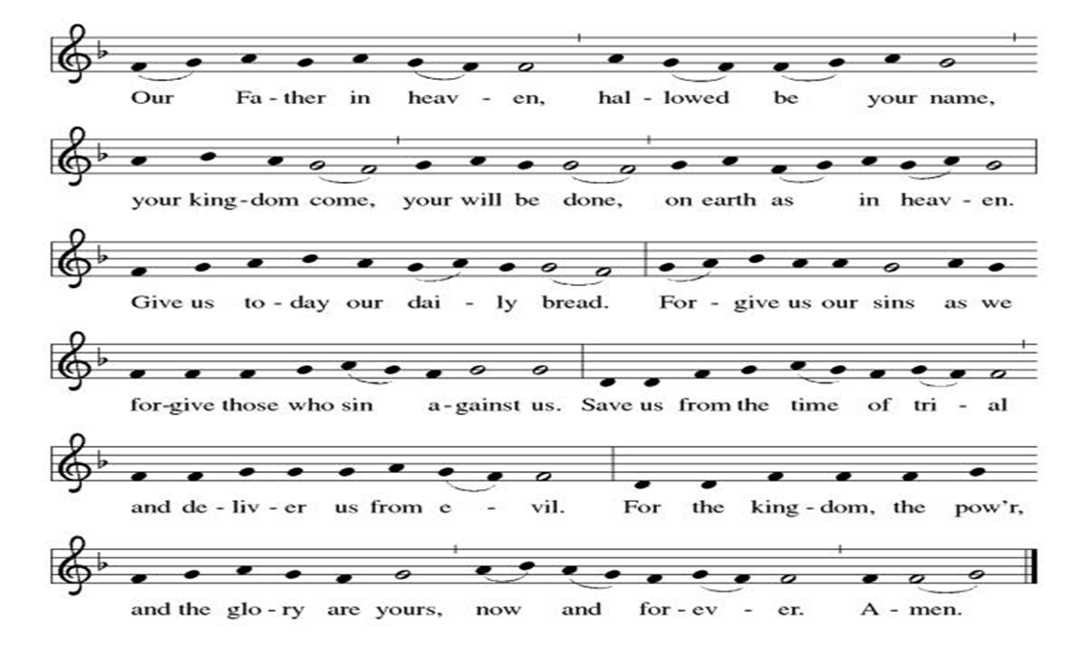

Invitation to Communion

Communion Hymn By Your Hand You Feed Your People ELW#469

**Sending Song

Now Lord ELW#201

**Prayer After Communion
Alleluia! We give you thanks, risen Lord, for your life-giving presence among us. You have fed and refreshed us with the healing gift of life. Now send us out to share the good news of the empty tomb, through all that we say and do. Amen! Alleluia!

**Blessing

**Closing Hymn Now Thank We All Our God ELW#840

**Dismissal

Go in peace to serve our Risen Christ. Alleluia!
THANKS BE TO GOD!

+ + + + + +

Hymns from Setting 05 and the Evangelical Lutheran Worship are under copyright and used with permission under One License #733618-A. Specific copyright information as listed in bulletin, the Prayers of Intercession are under copyright and are used with permission under Augsburg Fortress Liturgy License #SB155933. All other liturgy written by Sarah Pierce.
Weekly Attendance

Week of April 26
25

******************************************************************************************

Calendar of Events

Today
- Christian Nationalism Part 2

This Week
May 05 | Creative Friends
May 06 | Paint Party Fundraiser
May 09 | Men’s Breakfast IHOP

Upcoming Events

May 10 | Baptismal Sunday  Mother’s Day
May 12 | Creative Friends
May 13 | Church Council Meeting 6:30 pm
May 17 | Congregational Meeting after worship
May 19 | Creative Friends
May 20 | Newsletter Deadline
May 23 | Project Comfort 9:00 am-Noon
May 24 | Pentecost  Vigil 7:00 pm
May 25 | Memorial Day
May 26 | Creative Friends
May 31 | Fifth Sunday Conversation
June 03 | Paint Party Fundraiser
June 07 | View Christian Nationalism part 3  Ice Cream Social
June 19 | Juneteenth Office Closed
June 21 | Father’s Day
June 28 | Coffee with Council
July 01 | Paint Party Fundraiser
July 04 | Independence Day
July 26 | Coffee with Council  Celebrate Niel’s Birthday (July 28)
September 13 | God’s Work. Our Hands.

Note: 2026 paint party fundraisers: May 6, June 3, July 1, Aug. 5, Sept. 2, Oct. 7, Nov. 4, Dec. 2

Thank you all again for the generous Christmas gift! It always takes some time for us to decide what we'll do with the gift, and this year we have a once-in-a-lifetime opportunity. My sister called a couple of weeks ago to say that her colleague has 4 tickets to the Netherlands - Tunisia World Cup game at Arrowhead that he's not going to be able to use, and he wondered if she would be interested. So, she invited Rebecca and I to go along with her and her husband. We love live sporting events, so we were eager to say yes! Pastor Sarah
*****************************************************************************
Pastor Sarah Questions:

- If you’re interested to do a comparison of how Paul preaches into his context, compare this text with Acts 13:14-41, when Paul and his companions are in Antioch in Pisidia. There, he’s preaching in a synagogue, to people who are very familiar with the Hebrew Scriptures, so his entire sermon references this history and places Jesus within David’s lineage and within that story. In this text, notice that Paul doesn’t mention Jesus by name as he’s speaking before the council – the only mention of Jesus is when the Stoics and Epicureans are talking about him. Why don’t you think he mentions Jesus by name when speaking to the council?
- Paul draws on Athenian cultural traditions in his speech: “the One in whom we live and move and have our being” is a statement that, by this point, is probably 5 centuries old and was first said to refer to Zeus, by a Cretan philosopher. It has become just a commonly said phrase by this point – not a cliché, because it still holds meaning. And Paul uses it because it means something to him too; it’s a phrase that speaks across cultures. And “We too are God’s children” is a line from a Greek poem from the 3rd century BCE.
- The Stoics probably were the ones who had a tendency to agree with what he was saying; at least until verse 28, Paul is speaking in pretty broad generalities that anyone who believes in a benign divine power would have a hard time disagreeing with. The Epicureans, on the other hand, who didn’t believe in ANY kind of divine power, thought he was full of nonsense. They were most likely the ones having a hard time with what he was saying.
- But he’s pushing back against the idea that the gods, or God, at least, demands some kind of divine reciprocity for accidentally stumbling into some religious taboo or something of the sort, as he starts to talk about the need for repentance (which our translation translates as “reform[ing] their lives”) and Jesus as a “judge, who is a human being” who has been raised from the dead. I love the idea of repentance as reforming our lives!
- One of the podcasts I watched this week features the pastor of The Riverside Church in NYC, a progressive Baptist church. She talked about over the past several years as she has engaged in more and more social justice work, she’s gotten to know her non-Christian neighbors better and better. She spoke particularly about Jews and Muslims and even a little bit about Hindus, and she commented that they are devout in every way – from the food they eat to the way they dress, to (for some people) answering calls to prayer several times a day. She commented that many Christians tend to wear our faith much more lightly, as though it were an intellectual exercise rather than an embodied thing. I’m not sure I accept that premise, although I think I do agree that there are other faiths that call adherents to be more devout. How do we embody our faith? How do we live it out with our bodies, with our lives, and not just with the things we think or say?

******************************************************************************************
BLUE SPRINGS COMMUNITY SERVICE LEAGUE is very appreciative of your continued support of your neighbor.
Birthdays
May 09-Paul Blixrud

May 03
Altar Guild – Mary Ann Gross & Donna Taylor
Lector – Kent Deubner
Communion Assistant – Flavia Via
Greeter – Donna Taylor
Usher-Paul Blixrud
Tech – Gary Antes

Prayer Requests
Monty & Marie Health Concerns (Maech 04)
Paul Health Concerns (May 31)
Mary Health Concerns (May 15)
James & Family Health Concerns (September 11)
Betty F (Sara’s friend) Health Concerns (July 15)
William and Family Health Concerns (September 25)
Becky H Health Concerns (October 28)
David Health Concerns (November 18)
Becky W Health Concerns (November 18)
Judy Health Issues (December 16)
Kay (Sara’s cousin) Health Concerns (July 15)
Sharon Health Concerns (October 22)
Michael Health Concerns (October 22)
Peter and Carrie Health Concerns (November 26)
Melian Health Concerns (November 16)
RJ Health Concerns (November 17)
Barbara Health Concerns (December 30)
Helen Health Concerns (February 25)
Val (Tonya’s sister) Health Concerns (February 18)
Lorey Health Concerns (April 14)

Merciful God, your justice and mercy are without limits. Bring courage and resilience to those who resist tyranny with their words and their bodies. Strengthen those who fight for justice in your name across the country, and around the world.

Please pray for the people of Venezuela & Iran, Sudan, Gaza, Ukraine, Israel, Cuba, Iran and Palestine.
Please pray for the Homeless.
Please pray for legal & illegal immigrants & those seeking asylum or citizenship

