All Saints Lutheran Church, ELCA
421 SW 19th St. Blue Springs, Missouri 64015 816-229-3633
Pastor Sarah Pierce Spierce.aslcpastor@gmail.com
allsaintslc64015@gmail.com https://aslcbs.org/

Sunday, August 02, 2026

Tenth Sunday after Pentecost

You are absolutely invited into this sacred space. We welcome all who are seeking God’s love and grace. All Saints recognizes that we are all unique and beloved children of God. We celebrate and give thanks for the many diverse gifts that God has given us. We affirm the sacredness of people of all sexual orientations, gender identities, and gender expressions. We affirm the sacredness of all those who have experienced exclusion because of race, ability, age, or culture. We are committed to working towards anti-racism in ourselves and our community. We affirm the sacredness of all those who wrestle with addiction, physical or mental health, imprisonment, socio-economic circumstances, or anything that too often divides us. We believe that through our openness we all grow in our faith through Christ’s teaching to love one another as God loves us. We need each other and our sincere hope is by being in community together, we will experience God’s presence in new and real ways.

The offering plate is by the main door to the sanctuary for your convenience.

We practice open communion at All Saints Lutheran Church. What does that mean? It means that if you believe and trust that Christ offers his body and blood For You, you are welcome at the table. At All Saints, we believe that Christ invites all people to the feast. “Come to the banquet for all is now ready.”

**Stand as you are comfortable

Note: Bold Print: Congregational Statements

Prelude

Announcements

** Confession and Forgiveness

The God that we worship is complex, multi-faceted, a single God made up of three Persons. When we try to understand the fullness of God, we fail. But God knows us and loves us and wants to be in relationship with us, so God is constantly finding new ways to be present with us. But sometimes, we fall short in our awareness. When that happens, we find that we have turned away from God to the idols of our own making.

Let us confess our sins together, as a community.

God of All the Cosmos,
Sometimes we try to make you small.
We try to put you in a box,
confine you to our way of understanding.
God, sometimes we misunderstand what you tell us.
Inspire us, Holy Spirit, to remember that you are beyond definition.
Help us to remember that you cannot be made small.
Help us to think deeply about who you are
and to respect and honor other people’s experiences of you.
Beloved in Christ, the God who walks beside you
is the same God who brings peace passing all understanding.
The Spirit who inspires your knowledge of the presence of God
is the same Spirit who moves over the waters of creation.
The Christ who hears your prayers
is the same Christ + who defeated death for the forgiveness of all sin, for all time.
Be at peace, for your sins are forgiven.

Amen.

**Entrance Hymn Children of the Heavenly Father ELW#781

**Greeting
The grace of our Lord Jesus Christ, the love of God,
and the communion of the Holy Spirit be with you all.
And also with you.

**Kyrie ELW 513
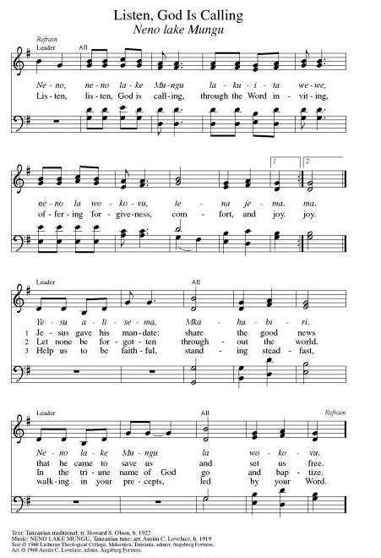
**Hymn of Praise ELW 866
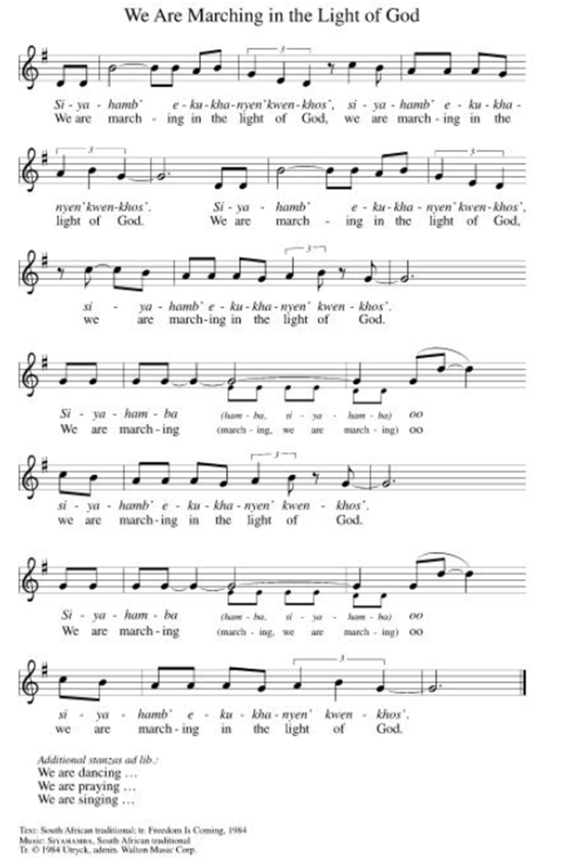

**Prayer of the Day
Jesus, you invite us to your Table to share in the feast you have set before us. Help us to remember that you have invited us and found us worthy to share in the new covenant, and empower us to welcome all your beloved children to the Table in your name. Amen.

Reading: 1 Samuel 21:1-9

¹David came to Nob, to the priest Ahimelech; the trembling cleric met David with, “Why are you alone? Shouldn’t you be accompanied?”

²David answered Ahimelech, “I am under orders from the ruler that my mission be carried out alone and in secret. When I took leave of my troops I told them to meet me at a certain place. No one is to know about your mission or your instructions. ³Now then, I need five loaves, or whatever you can spare.”

⁴Ahimelech said, “I am out of ordinary bread. There is some consecrated bread here; but are your troops ritually pure?”

⁵David replied, “Because we are on a campaign, my young troops are ritually pure; and they will be much holier today!”

⁶So the priest gave five consecrated loaves to David which had been removed from the presence of God and replaced by hot bread on the day it was removed. ⁷One of Saul’s attendants, Doeg the Edomite, the ruler’s chief shepherd, was detained there before God and saw what David did.

⁹David said to Ahimelech, “Do you have a spear or a sword here? I am without my own weapons because the ruler’s business was urgent.”

⁹The priest replied, “The sword of Goliath the Philistine, whom you killed in the Valley of Elah, is here. It is wrapped in a cloth behind the ephod. Take it if you need it. It is the only one here.”

David said, “There is none like it. I will take it.”

Word of God, Word of Life
Thanks be to God

**Gospel Acclamation ELW 519
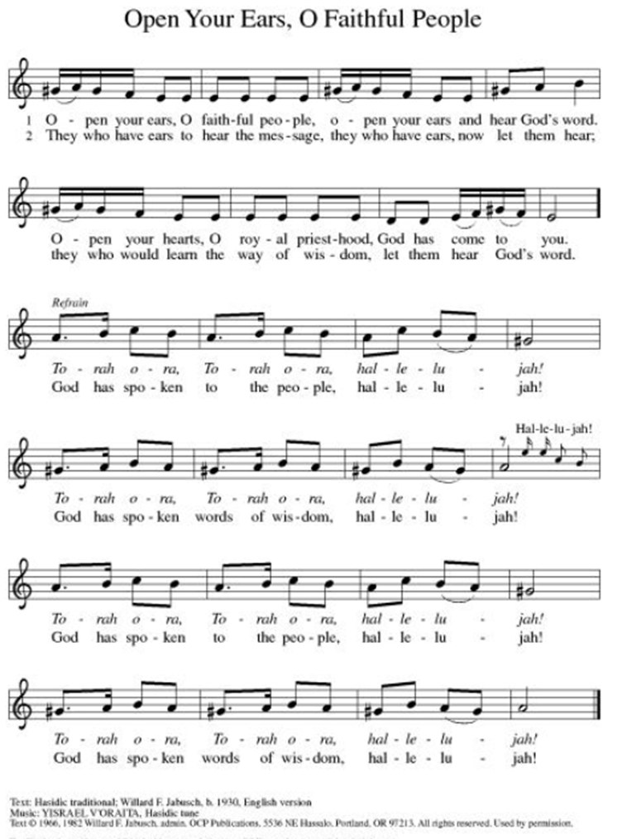
Announcement of the Gospel
Glory to you, O Lord.

Gospel: Mark 14:12-25

¹²On the first day of the Feast of Unleavened Bread, when it was customary to sacrifice the paschal lamb, the disciples said to Jesus, “Where do you want us to prepare the Passover supper for you?”

¹³He directed two of the disciples and said to them, “Go into the city, and you will come upon a man carrying a water jar. Follow him ¹⁴into a house he enters and say to the owner, ‘The Teacher asks, “Where is my guestroom? I want to eat the Passover meal there with my disciples.”’ ¹⁵Then you will be shown an upstairs room, spacious, furnished, with everything in order. That is the place you are to get ready for us.”

¹⁶Then the disciples went off. When they reached the city, they found it just as Jesus had told them, and they prepared the Passover supper.

¹⁷As it grew dark, Jesus arrived with the Twelve. ¹⁸They reclined at table, and in the course of the meal Jesus said, “The truth is, one of you is about to betray me – one who is eating with me.”

¹⁹They were very upset at these words, and one by one they said to him, “Surely it’s not me!”

²⁰Jesus replied, “It is one of you Twelve – one who dips into the dish with me. The Chosen One is going the way the scriptures foretell. But woe to the one by whom the Chosen One is betrayed! It were better had that person never been born.”

²²During the meal Jesus took bread, blessed and broke it, and gave it to them saying, “Take and eat. This is my body.” ²³He likewise took a cup, gave thanks and passed it to them, and they all drank from it. ²⁴Jesus said to them, “This is my blood, the blood of the Covenant, which will be poured out on behalf of many. ²⁵The truth is, I will never again drink of the fruit of the vine until the day I drink it anew in the kingdom of God.”

The Gospel of the Lord.
Praise to you, O Christ.

Sermon "Life and Death"

Hymn of the Day Lord, Who the Night You Were Betrayed ELW#463

**Affirmation of Faith – Immigrant’s Creed by Jose Luis Casal

I believe in Almighty God, who guided the people in exile and in exodus, the God of Joseph in Egypt and Daniel in Babylon, the God of foreigners and immigrants.

I believe in Jesus Christ, a displaced Galilean, who was born away from his people and his home, who fled his country with his parents when his life was in danger. When he returned to his own country he suffered under the oppression of Pontius Pilate, the servant of a foreign power. Jesus was persecuted, beaten, tortured, and unjustly condemned to death. But on the third day Jesus rose from the dead, not as a scorned foreigner but to offer us citizenship in God’s kingdom.

I believe in the Holy Spirit, the eternal immigrant from God’s kingdom among us, who speaks all languages, lives in all countries, and reunites all races.

I believe that the Church is the secure home for foreigners and for all believers. I believe that the communion of saints begins when we embrace all God’s people in all their diversity. I believe in forgiveness, which makes us all equal before God, and in reconciliation, which heals our brokenness. I believe that in the Resurrection God will unite us as one people in which all are distinct and all are alike at the same time. I believe in life eternal, in which no one will be foreigner but all will be citizens of the kingdom where God reigns forever and ever. Amen.

Affirmation of Baptism

People of God, you have made a public profession of your faith. Do you intend to continue in the covenant God made with you in your baptism:
To live together as God’s faithful people with all the body of Christ;
To listen to the Word preached and taught, and to answer Jesus’ invitation to the Table;
To proclaim the good news: that in Christ, we are set free to love and serve our neighbor, through our words and our actions; To serve our neighbors in our community and around the world, striving always to follow Jesus’ example to the best of our abilities;
And to work for God’s justice and the peace that is beyond our understanding, throughout creation?

I do, and I ask God to help and guide me.

People of God, do you promise to support and pray for one another in your life in Christ?

We do, and we ask God to help and guide us.

Let us pray. Loving God, through water and the Holy Spirit you give us new birth, cleanse us from sin, and raise us to eternal life. Stir up in all your people the gift of your Holy Spirit: the spirit of wisdom and understanding, the spirit of counsel and strength, the spirit of knowledge and the reverence for our God, that we ay delight in your presence now and forever.
Amen.

**Prayers of Intercession

Holy God, our prayers rise to you like the wings of a dove. We call upon your name, and we ask that you hear us.

For your church in every place, that it satisfies those who hunger for your word. Bless the ministry of readers, translators, Bible study leaders, and writers, that God’s word is broken open and shared with all. Merciful God,
receive our prayer.
For your wondrous creation and all the bounty it provides, that your creatures are fed and nourished. Bless the work of farmers, farmworkers, those who fish, and all whose labor brings your abundance to our tables. Merciful God,
receive our prayer.
For your children in every nation, that they learn to love justice and live in harmony. As this week we remember the atomic bombings of Hiroshima and Nagasaki, keep us mindful of the horrors of war; draw our hearts instead toward your reign of love, hope, and peace. Merciful God,
receive our prayer.
For all who cry out with great sorrow and unceasing anguish, that they are comforted. Feed all who struggle with food insecurity; have mercy on all who are suffering in body, mind, and spirit especially for Monty & Marie, Paul, Helen, Linda, Betty F., Kay, Becky H., Jim & Jan, Melian, Becky W., David, Val, William & family, Judy, Peter & Carrie, Barbara & Donna, and Brad & Chris. Merciful God,
receive our prayer.
For this congregation, that it bears faithful witness to the abundance and joy of life in you. Bless all your faithful people gathered here, that they may become blessings for this community. Merciful God,
receive our prayer.
Pave a way to justice, drown the forces of oppression, bring peace on earth. Give leaders the will to turn from war and violence. Especially we pray for the people of Cuba, Venezuela, Iran, Sudan, Gaza, Israel, and Ukraine. When people must flee their homes, guide them to safety. Comfort those living with deep trauma, anxiety, or fear; all those who serve people in need, and accompany all those who care for people in harm’s way. We also lift up Jim’s grandson, Dylan, who is deployed, and Sharon’s great nephew, Taylor, who is serving in the military. Merciful God,
receive our prayer.
We pray for people who rise up against injustice. Bring courage and resilience to those who resist tyranny with their words and their bodies. Strengthen those who fight for justice in your name across the country, and around the world. Protect and sustain immigrants and refugees and all who work with them, that your kingdom, without borders and without walls, may truly come on earth as it is in heaven. We pray for all victims of gun violence or kidnapping. Embolden us to holy outrage and empower us to speak our truth of love and justice. Merciful God,
receive our prayer.
With thanksgiving for the faithful who now rest in your mercy, that their witness continues to inspire the church. By their example, may we trust your promises in life and in death. Merciful God,
receive our prayer.

Good and loving God, we give everyone we have prayed for into your care. Amen.

** Sharing of the Peace

**Offering is brought forward

** Offertory Response ELW486

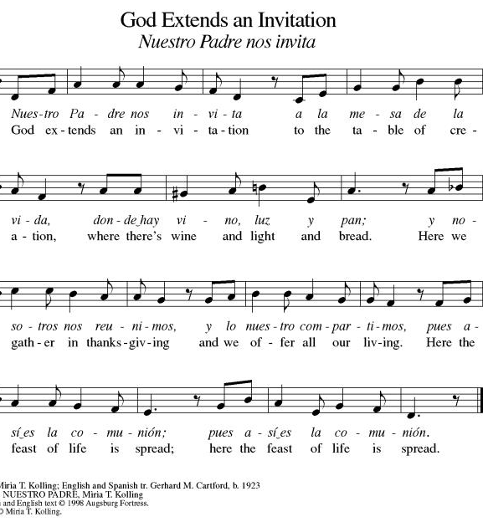

Blessing of CSL Gifts

**Offertory Prayer
Jesus, all that we have and all that we are comes from you. Thank you for the gifts you have given us. Receive these gifts – our money, our service, our time – which we give in gratitude for all that we have received from you. Amen.
Dialogue
Christ is with you!
And also with you!
Lift up your hearts in joyful praise!
We lift them up to God in joy!

**Preface: We give thanks and praise to God...this hymn of praise:
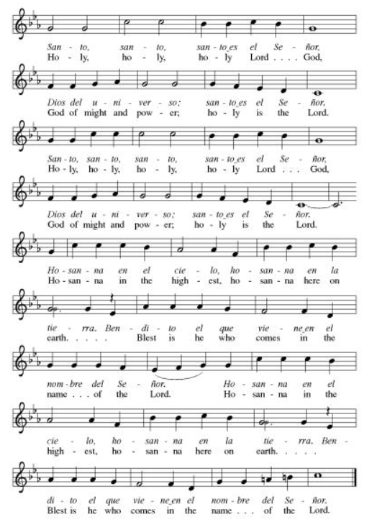
**Words of Institution

**LORD’S PRAYER
You are invited during this Pentecost season to pray whichever version feels most comfortable on your lips and in your soul. A separate sheet is available with alternate versions, should you be interested. Or, you are invited to use one of these:
Our Father in heaven, Our Father, who art in heaven,
hallowed be your name, hallowed be thy name,
your kingdom come, thy kingdom come,
your will be done, thy will be done,
on earth as in heaven. on earth as it is in heaven.
Give us today our daily bread. Give us this day our daily bread;
Forgive us our sins and forgive us our trespasses
as we forgive those as we forgive those
who sin against us. who trespass against us;
Save us from the time of trial and lead us not into temptation,
and deliver us from evil. but deliver us from evil.
For the kingdom, the power, For thine is the kingdom,
and the glory are yours, and the power, and the glory,
now and forever. Amen. forever and ever. Amen.

Invitation to Communion

Communion Hymn Eat This Bread, Drink This Cup ELW#492

**Sending Song ELW 535

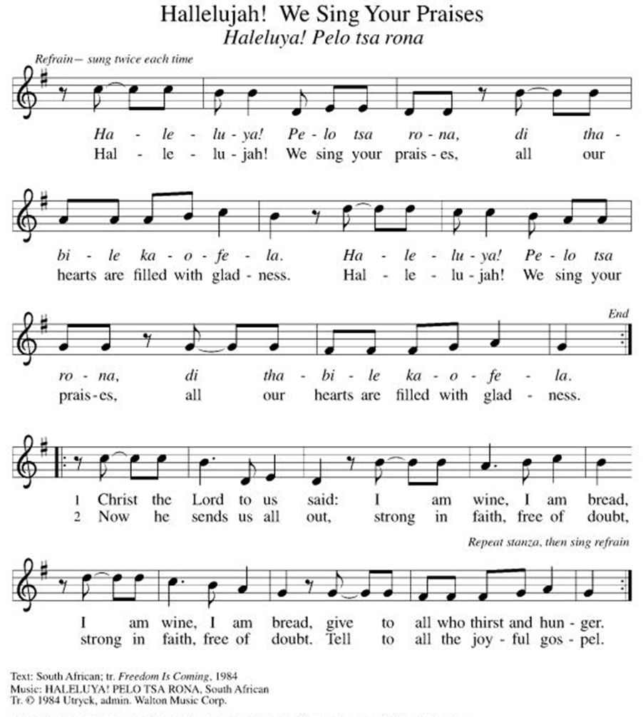

**Prayer After Communion
Holy God, you love us so much that you transformed an act of destruction into an act that gives new life. Thank you for the renewal we receive at your Table, as you send us out from this place into the world. Strengthen us for your service. In Jesus’ name we pray. Amen.

**Blessing

**Closing Hymn Softly and Tenderly Jesus Is Calling ELW#608

**Dismissal
Empowered by the Spirit, may you go in peace to share the gospel!
THANKS BE TO GOD!

+ + + + + +

Setting 07 and hymns from the Evangelical Lutheran Worship are under copyright and used with permission under One License #733618-A. Specific copyright information as listed in bulletin, the Prayers of Intercession are under copyright and are used with permission under Augsburg Fortress Liturgy License #SB155933. All other liturgy written by Sarah Pierce.
Weekly Attendance

Week of July 26:
36
******************************************************************************************

Next Week:
11th Sunday after Pentecost:
Psalm 34:1-10
John 6:1-15

John 4:1-14
The color of the day is Green

Calendar of Events

Today
- Blessing of CSL Gifts

This Week
August 04 | Creative Friends 1:00 pm
August 08 | Men’s Breakfast 8:00 am

Upcoming Events

August 09 | Baptismal Sunday
August 11 | Creative Friends 1:00 pm
August 18 | Creative Friends 1:00 pm
August 19 | Council Meeting 6:30
August 20 | Newsletter Deadline
August 22 | Project Comfort 9:00 am-Noon
August 23 | Coffee with Council
August 25 | Creative Friends 1:00 pm
August 30 | Fifth Sunday Conversation
September 09 | Bell’s Practice 6:30 pm
September 13 | God’s Work. Our Hands.
September 23 | Council Meeting 6:30 pm
September 27 | Celebration 5th year Anniversary of Pastor’s Ordination
October 03 | Blessing of Animals
October 25 | Reformation Sunday
November 01 | Healing for World
November 25 | Pie Night 7:00 pm
November 26  November 27 | Thanksgiving - Office Closed

SYNOD CONFIRMATION

As announced during the recent conference gatherings and synod assembly, the Central States Synod is putting together synod-wide confirmation. Details are in the works, but here are the basics. . .

  - Classes will run from September 3 through April 15. We will meet via Zoom from 6:30 – 7:45 pm on the 1st & 3rd Thursdays.
  - We will be on a two-year cycle. One year will be a Catechism year, and one will be a Bible year. We will be starting this fall with the Catechism year.
  - Anyone of any age can participate. (It's not just for students)
  - Each student will receive a Confirmation Kit containing items that will be used throughout the year.
  - There will be a weekly homework assignment.
  - Participants will be connected via GroupMe. Parents will need to give permission for this.
  - There will be some in-person retreats and/or camps offered along the way to connect in person with the other students.
  

As we prepare, we are hosting orientation meetings for parents, pastoral leaders, and students. We will talk about expectations, logistics, and answer your questions. If you are thinking of participating in the synod confirmation, please join us for one of two sessions, to be held on August 13 and August 20 at 6:30. Ask Pastor Sarah for the link or go to
https://www.css-elca.org/workshops#confirmation to register.

******************************************************************************************

Pastor Sarah Questions:

Questions for Reflection and Discussion

- Jesus dies during the Jewish feast of liberation from Egypt, which is significant. The last meal he eats with his disciples is Passover, but Passover followed a specific ritual, and Jesus did something new when he shared the bread and the wine with them, speaking words that are similar to (but not identical with) the words that we speak during our celebration of communion. It’s interesting to compare the Last Supper stories from the 3 synoptic gospels (Matthew, Mark, and Luke); the overarching story is the same, but the details are slightly different.
- One of the commentators that I read this week linked this passage in Mark with Mark 8:34-35 (to follow Jesus, we must deny him, take up our cross, and follow; if we want to save our life, we’ll lose it, if we lose our life we’ll save it); probably because Jesus is on his way to the crucifixion. Another commentator I read had critical things to say about the way the Mark 8 passage is often interpreted generally to say that suffering and oppression, especially because this interpretation leads to legitimate concerns and we shouldn’t just put up with dangerous or uncomfortable situations. That commentator goes on to point out that a cross is a very specific form of suffering, the punishment imposed by the government in Rome for the rebels and troublemakers who challenged the might and authority of Rome. That’s a very different, very specific kind of suffering that Jesus calls us to, for the good of ourselves and the world.
- Our communion with Jesus, even today, is incomplete and anticipatory. I tell a story in my sermon about a time when I was particularly moved by serving communion, maybe the first time that I felt something soul-deep when serving communion. And I think that, as a symbol of the way the eucharist binds us to Jesus and to each other, it’s important for me to use names when I serve communion; I’m sure you’ll have noticed that I do that. When we have visitors, I ask their names when they come up to receive communion, specifically so I can do that. But it is incomplete. It’s a foretaste of the feast to come. That’s why continue to proclaim Jesus’ death until he comes.
- I don’t say much about the 1 Samuel text in my sermon – I just touch on it briefly. I didn’t take many notes on it when I was doing my sermon prep, but one point that I thought was interesting was the question of ritual purity (verse 4) apparently related only to abstinence from intercourse while on a military campaign. The priest and David may or may not have been breaking any rules when Ahimelech gave David the bread, but a commentator pointed out that setting aside important rules or conventions is possible, and even the right thing to do under certain circumstances, but not for our own convenience. This was one of those circumstances, as David was acting in the best interests of the country and needed to keep his troops fed.

******************************************************************************************
BLUE SPRINGS COMMUNITY SERVICE LEAGUE is very appreciative of your continued support of your neighbor.
Birthdays
August 02-Marie Benz

August 02
Reader – Tonya Hamilton
Altar Guild – Mary Ann Gross & Donna Taylor
Greeter – Donna Taylor
Usher-Paul Blixrud
Tech – Gary Antes

Prayer Requests
Monty & Marie Health Concerns (March 04)
Paul Health Concerns (May 31)
Mary Health Concerns (May 15)
James & Family Health Concerns (September 11)
Betty F (Sara’s friend) Health Concerns (July 15)
William and Family Health Concerns (September 25)
Becky H Health Concerns (October 28)
David Health Concerns (November 18)
Becky W Health Concerns (November 18)
Judy Health Issues (December 16)
Kay (Sara’s cousin) Health Concerns (July 15)
Sharon Health Concerns (October 22)
Michael Health Concerns (October 22)
Peter and Carrie Health Concerns (November 26)
Melian Health Concerns (November 16)
RJ Health Concerns (November 17)
Barbara Health Concerns (December 30)
Helen Health Concerns (February 25)
Val (Tonya’s sister) Health Concerns (February 18)
Chris Health Concerns (June 09)

Merciful God, your justice and mercy are without limits. Bring courage and resilience to those who resist tyranny with their words and their bodies. Strengthen those who fight for justice in your name across the country, and around the world.

Please pray for the people of Venezuela & Iran, Sudan, Gaza, Ukraine, Israel, Cuba, Iran and Palestine.
Please pray for the Homeless.
Please pray for legal & illegal immigrants & those seeking asylum or citizenship

