All Saints Lutheran Church, ELCA
421 SW 19th St. Blue Springs, Missouri 64015 816-229-3633
Pastor Sarah Pierce Spierce.aslcpastor@gmail.com
allsaintslc64015@gmail.com https://aslcbs.org/

Sunday, October 12, 2025

Eighteenth Sunday after Pentecost

You are absolutely invited into this sacred space. We welcome all who are seeking God’s love and grace. All Saints recognizes that we are all unique and beloved children of God. We celebrate and give thanks for the many diverse gifts that God has given us. We affirm the sacredness of people of all sexual orientations, gender identities, and gender expressions. We affirm the sacredness of all those who have experienced exclusion because of race, ability, age, or culture. We are committed to working towards anti-racism in ourselves and our community. We affirm the sacredness of all those who wrestle with addiction, physical or mental health, imprisonment, socio-economic circumstances, or anything that too often divides us. We believe that through our openness we all grow in our faith through Christ’s teaching to love one another as God loves us. We need each other and our sincere hope is by being in community together, we will experience God’s presence in new and real ways.

The offering plate is by the main door to the sanctuary for your convenience.

We practice open communion at All Saints Lutheran Church. What does that mean? It means that if you believe and trust that Christ offers his body and blood For You, you are welcome at the table. At All Saints, we believe that Christ invites all people to the feast. “Come to the banquet for all is now ready.”

**Stand as you are comfortable

Prelude

Bells Holy, Holy, Holy

Announcements

Baptism Birthdays
October 22-Addison Antes
October22-ZacharyAntes

** Confession and Forgiveness

God who created the heavens, the earth, and all that exists, sometimes we feel small when we stand before you. But we trust that you see and hear us when we come to you.

Let us take a moment to draw near to God.

Holy God,
You always listen to us when we pray.
Forgive us when we forget to center our lives around you.
Forgive us when we turn away, distracted by other things that delight or distress us.
Forgive us when we sin against you, scorning the promises you have made to us.
Help us remember that you are always the solid foundation on which we stand.
Remind us, your children, to turn back to you.
Beloved children of God, the Spirit moves among us, bringing comfort and renewal. Our Creator, the Source of all that is good and holy, is making all things new. And in Jesus, our Savior +, we find the promise of forgiveness and mercy.

Amen.

**Entrance Hymn Come, Thou Fount Of Every Blessing ELW #807

**Greeting
The grace of our Lord Jesus Christ, the love of God,
and the communion of the Holy Spirit be with you all.
And also with you.

**Kyrie
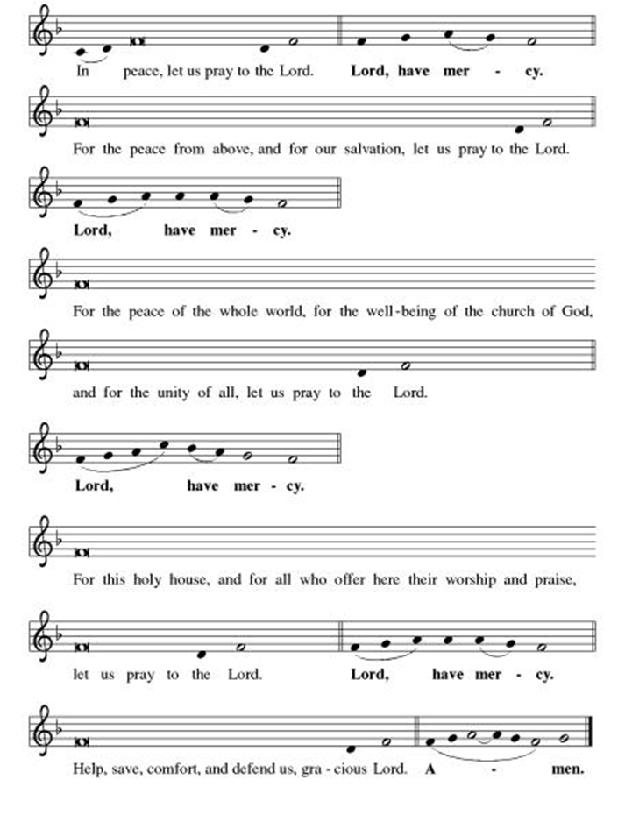
**This is the Feast
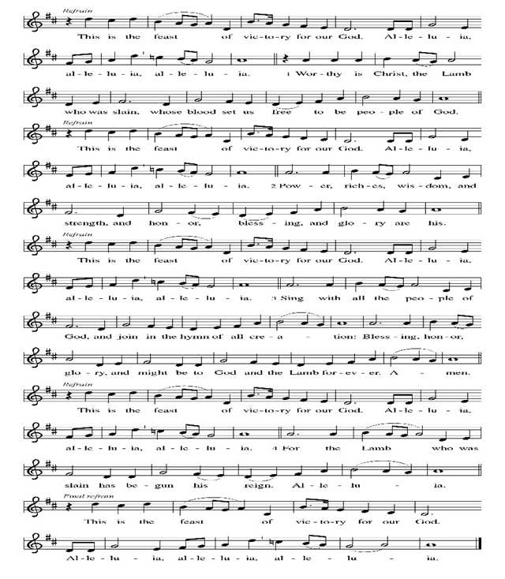
**Prayer of the Day

Gracious God, as your children, baptized into your church and given the gift of your Spirit, we know that you call us to serve you. Help us listen to you, and empower us to use our gifts for your service. We pray this in Jesus’ name. Amen.

Bells Beautiful Savior

Reading: 1 Samuel 3:1-21

¹Now young Samuel was in the service of God under Eli. In those days, the voice of God was rarely heard—prophesy was uncommon. ²One night Eli, whose eyes had grown so weak that he could no longer see, was sleeping in his bed. ³The lamp of God had not gone out, and Samuel was sleeping in the Tent of Meeting, near the Ark of the Covenant.

⁴Then God called to Samuel.

Samuel answered, “Here I am!” ⁵and ran to Eli saying, “You called. Here I am!”

Eli said, “I didn’t call you. Now go back to sleep.” He went back to sleep.

⁶A second time, God called Samuel, and he got up and went to Eli.

“Here I am!” Samuel said, “You called me.”

Eli repeated, “I did not call you. Go back to sleep.”

⁷At that time Samuel had not yet encountered God, and the word of God had not yet been revealed to him.

⁸God called Samuel a third time, and Samuel got up, went to Eli, and said once more, “Here I am. You called me.”

⁹Then Eli realized that God was calling the boy.

So he said to Samuel, “Go back and go to sleep, and if you are called, say, ‘Speak, God, for your servant is listening.’” So Samuel went back to sleep.

¹⁰And God called, “Samuel! Samuel!”

And Samuel replied, “Yes, God, I am listening.”

¹¹Then God said to Samuel, “I am going to do things in Israel that will make the ears of all who hear about them ring. ¹²I am going to fulfill all the dreadful things I told Eli I would do against his family—from the beginning to the end. ¹³You are to tell Eli that I condemn his family forever because he knew of the blasphemies of his sons against God which he ignored. ¹⁴Therefore, I swear it to the house of Eli, neither sacrifice nor offering will ever expiate the guilt of the House of Eli.”

¹⁵Samuel lay down to rest till morning, when he opened the doors of the Tent of Meeting. He feared to tell Eli about the vision, ¹⁶but Eli called to Samuel, who answered, “Here I am.”

¹⁷“Samuel, come here, what did God say to you? Don’t hide it from me. May God curse you if you conceal from me one word of what you were told.”
¹⁸Then Samuel told Eli everything, concealing nothing. Eli said, “God reigns. God will do what must be done.”

¹⁹As Samuel grew, God was with him. None of Samuel’s words remained unfulfilled. ²⁰From Dan to Beersheba, all Israel recognized that Samuel was a prophet of God.

²¹God continued to appear in Shiloh, for Samuel first encountered God there.

Word of God, Word of Life
Thanks be to God

**Gospel Acclamation
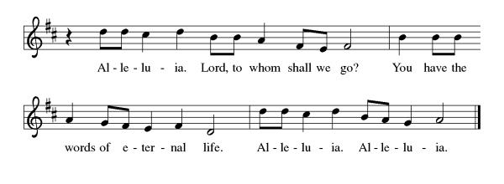
Announcement of the Gospel
Glory to you, O Lord.

Gospel John 20:21-23

²¹[Jesus] said to them again, “Peace be with you. As Abba God sent me, so I’m sending you.” ²²After saying this, Jesus breathed on them and said, “Receive the Holy Spirit. ²³If you forgive anyone’s sins, they are forgiven. If you retain anyone’s sins, they are retained.”

The Gospel of the Lord.
Praise to you, O Christ.

Sermon "The Stewardship Sermon About Talent"
Hymn of the Day Here I Am, Lord ELW#574

**Affirmation of Faith – Immigrant’s Creed by Jose Luis Casal

I believe in Almighty God, who guided the people in exile and in exodus, the God of Joseph in Egypt and Daniel in Babylon, the God of foreigners and immigrants.

I believe in Jesus Christ, a displaced Galilean, who was born away from his people and his home, who fled his country with his parents when his life was in danger. When he returned to his own country he suffered under the oppression of Pontius Pilate, the servant of a foreign power. Jesus was persecuted, beaten, tortured, and unjustly condemned to death. But on the third day Jesus rose from the dead, not as a scorned foreigner but to offer us citizenship in God’s kingdom.

I believe in the Holy Spirit, the eternal immigrant from God’s kingdom among us, who speaks all languages, lives in all countries, and reunites all races.
I believe that the Church is the secure home for foreigners and for all believers. I believe that the communion of saints begins when we embrace all God’s people in all their diversity. I believe in forgiveness, which makes us all equal before God, and in reconciliation, which heals our brokenness. I believe that in the Resurrection God will unite us as one people in which all are distinct and all are alike at the same time. I believe in life eternal, in which no one will be foreigner but all will be citizens of the kingdom where God reigns forever and ever. Amen.

**Prayers of Intercession

God of Love, hear the prayers that we lift before you. Hold close to you all those for whom we pray.

We pray for the church, that it would remain faithful to the gospel, always striving to serve the needs of those who are oppressed and rejecting the complacency that comes from wealth. God of grace,
receive our prayer.
We pray for creation, that the nations work together to protect and restore the earth, preserving the beauty of the planet for future generations and honoring the gift of your creation. God of grace,
receive our prayer.
We pray for those in positions of authority, that they govern with justice and compassion, recognizing the dignity of all people and working to promote peace and prosperity for all. God of grace,
receive our prayer.
We pray for people in any need especially Monty, Paul, Linda, Betty F., Kay, Becky H., Jim & Jan, Becky W., David, William and family, Helen, Larry, family of Jennifer, Otto, families in our community who endure hunger, Kevin, Kent and Carla and our beloved for whom death is near. Liberate us from all that binds us, lift us up when we are bowed down, and show us your love. God of grace,
receive our prayer.
We pray for this congregation, that we would be strengthened to build a world where all can thrive. Incite us to advocate for fair wages and just policies, and guide us in building a community of mutual support. God of grace,
receive our prayer.
Calm the fears of migrants and refugees who set out, not knowing where they go. Provide shelter, sustenance, protection from harm, and welcome. Bless the work of Global Refuge and other support and advocacy programs. God of grace,
receive our prayer.
We pray for the nations. Pave a way to justice, drown the forces of oppression, bring peace on earth. Give leaders the will to turn from war and violence. Especially we pray for the people of Gaza, Israel, and Ukraine, and for Jim’s grandson Dylan, who is deployed in Oman. When people must flee their homes, guide them to safety. Comfort those living with deep trauma, anxiety, or fear; all those who serve people in need, and accompany all those who care for people in harm’s way. God of grace,
receive our prayer.
We pray for people who rise up against injustice. Bring courage and resilience to those who resist tyranny with their words and their bodies. Strengthen those who fight for justice in your name across the country, and around the world. Protect and sustain immigrants and refugees and all who work with them, that your kingdom, without borders and without walls, may truly come on earth as it is in heaven. We pray for all victims of gun violence or kidnapping, especially those who are targeted out of hate or fear. Embolden us to holy outrage and empower us to speak our truth of love and justice. God of grace,
receive our prayer.
God of learning, we lift up all who teach and all who learn. Thank you for teachers who share their knowledge and wisdom. Bless the students in our midst. Especially we remember Evie, in kindergarten; Addison, in high school; and Tyler, Zach, Katie and Katy, in college. Bless Janet and Lisa as they teach. God of grace,
receive our prayer.
We remember in thanksgiving the faithful departed. Inspire us by their example to love and serve our neighbors, and bring us to eternal life. God of grace,
receive our prayer.

Good and loving God, we give everyone we have prayed for into your care. Amen.

** Sharing of the Peace

**Offering is brought forward

** Offertory Response

Create in Me ELW#186

**Offertory Prayer
Good and loving God, everything that we have and everything that we are comes from you. We respond in gratitude, offering up to you our gifts of our money, our time, and our talents. We dedicate these gifts to your service. In Jesus’ name we pray, amen.

**Dialogue
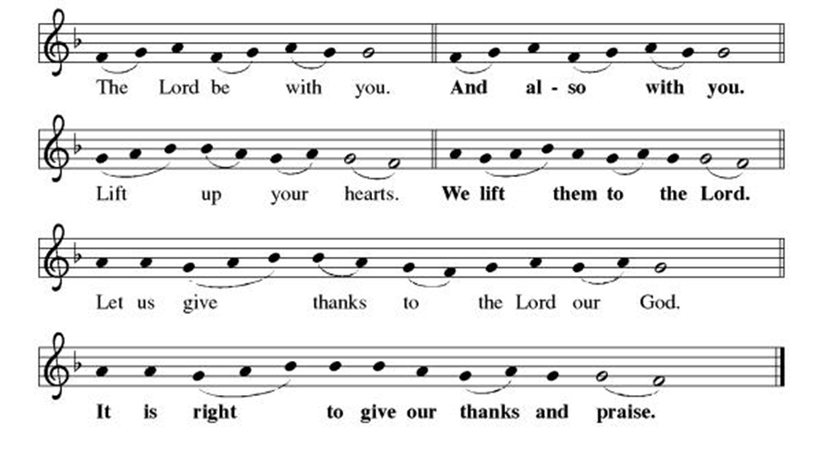

**Preface: Since the earliest days of the covenant… this hymn of praise:

**Holy, Holy, Holy
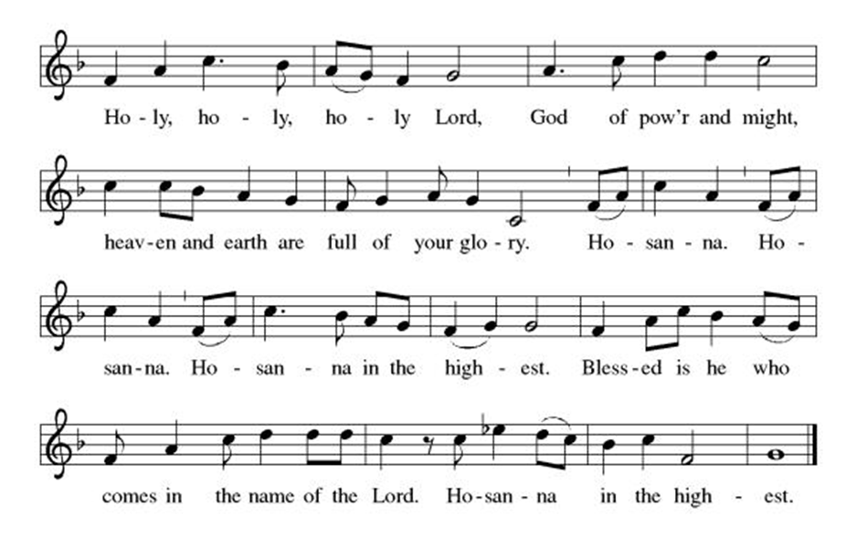
**Words of Institution

**LORD’S PRAYER

Our Father, who art in heaven,
hallowed be thy name,
thy kingdom come,
thy will be done,
on earth as it is in heaven.
Give us this day our daily bread;
and forgive us our trespasses,
as we forgive those
who trespass against us;
and lead us not into temptation,
but deliver us from evil.
For thine is the kingdom,
and the power, and the glory,
forever and ever. Amen.

Invitation to Communion

Communion Hymn O Jesus, I have Promised ELW#513

**Sending Song

Praise to you, O God of Mercy ELW#208

**Prayer After Communion

Abiding God, you call us then feed and nurture us. Now you send us out in the world you created with a purpose: to love our neighbors and care for those who need us. Strengthen us to do your work. In Jesus’ name we pray, Amen.

**Blessing

**Closing Hymn Listen, God is Calling ELW#810

**Dismissal

Go in peace to serve Christ and the world!

THANKS BE TO GOD!

+ + + + + +
Setting 3 liturgy are under copyright and used with permission under One License #733618-A. Specific copyright information as listed in bulletin, the Prayers of Intercession are under copyright and are used with permission under Augsburg Fortress Liturgy License #SB155933. All other liturgy written by Sarah Pierce.

***********************************************************************************************************
Weekly Attendance

Week of October 05
20
******************************************************************************************
Calendar of Events
Today

- Baptism Birthdays
- Bells
- Stewardship: Talent
- Balloon Payment Cake after Worship
- Fall Work Day
This Week
October 14 | Creative Friends 1:00 pm
October 15 | Council Meeting 6:30 pm
October 15-16 | Fall Theological Conference

Upcoming Events
October 19 | Coffee with Council/Stewardship: Treasure
October 21 | Creative Friends 1:00 pm
October 21 | Jean’s Surgery Scheduled
October 25 | Project Comfort 9:00 am-Noon
October 26 | Reformation Sunday; Pledge Sunday Film/Potluck after Worship
October 28 | Creative Friends 1:00 pm
November 02 | Daylight Savings Time Clocks back 1 Hour/All Saints Sunday: Celebrating gifts/Follow up film after Worship
November 05 | Council Meeting 6:30 pm
November 16 | Congregational Meeting
November 26 | Thanksgiving Eve Worship 7:00 pm Pie Night
December 07 | Advent Dinner after Worship
December 10 | Council Meeting 6:30 pm
January 14, 2026 | Council Meeting 6:30 pm
February 18 | Ash Wednesday
March 29 | Palm Sunday
April 05 | Easter Sunday
Bible study will resume November 2nd

BLUE SPRINGS COMMUNITY SERVICE LEAGUE is very appreciative of your continued support of your neighbor.
CSL Cuts Ribbon on First New Home Built!

On Tuesday, September 23, CSL celebrated a first in our 109+ year history. CSL developed a vacant piece of land into three single-family home lots, and our first home is now finished and sold to a first-time homebuyer. We celebrated the contributions of many community members, including dedicated student laborers from the Independence School District, donated siding from Continental Siding, and donated roofs from the National Women in Roofing Kansas City Council.

The other home, located next door, is under contract and the sale should be finalized by the end of 2025. CSL has ownership, or is under contract to own, six more lots in Northwest Independence. We are working on development plans for all six lots for 2026 and 2027.

Read our most recent housing blog for more updates about the impact of this work. You can read more at CSLcares.org.

******************************************************************************************
Questions for Reflection and Discussion from Pastor Sarah

- Samuel is the last judge (or pre-king ruler) that Israel will have. This is his “call” story, which is quite interesting because he’s already been dedicated to God and is living at the Tent of Meeting, serving God. It speaks to a different understanding of priesthood, if he was being prepared to be a priest without having been called.
- God calls Samuel four times. The first three times, Samuel goes to Eli, saying, “Here I am,” thinking that Eli had called out to him. Eli realizes that it’s God and coaches him what to say. It’s been a long time since I studied grammar and I don’t remember my verb forms, but in Hebrew, the verb form that we translate in English as “am listening” in Samuel’s response to God, during the fourth calling, implies an ongoing action. In other words, Samuel isn’t just listening right now: Samuel will continue to listen, as long as God continues to have a word to speak. This is directly in response to the statement in verse 1 that “the voice of God was rarely heard” in Samuel’s day: others were not listening, but Samuel, now that he knows to listen, is listening.
- Often, when we hear this text preached on, that’s where this text ends: with Samuel saying, “Yes, God, I am listening.” Or words to that effect. But the people who put together the narrative lectionary chose to have us continue on through the end of the chapter, so we see that Samuel is being called to do the hard thing: to tell his mentor, Eli, essentially that God has found a replacement for Eli, and that Eli’s family would basically be destroyed. None of this was news to Eli; but it was still incredibly devastating for Samuel to have that be his first act of prophecy.
- A prophet, rather than being someone who foretells the future, is someone who listens to what God tells them, and then tells it to who God tells them to tell it to. It’s no wonder prophecy was uncommon; there likely were not many people willing to take on the inherent risk of that line of work. Are there any prophets today? Are we listening to them, or are we ignoring them? What are they saying? (I would argue that there are prophets among us. I think William Barber is one, but only one.)
- We are all called by our baptisms to listen to God, and to continue listening to God throughout our lives, to hear how God is calling us to use our gifts, our talents, and our interests. What HAVE you done in the past to make use of your gifts, your talents, your interests, that demonstrates your love of God, your neighbor and your community, and yourself? What ARE you doing now? As you listen to God, what is God calling you to do in the FUTURE? Both here at church and in the community/the world?
- Listening to God isn’t always easy. Sometimes, we really want to turn around and walk the other way. But when we listen to God and follow where God calls us, we generally discover that using our gifts in the way God intends leads to fulfillment of God’s greatest commandment in ways we never could have imagined. What a great gift that is!

**************************************************************************************
Greeter – October 12-Donna Taylor
Usher – October 12-Paul Blixrud
Community Assistant- October 12-Flavia Via
Tech- October 12-Gary Antes

Prayer Requests
Monty Health Concerns (May 15)
Paul Health Concerns (May 31)
Mary Health Concerns (May 15)
James & Family Health Concerns (September 11)
Betty F (Sara’s friend) Health Concerns (July 15)
William and Family Health Concerns (September 25)
Becky H Health Concerns (October 28)
David Health Concerns (November 18)
Becky W Health Concerns (November 18)
Larry Health Issues (December 16)
Helen Health Issues (January 14)
Jennifer Health Concerns (February 27)
Otto Health Concerns (July 15)
Kay (Sara’s cousin) Health Concerns (July 15)
Kevin Health Concerns (October 01)
Kent Health Concerns (October 01)
Carla Health Concerns (October 01)

Family of Jennifer (October 05)

Merciful God, your justice and mercy are without limits. Bring courage and resilience to those who resist tyranny with their words and their bodies. Strengthen those who fight for justice in your name in Los Angeles, across the country, and around the world.

Please pray for the victims of the shooting at Annunciation Catholic School in Minneapolis.

Please pray for the people of Gaza, Ukraine, Israel, Iran and Palestine.
Please pray for the people of the Sudan.
Please pray for the Homeless.
Please pray for legal & illegal immigrants & those seeking asylum or citizenship.

