All Saints Lutheran Church ELCA
421 SW 19th St. Blue Springs, Missouri 64015 816-229-3633
Pastor Sarah Pierce Spierce.aslcpastor@gmail.com
allsaintslc64015@gmail.com https://aslcbs.org/
Thursday, April 02, 2026
Maundy Thursday

You are absolutely invited into this sacred space. We welcome all who are seeking God’s love and grace. All Saints recognizes that we are all unique and beloved children of God. We celebrate and give thanks for the many diverse gifts that God has given us. We affirm the sacredness of people of all sexual orientations, gender identities, and gender expressions. We affirm the sacredness of all those who have experienced exclusion because of race, ability, age, or culture. We are committed to working towards anti-racism in ourselves and our community. We affirm the sacredness of all those who wrestle with addiction, physical or mental health, imprisonment, socio-economic circumstances, or anything that too often divides us. We believe that through our openness we all grow in our faith through Christ’s teaching to love one another as God loves us. We need each other and our sincere hope is by being in community together, we will experience God’s presence in new and real ways.
The offering plate is by the main door to the sanctuary for your convenience.

We practice open communion at All Saints Lutheran Church. What does that mean? It means that if you believe and trust that Christ offers his body and blood For You, you are welcome at the table. At All Saints, we believe that Christ invites all people to the feast. “Come to the banquet for all is now ready.”

**Stand as you are comfortable

Prelude

Announcements

**GREETING

**Prayer of the Day

Loving God, be with us tonight as we contemplate Jesus’ final journey to the cross and beyond. Accompany us on our journey of faith and remind us of the healing power of your story. We know that you understand suffering; empower us to walk with those who suffer, and strengthen our hope in the peace that only you can bring. In the name of your son, our savior. Amen.

**Opening Hymn “Ah, Holy Jesus” ELW#349
Station 1: Jesus is Tempted
Reading: Luke 4:1-13
We adore you, O Christ, and we bless you, because by your holy cross you have redeemed the world.
Reflection
Station 2: Jesus is betrayed
Reading: Luke 22:47b-48
We adore you, O Christ, and we bless you, because by your holy cross you have redeemed the world. Reflection
Station 3: Jesus is condemned
Reading: Luke 22:66-71
We adore you, O Christ, and we bless you, because by your holy cross you have redeemed the world.
Reflection
Station 4: Jesus is mocked
Reading: Luke 22:63-65
We adore you, O Christ, and we bless you, because by your holy cross you have redeemed the world.
Reflection
Hymn “In the Cross of Christ I Glory” ELW#324
Station 5: Jesus is given his cross
Reading: John 19:16b-17
We adore you, O Christ, and we bless you, because by your holy cross you have redeemed the world.
Reflection
Station 6: Simon carries Jesus’ cross
Reading: Luke 23:26
We adore you, O Christ, and we bless you, because by your holy cross you have redeemed the world.
Reflection
Station 7: Jesus is stripped
Reading: Luke 23:34b
We adore you, O Christ, and we bless you, because by your holy cross you have redeemed the world.
Reflection
Station 8: Jesus is nailed to the cross
Reading: Luke 23:32-34a
We adore you, O Christ, and we bless you, because by your holy cross you have redeemed the world. Reflection
Hymn “Beneath the Cross of Jesus” ELW#338
Station 9: Jesus is mocked on the cross
Reading: Luke 23:35-39
We adore you, O Christ, and we bless you, because by your holy cross you have redeemed the world.
Reflection
Station 10: Jesus dies
Reading: Luke 23:44-49
We adore you, O Christ, and we bless you, because by your holy cross you have redeemed the world.
Reflection
Station 11: Jesus is buried
Reading: Luke 23:50-56, because by your holy cross you have redeemed the world.
We adore you, O Christ, and we bless you, because by your holy cross you have redeemed the world.
Reflection
Station 12: Jesus rises
Reading: Luke 24:1-6a
We adore you, O Christ, and we bless you, because by your holy cross you have redeemed the world.
Reflection
Hymn of the Day Jesus Priceless Treasure ELW#775

** Affirmation of Faith – Immigrant’s Creed by Jose Luis Casal

I believe in Almighty God, who guided the people in exile and in exodus, the God of Joseph in Egypt and

Daniel in Babylon, the God of foreigners and immigrants.

I believe in Jesus Christ, a displaced Galilean, who was born away from his people and his home, who

fled his country with his parents when his life was in danger. When he returned to his own country he

suffered under the oppression of Pontius Pilate, the servant of a foreign power. Jesus was persecuted,

beaten, tortured, and unjustly condemned to death. But on the third day Jesus rose from the dead, not as

a scorned foreigner but to offer us citizenship in God’s kingdom.

I believe in the Holy Spirit, the eternal immigrant from God’s kingdom among us, who speaks all

languages, lives in all countries, and reunites all races.

I believe that the Church is the secure home for foreigners and for all believers. I believe that the

communion of saints begins when we embrace all God’s people in all their diversity. I believe in

forgiveness, which makes us all equal before God, and in reconciliation, which heals our brokenness. I

believe that in the Resurrection God will unite us as one people in which all are distinct and all are alike

at the same time. I believe in life eternal, in which no one will be foreigner but all will be citizens of the

kingdom where God reigns forever and ever. Amen.

**Prayers of Intercession

God of Love, hear the prayers that we lift before you. Hold close to you all those for whom we pray.

Gracious host, you knelt to wash your disciples’ feet. Cleanse us from pride and self-centeredness, and teach us to love one another as you have loved us. Hear us, O God.
Your mercy is great.
Creator God, the earth is yours and everything in it. Awaken us to care for all you have made and conserve the rich diversity of your good creation. Hear us, O God.
Your mercy is great.
God of the nations, guide the world’s leaders in the ways of justice and peace. Where they wield power unjustly, confront them. Where they are indifferent to suffering, awaken their conscience. Hear us, O God.
Your mercy is great.
Compassionate One, embrace all who are lonely or in captivity, comfort the grieving, and relieve those in pain. Draw near to all who suffer especially Monty & Marie, Paul, Helen, Linda, Betty F., Kay, Becky H., Jim & Jan, Melian, Becky W., David, Val, William & family, Judy, Kevin, Peter & Carrie, Barbara & Donna, families in our community who endure hunger, and our beloved for whom death is near. Hear us, O God.
Your mercy is great.
Blessed redeemer, we give you thanks for this community of faith, and for all who gather around your table of grace. Unite us in love for you and for one another. Hear us, O God.
Your mercy is great.
Pave a way to justice, drown the forces of oppression, bring peace on earth. Give leaders the will to turn from war and violence. Especially we pray for the people of Venezuela, Iran, Cuba, Sudan, Gaza, Israel, and Ukraine. When people must flee their homes, guide them to safety. Comfort those living with deep trauma, anxiety, or fear; all those who serve people in need, and accompany all those who care for people in harm’s way. We also lift up Jim’s grandson Dylan, who is deployed, and Sharon’s great nephew, Taylor, who is deployed in the Middle East. Hear us, O God.
Your mercy is great.
We pray for people who rise up against injustice. Bring courage and resilience to those who resist tyranny with their words and their bodies. Strengthen those who fight for justice in your name across the country, and around the world. Protect and sustain immigrants and refugees and all who work with them, that your kingdom, without borders and without walls, may truly come on earth as it is in heaven. We pray for all victims of gun violence or kidnapping, especially those who are targeted out of hate or fear. Embolden us to holy outrage and empower us to speak our truth of love and justice. Hear us, O God.
Your mercy is great.
We lift up all who teach and all who learn. Thank you for teachers who share their knowledge and wisdom. Bless the students in our midst. Especially we remember Evie, in kindergarten; Addison, in high school; and Tyler, Zach, Katie and Katy, in college. Bless Janet, Carla, and Lisa as they teach. Hear us, O God.
Your mercy is great.
Eternal God, we praise you for the great cloud of witnesses who now rest from their labors. At the last, gather us with them at your heavenly banquet. Hear us, O God.
Your mercy is great.

Good and loving God, we give everyone we have prayed for into your care. Amen.

**Offertory Response

Let Us Talents and Tongues Employ (Refrain Only) ELW#674

**Offertory Prayer

Good and loving God, we give to you these offerings of our time, our talents, and our money, for the work of your people in this place, as we seek to follow your Son. Prepare our hearts and minds to come to your Table, as you feed us with the life-giving body and blood of your son Jesus Christ, through whom we receive the gift of eternal life. Amen.

The Great Thanksgiving
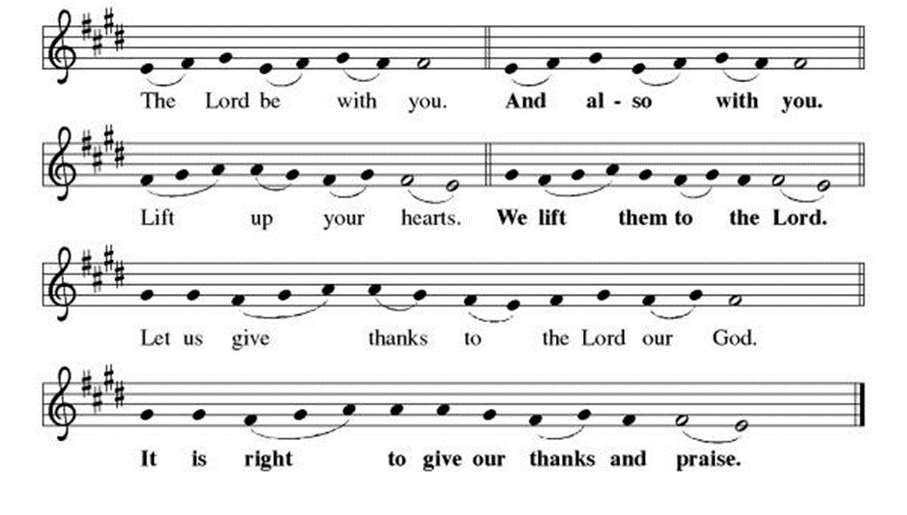
Preface: "We give you thanks, Holy God…this hymn of praise:
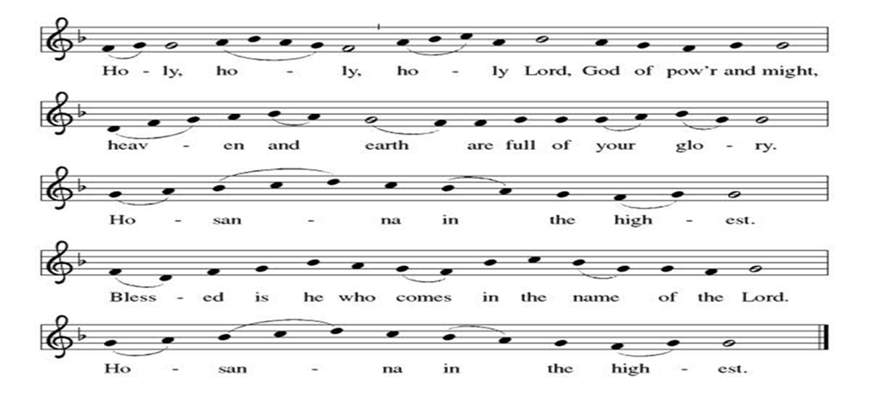
**Words of Institution

**LORD’S PRAYER
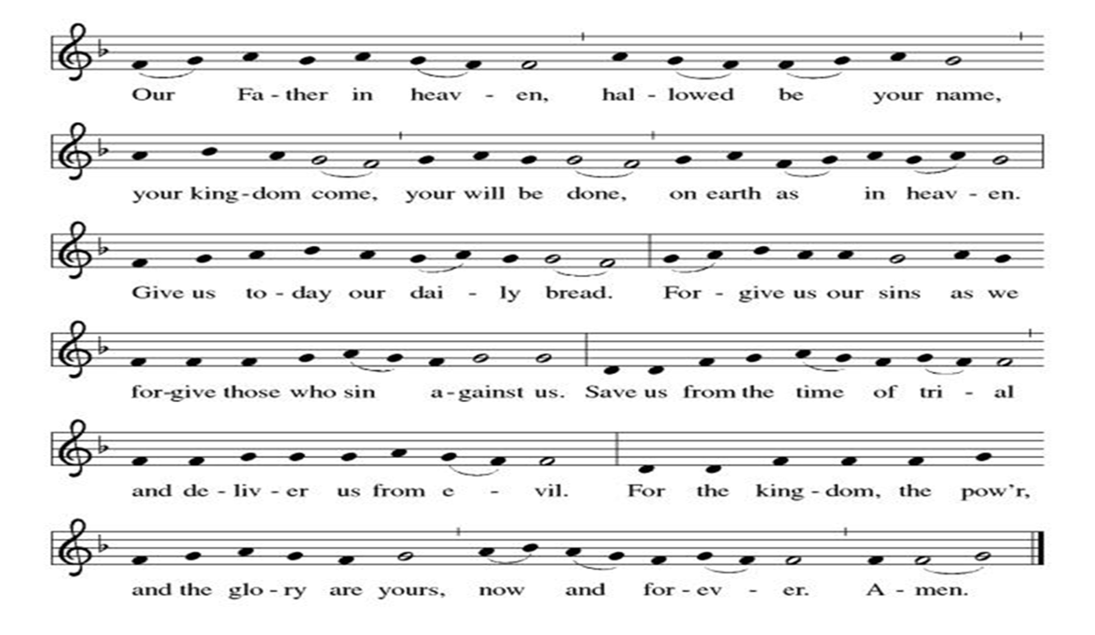

Invitation to Communion

Communion Hymn There in God’s Garden ELW#342

**Prayer After Communion

Holy and Eternal God, we have been fed at your Table with the goodness of our Savior. Send us out, emboldened to share the good news of your promise of forgiveness and eternal life. Strengthen our resolve to respond to the needs of our neighbors and to care for your world. Amen.

Stripping of the Altar while Psalm 22 is read.

Depart in Silence

+ + + + + +
Hymns from Setting 05 and the Evangelical Lutheran Worship are under copyright and used with permission under One License #733618-A. Specific copyright information as listed in bulletin, the Prayers of Intercession are under copyright and are used with permission under Augsburg Fortress Liturgy License #SB155933. All other liturgy written by Sarah Pierce.
*********************************************************************************************************
Weekly Attendance

Week of March 29

April 02
Altar Guild – Sara Meyers
Lector – Tonya Hamilton
Greeter – Donna Taylor
Tech – Gary Antes

Prayer Requests
Monty & Marie Health Concerns (Maech 04)
Paul Health Concerns (May 31)
Mary Health Concerns (May 15)
James & Family Health Concerns (September 11)
Betty F (Sara’s friend) Health Concerns (July 15)
William and Family Health Concerns (September 25)
Becky H Health Concerns (October 28)
David Health Concerns (November 18)
Becky W Health Concerns (November 18)
Judy Health Issues (December 16)
Kay (Sara’s cousin) Health Concerns (July 15)
Kevin Health Concerns (October 01)
Sharon Health Concerns (October 22)
Michael Health Concerns (October 22)
Peter and Carrie Health Concerns (November 26)
Melian Health Concerns (November 16)
RJ Health Concerns (November 17)
Barbara Health Concerns (December 30)
Helen Health Concerns (February 25)
Val (Tonya’s sister) Health Concerns (February 18)

Merciful God, your justice and mercy are without limits. Bring courage and resilience to those who resist tyranny with their words and their bodies. Strengthen those who fight for justice in your name across the country, and around the world.

Please pray for the people of Venezuela & Iran, Cuba, Sudan, Gaza, Ukraine, Israel, Iran and Palestine.
Please pray for the Homeless.
Please pray for legal & illegal immigrants & those seeking asylum or citizenship

