**All Saints Lutheran Church, ELCA**

**421 SW 19th St. Blue Springs, Missouri 64015 816-229-3633**

**Pastor Sarah Pierce** Spierce.aslcpastor@gmail.com

[allsaintslc64015@gmail.com](mailto:allsaintslc64015@gmail.com) <https://aslcbs.org/>

## Sunday, August 03, 2025

## Eighth Sunday after Pentecost

## Service of the Word

## *You are absolutely invited into this sacred space.  We welcome all who are seeking God’s love and grace.  All Saints recognizes that we are all unique and beloved children of God.  We celebrate and give thanks for the many diverse gifts that God has given us.  We affirm the sacredness of people of all sexual orientations, gender identities, and gender expressions.  We affirm the sacredness of all those who have experienced exclusion because of race, ability, age, or culture. We are committed to working towards anti-racism in ourselves and our community. We affirm the sacredness of all those who wrestle with addiction, physical or mental health, imprisonment, socio-economic circumstances, or anything that too often divides us.  We believe that through our openness we all grow in our faith through Christ’s teaching to love one another as God loves us.  We need each other and our sincere hope is by being in community together, we will experience God’s presence in new and real ways.*

*The offering plate is by the main door to the sanctuary for your convenience.*

*We practice open communion at All Saints Lutheran Church. What does that mean? It means that if you believe and trust that Christ offers his body and blood For You, you are welcome at the table. At All Saints, we believe that Christ invites all people to the feast. “Come to the banquet for all is now ready.”*

***\*\*Stand as you are comfortable***

***Prelude***

***Announcements***

**\*\* Confession and Forgiveness**

In times of uncertainty and challenge, we seek Your divine wisdom to guide our hearts and minds.

**When we try to figure things out on our own and forget to go to you for clarity**

**and discernment, forgive us, O God.**

**When we lose trust in you because times are so difficult, painful and scary, help us trust you. Remember us, O God, in our time of need. Give us courage when we need it. Help us listen for your voice amidst the chaos. Shine your light on our path and lead us to choices that honor you and bring peace to the world.**

God remains faithful at all times and in all places. Even when we turn our backs on God, God never abandons us. God always forgives our sins + and gives us the strength and courage to start again.

**Amen.**

***\*\*Entrance Hymn Take My Life, That I May Be ELW #685***

***\*\*Greeting***

The grace of our Lord Jesus Christ, the love of God,

and the communion of the Holy Spirit be with you all.

**And also with you.**

**\*\*Kyrie**

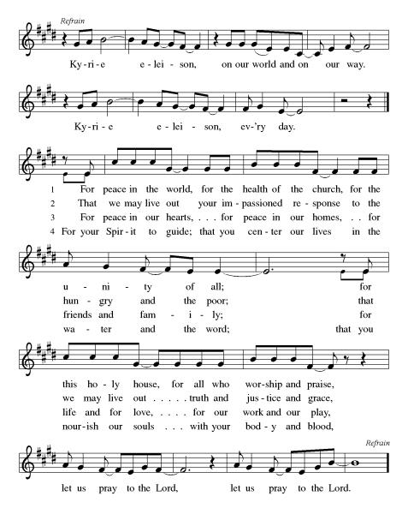

**\*\* Hymn of Praise**

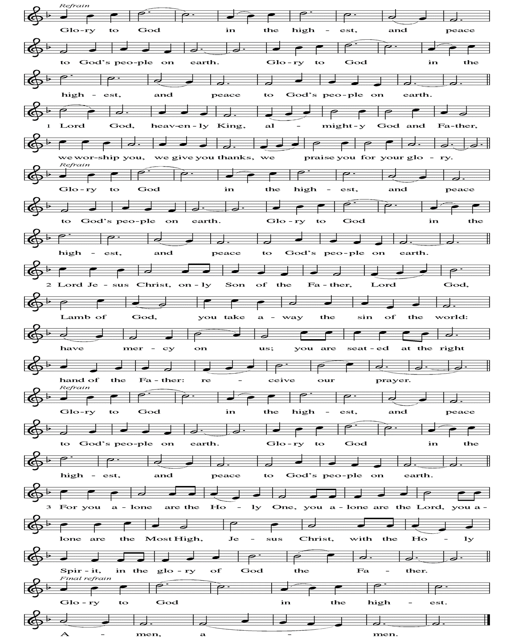

***\*\*Prayer of the Day***

**Benevolent God, we are so grateful to be yours. You are the source, the guide, and the goal of our lives. Teach us to be guided by you and to treasure what is precious in your sight, through Jesus Christ, our Savior and Lord.**

**Amen.**

***Reading:*** **2 Timothy 4:7-8**

I have fought the good fight, I have finished the race, I have kept the faith. Now there is in store for me the crown of righteousness, which the Lord, the righteous Judge, will award to me on that day—and not only to me, but also to all who have longed for his appearing.

**Isaiah 41:10**

Do not fear, for I am with you; do not be afraid, for I am your God. I will strengthen you; I will surely help you; I will uphold you with My righteous right hand.

Word of God, Word of Life

**Thanks be to God**

***\*\*Gospel Acclamation***

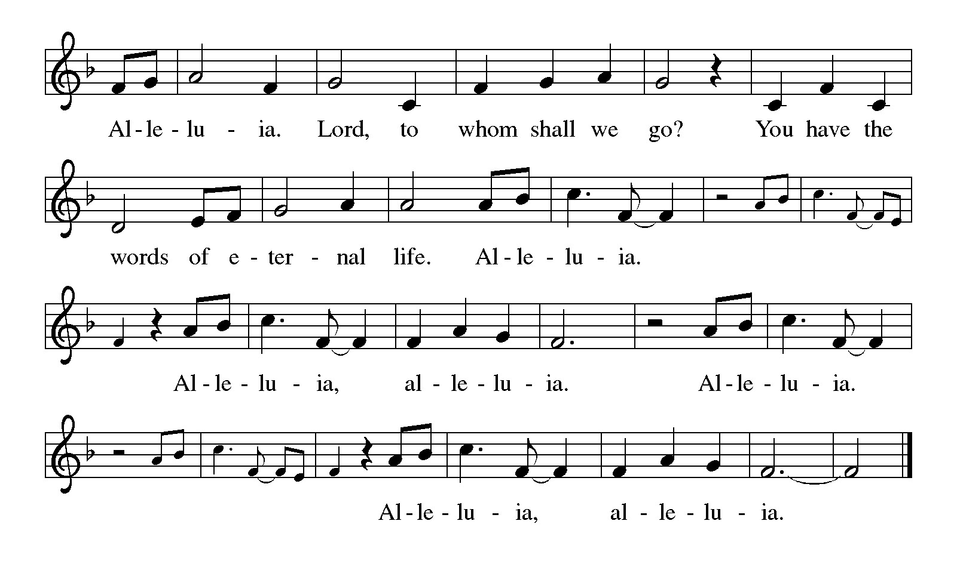

*Announcement of the Gospel*

**Glory to you, O Lord.**

***Gospel:* Matthew 7:7-8**

Ask, and it will be given to you; seek, and you will find; knock, and the door will be opened to you. For everyone who asks receives; he who seeks finds; and to him who knocks, the door will be opened.

**Mark 11:24**

Therefore, I tell you, whatever you ask for in prayer, believe that you have received it, and it will be yours.

The Gospel of the Lord.

**Praise to you, O Christ.**

**Betsy Reese What Do I Value?**

***Hymn of the Day*  *Lord, Teach Us How to Pray Aright* ELW#*745***

\*\***Affirmation of Faith – Immigrant’s Creed by Jose Luis Casal**

**I believe in Almighty God, who guided the people in exile and in exodus, the God of Joseph in Egypt and Daniel in Babylon, the God of foreigners and immigrants.**

**I believe in Jesus Christ, a displaced Galilean, who was born away from his people and his home, who fled his country with his parents when his life was in danger. When he returned to his own country he suffered under the oppression of Pontius Pilate, the servant of a foreign power. Jesus was persecuted, beaten, tortured, and unjustly condemned to death. But on the third day Jesus rose from the dead, not as a scorned foreigner but to offer us citizenship in God’s kingdom.**

**I believe in the Holy Spirit, the eternal immigrant from God’s kingdom among us, who speaks all languages, lives in all countries, and reunites all races.**

**I believe that the Church is the secure home for foreigners and for all believers. I believe that the communion of saints begins when we embrace all God’s people in all their diversity. I believe in forgiveness, which makes us all equal before God, and in reconciliation, which heals our brokenness. I believe that in the Resurrection God will unite us as one people in which all are distinct and all are alike at the same time. I believe in life eternal, in which no one will be foreigner but all will be citizens of the kingdom where God reigns forever and ever. Amen.**

***\*\*Prayers of Intercession***

**God of Love, hear the prayers that we lift before you. Hold close to you all those for whom we pray.**

Renew in your church a perspective of life beyond worldly pursuits. Build an enthusiasm to embrace life in Christ, so that Christ, the life of the world, is revealed to everyone. God of grace,

**hear our prayer.**

Revitalize and protect the treasures of wild places. Teach all people to value the earth, winds, waters, trees, and animals, the gifts that make life possible on this planet. God of grace,

**hear our prayer.**

Speak wisdom to any in positions of power, that they cease practices of divisiveness, insult, and oppression. Clothe all people in your image, and establish equity and peace. God of grace,

**hear our prayer.**

Reveal your loving presence in the lives of people suffering hunger and need, illness and grief, pain and fear especially Monty, Paul, Linda, Betty F., Kay, Becky H., Jim & Jan, Becky W., David, William and family, Helen, Larry, Jennifer, Otto, families in our community who endure hunger, and our beloved for whom death is near. Carry your people when grief is heavy, and lift burdens of shame and self-doubt. Provide protection and aid to children who are unsafe and undernourished while on summer break. Bring honor to any who experience slander and evil intent or are discredited by others. Give strength to those who give care, and equip them with compassion as they make your love known. God of grace,

**hear our prayer.**

Store up in this congregation a full measure of gratitude and generosity. Guide the work of treasurers and all who attend to financial matters. Support those whose work in our community is difficult and demanding; make us mindful of the toil that goes unnoticed. God of grace,

**hear our prayer.**

We pray for the nations. Pave a way to justice, drown the forces of oppression, bring peace on earth. Give leaders the will to turn from war and violence. Especially we pray for the people of Gaza, Israel, and Ukraine, and for Jim’s grandson Dylan, who is deployed in Oman. When people must flee their homes, guide them to safety. Comfort those living with deep trauma, anxiety, or fear; all those who serve people in need, and accompany all those who care in harm’s way. God of grace,

**hear our prayer.**

Provide comfort to those whose loved ones have died in the Texas flood. Accompany the first responders and all who are searching for the missing. And may those who are waiting feel your presence and know they do not wait alone. God of grace,

**hear our prayer.**

We pray for people who rise up against injustice. Bring courage and resilience to those who resist tyranny with their words and their bodies. Strengthen those who fight for justice in your name across the country, and around the world. Protect and sustain immigrants and refugees and all who work with them, that your kingdom, without borders and without walls, may truly come on earth as it is in heaven. We pray for all victims of gun violence or kidnapping, especially those who are targeted out of hate or fear. Embolden us to holy outrage and empower us to speak our truth of love and justice, God of grace,

**hear our prayer.**

In times of personal transition, we look to you for strength and guidance. We ask that you be with David and his sisters, as they negotiate a new family dynamic. God of grace,

**hear our prayer.**

Receive our thanks for the lives of your saints who now rest from their labors. Give us wisdom through their witness and encourage us in love as we continue our lives in the world. God of grace,

**hear our prayer.**

**Good and loving God, we give everyone we have prayed for into your care. Amen.**

*\*\** ***Sharing of the Peace***

### *\*\*Offering is brought forward*

### *\*\** *Offertory Response*

### As the Grains of Wheat (Refrain Only) ELW #465

### *\*\*Blessing of CSL Offering*

### *\*\*Offertory Prayer*

**Holy God, we return to you with gratitude the gifts you have given us. Use them to your service and for your ministry in this place. We pray this in Jesus’ name. Amen.**

**\*\*tHE THANKSGIVING for the Word……………………………………………………ELW p.220**

Let us pray.

Praise and thanks to you, holy God, for by your Word you made all things; you spoke light into darkness, called forth beauty from chaos, and brought life into being. For your Word of life, O God,

**We give you thanks and praise.**

By your Word you called your people Israel to tell of your wonderful gifts: freedom from captivity, water on the desert journey, a pathway home from exile, wisdom for life with you. For your Word of life, O God,

**We give you thanks and praise.**

Through Jesus, your Word made flesh, you speak to us and call us to witness: forgiveness through the cross, life to those entombed by death, the way of your self-giving love. For your Word, O God,

**We give you thanks and praise.**

Send your Spirit of truth, O God; rekindle your gifts within us: renew our faith, increase our hope, and deepen our love, for the sake of a world in need. Faithful to your Word, O God, draw near to all who call on you; through Jesus Christ, our Savior and Lord, to whom, with you and the Holy Spirit, be honor and glory forever.

**Amen.**

***\*\*Words of Institution***

**\*\*LORD’S PRAYER**

**Our Father, who art in heaven,**

**hallowed be thy name,**

**thy kingdom come,**

**thy will be done,**

**on earth as it is in heaven.**

**Give us this day our daily bread;**

**and forgive us our trespasses,**

**as we forgive those**

**who trespass against us;**

**and lead us not into temptation,**

**but deliver us from evil.**

**For thine is the kingdom,**

**and the power, and the glory,**

**forever and ever. Amen.**

### *\*\*Sending Song*

### *Praise to you, O God of Mercy ELW#208*

### *\*\*Blessing*

***\*\*Closing Hymn*** ***Great is Thy Faithfulness******ELW#733***

### 

### *\*\*Dismissal*

Go in peace to serve Christ and the world!

**THANKS BE TO GOD!**

### + + + + + +

*Setting 8 liturgy are under copyright and used with permission under One License #733618-A. Specific copyright information as listed in bulletin, the Prayers of Intercession are under copyright and are used with permission under Augsburg Fortress Liturgy License #SB155933. All other liturgy written by Sarah Pierce.*

*Confession and Forgiveness based on Psalm 51:1-6 and Psalm 103:104, 17-18 (adapted). Dialog based on Psalm 136:1, 4-8. Thanksgiving based on Psalm 100 (adapted). Benediction based on 1 Thessalonians 5:16-24 (adapted).*

**Weekly Attendance**

***Week of July 27***

***27***

*\*\*\*\*\*\*\*\*\*\*\*\*\*\*\*\*\*\*\*\*\*\*\*\*\*\*\*\*\*\*\*\*\*\*\*\*\*\*\*\*\*\*\*\*\*\*\*\*\*\*\*\*\*\*\*\*\*\*\*\*\*\*\*\*\*\*\*\*\*\*\*\*\*\*\*\*\*\*\*\*\*\*\*\*\*\*\*\*\*\**

**Calendar of Events**

***Today***

* ***Blessing of CSL***
* ***Adult Bible Study***

***This Week***

|  |  |
| --- | --- |
| ***July 28 – Aug 03*** | ***Pastor Sarah’s Vacation*** |
| ***August 05*** | ***Creative Friends 1:30 pm*** |
| ***August 09*** | ***Men’s Group Breakfast 8:00 am*** |
| ***August 09*** | ***BS Back to School Bingo 1:00 p -3:00 pm*** |

***Upcoming Events***

|  |  |
| --- | --- |
| ***August 10*** | ***Baptismal Birthdays*** |
| ***August 12*** | ***Creative Friends 1:30 pm*** |
| ***August 13*** | ***Council Meeting 6:30 pm*** |
| ***August 19*** | ***Creative Friends 1:30 pm*** |
| ***August 20*** | ***Newsletter Deadline*** |
| ***August 23*** | ***Project Comfort 9:00 am-Noon*** |
| ***August 24*** | ***Coffee with Council/ Pot Luck after Worship*** |
| ***August 26*** | ***Creative Friends 1:30 pm*** |
| ***August 31*** | ***Fifth Sunday Conversation*** |
| ***September 07*** | ***God’s Work. Our Hands/Zoo after Worship*** |
| ***September 14*** | ***Council Meeting 6:30 pm after Worship*** |
| ***September 22-23*** | ***Blue Springs Theatre 7:00 pm-9:00 pm*** |
| ***September 29-October 01*** | ***Blue Springs Theatre 7:00 pm-9:00 pm*** |
| ***September 28*** | ***Bishop Installation/Atonement Lutheran Church 5:00 pm Overland Park*** |
| ***October 04*** | ***Blessing of Animals TBA*** |
| ***October 12*** | ***Fall Work Day*** |

* **August 10: Pastor Sarah will be at ASLC. We'll be exploring questions of privilege and power as Esther becomes queen.**
* **August 17: Pulpit swap! Pastor Sami will be at ASLC and Pastor Sarah will be at First in St. Joe. We'll be exploring how we speak about justice as Haman persecutes the Jewish people.**
* **August 24: Joint sermon! Pastor Sarah and Pastor Sami will both be at ASLC to preach together! We'll be exploring courage and strength as Esther and Mordecai work together to find justice.**
* **August 31: Pastor Sarah will be at ASLC for our 5th Sunday Conversation as we wrap up the book of Esther, talking about the power of stories to help us work through our desire for justice that looks like vengeance, when God's justice looks more like mercy.**

****************************************************************************************

*You may recall that there has been an announcement in the bulletin over the past year directing you to Lutheran Immigration and Refugee Services (LIRS) if you wish to support the people of Ukraine. LIRS has changed its name to Global Refuge and can be found at* ***globalrefuge.org****. Although their name has changed, their mission remains the same: to assist and support refugees in the United States and around the world. Visit their website to see all the ways you can support this important work.*

**\*\*\*\*\*\*\*\*\*\*\*\*\*\*\*\*\*\*\*\*\*\*\*\*\*\*\*\*\*\*\*\*\*\*\*\*\*\*\*\*\*\*\*\*\*\*\*\*\*\*\*\*\*\*\*\*\*\*\*\*\*\*\*\*\*\*\*\*\*\*\*\*\*\*\*\*\*\*\*\*\*\*\*\*\*\*\*\*\***

**BLUE SPRINGS COMMUNITY SERVICE LEAGUE** *is very appreciative of your continued support of your neighbor.*

***Greeter –*** **August 03*-******Donna Taylor***

***Usher –* August 03*-Paul Blixrud***

***Altar Guild-* August 03-**

***Tech-* August 03*-Gary Antes***

**Prayer Requests**

***Monty Health Concerns (May 15)***

*Paul Health Concerns (May 31)*

*Mary Health Concerns (May 15)*

*James & Family Health Concerns (September 11)*

*Betty F (Sara’s friend) Health Concerns (July 15)*

*William and Family Health Concerns (September 25)*

*Becky H Health Concerns (October 28)*

*David Health Concerns (November 18)*

*Becky W Health Concerns (November 18)*

*Larry Health Issues (December 16)*

*Helen Health Issues (January 14)*

*Jennifer Health Concerns (February 27)*

*Otto Health Concerns (July 15)*

*Kay (Sara’s cousin) Health Concerns (**July 15)*

***Merciful God, your justice and mercy are without limits. Bring courage and resilience to those who resist tyranny with their words and their bodies. Strengthen those who fight for justice in your name in Los Angeles, across the country, and around the world.***

***Please pray for the people of Gaza, Ukraine, Israel, Iran and Palestine.***

***Please pray for the people of the Sudan.***

***Please pray for the Homeless.***

***Please pray for legal & illegal immigrants & those seeking asylum or citizenship.***