**All Saints Lutheran Church, ELCA**

**421 SW 19th St. Blue Springs, Missouri 64015 816-229-3633**

**Pastor Sarah Pierce** Spierce.aslcpastor@gmail.com

[allsaintslc64015@gmail.com](mailto:allsaintslc64015@gmail.com) <https://aslcbs.org/>

## Sunday, August 24, 2025

## Eleventh Sunday after Pentecost

## *You are absolutely invited into this sacred space.  We welcome all who are seeking God’s love and grace.  All Saints recognizes that we are all unique and beloved children of God.  We celebrate and give thanks for the many diverse gifts that God has given us.  We affirm the sacredness of people of all sexual orientations, gender identities, and gender expressions.  We affirm the sacredness of all those who have experienced exclusion because of race, ability, age, or culture. We are committed to working towards anti-racism in ourselves and our community. We affirm the sacredness of all those who wrestle with addiction, physical or mental health, imprisonment, socio-economic circumstances, or anything that too often divides us.  We believe that through our openness we all grow in our faith through Christ’s teaching to love one another as God loves us.  We need each other and our sincere hope is by being in community together, we will experience God’s presence in new and real ways.*

*The offering plate is by the main door to the sanctuary for your convenience.*

*We practice open communion at All Saints Lutheran Church. What does that mean? It means that if you believe and trust that Christ offers his body and blood For You, you are welcome at the table. At All Saints, we believe that Christ invites all people to the feast. “Come to the banquet for all is now ready.”*

***\*\*Stand as you are comfortable***

***Prelude***

***Announcements***

**\*\* Confession and Forgiveness**

As with Esther and Mordecai, in times of uncertainty and challenge, we seek Your

divine wisdom to guide our hearts and minds.

**When we try to figure things out on our own and forget to go to you for clarity**

**and discernment, forgive us, O God.**

**When we lose trust in you because times are so difficult, painful and scary, help us trust you. Remember us, O God, in our time of need. Give us courage when we need it. Help us listen for your voice amidst the chaos. Shine your light on our path and lead us to choices that honor you and bring peace to the world.**

God remains faithful at all times and in all places. Even when we turn our backs on God, God never abandons us. God always forgives our sins + and gives us the strength and courage to start again.

**Amen.**

***\*\*Entrance Hymn Softly and Tenderly ELW #608***

***\*\*Greeting***

The grace of our Lord Jesus Christ, the love of God,

and the communion of the Holy Spirit be with you all.

**And also with you.**

**\*\*Kyrie**

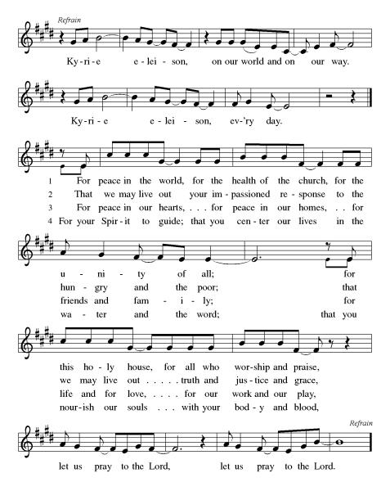

***\*\*Prayer of the Day***

**God of all times and places, we know that you are with us always. Help us to see the ways you answer our prayers, even when those answers may not be the ones we hope for. Empower us to speak out, so that, like Esther, you can call us to become an answer to other people’s prayers. In Jesus’ name we pray. Amen.**

***Reading:*** **Esther 5:1, 3-9, 6:1-3a, 7:1—8:2**

1On the third day, Esther put on her royal garments and went to the courtyard of the palace, in front of the Imperial Court. Ahasuerus was sitting on the royal throne facing the entrance.

3Ahasuerus said to her, “What is your desire, Queen Esther? What do you request of me? Whatever it is, I will give it to you—up to half of my empire.”

4And Esther said, “This is a special day for me. If it pleases my sovereign, I would like you and Haman to be the guests of honor at a banquet I will prepare today.”

5Ahasuerus said, “Summon Haman right now, so that we may do what Esther desires.”

So they both came to the banquet that Esther had prepared. 6While they were drinking wine, Ahasuerus said to Esther, “What do you desire, Esther? Anything you say will be given to you.”

7So Esther said, “This is my request: 8if I have found favor in the sight of my sovereign, let my sovereign and Haman return again to a second banquet that I will prepare for them. I will do tomorrow what I have done today.”

9So Haman left the palace filled with joy. But when he caught sight of Mordecai in the courtyard, he burned with rage.

6:1That same night, Ahasuerus could not sleep. He called for the record book, the Annals, to be brought and read to him. 2The texts told the story of how Mordecai had exposed the fiendish plot of Bigthan and Teresh, the two eunuchs who were Guardians of the Threshold who planned to assassinate Ahasuerus.

3“How was Mordecai rewarded for this?” asked Ahasuerus.

“He received nothing,” the attendant on duty said.

7 :1Ahasuerus and Haman arrived at Esther’s banquet. 2The next day, as they were drinking their wine, Ahasuerus said, “What do you desire, Esther? Anything you say will be given to you.”

3Esther replied, “My sovereign, if I have found favor in your eyes and if it be your wish, I ask you to spare my life, and the lives of my people. That is what I desire most. 4For we, my people and I, have been condemned to be destroyed, slain and turned into chattel—ourselves and our children. Had you merely intended to make us slaves, I would have said nothing. All this has been told to me by a reliable source. Our enemy brings shame upon the imperial court.”

5Ahasuerus said, “Who is this person who would dare do such a thing?”

6Esther replied, “Our enemy is this scoundrel Haman.” Haman was terrified and shrank in the presence of Ahasuerus and Esther.

7Ahasuerus rose from the banquet table, enraged, and went into the garden. Haman began to beg for his life from Esther, for he knew that his very life was in danger.

8When Ahasuerus returned from the garden, he saw that Haman had thrown himself on the couch to plead to Esther. He said, “Do you dare to attack my wife in our own house?”

At these words, Haman tried to sneak away. 9Then Harbona, one of the eunuchs, said, “I have seen it myself. Haman has prepared a gallows for Mordecai—the very person who gave you true information. The gallows stands in front of Haman’s house and is seventy-five feet high.” Ahasuerus declared, “That is where Haman will hang.” 10So Haman was hung on the gallows that he had built for Mordecai. Only then was Ahasuerus’ anger abated.

8:1That very day, Ahasuerus presented Esther with Haman’s house. Mordecai was brought in to see the ruler after Esther revealed that he was her uncle. 2Ahasuerus had taken the signet ring from Haman, and now gave it to Mordecai, and Esther placed Mordecai in charge of Haman’s house.

Word of God, Word of Life

**Thanks be to God**

**Sermon Pastor Sarah & Pastor Sami**

***Hymn of the Day* What a Fellowship, What a Joy Divine ELW#7*74***

\*\***Affirmation of Faith – Immigrant’s Creed by Jose Luis Casal**

**I believe in Almighty God, who guided the people in exile and in exodus, the God of Joseph in Egypt and Daniel in Babylon, the God of foreigners and immigrants.**

**I believe in Jesus Christ, a displaced Galilean, who was born away from his people and his home, who fled his country with his parents when his life was in danger. When he returned to his own country he suffered under the oppression of Pontius Pilate, the servant of a foreign power. Jesus was persecuted, beaten, tortured, and unjustly condemned to death. But on the third day Jesus rose from the dead, not as a scorned foreigner but to offer us citizenship in God’s kingdom.**

**I believe in the Holy Spirit, the eternal immigrant from God’s kingdom among us, who speaks all languages, lives in all countries, and reunites all races.**

**I believe that the Church is the secure home for foreigners and for all believers. I believe that the communion of saints begins when we embrace all God’s people in all their diversity. I believe in forgiveness, which makes us all equal before God, and in reconciliation, which heals our brokenness. I believe that in the Resurrection God will unite us as one people in which all are distinct and all are alike at the same time. I believe in life eternal, in which no one will be foreigner but all will be citizens of the kingdom where God reigns forever and ever. Amen.**

***\*\*Prayers of Intercession***

**God of Love, hear the prayers that we lift before you. Hold close to you all those for whom we pray.**

You call your church to proclaim liberation and freedom to all. Give wisdom to bishops, synod councils and staff, and congregation leaders as they pursue a more just and equitable church and society. Hear us, O God.

**Your mercy is great.**

You inspire all creation to sing and bless your holy name. Send healing rains to parched places and relief to flooded lands. Lead us to enact policies to rebuild ruined ecosystems and habitats. Hear us, O God.

**Your mercy is great.**

Your work vindicates and provides justice for all who are oppressed. Strengthen the resolve of world leaders and local officials in the way of love and mercy, so that all persons may experience abundant life. Hear us, O God.

**Your mercy is great.**

You satisfy your people with good things. In your steadfast love, receive the cries of all who are bent over under the weight of addiction, isolation, and mental or physical illness especially Monty, Paul, Linda, Betty F., Kay, Becky H., Jim & Jan, Becky W., David, William and family, Helen, Larry, Jennifer, Otto, families in our community who endure hunger, and our beloved for whom death is near. Carry your people when grief is heavy, and lift burdens of shame and self-doubt. Bring honor to any who experience slander and evil intent or are discredited by others. Assure all who are afraid or experiencing great uncertainty that your promises are sure. Reassure them of your care in all times and places. Manifest your healing presence in their midst. Hear us, O God.

**Your mercy is great.**

Calm the fears of migrants and refugees who set out, not knowing where they go. Provide shelter, sustenance, protection from harm, and welcome. Bless the work of Global Refuge and other support and advocacy programs. Hear us, O God.

**Your mercy is great.**

We pray for the nations. Pave a way to justice, drown the forces of oppression, bring peace on earth. Give leaders the will to turn from war and violence. Especially we pray for the people of Gaza, Israel, and Ukraine, and for Jim’s grandson Dylan, who is deployed in Oman. When people must flee their homes, guide them to safety. Comfort those living with deep trauma, anxiety, or fear; all those who serve people in need, and accompany all those who care for people in harm’s way. Hear us, O God.

**Your mercy is great.**

We pray for people who rise up against injustice. Bring courage and resilience to those who resist tyranny with their words and their bodies. Strengthen those who fight for justice in your name across the country, and around the world. Protect and sustain immigrants and refugees and all who work with them, that your kingdom, without borders and without walls, may truly come on earth as it is in heaven. We pray for all victims of gun violence or kidnapping, especially those who are targeted out of hate or fear us. Embolden us to holy outrage and empower us to speak our truth of love and justice, Hear us, O God.

**Your mercy is great.**

God of learning, we lift up all who teach and all who learn. Thank you for teachers who share their knowledge and wisdom. Bless the students in our midst. Especially we remember Evie, in kindergarten; Addison, in high school; Tyler, Zach, and Katy, in college; and Suelyn, who is pursuing continuing education. Bless Janet and Lisa as they teach. Hear us, O God.

**Your mercy is great.**

With all your apostles, prophets, and saints, we give thanks and bless your holy name. As they now rest from their labors, guide us by the witness of their lives to pursue your reign, which can never be shaken. Hear us, O God.

**Your mercy is great.**

**Good and loving God, we give everyone we have prayed for into your care. Amen.**

*\*\** ***Sharing of the Peace***

### *\*\*Offering is brought forward*

### *\*\** *Offertory Response*

**Create in Me ELW#186**

### *\*\*Offertory Prayer*

**Holy God, we return to you with gratitude the gifts you have given us. Use them to your service and for your ministry in this place. We pray this in Jesus’ name. Amen.**

**Thanksgiving at the Table**

Thank you God, for you are good!

Your love is everlasting!

**You alone perform such great marvels.**

**Your love is everlasting!**

Your wisdom made the heavens.

Your love is everlasting!

**You spread the land out over the waters.**

**Your love is everlasting!**

You made the great lights:

Your love is everlasting!

**The sun to govern the day, moon and stars to govern the night.**

**Your love is everlasting!**

**\*\*Preface:** O God, you called your servant Esther……..all creation as we sing:

**\*\*Holy, Holy, Holy**

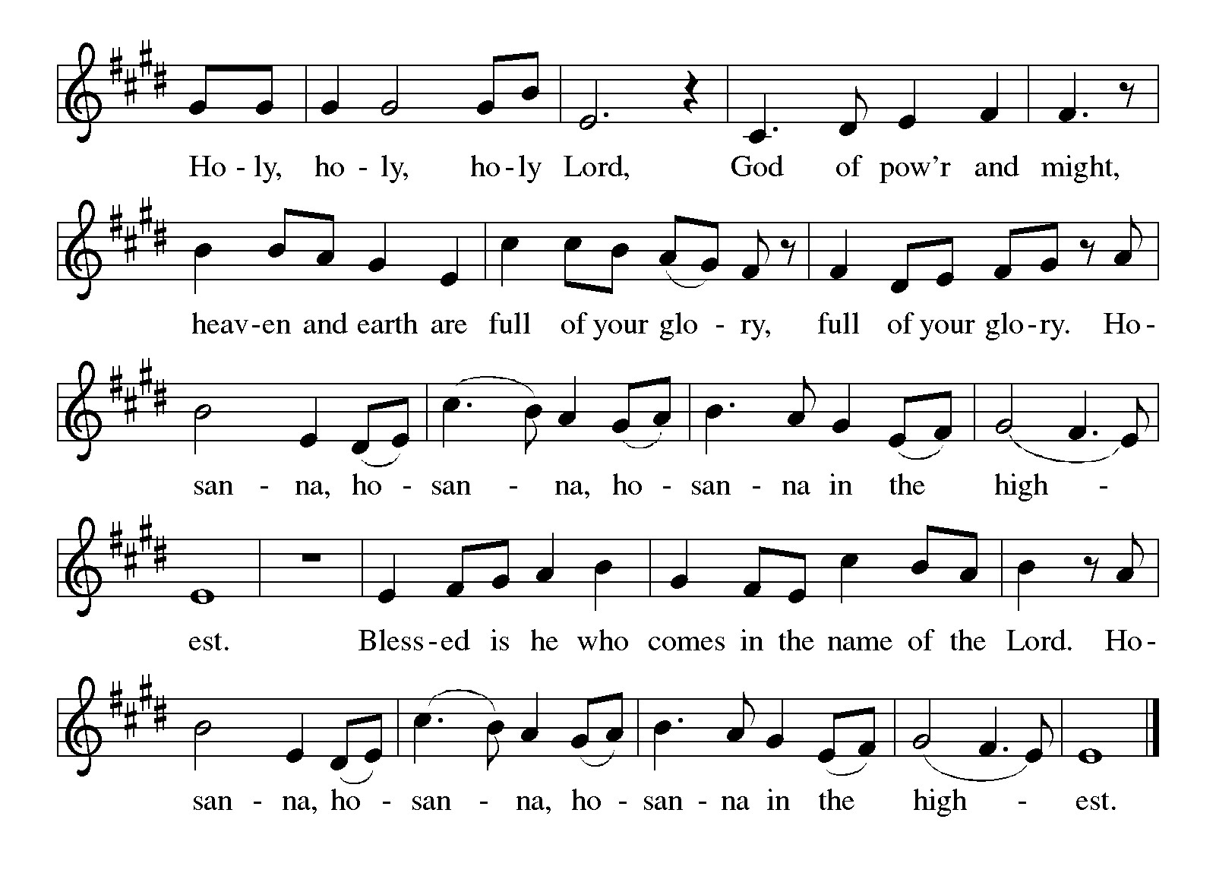

***\*\*Words of Institution***

**\*\*LORD’S PRAYER**

**Our Father, who art in heaven,**

**hallowed be thy name,**

**thy kingdom come,**

**thy will be done,**

**on earth as it is in heaven.**

**Give us this day our daily bread;**

**and forgive us our trespasses,**

**as we forgive those**

**who trespass against us;**

**and lead us not into temptation,**

**but deliver us from evil.**

**For thine is the kingdom,**

**and the power, and the glory,**

**forever and ever. Amen.**

***Invitation to Communion***

# ***Communion Hymn Let Us Break Bread Together ELW#471***

### *\*\*Sending Song*

### *Praise to you, O God of Mercy ELW#208*

### *\*\*Prayer After Communion*

**Grafted onto the tree of faith and grounded in the promise of your faithful mercy, we have been fed by the Word and at the Table. Now send us out to share the joy of Christ with all whom we encounter. Amen.**

### *\*\*Blessing*

***\*\*Closing Hymn******A Mighty Fortress Is Our God******ELW#504***

### 

### *\*\*Dismissal*

Go in peace to serve Christ and the world!

**THANKS BE TO GOD!**

### + + + + + +

*Setting 8 liturgy are under copyright and used with permission under One License #733618-A. Specific copyright information as listed in bulletin, the Prayers of Intercession are under copyright and are used with permission under Augsburg Fortress Liturgy License #SB155933. All other liturgy written by Sarah Pierce and Sami Pfalzgraf.*

*Dialog based on Psalm 136:1, 4-8. Thanksgiving based on Psalm 100 (adapted).*

*\*\*\*\*\*\*\*\*\*\*\*\*\*\*\*\*\*\*\*\*\*\*\*\*\*\*\*\*\*\*\*\*\*\*\*\*\*\*\*\*\*\*\*\*\*\*\*\*\*\*\*\*\*\*\*\*\*\*\*\*\*\*\*\*\*\*\*\*\*\*\*\*\*\*\*\*\*\*\*\*\*\*\*\*\*\*\*\*\*\*\*\*\*\*\*\*\*\*\*\*\*\*\*\*\*\*\**

**Weekly Attendance**

***Week of August 17***

***25***

*\*\*\*\*\*\*\*\*\*\*\*\*\*\*\*\*\*\*\*\*\*\*\*\*\*\*\*\*\*\*\*\*\*\*\*\*\*\*\*\*\*\*\*\*\*\*\*\*\*\*\*\*\*\*\*\*\*\*\*\*\*\*\*\*\*\*\*\*\*\*\*\*\*\*\*\*\*\*\*\*\*\*\*\*\*\*\*\*\*\**

**Calendar of Events**

***Today***

* ***Pot Luck***

***This Week***

|  |  |
| --- | --- |
| ***August 26*** | ***Creative Friends 1:00 pm*** |
| ***August 27*** | ***Handbell rehearsal 6:30 pm*** |

***Upcoming Events***

|  |  |
| --- | --- |
| ***August 31*** | ***Fifth Sunday Conversation*** |
| ***September 03*** | ***Handbell rehearsal 6:30 pm*** |
| ***September 07*** | ***God’s Work. Our Hands/Zoo after Worship*** |
| ***September 10*** | ***Handbell rehearsal 6:30 pm*** |
| ***September 14*** | ***Council Meeting 11:30 after Bible Study*** |
| ***September 17*** | ***Handbell rehearsal 6:30 pm*** |
| ***September 17- September 21*** | ***Pastor Sarah Vacation*** |
| ***September 22-23*** | ***Blue Springs Theatre 7:00 pm-9:00 pm*** |
| ***September 29-October 01*** | ***Blue Springs Theatre 7:00 pm-9:00 pm*** |
| ***September 28*** | ***Bishop Installation/Atonement Lutheran Church 5:00 pm Overland Park*** |
| ***October 1*** | ***Handbell rehearsal 6:30 pm*** |
| ***October 04*** | ***Blessing of Animals TBA*** |
| ***October 8*** | ***Handbell rehearsal 6:30 pm*** |
| ***October 12*** | ***Fall Work Day*** |
| ***October 15*** | ***Council Meeting 6:30 pm*** |
| ***October 22*** | ***Handbell rehearsal 6:30 pm*** |
| ***October 29*** | ***Handbell rehearsal 6:30 pm*** |
| ***November 05*** | ***Council Meeting 6:30 pm*** |
| ***November 12*** | ***Handbell rehearsal 6:30pm*** |
| ***November 16*** | ***Congregational Meeting*** |
| ***November 19*** | ***Handbell rehearsal 6:30 pm*** |
| ***December 05*** | ***Council Meeting 6:30 pm*** |
| ***January 14, 2027*** | ***Council Meeting 6:30 pm*** |

* **August 31: Pastor Sarah will be at ASLC for our 5th Sunday Conversation as we wrap up the book of Esther, talking about the power of stories to help us work through our desire for justice that looks like vengeance, when God's justice looks more like mercy.**

****************************************************************************************

*You may recall that there has been an announcement in the bulletin over the past year directing you to Lutheran Immigration and Refugee Services (LIRS) if you wish to support the people of Ukraine. LIRS has changed its name to Global Refuge and can be found at* ***globalrefuge.org****. Although their name has changed, their mission remains the same: to assist and support refugees in the United States and around the world. Visit their website to see all the ways you can support this important work.*

**\*\*\*\*\*\*\*\*\*\*\*\*\*\*\*\*\*\*\*\*\*\*\*\*\*\*\*\*\*\*\*\*\*\*\*\*\*\*\*\*\*\*\*\*\*\*\*\*\*\*\*\*\*\*\*\*\*\*\*\*\*\*\*\*\*\*\*\*\*\*\*\*\*\*\*\*\*\*\*\*\*\*\*\*\*\*\*\*\***

**BLUE SPRINGS COMMUNITY SERVICE LEAGUE** *is very appreciative of your continued support of your neighbor.*

*\*\*\*\*\*\*\*\*\*\*\*\*\*\*\*\*\*\*\*\*\*\*\*\*\*\*\*\*\*\*\*\*\*\*\*\*\*\*\*\*\*\*\*\*\*\*\*\*\*\*\*\*\*\*\*\*\*\*\*\*\*\*\*\*\*\*\*\*\*\*\*\*\*\*\*\*\*\*\*\*\*\*\*\*\*\*\*\*\*\**

**Questions for Reflection and Discussion from Pastor Sarah**

1. It’s hard to get a sense of this in the English translation, but in Hebrew, when Esther invites Ahasuerus and Haman to the banquet, Haman is very much an afterthought. It’s more like, “If it pleases the sovereign, I have prepared a special banquet for you. Oh, and Haman.” How is this different from “If it pleases my sovereign, I would like you and Haman to be the guests of honor at a banquet.” Why does it matter? Does it?
2. Pr. Sami and I talk some about why Esther hosts banquets two days in a row, and we get into the question about whether this is strategic or manipulative on Esther’s part. What are your thoughts?
3. Some important events take place overnight between the first and second banquet: Haman builds a 75-foot-tall gallows in his yard from which to hang Mordecai. Ahasuerus finally realizes Mordecai’s part in saving his life from assassination, and Haman learns that Ahasuerus knows this, and his anger and shame grow even more profound. And so when they arrive at the second banquet, the pieces on the chess board have shifted.
4. How do you think these overnight events (except the gallows, which the king doesn’t know about) impact Ahasuerus’ willingness to believe Esther, his wife whom he hasn’t called for in a month, over Haman, his trusted chief of staff?

***\*\*\*\*\*\*\*\*\*\*\*\*\*\*\*\*\*\*\*\*\*\*\*\*\*\*\*\*\*\*\*\*\*\*\*\*\*\*\*\*\*\*\*\*\*\*\*\*\*\*\*\*\*\*\*\*\*\*\*\*\*\*\*\*\*\*\*\*\*\*\*\*\*\*\*\*\*\*\*\*\*\*\*\*\*\****

***Greeter –*** **August 24*-******Donna Taylor***

***Usher –* August 24*-Paul Blixrud***

***Altar Guild-* August 24-Sara Meyers**

***Reader-* August 24-Betsy Reese**

***Communion Assistant-* August 24-Flavia Via**

***Tech-* August 24*-Gary Antes***

**Prayer Requests**

***Monty Health Concerns (May 15)***

*Paul Health Concerns (May 31)*

*Mary Health Concerns (May 15)*

*James & Family Health Concerns (September 11)*

*Betty F (Sara’s friend) Health Concerns (July 15)*

*William and Family Health Concerns (September 25)*

*Becky H Health Concerns (October 28)*

*David Health Concerns (November 18)*

*Becky W Health Concerns (November 18)*

*Larry Health Issues (December 16)*

*Helen Health Issues (January 14)*

*Jennifer Health Concerns (February 27)*

*Otto Health Concerns (July 15)*

*Kay (Sara’s cousin) Health Concerns (**July 15)*

***Merciful God, your justice and mercy are without limits. Bring courage and resilience to those who resist tyranny with their words and their bodies. Strengthen those who fight for justice in your name in Los Angeles, across the country, and around the world.***

***Please pray for the people of Gaza, Ukraine, Israel, Iran and Palestine.***

***Please pray for the people of the Sudan.***

***Please pray for the Homeless.***

***Please pray for legal & illegal immigrants & those seeking asylum or citizenship.***