All Saints Lutheran Church, ELCA
421 SW 19th St. Blue Springs, Missouri 64015 816-229-3633
Pastor Sarah Pierce Spierce.aslcpastor@gmail.com
allsaintslc64015@gmail.com https://aslcbs.org/

Sunday, September 27, 2026

Eighteenth Sunday after Pentecost

You are absolutely invited into this sacred space. We welcome all who are seeking God’s love and grace. All Saints recognizes that we are all unique and beloved children of God. We celebrate and give thanks for the many diverse gifts that God has given us. We affirm the sacredness of people of all sexual orientations, gender identities, and gender expressions. We affirm the sacredness of all those who have experienced exclusion because of race, ability, age, or culture. We are committed to working towards anti-racism in ourselves and our community. We affirm the sacredness of all those who wrestle with addiction, physical or mental health, imprisonment, socio-economic circumstances, or anything that too often divides us. We believe that through our openness we all grow in our faith through Christ’s teaching to love one another as God loves us. We need each other and our sincere hope is by being in community together, we will experience God’s presence in new and real ways.
The offering plate is by the main door to the sanctuary for your convenience.

We practice open communion at All Saints Lutheran Church. What does that mean? It means that if you believe and trust that Christ offers his body and blood For You, you are welcome at the table. At All Saints, we believe that Christ invites all people to the feast. “Come to the banquet for all is now ready.”

**Stand as you are comfortable

Note: Bold Print - Congregational Statements

Prelude
Announcements

** Confession and Forgiveness
God who created the heavens, the earth, and all that exists, sometimes we feel small when we
stand before you. But we trust that you see and hear us when we come before you.

Let us take a moment to draw near to God.

Holy God,
You always listen to us when we pray.
Forgive us when we forget to center our lives around you.
Forgive us when we turn away, distracted by other things that delight or distress us.
Forgive us when we sin against you, scorning the promises you have made to us.
Help us remember that you are always the solid foundation on which we stand.
Remind us, your children, to turn back to you.

Beloved children of God, the Spirit moves among us, bringing comfort and renewal. Our
Creator, the Source of all that is good and holy, is making all things new. And in Jesus, our
Savior +, we find the promise of forgiveness and mercy.
Amen.

**Entrance Hymn Love Divine, All Loves Excelling ELW #631

**Greeting

The grace of our Lord Jesus Christ, the love of God,
and the communion of the Holy Spirit be with you all.
And also with you.

**Kyrie
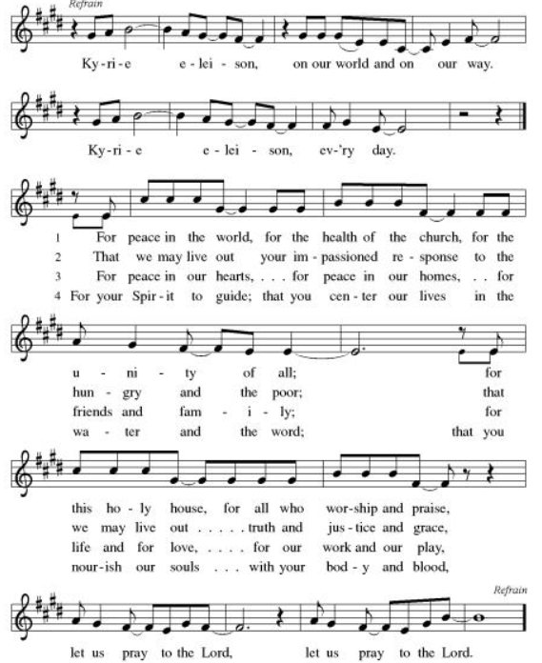

**Hymn of Praise: ELW Canticle of Praise: This Is The Feast (front of hymnal, pg #).
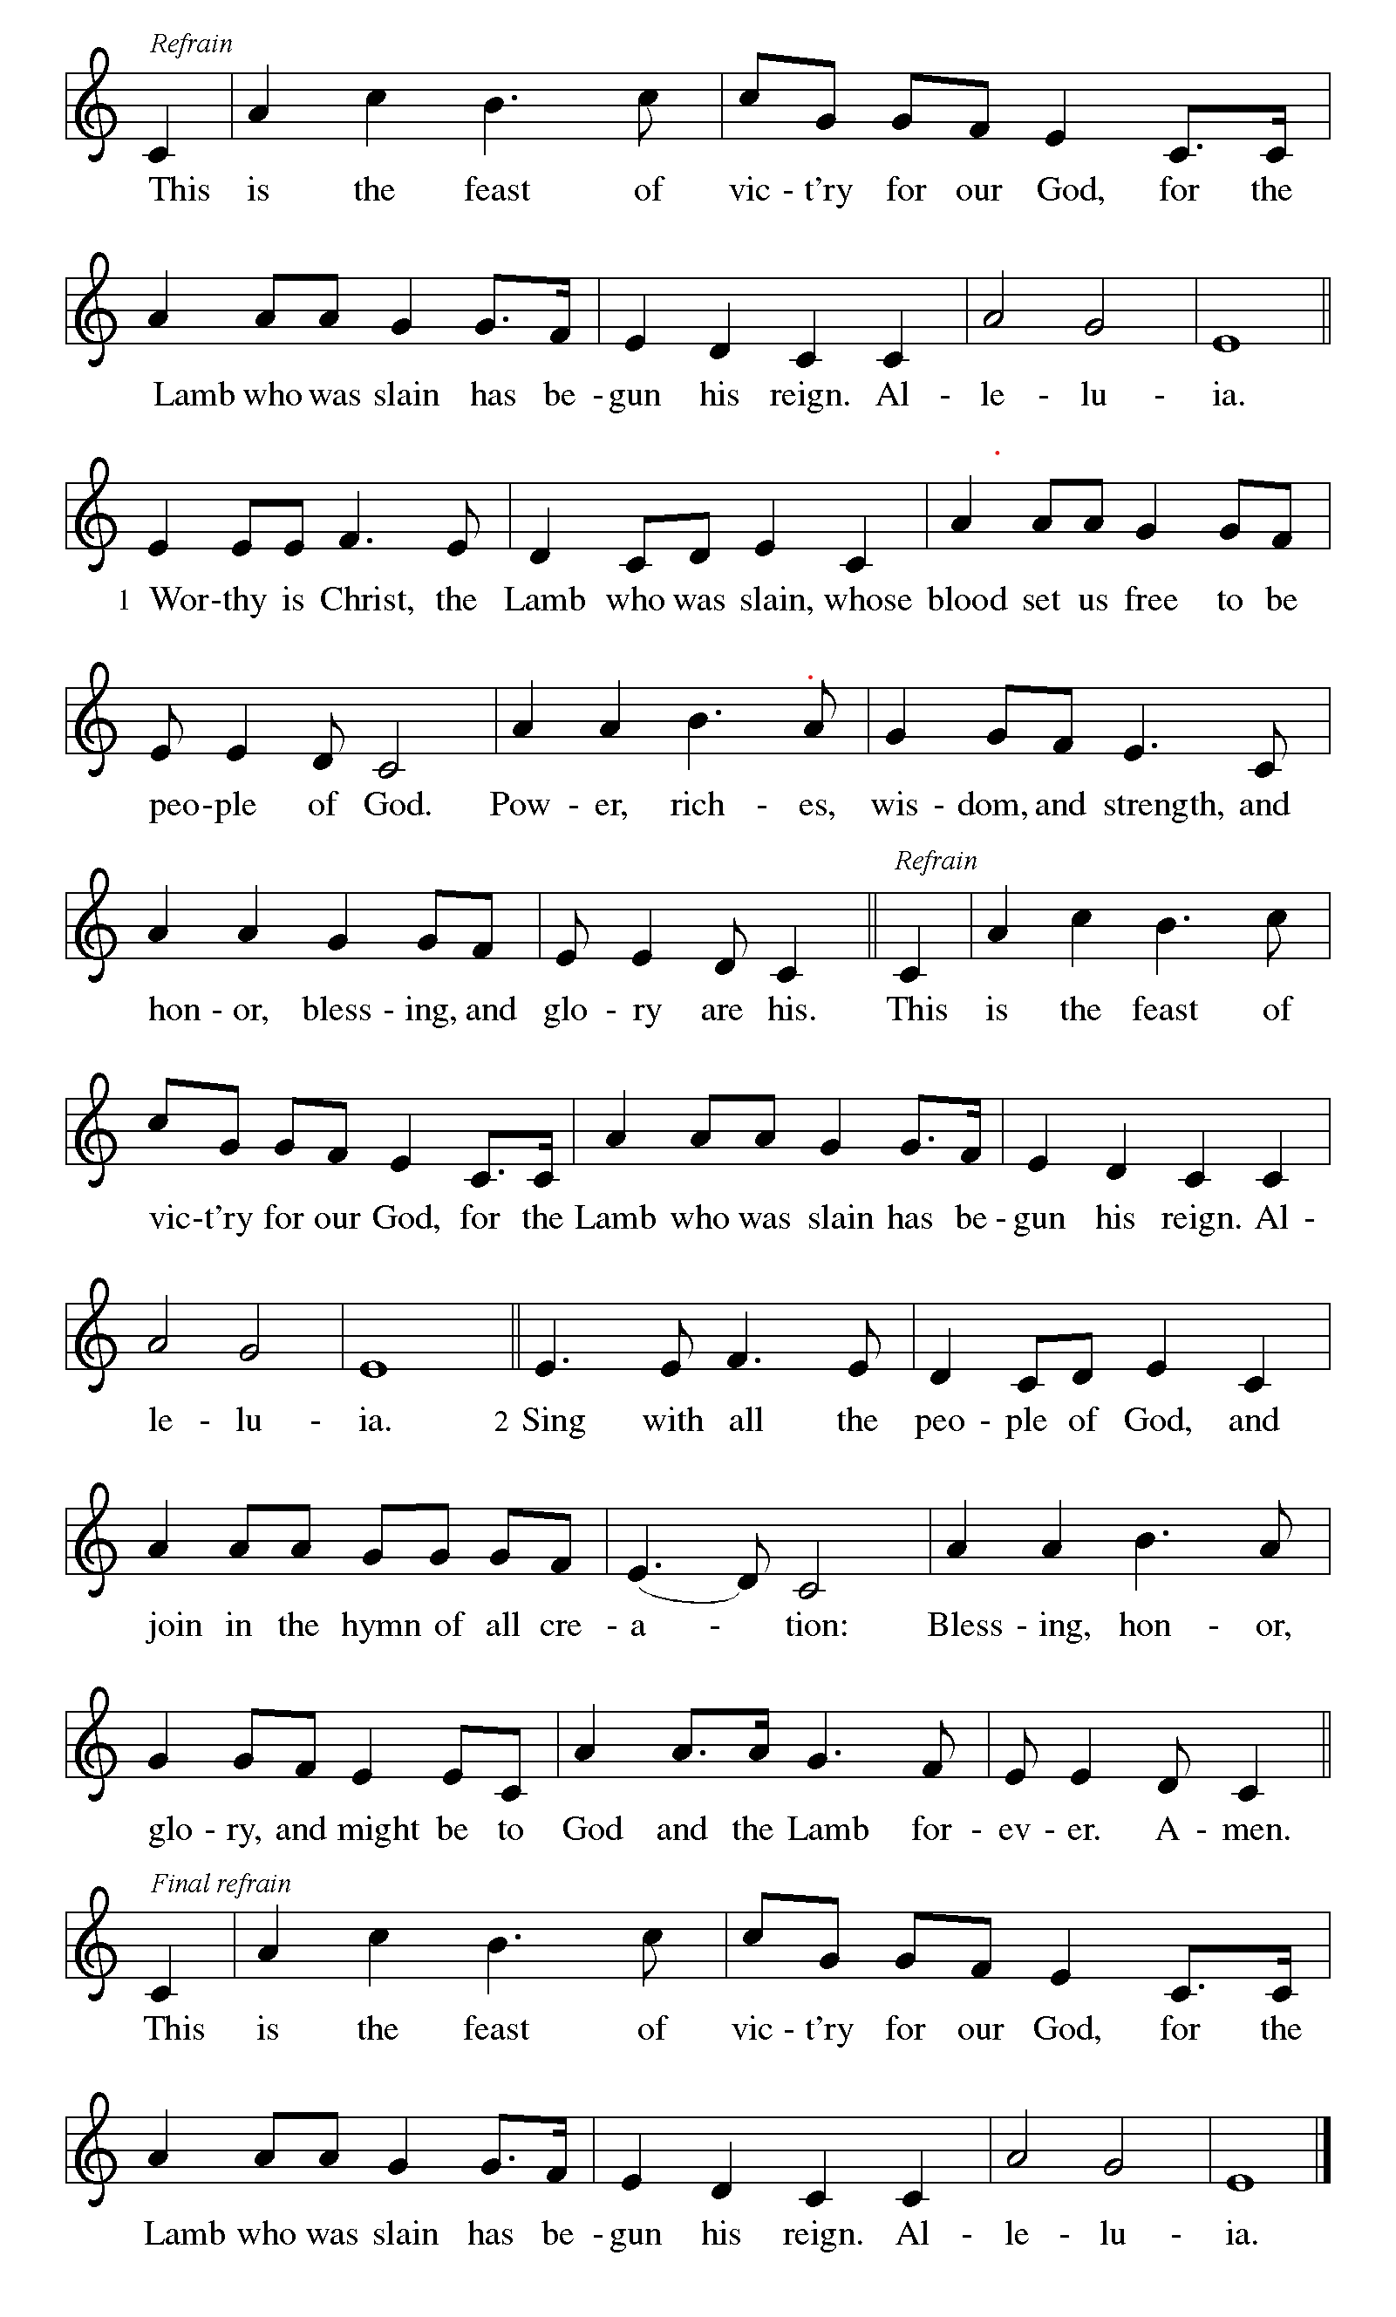
**Prayer of the Day
Abiding God, you call us then feed and nurture us. Now you send us out in the world you created with a purpose: to love our neighbors and care for those who need us. Strengthen us to do your work. In Jesus’ name we pray, amen.

Bells: Holy, Holy, Holy

Reading: Joseph in Prison - Genesis 39:1-23

¹When Joseph was taken down to Egypt by the Ishmaelites, he was sold to an official of the Pharaoh – Potiphar, a captain of the guard. ²God was with Joseph, so he became a success: while he lived in the Egyptian’s household, ³the official saw that God was with Joseph and brought him success in everything he did. ⁴Potiphar was so impressed by what he witnessed that he put Joseph in charge of the household and made him overseer of everything he owned. ⁵From the time Potiphar put Joseph in charge of the household and of all his holdings, God blessed the household of Potiphar because of Joseph. God blessed everything Potiphar owned, from house to fields. ⁶So the Egyptian left everything in Joseph’s hands and never worried about anything while Joseph was there, except what to eat.

Now Joseph was a handsome youth, and well-built, ⁷and in time Potiphar’s spouse noticed him and said, “Come to bed with me.”

⁸But he refused, saying, “Look, Potiphar doesn’t need to worry about anything to do with the household with me here. I am entrusted with everything you and he possess. ⁹He has made me his equal, and nothing has been withheld from me except you, for you are his wife. How could I do such a monstrous thing? I would be sinning against God to do so!” ¹⁰And though she pursued Joseph day after day, Joseph refused to have intercourse with her, or even listen to her.

¹¹One day when Joseph came into the house to carry out his duties, he noticed there were no workers in the household. ¹²Potiphar’s spouse grabbed Joseph’s loincloth, saying, “Come to bed with me!” But he left the loincloth in her hands and ran from the house.

¹³When she saw that he had left his loincloth and fled, ¹⁴she called for the household workers, and said, “Would you look at this! This Hebrew has come into our house to insult us! He came in to rape me, but I screamed, ¹⁵and he panicked and ran out of the house, leaving his loincloth behind.” ¹⁶She kept the loincloth beside her until Potiphar came home. ¹⁷She then related her version of the incident: “That Hebrew you brought us tried to rape me, ¹⁸but as soon as I screamed for help, he left this loincloth and ran from the house!”

¹⁹When Potiphar heard what his wife was telling him – “this is what your worker did to me!” – he was furious. ²⁰He had Joseph thrown into prison – the prison where Pharao’s prisoners are kept.

While Joseph was there in prison, ²¹God was with Joseph and showed him kindness, so that he soon won the favor of the warden. ²²Joseph was put in charge of the other inmates, supervising their work; whatever needed to be done, he was the one to do it. ²³The warden trusted him so much he hardly supervised his work, because God was with Joseph and made him successful in all his work.

Word of God, Word of Life
Thanks be to God

**Gospel Acclamation
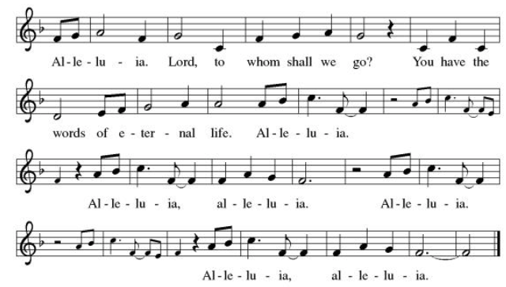
Announcement of the Gospel
Glory to you, O Lord.
Gospel: Matthew 5:11-12

¹¹[Jesus said,] “You are fortunate when others insult you and persecute you, and utter every kind of slander against you because of me. ¹²Be glad and rejoice, for your reward in heaven is great; they persecuted the prophets before you in the very same way.”

The Gospel of the Lord.
Praise to you, O Christ.

Sermon

Hymn of the Day Canticle of the Turning ELW #723

**Affirmation of Faith – Immigrant’s Creed by Jose Luis Casal

I believe in Almighty God, who guided the people in exile and in exodus, the God of Joseph in Egypt and Daniel in Babylon, the God of foreigners and immigrants.

I believe in Jesus Christ, a displaced Galilean, who was born away from his people and his home, who fled his country with his parents when his life was in danger. When he returned to his own country he suffered under the oppression of Pontius Pilate, the servant of a foreign power. Jesus was persecuted, beaten, tortured, and unjustly condemned to death. But on the third day Jesus rose from the dead, not as a scorned foreigner but to offer us citizenship in God’s kingdom.

I believe in the Holy Spirit, the eternal immigrant from God’s kingdom among us, who speaks all languages, lives in all countries, and reunites all races.

I believe that the Church is the secure home for foreigners and for all believers. I believe that the communion of saints begins when we embrace all God’s people in all their diversity. I believe in forgiveness, which makes us all equal before God, and in reconciliation, which heals our brokenness. I believe that in the Resurrection God will unite us as one people in which all are distinct and all are alike at the same time. I believe in life eternal, in which no one will be foreigner but all will be citizens of the kingdom where God reigns forever and ever. Amen.

**Prayers of Intercession

Holy God, our prayers rise to you like the wings of a dove. We call upon your name, and we ask that you hear us.

Center your church in humility as we strive to follow in your way. Help us listen to the cries of those who have been unfairly hurt by the church and dare to name difficult truths. Show all your love. Hear us, O God.
Your mercy is great.
You call us to care for your creation. Lead us into your promise of a better world through sustainable practices and respect for your handiwork. Hear us, O God.
Your mercy is great.
Inspire all in positions of authority to act honorably. Remind them of their call to use their authority for the sake of the common good. Give them the gift of humility. Hear us, O God.
Your mercy is great.
Comfort those who come before you in fear and trembling. Calm troubled hearts with your forgiveness. Help all those in need especially Monty & Marie, Paul, Helen, Linda, Kay, Becky H., Jim & Jan, Melian, Becky W., David, William & family, Judy, Peter & Carrie, Barbara & Donna, Brad & Chris, Drake, Bill & Sandy, Betsy and the people of Spokane, Washington, Hawaii, Indonesia, El Salvador, Honduras, Nicaragua, Nepal, and Tibet. Grant us your salvation. Hear us, O God.
Your mercy is great.
Change this congregation’s heart when we say no to your call. Open us to courageous learning and service in our community, especially in new or challenging places. Hear us, O God.
Your mercy is great.
Pave a way to justice, drown the forces of oppression, bring peace on earth. Give leaders the will to turn from war and violence. Especially we pray for the people of Cuba, Venezuela, Iran, Sudan, Gaza, Israel, and Ukraine. When people must flee their homes, guide them to safety. Comfort those living with deep trauma, anxiety, or fear; all those who serve people in need, and accompany all those who care for people in harm’s way. We also lift up Jim’s grandson, Dylan, who is deployed, and Sharon’s great nephew, Taylor, who is serving in the military. Hear us, O God.
Your mercy is great.
Your steadfast love holds all the saints who have finished their work and are at rest. As we grieve, remind us of your mercy so we may also give thanks. Hear us, O God.
Your mercy is great.
We lift up all who teach and all who learn. Thank you for teachers who share their knowledge and wisdom. Bless the students in our midst. Especially we remember Evie, in Elementary school; Addison, in high school; and Tyler and Zack, in college. Bless Lisa and Carla as they teach Loving God, all who die in faith have life with you. We give you thanks for the nearness of your salvation for all who have gone before us. Hear us, O God.
Your mercy is great.
Grant the prayers we have offered, what we have forgotten to ask, and whatever else you see that we need. We ask this in Jesus’ name.
Amen.

Good and loving God, we give everyone we have prayed for into your care. Amen.

** Sharing of the Peace

**Offering is brought forward

** Offertory Response Take Oh, Take Me As I Am ELW #814
** Offertory Prayer
Good and loving God, everything that we have and everything that we are comes from you.
We respond in gratitude, offering up to you our gifts of our money, our time, and our
talents. We dedicate these gifts to your service. In Jesus’ name we pray, amen.

Dialogue
Christ is with you!
And also with you!
Lift up your hearts in joyful praise!
We lift them up to God in joy!

**Preface: Since the earliest days of the covenant…this hymn of praise:
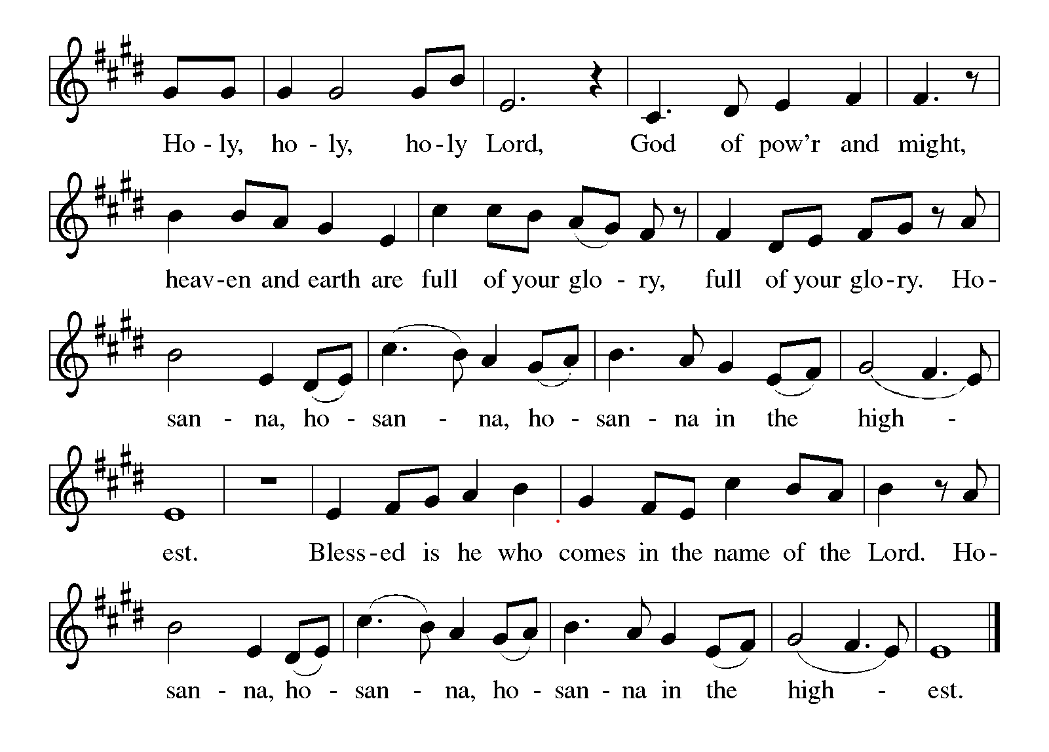

**words of institution

**LORD’S PRAYER
Our Father in heaven,
hallowed be your name,
your kingdom come,
your will be done,
on earth as in heaven.
Give us today our daily bread.
Forgive us our sins
as we forgive those
who sin against us.
Save us from the time of trial
and deliver us from evil.
For the kingdom, the power,
and the glory are yours,
now and forever. Amen.

Invitation to Communion

Communion Hymn Eat This Bread ELW472

**Sending Song Lord Jesus, You Shall Be My Song (verse 1) ELW #808

**Prayer After Communion

Abiding God, you call us then feed and nurture us. Now you send us out in the world you created with a purpose: to love our neighbors and care for those who need us. Strengthen us to do your work. In Jesus’ name we pray, amen.

** Blessing

** Closing Hymn Joyful, Joyful We Adore Thee ELW #836

**Dismissal

Go In Peace! Serve Your Neighbor!
THANKS BE TO GOD

+ + + + + +

Setting 08 from the Evangelical Lutheran Worship are under copyright and used with permission under One License #733618-A. Specific copyright information as listed in bulletin, the Prayers of Intercession are under copyright and are used with permission under Augsburg Fortress Liturgy License #SB155933. All other liturgy written by Sarah Pierce.

Weekly Attendance
Week of September 20: 17

Next Week:
19th Sunday after Pentecost:
Exodus 14:5-7, 10-14, 21-29; 15:20-21
Matthew 2:13-15

Calendar of Events

This Week
September 27 | Celebration - 5th year Anniversary of Pastor’s Ordination
September 30 | Bell Practice 6:30 pm
September 30 | 1pm - Oct 2 12:30 Pr. Sarah at Fall Theological Conference

Upcoming Events

October 03 | Blessing of the Animals
October 04 | Wear Your Work-clothes to Church - Work Day
October 11 | Zoo after services
October 14 | Council Meeting 6:30 pm
October 25 | Reformation Sunday
November 01 | All Saints Sunday  Celebration of Gifts  Service for the Healing of the World
November 11 | Council Meeting 6:30 pm
November 15 | Congregational Meeting, after worship
November 25 | Thanksgiving Eve Service 7:00 pm  Pie Night
November 26 - 27 | Thanksgiving - Office Closed
December 6 | Advent Dinner, after worship
December 19 | Council Meeting 6:30pm

******************************************************************************************
Pastor Sarah Questions:
Questions for Reflection and Discussion
1.

2.

3.

4.

******************************************************************************************
BLUE SPRINGS COMMUNITY SERVICE LEAGUE is very appreciative of your continued support of your neighbor.
Birthdays: none this week
September 27
Altar Guild – Sara Meyers
Reader – Tonya Hamilton
Greeter – Donna Taylor
Usher – Paul Blixrud
Tech – Gary Antes

Prayer Requests
Monty & Marie Health Concerns (March 04)
Paul Health Concerns (May 31)
Mary Health Concerns (May 15)
James & Family Health Concerns (September 11)
William and Family Health Concerns (September 25)
Becky H Health Concerns (October 28)
David Health Concerns (November 18)
Becky W Health Concerns (November 18)
Judy Health Issues (December 16)
Kay (Sara’s cousin) Health Concerns (July 15)
Sharon Health Concerns (October 22)
Michael Health Concerns (October 22)
Peter and Carrie Health Concerns (November 26)
Melian Health Concerns (November 16)
RJ Health Concerns (November 17)
Barbara Health Concerns (December 30)
Helen Health Concerns (February 25)
Chris Health Concerns (June 09)
Drake Issues (August 11)
Bill & Sandy Health Issues (August 12)
Betsy Surgery Sept. 17th (September 2)

Merciful God, your justice and mercy are without limits. Bring courage and resilience to those who resist tyranny with their words and their bodies. Strengthen those who fight for justice in your name across the country, and around the world.

Please pray for the people of Venezuela & Iran, Sudan, Gaza, Ukraine, Israel, Cuba, Iran and Palestine.
Please pray for the Homeless.
Please pray for legal & illegal immigrants & those seeking asylum or citizenship

