All Saints Lutheran Church, ELCA
421 SW 19th St. Blue Springs, Missouri 64015 816-229-3633
Pastor Sarah Pierce Spierce.aslcpastor@gmail.com
allsaintslc64015@gmail.com https://aslcbs.org/

Sunday, February 01, 2026

Fourth Sunday of Epiphany

You are absolutely invited into this sacred space. We welcome all who are seeking God’s love and grace. All Saints recognizes that we are all unique and beloved children of God. We celebrate and give thanks for the many diverse gifts that God has given us. We affirm the sacredness of people of all sexual orientations, gender identities, and gender expressions. We affirm the sacredness of all those who have experienced exclusion because of race, ability, age, or culture. We are committed to working towards anti-racism in ourselves and our community. We affirm the sacredness of all those who wrestle with addiction, physical or mental health, imprisonment, socio-economic circumstances, or anything that too often divides us. We believe that through our openness we all grow in our faith through Christ’s teaching to love one another as God loves us. We need each other and our sincere hope is by being in community together, we will experience God’s presence in new and real ways.

The offering plate is by the main door to the sanctuary for your convenience.

We practice open communion at All Saints Lutheran Church. What does that mean? It means that if you believe and trust that Christ offers his body and blood For You, you are welcome at the table. At All Saints, we believe that Christ invites all people to the feast. “Come to the banquet for all is now ready.”

**Stand as you are comfortable

Prelude

Announcements

** Affirmation of Baptism

God prepares a way for us, a path through the desert. In our baptisms, Jesus calls us to follow that path, and we receive the gift of the Holy Spirit, empowering us to answer Jesus’ call. But sometimes, we forget the gift of forgiveness and unending love that we have been given, and we need to be reminded.

Jesus, sometimes we forget to listen to your call. We forget about the power of our baptisms. Sometimes, we get distracted with other things and forget to place you first. We ask that you help us to turn back to you when we turn away. We ask you to help us recenter our lives on you, so that we remember the power of our baptisms. We pray that we can feel your presence in our lives.

We ask you to receive our prayers and to be with us, today and forever. We pray that your presence shines through us to those who most need to see it.
Let your light so shine before others that they may see your good work and glorify God in heaven.

Holy and loving God, we thank you for the gift of forgiveness. We thank you for the gift of your unconditional love.

Holy and loving Jesus, we thank you for the gift of the baptism which frees us from the power of sin and death, for all time. We thank you for showing us how to live in that freedom.

Holy and loving Spirit, we thank you for infusing us with your presence. Empower us to live out our baptismal call to proclaim Christ through word and deed, to care for others and for the world, and to work for justice and peace. Amen.

**Entrance Hymn Give Me Jesus ELW#770

**Greeting
The grace of our Lord Jesus Christ, the love of God,
and the communion of the Holy Spirit be with you all.
And also with you.

**Kyrie
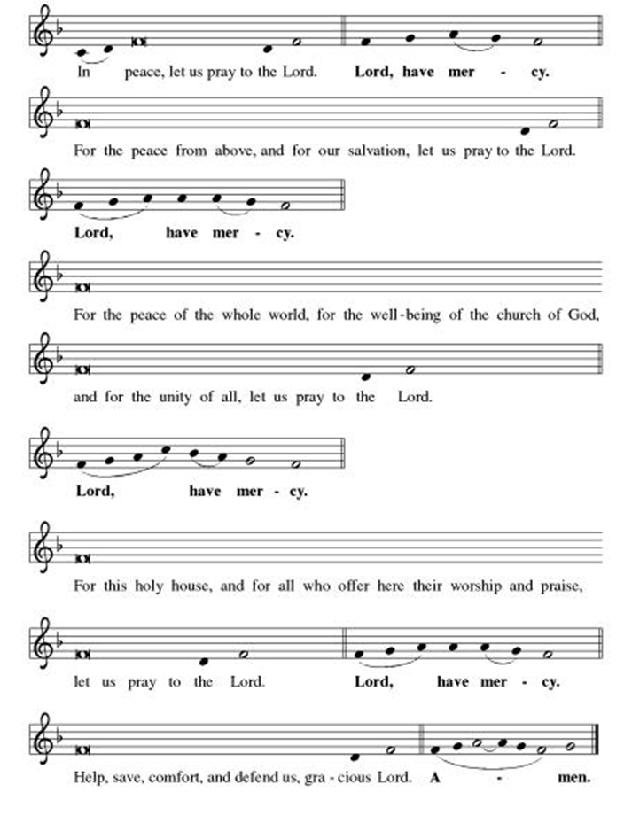

**This is the Feast
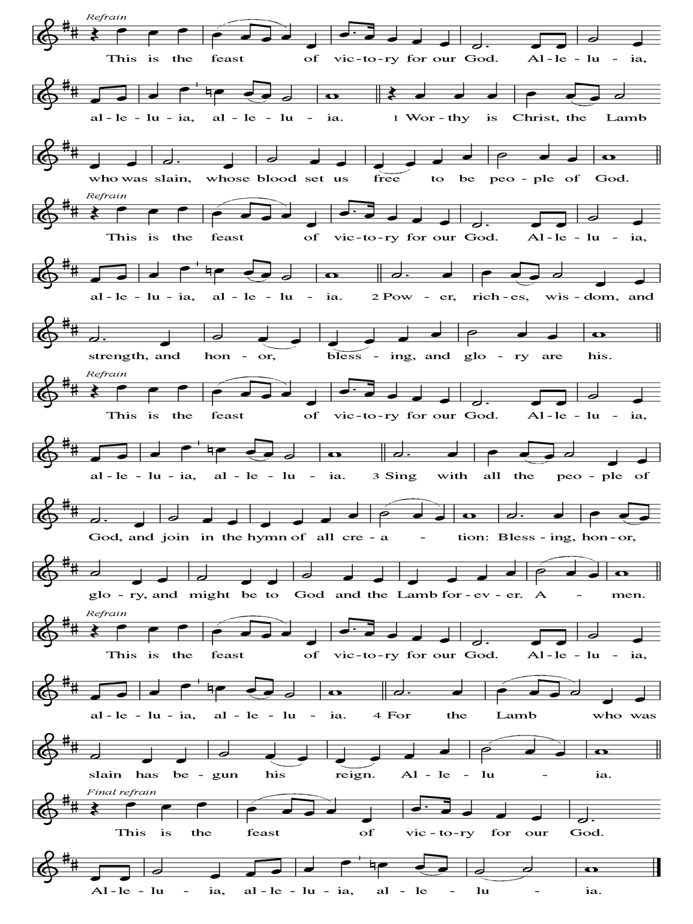
**Prayer of the Day
Holy One, you love all people, and the world, more than we can possibly comprehend. Help us to feel your love in some small way, and to reap what you have sown throughout the world: love, and justice, and compassion. We pray this in Jesus’ name. Amen.

Reading: Psalm 42:1-3

¹Like a stag, a doe,
longing for streams of cool water,
my whole being longs for you, my God.
²My soul aches with thirst for God,
for a god that lives!
When can I go and see God face to face?
³My only food, day or night, is my tears;
they recriminate me:
“Where is your God?” they say.

Word of God, Word of Life
Thanks be to God

**Gospel Acclamation

**Alleluia
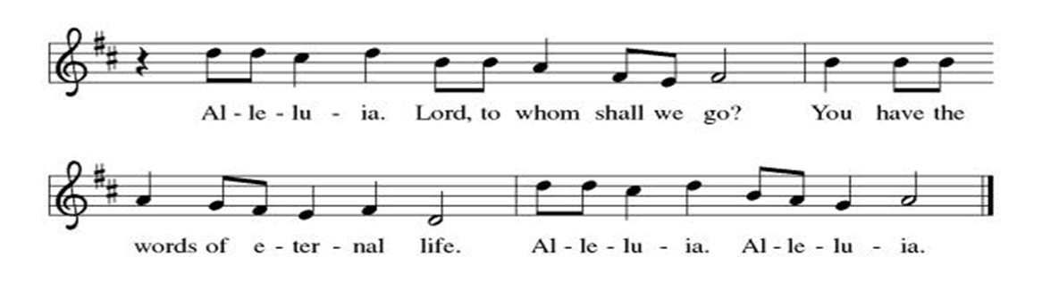
Announcement of the Gospel
Glory to you, O Lord.

Gospel: John 4:1-42

Narrator: When Jesus learned that the Pharisees had heard he was attracting and baptizing more disciples than John —though it was really not Jesus baptizing, but his disciples—he left Judea and returned to Galilee. This meant that he had to pass through Samaria. He stopped at Sychar, a town in Samaria, near the tract of land Jacob had given to his son Joseph, and Jacob’s Well was there. Jesus, weary from the journey, came and sat by the well. It was around noon when Samaritan woman came to draw water.

Jesus: “Give me a drink.”

Narrator: The disciples had gone off to the town to buy provisions.

Woman: “You’re a Jew. How can you ask me, a Samaritan, for a drink?”

Narrator: Jews had nothing to do with Samaritans.
Jesus: “If only you recognized God’s gift, and who it is that is asking you for a drink, you would have asked him for a drink instead, and he would have given you living water.”

Woman: “If you please, you don’t have a bucket and this well is deep. Where do you expect to get this ‘living water’? Surely you don’t pretend to be greater than our ancestors Leah and Rachel and Jacob, who gave us this well and drank from it with their descendants and flocks?”

Jesus: “Everyone who drinks this water will be thirsty again. But those who drink the water I give them will never be thirsty; no, the water I give will become fountains within them, springing up to provide eternal life.”

Woman: “Give me this water, so that I won’t grow thirsty and have to keep coming all the way here to draw water.”

Jesus: “Go, call your husband and then come back here.”

Woman: “I don’t have a husband.”

Jesus: “You’re right—you don’t have a husband! “The fact is, you’ve had five, and the man you’re living with now is not your husband. So what you’ve said is quite true.”

Woman: “I can see you’re a prophet. Our ancestors worshiped on this mountain, but you people claim that Jerusalem is the place where God ought to be worshiped.”

Jesus: “Believe me, the hour is coming when you’ll worship Abba God neither on this mountain nor in Jerusalem. You people worship what you don’t understand; we worship what we do understand—after all, salvation is from the Jewish people. Yet the hour is coming—and is already here—when real worshipers will worship Abba God in Spirit and truth. Indeed, it is just such worshipers whom Abba God seeks. God is Spirit, and those who worship God must worship in spirit and truth.”

Woman: “I know that the Messiah—the Anointed One—is coming and will tell us everything.”

Jesus: “I who speak to you am the Messiah.”

Narrator: The disciples, returning at this point, were shocked to find Jesus having a private conversation with a woman. But no one dared to ask, “What do you want of him?” or “Why are you talking with her?” The woman then left her water jar and went off into the town. She said to the people,

Woman: “Come and see someone who told me everything I have ever done! Could this be the Messiah?”

Narrator: At that, everyone set out from town to meet Jesus.

Disciples: “Rabbi, eat something.”

Jesus: “I have food to eat that you know nothing about.”

Disciples: “Do you think someone has brought him something to eat?”

Jesus: “Doing the will of the One who sent me
and bringing this work to completion
is my food.
Don’t you have a saying,
‘Four months more
and it will be harvest time’?
I tell you,
open your eyes and look at the fields—
they’re ripe and ready for harvest!
Reapers are already collecting their wages;
they’re gathering fruit for eternal life,
and sower and reaper will rejoice together.
So the saying is true:
‘One person sows; another reaps.’
I have sent you to reap
what you haven’t worked for.
Others have done the work,
and you’ve come upon the fruits of their labor.”

Narrator: Many Samaritans from that town believed in Jesus on the strength of the woman’s testimony—

Woman: “he told me everything I ever did.”

Narrator: The result was that, when these Samaritans came to Jesus, they begged him to stay with them awhile. So Jesus stayed there two days, and through his own spoken word many more came to faith.

Samaritans: “No longer does our faith depend on your story. We’ve heard for ourselves, and we know that this really is the savior of the world.”

The Gospel of the Lord.
Praise to you, O Christ.

Sermon "It's a Love Story"

Hymn of the Day For All the Faithful Women (v. 1,2,8. last) ELW#419

**Affirmation of Faith – Immigrant’s Creed by Jose Luis Casal

I believe in Almighty God, who guided the people in exile and in exodus, the God of Joseph in Egypt and Daniel in Babylon, the God of foreigners and immigrants.

I believe in Jesus Christ, a displaced Galilean, who was born away from his people and his home, who fled his country with his parents when his life was in danger. When he returned to his own country he suffered under the oppression of Pontius Pilate, the servant of a foreign power. Jesus was persecuted, beaten, tortured, and unjustly condemned to death. But on the third day Jesus rose from the dead, not as a scorned foreigner but to offer us citizenship in God’s kingdom.

I believe in the Holy Spirit, the eternal immigrant from God’s kingdom among us, who speaks all languages, lives in all countries, and reunites all races.

I believe that the Church is the secure home for foreigners and for all believers. I believe that the communion of saints begins when we embrace all God’s people in all their diversity. I believe in forgiveness, which makes us all equal before God, and in reconciliation, which heals our brokenness. I believe that in the Resurrection God will unite us as one people in which all are distinct and all are alike at the same time. I believe in life eternal, in which no one will be foreigner but all will be citizens of the kingdom where God reigns forever and ever. Amen.

**Prayers of Intercession

Jesus, you came to live with us on earth so that we would know you love us no matter what. Listen to the prayers we lift to you.

God our wisdom, renew the church in the power of the Spirit, that it may do justice, love kindness, live humbly, and boldly proclaim Christ crucified. We pray for social justice and humanitarian aid ministries. Merciful God,
receive our prayer.
God our source, we honor you by caring wisely for your creation. We pray for the health of old growth forests, ice caps, and ocean currents. Preserve the diversity of life on earth. Merciful God,
receive our prayer.
God our righteousness, raise up visionary leaders who serve with integrity and respect human rights. Increase freedom in every nation. Protect educators, journalists, artists, and religious activists who are reviled for speaking truth. Merciful God,
receive our prayer.
God our advocate, you give hope to all who suffer because of persecution, poverty, or war. Reunite separated families and bring orphaned children to safety. Comfort any who grieve or suffer in any way especially Monty, Paul, Linda, Betty F., Kay, Becky H., Jim & Jan, Melian, Becky W., David, William & family, Helen, Larry & Judy, Otto, Kevin, Peter & Carrie, Barbara & Donna, families in our community who endure hunger, and our beloved for whom death is near. Merciful God,
receive our prayer.
God our blessing, we pray for the children and youth of this congregation, and for parents, grandparents, mentors, teachers, and youth ministers who model love for their neighbor and care for others. Merciful God,
receive our prayer.
Pave a way to justice, drown the forces of oppression, bring peace on earth. Give leaders the will to turn from war and violence. Especially we pray for the people of Venezuela, Sudan, Gaza, Israel, and Ukraine, and for Jim’s grandson Dylan, who is deployed. When people must flee their homes, guide them to safety. Comfort those living with deep trauma, anxiety, or fear; all those who serve people in need, and accompany all those who care for people in harm’s way. Merciful God,
receive our prayer.
We pray for people who rise up against injustice. Bring courage and resilience to those who resist tyranny with their words and their bodies. Strengthen those who fight for justice in your name across the country, and around the world. Protect and sustain immigrants and refugees and all who work with them, that your kingdom, without borders and without walls, may truly come on earth as it is in heaven. We pray for all victims of gun violence or kidnapping, especially those who are targeted out of hate or fear. Embolden us to holy outrage and empower us to speak our truth of love and justice. Merciful God,
receive our prayer.
We lift up all who teach and all who learn. Thank you for teachers who share their knowledge and wisdom. Bless the students in our midst. Especially we remember Evie, in kindergarten; Addison, in high school; and Tyler, Zach, Katie and Katy, in college. Bless Janet and Lisa as they teach. Merciful God,
receive our prayer.
od our joy, we give thanks for the lives of those before us who journeyed humbly with you. Merciful God,
receive our prayer.

Loving God, because you lived among us, we know that you hear our prayers and hold close all for whom we pray. Amen

** Sharing of the Peace

**Offering is brought forward

** Offertory Response Let Us Talents and Tongues Employ (V. 1) ELW#674

Blessing for CSL Gifts

**Offertory Prayer
God of abundance, with thanks, we return to you the gifts you have given us so freely. Bless these offerings of our time, our talents, and our treasure. Shape us to be your hands and feet. Use our gifts to shower each other, our communities, and the world with your loving kindness. All this we ask in Jesus’ name. Amen.

**Dialogue
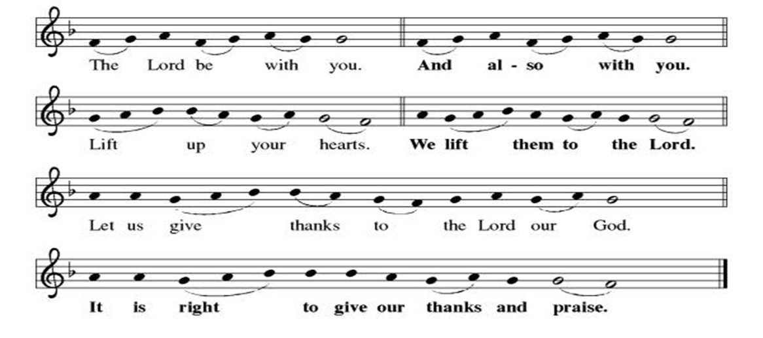

**Preface: From the beginning of time…this hymn of praise:

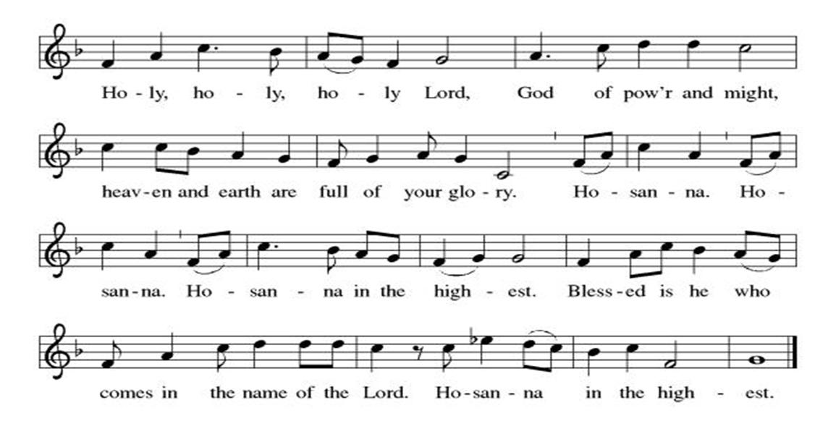
** Thanksgiving at the Table

**LORD’S PRAYER
Our Father in heaven,
hallowed be your name,
your kingdom come,
your will be done,
on earth as in heaven.
Give us today our daily bread.
Forgive us our sins
as we forgive those
who sin against us.
Save us from the time of trial
and deliver us from evil.
For the kingdom, the power,
and the glory are yours,
now and forever. Amen.

Invitation to Communion

Communion Hymn All Who Hunger. Gather Gladly ELW#461

**Post-communion prayer

Holy One, Human and Divine, we give you thanks for the life-giving invitation to gather at your table and be fed. Strengthen us now for your service, and send us out from this place renewed in our commitment to love you and serve each other and all of creation. Send your Spirit upon us, so that we can proclaim your blessings to a world that hungers to receive them. All this we ask in your name, the one who is, who was, and who is to come. Amen.

**Sending Song

Listen, God Is Calling (refrain, V. 1, refrain) ELW#513

**Benediction

**Closing Hymn Take My Life, That I May Be ELW#685

**Dismissal

Go in peace. Share the good news!
THANKS BE TO GOD!

+ + + + + +

Hymns from the Evangelical Lutheran Worship are under copyright and used with permission under One License #733618-A. ELW setting #3 the Prayers of Intercession are under copyright and are used with permission under Augsburg Fortress Liturgy License #SB155933. All other liturgy written by Sarah Pierce.

Weekly Attendance

Week of January 25

Service was cancelled to snow

Next Week:
Fifth Sunday after Epiphany

The Color of the day is Green
Psalm 40 1-5
John 4:46-54, 5:1-18

Calendar of Events
Today
- Adult Bible Study
- CSL Blessing
Upcoming Week
- February 04 Paint Party Fundraiser
- February 05 Zoom Presentation: ELCA Social Statement
February 08 | Souper Bowl for CSL  Special Offering for Hollis
February 11 | Church Council Meeting 6:30 pm
February 12 | BSCT Bingo Event
February 15 | Pre-Lent Ice Cream Social after Church
February 18 | Ash Wednesday  God’s Global Barn yard begins February 18-April 05
February 22 | Coffee with Council
March 04 | Paint Party Fundraiser
March 15 | Church Council Meeting 6:30 pm
March 22 | Coffee with Council
March 29 | Palm Sunday
April 01 | Paint Party Fundraiser
April 02 | Maundy Thursday
April 05 | Easter Sunday
April 06 | Church Council Meeting 6:30 pm
April 26 | Coffee with Council
May 06 | Paint Party Fundraiser
May 10 | Mother’s Day
May 13 | Church Council Meeting 6:30 pm
May 17 | Congregational Meeting
May 24 | Pentecost
May 25 | Memorial Day
June 03 | Paint Party Fundraiser
June 19 | Juneteenth Office Closed
July 01 | Paint Party Fundraiser
July 04 | Independence Day
July 26 | Coffee with Council  Celebrate Niel’s Birthday (July 28)
Note: 2006 paint party fundraisers: Feb. 4, March 4, April 1, May 6, June 3, July 1, Aug. 5, Sept. 2, Oct. 7, Nov. 4, Dec. 2
Note: Theater group church use: auditions Feb. 6&7, 6:30-9:30; callbacks Feb. 8, 1-5; rehearsals MWF & Saturday, Feb.16-April 18, MWF 6:30-9:30 and Saturdays 12-4.
**All Saints no longer has a source to reuse old greeting cards.
Pastor Sarah Questions

- Other than a brief interlude with John, this story follows immediately after the story of Nicodemus in chapter 3, and it contrasts sharply with that story in several key ways (including the time of day, their genders, their roles in life, his name/her lack of name). Why should/shouldn’t we read these two stories together? How does each story help us interpret the other?
- In verse 4, “had to” in Greek is eidi, which means “it was necessary.” This word is used 10 times in John, one of those times to refer to the crucifixion. That means we’re probably talking about a theological necessity, not a literal necessity, such as this being the only way – it wasn’t. It was the shortest route, but it wasn’t the most common, especially for Jews, who would become ritually unclean by coming into contact with Samaritans.
- The interchange between Jesus and the woman where he seems (to our eyes) to abruptly change subjects to ask her to bring her husband, and the subsequent comment about her five previous husbands, and current living situation, has been interpreted often by Christian preachers and theologians as condemnatory on Jesus’ part, as though she is particularly sinful/immoral. There is nothing in the text that points to this. In fact, every single commentary I read this week, as well as the podcast I listened to, cautioned against this interpretation, and even noted that it may be important to offer correctives against it. She is most likely barren. Levirate marriage is defined in Deuteronomy 25:5-10 and can be summed up this way: if a man dies and leaves a wife but no son, brother should marry her, or take her into his home, so that she can conceive and bear a son. (This gives someone to inherit her original husband’s property, as well as someone to care for her when she gets old.) There are punishments for men who refuse to honor this commitment, but the woman has no choice. She could also be divorced by her husband for being barren; so she may have some combination of being widowed and divorced in her past. And whoever she’s currently living with is either a brother-in-law who took her in but would not marry her, or someone who took pity on her because she was destitute.
- Just to round out her story, this probably explains her comment in verse 39 of “he told me everything I ever did;” barrenness was thought to be the result of some offense against God. And so, even though she had done nothing to cause it, she’s living into her new vocation of being a witness by speaking to her community in language they will understand, reshaping her narrative in the light of Jesus’ presence.
- Two last comments about the woman: if the words “Come and see” ring a bell for you in verse 29, go back and look and re-read John 1:35:51, our text from January 4. Additionally, some scholars suggest that she is nameless because we are more likely to identify with nameless characters.
- A few things about verses 34-48: Jesus and his disciples have just left Jerusalem after the Passover, which occurs 4 months before the Festival of Booths in the Jewish calendar, which occurs at the celebration of the harvest. So when Jesus asks them about their saying about “Four months more…” it is literally 4 months until the harvest on the calendar. And then he moves into the world of metaphor: he is the sower and the disciples (and the woman, and anyone else who follows Jesus) are the reapers; their work is indistinguishable from his. The woman has realized that, and has gone out to invite people; Jesus is saying to the disciples, in essence, “See what she just did? Y’all go do that too!” How do we reap the message Jesus sows? How are we to reap the message Jesus sows?

*****************************************************************************************
BLUE SPRINGS COMMUNITY SERVICE LEAGUE is very appreciative of your continued support of your neighbor.
*****************************************************************************************
The Central States Synod and Kansas Interfaith Action present “We the People: a virtual series on faith & public life”
- Thursday, February 05 6:30pm: “Diving Into the ELCA Social Statement on Faith and Civic Life” with Dr. Jim Brandt

We will join all of these sessions from the sanctuary via Zoom.

February 01
Lector – Tonya Hamilton
Greeter – Donna Taylor
Tech – Gary Antes

Prayer Requests
Monty Health Concerns (May 15)
Paul Health Concerns (May 31)
Mary Health Concerns (May 15)
James & Family Health Concerns (September 11)
Betty F (Sara’s friend) Health Concerns (July 15)
William and Family Health Concerns (September 25)
Becky H Health Concerns (October 28)
David Health Concerns (November 18)
Becky W Health Concerns (November 18)
Larr & Judy Health Issues (December 16)
Helen Health Issues (January 14)
Otto Health Concerns (July 15)
Kay (Sara’s cousin) Health Concerns (July 15)
Kevin Health Concerns (October 01)
Sharon Health Concerns (October 22)
Michael Health Concerns (October 22)
Peter and Carrie Health Concerns (November 26)
Melian Health Concerns (November 16)
RJ Health Concerns (November 17)
Barbara Health Concerns (December 30)

Merciful God, your justice and mercy are without limits. Bring courage and resilience to those who resist tyranny with their words and their bodies. Strengthen those who fight for justice in your name across the country, and around the world.

Please pray for the people of Venezuela, Sudan, Gaza, Ukraine, Israel, Iran and Palestine.
Please pray for the Homeless.
Please pray for legal & illegal immigrants & those seeking asylum or citizenship

