**All Saints Lutheran Church, ELCA**

**421 SW 19th St. Blue Springs, Missouri 64015 816-229-3633**

**Pastor Sarah Pierce** Spierce.aslcpastor@gmail.com

[allsaintslc64015@gmail.com](mailto:allsaintslc64015@gmail.com) <https://aslcbs.org/>

## Sunday, August 31, 2025

## Twelfth Sunday after Pentecost

## *You are absolutely invited into this sacred space.  We welcome all who are seeking God’s love and grace.  All Saints recognizes that we are all unique and beloved children of God.  We celebrate and give thanks for the many diverse gifts that God has given us.  We affirm the sacredness of people of all sexual orientations, gender identities, and gender expressions.  We affirm the sacredness of all those who have experienced exclusion because of race, ability, age, or culture. We are committed to working towards anti-racism in ourselves and our community. We affirm the sacredness of all those who wrestle with addiction, physical or mental health, imprisonment, socio-economic circumstances, or anything that too often divides us.  We believe that through our openness we all grow in our faith through Christ’s teaching to love one another as God loves us.  We need each other and our sincere hope is by being in community together, we will experience God’s presence in new and real ways.*

*The offering plate is by the main door to the sanctuary for your convenience.*

*We practice open communion at All Saints Lutheran Church. What does that mean? It means that if you believe and trust that Christ offers his body and blood For You, you are welcome at the table. At All Saints, we believe that Christ invites all people to the feast. “Come to the banquet for all is now ready.”*

***\*\*Stand as you are comfortable***

***Prelude***

***Announcements***

**\*\* Confession and Forgiveness**

As with Esther and Mordecai, in times of uncertainty and challenge, we seek Your

divine wisdom to guide our hearts and minds.

**When we try to figure things out on our own and forget to go to you for clarity**

**and discernment, forgive us, O God.**

**When we lose trust in you because times are so difficult, painful and scary, help us trust you. Remember us, O God, in our time of need. Give us courage when we need it. Help us listen for your voice amidst the chaos. Shine your light on our path and lead us to choices that honor you and bring peace to the world.**

God remains faithful at all times and in all places. Even when we turn our backs on God, God never abandons us. God always forgives our sins + and gives us the strength and courage to start again.

**Amen.**

***\*\*Entrance Hymn All Depends on Our Possessing ELW #589***

***\*\*Greeting***

The grace of our Lord Jesus Christ, the love of God,

and the communion of the Holy Spirit be with you all.

**And also with you.**

**\*\*Kyrie**

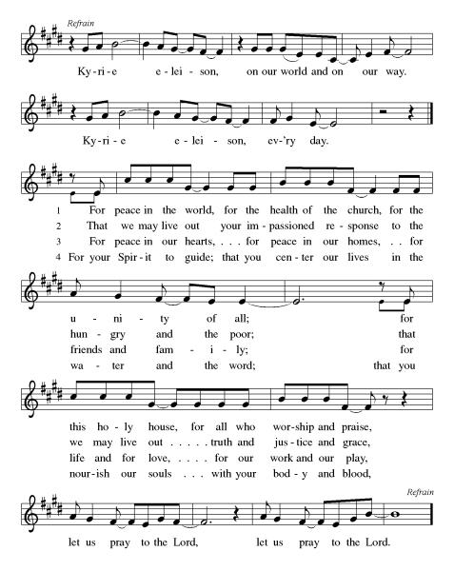

***\*\*Prayer of the Day***

**Eternal God, you call us to holiness, but we don’t always know how to do that in our messy world. As you gifted Esther with wisdom and inspired her to lead her people, show us the gifts you have given us, and empower us to use them for your service. In Jesus’ name we pray. Amen.**

***Reading:*** **Esther 8:3, 5-17; 9:1b-6, 10-27a**

3Then Esther spoke to the ruler again. Showing him honor, she asked him to stop all of the violence that Haman had planned against the Jewish people.

5Esther said, “If it is your will, and if I have pleased you, issue a decree rescinding the letter that Haman wrote and sent, ordering the destruction of the Jewish people throughout the empire. 6How can I watch my people be destroyed?”

7Ahasuerus said to Esther, “I have given all of Haman’s property to you and hung him on a tree because he acted against the Jewish people. 8Now write a letter in my name ordering what you think best, and seal it with the royal seal. Whatever is written at my command and sealed with my ring can never be defied.”

9The scribes were summoned on the twenty-fourth day of the first month, Nisan, of that same year. All that was commanded with respect to the Jewish people was written in a letter to the administrators and governors of the provinces from India to Ethiopia—one hundred twenty-seven in all, each with its own culture and language. 10The order was issued with the full authority of the emperor and sealed with the imperial seal, and then sent out by messengers.

11In the letter Ahasuerus ordered that the Jewish community in each city be allowed to observe their own laws, defend themselves, and act as they wished against their enemies.

15Mordecai left Ahasuerus’ presence clothed in royal robes made from purple and white cotton and wearing a golden crown and a turban made from purple linen. 16All of Susa shouted for joy when they saw Mordecai, and there was a great celebration in the Jewish community. 17Throughout the provinces and in every city, wherever the decree was read, there was great rejoicing and celebration among the Jews there. Many people of the land became Jewish, because Jews were now feared.

9:1bThe day on which the enemies of the Jewish community had planned to destroy them, the opposite occurred: it was the Jews who destroyed their enemies. 2Throughout Ahasuerus’ provinces, the Jews gathered to defend themselves against those who had planned to hurt them. People everywhere were afraid, and would not stand against the Jewish community. 3The provincial governors, administrators and royal scribes paid honor to them because they were afraid of Mordecai. 4The emperor’s decree required that Mordecai’s name be held in honor throughout the empire.

5The Jewish people struck down their enemies with the sword and laid to waste all their foes. 6In the city of Susa, they killed five hundred people, including 10the ten children of Haman ben-Hammedatha, the enemy of the Jewish community. But they did not indulge themselves in plunder.

11That same day, the number of those killed was reported to the emperor. 12Ahasuerus said to Esther, “Your people have killed five hundred people in Susa alone. How many more can they be killing in the provinces? Tell me what you desire and I will grant it!”

13Esther said, “Allow my people to do the same thing tomorrow. And hang the bodies of Haman’s children in public view.”

15Ahasuerus permitted this to be done, and handed over the bodies of Haman’s children to the Jewish community. They gathered together on the fourteenth day and killed three hundred people, but again took no plunder.

16The other Jewish people in the empire gathered to defend themselves and fended off their enemies. They vanquished fifteen thousand of their enemies, but did not plunder their houses. 17On the fourteenth day, they stopped their fighting and turned that day into a day of rest, celebrating it with gladness and joy. 18The Jewish community in the capital city of Susa did not stop fighting on the fourteenth day, but they did stop on the fifteenth day. 19This is why the Jewish community in the countryside celebrates the feast on the fourteenth day of Adar – a time of celebrating gifts to one another while those who live in the cities celebrate the fifteenth day of Adar.

20Mordecai wrote down all these things in a scroll and sent copies to all the Jewish communities throughout the empire of Ahasuerus, both far and near, 21telling them that they should keep the fourteenth and fifteenth day of Adar, 22the days that they vanquished their enemies. They were to commemorate the entire month of Adar, for it was in that month when their lot had been changed from sorrow to joy. They were told to observe these days with celebrations and feasts, giving gifts of food to friends and to the poor. 23And the Jewish community observed all that Mordecai had said.

24Mordecai wrote how Haman ben-Hammedatha, a Macedonian, tried to destroy the Jewish people, how he sent a decree and cast lots to determine the day that he would destroy them, 25and how he had gone to the emperor to ask that Mordecai be hung from a gallows. But Haman fell into the very trap he had set for the Jewish community—both he and his children were hung on the gallows. 26And so, from Mordecai’s suggestion and because of the great suffering that they experienced, 27the Jewish people established these days as the Feast of Purim.

Word of God, Word of Life

**Thanks be to God**

**Fifth Sunday Conversation**

***Hymn of the Day* God, Whose Almighty Word ELW#673**

\*\***Affirmation of Faith – Immigrant’s Creed by Jose Luis Casal**

**I believe in Almighty God, who guided the people in exile and in exodus, the God of Joseph in Egypt and Daniel in Babylon, the God of foreigners and immigrants.**

**I believe in Jesus Christ, a displaced Galilean, who was born away from his people and his home, who fled his country with his parents when his life was in danger. When he returned to his own country he suffered under the oppression of Pontius Pilate, the servant of a foreign power. Jesus was persecuted, beaten, tortured, and unjustly condemned to death. But on the third day Jesus rose from the dead, not as a scorned foreigner but to offer us citizenship in God’s kingdom.**

**I believe in the Holy Spirit, the eternal immigrant from God’s kingdom among us, who speaks all languages, lives in all countries, and reunites all races.**

**I believe that the Church is the secure home for foreigners and for all believers. I believe that the communion of saints begins when we embrace all God’s people in all their diversity. I believe in forgiveness, which makes us all equal before God, and in reconciliation, which heals our brokenness. I believe that in the Resurrection God will unite us as one people in which all are distinct and all are alike at the same time. I believe in life eternal, in which no one will be foreigner but all will be citizens of the kingdom where God reigns forever and ever. Amen.**

***\*\*Prayers of Intercession***

**God of Love, hear the prayers that we lift before you. Hold close to you all those for whom we pray.**

For the leaders of the church, we pray. Inspire deacons, pastors, Sunday school teachers, and Christian education directors with a passion for speaking the word of God. Equip all the baptized to share your word of grace. Hear us, O God.

**Your mercy is great.**

For the well-being of creation, we pray. Sustain farm workers and all who labor in fields and vineyards to grow the food we eat. Revive plains and pastures, and provide for the cattle and creatures who rely on the land for their sustenance. Hear us, O God.

**Your mercy is great.**

For the leaders of towns, cities, provinces, states, and nations, we pray. Guide them to enact equitable laws and policies for all. On this Labor Day weekend, make us mindful of workers whose labor often goes unnoticed. Hear us, O God.

**Your mercy is great.**

For the lowly and those who are ignored, we pray. Provide for the needs of vulnerable communities, those who are unemployed, burdened by debt, or struggle to make ends meet. Accompany all who need reassurance of your loving presence. Hear us, O God.

**Your mercy is great.**

For the hospitality ministries of this congregation, we pray. Give ushers and greeters a spirit of welcome for visitors, and bless the work of those who feed and nourish us. Hear us, O God.

**Your mercy is great.**

You satisfy your people with good things. In your steadfast love, receive the cries of all who are bent over under the weight of addiction, isolation, and mental or physical illness especially Monty, Paul, Linda, Betty F., Kay, Becky H., Jim & Jan, Becky W., David, William and family, Helen, Larry, Jennifer, Otto, families in our community who endure hunger, and our beloved for whom death is near. Carry your people when grief is heavy, and lift burdens of shame and self-doubt. Bring honor to any who experience slander and evil intent or are discredited by others. Assure all who are afraid or experiencing great uncertainty that your promises are sure. Reassure them of your care in all times and places. Manifest your healing presence in their midst. Hear us, O God.

**Your mercy is great.**

Calm the fears of migrants and refugees who set out, not knowing where they go. Provide shelter, sustenance, protection from harm, and welcome. Bless the work of Global Refuge and other support and advocacy programs. Hear us, O God.

**Your mercy is great.**

We pray for the nations. Pave a way to justice, drown the forces of oppression, bring peace on earth. Give leaders the will to turn from war and violence. Especially we pray for the people of Gaza, Israel, and Ukraine, and for Jim’s grandson Dylan, who is deployed in Oman. When people must flee their homes, guide them to safety. Comfort those living with deep trauma, anxiety, or fear; all those who serve people in need, and accompany all those who care for people in harm’s way. Hear us, O God.

**Your mercy is great.**

We pray for people who rise up against injustice. Bring courage and resilience to those who resist tyranny with their words and their bodies. Strengthen those who fight for justice in your name across the country, and around the world. Protect and sustain immigrants and refugees and all who work with them, that your kingdom, without borders and without walls, may truly come on earth as it is in heaven. We pray for all victims of gun violence or kidnapping, especially those who are targeted out of hate or fear us. Please pray for the victims of the shooting at Annunciation Catholic School in Minneapolis. Embolden us to holy outrage and empower us to speak our truth of love and justice, Hear us, O God.

**Your mercy is great.**

God of learning, we lift up all who teach and all who learn. Thank you for teachers who share their knowledge and wisdom. Bless the students in our midst. Especially we remember Evie, in kindergarten; Addison, in high school; Tyler, Zach, Katie and Katy, in college; and Suelyn, who is pursuing continuing education. Bless Janet and Lisa as they teach. Hear us, O God.

**Your mercy is great.**

For all the saints who from their labors rest, we give thanks. With them, we offer our sacrifice of praise to you, O God, the same yesterday and today and forever. Hear us, O God.

**Your mercy is great.**

**Good and loving God, we give everyone we have prayed for into your care. Amen.**

*\*\** ***Sharing of the Peace***

### *\*\*Offering is brought forward*

### *\*\** *Offertory Response*

**Create in Me ELW#186**

### *\*\*Offertory Prayer*

**Holy God, we return to you with gratitude the gifts you have given us. Use them to your service and for your ministry in this place. We pray this in Jesus’ name. Amen.**

**Thanksgiving at the Table**

Thank you God, for you are good!

Your love is everlasting!

**You alone perform such great marvels.**

**Your love is everlasting!**

Your wisdom made the heavens.

Your love is everlasting!

**You spread the land out over the waters.**

**Your love is everlasting!**

You made the great lights:

Your love is everlasting!

**The sun to govern the day, moon and stars to govern the night.**

**Your love is everlasting!**

**\*\*Preface:** O God, you called your servant Esther……..all creation as we sing:

**\*\*Holy, Holy, Holy**

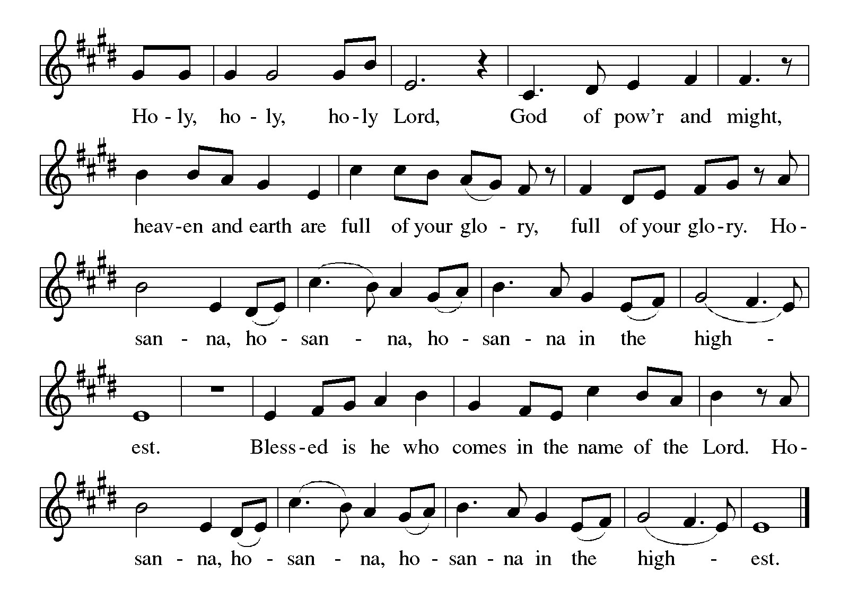

***\*\*Words of Institution***

**\*\*LORD’S PRAYER**

**Our Father, who art in heaven,**

**hallowed be thy name,**

**thy kingdom come,**

**thy will be done,**

**on earth as it is in heaven.**

**Give us this day our daily bread;**

**and forgive us our trespasses,**

**as we forgive those**

**who trespass against us;**

**and lead us not into temptation,**

**but deliver us from evil.**

**For thine is the kingdom,**

**and the power, and the glory,**

**forever and ever. Amen.**

***Invitation to Communion***

# ***Communion Hymn Now We Join in Celebration ELW#462***

### *\*\*Sending Song*

### *Praise to you, O God of Mercy ELW#208*

### *\*\*Prayer After Communion*

**Grafted onto the tree of faith and grounded in the promise of your faithful mercy, we have been fed by the Word and at the Table. Now send us out to share the joy of Christ with all whom we encounter. Amen.**

### *\*\*Blessing*

***\*\*Closing Hymn******Blessed Assurance******ELW#638***

### 

### *\*\*Dismissal*

Go in peace to serve Christ and the world!

**THANKS BE TO GOD!**

### + + + + + +

*Setting 8 liturgy are under copyright and used with permission under One License #733618-A. Specific copyright information as listed in bulletin, the Prayers of Intercession are under copyright and are used with permission under Augsburg Fortress Liturgy License #SB155933. All other liturgy written by Sarah Pierce and Sami Pfalzgraf.*

*Dialog based on Psalm 136:1, 4-8. Thanksgiving based on Psalm 100 (adapted).*

*\*\*\*\*\*\*\*\*\*\*\*\*\*\*\*\*\*\*\*\*\*\*\*\*\*\*\*\*\*\*\*\*\*\*\*\*\*\*\*\*\*\*\*\*\*\*\*\*\*\*\*\*\*\*\*\*\*\*\*\*\*\*\*\*\*\*\*\*\*\*\*\*\*\*\*\*\*\*\*\*\*\*\*\*\*\*\*\*\*\*\*\*\*\*\*\*\*\*\*\*\*\*\*\*\*\*\**

**Weekly Attendance**

***Week of August 24***

***28***

*\*\*\*\*\*\*\*\*\*\*\*\*\*\*\*\*\*\*\*\*\*\*\*\*\*\*\*\*\*\*\*\*\*\*\*\*\*\*\*\*\*\*\*\*\*\*\*\*\*\*\*\*\*\*\*\*\*\*\*\*\*\*\*\*\*\*\*\*\*\*\*\*\*\*\*\*\*\*\*\*\*\*\*\*\*\*\*\*\*\**

**Calendar of Events**

***Today***

* ***Fifth Sunday Conversation***

***This Week***

|  |  |
| --- | --- |
| ***September 02*** | ***Creative Friends 1:00 pm*** |
| ***September 03*** | ***Handbell rehearsal 6:30 pm*** |

***Upcoming Events***

|  |  |
| --- | --- |
| ***September 07*** | ***God’s Work. Our Hands/Zoo after Worship*** |
| ***September 09*** | ***Creative Friends 1:00 pm*** |
| ***September 10*** | ***Handbell rehearsal 6:30 pm*** |
| ***September 13*** | ***Men’s Breakfast 8:00 am*** |
| ***September 14*** | ***Council Meeting after Worship*** |
| ***September 16*** | ***Creative Friends 1:00 pm*** |
| ***September 17- September 21*** | ***Pastor Sarah Vacation*** |
| ***September 23*** | ***Creative Friends 1:00 pm*** |
| ***September 22-23*** | ***Blue Springs Theatre 7:00 pm-9:00 pm*** |
| ***September 29-October 01*** | ***Blue Springs Theatre 7:00 pm-9:00 pm*** |
| ***September 28*** | ***Bishop Installation/Atonement Lutheran Church 5:00 pm Overland Park*** |
| ***September 30*** | ***Creative Friends 1:00 pm*** |
| ***October 04*** | ***Blessing of Animals TBA*** |
| ***October 12*** | ***Fall Work Day*** |
| ***October 15*** | ***Council Meeting 6:30 pm*** |
| ***November 05*** | ***Council Meeting 6:30 pm*** |
| ***November 16*** | ***Congregational Meeting*** |
| ***December 10*** | ***Council Meeting 6:30 pm*** |
| ***January 14, 2026*** | ***Council Meeting 6:30 pm*** |

****************************************************************************************

*You may recall that there has been an announcement in the bulletin over the past year directing you to Lutheran Immigration and Refugee Services (LIRS) if you wish to support the people of Ukraine. LIRS has changed its name to Global Refuge and can be found at* ***globalrefuge.org****. Although their name has changed, their mission remains the same: to assist and support refugees in the United States and around the world. Visit their website to see all the ways you can support this important work.*

**\*\*\*\*\*\*\*\*\*\*\*\*\*\*\*\*\*\*\*\*\*\*\*\*\*\*\*\*\*\*\*\*\*\*\*\*\*\*\*\*\*\*\*\*\*\*\*\*\*\*\*\*\*\*\*\*\*\*\*\*\*\*\*\*\*\*\*\*\*\*\*\*\*\*\*\*\*\*\*\*\*\*\*\*\*\*\*\*\***

**BLUE SPRINGS COMMUNITY SERVICE LEAGUE** *is very appreciative of your continued support of your neighbor.*

*\*\*\*\*\*\*\*\*\*\*\*\*\*\*\*\*\*\*\*\*\*\*\*\*\*\*\*\*\*\*\*\*\*\*\*\*\*\*\*\*\*\*\*\*\*\*\*\*\*\*\*\*\*\*\*\*\*\*\*\*\*\*\*\*\*\*\*\*\*\*\*\*\*\*\*\*\*\*\*\*\*\*\*\*\*\*\*\*\*\**

**Questions for Reflection and Discussion from Pastor Sarah**

1. We have finally reached the end of Esther. What do you think about this story? About the characters, from Esther and Mordecai to Ahasuerus and Haman?
2. This week, we see Esther pleading with Ahasuerus to overturn the edict Haman had put in place to “kill, destroy, and annihilate” the Jews, only to learn that the only way for this to happen is for a second edict to be issued that counteracts it. Do you think what Mordecai wrote in the king’s name was the most effective way to manage this? (Keep in mind that, according to the law as presented in Esther, the edict that Haman wrote could not be overturned or withdrawn.)
3. Do you think that people became Jewish out of fear because they were recognized that the Jews now had real power to resist annihilation and genocide, or because they had heard stories about what other oppressed peoples did when they revolted against their imperial overlords, or because they knew what the Babylonian forces were like on a rampage? Or some other reason entirely? How many of those conversions “stuck,” do you think?
4. Was God able to work through that fear?
5. Do we see God in the way the Jews act once the battle commences? If so, how?
6. The Jewish people are to be grounded in the law of God (see Exodus 20 for the commandments and Leviticus 19:1-2 for the call to holiness). In Judaism, the law is not good in itself; it is good because it was given by God to make the people a holy nation. How do we interpret Esther in this light? Is this remnant faction of the Jewish people that remains in Persia a “holy nation” under God, or at least doing their best to be? (As Pr. Sami and I talked about last week, try to keep in mind that this was a very different culture and a different religion in a different time; we should try not to impose our Christianity on events that “happened” hundreds of years before the birth of Christ.)
7. The holiday Purim comes from the Hebrew word Pur, which means to cast lots, as Haman had done when deciding when to destroy the Jews. It is a fun family and community holiday involving the reading of the book of Esther, family feasts, sharing food with friends, and giving to charity.

***\*\*\*\*\*\*\*\*\*\*\*\*\*\*\*\*\*\*\*\*\*\*\*\*\*\*\*\*\*\*\*\*\*\*\*\*\*\*\*\*\*\*\*\*\*\*\*\*\*\*\*\*\*\*\*\*\*\*\*\*\*\*\*\*\*\*\*\*\*\*\*\*\*\*\*\*\*\*\*\*\*\*\*\*\*\****

***Birthdays***

***August 26-Jerrian Renfro***

***August 27-Kent Deubner***

***August 27-Tom Meek***

***September 01-Sara Myers***

***Greeter –*** **August 31*-******Donna Taylor***

***Usher –* August 31*-Paul Blixrud***

***Altar Guild-* August 31-Sara Meyers**

***Reader-* August 31-Kent Deubner**

***Tech-* August 31*-Gary Antes***

**Prayer Requests**

***Monty Health Concerns (May 15)***

*Paul Health Concerns (May 31)*

*Mary Health Concerns (May 15)*

*James & Family Health Concerns (September 11)*

*Betty F (Sara’s friend) Health Concerns (July 15)*

*William and Family Health Concerns (September 25)*

*Becky H Health Concerns (October 28)*

*David Health Concerns (November 18)*

*Becky W Health Concerns (November 18)*

*Larry Health Issues (December 16)*

*Helen Health Issues (January 14)*

*Jennifer Health Concerns (February 27)*

*Otto Health Concerns (July 15)*

*Kay (Sara’s cousin) Health Concerns (**July 15)*

***Merciful God, your justice and mercy are without limits. Bring courage and resilience to those who resist tyranny with their words and their bodies. Strengthen those who fight for justice in your name in Los Angeles, across the country, and around the world.***

***Please pray for the victims of the shooting at Annunciation Catholic School in Minneapolis.***

***Please pray for the people of Gaza, Ukraine, Israel, Iran and Palestine.***

***Please pray for the people of the Sudan.***

***Please pray for the Homeless.***

***Please pray for legal & illegal immigrants & those seeking asylum or citizenship.***