All Saints Lutheran Church, ELCA
421 SW 19th St. Blue Springs, Missouri 64015 816-229-3633
Pastor Sarah Pierce Spierce.aslcpastor@gmail.com
allsaintslc64015@gmail.com https://aslcbs.org/

Sunday, June 14, 2026

Third Sunday after Pentecost

You are absolutely invited into this sacred space. We welcome all who are seeking God’s love and grace. All Saints recognizes that we are all unique and beloved children of God. We celebrate and give thanks for the many diverse gifts that God has given us. We affirm the sacredness of people of all sexual orientations, gender identities, and gender expressions. We affirm the sacredness of all those who have experienced exclusion because of race, ability, age, or culture. We are committed to working towards anti-racism in ourselves and our community. We affirm the sacredness of all those who wrestle with addiction, physical or mental health, imprisonment, socio-economic circumstances, or anything that too often divides us. We believe that through our openness we all grow in our faith through Christ’s teaching to love one another as God loves us. We need each other and our sincere hope is by being in community together, we will experience God’s presence in new and real ways.

The offering plate is by the main door to the sanctuary for your convenience.

We practice open communion at All Saints Lutheran Church. What does that mean? It means that if you believe and trust that Christ offers his body and blood For You, you are welcome at the table. At All Saints, we believe that Christ invites all people to the feast. “Come to the banquet for all is now ready.”

**Stand as you are comfortable

Prelude

Announcements
Recognition of Baptismal Birthdays
Jun 07-Janet Cooper
June11-Becky Wilson
June 25-Sharon Levasseur

** Confession and Forgiveness

The God that we worship is complex, multi-faceted, a single God made up of three Persons. When we try to understand the fullness of God, we fail. But God knows us and loves us and wants to be in relationship with us, so God is constantly finding new ways to be present with us. But sometimes, we fall short in our awareness. When that happens, we find that we have turned away from God to the idols of our own making.

Let us confess our sins together, as a community.

God of All the Cosmos,
Sometimes we try to make you small.
We try to put you in a box,
confine you to our way of understanding.
God, sometimes we misunderstand what you tell us.
Inspire us, Holy Spirit, to remember that you are beyond definition.
Help us to remember that you cannot be made small.
Help us to think deeply about who you are
and to respect and honor other people’s experiences of you.

Beloved in Christ, the God who walks beside you
is the same God who brings peace passing all understanding.
The Spirit who inspires your knowledge of the presence of God
is the same Spirit who moves over the waters of creation.
The Christ who hears your prayers
is the same Christ + who defeated death for the forgiveness of all sin, for all time.
Be at peace, for your sins are forgiven.

Amen.

**Entrance Hymn Lamb of God ELW#336

**Greeting
The grace of our Lord Jesus Christ, the love of God,
and the communion of the Holy Spirit be with you all.
And also with you.

**Kyrie ELW 513
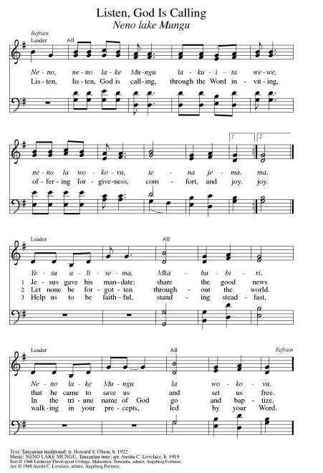
**Hymn of Praise ELW 866
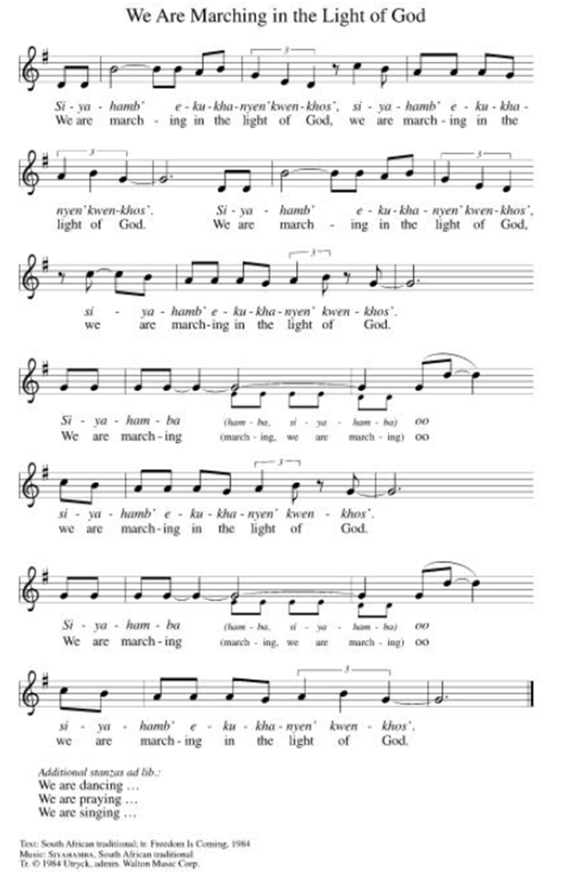

**Prayer of the Day
Holy One, even as we praise you, make us ever mindful of all the voices in the choir. Empower us to listen to all of the stories of you that we hear every day – especially the ones that are different from our own. We pray this in Jesus’ name. Amen.

Reading: Revelation 5:1-13

¹In the right hand of the One who sat on the throne, I saw a scroll. It had writing on both sides and was sealed with seven seals.

²Then I saw a mighty angel proclaiming in a loud voice, Who is worthy to open the scroll and break its seals?” ³But no one in heaven, on earth or under the earth could be found to open the scroll or examine its contents. ⁴I wept bitterly because no one could be found to open or examine the scroll.

⁵One of the elders said to me, “Don’t weep. The Lion of the tribe of Judah, the Root of David, has triumphed and will open the scroll with the seven seals.”

⁶Then, between the throne with the four living creatures and the elders, I saw a Lamb standing, a Lamb that had been slain. It had seven horns and seven eyes; these eyes are the seven spirits of God sent to all parts of the world. ⁷The Lamb came and received the scroll from the right hand of the One who sat on the throne.
⁸When it had taken the scroll, the four living creatures and the twenty-four elders fell down before the Lamb. Each of the elders held a harp, and golden bowls filled with incense, which are the prayers of God’s holy people. ⁹This is the new hymn they sang:
“Worthy are you to receive the scroll
and break the seven seals,
for you were slain.
With your blood you purchased for God
members of every race and tongue,
of every people and nation.
¹⁰You made of them a kingdom,
priests to serve our God,
and they will reign on the earth."

¹¹Then in my vision, I heard the voices of many angels who surrounded the throne together with the living creatures and the elders. They were numberless, thousands and tens of thousands, ¹²and they all cried out:
Worthy is the Lamb that was slain
to receive power and wealth,
wisdom and strength,
honor and glory and praise!

¹³Then I heard the voice of every creature in heaven, on the earth, under the earth and in the sea. Everything in all creation cried aloud:
“To the one seated on the throne and to the Lamb,
be praise and honor,
glory and dominion,
forever and ever!”

Word of God, Word of Life
Thanks be to God

**Gospel Acclamation ELW 519
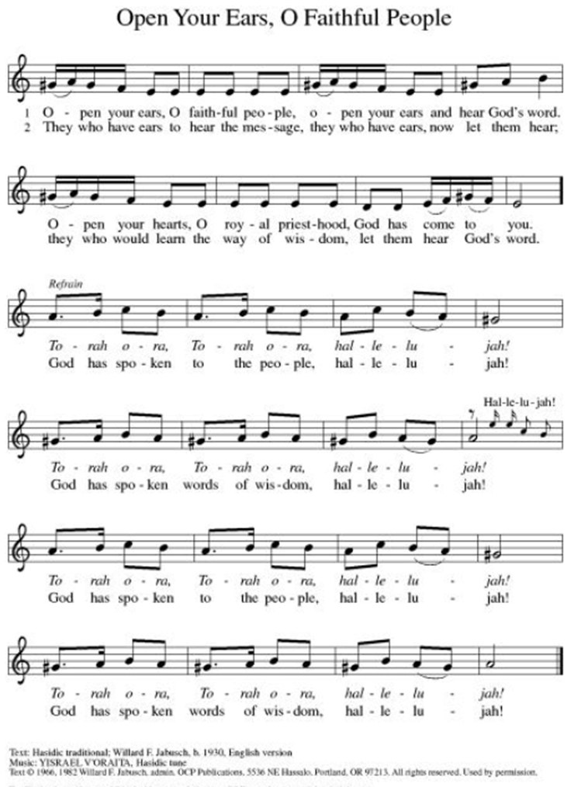
Announcement of the Gospel
Glory to you, O Lord.

Gospel: John 1:29-31

²⁹The next day, catching sight of Jesus approaching, John exclaimed, “Look, there’s God’s sacrificial lamb, who takes away the world’s sin! ³⁰This is the one I was talking about when I sad, ‘The one who comes after me ranks ahead of me, for this One existed before I did.’ ³¹I didn’t recognize him, but it was so that he would be revealed to Israel that I came baptizing with water.”

The Gospel of the Lord.
Praise to you, O Christ.

Sermon "Listening to the Stories"

Hymn of the Day Come Let Us Join Our Cheerful Songs ELW#847

**Affirmation of Faith – Immigrant’s Creed by Jose Luis Casal

I believe in Almighty God, who guided the people in exile and in exodus, the God of Joseph in Egypt and Daniel in Babylon, the God of foreigners and immigrants.

I believe in Jesus Christ, a displaced Galilean, who was born away from his people and his home, who fled his country with his parents when his life was in danger. When he returned to his own country he suffered under the oppression of Pontius Pilate, the servant of a foreign power. Jesus was persecuted, beaten, tortured, and unjustly condemned to death. But on the third day Jesus rose from the dead, not as a scorned foreigner but to offer us citizenship in God’s kingdom.

I believe in the Holy Spirit, the eternal immigrant from God’s kingdom among us, who speaks all languages, lives in all countries, and reunites all races.

I believe that the Church is the secure home for foreigners and for all believers. I believe that the communion of saints begins when we embrace all God’s people in all their diversity. I believe in forgiveness, which makes us all equal before God, and in reconciliation, which heals our brokenness. I believe that in the Resurrection God will unite us as one people in which all are distinct and all are alike at the same time. I believe in life eternal, in which no one will be foreigner but all will be citizens of the kingdom where God reigns forever and ever. Amen.

**Prayers of Intercession

Holy God, our prayers rise to you like the wings of a dove. We call upon your name, and we ask that you hear us.

God of freedom, you ransomed Israel from slavery to be a holy people. As we observe Juneteenth this coming week, free us also to be a people who proclaim your liberating love. God of grace,
hear our prayer.
God of creation, you call all the earth to make a joyful noise to you. Let us join the chorus of the natural world in proclaiming your glory. God of grace,
hear our prayer.
God of the nations, you sent Jesus as peace for all of humankind. Bring an end to war and conflict, bring hope to places devasted by destruction, and sustain those who advocate for peace. God of grace,
hear our prayer.
God of grace, you pour hope and love into our hearts in times of shame and doubt. Protect those experiencing housing insecurity. Uplift anyone struggling with hopelessness, illness, or other worries especially Monty & Marie, Paul, Helen, Linda, Betty F., Kay, Becky H., Jim & Jan, Melian, Becky W., David, Val, William & family, Judy, Peter & Carrie, Barbara & Donna, Lorey, Brad & Chris, families in our community who endure hunger, and our beloved for whom death is near. God of grace,
hear our prayer.
God of all, you call your children to serve in a plentiful harvest. Give us the wisdom to know how best to serve our local community and our neighbors. God of grace,
hear our prayer.
Pave a way to justice, drown the forces of oppression, bring peace on earth. Give leaders the will to turn from war and violence. Especially we pray for the people of Cuba & Venezuela, Iran, Sudan, Gaza, Israel, and Ukraine. When people must flee their homes, guide them to safety. Comfort those living with deep trauma, anxiety, or fear; all those who serve people in need, and accompany all those who care for people in harm’s way. We also lift up Jim’s grandson Dylan, who is deployed, and Sharon’s great nephew, Taylor, who is deployed in the Middle East. God of grace,
hear our prayer.
We pray for people who rise up against injustice. Bring courage and resilience to those who resist tyranny with their words and their bodies. Strengthen those who fight for justice in your name across the country, and around the world. Protect and sustain immigrants and refugees and all who work with them, that your kingdom, without borders and without walls, may truly come on earth as it is in heaven. We pray for all victims of gun violence or kidnapping, especially those who are targeted out of hate or fear. Embolden us to holy outrage and empower us to speak our truth of love and justice. God of grace,
hear our prayer.
God of faith, we give thanks for the saints who earnestly seek you. Guide us as we seek to follow those who have led your church. God of grace,
hear our prayer.

Good and loving God, we give everyone we have prayed for into your care. Amen.

** Sharing of the Peace

**Offering is brought forward

** Offertory Response

**Offertory Prayer ELW 486

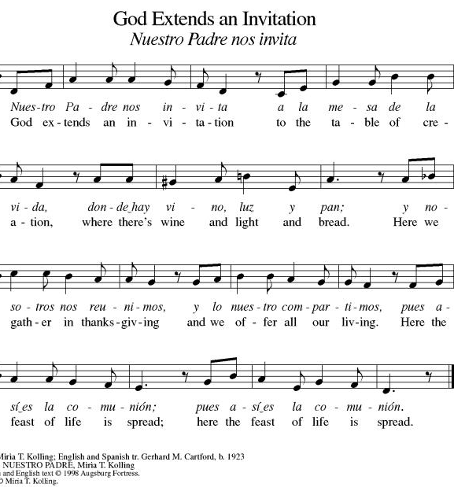

**Offertory Prayer
Jesus, all that we have and all that we are comes from you. Thank you for the gifts you have given us. Receive these gifts – our money, our service, our time – which we give in gratitude for all that we have received from you. Amen.
Dialogue
Christ is with you!
And also with you!

Lift up your hearts in joyful praise!
We lift them up to God in joy!

**Preface: We give thanks and praise to God...this hymn of praise:
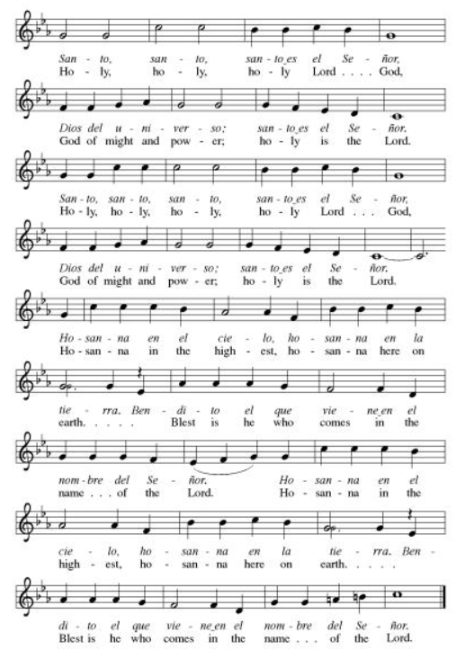
**Words of Institution

**LORD’S PRAYER
You are invited during this Pentecost season to pray whichever version feels most comfortable on your lips and in your soul. A separate sheet is available with alternate versions, should you be interested. Or, you are invited to use one of these:
Our Father in heaven, Our Father, who art in heaven,
hallowed be your name, hallowed be thy name,
your kingdom come, thy kingdom come,
your will be done, thy will be done,
on earth as in heaven. on earth as it is in heaven.
Give us today our daily bread. Give us this day our daily bread;
Forgive us our sins and forgive us our trespasses
as we forgive those as we forgive those
who sin against us. who trespass against us;
Save us from the time of trial and lead us not into temptation,
and deliver us from evil. but deliver us from evil.
For the kingdom, the power, For thine is the kingdom,
and the glory are yours, and the power, and the glory,
now and forever. Amen. forever and ever. Amen.

Invitation to Communion

Communion Hymn All Are Welcome ELW#641

**Sending Song ELW 535

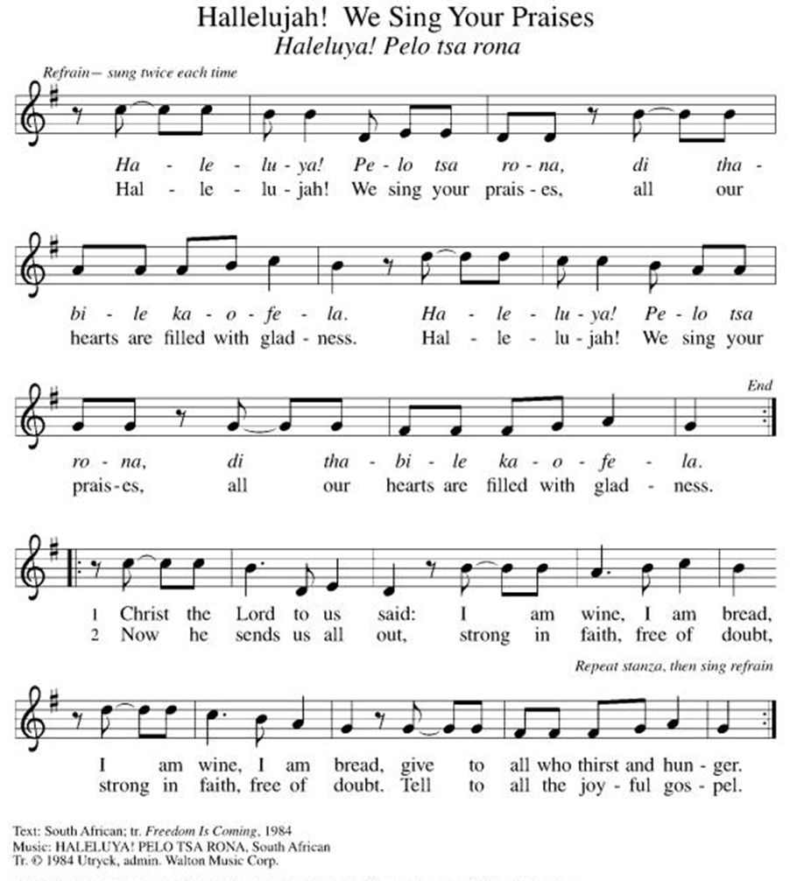

**Prayer After Communion
Holy God, you love us so much that you transformed an act of destruction into an act that gives new life. Thank you for the renewal we receive at your Table, as you send us out from this place into the world. Strengthen us for your service. In Jesus’ name we pray. Amen.

**Blessing

**Closing Hymn All Hail the Power of Jesus Name! ELW#634

**Dismissal

Empowered by the Spirit, may you go in peace to share the gospel!
THANKS BE TO GOD!

+ + + + + +

Setting 07 and hymns from the Evangelical Lutheran Worship are under copyright and used with permission under One License #733618-A. Specific copyright information as listed in bulletin, the Prayers of Intercession are under copyright and are used with permission under Augsburg Fortress Liturgy License #SB155933. All other liturgy written by Sarah Pierce.

Weekly Attendance

Week of June 07:
21

******************************************************************************************

Next Week:
4th Sunday after Pentecost
Revelation 7:9-17
John 14:1-4
The color of the day is Green

Calendar of Events

Today
- Baptismal Sunday

This Week
June 16 | Creative Friends
June 17  June 21 | Pastor Sarah Vacation

Upcoming Events

June 19 | Juneteenth Office Closed
June 20 | Newsletter Deadline
June 21 | Father’s Day
June 23 | Creative Friends
June 27 | Project Comfort 9:00 am-Noon
June 28 | Coffee with Council
June 30 | Creative Friends
July 01 | Paint Party Fundraiser
July 04 | Independence Day
July 06 | Healing Service for the World
July 15 | Council Meeting 6:30 pm
July 26 | Coffee with Council  Celebrate Niel’s Birthday (July 28)
July 28 | Report Synod Assembly
August 19 | Council Meeting 6:30
September 13 | God’s Work. Our Hands.
September 23 | Council Meeting 6:30 pm
September 27 | Celebration 5th year Anniversary of Pastor’s Ordination

Note: 2026 paint party fundraisers: July 1, Aug. 5, Sept. 2, Oct. 7, Nov. 4, Dec. 2

Pastor Sarah Questions:

Questions for Reflection and Discussion

- There was an interesting side discussion in the podcast that I was listening to while preparing for this sermon. Our English word for apocalyptic literature comes from Revelation (the Greek word for revelation is apokalypsis). However, there are criteria used to define Hebrew Testament and 2nd Temple Jewish apocalyptic literature: someone has to have a vision they can’t interpret and they need an angelic guide (or someone inspired by God) to help them (think Daniel); and it is essentially resistance literature that was “coded” so the powers that be couldn’t figure it out, but we can look backwards in time and interpret it (again, think Daniel). However, Revelation is different. Yes, it’s a vision, but John doesn’t need an angelic guide to help him interpret it: he’s providing his own interpretation. They’re not necessarily mysterious, at least not for people who are well-versed in the Hebrew Testament. Additionally, Revelation has consistently resisted historical mapping. Think of all the times throughout the last 500 years or so that people have tried to do so. Every single one has been wrong.
- More than anything else, Revelation is a songbook. After the psalms and the gospels, more hymns have been inspired by Revelation than any other book of the Bible. When we sing “This is the Feast” from, say, setting 3, we are singing pretty much straight from Revelation 5 (and 19). “Worthy is Christ, the Lamb who was slain, whose blood set us free to be people of God!” (Verse 9) “Power, riches, wisdom, and strength, and honor, blessing, and glory are his!” (Verse 12)
- Another interesting fact about the 7 seals: in order to be legal, a Roman will had to be sealed 7 times. This was also true for many important imperial edicts. Seven seals implied that the contents are valid.
- The lion and the lamb is not the only paradox in this text. There’s also the implied paradox that Jesus is both the Root of David (David’s ancestor) and heir to David’s throne. How can he be both? Because he is the One who is, who was, and who is to come.
- The slain lamb would have immediately brought to mind for John’s early readers the thought of the Passover, when God commanded the people to kill and prepare a lamb and to mark their doors with the blood so God would “pass over” their homes during the tenth plague in Egypt. It also would have reminded them of a passage from Isaiah 53, often called the “Suffering Servant.”

******************************************************************************************
BLUE SPRINGS COMMUNITY SERVICE LEAGUE is very appreciative of your continued support of your neighbor.
June 14
Altar Guild – Mary Ann Gross & Donna Taylor
Lector – Sara Meyers
Greeter – Donna Taylor
Usher-Paul Blixrud
Tech – Gary Antes

Prayer Requests
Monty & Marie Health Concerns (March 04)
Paul Health Concerns (May 31)
Mary Health Concerns (May 15)
James & Family Health Concerns (September 11)
Betty F (Sara’s friend) Health Concerns (July 15)
William and Family Health Concerns (September 25)
Becky H Health Concerns (October 28)
David Health Concerns (November 18)
Becky W Health Concerns (November 18)
Judy Health Issues (December 16)
Kay (Sara’s cousin) Health Concerns (July 15)
Sharon Health Concerns (October 22)
Michael Health Concerns (October 22)
Peter and Carrie Health Concerns (November 26)
Melian Health Concerns (November 16)
RJ Health Concerns (November 17)
Barbara Health Concerns (December 30)
Helen Health Concerns (February 25)
Val (Tonya’s sister) Health Concerns (February 18)
Lorey Health Concerns (April 14)
Chris Health Concerns (June 09)

Merciful God, your justice and mercy are without limits. Bring courage and resilience to those who resist tyranny with their words and their bodies. Strengthen those who fight for justice in your name across the country, and around the world.

Please pray for the people of Venezuela & Iran, Sudan, Gaza, Ukraine, Israel, Cuba, Iran and Palestine.
Please pray for the Homeless.
Please pray for legal & illegal immigrants & those seeking asylum or citizenship

