**All Saints Lutheran Church, ELCA**

**421 SW 19th St. Blue Springs, Missouri 64015 816-229-3633**

**Pastor Sarah Pierce** Spierce.aslcpastor@gmail.com

[allsaintslc64015@gmail.com](mailto:allsaintslc64015@gmail.com) <https://aslcbs.org/>

## Sunday, August 10, 2025

## Nineth Sunday after Pentecost

## *You are absolutely invited into this sacred space.  We welcome all who are seeking God’s love and grace.  All Saints recognizes that we are all unique and beloved children of God.  We celebrate and give thanks for the many diverse gifts that God has given us.  We affirm the sacredness of people of all sexual orientations, gender identities, and gender expressions.  We affirm the sacredness of all those who have experienced exclusion because of race, ability, age, or culture. We are committed to working towards anti-racism in ourselves and our community. We affirm the sacredness of all those who wrestle with addiction, physical or mental health, imprisonment, socio-economic circumstances, or anything that too often divides us.  We believe that through our openness we all grow in our faith through Christ’s teaching to love one another as God loves us.  We need each other and our sincere hope is by being in community together, we will experience God’s presence in new and real ways.*

*The offering plate is by the main door to the sanctuary for your convenience.*

*We practice open communion at All Saints Lutheran Church. What does that mean? It means that if you believe and trust that Christ offers his body and blood For You, you are welcome at the table. At All Saints, we believe that Christ invites all people to the feast. “Come to the banquet for all is now ready.”*

***\*\*Stand as you are comfortable***

***Prelude***

***Announcements***

### *Baptismal Birthdays*

**August 02 Pam Meek**

**August 08 Pastor Sarah Pierce**

**\*\* Confession and Forgiveness**

As with Esther and Mordecai, in times of uncertainty and challenge, we seek Your

divine wisdom to guide our hearts and minds.

**When we try to figure things out on our own and forget to go to you for clarity**

**and discernment, forgive us, O God.**

**When we lose trust in you because times are so difficult, painful and scary, help us trust you. Remember us, O God, in our time of need. Give us courage when we need it. Help us listen for your voice amidst the chaos. Shine your light on our path and lead us to choices that honor you and bring peace to the world.**

God remains faithful at all times and in all places. Even when we turn our backs on God, God never abandons us. God always forgives our sins + and gives us the strength and courage to start again.

**Amen.**

***\*\*Entrance Hymn When Peace Like a River ELW #785***

***\*\*Greeting***

The grace of our Lord Jesus Christ, the love of God,

and the communion of the Holy Spirit be with you all.

**And also with you.**

**\*\*Kyrie**

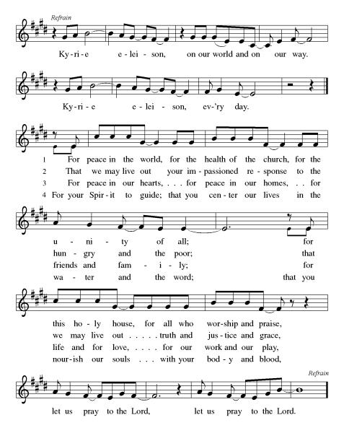

***\*\*Prayer of the Day***

**Loving God, we give you thanks for all of the ways in which we have choices in our lives, and we pray for people who have none. Empower us to speak out when we should, and help us to see when we should choose to hold our power close instead. In Jesus’ name we pray. Amen.**

***Reading:*** **Esther 1:1-20, 2:1-3, 5-10 15, 17-18**

1The following events took place during the time of Ahasuerus—the same Ahasuerus who ruled 127 provinces from India to Ethiopia—when he set up the imperial throne in the capital city of Susa.

3During the third year of his reign, he gave a feast for all the government officials and members of the royal court as well as the governors of Persia and Media and all the nobles and administrators of the provinces. 4So Ahasuerus put all the wealth of the empire on display for many days—180 in all—with a great show of pomp and grandeur.

5At the end of those six months, Ahasuerus gave a banquet for everyone in the capital city of Susa, both the mighty and the lowly. 6The banquet lasted for seven days and was held in the courtyard of the royal gardens. The regal court was adorned with white and purple tapestries which hung by cords of fine linen and purple thread attached to silver rings on large marble pillars. Couches of gold and silver were placed on a mosaic floor of malachite, marble, mother of pearl, and turquoise. 7Wine was served in golden goblets, each one unique in design. 8The wine flowed freely, as was the style at an imperial banquet. The ruler gave strict orders, however, that no one was required to drink and that the waiters respect the preferences of the guests. 9Queen Vashti also gave a banquet for the women in the court of Ahasuerus.

10On the seventh day of the revels, Ahasuerus was drunk after a great deal of wine. He ordered Mehuman, Biztha, Harbona, Bigtha, Abagtha, Zethar, and Carkas, the seven eunuchs who attended to his every need, 11to bring Queen Vashti into his presence, crowned with the royal diadem, to put on “a show of her beauty” for those present and for the government officials—she was very beautiful. 12But Queen Vashti rebuffed the eunuchs and refused to obey the order.

At this, Ahasuerus became irate and his rage boiled over. 13So he consulted all his chief advisors, all experts in matters of law, since it was common to consult lawyers and jurists in such matters. 14He called Carshena, Shethar, Admatha, Tarshish, Meres, Marsena, and Memucan, the seven governors of Persia and Media who had special access to the royal court and held the top offices of the empire. 15“What does the law say about this?” Ahasuerus asked. “How do we deal with the matter of Vashti’s disobedience of the order which I, Ahasuerus, delivered to her through the eunuchs?”

16Memucan answered in the presence of the sovereign and all the governors, “Vashti has shown disrespect not only to you, Ahasuerus, but also to all the governors and peoples in all the provinces of your empire. 17News of her conduct will spread to the women of the empire, and it will fan the flames of insolence among them toward their spouses—18they could say, ‘Look, Ahasuerus ordered Vashti to appear before him and she refused.’ The spouses of all the governors of Persia and Media will hear of Vashti’s behavior by the end of the day, and will start talking to the governors in the same manner. That will encourage anger and scorn all around.

19“If it is your will, then, issue a royal decree to be fixed irreversibly into the laws of Persia and Media, which states that Vashti is never again to appear before Ahasuerus and that her position is to be given to another who is more worthy. 20Let this decree which you issue be proclaimed throughout the length and breadth of your empire, so that all women, whether aristocrat or commoner, will from now on submit to the authority of their husbands.”

2:1After a while, when Ahasuerus’ anger abated, he thought of Vashti and her behavior and the sanctions he brought against her.

2The members of the imperial court approached Ahasuerus and said, “Why don’t we seek out all the most beautiful women of the empire for the ruler? 3You can appoint a committee representing all the provinces of the empire to bring all the most beautiful women to the palace at Susa, to the harem which is supervised by Hegai, our ruler’s eunuch.”

5Now, in the palace of Susa there lived a Jew named Mordecai-ben-Jair-ben-Shimei ben-Kish of the tribe of Benjamin, 6who was taken captive in Jerusalem along with Jeconiah, ruler of Judah by Nebuchadnezzar, ruler of Babylon. 7He was the guardian of Hadassah, who was also known as Esther. She was extremely beautiful. Esther was the daughter of Mordecai’s cousin. After her parents died, Mordecai adopted her as his own child.

8After Ahasuerus‘ edict was issued, a great number of young women came to the palace at Susa and were placed under the supervision of Hegai, the chaperone. Esther was among them. 9It was Esther who caught the ruler’s attention; not only did he provide her with everything she wanted for her wardrobe and meals, he also gave her special attendants from his own court and transferred her personal attendants to the best part of the harem.

During this time, 10Esther never revealed that she or her relatives were Jewish, because Mordecai warned her against doing so.

15When it came time for Esther, daughter of Abihail, whose nephew Mordecai adopted her as his own daughter, to go to the palace, she did not bring anything with her beyond what had been given to her by Hegai, the royal eunuch and supervisor of the harem. Esther soon won the esteem of everyone who saw her.

17Ahasuerus liked Esther more than all the others—none of the others found as much favor with him. So he placed the crown on her head and proclaimed her to be queen in place of Vashti.

18Then Ahasuerus gave a great feast in her honor for all the governors and government officials, proclaiming a holiday in all the provinces and making bounteous gifts with royal abandon.

Word of God, Word of Life

**Thanks be to God**

**Sermon "Esther: Power and Beauty"**

***Hymn of the Day*  *Oh, God Our Help in Ages Past* ELW#*632***

\*\***Affirmation of Faith – Immigrant’s Creed by Jose Luis Casal**

**I believe in Almighty God, who guided the people in exile and in exodus, the God of Joseph in Egypt and Daniel in Babylon, the God of foreigners and immigrants.**

**I believe in Jesus Christ, a displaced Galilean, who was born away from his people and his home, who fled his country with his parents when his life was in danger. When he returned to his own country he suffered under the oppression of Pontius Pilate, the servant of a foreign power. Jesus was persecuted, beaten, tortured, and unjustly condemned to death. But on the third day Jesus rose from the dead, not as a scorned foreigner but to offer us citizenship in God’s kingdom.**

**I believe in the Holy Spirit, the eternal immigrant from God’s kingdom among us, who speaks all languages, lives in all countries, and reunites all races.**

**I believe that the Church is the secure home for foreigners and for all believers. I believe that the communion of saints begins when we embrace all God’s people in all their diversity. I believe in forgiveness, which makes us all equal before God, and in reconciliation, which heals our brokenness. I believe that in the Resurrection God will unite us as one people in which all are distinct and all are alike at the same time. I believe in life eternal, in which no one will be foreigner but all will be citizens of the kingdom where God reigns forever and ever. Amen.**

***\*\*Prayers of Intercession***

**God of Love, hear the prayers that we lift before you. Hold close to you all those for whom we pray.**

Keep the heart of your church set firmly in you so that, with lamps lit and attentive to Christ’s call at any time or place, your people are ready to respond with faithful action for the sake of the world. God of grace,

**hear our prayer.**

Worlds were prepared by your word. Speak healing and protection upon the earth, especially where life and habitats are threatened. Guide the work of astronomers and all who teach us about the stars and galaxies. God of grace,

**hear our prayer.**

You know the actions and deeds of the nations. Turn humanity away from instruments of war and violence. Fashion the hearts of world leaders to work for peace. God of grace,

**hear our prayer.**

Let your loving kindness be on those in need despair especially Monty, Paul, Linda, Betty F., Kay, Becky H., Jim & Jan, Becky W., David, William and family, Helen, Larry, Jennifer, Otto, families in our community who endure hunger, and our beloved for whom death is near. Carry your people when grief is heavy, and lift burdens of shame and self-doubt. Provide protection and aid to children who are unsafe and undernourished while on summer break. Bring honor to any who experience slander and evil intent or are discredited by others. Assure all who are afraid or experiencing great uncertainty that your promises are sure. God of grace,

**hear our prayer.**

Calm the fears of migrants and refugees who set out, not knowing where they go. Provide shelter, sustenance, protection from harm, and welcome. Bless the work of Global Refuge and other means of support and advocacy. God of grace,

**hear our prayer.**

We pray for the nations. Pave a way to justice, drown the forces of oppression, bring peace on earth. Give leaders the will to turn from war and violence. Especially we pray for the people of Gaza, Israel, and Ukraine, and for Jim’s grandson Dylan, who is deployed in Oman. When people must flee their homes, guide them to safety. Comfort those living with deep trauma, anxiety, or fear; all those who serve people in need, and accompany all those who care for people in harm’s way. God of grace,

**hear our prayer.**

We pray for people who rise up against injustice. Bring courage and resilience to those who resist tyranny with their words and their bodies. Strengthen those who fight for justice in your name across the country, and around the world. Protect and sustain immigrants and refugees and all who work with them, that your kingdom, without borders and without walls, may truly come on earth as it is in heaven. We pray for all victims of gun violence or kidnapping, especially those who are targeted out of hate or fear. Embolden us to holy outrage and empower us to speak our truth of love and justice, God of grace,

**hear our prayer.**

We celebrate the ancestors in the faith who built their lives on your promises and died having seen them only from a distance. Sustain us in our hope of things not seen. God of grace,

**hear our prayer.**

**Good and loving God, we give everyone we have prayed for into your care. Amen.**

*\*\** ***Sharing of the Peace***

### *\*\*Offering is brought forward*

### *\*\** *Offertory Response*

**Create in Me ELW#186**

### *\*\*Offertory Prayer*

**Holy God, we return to you with gratitude the gifts you have given us. Use them to your service and for your ministry in this place. We pray this in Jesus’ name. Amen.**

**Thanksgiving at the Table**

Thank you God, for you are good!

Your love is everlasting!

**You alone perform such great marvels.**

**Your love is everlasting!**

Your wisdom made the heavens.

Your love is everlasting!

**You spread the land out over the waters.**

**Your love is everlasting!**

You made the great lights:

Your love is everlasting!

**The sun to govern the day, moon and stars to govern the night.**

**Your love is everlasting!**

**\*\*Preface:** O God, you called your servant Esther……..all creation as we sing:

**\*\*Holy, Holy, Holy**

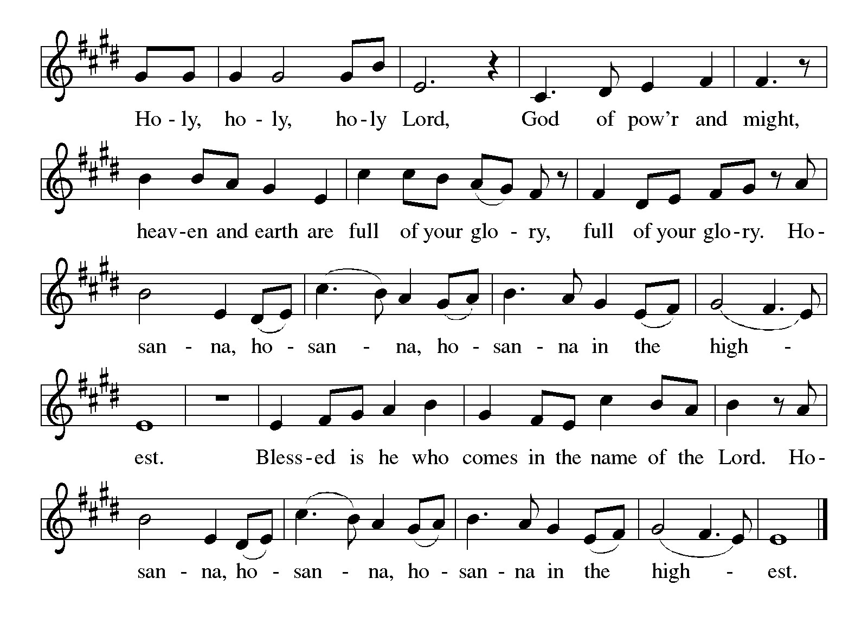

***\*\*Words of Institution***

**\*\*LORD’S PRAYER**

**Our Father, who art in heaven,**

**hallowed be thy name,**

**thy kingdom come,**

**thy will be done,**

**on earth as it is in heaven.**

**Give us this day our daily bread;**

**and forgive us our trespasses,**

**as we forgive those**

**who trespass against us;**

**and lead us not into temptation,**

**but deliver us from evil.**

**For thine is the kingdom,**

**and the power, and the glory,**

**forever and ever. Amen.**

***Invitation to Communion***

# ***Communion Hymn For the Bread Which You Have Broken ELW#494***

### *\*\*Sending Song*

### *Praise to you, O God of Mercy ELW#208*

### *\*\*Prayer After Communion*

**Grafted onto the tree of faith and grounded in the promise of your faithful mercy, we have been fed by the Word and at the Table. Now send us out to share the joy of Christ with all whom we encounter. Amen.**

### *\*\*Blessing*

***\*\*Closing Hymn******Let All Things Now Living******ELW#881***

### 

### *\*\*Dismissal*

Go in peace to serve Christ and the world!

**THANKS BE TO GOD!**

### + + + + + +

*Setting 8 liturgy are under copyright and used with permission under One License #733618-A. Specific copyright information as listed in bulletin, the Prayers of Intercession are under copyright and are used with permission under Augsburg Fortress Liturgy License #SB155933. All other liturgy written by Sarah Pierce.*

*Confession and Forgiveness based on Psalm 51:1-6 and Psalm 103:104, 17-18 (adapted). Dialog based on Psalm 136:1, 4-8. Thanksgiving based on Psalm 100 (adapted). Benediction based on 1 Thessalonians 5:16-24 (adapted).*

**Weekly Attendance**

***Week of August 03***

***24***

*\*\*\*\*\*\*\*\*\*\*\*\*\*\*\*\*\*\*\*\*\*\*\*\*\*\*\*\*\*\*\*\*\*\*\*\*\*\*\*\*\*\*\*\*\*\*\*\*\*\*\*\*\*\*\*\*\*\*\*\*\*\*\*\*\*\*\*\*\*\*\*\*\*\*\*\*\*\*\*\*\*\*\*\*\*\*\*\*\*\**

**Calendar of Events**

***Today***

* ***Baptismal Birthdays***
* ***Adult Bible Study***

***This Week***

|  |  |  |
| --- | --- | --- |
| ***August 12*** | | ***Creative Friends 1:30 pm*** |
| ***August 13*** | ***Council Meeting 6:30 pm*** | |

***Upcoming Events***

|  |  |
| --- | --- |
| ***August 19*** | ***Creative Friends 1:30 pm*** |
| ***August 20*** | ***Newsletter Deadline*** |
| ***August 23*** | ***Project Comfort 9:00 am-Noon*** |
| ***August 24*** | ***Coffee with Council/ Pot Luck after Worship*** |
| ***August 26*** | ***Creative Friends 1:30 pm*** |
| ***August 31*** | ***Fifth Sunday Conversation*** |
| ***September 07*** | ***God’s Work. Our Hands/Zoo after Worship*** |
| ***September 14*** | ***Council Meeting 6:30 pm after Worship*** |
| ***September 22-23*** | ***Blue Springs Theatre 7:00 pm-9:00 pm*** |
| ***September 29-October 01*** | ***Blue Springs Theatre 7:00 pm-9:00 pm*** |
| ***September 28*** | ***Bishop Installation/Atonement Lutheran Church 5:00 pm Overland Park*** |
| ***October 04*** | ***Blessing of Animals TBA*** |
| ***October 12*** | ***Fall Work Day*** |

* **August 17: Pulpit swap! Pastor Sami will be at ASLC and Pastor Sarah will be at First in St. Joe. We'll be exploring how we speak about justice as Haman persecutes the Jewish people.**
* **August 24: Joint sermon! Pastor Sarah and Pastor Sami will both be at ASLC to preach together! We'll be exploring courage and strength as Esther and Mordecai work together to find justice.**
* **August 31: Pastor Sarah will be at ASLC for our 5th Sunday Conversation as we wrap up the book of Esther, talking about the power of stories to help us work through our desire for justice that looks like vengeance, when God's justice looks more like mercy.**

****************************************************************************************

*You may recall that there has been an announcement in the bulletin over the past year directing you to Lutheran Immigration and Refugee Services (LIRS) if you wish to support the people of Ukraine. LIRS has changed its name to Global Refuge and can be found at* ***globalrefuge.org****. Although their name has changed, their mission remains the same: to assist and support refugees in the United States and around the world. Visit their website to see all the ways you can support this important work.*

**\*\*\*\*\*\*\*\*\*\*\*\*\*\*\*\*\*\*\*\*\*\*\*\*\*\*\*\*\*\*\*\*\*\*\*\*\*\*\*\*\*\*\*\*\*\*\*\*\*\*\*\*\*\*\*\*\*\*\*\*\*\*\*\*\*\*\*\*\*\*\*\*\*\*\*\*\*\*\*\*\*\*\*\*\*\*\*\*\***

**BLUE SPRINGS COMMUNITY SERVICE LEAGUE** *is very appreciative of your continued support of your neighbor.*

*\*\*\*\*\*\*\*\*\*\*\*\*\*\*\*\*\*\*\*\*\*\*\*\*\*\*\*\*\*\*\*\*\*\*\*\*\*\*\*\*\*\*\*\*\*\*\*\*\*\*\*\*\*\*\*\*\*\*\*\*\*\*\*\*\*\*\*\*\*\*\*\*\*\*\*\*\*\*\*\*\*\*\*\*\*\*\*\*\*\**

**Questions for Reflection and Discussion**

1. Interestingly enough, there are two different versions of the book of Esther! One version, considered canon (genuine) by Jews and Protestants, doesn’t mention God at all. The other version, considered canon by Catholics and Orthodox Christians (and the version included in the Inclusive Bible), contains an additional 6 sections, comprised of 107 verses, which contain prayers to God by Esther and her uncle.
2. I mention at the start of my sermon that scholars don’t believe Esther is a historically true story. Here are a few examples: at the time Esther takes place, Ahasuerus/Xerxes was not in his capital city. He was off at war, then was involved in a several month-long affair with his daughter-in-law, per the ancient Greek historian Herodotus. Additionally, his queen’s name was Amestris, not Vashti, and she was almost certainly from one of 7 noble Persian families (and he would not have been allowed to marry anyone who wasn’t – such as Esther). The Persian empire had 20-30 provinces, not 127. And lastly, Esther and Daniel are the only places that record that Persian laws could not be modified. So this is almost certainly a literary detail.
3. There are also some logical improbabilities: why would Ahasuerus/Xerxes throw a 180-day drinking party for all the officials in the empire, including the entire army? We’ll also get, later, to a gallows that’s built in a backyard – 75 feet high. This is the height of a modern 6-story building. I’m no engineer, but I don’t see how that’s possible.
4. These facts and improbabilities point to the book of Esther being a novella, essentially. Does this matter? Or is the fact that it speaks truth, in the same way that other great works speak truth, more important?
5. The overall theme and questions for today’s reading and sermon that I’d like you to consider are these? Do we as a society still place too much emphasis on beauty for women, over and above other gifts that women have? And how can/does that influence the way people in power treat others poorly or disrespectfully?
6. Esther makes the best of a bad situation. She has no choice other than joining the harem. And as a woman and a Jew, she’s in a doubly-dangerous situation. So not only does she see no future for herself that doesn’t involve sex work (let’s call it what it is), she also has to be vigilant against any slips regarding language, prayer or ritual, diet, differences in cleanliness habits, etc. that might mark her as different.

***\*\*\*\*\*\*\*\*\*\*\*\*\*\*\*\*\*\*\*\*\*\*\*\*\*\*\*\*\*\*\*\*\*\*\*\*\*\*\*\*\*\*\*\*\*\*\*\*\*\*\*\*\*\*\*\*\*\*\*\*\*\*\*\*\*\*\*\*\*\*\*\*\*\*\*\*\*\*\*\*\*\*\*\*\*\****

***Birthdays***

***August 11 Heather Antes***

***August 14 Donna Taylor***

***August 15 August Benz***

***Greeter –*** **August 10*-******Donna Taylor***

***Usher –* August 10*-Paul Blixrud***

***Altar Guild-* August 10- *Mary Ann Gross & Donna Taylor***

***Tech-* August 10*-Gary Antes***

**Prayer Requests**

***Monty Health Concerns (May 15)***

*Paul Health Concerns (May 31)*

*Mary Health Concerns (May 15)*

*James & Family Health Concerns (September 11)*

*Betty F (Sara’s friend) Health Concerns (July 15)*

*William and Family Health Concerns (September 25)*

*Becky H Health Concerns (October 28)*

*David Health Concerns (November 18)*

*Becky W Health Concerns (November 18)*

*Larry Health Issues (December 16)*

*Helen Health Issues (January 14)*

*Jennifer Health Concerns (February 27)*

*Otto Health Concerns (July 15)*

*Kay (Sara’s cousin) Health Concerns (**July 15)*

***Merciful God, your justice and mercy are without limits. Bring courage and resilience to those who resist tyranny with their words and their bodies. Strengthen those who fight for justice in your name in Los Angeles, across the country, and around the world.***

***Please pray for the people of Gaza, Ukraine, Israel, Iran and Palestine.***

***Please pray for the people of the Sudan.***

***Please pray for the Homeless.***

***Please pray for legal & illegal immigrants & those seeking asylum or citizenship.***