All Saints Lutheran Church, ELCA
421 SW 19th St. Blue Springs, Missouri 64015 816-229-3633
Pastor Sarah Pierce Spierce.aslcpastor@gmail.com
allsaintslc64015@gmail.com https://aslcbs.org/

Sunday, December 21, 2025

Fourth Sunday in Advent

You are absolutely invited into this sacred space. We welcome all who are seeking God’s love and grace. All Saints recognizes that we are all unique and beloved children of God. We celebrate and give thanks for the many diverse gifts that God has given us. We affirm the sacredness of people of all sexual orientations, gender identities, and gender expressions. We affirm the sacredness of all those who have experienced exclusion because of race, ability, age, or culture. We are committed to working towards anti-racism in ourselves and our community. We affirm the sacredness of all those who wrestle with addiction, physical or mental health, imprisonment, socio-economic circumstances, or anything that too often divides us. We believe that through our openness we all grow in our faith through Christ’s teaching to love one another as God loves us. We need each other and our sincere hope is by being in community together, we will experience God’s presence in new and real ways.

The offering plate is by the main door to the sanctuary for your convenience.

We practice open communion at All Saints Lutheran Church. What does that mean? It means that if you believe and trust that Christ offers his body and blood For You, you are welcome at the table. At All Saints, we believe that Christ invites all people to the feast. You don’t have to be a member of All Saints; you don’t even have to be Lutheran. “Come to the banquet for all is now ready.”

**Stand as you are comfortable

Prelude

Announcements

Lighting of the Advent Wreath

We gather together as God’s people, a people who have hope even when it seems all hope is lost. A people who believe that God is with us, even in the midst of a doubt-filled world. To believe that God is with us, no matter what, can sometimes feel like the most audacious thing in the world. It flies in the face of every message that the world sends. And yet…

Light first, second, third, and fourth candles

We believe that you were sent to us to teach us a new way to live, and to grant us forgiveness for all the ways we turn away from you and toward ourselves. We trust that you alone forgive our sins - you alone call us into relationship with you and with each other.

Come, Jesus. We await the radical love and justice that you bring to all people and to all of creation.

**Remembrance of Baptism

Advent is a time of waiting. We prepare for the birth of our Savior, the Christ Child, into whose death and resurrection we are baptized. In our home in the northern half of the world, it is a time when the world grows colder and darker. And because we are baptized into Christ’s death and resurrection, we know the darkness is a holy time. A time to draw near to Jesus. To be reminded that you love the darkness as much as you love the light.

As we prepare for the coming of our Savior, in whose name we are baptized, let’s remember the promises that bind us to Jesus and each other.

Together, we reaffirm our baptismal promises:
To live together as God’s faithful people with all the body of Christ;
To listen to the Word preached and taught, and to answer Jesus’ invitation to the Table;
To proclaim the good news: that in Christ, we are set free to love and serve our neighbor, through our words and our actions;
To serve our neighbors in our community and around the world, striving always to follow Jesus’ example to the best of our abilities;
And to work for God’s justice and the peace that is beyond our understanding, throughout creation.

Siblings in Christ, we await the coming of the messiah, and we rejoice in the reign of God in our midst. Through the waters of baptism and the Holy Spirit, who moved across the dark waters of creation, you are a part of the body of Christ + forever.
Amen.

**Entrance Hymn God of Day and God of Darkness (tune: “Lord, Whose Love in Humble Service” 712)

God of day and God of darkness,
now we stand before the night.
As the shadows stretch and deepen,
come and make our darkness bright.
All creation still is groaning
for the dawning of your might.
When the Sun of peace and justice
fills the earth with radiant light.

Still the nations curse the darkness,
still the rich oppress the poor.
Still the earth is bruised and broken
by the ones who still want more.
Come and wake us from our sleeping,
so our hearts cannot ignore
all your people lost and broken,
all your children at our door.

Show us Christ in one another.
Make us servants strong and true.
Give us all your love of justice,
so we do what you would do.
Let us call all people holy.
Let us pledge our lives anew.
Make us one with all the lowly.
Let us all be one in you.

You shall be the path that guides us;
you the light that in us burns.
Shining deep within all people,
yours the love that we must learn.
For our hearts shall wander restless
‘til they safe to you return.
Finding you in one another,
We shall all your face discern.

Copyright Marty Haugen 1997, OneLicense 00033

**Greeting
The grace of our Lord Jesus Christ, the love of God,
and the communion of the Holy Spirit be with you all.
And also with you.

**Kyrie: Creator of the Stars of Night ELW #245
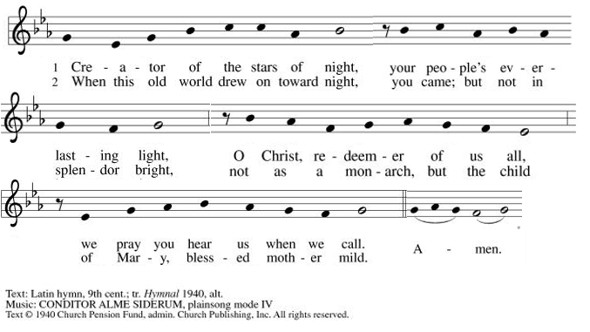

**Hymn of Praise: Rejoice, Rejoice, Believers ELW #244
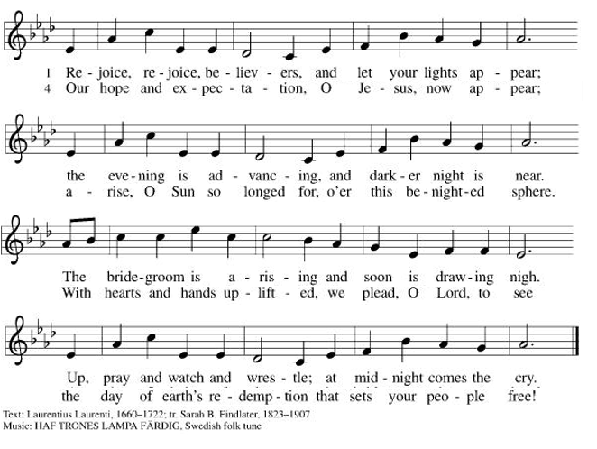
**Prayer of the Day

Loving God, from the beginning, Jesus was with you, and Jesus was you. And now, Jesus has come to bring us life, guiding our footsteps and calling us to newness of life. Help us to love and delight in his presence and in each other. Help us to remember that our lives are full of the gift of grace, and we are called to share that grace with one another and the world. We pray this in the name of Jesus, our Savior. Amen.

Bells: O Come, All Ye Faithful

Reading: Psalm 130:5-8

⁵So I wait for you, God—
my soul waits,
and in your word I place my trust.
⁶My soul longs for you, God,
more than sentinels long for the dawn,
more than sentinels long for the dawn.
⁷Israel, put your hope in God on High,
for with God is abundant love
and the fullness of deliverance;
⁸God will deliver Israel
from all its failings.

Word of God, Word of Life.
Thanks be to God!

**Gospel Acclamation: He Came Down ELW #253
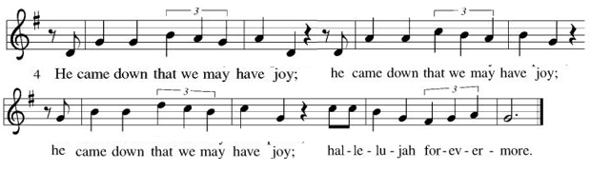
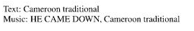
Announcement of the Gospel
Glory to you, O Lord.

Gospel: John 1:1-18

¹In the beginning
there was the Word;
the Word was in God’s presence,
and the Word was God.
²The Word was present to God
from the beginning.
³Through the Word
all things came into being,
and apart from the Word
nothing came into being
that has come into being.
⁴In the Word was life,
and that life was humanity’s light—
⁵a Light that shines in the darkness,
a Light that the darkness has never overtaken.

⁶Then came one named John, sent as an envoy from God, ⁷who came as a witness to testify about the Light, so that through his testimony everyone might believe. ⁸He himself wasn’t the Light; he only came to testify about the Light—the true Light that illumines all humankind.

⁹The Word was coming into the world—
¹⁰was in the world—
and though the world
was made through the Word,
the world didn’t recognize it.
¹¹Though the Word came to its own realm,
the Word’s own people didn’t accept it.
¹²Yet any who did accept the Word,
who believed in that Name,
were empowered to become children of God—
¹³children born not of natural descent,
nor urge of flesh
nor human will—
but born of God.
¹⁴And the Word became flesh
and stayed for a little while among us;
we saw the Word’s glory—
the favor and position a parent gives an only child—
filled with grace,
filled with truth.

¹⁵John testified by proclaiming, “This is the one I was talking about when I said, ‘The one who comes after me ranks ahead of me, for this One existed before I did.’ ”

¹⁶Of this One’s fullness
we’ve all had a share—
gift on top of gift.
¹⁷For while the Law was given through Moses,
the Gift—and the Truth—came through Jesus Christ.
¹⁸No one has ever seen God;
it is the Only Begotten,
ever at Abba’s side,
who has revealed God to us.

The Gospel of the Lord.
Praise to you, O Christ!

Sermon "A Different Kind of Christmas Story"

Hymn of the Day Of the Father's Love Begotten ELW#295

**Affirmation of Faith – Immigrant’s Creed by Jose Luis Casal

I believe in Almighty God, who guided the people in exile and in exodus, the God of Joseph in Egypt and Daniel in Babylon, the God of foreigners and immigrants.

I believe in Jesus Christ, a displaced Galilean, who was born away from his people and his home, who fled his country with his parents when his life was in danger. When he returned to his own country he suffered under the oppression of Pontius Pilate, the servant of a foreign power. Jesus was persecuted, beaten, tortured, and unjustly condemned to death. But on the third day Jesus rose from the dead, not as a scorned foreigner but to offer us citizenship in God’s kingdom.

I believe in the Holy Spirit, the eternal immigrant from God’s kingdom among us, who speaks all languages, lives in all countries, and reunites all races.

I believe that the Church is the secure home for foreigners and for all believers. I believe that the communion of saints begins when we embrace all God’s people in all their diversity. I believe in forgiveness, which makes us all equal before God, and in reconciliation, which heals our brokenness. I believe that in the Resurrection God will unite us as one people in which all are distinct and all are alike at the same time. I believe in life eternal, in which no one will be foreigner but all will be citizens of the kingdom where God reigns forever and ever. Amen.

**Prayers of Intercession

Loving God, as we wait for the coming of the Messiah, hear the prayers that we lift up to you.
In the anticipation of these days, prepare our hearts for your arrival. Stir our spirits through the gifts of artists, musicians, poets, and preachers, as together we proclaim your advent among us. God of grace,
hear our prayer.
The earth breaks forth in singing as it heralds the Messiah’s coming. Fill our hearts with wonder as we join heaven and nature in announcing this holy birth. God of grace,
hear our prayer.
You send your saving grace and peace to the nations. Lead us in work for justice and care for the common good. May we meet the Christ-child we seek in the faces of our neighbors. God of grace,
hear our prayer.
When tears of grief, exhaustion, or loneliness come, or physical or emotional hurt overwhelms us, come to our aid. Uphold all who are anxious, who know the challenges of depression, or who are ill, especially Monty, Paul, Linda, Betty F., Kay, Becky H., Jim & Jan, Becky W., David, William and family, Helen, Larry, Otto, Kevin, Peter and Carrie, families in our community who endure hunger, and our beloved for whom death is near. God of grace,
hear our prayer.
Surround expectant parents and those suffering from infant loss with communities of support. Bless young children and new parents. Guide us in ways that provide safety for all children and those who care for them. God of grace,
hear our prayer.
When people are imprisoned or held captive, break the chains and offer release. Strengthen the work of the church in restorative justice, breaking cycles of poverty, and welcoming the immigrant. Especially we pray for Global Refuge and Lutheran Social Services. God of grace,
hear our prayer.
Pave a way to justice, drown the forces of oppression, bring peace on earth. Give leaders the will to turn from war and violence. Especially we pray for the people of Sudan, Gaza, Israel, and Ukraine, and for Jim’s grandson Dylan, who is deployed in Oman. When people must flee their homes, guide them to safety. Comfort those living with deep trauma, anxiety, or fear; all those who serve people in need, and accompany all those who care for people in harm’s way. God of grace,
Hear our prayer.
We pray for people who rise up against injustice. Bring courage and resilience to those who resist tyranny with their words and their bodies. Strengthen those who fight for justice in your name across the country, and around the world. Protect and sustain immigrants and refugees and all who work with them, that your kingdom, without borders and without walls, may truly come on earth as it is in heaven. We pray for all victims of gun violence or kidnapping, especially those who are targeted out of hate or fear. Embolden us to holy outrage and empower us to speak our truth of love and justice. God of grace,
Hear our prayer.
We lift up all who teach and all who learn. Thank you for teachers who share their knowledge and wisdom. Bless the students in our midst. Especially we remember Evie, in kindergarten; Addison, in high school; and Tyler, Zach, Katie and Katy, in college. Bless Janet and Lisa as they teach. God of grace,
Hear our prayer.
We give thanks for all who have treasured the gospel and lived in faithful service. Strengthen our earthly journeys until, at the last, your face shines upon us and we are held in your in love. God of grace,
hear our prayer.

Holy and merciful God, we know that you are with us as we await your promise. We cling to the hope you offer. Amen.

** Sharing of the Peace

**Offering is brought forward

** Offertory Response Creator of the Stars of Night ELW#245

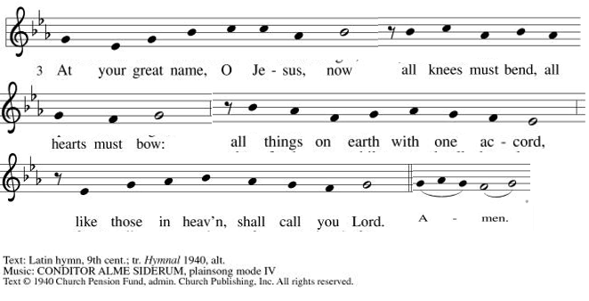

**Offertory Prayer
Almighty God, we give you thanks for all that you have given us. In return, we offer up these gifts of our skills, our time, and our money, which are a token of our offering to you. Help us to be good stewards of all that you have given us. We pray this in the name of Jesus, our Savior. Amen.

**Dialogue
Jesus has prepared a sacred meal for us.
We await your coming, Jesus.

All are welcome at your table. You call, and we respond with joy.
We await your coming, Jesus.

**Preface: In hope and patience… this hymn of praise:

**Sanctus: Prepare the Royal Highway ELW #264

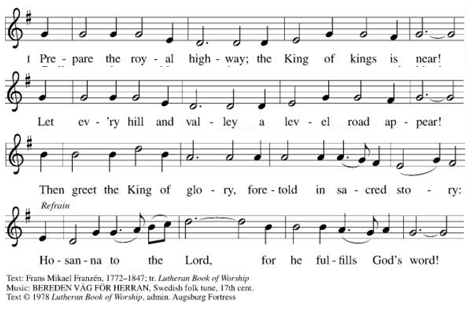
**Words of Institution

**LORD’S PRAYER

Our Father, who art in heaven,
hallowed be thy name,
thy kingdom come,
thy will be done,
on earth as it is in heaven.
Give us this day our daily bread;
and forgive us our trespasses,
as we forgive those
who trespass against us;
and lead us not into temptation,
but deliver us from evil.
For thine is the kingdom,
and the power, and the glory,
forever and ever. Amen.

Invitation to Communion

Communion Hymn People Look East ELW#248

**Sending Song Awake, Awake, and Greet the New Morn ELW#242

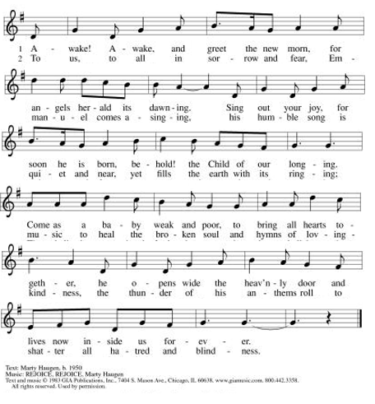

**Prayer After Communion

Loving and merciful God, you have fed us at the table and with your word. Strengthen us in our faith as we go out into the world to do the work you have sent us to do, as we await the coming of your Son, Jesus, our Savior. Amen.

**Blessing

**Closing Hymn Soon and Very Soon ELW#439

**Dismissal

Go in peace. Jesus is coming!

THANKS BE TO GOD!

+ + + + + +
All hymns under One License #733618-A. The Prayers of Intercession are under copyright and are used with permission under Augsburg Fortress Liturgy License #SB155933. All other liturgy written by Sarah Pierce.

***********************************************************************************************************
Weekly Attendance

Week of December 14

18

******************************************************************************************

Calendar of Events
Today

- Bible Study

This Week
- December 24: Christmas Eve Worship 7:00
- December 25: Office closed

Upcoming Events
December 28-December 31 | Pastor Sarah on vacation
January 07 | Paint Party Fundraiser
January 07 | Zoom presentation: Christian Nationalism
January 14, 2026 | Council Meeting 6:30 pm
January 22 | Zoom Presentation: Putting Faith into Action
January 25 | Dave Mareske Preaches/Coffee with Council
February 05 | Zoom Presentation: ELCA Social Statement
February 15 | Pre-Lent Ice Cream Social after Church
February 18 | Ash Wednesday
March 29 | Palm Sunday
April 05 | Easter Sunday

*****************************************************************************************
BLUE SPRINGS COMMUNITY SERVICE LEAGUE is very appreciative of your continued support of your neighbor.
*****************************************************************************************
Questions for Reflection and Discussion from Pastor Sarah

- I tend to be deeply uncomfortable with the metaphor of “light and dark” – there have been studies that show that we have an unconscious bias towards associating light with good and dark with bad, including skin color. (Harvard has an ongoing study at Project Implicit. You can either look that up or google Harvard Implicit Bias.) In fact, this text was the primary driver behind the “holy darkness” Advent theme.
- That being said, as long as we can deal with the light and dark, this is one of my favorite texts in the Bible. I love John, and I particularly love the prologue. I love the idea that light should be better translated “luminousness” and darkness should be better translated “obscurity!” What does that make you think of? What images does it put in your head, since this is such a poetic passage?
- It can feel jarring to have John suddenly appear in the middle of this lovely hymn to Jesus’ birth, but it’s a good reminder to us of Jesus’ humanity, because John was human. In John’s Gospel, this John is not John the Baptist, he’s John the witness. The whole gospel of John is a testimony to who Jesus is. Can we trust this witness? What does it mean to witness to who Jesus is? Our celebrations of Christmas depend on the witnessing of the shepherds, the angels, the wise men. What does it mean to accept what they have to say as truth? Is truth in the gospels objective? Or is it defined by our relationship with God?
- Although three of the four are replaced by the word “gift” in The Inclusive Bible, the word “grace” is only used four times in John’s gospel, and all four of them are in the Prologue: once in verse 14, twice in verse 16, and once in verse 17. The rest of the gospel doesn’t talk about grace: it SHOWS grace. (It’s like the old writing advice: “show, don’t tell.”) What does it mean to be filled with grace and truth? To receive grace upon grace as a gift? For grace and truth to come through Jesus?
- What does it mean to be a child of God? (verse 12)

**************************************************************************************
The Central States Synod and Kansas Interfaith Action present “We the People: a virtual series on faith & public life”

- Wednesday, January 07 6:30pm: “The Threat of Christian Nationalism” with Bishop Donna Simon
- Thursday, January 22 6:30pm: “Putting Faith Into Action” with Rev. Dr. Mandy Todd
- Thursday, February 05 6:30pm: “Diving Into the ELCA Social Statement on Faith and Civic Life” with Dr. Jim Brandt

We will join all of these sessions from the sanctuary via Zoom.

Birthdays:
Kimberly Girkin December 21
Darren Melton December 21
Larry Taylor December 24

December 21
Altar Guild – Anne Lee/Paul Blixrud
Communion Assistant – Sara Meyers
Lector – Kent Deubner
Greeter – Donna Taylor
Tech – Gary Antes

Prayer Requests
Monty Health Concerns (May 15)
Paul Health Concerns (May 31)
Mary Health Concerns (May 15)
James & Family Health Concerns (September 11)
Betty F (Sara’s friend) Health Concerns (July 15)
William and Family Health Concerns (September 25)
Becky H Health Concerns (October 28)
David Health Concerns (November 18)
Becky W Health Concerns (November 18)
Larry Health Issues (December 16)
Helen Health Issues (January 14)
Otto Health Concerns (July 15)
Kay (Sara’s cousin) Health Concerns (July 15)
Kevin Health Concerns (October 01)
Fred Health Concerns (October 22)
Sharon Health Concerns (October 22)
Michael Health Concerns (October 22)
Peter and Carrie Health Concerns (November 26)
Melian Health Concerns (November 16)
RJ Health Concrns (November 17)

Merciful God, your justice and mercy are without limits. Bring courage and resilience to those who resist tyranny with their words and their bodies. Strengthen those who fight for justice in your name across the country, and around the world.

Please pray for the people of Sudan, Gaza, Ukraine, Israel, Iran and Palestine.
Please pray for the people of Jamaica and Cuba.
Please pray for the Homeless.
Please pray for legal & illegal immigrants & those seeking asylum or citizenship.

