All Saints Lutheran Church, ELCA
421 SW 19th St. Blue Springs, Missouri 64015 816-229-3633
Pastor Sarah Pierce Spierce.aslcpastor@gmail.com
allsaintslc64015@gmail.com https://aslcbs.org/

Sunday, November 9, 2025

22nd Sunday after Pentecost

You are absolutely invited into this sacred space. We welcome all who are seeking God’s love and grace. All Saints recognizes that we are all unique and beloved children of God. We celebrate and give thanks for the many diverse gifts that God has given us. We affirm the sacredness of people of all sexual orientations, gender identities, and gender expressions. We affirm the sacredness of all those who have experienced exclusion because of race, ability, age, or culture. We are committed to working towards anti-racism in ourselves and our community. We affirm the sacredness of all those who wrestle with addiction, physical or mental health, imprisonment, socio-economic circumstances, or anything that too often divides us. We believe that through our openness we all grow in our faith through Christ’s teaching to love one another as God loves us. We need each other and our sincere hope is by being in community together, we will experience God’s presence in new and real ways.

The offering plate is by the main door to the sanctuary for your convenience.

We practice open communion at All Saints Lutheran Church. What does that mean? It means that if you believe and trust that Christ offers his body and blood For You, you are welcome at the table. At All Saints, we believe that Christ invites all people to the feast. “Come to the banquet for all is now ready.”

**Stand as you are comfortable

Prelude

Announcements

Remembrance of our Baptism

**Affirmation of Baptism

In the name of God, the Source of all that is good; Christ +, the Word who dwells among us; and the Spirit, who empowers and sends us. Amen.

Water is a powerful symbol for us as followers of Christ. It reminds us of God’s grace and presence with us: it reminds us of God’s spirit moving on the first day of creation. It reminds us of God’s saving work for Noah and his family and the animals during the flood, and the calling and sending of Jonah. It reminds us of the saving of the people of Israel through the parting of the Red Sea.

John baptized Jesus with water, and the Holy Spirit anointed him. In much the same way, through the water and the Word, we are claimed as God’s children, heirs to the promise of God’s salvation and stewards of all that God has created.

Holy God,
We give you thanks for this life-sustaining water. We give you thanks for the gift of new life in Jesus, our Savior. Shower us with your Spirit, and renew in us the knowledge of your forgiveness, your love, and your grace.

We believe in God’s grace, which is the gift of God’s unending love and forgiveness. In our baptisms we are given that gift and become members of God’s family. Let us take a moment to give thanks.

Holy God,
We can turn our backs on you, but you will never turn your back on us because we are members of your family. No matter how far we stray from you, you will always welcome us home. You will always love us. Remembering our baptism reassures us our sins are washed away so we can live the free and full lives you created us to live.

Together, we reaffirm our baptismal promises:
To live together as God’s faithful people with all the body of Christ;
To listen to the Word preached and taught, and to answer Jesus’ invitation to the Table;
To proclaim the good news: that in Christ, we are set free to love and serve our neighbor, through our words and our actions;
To serve our neighbors in our community and around the world, striving always to follow Jesus’ example to the best of our abilities;
And to work for God’s justice and the peace that is beyond our understanding, throughout creation.
Amen.

**Entrance Hymn Let Justice Flow Like Streams ELW #717

**Greeting
The grace of our Lord Jesus Christ, the love of God,
and the communion of the Holy Spirit be with you all.
And also with you.

**Kyrie
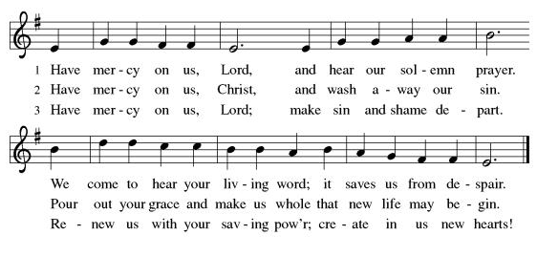

**Glory Be to God
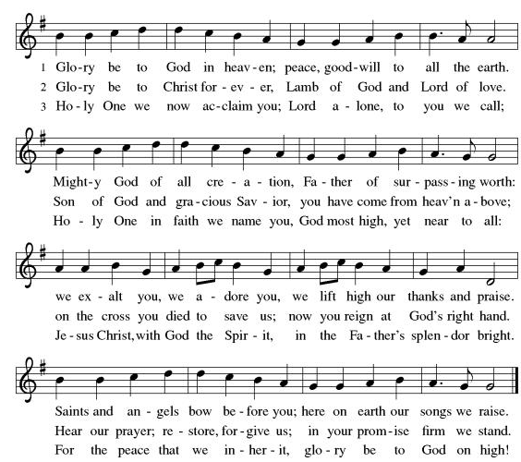
**Prayer of the Day

Holy God, you call us to care for those among us who are in need; to work for a world as you want it to be, and to foster healthy relationships with you, each other, and the world. Help us as we strive for these things, and strengthen us when we are weary or when we doubt. We pray this in the name of Jesus, our savior. Amen.

Reading: Amos 1:1-2; 5:14-24

^{1:1}The words of Amos, a sheep breeder from Tekoa. These are the visions Amos had about Israel in the time of Uzziah ruler of Judah and of Jeroboam ben-Joash, ruler of Israel, two years before the earthquake. ²Amos said:
God roars from Zion,
and thunders from Jerusalem!
The shepherds’ pastures will dry up
and the summit of Carmel will crumble.

^{5:14}Seek good and not evil, so that you may live,
and so that God the All-Powerful One
may truly be with you as you have been claiming.
¹⁵Hate what is evil, and love what is good;
maintain justice at the city gate,
and it may be that God the All-Powerful One
will take pity on the remnant of Joseph.
¹⁶For thus says God the All-Powerful One:
There will be dirges in every public square;
in every street, wails of “Woe is me! Woe is me!”
Farmers will be called upon to lament,
not just the professional mourners:
¹⁷there will be wailing in every vineyard,
for I am going to pass through your midst, says God.
¹⁸You who wish for the Day of God to come – why do you want it?
What will the Day of God mean to you?
It will be a day of darkness, not light!
¹⁹It will be like running from a lion
only to meet a bear,
or like getting home safe at last,
only to get bitten by a snake hiding in the corner!
²⁰Rest assured:
the Day of God will be darkness, not light.
²¹I despise and reject your feasts!
I am not appeased by your solemn assemblies!
²²When you offer me burnt offerings,
I reject your oblations,
and refuse to look at your sacrifices of fattened cattle!
²³Spare me the racket of your chanting!
Relieve me of the strumming of your harps!
²⁴Instead, let justice flow like a river,
and righteousness flow like an unfailing stream.

Word of God, Word of Life.
Thanks be to God!

**Gospel Acclamation
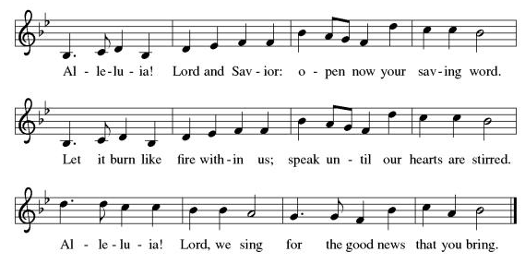
Announcement of the Gospel
Glory to you, O Lord.

Gospel: John 7:37-38

³⁷On the last and greatest day of the festival, Jesus stood up and shouted, “Any who are thirsty,
let them come to me and drink! ³⁸Those who believe in me, as the scripture says,
‘From their innermost being
will flow rivers of living water.’”

The Gospel of the Lord.
Praise to you, O Christ!

Sermon “River of Justice”

Hymn of the Day Let Streams of Living Justice ELW#710

**Affirmation of Faith – Immigrant’s Creed by Jose Luis Casal

I believe in Almighty God, who guided the people in exile and in exodus, the God of Joseph in Egypt and Daniel in Babylon, the God of foreigners and immigrants.

I believe in Jesus Christ, a displaced Galilean, who was born away from his people and his home, who fled his country with his parents when his life was in danger. When he returned to his own country he suffered under the oppression of Pontius Pilate, the servant of a foreign power. Jesus was persecuted, beaten, tortured, and unjustly condemned to death. But on the third day Jesus rose from the dead, not as a scorned foreigner but to offer us citizenship in God’s kingdom.

I believe in the Holy Spirit, the eternal immigrant from God’s kingdom among us, who speaks all languages, lives in all countries, and reunites all races.

I believe that the Church is the secure home for foreigners and for all believers. I believe that the communion of saints begins when we embrace all God’s people in all their diversity. I believe in forgiveness, which makes us all equal before God, and in reconciliation, which heals our brokenness. I believe that in the Resurrection God will unite us as one people in which all are distinct and all are alike at the same time. I believe in life eternal, in which no one will be foreigner but all will be citizens of the kingdom where God reigns forever and ever. Amen.

**Prayers of Intercession

God of Love, hear the prayers that we lift before you. Hold close to you all those for whom we pray.

God our Redeemer, bless your church universal and its leaders. Set all hearts on you from generation to generation in anticipation of Christ’s return. Hear us, O God.
Your mercy is great.
God of life, we give thanks for the fruits and grains of harvest, for rivers and streams, for all that is made of rock and iron. Renew the earth’s natural resources and the lands from which they come. Hear us, O God.
Your mercy is great.
God of justice, we give thanks for the service of our veterans and pray for those needing support for wounds of any kind. Strengthen those charged with the governance and protection of vulnerable populations. Bring an end to war throughout the world. Hear us, O God.
Your mercy is great.
God who leads us to belief and truth, we give thanks that you are always and already here. Nurture and support those who are unsteady in mind, unsafe in spirit, or unwell in body, especially Monty, Paul, Linda, Betty F., Kay, Becky H., Jim & Jan, Becky W., David, William and family, Helen, Larry, Otto, families in our community who endure hunger, Kevin, and our beloved for whom death is near. Comfort those who suffer from trauma and exposure to traumatic events. Hear us, O God.
Your mercy is great.
God who gathers us together, we give thanks for our pastors and deacons, teachers and musicians, administrators, and building caretakers. May they find joy in leadership as we grow in faith together. Hear us, O God.
Your mercy is great.
God who protects those who wander, calm the fears of migrants and refugees who set out, not knowing where they go. Provide shelter, sustenance, protection from harm, and welcome. Bless the work of Global Refuge and other support and advocacy programs. Hear us, O God.
Your mercy is great.
God who loves all people, we pray for the nations. Pave a way to justice, drown the forces of oppression, bring peace on earth. Give leaders the will to turn from war and violence. Especially we pray for the people of Sudan, Gaza, Israel, and Ukraine, and for Jim’s grandson Dylan, who is deployed in Oman. When people must flee their homes, guide them to safety. Comfort those living with deep trauma, anxiety, or fear; all those who serve people in need, and accompany all those who care for people in harm’s way. Hear us, O God.
Your mercy is great.
God who years for justice, we pray for people who rise up against injustice. Bring courage and resilience to those who resist tyranny with their words and their bodies. Strengthen those who fight for justice in your name across the country, and around the world. Protect and sustain immigrants and refugees and all who work with them, that your kingdom, without borders and without walls, may truly come on earth as it is in heaven. We pray for all victims of gun violence or kidnapping, especially those who are targeted out of hate or fear. Embolden us to holy outrage and empower us to speak our truth of love and justice. Hear us, O God.
Your mercy is great.
God who blesses us with learning, we lift up all who teach and all who learn. Thank you for teachers who share their knowledge and wisdom. Bless the students in our midst. Especially we remember Evie, in kindergarten; Addison, in high school; and Tyler, Zach, Katie and Katy, in college. Bless Janet and Lisa as they teach. Hear us, O God.
Your mercy is great.
God of the saints, we give thanks for all who have died in faith. Uplift us as we honor their memory and await your coming in glory. Hear us, O God.
Your mercy is great.

Good and loving God, we give everyone we have prayed for into your care. Amen.

** Sharing of the Peace

Special offering for Community Services League Food Pantry

**Offering is brought forward

** Offertory Response Create in Me ELW#186

**Offertory Prayer
Holy One, all that we have and all that we are comes from you. Accept these gifts, which are a token of the lives we offer to you, and inspire us to be good stewards of your bounty. We pray this in Jesus’ name. Amen.

**Dialogue
God has prepared a sacred meal for us.
We praise you, O God.

God invites us to this sacred meal; we lift our voices in gratitude.
We praise you, O God.

**Preface: Since the earliest days of the covenant… this hymn of praise:

**Holy, Holy, Holy
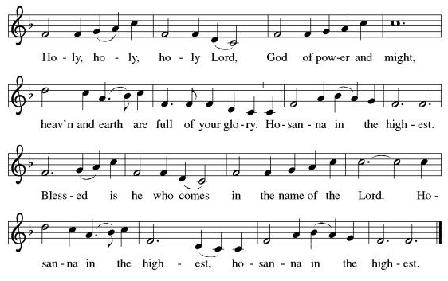
**Words of Institution

**LORD’S PRAYER

Our Father, who art in heaven,
hallowed be thy name,
thy kingdom come,
thy will be done,
on earth as it is in heaven.
Give us this day our daily bread;
and forgive us our trespasses,
as we forgive those
who trespass against us;
and lead us not into temptation,
but deliver us from evil.
For thine is the kingdom,
and the power, and the glory,
forever and ever. Amen.

Invitation to Communion

Communion Hymn By Your Hand You Feed Your People ELW#469

**Sending Song Now Thank We All Our God (verse 1) ELW#840

**Prayer After Communion

Gracious God, when we participate in this holy meal, we are connected to all who believe throughout the world. We are connected through faith, through your presence and through your mission to share your grace with all we meet. Amen.

**Blessing

**Closing Hymn Glorious Things of You Are Spoken ELW#647

**Dismissal

Go in peace to serve Christ and the world!

THANKS BE TO GOD!

+ + + + + +
Setting 10 liturgy is under copyright and used with permission under One License #733618-A. The Prayers of Intercession are under copyright and are used with permission under Augsburg Fortress Liturgy License #SB155933. All other liturgy written by Sarah Pierce.

***********************************************************************************************************
Weekly Attendance

Week of November 2

30

******************************************************************************************

Calendar of Events
Today

- Bible Study

This Week
- November 11: Creative Friends
- November 12: Bells rehearsal 6:30pm

Upcoming Events
November 16 | Congregational Meeting
November 18 | Creative Friends
November 19 | Bells 6:30
November 23 | Bells play during worship
November 25 | Creative Friends
November 26 | Thanksgiving Eve Worship 7:00 pm Pie Night
December 07 | Advent Dinner after Worship
December 10 | Council Meeting 6:30 pm
December 21 | Bells play during worship
January 14, 2026 | Council Meeting 6:30 pm
February 18 | Ash Wednesday
March 29 | Palm Sunday
April 05 | Easter Sunday

*****************************************************************************************
BLUE SPRINGS COMMUNITY SERVICE LEAGUE is very appreciative of your continued support of your neighbor.

SNAP (Supplemental Nutritional Assistance Program) Funding was allowed to expire by the federal government on 10/31. Because of this, the hunger need in our community is real, and growing. In addition to our ingathering of food for BSCSL, we will collect a special offering for them today, November 9, to provide additional funds for the food pantry.
******************************************************************************************
Questions for Reflection and Discussion from Pastor Sarah
- One of the commentators in the podcast I listened to this week said that one of his former colleagues used to say, “If you like Amos, you don’t understand him.” This is a challenging text, and a challenging book. The people in the upper levels of society are doing well, and are at peace, but aren’t paying attention to or caring for the poor among them. Humans are treated as commodities. And God sends Amos to speak out against this injustice and oppression.
- What do you think of the lion roaring from Jerusalem (in Judah, to the south) towards Carmel (where worship happens, in the north)? If you were to read all of Amos, you would find the prophet returning to this theme of the lion roaring, and hunting, repeatedly. The roar is a signal that the lion has found prey and is hunting. Lions were not unknown at the time in Israel and Judah (see Daniel in the lions’ den for a popular story involving lions).
- I talk about the “justice at the city gate” piece in my sermon, but essentially, that’s where regular citizens could seek justice by assembling a jury of their peers. The problem was, the jury could be bought off, and in Amos’ time, “justice” usually went to the highest bidder. And so the poor, if they could pay enough to be heard at all, would never win the case because they couldn’t outbid whoever they were seeking justice against, unless it was someone even poorer than they were. In verse 15, in the phrase, “it may be that God the All-Powerful One will take pity…”, the word that’s translated “it may be” really means maybe or perhaps. So Amos makes no guarantees that the Israelites will receive justice. Because human justice is a pale imitation of God’s justice, and human justice is all about the process, and how our values play out. In the same way God’s justice, which is always moving, and always about our response to God’s actions, and preferences the powerless, is even more about process.
- I want to tease out a little bit about verses 21-23: our translation doesn’t do a great job with it, but Amos talks about 7 aspects of worship: 1. festivals (Passover, weeks, booths); 2. solemn assemblies (or worship gatherings); 3-5. what our text calls “oblations” but what other texts call burnt offerings, cereal offerings, and offerings of well-being, which are the three primary types of offering; 6. noise and 7. melody, which are all the singing, instrumental music, and just general sounds of a place being occupied. This is important because in rejecting 7 aspects of worship, God is rejecting their worship totally. (Remember over the summer when we talked about 7 being a perfect number for God in the Hebrew scripture?) And the reason God is rejecting their worship totally is because they’re neglecting justice and righteousness, which is everything that God has asked them to do to live in healthy relationship with each other and make sure that everyone is cared for, and everyone has enough.
- I talk about justice in my sermon, but what about righteousness? That goes beyond justice to having healthy relationships, when everything works the way it should.

**************************************************************************************
Birthdays
Betsy Reese 11/9

November 9
Altar Guild – Mary Ann Gross & Donna Taylor
Communion Assistant –Sara Meyers
Lector –Tonya Hamilton
Tech- Gary Antes

Prayer Requests
Monty Health Concerns (May 15)
Paul Health Concerns (May 31)
Mary Health Concerns (May 15)
James & Family Health Concerns (September 11)
Betty F (Sara’s friend) Health Concerns (July 15)
William and Family Health Concerns (September 25)
Becky H Health Concerns (October 28)
David Health Concerns (November 18)
Becky W Health Concerns (November 18)
Larry Health Issues (December 16)
Helen Health Issues (January 14)
Otto Health Concerns (July 15)
Kay (Sara’s cousin) Health Concerns (July 15)
Kevin Health Concerns (October 01)
Fred Health Concerns (October 22)
Sharon Health Concerns (October 22)
Michael Health Concerns (October 22)

Merciful God, your justice and mercy are without limits. Bring courage and resilience to those who resist tyranny with their words and their bodies. Strengthen those who fight for justice in your name across the country, and around the world.

Please pray for the people of Sudan, Gaza, Ukraine, Israel, Iran and Palestine.
Please pray for the people of Jamaica and Cuba.
Please pray for the Homeless.
Please pray for legal & illegal immigrants & those seeking asylum or citizenship.

