All Saints Lutheran Church, ELCA
421 SW 19th St. Blue Springs, Missouri 64015 816-229-3633
Pastor Sarah Pierce Spierce.aslcpastor@gmail.com
allsaintslc64015@gmail.com https://aslcbs.org/

Sunday, November 2, 2025

All Saints Sunday

You are absolutely invited into this sacred space. We welcome all who are seeking God’s love and grace. All Saints recognizes that we are all unique and beloved children of God. We celebrate and give thanks for the many diverse gifts that God has given us. We affirm the sacredness of people of all sexual orientations, gender identities, and gender expressions. We affirm the sacredness of all those who have experienced exclusion because of race, ability, age, or culture. We are committed to working towards anti-racism in ourselves and our community. We affirm the sacredness of all those who wrestle with addiction, physical or mental health, imprisonment, socio-economic circumstances, or anything that too often divides us. We believe that through our openness we all grow in our faith through Christ’s teaching to love one another as God loves us. We need each other and our sincere hope is by being in community together, we will experience God’s presence in new and real ways.

The offering plate is by the main door to the sanctuary for your convenience.

We practice open communion at All Saints Lutheran Church. What does that mean? It means that if you believe and trust that Christ offers his body and blood For You, you are welcome at the table. At All Saints, we believe that Christ invites all people to the feast. “Come to the banquet for all is now ready.”

**Stand as you are comfortable

Prelude

Announcements

**Confession and Forgiveness

God who created the heavens, the earth, and all that exists, sometimes we feel small when we stand before you. But we trust that you see and hear us when we come before you.

Let us take a moment to draw near to God.

Holy God,
You always listen to us when we pray.
Forgive us when we forget to center our lives around you.
Forgive us when we turn away, distracted by other things that delight or distress us.
Forgive us when we sin against you, scorning the promises you have made to us.
Help us remember that you are always the solid foundation on which we stand.
Remind us, your children, to turn back to you.

Beloved children of God, the Spirit moves among us, bringing comfort and renewal. Our Creator, the Source of all that is good and holy, is making all things new. And in Jesus, our Savior +, we find the promise of forgiveness and mercy.

Amen.

**Entrance Hymn For All the Saints ELW #422

**Greeting
The grace of our Lord Jesus Christ, the love of God,
and the communion of the Holy Spirit be with you all.
And also with you.

**Kyrie
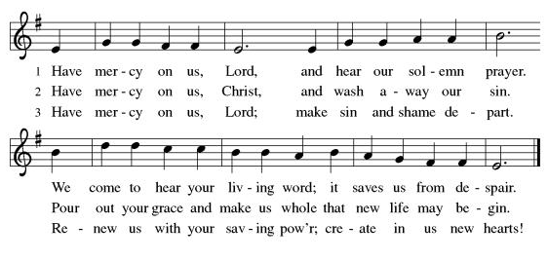

**Glory Be to God
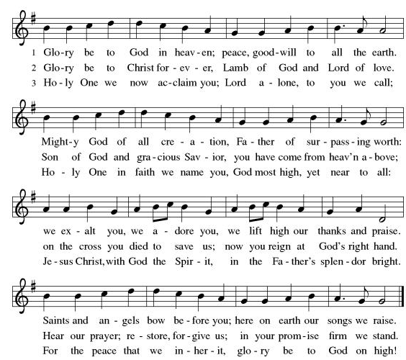
**Prayer of the Day

Gracious God, we know that you are always calling us to serve you. Help us to remember it’s important to find time to rest, so that we can return to your service refreshed and renewed. Help us to sense your call, however it comes to us, even if it comes in a way that we don’t expect; and empower us to respond in love for Jesus and service for our neighbor. We pray this in Jesus’ name. Amen.

Reading: 1 Kings 19:1-18

¹Now, Ahab told Jezebel everything Elijah did, and how he killed all the prophets with the sword. ²So Jezebel sent a messenger to Elijah, saying, “May the gods deal with me, be it ever so severely, if by this time tomorrow I do not make your life like that of one of them!”

³Full of fear, Elijah fled for his life. When he came to Beersheba in Judah, he left his attendant there, ⁴while he himself went a day’s journey into the desert. He came to a broom tree, sat down under it and prayed that he might die. “I have had enough, God,” he said. “Take my life; I am no better than my ancestors.” ⁵Then he lay down under the tree and fell asleep. Suddenly an angel of God touched him and said, “Get up and eat.”

⁶He looked around, and there near his head was a cake of bread baked over hot coals, and a jar of water. He ate the cake and drank the water and then lay down again.

⁷The angel of God came back a second time and touched him and said, “Get up and eat, for the journey is too much for you.” ⁸So he got up and ate and drank some more.

Strengthened by that food, he traveled for forty days and forty nights until he reached Horeb, the mountain of God. ⁹There he went into a cave and spent the night.

And the word of God came to him: “What are you doing here, Elijah?”

¹⁰Elijah replied, “I have been very zealous for God the All-Powerful One. The people of Israel have abandoned your covenant, broken down your altars, and put your prophets to death by the sword. I am the only one left, and now they’re trying to kill me, too.”

¹¹God said, “Go out and stand on the mountain in the presence of God, for God is about to pass by.”

Then a great and powerful wind tore the mountain apart and shattered the rocks by God’s power—but God was not in the whirlwind. After the wind there was an earthquake—but God was not in the earthquake. ¹²After the earthquake came a fire—but God was not in the fire. And after the fire came a gentle whisper.

¹³When Elijah heard it, he pulled his cloak over his face and went out and stood at the mouth of the cave.

Then a voice said to him, “What are you doing here, Elijah?”

¹⁴He replied, “Elijah replied, “I have been very zealous for God the All-Powerful One. The people of Israel have abandoned your covenant, broken down your altars, and put your prophets to death by the sword. I am the only one left, and now they’re trying to kill me, too.”

¹⁵God told Elijah, “Go back the way you came, to the Desert of Damascus. When you get there, anoint Hazael as ruler of Aram. ¹⁶Also anoint Jehu ben-Nimshi as ruler over Israel, and anoint Elisha ben-Shaphat, from Abel Meholah, to succeed you as prophet. ¹⁷Jehu will put to death any who escape the sword of Hazael, and Elisha will put to death any who escape the sword of Jehu. ¹⁸Yet I reserve 7,000 in Israel—all whose knees have not bowed down to Ba’al and all whose mouths have not kissed his images.”

¹⁹So Elijah went from there and found Elisha ben-Shaphat. He was plowing with twelve yoke of oxen, and he himself was driving the twelfth pair. Elijah went up to him and threw his cloak around him. ²⁰Elisha immediately left his oxen and ran after Elijah.

“Let me kiss my parents good-bye,” he said, “and then I will come with you.”

“Go back,” Elijah replied. “What have I done to you?”

²¹So Elisha left him and went back. He took his yoke of oxen and slaughtered them. He burned the plowing equipment to cook the meat and gave it to the people, and they ate. Then he set out to follow Elijah and become his servant.

Word of God, Word of Life.
Thanks be to God!

**Gospel Acclamation
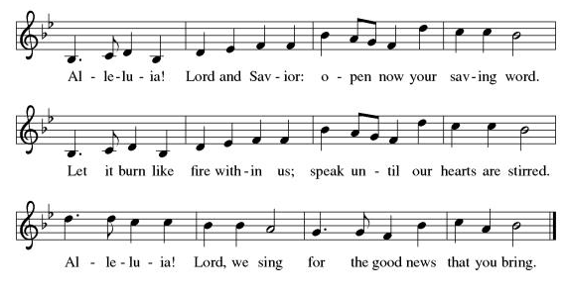
Announcement of the Gospel
Glory to you, O Lord.

Gospel: John 12:27-28

²⁷[Jesus prayed,] “Now my soul is troubled.
What will I say:
‘Abba, save me from this hour?’
But it was for this very reason
that I have come to this hour.
²⁸Abba, glorify your name!”

A voice came from heaven:
“I have glorified it, and I will glorify it again.”

The Gospel of the Lord.
Praise to you, O Christ!

Sermon “Renewing the Call”

Hymn of the Day Give Thanks for Saints ELW#428

Remembrance of the Saints Who Have Gone Before

Recognition of the Saints Among Us

**Affirmation of Faith – Immigrant’s Creed by Jose Luis Casal

I believe in Almighty God, who guided the people in exile and in exodus, the God of Joseph in Egypt and Daniel in Babylon, the God of foreigners and immigrants.

I believe in Jesus Christ, a displaced Galilean, who was born away from his people and his home, who fled his country with his parents when his life was in danger. When he returned to his own country he suffered under the oppression of Pontius Pilate, the servant of a foreign power. Jesus was persecuted, beaten, tortured, and unjustly condemned to death. But on the third day Jesus rose from the dead, not as a scorned foreigner but to offer us citizenship in God’s kingdom.

I believe in the Holy Spirit, the eternal immigrant from God’s kingdom among us, who speaks all languages, lives in all countries, and reunites all races.

I believe that the Church is the secure home for foreigners and for all believers. I believe that the communion of saints begins when we embrace all God’s people in all their diversity. I believe in forgiveness, which makes us all equal before God, and in reconciliation, which heals our brokenness. I believe that in the Resurrection God will unite us as one people in which all are distinct and all are alike at the same time. I believe in life eternal, in which no one will be foreigner but all will be citizens of the kingdom where God reigns forever and ever. Amen.

**Prayers of Intercession

God of Love, hear the prayers that we lift before you. Hold close to you all those for whom we pray.

God who became human in Jesus, challenge the church to recognize Christ in all our neighbors. Give church leaders endurance in times of weakness and affliction. Grant wisdom in conflict and joy in service. Hear us, O God.
Your mercy is great.
God who preserves us in trouble, guide us to properly care for the earth’s resources. Heal waters, land, and air to sustain future generations. Hear us, O God.
Your mercy is great.
God who guides our ways, give the world’s leaders, voters, and those seeking election humility and respect for the dignity of all. Accompany local election workers and community volunteers. Increase and sustain your justice through all the world. Hear us, O God.
Your mercy is great.
God who brings grace and peace, we pray for those who are unhoused and in need of shelter, suffering and in need of comfort, and sick and in need of relief, especially Monty, Paul, Linda, Betty F., Kay, Becky H., Jim & Jan, Becky W., David, William and family, Helen, Larry, Otto, families in our community who endure hunger, Kevin, Kent and Carla, and our beloved for whom death is near. Be with the people of Jamaica and Cuba, and all others who feel the devastating effects of Hurricane Melissa. Hear us, O God.
Your mercy is great.
God who knows us by name, bless our congregational leaders with wisdom and give them a faithful vison for your church. Bless this congregation’s children and young people as they grow and are nourished. Hear us, O God.
Your mercy is great.
God who protects those who wander, calm the fears of migrants and refugees who set out, not knowing where they go. Provide shelter, sustenance, protection from harm, and welcome. Bless the work of Global Refuge and other support and advocacy programs. Hear us, O God.
Your mercy is great.

God who loves all people, we pray for the nations. Pave a way to justice, drown the forces of oppression, bring peace on earth. Give leaders the will to turn from war and violence. Especially we pray for the people of Gaza, Israel, and Ukraine, and for Jim’s grandson Dylan, who is deployed in Oman. When people must flee their homes, guide them to safety. Comfort those living with deep trauma, anxiety, or fear; all those who serve people in need, and accompany all those who care for people in harm’s way. Hear us, O God.
Your mercy is great.
God who years for justice, we pray for people who rise up against injustice. Bring courage and resilience to those who resist tyranny with their words and their bodies. Strengthen those who fight for justice in your name across the country, and around the world. Protect and sustain immigrants and refugees and all who work with them, that your kingdom, without borders and without walls, may truly come on earth as it is in heaven. We pray for all victims of gun violence or kidnapping, especially those who are targeted out of hate or fear. Embolden us to holy outrage and empower us to speak our truth of love and justice. Hear us, O God.
Your mercy is great.
God who blesses us with learning, we lift up all who teach and all who learn. Thank you for teachers who share their knowledge and wisdom. Bless the students in our midst. Especially we remember Evie, in kindergarten; Addison, in high school; and Tyler, Zach, Katie and Katy, in college. Bless Janet and Lisa as they teach. Hear us, O God.
Your mercy is great.
God who welcomes us home, we remember your saints. Let us trust in the peace and promise of the resurrection. Hear us, O God.
Your mercy is great.

Good and loving God, we give everyone we have prayed for into your care. Amen.

** Sharing of the Peace

**Offering is brought forward

** Offertory Response Create in Me ELW#186

**Blessing of CSL Gifts

**Offertory Prayer
Holy One, all that we have and all that we are comes from you. Accept these gifts, which are a token of the lives we offer to you, and inspire us to be good stewards of your bounty. We pray this in Jesus’ name. Amen.

**Dialogue
God has prepared a sacred meal for us.
We praise you, O God.

God invites us to this sacred meal; we lift our voices in gratitude.
We praise you, O God.

**Preface: Since the earliest days of the covenant… this hymn of praise:

**Holy, Holy, Holy
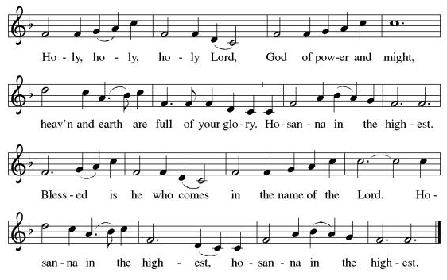
**Words of Institution

**LORD’S PRAYER

Our Father, who art in heaven,
hallowed be thy name,
thy kingdom come,
thy will be done,
on earth as it is in heaven.
Give us this day our daily bread;
and forgive us our trespasses,
as we forgive those
who trespass against us;
and lead us not into temptation,
but deliver us from evil.
For thine is the kingdom,
and the power, and the glory,
forever and ever. Amen.

Invitation to Communion

Communion Hymn Now We Join in Celebration ELW#462

**Sending Song Now Thank We All Our God (verse 1) ELW#840

**Prayer After Communion

Gracious God, when we participate in this holy meal, we are connected to all who believe throughout the world. We are connected through faith, through your presence and through your mission to share your grace with all we meet. Amen.

**Blessing

**Closing Hymn Now the Silence ELW#460

**Dismissal

Go in peace to serve Christ and the world!

THANKS BE TO GOD!

+ + + + + +
Setting 10 liturgy is under copyright and used with permission under One License #733618-A. The Prayers of Intercession are under copyright and are used with permission under Augsburg Fortress Liturgy License #SB155933. All other liturgy written by Sarah Pierce.

***********************************************************************************************************
Weekly Attendance

Week of October 19

24

******************************************************************************************

Calendar of Events
Today

- Film after Worship

This Week
- November 4: Creative Friends
- November 5: Council Meeting 6:30pm

Upcoming Events
November 11 | Creative Friends
November 12 | Bells 6:30
November 16 | Congregational Meeting
November 18 | Creative Friends
November 19 | Bells 6:30
November 25 | Creative Friends
November 26 | Thanksgiving Eve Worship 7:00 pm Pie Night
December 07 | Advent Dinner after Worship
December 10 | Council Meeting 6:30 pm
January 14, 2026 | Council Meeting 6:30 pm
February 18 | Ash Wednesday
March 29 | Palm Sunday
April 05 | Easter Sunday

*****************************************************************************************
BLUE SPRINGS COMMUNITY SERVICE LEAGUE is very appreciative of your continued support of your neighbor.

SNAP (Supplemental Nutritional Assistance Program) Funding was allowed to expire by the federal government on 10/31. Because of this, the hunger need in our community is real, and growing. In addition to our ingathering of food for BSCSL, we will collect a special offering for them next Sunday, November 9, to provide additional funds for the food pantry.
******************************************************************************************
Questions for Reflection and Discussion from Pastor Sarah
- Every commentary that I read pointed out that we tend to focus on the wrong thing in this story. We tend to focus on the presence of God in the “still small voice.” We like a good theophany story (theophany means the unambiguous manifestation of God), and we especially like this one – maybe because the gentle whisper is so much less threatening than the tornado, the earthquake, or the fire. But it does tend to detract us from the main point of the story, which is Elijah trying to quit his job.
- There’s that phrase that makes the rounds as a curse every now and again – “May you live in interesting times” – and it certainly seems like it could apply to Elijah’s life. 1 and 2 Kings rates the kings of Judah and Israel as “good” or “bad” based on whether they were faithful to God, and Ahab’s rating is worse than any of the 7 kings of Israel who came before him, according to 1 Kings 16:30. Elijah was the lucky one who God called to be a prophet specifically to speak out against Ahab, although there were a lot of prophets at the time; 1 Kings 18 tells a story of Obadiah saving 100 of them from Jezebel by hiding them in caves. Elijah warned Ahab of a drought and famine that would be brought on by his evil ways, and then God sent Elijah to a small town to live with a widow and her son. They survived because of the daily miracle of flour and oil that replenished, and when the son died, Elijah prayed for him to be brought back to life and God answered that prayer. Elijah “battled” with the 450 prophets of Ba’al over whose God was more powerful, before killing them all. (It was a pretty bloodthirsty time.) It’s no wonder that Elijah is burned out – he’s been through more than a lifetime’s worth of drama and power and miracles, all in three years!
- One of the commentators in the podcast that I like to listen to compared this story in particular to a piece of music, and said it’s important to listen to the voices. How do you hear the dialog? What’s the tone that the angel uses with Elijah? How does the conversation sound between God and Elijah – what tone of voice does each take with the other? How does the wind, and the earthquake, and the fire, and the silence sound? And finally, how does God sound when re-commissioning Elijah?
- The symbols of God are important: the wind storm is often a symbol of the Holy Spirit, going back as far as creation. And the Hebrew word for wind, ruach, also means Spirit. (the same is true in Greek: pneuma.) The earthquake was one of the ways that God made God’s presence known to the Israelites on Horeb, as was fire – as well as the pillar of fire that led them, and the burning bush; and fire is also a common symbol of the Holy Spirit. So do you think it’s significant that Elijah didn’t sense God in any of those manifestations? Is it significant for YOU in any way?
- How is the Spirit speaking to you and showing up in your life these days? How do you feel called?

**************************************************************************************
Tech- October 26-Gary Antes

Prayer Requests
Monty Health Concerns (May 15)
Paul Health Concerns (May 31)
Mary Health Concerns (May 15)
James & Family Health Concerns (September 11)
Betty F (Sara’s friend) Health Concerns (July 15)
William and Family Health Concerns (September 25)
Becky H Health Concerns (October 28)
David Health Concerns (November 18)
Becky W Health Concerns (November 18)
Larry Health Issues (December 16)
Helen Health Issues (January 14)
Otto Health Concerns (July 15)
Kay (Sara’s cousin) Health Concerns (July 15)
Kevin Health Concerns (October 01)
Kent Health Concerns (October 01)
Carla Health Concerns (October 01)
Fred Health Concerns (October 22)
Sharon Health Concerns (October 22)
Michael Health Concerns (October 22)

Merciful God, your justice and mercy are without limits. Bring courage and resilience to those who resist tyranny with their words and their bodies. Strengthen those who fight for justice in your name across the country, and around the world.

Please pray for the people of Gaza, Ukraine, Israel, Iran and Palestine.
Please pray for the people of the Sudan.
Please pray for the people of Jamaica and Cuba.
Please pray for the Homeless.
Please pray for legal & illegal immigrants & those seeking asylum or citizenship.

