All Saints Lutheran Church, ELCA
421 SW 19th St. Blue Springs, Missouri 64015 816-229-3633
Pastor Sarah Pierce Spierce.aslcpastor@gmail.com
allsaintslc64015@gmail.com https://aslcbs.org/

Sunday, October 25, 2026

Reformation Sunday

You are absolutely invited into this sacred space. We welcome all who are seeking God’s love and grace. All Saints recognizes that we are all unique and beloved children of God. We celebrate and give thanks for the many diverse gifts that God has given us. We affirm the sacredness of people of all sexual orientations, gender identities, and gender expressions. We affirm the sacredness of all those who have experienced exclusion because of race, ability, age, or culture. We are committed to working towards anti-racism in ourselves and our community. We affirm the sacredness of all those who wrestle with addiction, physical or mental health, imprisonment, socio-economic circumstances, or anything that too often divides us. We believe that through our openness we all grow in our faith through Christ’s teaching to love one another as God loves us. We need each other and our sincere hope is by being in community together, we will experience God’s presence in new and real ways.
The offering plate is by the main door to the sanctuary for your convenience.
We practice open communion at All Saints Lutheran Church. What does that mean? It means that if you believe and trust that Christ offers his body and blood For You, you are welcome at the table. At All Saints, we believe that Christ invites all people to the feast. “Come to the banquet for all is now ready.”
**Stand as you are comfortable
Note: Bold Print - Congregational Statements

Prelude
Announcements

** Confession and Forgiveness
God who created the heavens, the earth, and all that exists, sometimes we feel small when we
stand before you. But we trust that you see and hear us when we come before you.
Let us take a moment to draw near to God.
Holy God,
You always listen to us when we pray.
Forgive us when we forget to center our lives around you.
Forgive us when we turn away, distracted by other things that delight or distress us.
Forgive us when we sin against you, scorning the promises you have made to us.
Help us remember that you are always the solid foundation on which we stand.
Remind us, your children, to turn back to you.

Beloved children of God, the Spirit moves among us, bringing comfort and renewal. Our
Creator, the Source of all that is good and holy, is making all things new. And in Jesus, our
Savior +, we find the promise of forgiveness and mercy.
Amen.

**Entrance Hymn A Mighty Fortress is Our God ELW # 504

**Greeting
The grace of our Lord Jesus Christ, the love of God,
and the communion of the Holy Spirit be with you all.
And also with you.
**Kyrie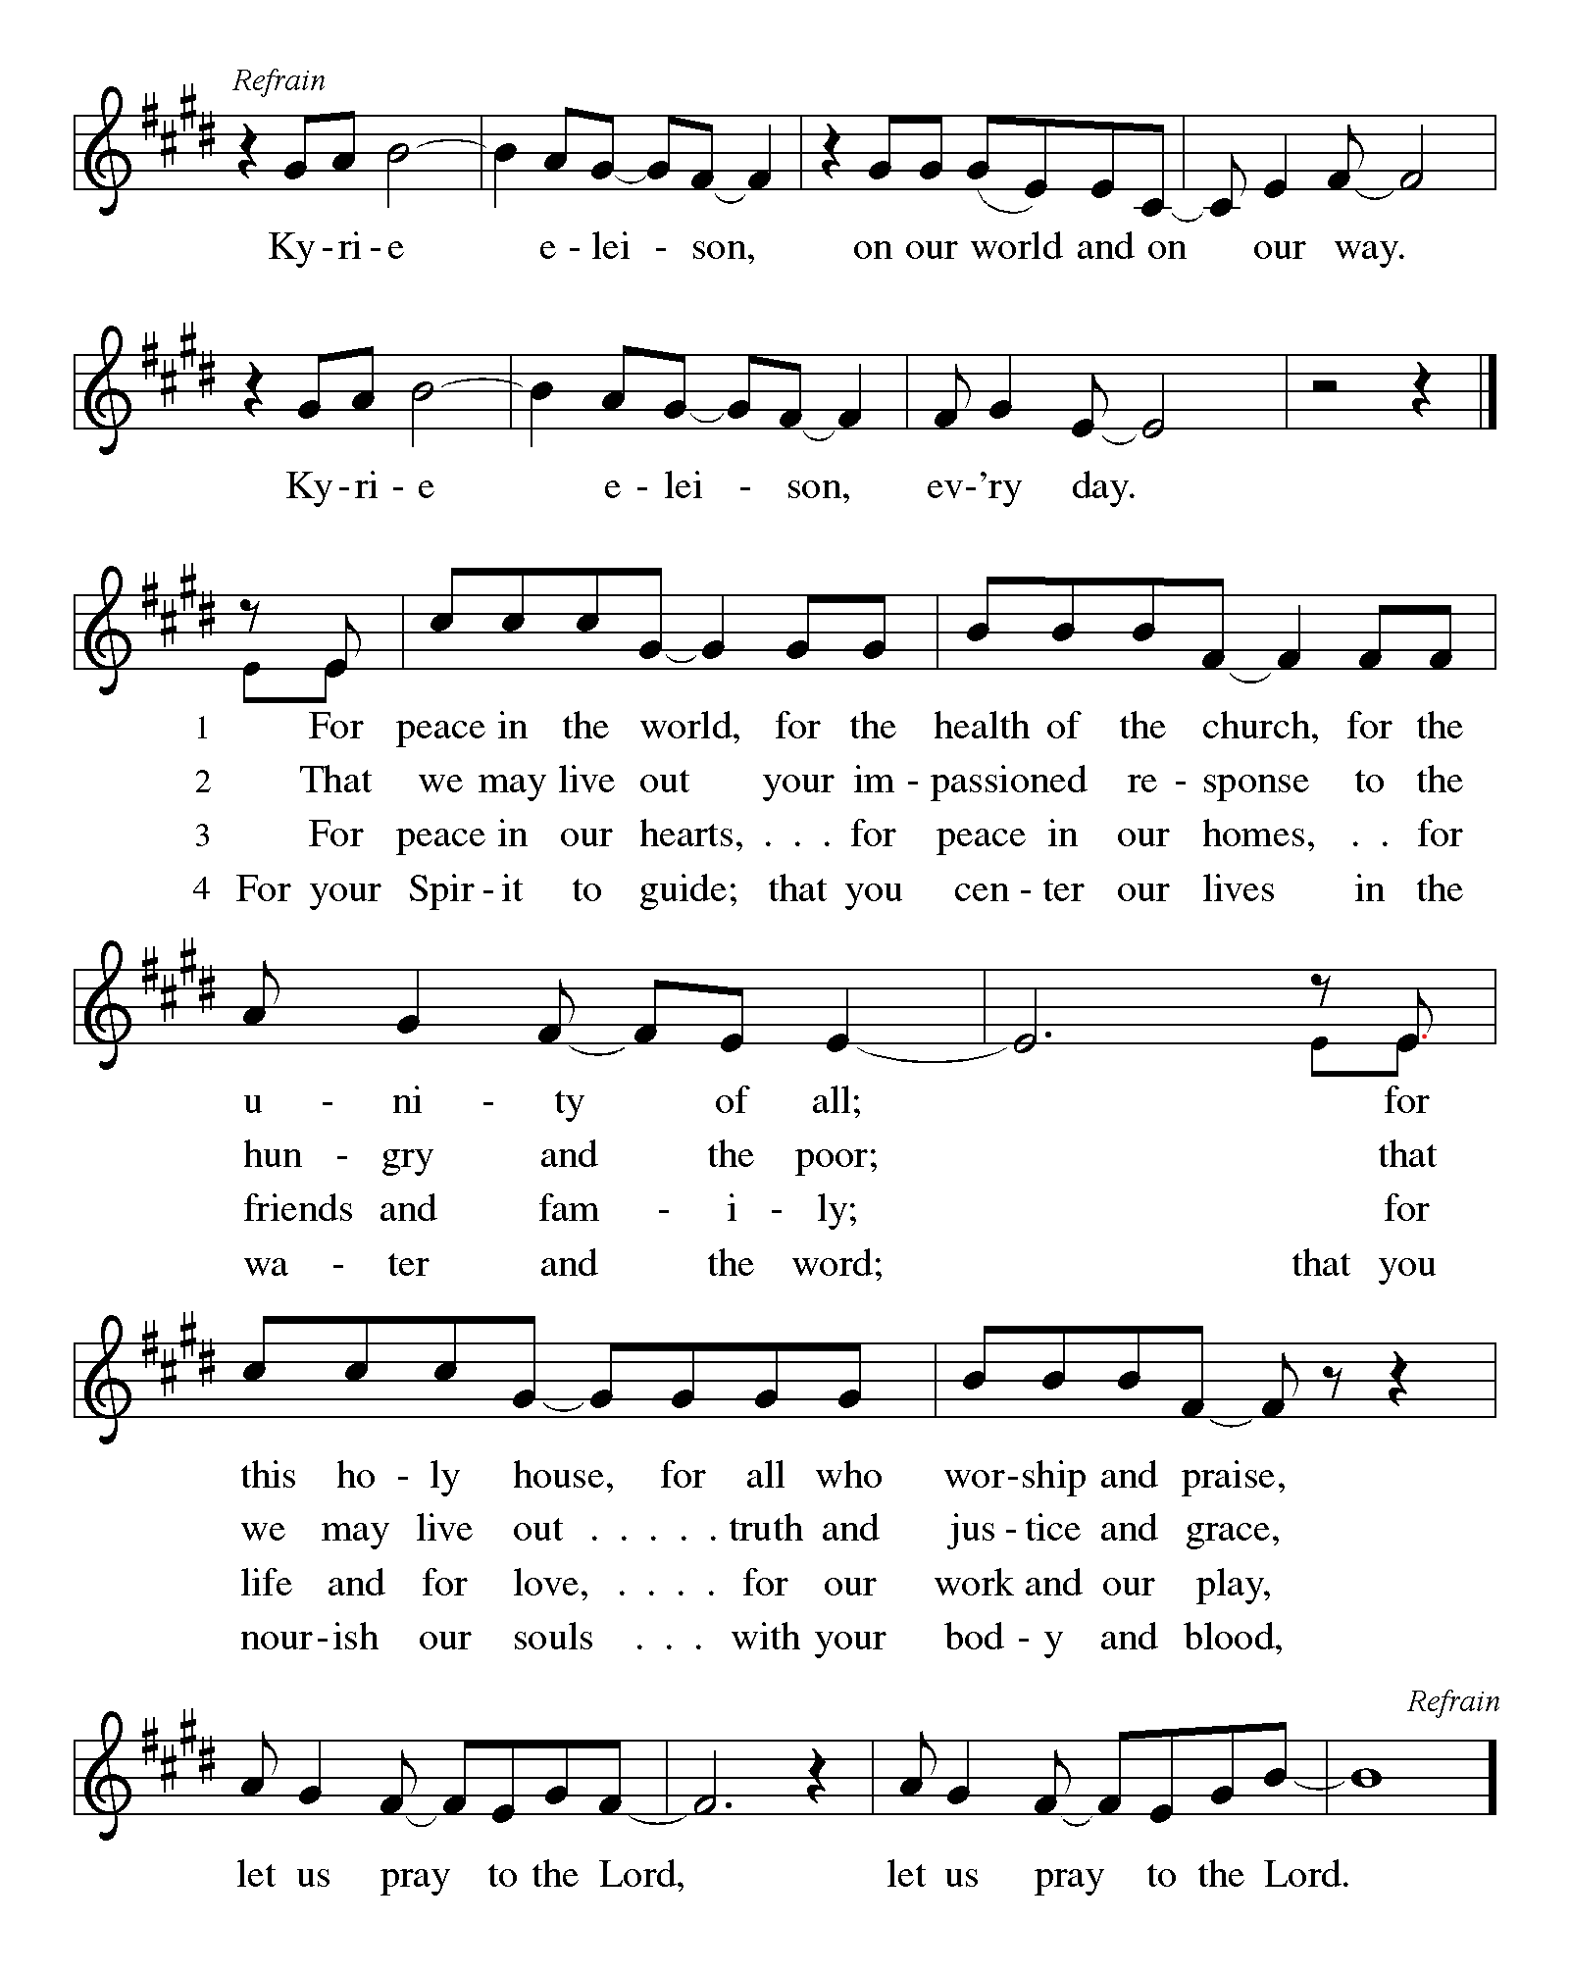
**Hymn of Praise:
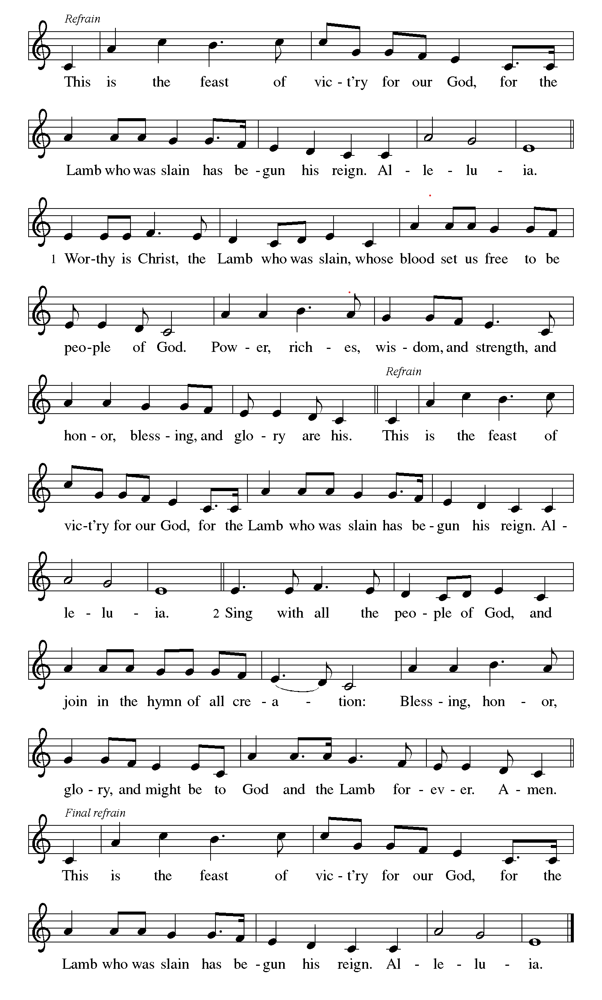
**Prayer of the Day

Faithful God, you carry us on eagle’s wings, claiming us in grace before we are ever able to
respond. When we forget you and turn aside, call us back through the promise of our baptism, and
help us to live as your people in trust, gratitude, and love. We pray this in Jesus’ name. Amen.

Reading: 2 Samuel 11:1-5; 26--12:9

¹In the spring, that time of the year when rulers go off to war, David sent Joab out along with his officers and troops. They massacred the Ammonites and laid siege to Rabbah.

David, however, stayed in Jerusalem. ²As evening approached, David rose from his couch and strolled about on the flat roof of the palace. From the roof he saw a woman – a very beautiful woman – bathing. ³David made inquiries about her and learned that her name was Bathsheba, and that she was the daughter of Eilam and the wife of Uriah the Hittite. ⁴Then David sent messengers to fetch her. She came to him, and he slept with her, at a time when she had been declared ritually clean after her monthly period. Then she returned to her house. ⁵But she conceived, and sent this message to David: “I’m pregnant.”

²⁶When Bathsheba heard that her husband was dead, she mourned for him. ²⁷After the time of mourning was over, David had her brought to the palace, and she became his wife and bore him a son.

But David’s actions displeased God.

^{12:1}God sent Nathan to David. Nathan went to David, and said, “Let me present you with a case for your judgment: There were two people in a certain town; one was rich and the other was poor. ²The rich person had very large herds of cattle and sheep, ³but the poor person had only one recently-purchased little ewe lamb. The poor person raised it, and it grew with the family, adults and children alike. They shared their food with it; it drank from its own cup, and even slept with family. It was like another child to the family.

⁴“Now a traveler came to the rich person, who went about giving hospitality to the traveler. But rather than taking one of his own livestock to prepare a meal for the traveler, the rich person took the little ewe lamb from the poor family to serve to the traveler.”

⁵When David heard the story, he became livid, and burst out, “As God lives, the rich person who did this must die! ⁶The rich person must pay for the lamb four times over! To do such a thing is evil!”

⁷Then Nathan said to David, “You are that corrupt person! This is what the God of Israel says: ‘I anointed you ruler over Israel. And I delivered you from the hand of Saul. ⁸I gave you your palace, along with your many wives in your arms. I gave you the tribes of Israel and Judah. And if all this had been too little, I would have added other favors as well. ⁹Why did you despise the word of God by doing what you did, which is evil in God’s eyes? You struck down Uriah the Hittite with the sword and took his wife as your own. You murdered Uriah with the sword of the Ammonites. ¹⁰Now, therefore, the sword will never be far from your house; for you showed contempt of me and took Bathsheba to be your own.’

¹¹“This is what God says, ‘I will stir up evil for you out of your own house. Before your very eyes I will take your wives and give them to your neighbor; and your neighbor will lie with your wives in broad daylight. ¹²You did it secretly, but I will do it in broad daylight before all Israel.’”

Psalm 51:1-9

¹O God, have mercy on me!
Because of your love and your compassion,
wipe away my faults;
²wash me clean of my guilt;
purify me of my sin.
³For I am aware of my faults,
and have my sin constantly in mind.
⁴I sinned against you alone,
and did what is evil in your sight.
You are just when you pass sentence on me,
blameless when you give judgment.

⁵I was born in sin,
conceived in sin –
⁶yet you want truth to live in my innermost being.
Teach me your wisdom!
⁷Purify me with hyssop until I am clean;
wash me until I am purer than new-fallen snow.
⁸Instill some joy and gladness into me;
let the bones you have crushed rejoice again.
⁹Turn your face from my sins,
and wipe out all my guilt.

Word of God, Word of Life
Thanks be to God

**Gospel Acclamation
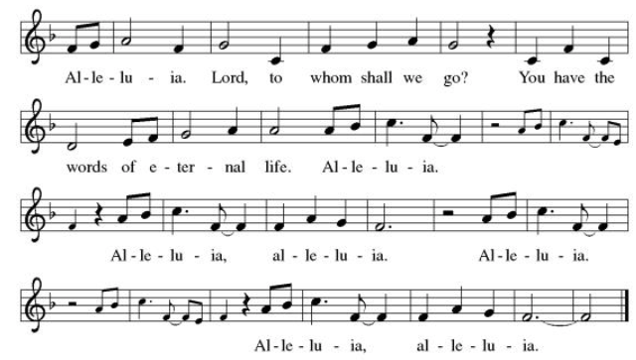

Announcement of the Gospel

Glory to you, O Lord.

Gospel: Matthew 21:33-41

³³[Jesus said,] “Listen to another parable. There was a property owner who planted a vineyard, put a hedge around it, installed a winepress and erected a tower. Then the owner leased it out to tenant farmers and went on a journey.
³⁴“When vintage time arrived, the owner sent aides to the tenants to divide the shares of the grapes. ³⁵The tenants responded by seizing the aides. They beat one, killed another and stoned a third. ³⁶A second time the owner sent even more aides than before, but they treated them the same way. ³⁷Finally, the owner sent the family heir to them, thinking, ‘They will respect my heir.’

³⁸“When the vine growers saw the heir, they said to one another, ‘Here’s the one who stands in the way of our having everything. With a single act of murder we could seize the inheritance.’ ³⁹With that, they grabbed and killed the heir outside the vineyard. ⁴⁰What do you suppose the owner of the vineyard will do to those tenants?”

The Gospel of the Lord.
Praise to you, O Christ.

Sermon "Self-Justification/Justification"

Hymn of the Day Our Father, We Have Wandered ELW # 606

**Affirmation of Faith – Immigrant’s Creed by Jose Luis Casal
I believe in Almighty God, who guided the people in exile and in exodus, the God of Joseph in Egypt and Daniel in Babylon, the God of foreigners and immigrants.

I believe in Jesus Christ, a displaced Galilean, who was born away from his people and his home, who fled his country with his parents when his life was in danger. When he returned to his own country he suffered under the oppression of Pontius Pilate, the servant of a foreign power. Jesus was persecuted, beaten, tortured, and unjustly condemned to death. But on the third day Jesus rose from the dead, not as a scorned foreigner but to offer us citizenship in God’s kingdom.

I believe in the Holy Spirit, the eternal immigrant from God’s kingdom among us, who speaks all languages, lives in all countries, and reunites all races.

I believe that the Church is the secure home for foreigners and for all believers. I believe that the communion of saints begins when we embrace all God’s people in all their diversity. I believe in forgiveness, which makes us all equal before God, and in reconciliation, which heals our brokenness. I believe that in the Resurrection God will unite us as one people in which all are distinct and all are alike at the same time. I believe in life eternal, in which no one will be foreigner but all will be citizens of the kingdom where God reigns forever and ever. Amen.

**Prayers of Intercession

Holy God, our prayers rise to you like the wings of a dove. We call upon your name, and we ask that you hear us.

Gracious God, as we remember the Reformation, we thank you for all those who have worked to hold the church accountable to its mission. Protect them as they speak truth to power. Hear us, O God.
Your mercy is great.
We give thanks for the beauty of the world’s islands, coastlines, and low-lying places. Keep them and their inhabitants safe from harm. Hear us, O God.
Your mercy is great.
We thank you for the diversity of humankind, made in your image. We pray for the future of endangered languages and cultures. Preserve them to show forth your glory. Hear us, O God.
Your mercy is great.
We pray for the healing of all who are sick or injured, especially those who cannot access medical care. We remember those whom we love who are suffering or in pain especially Monty & Marie, Paul, Helen, Linda, Kay, Becky H., Jim & Jan, Melian, Becky W., David, William & family, Judy, Peter & Carrie, Barbara & Donna, Brad & Chris, Drake, Bill & Sandy, Betsy, Jean, Howard & Sara, the Frances Davis family, and the people of Hawaii, Nepal, and Tibet. Hear us, O God.
Your mercy is great.
We give thanks for retired clergy and their families, honoring their faithful service to your church. Bless them as they find new ways to live into their vocation. Hear us, O God.
Your mercy is great.
Pave a way to justice, drown the forces of oppression, bring peace on earth. Give leaders the will to turn from war and violence. Especially we pray for the people of Cuba, Venezuela, Iran, Sudan, Gaza, Israel, and Ukraine. When people must flee their homes, guide them to safety. Comfort those living with deep trauma, anxiety, or fear; all those who serve people in need, and accompany all those who care for people in harm’s way. We also lift up Jim’s grandson, Dylan, who is deployed, and Sharon’s great nephew, Taylor, who is serving in the military. Hear us, O God.
Your mercy is great.
We lift up all who teach and all who learn. Thank you for teachers who share their knowledge and wisdom. Bless the students in our midst. Especially we remember Evie, in Elementary school; Addison, in high school; and Tyler and Zack, in college. Bless Lisa and Carla as they teach. Hear us, O God.
Your mercy is great.
We thank you for all the faithful departed who taught us to love God and our neighbor. By their example, help us to seek after you with heart, soul, and mind. Hear us, O God.
Your mercy is great.
Good and loving God, we give everyone we have prayed for into your care. Amen.

** Sharing of the Peace

**Offering is brought forward

** Offertory Response Take Oh, Take Me As I Am ELW # 814

** Offertory Prayer

Good and loving God, everything that we have and everything that we are comes from you.
We respond in gratitude, offering up to you our gifts of our money, our time, and our
talents. We dedicate these gifts to your service. In Jesus’ name we pray, amen.

Dialogue
Christ is with you!
And also with you!
Lift up your hearts in joyful praise!
We lift them up to God in joy!

**Preface: Since the earliest days of the covenant…this hymn of praise: 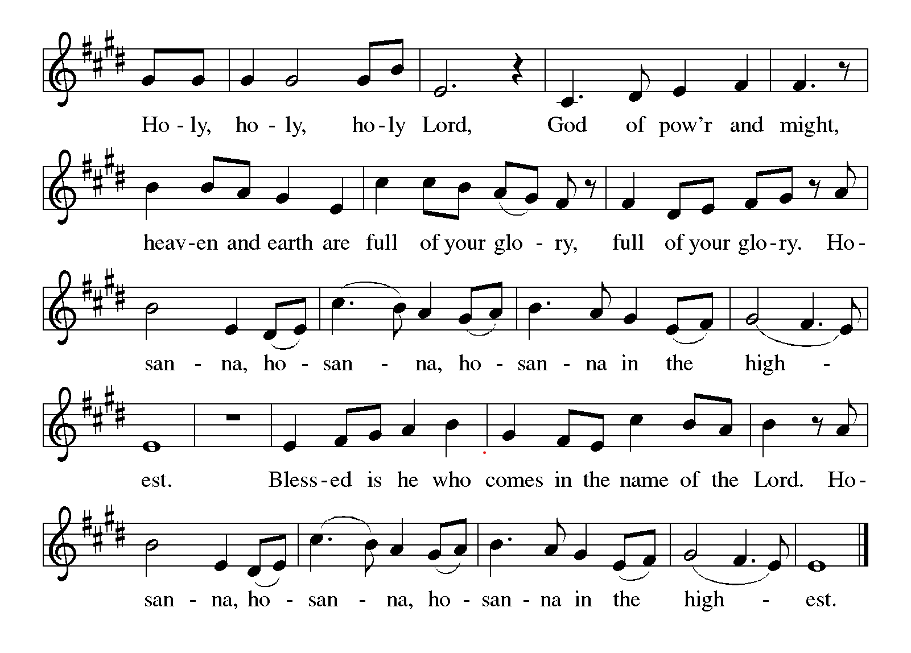
**words of institution

**LORD’S PRAYER

Our Father in heaven,
hallowed be your name,
your kingdom come,
your will be done,
on earth as in heaven.
Give us today our daily bread.
Forgive us our sins
as we forgive those
who sin against us.
Save us from the time of trial
and deliver us from evil.
For the kingdom, the power,
and the glory are yours,
now and forever. Amen.

Invitation to Communion

Communion Hymn For the Bread Which You Have Broken ELW # 494

**Prayer After Communion

Abiding God, you call us then feed and nurture us. Now you send us out in the world you created with a purpose: to love our neighbors and care for those who need us. Strengthen us to do your work. In Jesus’ name we pray, amen.

Affirmation of Christian Vocation

Siblings in Christ, both your work and your rest are gifts from God, given to you by the Spirit. Will you continue to pattern your life on our risen Savior, Jesus Christ, in a spirit of thanks to God and in service to others, from the opening to the closing of the day, while you work and while you rest, all the days of your life?

We will, and we ask God to help us.

Let us pray.
Good and loving God, by the power of the Spirit, you have formed your people into the body of your Son, Jesus Christ. Shower us with your blessings as we renew our commitment to serve and to rest in Jesus’ name. Give us courage, patience, and vision, and strengthen us all in our Christian vocation of witness to the world and service to others. We pray this in the name of Jesus Christ, who lives and reigns with you. Amen.

** Sending Song Lord Jesus, You Shall Be My Song (verse 1) ELW # 808

** Blessing

** Closing Hymn On Our Way Rejoicing ELW #537

**Dismissal

Go In Peace! Serve Your Neighbor!
THANKS BE TO GOD!

+ + + + + +
Setting 08 from the Evangelical Lutheran Worship are under copyright and used with permission under One License #733618-A. Specific copyright information as listed in bulletin, the Prayers of Intercession are under copyright and are used with permission under Augsburg Fortress Liturgy License #SB155933. All other liturgy written by Sarah Pierce.
******************************************************************************************
Weekly Attendance
Week of October 11: 19
Next Week:
23rd Sunday after Pentecost:
1 Kings 10:1-13
Matthew 6:9-110

Calendar of Events

This Week
October 25 | Reformation Sunday | Stewardship Time | Coffee with Council  MOVE using building 11:30am-6:30pm

Upcoming Events
October 31 | MOVE using building 8:30am-3:30pm
November 1 | All Saints Sunday | Stewardship Treasure | Celebration of Gifts  Service for the Healing of the World | MOVE using building 9:30am-4:30pm
November 2 | MOVE using building 9:30am-4:30pm
November 3 | MOVE using building 8:30am-7:30pm
November 8 | Pledge Sunday
November 11 | Council Meeting 6:30 pm
November 15 | Congregational Meeting after worship
November 25 | Thanksgiving Eve Service 7:00 pm | Pie Night
November 26 - 27 | Thanksgiving - Office Closed
November 29 | Last day to bring shoes to MLM – Thrivent will match us if we donate 10 pairs
December 4 | Council Meeting 6:30pm
December 6 | Advent Dinner after worship | Shoes will be delivered to MLM
December 13 | Coffee with Council
******************************************************************************************
Pastor Sarah Questions:

Questions for Reflection and Discussion
Second Samuel begins by telling us that it was “the time of year when kings go off to war,” but
David stayed behind in Jerusalem. We see that David is “not where he is supposed to be,” and
that the story unfolds within an uneven power dynamic. Where do you notice power being
misused in this passage? Where might this story invite us to examine the responsibilities that
come with whatever power, influence, or authority we hold?
Bathsheba speaks only two recorded words in this passage: “I’m pregnant.” Much of the story is
told through David’s actions, decisions, and attempts to control the consequences. What changes
when we pay attention not only to David’s guilt, but also to Bathsheba’s vulnerability, grief, and
agency? How might careful listening become part of faithful repentance?
Nathan does not confront David directly at first. Instead, he tells a parable about a rich person
who takes a poor person’s beloved lamb. David can clearly see injustice when it appears in
someone else’s story, but not when it is his own. When have you found it easier to recognize
wrongdoing “out there” than in yourself, your community, or the systems you participate in?
When Nathan says, “You are that man,” the prophet interrupts David’s self-protective story.
Reformation Sunday reminds us that communities of faith are always being called back to truth,
accountability, and renewal. What stories do individuals, churches, or societies tell in order to
avoid confession? What truth might God’s reforming grace be inviting us to face more honestly?
Psalm 51 gives us the language of confession: “Have mercy on me,” “wash me,” “teach me
wisdom,” and “let truth live in my innermost being.” The psalm’s “I” can also speak as part of a
collective “us.” How might confession be more than private regret? What would it mean for us to
confess not only personal failures, but also the harms we inherit, ignore, or allow to continue?
There is often a tension between forgiveness and justice: this is not a simple story of sin and easy
reconciliation. In Psalm 51, the plea for mercy does not erase the harm done to Bathsheba, Uriah,
or the community. How do you understand the difference between forgiveness, accountability,
and repair? Where in your own life or in the life of the church do you long for grace that tells the
truth and makes healing possible?
******************************************************************************************
BLUE SPRINGS COMMUNITY SERVICE LEAGUE is very appreciative of your continued support of your neighbor.
Birthdays
October 25 – Jordin Via

October 25
Altar Guild – Sarah Meyers
Reader – Tonya Hamilton
Greeter – Donna Taylor
Usher - Paul Blixrud
Tech – Gary Antes

Prayer Requests
Monty & Marie Health Concerns (March 04)
Paul Health Concerns (May 31)
Mary Health Concerns (May 15)
James & Family Health Concerns (September 11)
William and Family Health Concerns (September 25)
Becky H Health Concerns (October 28)
David Health Concerns (November 18)
Becky W Health Concerns (November 18)
Judy Health Issues (December 16)
Kay (Sara’s cousin) Health Concerns (July 15)
Sharon Health Concerns (October 22)
Michael Health Concerns (October 22)
Peter and Carrie Health Concerns (November 26)
Melian Health Concerns (November 16)
RJ Health Concerns (November 17)
Barbara Health Concerns (December 30)
Helen Health Concerns (February 25)
Chris Health Concerns (June 09)
Drake Issues (August 11)
Bill & Sandy Health Issues (August 12)
Betsy Surgery Sept. 17th (September 2)
Frances Davis family & friends Loss of loved one (September 28)
Jim Health Concerns (September 29)
Howard & Sarah Health Concerns (September 29)
Family of Jean Loss of loved one (September 29)
Dennis & Mary Health Concerns (October 01)

Merciful God, your justice and mercy are without limits. Bring courage and resilience to those who resist tyranny with their words and their bodies. Strengthen those who fight for justice in your name across the country, and around the world.

Please pray for the people of Venezuela & Iran, Sudan, Gaza, Ukraine, Israel, Cuba, Iran and Palestine.
Please pray for the Homeless.
Please pray for legal & illegal immigrants & those seeking asylum or citizenship

