All Saints Lutheran Church, ELCA
421 SW 19th St. Blue Springs, Missouri 64015 816-229-3633
Pastor Sarah Pierce Spierce.aslcpastor@gmail.com
allsaintslc64015@gmail.com https://aslcbs.org/

Sunday, December 7, 2025

Second Sunday in Advent

You are absolutely invited into this sacred space. We welcome all who are seeking God’s love and grace. All Saints recognizes that we are all unique and beloved children of God. We celebrate and give thanks for the many diverse gifts that God has given us. We affirm the sacredness of people of all sexual orientations, gender identities, and gender expressions. We affirm the sacredness of all those who have experienced exclusion because of race, ability, age, or culture. We are committed to working towards anti-racism in ourselves and our community. We affirm the sacredness of all those who wrestle with addiction, physical or mental health, imprisonment, socio-economic circumstances, or anything that too often divides us. We believe that through our openness we all grow in our faith through Christ’s teaching to love one another as God loves us. We need each other and our sincere hope is by being in community together, we will experience God’s presence in new and real ways.

The offering plate is by the main door to the sanctuary for your convenience.

We practice open communion at All Saints Lutheran Church. What does that mean? It means that if you believe and trust that Christ offers his body and blood For You, you are welcome at the table. At All Saints, we believe that Christ invites all people to the feast. You don’t have to be a member of All Saints; you don’t even have to be Lutheran. “Come to the banquet for all is now ready.”

**Stand as you are comfortable

Prelude

Announcements

Lighting of the Advent Wreath

We gather together as God’s people, a people who have hope even when it seems all hope is lost. A people who believe that God is with us, even in the midst of a doubt-filled world. To believe that God is with us, no matter what, can sometimes feel like the most audacious thing in the world. It flies in the face of every message that the world sends. And yet…

Light first and second candles

We ARE audacious in our faith. We believe that we are here, in this place, in our community and in the world, for just this moment. And so we look for Jesus, the one who calls us to new belonging and to do Jesus’ work in new ways.

Come, Jesus. We await the radical love and justice that you bring to all people and to all of creation.

**Remembrance of Baptism

Advent is a time of waiting. We prepare for the birth of our Savior, the Christ Child, into whose death and resurrection we are baptized. In our home in the northern half of the world, it is a time when the world grows colder and darker. And because we are baptized into Christ’s death and resurrection, we know the darkness is a holy time. A time to draw near to Jesus. To be reminded that you love the darkness as much as you love the light.

As we prepare for the coming of our Savior, in whose name we are baptized, let’s remember the promises that bind us to Jesus and each other.

Together, we reaffirm our baptismal promises:
To live together as God’s faithful people with all the body of Christ;
To listen to the Word preached and taught, and to answer Jesus’ invitation to the Table;
To proclaim the good news: that in Christ, we are set free to love and serve our neighbor, through our words and our actions;
To serve our neighbors in our community and around the world, striving always to follow Jesus’ example to the best of our abilities;
And to work for God’s justice and the peace that is beyond our understanding, throughout creation.

Siblings in Christ, we await the coming of the messiah, and we rejoice in the reign of God in our midst. Through the waters of baptism and the Holy Spirit, who moved across the dark waters of creation, you are a part of the body of Christ + forever.
Amen.

**Entrance Hymn Come Down, O Love Divine ELW #804

**Greeting
The grace of our Lord Jesus Christ, the love of God,
and the communion of the Holy Spirit be with you all.
And also with you.

**Kyrie: Creator of the Stars of Night ELW #245
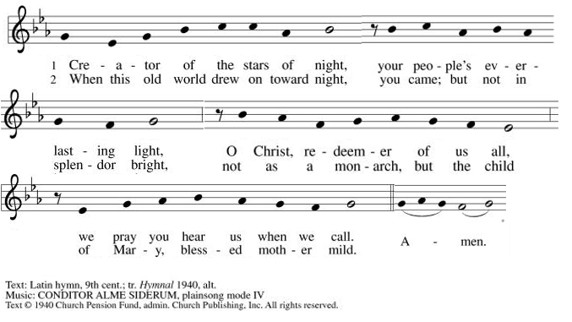

**Hymn of Praise: Rejoice, Rejoice, Believers ELW #244
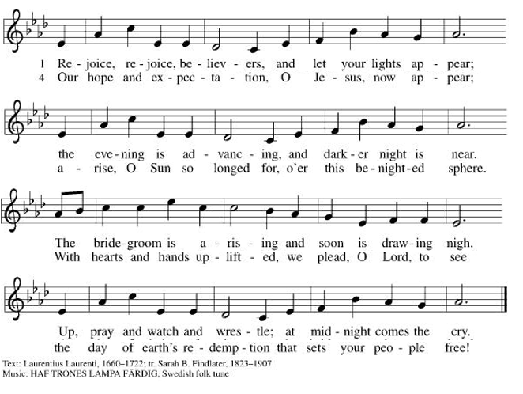
**Prayer of the Day

God of Love, we know that you are always among us, even when we don’t sense you. As we await your coming during this season of Advent, help us to see signs of your presence among us. When our hope is gone, send your Spirit to breathe new life into us. We pray this in the name of Jesus, the One for whom we wait. Amen.

Reading: Ezekiel 37:1-14

¹The hand of the Most High God was upon me, and it carried me away by the Spirit of God and set me down in a valley—a valley full of bones. ²God made me walk up and down among them. And I saw that there was a vast number of bones lying there in the valley, and they were very dry. ³God asked me, “Mere mortal, can these bones live?”

I answered, “Only you know that, Sovereign God.”

⁴And God said, “Prophesy to these bones, and say to them: ‘Dry bones, hear the word of the Most High God! ⁵Sovereign God says to these bones: I am going to breathe life into you. ⁶I will fasten sinews on you, clothe you with flesh, cover you with skin, and give you breath. And you will live; and you will know that I am Sovereign God.”’

⁷So I prophesied as I was commanded, and as I prophesied, suddenly there was a noise, a rattling, and all the bones came together, bone to matching bone. ⁸As I watched, sinews appeared on them, flesh clothed them, and skin covered them. But there was no breath in them.

⁹Then God said to me, “Prophesy to the wind; prophesy, mere mortal, and say to it: ‘Thus says Sovereign God: Approach from the four winds, Breath, and breathe on these slain, that they may live.”’

¹⁰I prophesied as I was commanded, and breath came into them; they came alive, and stood up on their feet—a vast multitude.

¹¹Then God said to me, “Mere mortal, these bones are the whole House of Israel. The people keep saying, ‘Our bones are dry, our hope is gone, and we are doomed.’ ¹²Prophesy, therefore, and say to them, ‘Thus says Sovereign God: I am going to open your graves and raise you up from the dead, my people. I will return you to the land of Israel. ¹³When I open your graves and raise you up, you, my people, will know that I am God. ¹⁴Then I will put my Spirit into you and you will return to life, and I will settle you back on your own land. Then you will know that I, the Most High God, have spoken and made all this happen, says Sovereign God.”’

Word of God, Word of Life.
Thanks be to God!

**Gospel Acclamation: He Came Down ELW #253
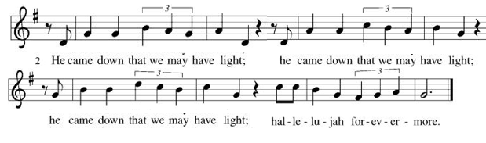
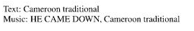
Announcement of the Gospel
Glory to you, O Lord.

Gospel: John 11:25-26

²⁵Jesus told her, “I am the Resurrection,
and I am Life:
those who believe in me
will live, even if they die;
²⁶and those who are alive and believe in me
will never die. “Do you believe this?”

The Gospel of the Lord.
Praise to you, O Christ!

Sermon “A Word of Hope”

Hymn of the Day Awake, O Sleeper, Rise From Death ELW#452

**Affirmation of Faith – Immigrant’s Creed by Jose Luis Casal

I believe in Almighty God, who guided the people in exile and in exodus, the God of Joseph in Egypt and Daniel in Babylon, the God of foreigners and immigrants.

I believe in Jesus Christ, a displaced Galilean, who was born away from his people and his home, who fled his country with his parents when his life was in danger. When he returned to his own country he suffered under the oppression of Pontius Pilate, the servant of a foreign power. Jesus was persecuted, beaten, tortured, and unjustly condemned to death. But on the third day Jesus rose from the dead, not as a scorned foreigner but to offer us citizenship in God’s kingdom.

I believe in the Holy Spirit, the eternal immigrant from God’s kingdom among us, who speaks all languages, lives in all countries, and reunites all races.

I believe that the Church is the secure home for foreigners and for all believers. I believe that the communion of saints begins when we embrace all God’s people in all their diversity. I believe in forgiveness, which makes us all equal before God, and in reconciliation, which heals our brokenness. I believe that in the Resurrection God will unite us as one people in which all are distinct and all are alike at the same time. I believe in life eternal, in which no one will be foreigner but all will be citizens of the kingdom where God reigns forever and ever. Amen.

**Prayers of Intercession

Loving God, as we wait for the coming of the Messiah, hear the prayers that we lift up to you.

Inspire the faithful around the world. Unite hearts and minds in work to address poverty, access to housing, and equity among peoples. God of grace,
hear our prayer.
Move us to care for creation. As we dream of the day when all creatures will flourish alongside one another, guide us in ways humanity and all creation will mutually thrive. God of grace,
hear our prayer.
Encourage nations to live in harmony with one another. We pray for international student and teacher exchanges, for our partner churches, and for the shared mission of Lutheran World Relief and Lutheran Disaster Response. God of grace,
hear our prayer.
Strengthen those who have lost hope in the face of grief, depression, or disease, especially Monty, Paul, Linda, Betty F., Kay, Becky H., Jim & Jan, Becky W., David, William and family, Helen, Larry, Otto, Kevin, Peter and Carrie, families in our community who endure hunger, and our beloved for whom death is near. Renew the spirits of those recovering from surgery and medical procedures. God of grace,
hear our prayer.
Embolden us in our shared ministry to overcome all that divides. In acts of repentance, reconciliation, and reparation, may we serve in the way of Christ. God of grace,
hear our prayer.
We pray for migrants and refugees who set out, not knowing where they go. Provide shelter, sustenance, protection from harm, and welcome. Bless the work of Global Refuge and other support and advocacy programs. God of grace,
Hear our prayer.

Pave a way to justice, drown the forces of oppression, bring peace on earth. Give leaders the will to turn from war and violence. Especially we pray for the people of Sudan, Gaza, Israel, and Ukraine, and for Jim’s grandson Dylan, who is deployed in Oman. When people must flee their homes, guide them to safety. Comfort those living with deep trauma, anxiety, or fear; all those who serve people in need, and accompany all those who care for people in harm’s way. God of grace,
Hear our prayer.
We pray for people who rise up against injustice. Bring courage and resilience to those who resist tyranny with their words and their bodies. Strengthen those who fight for justice in your name across the country, and around the world. Protect and sustain immigrants and refugees and all who work with them, that your kingdom, without borders and without walls, may truly come on earth as it is in heaven. We pray for all victims of gun violence or kidnapping, especially those who are targeted out of hate or fear. Embolden us to holy outrage and empower us to speak our truth of love and justice. God of grace,
Hear our prayer.
We lift up all who teach and all who learn. Thank you for teachers who share their knowledge and wisdom. Bless the students in our midst. Especially we remember Evie, in kindergarten; Addison, in high school; and Tyler, Zach, Katie and Katy, in college. Bless Janet and Lisa as they teach. God of grace,
Hear our prayer.
With joy and peace, we remember our ancestors in the faith. Fill us with the hope of the Holy Spirit now and into the ages of ages. God of grace,
hear our prayer.

Holy and merciful God, we know that you are with us as we await your promise. We cling to the hope you offer. Amen.

** Sharing of the Peace

**Offering is brought forward

** Offertory Response Creator of the Stars of Night ELW#245

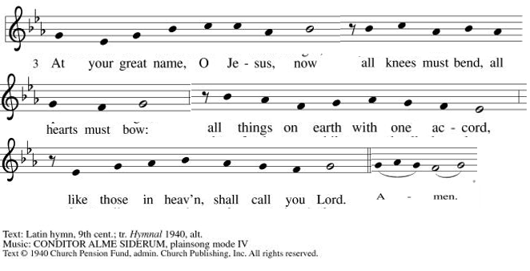

**Offertory Prayer
Almighty God, we give you thanks for all that you have given us. In return, we offer up these gifts of our skills, our time, and our money, which are a token of our offering to you. Help us to be good stewards of all that you have given us. We pray this in the name of Jesus, our Savior. Amen.

**Dialogue
Jesus has prepared a sacred meal for us.
We await your coming, Jesus.

All are welcome at your table. You call, and we respond with joy.
We await your coming, Jesus.

**Preface: In hope and patience… this hymn of praise:

**Sanctus: Prepare the Royal Highway ELW #264

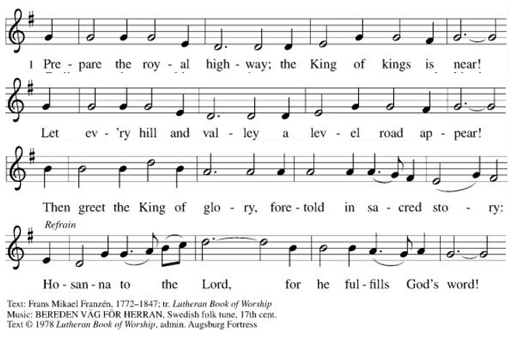
**Words of Institution

**LORD’S PRAYER

Our Father, who art in heaven,
hallowed be thy name,
thy kingdom come,
thy will be done,
on earth as it is in heaven.
Give us this day our daily bread;
and forgive us our trespasses,
as we forgive those
who trespass against us;
and lead us not into temptation,
but deliver us from evil.
For thine is the kingdom,
and the power, and the glory,
forever and ever. Amen.

Invitation to Communion

Communion Hymn All Earth is Hopeful ELW#266

**Sending Song Awake, Awake, and Greet the New Morn ELW#242

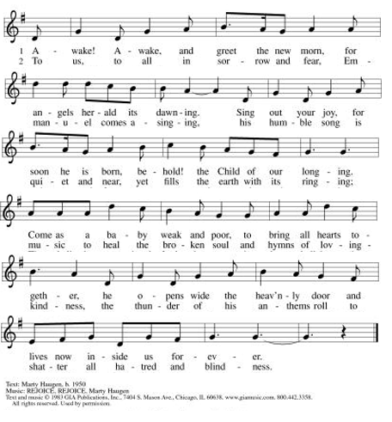

**Prayer After Communion

Loving and merciful God, you have fed us at the table and with your word. Strengthen us in our faith as we go out into the world to do the work you have sent us to do, as we await the coming of your Son, Jesus, our Savior. Amen.

**Blessing

**Closing Hymn Now the Green Blade Rises ELW#379

**Dismissal

Go in peace. Jesus is coming!

THANKS BE TO GOD!

+ + + + + +
All hymns under One License #733618-A. The Prayers of Intercession are under copyright and are used with permission under Augsburg Fortress Liturgy License #SB155933. All other liturgy written by Sarah Pierce.

***********************************************************************************************************
Weekly Attendance

Week of November 30

33

******************************************************************************************

Calendar of Events
Today

- Advent Dinner

This Week
- December 9: Creative Friends
- December 10: Council meeting 6:30
- December 13: Project Comfort Lunch: 30 Hops, NW Pryor road G 11:00 am. All are welcome!

Upcoming Events
December 16 | Creative Friends
December 17 | Bells rehearsal 6:30pm
December 20 | Secret Prayer Sisters Brunch: Corner Café 9:30. All are welcome!
December 21 | Bells play during worship: O Come, All Ye Faithful
December 23 | Creative Friends
December 24 | Christmas Eve worship 7:00pm
December 28 | Pastor Sarah on vacation
January 14, 2026 | Council Meeting 6:30 pm
January 25 | Deacon Dave Mareske preaching
January 25 | Coffee with Council: discussion about Hollis Renewal Center with Dave Mareske and Paula Kitt
February 15 | Pre-Lent Ice Cream Social after church
February 18 | Ash Wednesday
March 29 | Palm Sunday
April 05 | Easter Sunday

*****************************************************************************************
BLUE SPRINGS COMMUNITY SERVICE LEAGUE is very appreciative of your continued support of your neighbor.
Our special offering to the CSL food bank totaled $1395! Thank you for your generosity to help feed the hungry in our community!
*****************************************************************************************
Traci has suggested we do a mini school supply drive (paper, pens and pencils, notebooks, etc.) for middle and high school students transitioning to new classes in the second semester. We would like to collect these supplies in November and December, donating to CSL in mid- to late-December.
******************************************************************************************
Questions for Reflection and Discussion from Pastor Sarah
- The Hebrew word ruach runs throughout this text. The word has three different meanings: Spirit, breath, and wind. In what ways can you find them in this text? How are they used?
- The key to understanding this text is in verse 11, when God tells Ezekiel that the people of Israel keep saying that their bones are dry, their hope is gone, and they are doomed. The sense of hopelessness, of doom that they feel is a fear that they have been cut off completely from God. And so the entire vision becomes a play on the metaphor of the dry bones.
- The “you” in verse 14 is plural: God says, “I will put my Spirit in y’all and y’all will return to life.” Is that important for us as a community at All Saints, or as a wider church, to hear right now? Why or why not?
- There’s something very “Bedknobs and Broomsticks” about this text (remember that scene where she enchants the empty suits of armor, and they come to life?), very mystical and also maybe a little creepy. And there’s also something a little VBS about this text (remember the song, “The foot bone’s connected to the heel bone…now hear the word of the Lord!”). But do you find the hope in this text? What does it say to you?
- The really amazing thing about this text isn’t the dry bones being knit back together to form people and brought back to life (because it isn’t really happening – Ezekiel is having a vision!). It’s the power of words. Especially the power of the words of the God of Life. What words does Jesus have for you when you need a moment of hope?

**************************************************************************************
Birthdays:
Tyler Melton December 12

December 7
Altar Guild – Sara Meyers
Communion Assistant – Tracy Nelson
Lector – Sara Meyers
Greeter – Donna Taylor
Tech – Gary Antes

Prayer Requests
Monty Health Concerns (May 15)
Paul Health Concerns (May 31)
Mary Health Concerns (May 15)
James & Family Health Concerns (September 11)
Betty F (Sara’s friend) Health Concerns (July 15)
William and Family Health Concerns (September 25)
Becky H Health Concerns (October 28)
David Health Concerns (November 18)
Becky W Health Concerns (November 18)
Larry Health Issues (December 16)
Helen Health Issues (January 14)
Otto Health Concerns (July 15)
Kay (Sara’s cousin) Health Concerns (July 15)
Kevin Health Concerns (October 01)
Fred Health Concerns (October 22)
Sharon Health Concerns (October 22)
Michael Health Concerns (October 22)
Peter and Carrie Health Concerns (November 26)

Merciful God, your justice and mercy are without limits. Bring courage and resilience to those who resist tyranny with their words and their bodies. Strengthen those who fight for justice in your name across the country, and around the world.

Please pray for the people of Sudan, Gaza, Ukraine, Israel, Iran and Palestine.
Please pray for the people of Jamaica and Cuba.
Please pray for the Homeless.
Please pray for legal & illegal immigrants & those seeking asylum or citizenship.

