All Saints Lutheran Church, ELCA
421 SW 19th St. Blue Springs, Missouri 64015 816-229-3633
Pastor Sarah Pierce Spierce.aslcpastor@gmail.com
allsaintslc64015@gmail.com https://aslcbs.org/

Sunday, July 26, 2026

Ninth Sunday after Pentecost

You are absolutely invited into this sacred space. We welcome all who are seeking God’s love and grace. All Saints recognizes that we are all unique and beloved children of God. We celebrate and give thanks for the many diverse gifts that God has given us. We affirm the sacredness of people of all sexual orientations, gender identities, and gender expressions. We affirm the sacredness of all those who have experienced exclusion because of race, ability, age, or culture. We are committed to working towards anti-racism in ourselves and our community. We affirm the sacredness of all those who wrestle with addiction, physical or mental health, imprisonment, socio-economic circumstances, or anything that too often divides us. We believe that through our openness we all grow in our faith through Christ’s teaching to love one another as God loves us. We need each other and our sincere hope is by being in community together, we will experience God’s presence in new and real ways.

The offering plate is by the main door to the sanctuary for your convenience.

We practice open communion at All Saints Lutheran Church. What does that mean? It means that if you believe and trust that Christ offers his body and blood For You, you are welcome at the table. At All Saints, we believe that Christ invites all people to the feast. “Come to the banquet for all is now ready.”

**Stand as you are comfortable

Note: Bold Print: Congregational Statements

Prelude

Announcements

** Confession and Forgiveness

The God that we worship is complex, multi-faceted, a single God made up of three Persons. When we try to understand the fullness of God, we fail. But God knows us and loves us and wants to be in relationship with us, so God is constantly finding new ways to be present with us. But sometimes, we fall short in our awareness. When that happens, we find that we have turned away from God to the idols of our own making.

Let us confess our sins together, as a community.

God of All the Cosmos,
Sometimes we try to make you small.
We try to put you in a box,
confine you to our way of understanding.
God, sometimes we misunderstand what you tell us.
Inspire us, Holy Spirit, to remember that you are beyond definition.
Help us to remember that you cannot be made small.
Help us to think deeply about who you are
and to respect and honor other people’s experiences of you.
Beloved in Christ, the God who walks beside you
is the same God who brings peace passing all understanding.
The Spirit who inspires your knowledge of the presence of God
is the same Spirit who moves over the waters of creation.
The Christ who hears your prayers
is the same Christ + who defeated death for the forgiveness of all sin, for all time.
Be at peace, for your sins are forgiven.

Amen.

**Entrance Hymn Oh, Worship the King ELW#842

**Greeting
The grace of our Lord Jesus Christ, the love of God,
and the communion of the Holy Spirit be with you all.
And also with you.

**Kyrie ELW 513
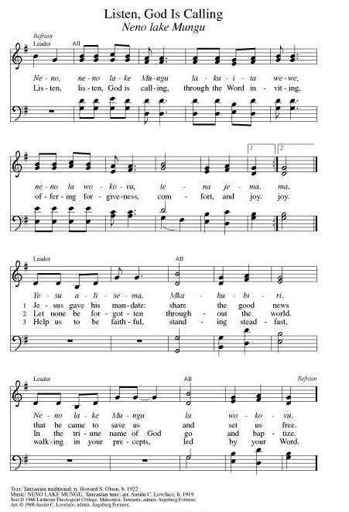
**Hymn of Praise ELW 866
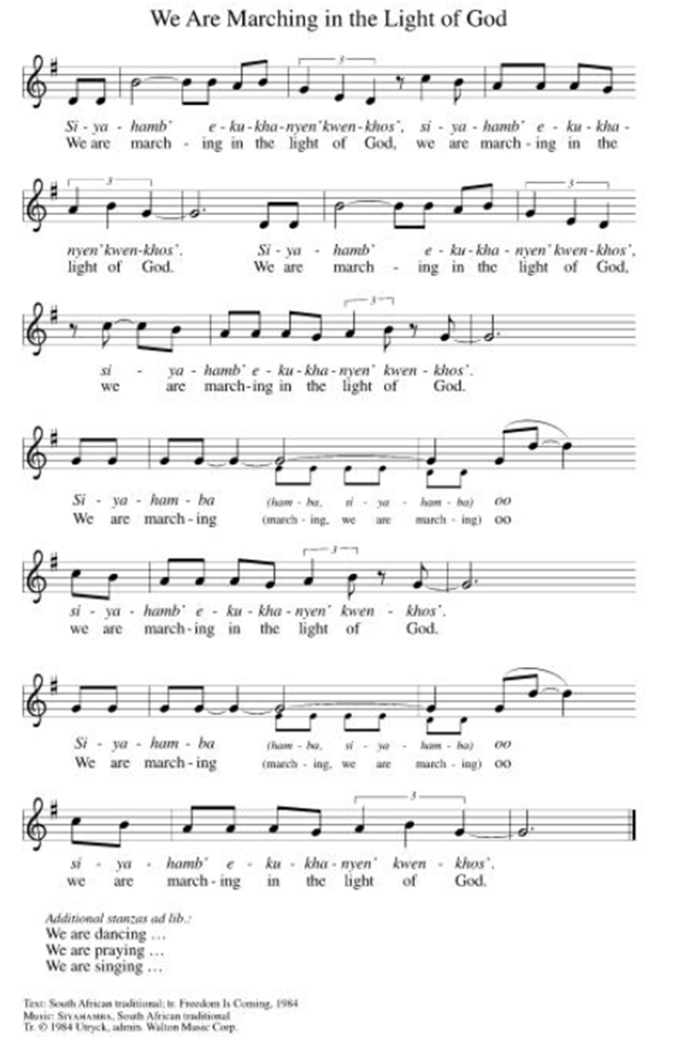

**Prayer of the Day

Loving God, you invite us to your table and feed us, forgiving our sins and restoring us to newness of life. Help us to remember that with this meal, you are calling and empowering us to care for the hungry in our midst, as Jesus did for the five thousand. We pray this in Jesus’ name. Amen.

Reading: Psalm 65

¹O God, to you we owe hymns of praise in Zion;
to you our vows must be fulfilled,
²you who hear our prayers
and before whom all flesh must stand.
³When we are overcome by our sins,
you provide the atonement for them.
⁴Happy are those you choose, those you draw near
to dwell in your courts!
We are filled with the blessings of your house,
the holy things of your Temple!
⁵With powerful deeds of justice
you answer us, God our Deliverer,
in whom all the ends of the earth
and the farthest seas put their trust.
⁶You set the mountains in place by your power,
having armed yourself with might.
⁷You still the roaring of the seas,
the roaring of the waves, and the tumult of the peoples.
⁸And those who dwell at the ends of the earth
stand in awe of your marvels;
you make the sunrise and sunset shout for joy!
⁹You nourish and water the land –
greatly you have enriched it.
The streams of God are full of water;
you provide us with grain as you ordained.
¹⁰Thus have you prepared the land:
drenching its furrows,
breaking up its clods, softening it with showers,
blessing its yield.
¹¹You have crowned the year with your beauty
and your paths overflow with a rich harvest;
¹²the untilled meadows overflow with abundance,
and rejoicing clothes the hills.
¹³The fields are covered with flocks
and the valleys are blanketed with grain.
They shout and sign for joy!

Word of God, Word of Life
Thanks be to God

Reading: 1 Corinthians 11:17-34a

¹⁷What I now have to say is not said in praise.

Your meetings do more harm than good. ¹⁸In the first place, I hear that when you gather for a meeting there are divisions among you, and I’m inclined to believe it. ¹⁹No doubt there have to be factions among you, to distinguish those who are to be trusted from those who aren’t. ²⁰The point is, when you hold your agape meals, it is not the Eucharist you’ve been commemorating, ²¹for as you eat, each of you goes ahead without waiting for anyone else. One remains hungry, while another gets drunk. ²²Don’t you have homes where you can eat and drink? Surely you have enough respect for the community of God not to embarrass poor people! What can I say to you? You’ll get no praise from me in this matter!

²³What I have passed on to you, I received from Christ – that on the night when he was betrayed, our Savior Jesus took bread, gave thanks and broke it, saying, “This is my body, which is broken for you. Do this in remembrance of me.” ²⁵In the same way, after supper, he took the cup and said, “This cup is the New Covenant in my blood. Whenever you drink it, do it in remembrance of me.” ²⁶For every time you eat this bread and drink this cup, you proclaim Jesus’ death until Christ comes.

²⁷Any unfit person who eats the bread or drinks from the cup sins against the body and blood of Christ. ²⁸Everyone, therefore, should examine themselves before they eat of the bread and drink of the cup, ²⁹because those who eat and drink without discerning the Body of Christ eat and drink condemnation on themselves. ³⁰This is why many of you are weak and ill, and some of you are dying.

³¹If only we judged ourselves rightly, we wouldn’t be judged in this way. ³²But when God punishes us like this, we are being disciplined so that we will not be condemned along with the world. ³³Therefore, my siblings in Christ, when you assemble for a meal, wait for one another. ³⁴All who are hungry should eat at home, so that your meetings will not be the cause of your condemnation.

Word of God, Word of Life
Thanks be to God

**Gospel Acclamation ELW 519
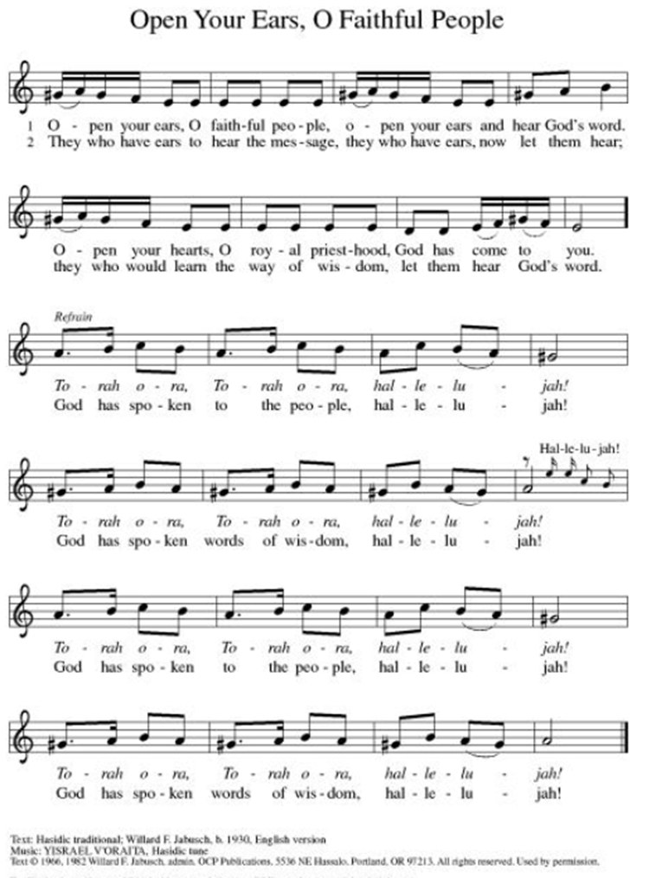
Announcement of the Gospel
Glory to you, O Lord.

Gospel: Luke 9:12-17

¹²As sunset approached, the Twelve came and said to Jesus, “Dismiss the crowd, so they can go into the surrounding villages and countryside and find lodging and food, for this is a remote and isolated area.”

¹³Jesus answered them, “Give them something to eat yourselves!” The disciples replied, “We have nothing but five loaves and two fish. Or do you want us to go and buy food for all these people?” ¹⁴There were about five thousand gathered.

Jesus said to the disciples, “Have them sit down in groups of fifty or so.” ¹⁵They did so and got them all seated. ¹⁶Then, taking the five loaves and two fishes, Jesus raised his eyes to heaven, said a blessing over them, broke them and gave them to the disciples for distribution to the crowd.

¹⁷They all ate until they were satisfied and, when the leftovers were collected, there were twelve baskets full.

The Gospel of the Lord.
Praise to you, O Christ.

Sermon “The Gift of Communion”

Hymn of the Day Blest Are They ELW#728

**Affirmation of Faith – Immigrant’s Creed by Jose Luis Casal

I believe in Almighty God, who guided the people in exile and in exodus, the God of Joseph in Egypt and Daniel in Babylon, the God of foreigners and immigrants.

I believe in Jesus Christ, a displaced Galilean, who was born away from his people and his home, who fled his country with his parents when his life was in danger. When he returned to his own country he suffered under the oppression of Pontius Pilate, the servant of a foreign power. Jesus was persecuted, beaten, tortured, and unjustly condemned to death. But on the third day Jesus rose from the dead, not as a scorned foreigner but to offer us citizenship in God’s kingdom.

I believe in the Holy Spirit, the eternal immigrant from God’s kingdom among us, who speaks all languages, lives in all countries, and reunites all races.

I believe that the Church is the secure home for foreigners and for all believers. I believe that the communion of saints begins when we embrace all God’s people in all their diversity. I believe in forgiveness, which makes us all equal before God, and in reconciliation, which heals our brokenness. I believe that in the Resurrection God will unite us as one people in which all are distinct and all are alike at the same time. I believe in life eternal, in which no one will be foreigner but all will be citizens of the kingdom where God reigns forever and ever. Amen.

Affirmation of Baptism

People of God, you have made a public profession of your faith. Do you intend to continue in the covenant God made with you in your baptism:
To live together as God’s faithful people with all the body of Christ;
To listen to the Word preached and taught, and to answer Jesus’ invitation to the Table;
To proclaim the good news: that in Christ, we are set free to love and serve our neighbor, through our words and our actions;
To serve our neighbors in our community and around the world, striving always to follow Jesus’ example to the best of our abilities;
And to work for God’s justice and the peace that is beyond our understanding, throughout creation?

I do, and I ask God to help and guide me.

People of God, do you promise to support and pray for one another in your life in Christ?

We do, and we ask God to help and guide us.

Let us pray. Loving God, through water and the Holy Spirit you give us new birth, cleanse us from sin, and raise us to eternal life. Stir up in all your people the gift of your Holy Spirit: the spirit of wisdom and understanding, the spirit of counsel and strength, the spirit of knowledge and the reverence for our God, that we may delight in your presence now and forever.
Amen.

**Prayers of Intercession

Holy God, our prayers rise to you like the wings of a dove. We call upon your name, and we ask that you hear us.

God our wisdom and our song, we pray for bishops, candidacy committees, those preparing for seminary, those awaiting call as deacons or pastors, and all who seek to lead your disciples in any way. God of grace,
hear our prayer.
God our breath and our heartbeat, help us to recognize signs of your presence among us. Protect and support diverse ecosystems, from national parks to family farms, from ranches to wild places. God of grace,
hear our prayer.
God our peace and our guide, help civic leaders hear all their peoples’ stories with compassion and curiosity, and remind us of your love from which we can never be separated. God of grace,
hear our prayer.
God our intercessor and our lawgiver, dismantle the barriers to care and recognition of all who live with chronic illness, mobility struggles, pain, and uncertainty. We pray especially for Monty & Marie, Paul, Helen, Linda, Betty F., Kay, Becky H., Jim & Jan, Melian, Becky W., David, Val, William & family, Judy, Peter & Carrie, Barbara & Donna, and Brad & Chris. God of grace,
hear our prayer.
God our redeemer, may we trust your love above and beyond all else that distracts, annoys, frightens, exhausts, or divides us. God of grace,
hear our prayer.
Pave a way to justice, drown the forces of oppression, bring peace on earth. Give leaders the will to turn from war and violence. Especially we pray for the people of Cuba, Venezuela, Iran, Sudan, Gaza, Israel, and Ukraine. When people must flee their homes, guide them to safety. Comfort those living with deep trauma, anxiety, or fear; all those who serve people in need, and accompany all those who care for people in harm’s way. We also lift up Jim’s grandson, Dylan, who is deployed, and Sharon’s great nephew, Taylor, who is serving in the military. God of grace,
hear our prayer.
We pray for people who rise up against injustice. Bring courage and resilience to those who resist tyranny with their words and their bodies. Strengthen those who fight for justice in your name across the country, and around the world. Protect and sustain immigrants and refugees and all who work with them, that your kingdom, without borders and without walls, may truly come on earth as it is in heaven. We pray for all victims of gun violence or kidnapping. Embolden us to holy outrage and empower us to speak our truth of love and justice. God of grace,
hear our prayer
God who seeks, finds, and saves, for our community’s part in the ongoing gift of creation, and for the riches of faith and hope which came before, we give you thanks. God of grace,
hear our prayer.

Good and loving God, we give everyone we have prayed for into your care. Amen.

** Sharing of the Peace

**Offering is brought forward

** Offertory Response ELW486

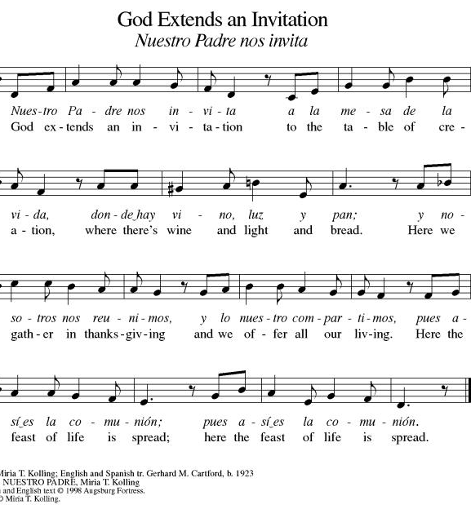

**Offertory Prayer
Jesus, all that we have and all that we are comes from you. Thank you for the gifts you have given us. Receive these gifts – our money, our service, our time – which we give in gratitude for all that we have received from you. Amen.

Dialogue
Christ is with you!
And also with you!
Lift up your hearts in joyful praise!
We lift them up to God in joy!

**Preface: We give thanks and praise to God...this hymn of praise:
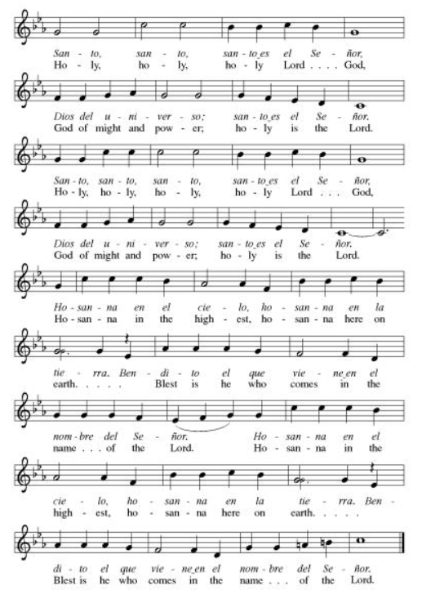
**Words of Institution

**LORD’S PRAYER
You are invited during this Pentecost season to pray whichever version feels most comfortable on your lips and in your soul. A separate sheet is available with alternate versions, should you be interested. Or, you are invited to use one of these:
Our Father in heaven, Our Father, who art in heaven,
hallowed be your name, hallowed be thy name,
your kingdom come, thy kingdom come,
your will be done, thy will be done,
on earth as in heaven. on earth as it is in heaven.
Give us today our daily bread. Give us this day our daily bread;
Forgive us our sins and forgive us our trespasses
as we forgive those as we forgive those
who sin against us. who trespass against us;
Save us from the time of trial and lead us not into temptation,
and deliver us from evil. but deliver us from evil.
For the kingdom, the power, For thine is the kingdom,
and the glory are yours, and the power, and the glory,
now and forever. Amen. forever and ever. Amen.

Invitation to Communion

Communion Hymn O Living Bread from Heaven ELW#542

**Sending Song ELW 535

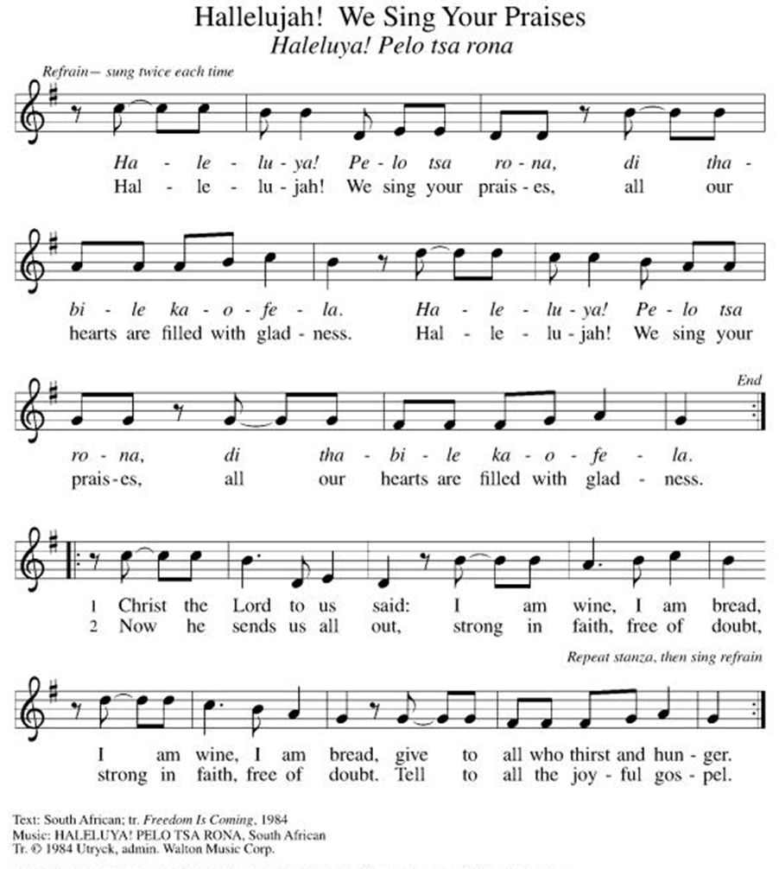

**Prayer After Communion
Holy God, you love us so much that you transformed an act of destruction into an act that gives new life. Thank you for the renewal we receive at your Table, as you send us out from this place into the world. Strengthen us for your service. In Jesus’ name we pray. Amen.

**Blessing

**Closing Hymn Go My Children ELW#543

**Dismissal

Empowered by the Spirit, may you go in peace to share the gospel!
THANKS BE TO GOD!

+ + + + + +

Setting 07 and hymns from the Evangelical Lutheran Worship are under copyright and used with permission under One License #733618-A. Specific copyright information as listed in bulletin, the Prayers of Intercession are under copyright and are used with permission under Augsburg Fortress Liturgy License #SB155933. All other liturgy written by Sarah Pierce.
Weekly Attendance

Week of July 19:
25
******************************************************************************************

Next Week:
10th Sunday after Pentecost:
1 Samuel 21:1-9
Mark 14:12-25

John 4:1-14
The color of the day is Green

Calendar of Events

Today
- Coffee with Council
- Celebrate Niel’s Birthday (July 28)

This Week
July 28 | Creative Friends

Upcoming Events

August 02 | Blessing of CSL Gifts
August 04 | Creative Friends 1:00 pm
August 08 | Men’s Breakfast 8:00 am
August 09 | Baptismal Sunday
August 11 | Creative Friends 1:00 pm
August 18 | Creative Friends 1:00 pm
August 19 | Council Meeting 6:30
August 20 | Newsletter Deadline
August 22 | Project Comfort 9:00 am-Noon
August 23 | Coffee with Council
August 25 | Creative Friends 1:00 pm
August 30 | Fifth Sunday Conversation
September 09 | Bell’s Practice 6:30 pm
September 13 | God’s Work. Our Hands.
September 23 | Council Meeting 6:30 pm
September 27 | Celebration 5th year Anniversary of Pastor’s Ordination
October 03 | Blessing of Animals
October 25 | Reformation Sunday
November 01 | Healing for World
November 25 | Pie Night 7:00 pm
November 26 | Thanksgiving Office Closed

SYNOD CONFIRMATION

As announced during the recent conference gatherings and synod assembly, the Central States Synod is putting together synod-wide confirmation. Details are in the works, but here are the basics. . .

  - Classes will run from September 3 through April 15. We will meet via Zoom from 6:30 – 7:45 pm on the 1st & 3rd Thursdays.
  - We will be on a two-year cycle. One year will be a Catechism year, and one will be a Bible year. We will be starting this fall with the Catechism year.
  - Anyone of any age can participate. (It's not just for students)
  - Each student will receive a Confirmation Kit containing items that will be used throughout the year.
  - There will be a weekly homework assignment.
  - Participants will be connected via GroupMe. Parents will need to give permission for this.
  - There will be some in-person retreats and/or camps offered along the way to connect in person with the other students.
  

As we prepare, we are hosting orientation meetings for parents, pastoral leaders, and students. We will talk about expectations, logistics, and answer your questions. If you are thinking of participating in the synod confirmation, please join us for one of two sessions, to be held on August 13 and August 20 at 6:30. Ask Pastor Sarah for the link or go to
https://www.css-elca.org/workshops#confirmation to register.

******************************************************************************************

Pastor Sarah Questions:

Questions for Reflection and Discussion

1. Paul talks in the beginning of our reading from 1 Corinthians about the divisions among the people in Corinth, and he says these factions will help distinguish “those who are to be trusted from those who are not.” He’s leaning on an apocalyptic trope (think the separating of the sheep and the goats from Matthew 25) to say that eventually, the authentic followers of Jesus will be winnowed out from the ones who aren’t.
2. I give this background in my sermon as well, but in short, in Roman cities, people worshiped in house churches, not in church buildings like we think of (or in temples like the Jews did). They would have agape meals similar to potlucks during which communion would happen, but in Corinth, they were falling into social patterns of separating by class, where the rich folks got more to eat, while the poor folks got less (or maybe none at all). Are there ways in which the modern church does similar things, if not in the practice of communion?
3. How does Paul offer a correction of what he sees as an abuse of the Lord’s Supper?
4. Verses 27-29 are troubling, but within the context of the issue, Paul is concerned that people are disregarding the needs within the community in a way that’s causing divisions. He is basically telling them that if they’re receiving communion in such a way that they’re disregarding the needs of others in their community (i.e. eating a big meal while others are standing right outside the door going hungry), they’re basically placing themselves in the same camp as those who were responsible for Jesus’ crucifixion, not those who are receiving the grace of salvation.
5. What does the Eucharist have to say to us about feeding the hungry and caring for our neighbor?

******************************************************************************************
BLUE SPRINGS COMMUNITY SERVICE LEAGUE is very appreciative of your continued support of your neighbor.
Birthdays
July 28- Carla Deubner
July 28- Niel Johnson
July 29- RJ Meek
July 30- Allison Meek

Anniversaries
July 29- Darren & Lisa Melton

July 26
Reader – Kent Deubner
Altar Guild – Sara Meyers
Communion Assistant- Suelyn Olson
Greeter – Donna Taylor
Usher-Paul Blixrud
Tech – Gary Antes

Prayer Requests
Monty & Marie Health Concerns (March 04)
Paul Health Concerns (May 31)
Mary Health Concerns (May 15)
James & Family Health Concerns (September 11)
Betty F (Sara’s friend) Health Concerns (July 15)
William and Family Health Concerns (September 25)
Becky H Health Concerns (October 28)
David Health Concerns (November 18)
Becky W Health Concerns (November 18)
Judy Health Issues (December 16)
Kay (Sara’s cousin) Health Concerns (July 15)
Sharon Health Concerns (October 22)
Michael Health Concerns (October 22)
Peter and Carrie Health Concerns (November 26)
Melian Health Concerns (November 16)
RJ Health Concerns (November 17)
Barbara Health Concerns (December 30)
Helen Health Concerns (February 25)
Val (Tonya’s sister) Health Concerns (February 18)
Chris Health Concerns (June 09)

Merciful God, your justice and mercy are without limits. Bring courage and resilience to those who resist tyranny with their words and their bodies. Strengthen those who fight for justice in your name across the country, and around the world.

Please pray for the people of Venezuela & Iran, Sudan, Gaza, Ukraine, Israel, Cuba, Iran and Palestine.
Please pray for the Homeless.
Please pray for legal & illegal immigrants & those seeking asylum or citizenship

