All Saints Lutheran Church, ELCA
421 SW 19th St. Blue Springs, Missouri 64015 816-229-3633
Pastor Sarah Pierce Spierce.aslcpastor@gmail.com
allsaintslc64015@gmail.com https://aslcbs.org/

Sunday, February 08, 2026

Fifth Sunday of Epiphany

You are absolutely invited into this sacred space. We welcome all who are seeking God’s love and grace. All Saints recognizes that we are all unique and beloved children of God. We celebrate and give thanks for the many diverse gifts that God has given us. We affirm the sacredness of people of all sexual orientations, gender identities, and gender expressions. We affirm the sacredness of all those who have experienced exclusion because of race, ability, age, or culture. We are committed to working towards anti-racism in ourselves and our community. We affirm the sacredness of all those who wrestle with addiction, physical or mental health, imprisonment, socio-economic circumstances, or anything that too often divides us. We believe that through our openness we all grow in our faith through Christ’s teaching to love one another as God loves us. We need each other and our sincere hope is by being in community together, we will experience God’s presence in new and real ways.

The offering plate is by the main door to the sanctuary for your convenience.

We practice open communion at All Saints Lutheran Church. What does that mean? It means that if you believe and trust that Christ offers his body and blood For You, you are welcome at the table. At All Saints, we believe that Christ invites all people to the feast. “Come to the banquet for all is now ready.”

**Stand as you are comfortable

Prelude

Announcements

Baptismal Birthdays

** Affirmation of Baptism

God prepares a way for us, a path through the desert. In our baptisms, Jesus calls us to follow that path, and we receive the gift of the Holy Spirit, empowering us to answer Jesus’ call. But sometimes, we forget the gift of forgiveness and unending love that we have been given, and we need to be reminded.

Jesus, sometimes we forget to listen to your call. We forget about the power of our baptisms. Sometimes, we get distracted with other things and forget to place you first. We ask that you help us to turn back to you when we turn away. We ask you to help us recenter our lives on you, so that we remember the power of our baptisms. We pray that we can feel your presence in our lives.

We ask you to receive our prayers and to be with us, today and forever. We pray that your presence shines through us to those who most need to see it.
Let your light so shine before others that they may see your good work and glorify God in heaven.

Holy and loving God, we thank you for the gift of forgiveness. We thank you for the gift of your unconditional love.

Holy and loving Jesus, we thank you for the gift of the baptism which frees us from the power of sin and death, for all time. We thank you for showing us how to live in that freedom.

Holy and loving Spirit, we thank you for infusing us with your presence. Empower us to live out our baptismal call to proclaim Christ through word and deed, to care for others and for the world, and to work for justice and peace. Amen.

**Entrance Hymn There is a Balm in Gilead ELW#614

**Greeting
The grace of our Lord Jesus Christ, the love of God,
and the communion of the Holy Spirit be with you all.
And also with you.

**Kyrie
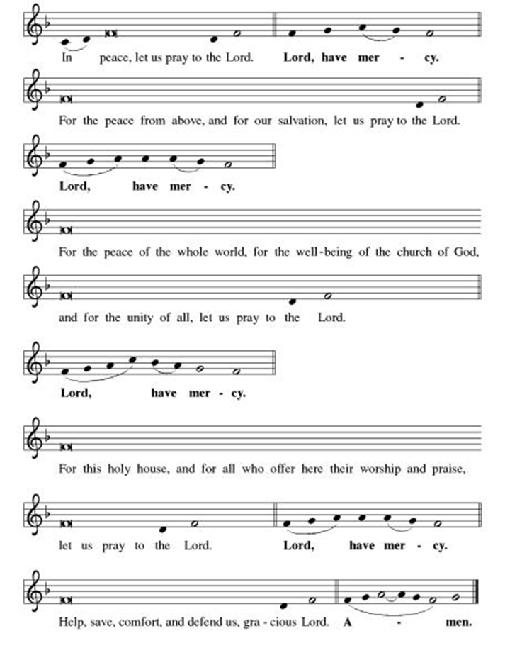
**This is the Feast
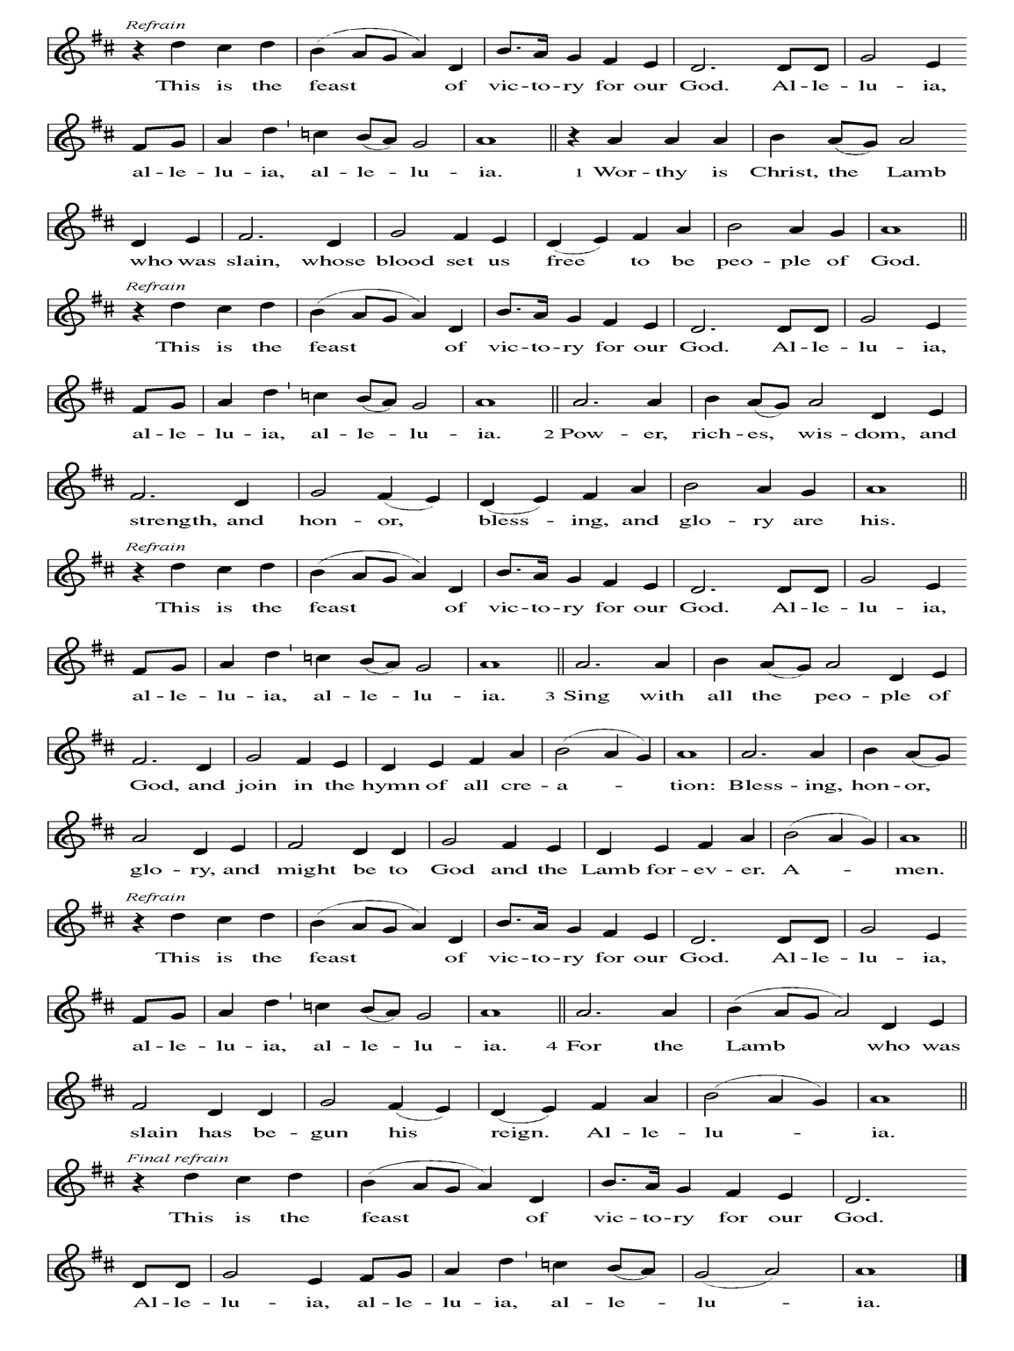
**Prayer of the Day
Loving God, we know that the signs you give us may be small and subtle, but that they point to you. They invite us into deeper relationship with you. Empower us to follow them to do the work you call us to do, loving and caring for those who need us. We pray this in Jesus’ name. Amen.

Reading: Psalm 40:1-5

¹Unyielding, I called to you, God,
now at last you have stooped to me
and answered my cry for help.
²You have pulled me out of the Pit of Destruction,
out of its mud and quicksand;
you set my feet on a rock
and made my steps firm.
³You put a new song in my mouth,
a song of praise to you.
Many will look on in wonder
and so will put their trust in you.
⁴Happiness comes to those
who put their trust inGod
instead of in human egos
or people blind to the truth!
⁵How many wonders you’ve worked for us,
Holy One, my God!
How many plans you’ve made for us; you have no equal!
I want to recount them again and again,
but their number is too great.

Word of God, Word of Life
Thanks be to God

**Gospel Acclamation

**Alleluia
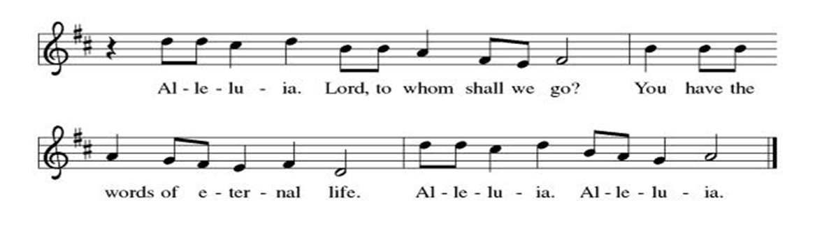
Announcement of the Gospel
Glory to you, O Lord.

Gospel: John 4:46-54; 5:1-18

⁴⁶Jesus returned to Cana in Galilee, where he had turned the water into wine. At Capernaum there lived a royal official whose child was ill. ⁴⁷Upon hearing that Jesus had returned to Galilee from Judea, the official went and begged Jesus to come down and restore health to the child, who was near death.

⁴⁸Jesus replied, “Unless you people see signs and wonders, you won’t believe!”

⁴⁹“Rabbi,” the official pleaded, “come down before my child dies.”

⁵⁰Jesus said, “Return home; your child lives.”

The official believed what Jesus said and started for home. ⁵¹On the way, the official was met by members of the household with the news that the child was going to live. ⁵²When the official asked at what time the fever broke, they said, “About one o’clock yesterday afternoon.” ⁵³The official realized that this was the very hour that Jesus had said, “Your child lives.” The whole household then became believers.

⁵⁴This was the second sign that Jesus performed, after he had left Judea for Galilee.

^{5:1}Some time after this, there was a Jewish festival and Jesus went up to Jerusalem. ²Now in Jerusalem, near the Sheep Gate, there is a pool with five porticoes; its Hebrew name is Bethesda. ³The place was crowded with sick people—those who were blind, lame or paralyzed—lying there waiting for the water to move. ⁴An angel of God would come down to the pool from time to time, to stir up the water; the first one to step into the water after it had been stirred up would be completely healed.

⁵One person there had been sick for thirty-eight years. ⁶Jesus, who knew this person had been sick for a long time, said, “Do you want to be healed?”

⁷“Rabbi,” the sick one answered, “I don’t have anyone to put me into the pool once the water has been stirred up. By the time I get there, someone else has gone in ahead of me.”

⁸Jesus replied, “Stand up! Pick up your mat and walk.”

⁹The individual was immediately healed, and picked up the mat and walked away.

This happened on a Sabbath. ¹⁰Consequently, some of the Temple authorities said to the one who had been healed, “It’s the Sabbath! You’re not allowed to carry that mat around!”

¹¹The healed one explained, “But the person who healed me told me, ‘Pick up your mat and walk.”'

¹²They asked, “Who is this who told you to pick up your mat and walk?”

¹³The healed person had no idea who it was, since Jesus had disappeared into the crowd that filled the place.

¹⁴Later on, Jesus met the individual in the Temple and said, “Remember, now, you’ve been healed. Give up your sins so that something worse won’t overtake you.” ¹⁵The healed one went off and informed the Temple authorities that Jesus was the one who had performed the healing.

¹⁶It was because Jesus did things like this on the Sabbath that the Temple authorities began to persecute him. ¹⁷Jesus said to them, “Abba God is working right now, and I am at work as well.” ¹⁸Because of this, the Temple authorities were even more determined to kill him. Not only was he breaking the Sabbath but, worse still, he was speaking of God as “Abba”—that is, “Papa”—thereby making their relationship one of intimacy and equality.

The Gospel of the Lord.
Praise to you, O Christ.

Sermon "Signs and Wonders?"

Hymn of the Day On My Heart Imprint your image ELW#811

**Affirmation of Faith – Immigrant’s Creed by Jose Luis Casal

I believe in Almighty God, who guided the people in exile and in exodus, the God of Joseph in Egypt and Daniel in Babylon, the God of foreigners and immigrants.

I believe in Jesus Christ, a displaced Galilean, who was born away from his people and his home, who fled his country with his parents when his life was in danger. When he returned to his own country he suffered under the oppression of Pontius Pilate, the servant of a foreign power. Jesus was persecuted, beaten, tortured, and unjustly condemned to death. But on the third day Jesus rose from the dead, not as a scorned foreigner but to offer us citizenship in God’s kingdom.

I believe in the Holy Spirit, the eternal immigrant from God’s kingdom among us, who speaks all languages, lives in all countries, and reunites all races.

I believe that the Church is the secure home for foreigners and for all believers. I believe that the communion of saints begins when we embrace all God’s people in all their diversity. I believe in forgiveness, which makes us all equal before God, and in reconciliation, which heals our brokenness. I believe that in the Resurrection God will unite us as one people in which all are distinct and all are alike at the same time. I believe in life eternal, in which no one will be foreigner but all will be citizens of the kingdom where God reigns forever and ever. Amen.

**Prayers of Intercession

Jesus, you came to live with us on earth so that we would know you love us no matter what. Listen to the prayers we lift to you.

Your church does ministry in many and various ways. Keep the baptized true to the mind of Christ, that our works and witness bring hope to a troubled world. Merciful God,
receive our prayer.
Your marvelous creation cries out to you. Restore polluted air, soil, and water sources to wholeness. Guard honeybees, elephants, great whales and songbirds from harm, and renew the face of the earth. Merciful God,
receive our prayer.
Your people in every nation suffer injustice, poverty, and the threat of violence. Guide those in authority to govern with compassion, and bring peace to war zones. We pray for our enemies. Merciful God,
receive our prayer.
Your blessings are poured out for all in need. Help and heal any who experience trauma, discrimination, disease, hunger, abuse, or persecution. Comfort those who are sick or grieving especially Monty, Paul, Linda, Betty F., Kay, Becky H., Jim & Jan, Melian, Becky W., David, William & family, Helen, Larry & Judy, Kevin, Peter & Carrie, Barbara & Donna, Irene, families in our community who endure hunger, and our beloved for whom death is near. Merciful God,
receive our prayer.
Your wisdom guides this congregation and its ministries. Sustain our ordained leaders, staff, lay leaders, and volunteers. Form us to be salt and light for the neighbors we serve, following the example of Christ. Merciful God,
receive our prayer.
Pave a way to justice, drown the forces of oppression, bring peace on earth. Give leaders the will to turn from war and violence. Especially we pray for the people of Venezuela, Sudan, Gaza, Israel, and Ukraine, and for Jim’s grandson Dylan, who is deployed. When people must flee their homes, guide them to safety. Comfort those living with deep trauma, anxiety, or fear; all those who serve people in need, and accompany all those who care for people in harm’s way. Merciful God,
receive our prayer.
We pray for people who rise up against injustice. Bring courage and resilience to those who resist tyranny with their words and their bodies. Strengthen those who fight for justice in your name across the country, and around the world. Protect and sustain immigrants and refugees and all who work with them, that your kingdom, without borders and without walls, may truly come on earth as it is in heaven. We pray for all victims of gun violence or kidnapping, especially those who are targeted out of hate or fear. Embolden us to holy outrage and empower us to speak our truth of love and justice. Merciful God,
receive our prayer.
We lift up all who teach and all who learn. Thank you for teachers who share their knowledge and wisdom. Bless the students in our midst. Especially we remember Evie, in kindergarten; Addison, in high school; and Tyler, Zach, Katie and Katy, in college. Bless Janet and Lisa as they teach. Merciful God,
receive our prayer.
Your saints rejoice at your heavenly banquet. We give thanks for their lives of faith, trusting that we also will be embraced by your eternal love. Merciful God,
receive our prayer.

Loving God, because you lived among us, we know that you hear our prayers and hold close all for whom we pray. Amen

** Sharing of the Peace

**Offering is brought forward

** Offertory Response Let Us Talents and Tongues Employ (V. 1) ELW#674

**Offertory Prayer
God of abundance, with thanks, we return to you the gifts you have given us so freely. Bless these offerings of our time, our talents, and our treasure. Shape us to be your hands and feet. Use our gifts to shower each other, our communities, and the world with your loving kindness. All this we ask in Jesus’ name. Amen.

**Dialogue
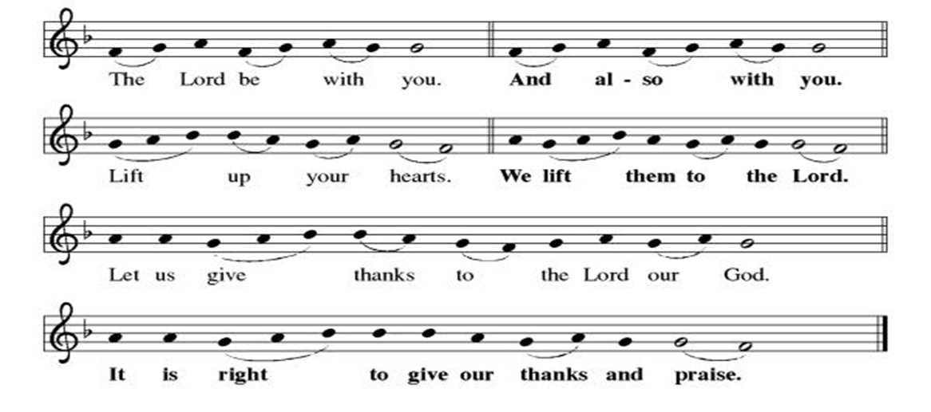
**Preface: From the beginning of time…this hymn of praise:

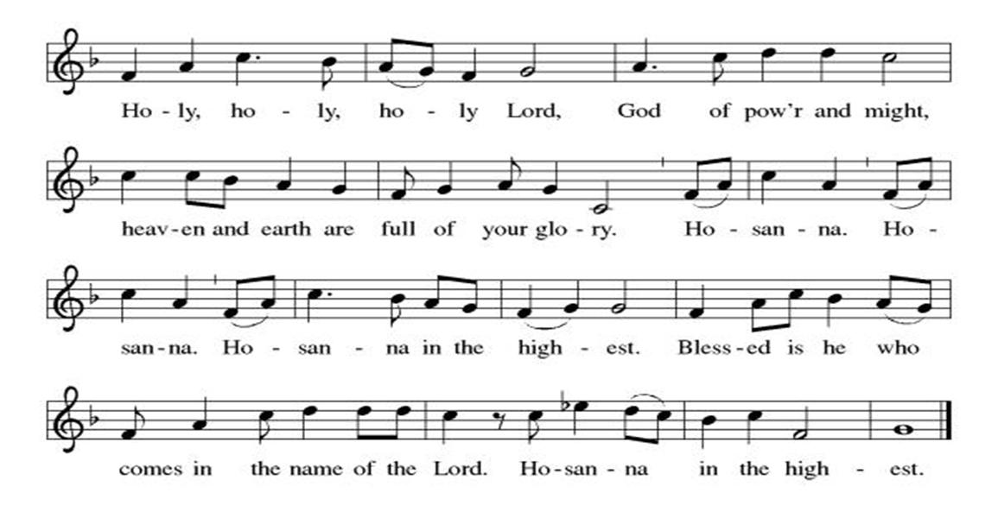
** Thanksgiving at the Table

**LORD’S PRAYER
Our Father in heaven,
hallowed be your name,
your kingdom come,
your will be done,
on earth as in heaven.
Give us today our daily bread.
Forgive us our sins
as we forgive those
who sin against us.
Save us from the time of trial
and deliver us from evil.
For the kingdom, the power,
and the glory are yours,
now and forever. Amen.

Invitation to Communion

Communion Hymn Now We Join in Celebration ELW#462

**Post-communion prayer

Holy One, Human and Divine, we give you thanks for the life-giving invitation to gather at your table and be fed. Strengthen us now for your service, and send us out from this place renewed in our commitment to love you and serve each other and all of creation. Send your Spirit upon us, so that we can proclaim your blessings to a world that hungers to receive them. All this we ask in your name, the one who is, who was, and who is to come. Amen.

**Sending Song

Listen, God Is Calling (refrain, V. 1, refrain) ELW#513

**Benediction

**Closing Hymn Go, My Children, With my Blessing ELW#543

**Dismissal

Go in peace. Share the good news!
THANKS BE TO GOD!

+ + + + + +

Hymns from the Evangelical Lutheran Worship are under copyright and used with permission under One License #733618-A. ELW setting #3 the Prayers of Intercession are under copyright and are used with permission under Augsburg Fortress Liturgy License #SB155933. All other liturgy written by Sarah Pierce.

Weekly Attendance

Week of February 01
24

Next Week:
Transfiguration of Our Lord

The Color of the day is White
Psalm 27:1-4
John 9:1-41

Calendar of Events
Today
- Adult Bible Study
- Baptismal Blessings
Upcoming Week
- February 11 Council Meeting 6:30 pm
- February 12 BSCT Bingo Event
- February 15 Pre-Lent Ice Cream Social after Church
February 18 | Ash Wednesday  God’s Global Barn yard begins February 18-April 05
February 18 | Bells will play: Let All Mortal Flesh Keep Silence
February 22 | Coffee with Council
February 24 | Bells
March 01 | Deacon Mareske will Preach
March 01 | Information on Hollis
March 03 | Bells
March 04 | Paint Party Fundraiser
March 10 | Bells
March 15 | Hollis Special Offering
March 15 | Church Council Meeting 11:30 am
March 17 | Bells
March 22 | Bells will play: Jesus the Very Thought Of You & O Master Let Me Walk With You
March 22 | Coffee with Council
March 24 | Bells
March 29 | Palm Sunday/Work Day wear your work clothes
March 31 | Bells
April 01 | Paint Party Fundraiser
April 02 | Maundy Thursday
April 05 | Easter Sunday
April 05 | Bells will play: My Lord What A Morning & TBD
April 08 | Church Council Meeting 6:30 pm
April 15 | Bells
Aril 20 | Good Friday Office Closed
April 22 | Bells
April 26 | Coffee with Council
April 29 | Bells
May 06 | Paint Party Fundraiser
May 10 | Mother’s Day
May 13 | Church Council Meeting 6:30 pm
May 17 | Congregational Meeting
May 24 | Pentecost
May 25 | Memorial Day
June 03 | Paint Party Fundraiser
June 19 | Juneteenth Office Closed
July 01 | Paint Party Fundraiser
July 04 | Independence Day
July 26 | Coffee with Council  Celebrate Niel’s Birthday (July 28)
Note: 2026 paint party fundraisers: Feb. 4, March 4, April 1, May 6, June 3, July 1, Aug. 5, Sept. 2, Oct. 7, Nov. 4, Dec. 2
Note: Theater group church use: auditions Feb. 6 &7, 6:30-9:30; callbacks Feb. 8, 1-5; rehearsals MWF & Saturday, Feb.16-April 18, MWF 6:30-9:30 and Saturdays 12-4.

As we have done for many years now, we will join together with our ecumenical siblings in Christ to worship together during Lent. We will gather for a meal at 5:30, with worship beginning at about 6:40. As in years past, the offerings will go to Community Services League. Here is the schedule:

- February 25: Worship at Chapel Hill Presbyterian; Rev. Jonathan Galles preaching
- March 04: Worship at Episcopal Church of the Resurrection; Rev. Louie Lowe preaching
- March 11: Worship at First Christian; Rev. Steve Crandall preaching
- March 18: Worship at Good Shepherd Christian; Rev. Sarah Pierce preaching
- March 25: Worship at All Saints Lutheran; Rev. Dr. Andrew Florio preaching

Our theme this year is Reconciliation.
******************************************************************************************
Pastor Sarah Questions

- There are two stories of healing in our gospel text for today. How are they similar? How are they different?
- Jesus is back in Cana, where he transformed water into wine. In that story, Mary told the servers at the wedding, “Listen to him.” She’s not present in this text, but there’s an echo of her, because in both stories, Jesus issues short, commanding sentences. In one, he says: “Go. Your child lives.” In the other, he says, “Stand up! Pick up your mat and walk.” As we learned from the story of the wedding at Cana, listening to Jesus leads to abundance: in the first story, the man has the abundance of life with his child, whom he feared was lost.
- The abundance in the second story takes a little more explaining: we trip a little bit sometimes over Jesus’ statement in 5:14 when he meets the person in the temple: “Give up your sins so that something worse won’t overtake you.” In John’s Gospel, sin is the state of not being in relationship with God/not believing in God. It’s not a question of morality. In the ancient Mediterranean world in general, sin was understood to be a breach of interpersonal relationships. So abundance for this person is both a return to relationship with God and with other people – perhaps the ones who weren’t around to help them get into the pool, or perhaps different people.
- So what would be worse than having been sick for 38 years, being alone, and being unable to be healed? Perhaps having no one to remember them after death.
- There are significant differences between John and the Synoptic Gospels (Matthew Mark, and Luke, which are called that because they have the same overall structure or synopsis); one of them is that John treats healing differently. In John, no one has a problem with Jesus healing anyone. Where they have a problem is when that healing results in “work” being done on the Sabbath under the Temple authorities’ fairly strict interpretation of the Sabbath laws, but also when Jesus begins to identify with God.

*****************************************************************************************
BLUE SPRINGS COMMUNITY SERVICE LEAGUE is very appreciative of your continued support of your neighbor.
*****************************************************************************************
February 08
Altar Guild – Sara Meyers
Lector – Tonya Hamilton
Greeter – Donna Taylor
Tech – Gary Antes

Prayer Requests
Monty Health Concerns (May 15)
Paul Health Concerns (May 31)
Mary Health Concerns (May 15)
James & Family Health Concerns (September 11)
Betty F (Sara’s friend) Health Concerns (July 15)
William and Family Health Concerns (September 25)
Becky H Health Concerns (October 28)
David Health Concerns (November 18)
Becky W Health Concerns (November 18)
Larry & Judy Health Issues (December 16)
Helen Health Issues (January 14)
Kay (Sara’s cousin) Health Concerns (July 15)
Kevin Health Concerns (October 01)
Fred Health Concerns (October 22)
Sharon Health Concerns (October 22)
Michael Health Concerns (October 22)
Peter and Carrie Health Concerns (November 26)
Melian Health Concerns (November 16)
RJ Health Concerns (November 17)
Barbara Health Concerns (December 30)
Irene Health Concerns (February 01)

Merciful God, your justice and mercy are without limits. Bring courage and resilience to those who resist tyranny with their words and their bodies. Strengthen those who fight for justice in your name across the country, and around the world.

Please pray for the people of Venezuela, Sudan, Gaza, Ukraine, Israel, Iran and Palestine.
Please pray for the Homeless.
Please pray for legal & illegal immigrants & those seeking asylum or citizenship

