**All Saints Lutheran Church, ELCA**

**421 SW 19th St. Blue Springs, Missouri 64015 816-229-3633**

**Pastor Sarah Pierce** Spierce.aslcpastor@gmail.com

[allsaintslc64015@gmail.com](mailto:allsaintslc64015@gmail.com) <https://aslcbs.org/>

## Sunday, September 14, 2025

## Fourteenth Sunday after Pentecost

## *You are absolutely invited into this sacred space.  We welcome all who are seeking God’s love and grace.  All Saints recognizes that we are all unique and beloved children of God.  We celebrate and give thanks for the many diverse gifts that God has given us.  We affirm the sacredness of people of all sexual orientations, gender identities, and gender expressions.  We affirm the sacredness of all those who have experienced exclusion because of race, ability, age, or culture. We are committed to working towards anti-racism in ourselves and our community. We affirm the sacredness of all those who wrestle with addiction, physical or mental health, imprisonment, socio-economic circumstances, or anything that too often divides us.  We believe that through our openness we all grow in our faith through Christ’s teaching to love one another as God loves us.  We need each other and our sincere hope is by being in community together, we will experience God’s presence in new and real ways.*

*The offering plate is by the main door to the sanctuary for your convenience.*

*We practice open communion at All Saints Lutheran Church. What does that mean? It means that if you believe and trust that Christ offers his body and blood For You, you are welcome at the table. At All Saints, we believe that Christ invites all people to the feast. “Come to the banquet for all is now ready.”*

***\*\*Stand as you are comfortable***

***Prelude***

***Announcements***

***Baptismal Birthdays***

***September 15-Kimberly Bradshaw***

**\*\* Confession and Forgiveness**

God who created the heavens, the earth, and all that exists, sometimes we feel small when we stand before you. But we trust that you see and hear us when we come to you.

Let us take a moment to draw near to God.

**Holy God,**

**You always listen to us when we pray.**

**Forgive us when we forget to center our lives around you.**

**Forgive us when we turn away, distracted by other things that delight or distress us.**

**Forgive us when we sin against you, scorning the promises you have made to us.**

**Help us remember that you are always the solid foundation on which we stand.**

**Remind us, your children, to turn back to you.**

Beloved children of God, the Spirit moves among us, bringing comfort and renewal. Our Creator, the Source of all that is good and holy, is making all things new. And in Jesus, our Savior +, we find the promise of forgiveness and mercy.

**Amen.**

***\*\*Entrance Hymn O Christ, Our Hope ELW #604***

***\*\*Greeting***

The grace of our Lord Jesus Christ, the love of God,

and the communion of the Holy Spirit be with you all.

**And also with you.**

**\*\*Kyrie**

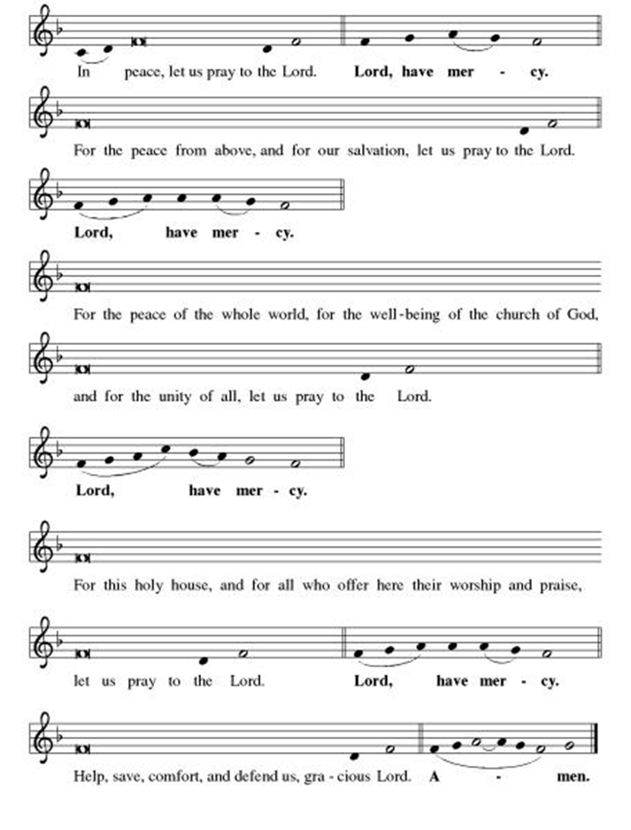

***\*\*This is the Feast***

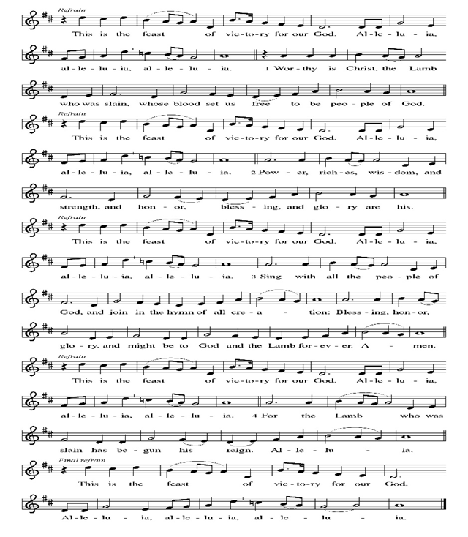

***\*\*Prayer of the Day***

**Holy God, you ask that we are obedient to you, and in return, you promise to care and provide for us. We don’t always know what that looks like, but we know that we aren’t always comfortable with it. Help us to rest securely in our obedience to you, and in your provision for us. In Jesus’ name we pray. Amen.**

***Reading:*** **Genesis 21:1-3; 22:1-14**

1God was gracious to Sarah as it had been foretold, and did what had been promised. 2Sarah conceived and gave birth to a child for Abraham, who was now in old age, at the very time God had promised. 3They named the child Isaac.

1After these events, God tested Abraham.

“Abraham!” God called.

**“Here I am,”** Abraham replied.

2“Take your son,” God said, “your only child Isaac, whom you love, and go to the land of Moriah, “Seeing.” Offer him there as a burnt offering, on a mountain I will point out to you.”

3Rising early the next morning, Abraham saddled a donkey and took along two workers and his son Isaac. Abraham chopped wood for the burnt offering, and started on the journey to the place God showed them. 4On the third day, Abraham looked up and saw the place in the distance. 5Then Abraham said to the workers, “Stay here with the donkey. The boy and I will go over there; we will worship and come back to you.”

6Abraham took wood for the burnt offering and gave it to Isaac to carry. In his own hands he carried the fire and the knife. Then the two of them went on alone.

7Isaac said, “Father!”

“**Here I am, my child,”** Abraham replied.

“Here are the fire and the wood, but where is the lamb for the burnt offering?”

8Abraham answered, “My child, God will provide the lamb for the burnt offering.”

Then the two of them went on together. 9When they arrived at the place God had pointed out, Abraham built an altar there, and arranged wood on it. Then he tied up his son Isaac and put him on the altar on top of the wood. 10Abraham stretched out his hand and seized the knife to kill the child.

11But the angel of God called to him from heaven: “Abraham! Abraham!”

**“Here I am!”** he replied.

12“Do not raise your hand against the boy!” the angel said. “Do not do the least thing to him. I know now how deeply you revere God, since you did not refuse me your son, your only child.”

13Then looking up, Abraham saw a ram caught by its horns in a bush. He went and took the ram, and offered it up as a burnt offering instead of his child. 14Abraham called the place “God Provides,” and so it is said to this day: “On this mountain GOD provides.”

Word of God, Word of Life

**Thanks be to God**

***\*\*Gospel Acclamation***

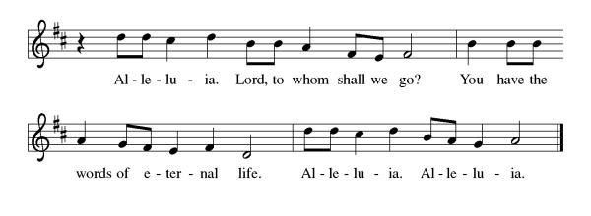

*Announcement of the Gospel*

**Glory to you, O Lord.**

***Gospel:* John 1:29**

29The next day, catching sight of Jesus approaching, John exclaimed, “Look, there’s God’s sacrificial lamb, who takes away the world’s sin!

The Gospel of the Lord.

**Praise to you, O Christ.**

**Sermon  "Total Obedience"**

***Hymn of the Day* The God of Abraham Praise v.1-4 ELW#831**

\*\***Affirmation of Faith – Immigrant’s Creed by Jose Luis Casal**

**I believe in Almighty God, who guided the people in exile and in exodus, the God of Joseph in Egypt and Daniel in Babylon, the God of foreigners and immigrants.**

**I believe in Jesus Christ, a displaced Galilean, who was born away from his people and his home, who fled his country with his parents when his life was in danger. When he returned to his own country he suffered under the oppression of Pontius Pilate, the servant of a foreign power. Jesus was persecuted, beaten, tortured, and unjustly condemned to death. But on the third day Jesus rose from the dead, not as a scorned foreigner but to offer us citizenship in God’s kingdom.**

**I believe in the Holy Spirit, the eternal immigrant from God’s kingdom among us, who speaks all languages, lives in all countries, and reunites all races.**

**I believe that the Church is the secure home for foreigners and for all believers. I believe that the communion of saints begins when we embrace all God’s people in all their diversity. I believe in forgiveness, which makes us all equal before God, and in reconciliation, which heals our brokenness. I believe that in the Resurrection God will unite us as one people in which all are distinct and all are alike at the same time. I believe in life eternal, in which no one will be foreigner but all will be citizens of the kingdom where God reigns forever and ever. Amen.**

***\*\*Prayers of Intercession***

**God of Love, hear the prayers that we lift before you. Hold close to you all those for whom we pray.**

Merciful God, pour out your grace upon your church. Forgive us for the times when we have been unfaithful, and renew our commitment to your gospel of love. Empower us to live as a community of mercy. God of grace,

**receive our prayer.**

Merciful God, we ask forgiveness for the ways we have neglected and harmed this earth and its creatures. Confirm our commitment to care for all you have made, and grant us wisdom and strength to take action toward restoring your creation to its fullness. God of grace,

**receive our prayer.**

Merciful God, govern all who hold positions of power and authority. Instruct them to make just decisions that serve the common good. Make them instruments of your mercy in the world, working to heal divisions and promote peace. God of grace,

**receive our prayer.**

Merciful God, we lift up all who suffer. Bring healing, comfort, and peace to those who are sick, grieving, or in pain especially Monty, Paul, Linda, Betty F., Kay, family of Lisa, Becky H., Jim & Jan, Becky W., David, William and family, Helen, Larry, Jennifer, Otto, families in our community who endure hunger, and our beloved for whom death is near. Carry your people when grief is heavy, and lift burdens of shame and self-doubt. Bring honor to any who experience slander and evil intent or are discredited by others. Assure all who are afraid or experiencing great uncertainty that your promises are sure. Reassure them of your care in all times and places. Manifest your healing presence in their midst. May they find healing through your love and the care of those around them. Give us compassionate hearts to accompany those who are hurting and courage to work for justice and mercy. God of grace,

**receive our prayer.**

Merciful God, bind us together as a community of forgiveness and love. Supply us with humility to seek forgiveness when we have wronged one another and generosity to extend mercy when we have been wronged. God of grace,

**receive our prayer.**

Calm the fears of migrants and refugees who set out, not knowing where they go. Provide shelter, sustenance, protection from harm, and welcome. Bless the work of Global Refuge and other support and advocacy programs. God of grace,

**receive our prayer.**

We pray for the nations. Pave a way to justice, drown the forces of oppression, bring peace on earth. Give leaders the will to turn from war and violence. Especially we pray for the people of Gaza, Israel, and Ukraine, and for Jim’s grandson Dylan, who is deployed in Oman. When people must flee their homes, guide them to safety. Comfort those living with deep trauma, anxiety, or fear; all those who serve people in need, and accompany all those who care for people in harm’s way. God of grace,

**receive our prayer.**

We pray for people who rise up against injustice. Bring courage and resilience to those who resist tyranny with their words and their bodies. Strengthen those who fight for justice in your name across the country, and around the world. Protect and sustain immigrants and refugees and all who work with them, that your kingdom, without borders and without walls, may truly come on earth as it is in heaven. We pray for all victims of gun violence or kidnapping, especially those who are targeted out of hate or fear. Embolden us to holy outrage and empower us to speak our truth of love and justice, God of grace,

**receive our prayer.**

God of learning, we lift up all who teach and all who learn. Thank you for teachers who share their knowledge and wisdom. Bless the students in our midst. Especially we remember Evie, in kindergarten; Addison, in high school; and Tyler, Zach, Katie and Katy, in college. Bless Janet and Lisa as they teach. God of grace,

**receive our prayer.**

Merciful God, we remember in love those who have departed this life. Console those who mourn, and give them the hope of resurrection. God of grace,

**receive our prayer.**

**Good and loving God, we give everyone we have prayed for into your care. Amen.**

*\*\** ***Sharing of the Peace***

### *\*\*Offering is brought forward*

### *\*\** *Offertory Response*

**Create in Me ELW#186**

### *\*\*Offertory Prayer*

**Good and loving God, everything that we have and everything that we are comes from you. We respond in gratitude, offering up to you our gifts of our money, our time, and our talents. We dedicate these gifts to your service. In Jesus’ name we pray, amen.**

**\*\*Dialogue**

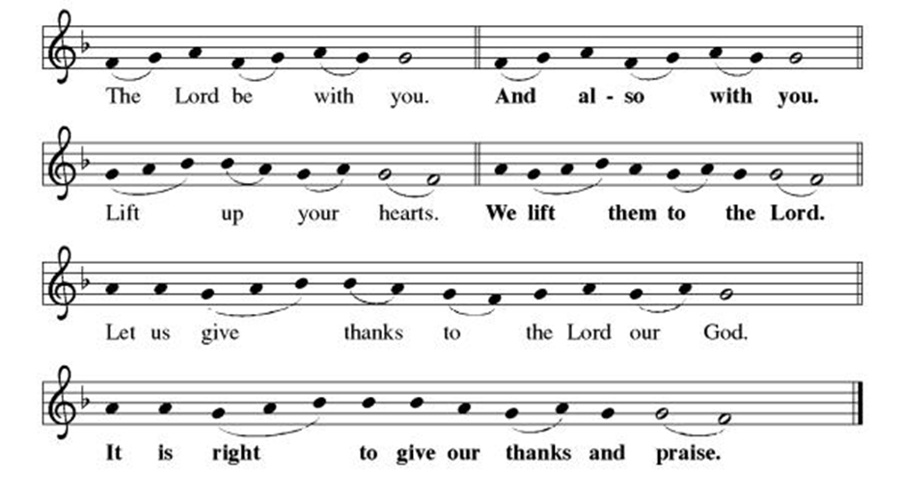

**\*\*Preface:** Since the earliest days of the covenant… this hymn of praise:

**\*\*Holy, Holy, Holy**

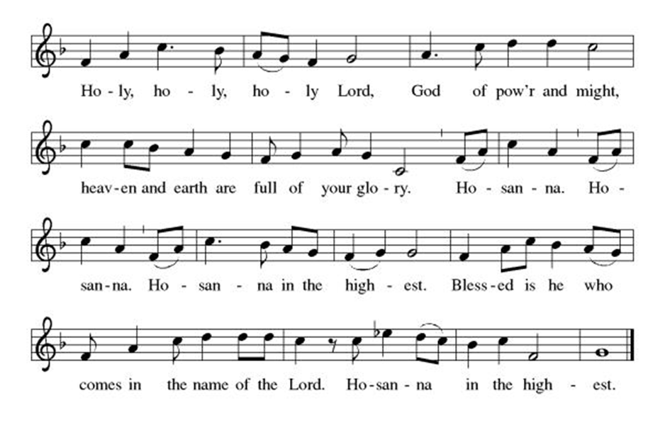

***\*\*Words of Institution***

**\*\*LORD’S PRAYER**

**Our Father, who art in heaven,**

**hallowed be thy name,**

**thy kingdom come,**

**thy will be done,**

**on earth as it is in heaven.**

**Give us this day our daily bread;**

**and forgive us our trespasses,**

**as we forgive those**

**who trespass against us;**

**and lead us not into temptation,**

**but deliver us from evil.**

**For thine is the kingdom,**

**and the power, and the glory,**

**forever and ever. Amen.**

***Invitation to Communion***

# ***Communion Hymn I Received the Living God ELW#477***

### *\*\*Sending Song*

### *Praise to you, O God of Mercy ELW#208*

### *\*\*Prayer After Communion*

**Abiding God, you call us then feed and nurture us. Now you send us out in the world you created with a purpose: to love our neighbors and care for those who need us. Strengthen us to do your work. In Jesus’ name we pray, Amen.**

### *\*\*Blessing*

***\*\*Closing Hymn******Amazing Grace******ELW#779***

### 

### *\*\*Dismissal*

Go in peace to serve Christ and the world!

**THANKS BE TO GOD!**

### + + + + + +

*Setting 3 liturgy are under copyright and used with permission under One License #733618-A. Specific copyright information as listed in bulletin, the Prayers of Intercession are under copyright and are used with permission under Augsburg Fortress Liturgy License #SB155933. All other liturgy written by Sarah Pierce.*

*\*\*\*\*\*\*\*\*\*\*\*\*\*\*\*\*\*\*\*\*\*\*\*\*\*\*\*\*\*\*\*\*\*\*\*\*\*\*\*\*\*\*\*\*\*\*\*\*\*\*\*\*\*\*\*\*\*\*\*\*\*\*\*\*\*\*\*\*\*\*\*\*\*\*\*\*\*\*\*\*\*\*\*\*\*\*\*\*\*\*\*\*\*\*\*\*\*\*\*\*\*\*\*\*\*\*\**

**Weekly Attendance**

***Week of September 07***

***26***

*\*\*\*\*\*\*\*\*\*\*\*\*\*\*\*\*\*\*\*\*\*\*\*\*\*\*\*\*\*\*\*\*\*\*\*\*\*\*\*\*\*\*\*\*\*\*\*\*\*\*\*\*\*\*\*\*\*\*\*\*\*\*\*\*\*\*\*\*\*\*\*\*\*\*\*\*\*\*\*\*\*\*\*\*\*\*\*\*\*\**

**Calendar of Events**

***Today***

* ***Baptismal Birthdays***
* ***Church Council Meeting***

***This Week***

|  |  |
| --- | --- |
| ***September 16*** | ***Creative Friends 1:00 pm*** |
| ***September 17- September 21*** | ***Pastor Sarah Vacation*** |

***Upcoming Events***

|  |  |
| --- | --- |
| ***September 23*** | ***Creative Friends 1:00 pm*** |
| ***September 22-23*** | ***Blue Springs Theatre 7:00 pm-9:00 pm*** |
| ***September 29-October 01*** | ***Blue Springs Theatre 7:00 pm-9:00 pm*** |
| ***September 28*** | ***Bishop Installation/Atonement Lutheran Church 5:00 pm Overland Park*** |
| ***September 30*** | ***Creative Friends 1:00 pm*** |
| ***October 04*** | ***Blessing of Animals TBA*** |
| ***October 12*** | ***Fall Work Day*** |
| ***October 15*** | ***Council Meeting 6:30 pm*** |
| ***November 05*** | ***Council Meeting 6:30 pm*** |
| ***November 16*** | ***Congregational Meeting*** |
| ***December 10*** | ***Council Meeting 6:30 pm*** |
| ***January 14, 2026*** | ***Council Meeting 6:30 pm*** |
|  |  |
|  |  |

****************************************************************************************

*You may recall that there has been an announcement in the bulletin over the past year directing you to Lutheran Immigration and Refugee Services (LIRS) if you wish to support the people of Ukraine. LIRS has changed its name to Global Refuge and can be found at* ***globalrefuge.org****. Although their name has changed, their mission remains the same: to assist and support refugees in the United States and around the world. Visit their website to see all the ways you can support this important work.*

**\*\*\*\*\*\*\*\*\*\*\*\*\*\*\*\*\*\*\*\*\*\*\*\*\*\*\*\*\*\*\*\*\*\*\*\*\*\*\*\*\*\*\*\*\*\*\*\*\*\*\*\*\*\*\*\*\*\*\*\*\*\*\*\*\*\*\*\*\*\*\*\*\*\*\*\*\*\*\*\*\*\*\*\*\*\*\*\*\***

**BLUE SPRINGS COMMUNITY SERVICE LEAGUE** *is very appreciative of your continued support of your neighbor.*

*\*\*\*\*\*\*\*\*\*\*\*\*\*\*\*\*\*\*\*\*\*\*\*\*\*\*\*\*\*\*\*\*\*\*\*\*\*\*\*\*\*\*\*\*\*\*\*\*\*\*\*\*\*\*\*\*\*\*\*\*\*\*\*\*\*\*\*\*\*\*\*\*\*\*\*\*\*\*\*\*\*\*\*\*\*\*\*\*\*\**

**Questions for Reflection and Discussion from Pastor Sarah**

1. There’s a lot we don’t know about this story. For example, how old is Isaac? Is he a child, barely old enough to carry the wood, or is he a young man? How old is Abraham? He was 100 years old when Isaac was born – but is he in his prime, middle-aged and full of vim and vigor, or is he an old man? And does it change your reading of the story if you imagine each of them in one age bracket or the other?
2. What about Sarah? Is she aware of this? How does she feel?
3. We might wonder at God calling Isaac Abraham’s only son, when just a chapter before, God promised to make Ishmael a great nation. A Jewish midrash, or ancient commentary, turns this sentence into an imagined dialog. “Take your son,” God says. “Which son,” Abraham asks. “I have two.” “Your only son,” God replies. “Each is the only son of his mother.” “The one you love,” God says. “Does a father’s love know now bounds?” “Isaac,” is finally God’s identifier.
4. This is a story that has been important to three faiths throughout the centuries, emphasizing three different characters within the stories. Christians have historically emphasized the character of Isaac, who carries the cord of wood for the burnt offering as Jesus will later carry his own cross in the gospel of John. Muslims, who tell this story about Ishmael rather than Isaac, have emphasized the character of Abraham, as their faith emphasizes submission to God’s will. And Jews have emphasized God in this story, who gives a ram to sacrifice in place of Isaac, as their faith emphasizes God’s provision.
5. I mention in my sermon that there are at least two (up to four) narratives that were woven together to create a more or less cohesive whole. If you want an example of what I mean by “more or less,” read the account of the flood from Genesis 6:11-9:17. Look for all of the less-cohesive parts. (Here’s a hint: how many pairs of animals? When were the birds sent out?)

***\*\*\*\*\*\*\*\*\*\*\*\*\*\*\*\*\*\*\*\*\*\*\*\*\*\*\*\*\*\*\*\*\*\*\*\*\*\*\*\*\*\*\*\*\*\*\*\*\*\*\*\*\*\*\*\*\*\*\*\*\*\*\*\*\*\*\*\*\*\*\*\*\*\*\*\*\*\*\*\*\*\*\*\*\*\****

***Greeter –*** **September 14*-******Donna Taylor***

***Usher –* September 14*-Paul Blixrud***

***Altar Guild-* September 14-Sara Meyers**

***Communion Assisitant-* September 14-Flavia Via**

***Tech-* September 14*-Gary Antes***

**Prayer Requests**

***Monty Health Concerns (May 15)***

*Paul Health Concerns (May 31)*

*Mary Health Concerns (May 15)*

*James & Family Health Concerns (September 11)*

*Betty F (Sara’s friend) Health Concerns (July 15)*

*William and Family Health Concerns (September 25)*

*Becky H Health Concerns (October 28)*

*David Health Concerns (November 18)*

*Becky W Health Concerns (November 18)*

*Larry Health Issues (December 16)*

*Helen Health Issues (January 14)*

*Jennifer Health Concerns (February 27)*

*Otto Health Concerns (July 15)*

*Kay (Sara’s cousin) Health Concerns (**July 15)*

*Family of Lisa (September 03)*

***Merciful God, your justice and mercy are without limits. Bring courage and resilience to those who resist tyranny with their words and their bodies. Strengthen those who fight for justice in your name in Los Angeles, across the country, and around the world.***

***Please pray for the victims of the shooting at Annunciation Catholic School in Minneapolis.***

***Please pray for the people of Gaza, Ukraine, Israel, Iran and Palestine.***

***Please pray for the people of the Sudan.***

***Please pray for the Homeless.***

***Please pray for legal & illegal immigrants & those seeking asylum or citizenship.***