All Saints Lutheran Church, ELCA
421 SW 19th St. Blue Springs, Missouri 64015 816-229-3633
Pastor Sarah Pierce Spierce.aslcpastor@gmail.com
allsaintslc64015@gmail.com https://aslcbs.org/

Sunday, October 05, 2025

Seventeenth Sunday after Pentecost

You are absolutely invited into this sacred space. We welcome all who are seeking God’s love and grace. All Saints recognizes that we are all unique and beloved children of God. We celebrate and give thanks for the many diverse gifts that God has given us. We affirm the sacredness of people of all sexual orientations, gender identities, and gender expressions. We affirm the sacredness of all those who have experienced exclusion because of race, ability, age, or culture. We are committed to working towards anti-racism in ourselves and our community. We affirm the sacredness of all those who wrestle with addiction, physical or mental health, imprisonment, socio-economic circumstances, or anything that too often divides us. We believe that through our openness we all grow in our faith through Christ’s teaching to love one another as God loves us. We need each other and our sincere hope is by being in community together, we will experience God’s presence in new and real ways.

The offering plate is by the main door to the sanctuary for your convenience.

We practice open communion at All Saints Lutheran Church. What does that mean? It means that if you believe and trust that Christ offers his body and blood For You, you are welcome at the table. At All Saints, we believe that Christ invites all people to the feast. “Come to the banquet for all is now ready.”

**Stand as you are comfortable

Prelude

Announcements

** Confession and Forgiveness

God who created the heavens, the earth, and all that exists, sometimes we feel small when we stand before you. But we trust that you see and hear us when we come to you.

Let us take a moment to draw near to God.

Holy God,
You always listen to us when we pray.
Forgive us when we forget to center our lives around you.
Forgive us when we turn away, distracted by other things that delight or distress us.
Forgive us when we sin against you, scorning the promises you have made to us.
Help us remember that you are always the solid foundation on which we stand.
Remind us, your children, to turn back to you.

Beloved children of God, the Spirit moves among us, bringing comfort and renewal. Our Creator, the Source of all that is good and holy, is making all things new. And in Jesus, our Savior +, we find the promise of forgiveness and mercy.

Amen.

**Entrance Hymn All Who Hunger, Gather Gladly ELW #461

**Greeting
The grace of our Lord Jesus Christ, the love of God,
and the communion of the Holy Spirit be with you all.
And also with you.

**Kyrie
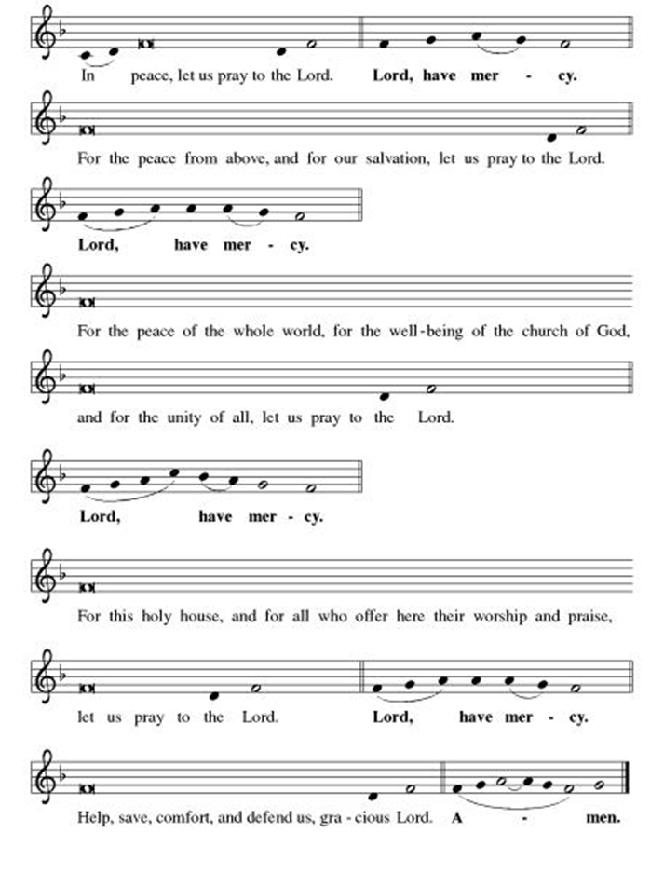

**This is the Feast
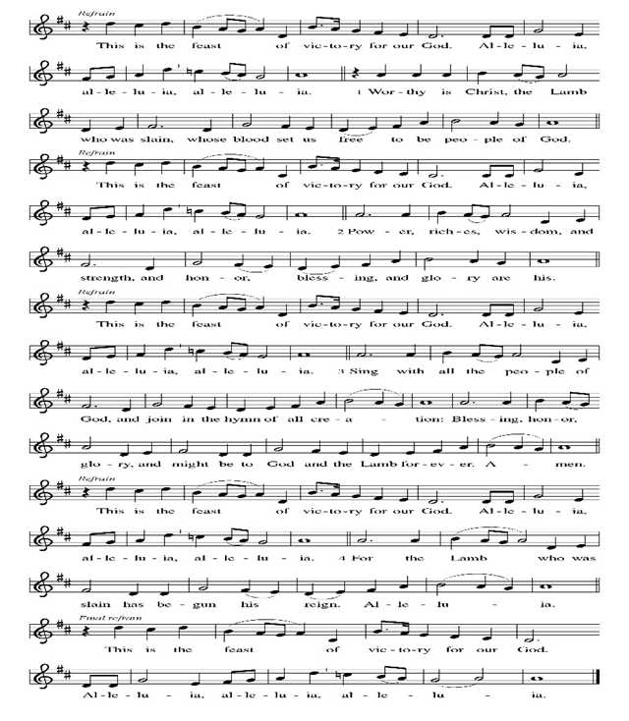
**Prayer of the Day

Holy and Loving God, you accompany and sustain us when we are in the wilderness. We give thanks for the manna you give us in times of hardship. Help us to share your abundance with those who are in need. We ask this in the name of Jesus, the living bread from heaven. Amen.

Reading: Exodus 16:1-18

¹From Elim they set out again, and the whole community of the Israelites reached the wilderness of Syn, which is between Elim and Sinai, on the fifteenth day of the second month after they left Egypt.

²They began to complain against Moses and Aaron there in the wilderness. ³The people of Israel said to them, “If only we had died by God’s hand in the land of Egypt, when we sat next to pots of meat and ate our bread till we were filled! But now you have brought the whole community out into this wilderness to die of hunger!”

⁴Then God said to Moses, “Look, I will rain down bread from heaven for you. The people will go out and gather a day’s portion every day, so that I can test them to see if they will follow my instructions. ⁵On the sixth day, when they prepare what they brought in, it will be twice as much as the daily gathering.”

⁶So Moses and Aaron said to the Israelites, “In the evening you will know that it was God who brought you up out of Egypt, ⁷and in the morning you will witness the glory of God, the One to whom you directed your complaints—for who are we, that you should complain to us?”

⁸Moses continued, “It is God who will give you meat in the evening for your meal, and all the bread you want in the morning, because God has heard your complaints. For it is not to us that you are complaining—who are we?—but to God.”

⁹ Then Moses said to Aaron, “Tell the whole Israelite community, ‘Present yourselves before God, who has heard your complaints.’”

¹⁰As Aaron was speaking to the whole Israelite community, they looked toward the desert, and there was the glory of God appearing in the form of a cloud. ¹¹Then God spoke to Moses and said, ¹²“I have heard the complaining of the people of Israel. Say this to them: ‘In the evening you will eat meat, and in the morning. you will have your fill of bread. Then you will know that I am your God.’”

¹³So it came about that in the evening quail flew in and all around the camp. And in the morning. there was a layer of dew all around the camp; ¹⁴when the layer of dew evaporated, there on the surface of the desert were flakes of something: delicate, powdery, fine as frost.

¹⁵ When they saw this, the people of Israel said to each other, “What is it?”—not knowing what it was. But Moses told them, “This is the bread God has given you to eat.

¹⁶“This is the command God gave you,” he continued. “Each one is to gather just enough to eat. Let everyone collect a two-quart measure of it for each person in your tent.” ¹⁷The Israelites did as they were told. Some took a large amount. Some took very little. ¹⁸But when they measured it by the two-quart measure, those who took a large amount did not have too much, and those who gathered very little did not have too little. Each had just as much as they needed.

Word of God, Word of Life
Thanks be to God

**Gospel Acclamation
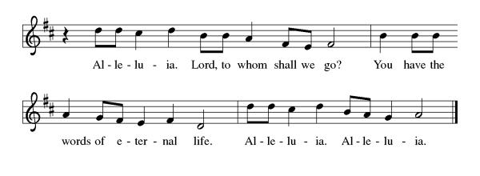
Announcement of the Gospel
Glory to you, O Lord.

Gospel John 6:51

⁵¹[Jesus said,] “I myself am the living bread
come down from heaven.
If any eat this bread,
they will live forever;
the bread I will give
for the life of the world
is my flesh.”

The Gospel of the Lord.
Praise to you, O Christ.

Sermon "Abundance in the Wilderness"

Hymn of the Day Glorious Things Of You Are Spoken ELW#647

**Affirmation of Faith – Immigrant’s Creed by Jose Luis Casal

I believe in Almighty God, who guided the people in exile and in exodus, the God of Joseph in Egypt and Daniel in Babylon, the God of foreigners and immigrants.

I believe in Jesus Christ, a displaced Galilean, who was born away from his people and his home, who fled his country with his parents when his life was in danger. When he returned to his own country he suffered under the oppression of Pontius Pilate, the servant of a foreign power. Jesus was persecuted, beaten, tortured, and unjustly condemned to death. But on the third day Jesus rose from the dead, not as a scorned foreigner but to offer us citizenship in God’s kingdom.

I believe in the Holy Spirit, the eternal immigrant from God’s kingdom among us, who speaks all languages, lives in all countries, and reunites all races.

I believe that the Church is the secure home for foreigners and for all believers. I believe that the communion of saints begins when we embrace all God’s people in all their diversity. I believe in forgiveness, which makes us all equal before God, and in reconciliation, which heals our brokenness. I believe that in the Resurrection God will unite us as one people in which all are distinct and all are alike at the same time. I believe in life eternal, in which no one will be foreigner but all will be citizens of the kingdom where God reigns forever and ever. Amen.

**Prayers of Intercession

God of Love, hear the prayers that we lift before you. Hold close to you all those for whom we pray.

We pray for the church, that it would remain faithful to the gospel, always striving to serve the needs of those who are oppressed and rejecting the complacency that comes from wealth. God of grace,
receive our prayer.
We pray for creation, that the nations work together to protect and restore the earth, preserving the beauty of the planet for future generations and honoring the gift of your creation. God of grace,
receive our prayer.
We pray for those in positions of authority, that they govern with justice and compassion, recognizing the dignity of all people and working to promote peace and prosperity for all. God of grace,
receive our prayer.
We pray for people in any need especially Monty, Paul, Linda, Betty F., Kay, Becky H., Jim & Jan, Becky W., David, William and family, Helen, Larry, Jennifer, Otto, families in our community who endure hunger, Kevin, Kent and Carla and our beloved for whom death is near. Carry your people when grief is heavy, and lift burdens of shame and self-doubt. Give them your assurance and courage when the path forward is not clear. Liberate us from all that binds us, lift us up when we are bowed down, and show us your love. God of grace,
receive our prayer.
We pray for this congregation, that we would be strengthened to build a world where all can thrive. Incite us to advocate for fair wages and just policies, and guide us in building a community of mutual support. God of grace,
receive our prayer.
Calm the fears of migrants and refugees who set out, not knowing where they go. Provide shelter, sustenance, protection from harm, and welcome. Bless the work of Global Refuge and other support and advocacy programs. God of grace,
receive our prayer.
We pray for the nations. Pave a way to justice, drown the forces of oppression, bring peace on earth. Give leaders the will to turn from war and violence. Especially we pray for the people of Gaza, Israel, and Ukraine, and for Jim’s grandson Dylan, who is deployed in Oman. When people must flee their homes, guide them to safety. Comfort those living with deep trauma, anxiety, or fear; all those who serve people in need, and accompany all those who care for people in harm’s way. God of grace,
receive our prayer.
We pray for people who rise up against injustice. Bring courage and resilience to those who resist tyranny with their words and their bodies. Strengthen those who fight for justice in your name across the country, and around the world. Protect and sustain immigrants and refugees and all who work with them, that your kingdom, without borders and without walls, may truly come on earth as it is in heaven. We pray for all victims of gun violence or kidnapping, especially those who are targeted out of hate or fear. Embolden us to holy outrage and empower us to speak our truth of love and justice, God of grace,
receive our prayer.
God of learning, we lift up all who teach and all who learn. Thank you for teachers who share their knowledge and wisdom. Bless the students in our midst. Especially we remember Evie, in kindergarten; Addison, in high school; and Tyler, Zach, Katie and Katy, in college. Bless Janet and Lisa as they teach. God of grace,
receive our prayer.
We remember in thanksgiving the faithful departed. Inspire us by their example to love and serve our neighbors, and bring us to eternal life. God of grace,
receive our prayer.

Good and loving God, we give everyone we have prayed for into your care. Amen.
** Sharing of the Peace

**Offering is brought forward

** Offertory Response

Create in Me ELW#186

**Offertory Prayer
Good and loving God, everything that we have and everything that we are comes from you. We respond in gratitude, offering up to you our gifts of our money, our time, and our talents. We dedicate these gifts to your service. In Jesus’ name we pray, amen.

**Dialogue
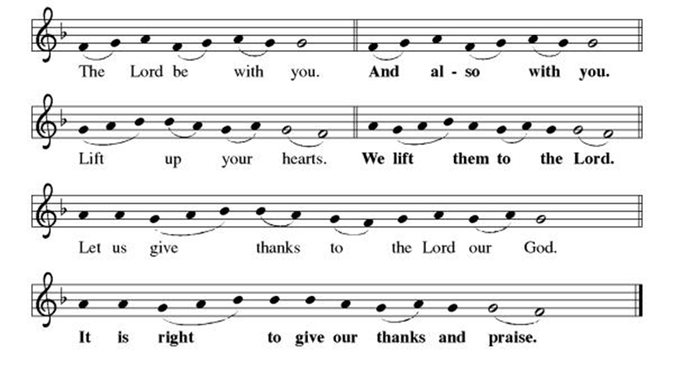

**Preface: Since the earliest days of the covenant… this hymn of praise:

**Holy, Holy, Holy
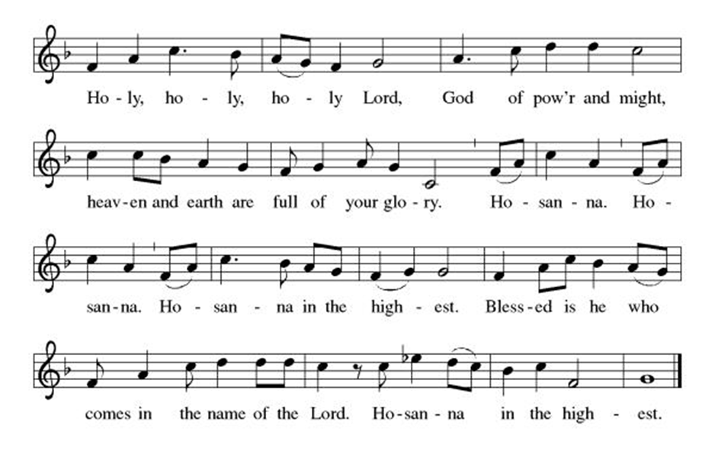
**Words of Institution

**LORD’S PRAYER

Our Father, who art in heaven,
hallowed be thy name,
thy kingdom come,
thy will be done,
on earth as it is in heaven.
Give us this day our daily bread;
and forgive us our trespasses,
as we forgive those
who trespass against us;
and lead us not into temptation,
but deliver us from evil.
For thine is the kingdom,
and the power, and the glory,
forever and ever. Amen.

Invitation to Communion

Communion Hymn For The Bread Which You Have Broken ELW#494

**Sending Song

Praise to you, O God of Mercy ELW#208

**Prayer After Communion

Abiding God, you call us then feed and nurture us. Now you send us out in the world you created with a purpose: to love our neighbors and care for those who need us. Strengthen us to do your work. In Jesus’ name we pray, Amen.

**Blessing

**Closing Hymn God Be With You Till We Meet Again ELW#536

**Dismissal

Go in peace to serve Christ and the world!

THANKS BE TO GOD!

+ + + + + +
Setting 3 liturgy are under copyright and used with permission under One License #733618-A. Specific copyright information as listed in bulletin, the Prayers of Intercession are under copyright and are used with permission under Augsburg Fortress Liturgy License #SB155933. All other liturgy written by Sarah Pierce.

***********************************************************************************************************
Weekly Attendance

Week of September 28
25
Birthdays
October 05-Pam Meek
October 09-Anne Lee

Anniversaries
October 05-Phil & Mary Ann Gross

******************************************************************************************
Calendar of Events
Today

- Blessing of CSL
- Stewardship: Time
This Week
October 07 | Creative Friends 1:00 pm
October 11 | Men’ s Breakfast 8:00 am

Upcoming Events
October 07 | Creative Friends 1:00 pm
October 11 | Men’ s Breakfast 8:00 am
October 12 | Baptism Birthdays/Stewardship: Talent/Balloon Payment Cake after Worship/Fall Work Day
October 14 | Creative Friends 1:00 pm
October 15 | Council Meeting 6:30 pm
October 15-16 | Fall Theological Conference
October 19 | Stewardship: Treasure
October 21 | Creative Friends 1:00 pm
October 21 | Jean’s Surgery Scheduled
October 25 | Project Comfort 9:00 am-Noon
October 26 | Reformation Sunday; Pledge Sunday Film/Potluck after Worship
October 28 | Creative Friends 1:00 pm
November 02 | Daylight Savings Time Clocks back 1 Hour/All Saints Sunday: Celebrating gifts/Follow up film after Worship
November 05 | Council Meeting 6:30 pm
November 16 | Congregational Meeting
November 26 | Thanksgiving Eve Worship 7:00 pm Pie Night
December 07 | Advent Dinner after Worship
December 10 | Council Meeting 6:30 pm
January 14, 2026 | Council Meeting 6:30 pm
February 18 | Ash Wednesday
March 29 | Palm Sunday
April 05 | Easter Sunday

*****************************************************************************************
BLUE SPRINGS COMMUNITY SERVICE LEAGUE is very appreciative of your continued support of your neighbor.
******************************************************************************************
Questions for Reflection and Discussion from Pastor Sarah

- Our preaching text last week started with God hearing the complaints of the children of Israel; this morning, we start with the same thing – God hearing the complaints of the Israelites. But the complaints are very different. Last week, in our preaching text, they were complaining about Egypt; this morning, they are complaining about God. What is God’s response?
- They are just at the beginning of their journey – not even to Mt. Sinai yet, “on the fifteenth day of the second month after they left Egypt,” so 45 days in, give or take. They will eat quail and manna for another 40 years. That’s a long time to eat the same thing! But it’s also a 40-year period that, in the book of Hosea (for those of you who are in Bible study), is described as the “honeymoon period” between Israel and God: the time in which they are given the law and learning to live with their freedom.
- What does freedom mean to you, in the context of escape from Egypt into the wilderness, to wander for 40 years? Do you think it would feel like freedom? If so, why? If not, why not?
- Martin Luther wrote in his letter to Pope Leo X titled “Concerning Christian Liberty,” in 1520: “A Christian is the most free lord of all, and subject to none; a Christian is the most dutiful servant of all, and subject to everyone.” What do you think he meant? And what does it have to do with manna, and the wilderness (if anything)?
- If you feel like it, look back on a time in your life that was particularly difficult. What happened during that time to sustain you and get you through it? Was there anything that anyone said or did, no matter how little, that helped you? When you look back on that now, does it feel like God may have played a hand in that, so that you knew you weren’t walking through your hard time alone?

**************************************************************************************
Greeter – October 05-Donna Taylor
Usher – October 05-Paul Blixrud
Altar Guild- October 05-Mary Ann Gross & Donna Taylor
Tech- September October 05-Gary Antes

Prayer Requests
Monty Health Concerns (May 15)
Paul Health Concerns (May 31)
Mary Health Concerns (May 15)
James & Family Health Concerns (September 11)
Betty F (Sara’s friend) Health Concerns (July 15)
William and Family Health Concerns (September 25)
Becky H Health Concerns (October 28)
David Health Concerns (November 18)
Becky W Health Concerns (November 18)
Larry Health Issues (December 16)
Helen Health Issues (January 14)
Jennifer Health Concerns (February 27)
Otto Health Concerns (July 15)
Kay (Sara’s cousin) Health Concerns (July 15)
Kevin Health Concerns (October 01)
Kent Health Concerns (October 01)
Carla Health Concerns (October 01)

Merciful God, your justice and mercy are without limits. Bring courage and resilience to those who resist tyranny with their words and their bodies. Strengthen those who fight for justice in your name in Los Angeles, across the country, and around the world.

Please pray for the victims of the shooting at Annunciation Catholic School in Minneapolis.

Please pray for the people of Gaza, Ukraine, Israel, Iran and Palestine.
Please pray for the people of the Sudan.
Please pray for the Homeless.
Please pray for legal & illegal immigrants & those seeking asylum or citizenship.

