All Saints Lutheran Church, ELCA
421 SW 19th St. Blue Springs, Missouri 64015 816-229-3633
Pastor Sarah Pierce Spierce.aslcpastor@gmail.com
allsaintslc64015@gmail.com https://aslcbs.org/
Easter Vigil Service April 04, 2026 7:45 PM All Saints Lutheran Church

You are absolutely invited into this sacred space. We welcome all who are seeking God’s love and grace. All Saints recognizes that we are all unique and beloved children of God. We celebrate and give thanks for the many diverse gifts that God has given us. We affirm the sacredness of people of all sexual orientations, gender identities, and gender expressions. We affirm the sacredness of all those who have experienced exclusion because of race, ability, age, or culture. We are committed to working towards anti-racism in ourselves and our community. We affirm the sacredness of all those who wrestle with addiction, physical or mental health, imprisonment, socio-economic circumstances, or anything that too often divides us. We believe that through our openness we all grow in our faith through Christ’s teaching to love one another as God loves us. We need each other and our sincere hope is by being in community together, we will experience God’s presence in new and real ways.

The offering plate is by the main door to the sanctuary for your convenience.

We practice open communion at All Saints Lutheran Church. What does that mean? It means that if you believe and trust that Christ offers his body and blood For You, you are welcome at the table. At All Saints, we believe that Christ invites all people to the feast. “Come to the banquet for all is now ready.”

**GATHERING
The Holy Spirit calls us as the people of God, to gather in silence and await the resurrection of our Christ.
We begin our worship with unlit candles.
**GREETING
The grace of our Lord Jesus Christ, the love of God, and the communion of the Holy Spirit be with you all.
And also with you.

Siblings in Christ, this is the most holy night of the year: the night when our Savior Jesus Christ passed from death back to life. And so tonight, we gather with the church throughout the world in vigil and prayer. This is the Passover of Jesus Christ. We proclaim Christ’s death and resurrection through light and the word, and through bread and wine. We share Christ’s triumph over sin and death, and we await Christ’s coming again in glory.

Let us pray.
God Who is, Who was, and Who is to come, Jesus Christ is the light of the world, bringing life to all whom you love. Bless this new fire. In the same was that a fire grows, grow in us the desire to shine Christ’s light of life to all we encounter, until we join you at the heavenly feast. We ask this through your Son, our Savior, who shines for all the world to see.
Amen.
An assisting minister holds the paschal candle:
The symbols on the paschal candle reminds us of the Christ whom we worship:
Christ, yesterday and today, (☩)
the beginning and the ending. (A Ω)
To Christ belongs all time (2)
and all the ages; (0)
to Christ belongs glory and dominion (2)
now and forever. (5)
Amen.

The presiding minister lights the paschal candle from the fire:
The light of Christ, rising in glory,
dispel the darkness of our hearts and minds.

The minister lifts the candle so that all may see it.

**PROCESSION
The minister carries the paschal candle around the fire. As the candle processes, the light of the
candle proceeds out until all individual candles are lit

The paschal candle is placed in its stand.

**EASTER PROCLAMATION
Rejoice, all who feast in heaven!
Sing, choirs of angels!
Dance for joy, all creation around God’s throne!
Jesus Christ is risen!
Celebrate the divine mysteries with joy and triumph;
and for so great a victory, sound the trumpet of salvation.
Rejoice, Earth, clothed in the beauty God has given you,
radiant in the brightness of your Savior!
Christ has conquered! Glory fills you! Darkness vanishes forever.
Rejoice, believers! Rejoice in glory! The risen Savior shines upon us!
Let this place resound with joy,
echoing the mighty song of all God’s people.

The Lord be with you.
And also with you.
Let us give thanks to the Lord our God.
It is right to give our thanks and praise.

Filled with the joy of the Holy Spirit, we lift our voices in praise to God, and to God’s Beloved, Jesus Christ our Savior!
Baptized into his life, ministry, death, and resurrection, we have been freed from the power of sin and death.
This is the night; this is the night!
in which the darkness of sin has been vanquished by the rising brightness.
This is the night; this is the night!
in which all who believe in Christ are rescued from sin,
are renewed in grace, and are restored to holiness.
This is the night; this is the night!
in which Christ breaks the chains of death for all time.
This night is truly blessed, the sole witness to Christ’s ascent from the dead!
This is the night; this is the night!
of which it is written: “The night is as clear as the day,”
and, “then shall my night be turned into day.”
The holiness of this night puts to flight the deeds of wickedness;
washes away sin; restores joy to those who mourn; casts out hate; brings peace;
and humbles earthly pride.

Therefore, in this night of grace,
we lift our praise to you, O God,
for the light of the resurrection of our Lord Jesus Christ,
reflected in the burning of this candle.
We sing the glories of this pillar of fire,
the brightness of which is not diminished
even when its light is divided and borrowed.
This is the night; this is the night!
in which heaven and earth are joined—things human and things divine.

And so we pray that this candle,
burning to the honor of your name,
will continue to vanquish the darkness of night
and be mingled with the lights of heaven.
May Christ the Morning Star find it burning,
that Morning Star who never sets,
that Morning Star who, rising from the grave,
faithfully sheds light on the whole human race.

And we pray, O God,
that you would continue to protect your whole church,
giving us peace as we rejoice at Christ’s resurrection;
through Jesus Christ, your Beloved,
who lives and reigns with you and the Holy spirit,
one God, now and forever.
Amen.

**PRAYER OF THE DAY
Let us pray.
Holy God, you create the world, liberate your people, and bring wisdom to earth. We thank you that Jesus has conquered death to free us from our fears, restore us in your image, and ignite us with your light. We pray this through Jesus Christ, our Savior, who lives and reigns with you and the Holy Spirit, one God, now and forever. Amen.
Individual candles are extinguished. Process inside the sanctuary to continue worship.

OPENING HYMN Come You Faithful, Raise the Strain ELW #363
FIRST READING: The Creation story (from the Prologue of the First Nations New Testament based on Genesis 1:1-2:4a)

Word of God, Word of Life.
Thanks be to God.

FIRST RESPONSE: Psalm 136:1-9, 23-26 (The Inclusive Bible)
1Thank you GOD, for you are good!
Your love is everlasting!
2Thank you, God of gods!
Your love is everlasting!
3Thank you, sovereign of sovereigns,
Your love is everlasting!
4you alone perform such great marvels.
Your love is everlasting!
5Your wisdom made the heavens.
Your love is everlasting!
6You spread the land out over the waters.
Your love is everlasting!
7You made the great lights:
Your love is everlasting!
8the sun to govern the day,
Your love is everlasting!
9moon and stars to govern the night.
Your love is everlasting!
23You remembered us when we were under the yoke,
Your love is everlasting!
24and snatched us from our oppressors.
Your love is everlasting!
25You give food to all who hunger,
Your love is everlasting!
26Thank you, God of heaven!
Your love is everlasting!

Time for silent reflection.

FIRST PRAYER
Good and loving God, you created humanity in your image and, day after day, restore us to your image. Let us share the divine life of Jesus Christ, your Son, who came to share our humanity. Amen.

SECOND READING: Genesis 22:1-18 (The Inclusive Bible) Testing of Abraham

Word of God, Word of Life.
Thanks be to God.

SECOND RESPONSE: Psalm 16 (NRSVUE)
¹Protect me, O God, for in you I take refuge.
² I say to the Lord, “You are my Lord;
I have no good apart from you.”
³ As for the holy ones in the land, they are the noble ones
in whom is all my delight.
⁴ Those who choose another god multiply their sorrows;
their drink offerings of blood I will not pour out
or take their names upon my lips.
⁵ The Lord is my chosen portion and my cup;
you hold my lot.
⁶ The boundary lines have fallen for me in pleasant places;
I have a goodly heritage.
⁷ I bless the Lord, who gives me counsel;
in the night also my heart instructs me.
⁸ I keep the Lord always before me;
because he is at my right hand, I shall not be moved.
⁹ Therefore my heart is glad, and my soul rejoices;
my body also rests secure.
¹⁰ For you do not give me up to Sheol
or let your faithful one see the Pit.
¹¹ You show me the path of life.
In your presence there is fullness of joy;
in your right hand are pleasures forevermore.

Time for silent reflection.

SECOND PRAYER
God of all the faithful, you promised your servants Abraham and Sarah that they would become the parents of many nations. Through this gift of faith, your chosen people have spread throughout the world. Mold our faith by the death of your Chosen One, that we may joyfully welcome the new life given to us in grace through our Savior, Jesus Christ. Amen.

THIRD READING: Exodus 14:10-31; 15:20-21 (The Message) Deliverance at the Red Sea

Word of God, Word of Life.
Thanks be to God.

THIRD RESPONSE: Exodus 15:1b-13; 17-18 (The Inclusive Bible)
1b“To you, O God, I sing:
you have triumphed powerfully;
horse and charioteer
you have flung into the sea!
2God is our strength and our courage;
you have become our deliverance.
You are God—we will praise you;
the God of our ancestors—we exalt you!
3God is a warrior;
‘I AM’ s your Name!
4Pharaoh’s chariots and army
you have hurled into the sea;
Pharaoh’s choicest warriors
sank in the Sea of Reeds.
5The deep waters consumed them;
they sank to the bottom like a stone.
6Your right hand, O God,
is mighty in power.
Your right hand, O God,
shattered our foe.
7In the splendor of your power
you threw down those who defied you;
you released your wrath like fire,
which consumed them like stubble.
8With a blast of your nostrils
the waters piled up. The waves stood like a dam,
waters congealing in the depths of the sea.
9The foe boasted,
‘I will chase them,
I will overcome them!
I will divide the plunder;
I will feast on the spoils.
Armed with my sword
I will destroy them handily!’
10But you poured out your breath
and the sea enveloped them.
They sank like lead
into the raging waters.
11Who is like you among the gods, O God?
Who is like you—majestic in holiness,
awesome and praiseworthy wonder-worker?
12You stretched out your hand
and the earth swallowed them up.
13You led your redeemed people
with your unfailing love.
With your strength you guided them
to your holy pasture.
17You brought them and planted them
upon your own mountain—
that place, O Most High God,
that place where you take your seat,
that sanctuary you have created
with your own hands.
18God will reign
forever and ever!”

Time for silent reflection.

THIRD PRAYER
God, your acts of salvation for your people are proclaimed even to today. By the power of your mighty arm you once delivered your chosen people from slavery under Pharaoh. This is a sign for us that salvation is offered to everyone by the water of baptism. Remind all people that we share in this salvation and dance together on the safe side of the sea. We pray this in the name of Jesus Christ, our Savior. Amen.

FOURTH READING: Isaiah 55:1-11 (The Voice) Salvation freely offered to all

Word of God, Word of Life.
Thanks be to God.

FOURTH RESPONSE: Isaiah 12:2-6 (The Inclusive Bible)
2You are my deliverer, O God!
I trust you and am no longer afraid of you—
you are my strength and my refuge. You are my deliverer.”
3With joy you will draw water
from the wells of salvation.
4And on that Day you will say:
“Give thanks to God,
invoke God’s holy Name!
Make known among all the people what God has done.
Proclaim that God’s Name is exalted.
5Sing praises to God, for God has triumphed.
Let this be known throughout the world!
6Cry out, shout aloud, you who dwell in Zion,
for the Holy One of Israel dwells among us in majesty!”

Time for silent reflection

FOURTH PRAYER
Holy God, who spoke all things into being, you renew the earth by your Spirit. Give the water of life to all who thirst for you. Rejoicing in the free gift of your mercy, empower us to live abundantly. We pray this through Jesus Christ, our Savior. Amen.

FIFTH READING: Ezekiel 36:24-28 (The Message) A new heart and a new spirit

Word of God, Word of Life.
Thanks be to God.

FIFTH RESPONSE: Psalms 42 and 43 (NRSVUE)
¹ As a deer longs for flowing streams,
so my soul longs for you, O God.
² My soul thirsts for God,
for the living God.
When shall I come and behold
the face of God?
³ My tears have been my food
day and night,
while people say to me continually,
“Where is your God?”
⁴ These things I remember,
as I pour out my soul:
how I went with the throng
and led them in procession to the house of God,
with glad shouts and songs of thanksgiving,
a multitude keeping festival.
⁵ Why are you cast down, O my soul,
and why are you disquieted within me?
Hope in God, for I shall again praise him,
my help ⁶and my God.
My soul is cast down within me;
therefore I remember you
from the land of Jordan and of Hermon,
from Mount Mizar.
⁷ Deep calls to deep
at the thunder of your torrents;
all your waves and your billows
have gone over me.
⁸ By day the Lord commands his steadfast love,
and at night his song is with me,
a prayer to the God of my life.
⁹ I say to God, my rock,
“Why have you forgotten me?
Why must I walk about mournfully
because the enemy oppresses me?”
¹⁰ As with a deadly wound in my body,
my adversaries taunt me,
while they say to me continually,
“Where is your God?”
¹¹ Why are you cast down, O my soul,
and why are you disquieted within me?
Hope in God, for I shall again praise,
my help and my God.
¹ Vindicate me, O God, and defend my cause
against an ungodly people;
from those who are deceitful and unjust,
deliver me!
² For you are the God in whom I take refuge;
why have you cast me off?
Why must I walk about mournfully
because of the oppression of the enemy?
³ O send out your light and your truth;
let them lead me;
let them bring me to your holy hill
and to your dwelling.
⁴ Then I will go to the altar of God,
to God my exceeding joy,
and I will praise you with the harp,
O God, my God.
⁵ Why are you cast down, O my soul,
and why are you disquieted within me?
Hope in God, for I shall again praise,
my help and my God.

Time for silent reflection

FIFTH PRAYER
God of holiness and mercy, in Jesus’ dying and rising to new life, you have renewed your covenant with us all, reconciling us to you. Give us a new spirit, cleansing our hearts that we may live as your people by your saving grace, through Jesus Christ, our Savior. Amen.

SIXTH READING: Ezekiel 37:1-14 (The Inclusive Bible) Valley of the dry bones

Word of God, Word of Life.
Thanks be to God.
SIXTH RESPONSE: Psalm 143 (NRSVUE)
¹ Hear my prayer, O Lord;
give ear to my supplications in your faithfulness;
answer me in your righteousness.
² Do not enter into judgment with your servant,
for no one living is righteous before you.
³ For the enemy has pursued me,
crushing my life to the ground,
making me sit in darkness like those long dead.
⁴ Therefore my spirit faints within me;
my heart within me is appalled.
⁵ I remember the days of old;
I think about all your deeds;
I meditate on the works of your hands.
⁶ I stretch out my hands to you;
my soul thirsts for you like a parched land.
⁷ Answer me quickly, O Lord;
my spirit fails.
Do not hide your face from me,
or I shall be like those who go down to the Pit.
⁸ Let me hear of your steadfast love in the morning,
for in you I put my trust.
Teach me the way I should go,
for to you I lift up my soul.
⁹ Save me, O Lord, from my enemies;
I have fled to you for refuge.
¹⁰ Teach me to do your will,
for you are my God.
Let your good spirit lead me
on a level path.
¹¹ For your name’s sake, O Lord, preserve my life.
In your righteousness bring me out of trouble.
¹² In your steadfast love cut off my enemies,
and destroy all my adversaries,
for I am your servant.

Time for silent reflection

SIXTH PRAYER
Living God, by the death and resurrection of your Son you have brought us out of sin into righteousness, and out of death into new life. Breath your life-giving Spirit into us so that we may live in hope through the gifts of word and sacrament, through the blessing of Jesus Christ, our Savior. Amen.

SEVENTH READING: Isaiah 61:1-4, 9-11 (The Inclusive Bible) Clothed in the garments of salvation

Word of God, Word of Life.
Thanks be to God.

SEVENTH RESPONSE: Deuteronomy 32: 1-4. 7, 36a, 43a (The Inclusive Bible)
¹Listen, O heavens, and I will speak;
hear, O earth, the words of my mouth.
²Let my teachings fall like rain
and my words descend like dew,
like rain on new grass,
like abundant showers on new growth.
³I proclaim the Name of God!
Oh, praise the greatness of God!
⁴God is a rock, whose works are perfect
and whose ways are just –
a faithful God who does no wrong,
who is always upright and just.
⁷Call to mind the days of old;
consider the generations long gone.
^{36a}God will judge the faithful people
and be compassionate with them.
^{43a}Rejoice, O nations, with God’s people,
let the angels praise God’s power!

Time for silent reflection

SEVENTH PRAYER
God, life of all the earth, through the ages you have sustained and comforted your people, and you continue to surround us with beauty and joy. Anoint us with the Spirit of the resurection that we may share your healing spirit with all that is broken in your world, through Jesus Christ, our Savior. Amen.

EIGHTH READING: Daniel 3:1-29 (The Inclusive Bible) Deliverance from the fiery furnace

The word of the Lord
Thanks be to God.

EIGHTH RESPONSE: Song of the Three 35-65 (The Inclusive Bible)
All you works of the Lord, bless the Lord.
You angels of the Lord, bless the Lord;
you heavens, bless the Lord;
all you powers of the Lord, bless the Lord.
You sun and moon, bless the Lord;
you stars of heaven, bless the Lord;
you rain and dew, bless the Lord.
You winds of God, bless the Lord;
you fire and heat, | bless the Lord;
you winter and summer, bless the Lord.
You dews and falling snow, bless the Lord;
you frost and cold, bless the Lord;
you ice and snow, bless the Lord.
You nights and days, bless the Lord;
you light and darkness, bless the Lord;
you lightnings and clouds, bless the Lord.
Let the earth bless the Lord;
you mountains and hills, bless the Lord;
all you green things that grow on the earth, bless the Lord.
You wells and springs, bless the Lord;
you seas and rivers, bless the Lord;
you whales and all that swim in the waters, bless the Lord.
All you birds of the air, bless the Lord;
all you wild animals and cattle, bless the Lord;
all you children of mortals, bless the Lord.
You people of God, bless the Lord;
you priests of the Lord, bless the Lord;
you servants of the Lord, bless the Lord.
You spirits and souls of the righteous, bless the Lord;
you holy and humble in heart, bless the Lord;
let us bless the Father and the Son and the Holy Spirit.

Time for silent reflection

EIGHTH PRAYER
Eternal God, you are the only hope of the world. Your prophets speak your word of salvation for all people. We pray that your Spirit would increase the devotion of all the baptized, so that we can withstand hardship and sorrow through the sure knowledge of your presence with us, and be united with your Son, Jesus Christ, our Savior. Amen.

NEW TESTAMENT READING: Romans 6:3-11
3Don’t you know that when we were baptized into Christ Jesus, we were baptized into Christ’s death? 4We‘ve been buried with Jesus through baptism, and we joined with Jesus in death, so that as Christ was raised from the dead by God’s glory, we too might live a new life. 5For if we have been united with Christ in the likeness of Christ’s death, we will also be united with Christ in the likeness of Christ’s resurrection. 6We must realize that our former selves have been crucified with Christ to make the body of sin and failure completely powerless, to free us from slavery to sin: 7for when people die, they have finished with sin. 8But we believe that, having died with Christ, we will also live with Christ—9knowing that Christ, having been raised from the dead, will never die again: death is now powerless over our Savior. 10When Christ died, Christ died to sin, once for all, so that the life Christ lives is now life in God. 11In this way, you too must consider yourselves to be dead to sin—but alive to God in Christ Jesus.

Word of God, Word of Life.
Thanks be to God.

**GOSPEL ACCLAMATION
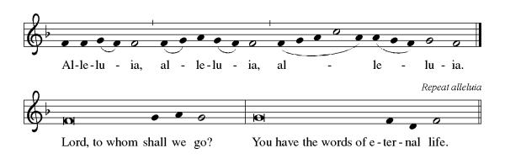
**Announcement of the Gospel
Glory to you, O Lord.

Gospel: John 20:1-18

¹Early in the morning on the first day of the week, while it was still dark, Mary of Magdala came to the tomb. She saw that the stone had been rolled away from the entrance, ²so she ran off to Simon Peter and the other disciple – the one Jesus loved – and told them, “The Rabbi has been taken from the tomb! We don’t know where they have put Jesus!”

³At that, Peter and the other disciple started out toward the tomb. ⁴They were running side by side, but then the other disciple outran Peter and reached the tomb first. ⁵He didn’t enter, but bent down to peer in and saw the linen wrappings on the ground. ⁶Then Simon Peter arrived and entered the tomb. He observed the linen wrappings on the ground, ⁷and saw the piece of cloth that had covered Jesus’ head lying not with the wrappings, but rolled up in a place by itself. ⁸Then the disciple who had arrived first at the tomb went in. He saw and believed. ⁹As yet, they didn’t understand the scripture that Jesus was to rise from the dead. ¹⁰Then the disciples went back to their homes.

¹¹Meanwhile, Mary stood weeping beside the tomb. Even as she wept, she stooped to peer inside, ¹²and there she saw two angels in dazzling robes. One was seated at the head and the other at the foot of the place where Jesus’ body had lain.

¹³They asked her, “why are you weeping?”

She answered them, “Because they have taken away my Rabbi, and I don’t know where they have put the body.”

¹⁴No sooner had she said this than she turned around and caught sight of Jesus standing there, but she didn’t know it was Jesus. ¹⁵He asked her, “Why are you weeping? For whom are you looking?”

She supposed it was the gardener, so she said, “Please, if you’re the one who carried Jesus away, tell me where you’ve laid the body and I will take it away.
¹⁶Jesus said to her, “Mary!”

She turned to him and said, “Rabboni!” – which means “Teacher.”

¹⁷Jesus then said, “Don’t hold on to me, for I have not yet ascended to Abba God. Rather, go to the others and tell them, ‘I’m ascending to my Abba and to your Abba, my God and your God!’”

¹⁸Mary of Magdala went to the disciples. “I have seen the Teacher!” she announced. Then she reported what the savior had said to her.

The gospel of the Lord.
Praise to you, O Christ.

Sermon: St. John Chrysostom’s Paschal Vigil Homily
Alleluia. Christ is risen!
Christ is risen indeed! Alleluia!

HYMN OF THE DAY The Strife is O’er ELW #366

**PRAYERS OF INTERCESSION
On this most holy night, God has acted. Raised with Christ, let us boldly offer our prayers for the whole people of God.

Your whole church rejoices, for Christ has risen! We rejoice with all the faithful around the world. Renew us all in our baptismal covenant and fill us with your Spirit. Risen Christ, in your mercy,
Hear our prayer.

All creation bears your image and sings your praise. Preserve the works of your hands - day and night, sea and land, plants and trees, birds, and every living creature. Inspire in us a renewed care for the world you have called very good. Risen Christ, in your mercy,
Hear our prayer.

You shatter tyranny and oppression and liberate your people from bondage. Rise up with might against tyrants and dictators. Grant wisdom to world leaders, that your reign of justice and freedom comes to all. Risen Christ, in your mercy,
Hear our prayer.

You break the chains of death and bring us up from the grave. Enter places of despair and breathe new life where hope wanes. Reconcile fractured relationships. Release us from all that ensnares us. Enliven our dry bones so we can live. Risen Christ, in your mercy,
Hear our prayer.

You give your people a heart of flesh in place of a heart of stone. Soften our hearts to the needs around us. Strengthen the ministries of care of this congregation and turn us outward to love and serve our neighbors. Risen Christ, in your mercy,
Hear our prayer.

We know that Christ is raised and dies no more. With thanksgiving, we lift our voices with the saints of every time and place around God’s eternal throne. Risen Christ, in your mercy,
Hear our prayer.

Rejoicing in the victory of Christ’s resurrection, we lift our prayers and praise to you, almighty and eternal God; through Jesus Christ, our risen Lord. Amen.

**PEACE
The peace of Christ be with you always.
And also with you.

**OFFERING IS BROUGHT FORWARD

**Offertory Response

Let Us Talents and Tongues Employ (Refrain Only) ELW#674

**OFFERING PRAYER
Let us pray.

Good and loving God, all you have created is good. Help us to be generous with that which you have first given us, so that we can respond to those who hunger in any way. As we gather now at your Table, prepare us to go out and proclaim Christ’s resurrection through what we say and do. Amen.

**GREAT THANKSGIVING

**PREFACE
As we celebrate Christ’s resurrection from the dead… raising our voices in this hymn of praise:

**HOLY, HOLY, HOLY
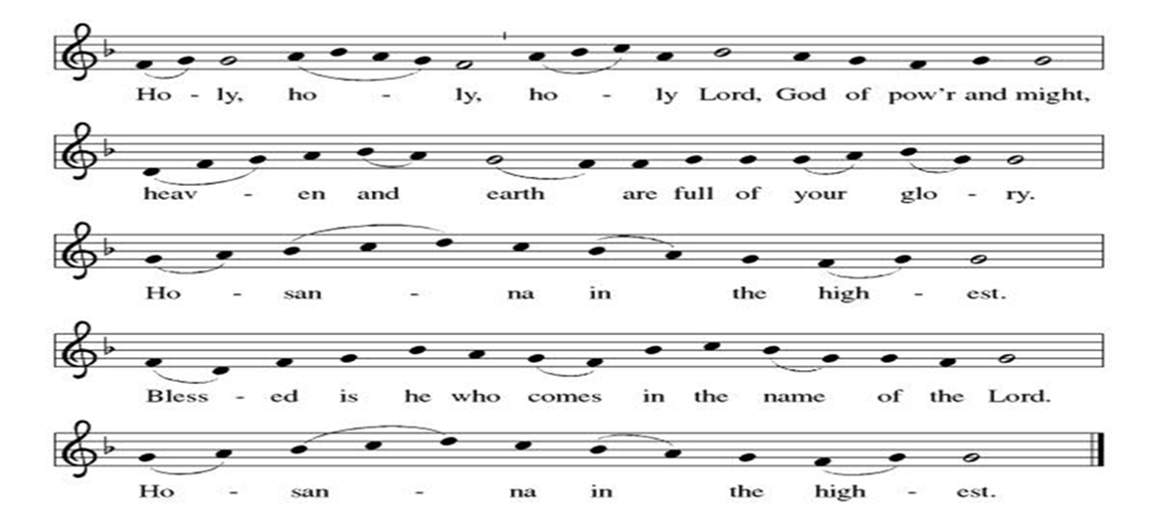
**THANKSGIVING AT THE TABLE

**LORD’S PRAYER
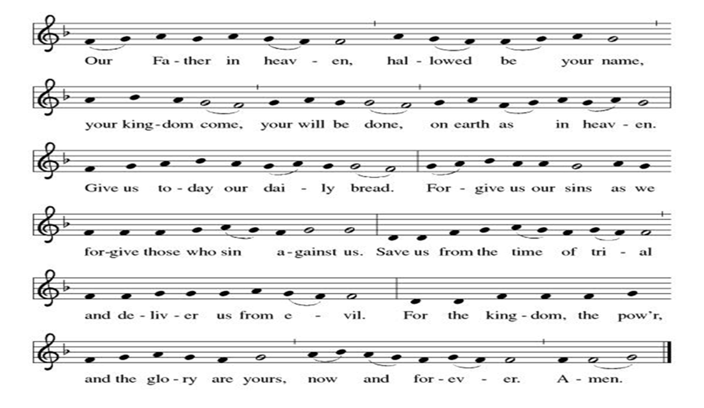
COMMUNION

COMMUNION HYMN At the Lamb’s High Feast (Vs. 1,2,6,7 ) ELW #362

**PRAYER AFTER COMMUNION

Let us pray.
Alleluia! We give you thanks, risen Lord, for your life-giving presence among us. You have fed and refreshed us with the healing gift of life. Now send us out to share the good news of the empty tomb, through all that we say and do. Amen! Alleluia!

**SONG AFTER COMMUNION Now Lord ELW #201

**BLESSING

CLOSING HYMN Hail Thee, Festival Day ELW #394

**DISMISSAL
Go in peace. Christ is with you.
Thanks be to God.

