All Saints Lutheran Church, ELCA
421 SW 19th St. Blue Springs, Missouri 64015 816-229-3633
Pastor Sarah Pierce Spierce.aslcpastor@gmail.com
allsaintslc64015@gmail.com https://aslcbs.org/

Sunday, September 20, 2026

Seventeenth Sunday after Pentecost

You are absolutely invited into this sacred space. We welcome all who are seeking God’s love and grace. All Saints recognizes that we are all unique and beloved children of God. We celebrate and give thanks for the many diverse gifts that God has given us. We affirm the sacredness of people of all sexual orientations, gender identities, and gender expressions. We affirm the sacredness of all those who have experienced exclusion because of race, ability, age, or culture. We are committed to working towards anti-racism in ourselves and our community. We affirm the sacredness of all those who wrestle with addiction, physical or mental health, imprisonment, socio-economic circumstances, or anything that too often divides us. We believe that through our openness we all grow in our faith through Christ’s teaching to love one another as God loves us. We need each other and our sincere hope is by being in community together, we will experience God’s presence in new and real ways.
The offering plate is by the main door to the sanctuary for your convenience.

We practice open communion at All Saints Lutheran Church. What does that mean? It means that if you believe and trust that Christ offers his body and blood For You, you are welcome at the table. At All Saints, we believe that Christ invites all people to the feast. “Come to the banquet for all is now ready.”

**Stand as you are comfortable
Note: Bold Print - Congregational Statements

Prelude
Announcements

** Confession and Forgiveness
God who created the heavens, the earth, and all that exists, sometimes we feel small when we
stand before you. But we trust that you see and hear us when we come before you.

Let us take a moment to draw near to God.

Holy God,
You always listen to us when we pray.
Forgive us when we forget to center our lives around you.
Forgive us when we turn away, distracted by other things that delight or distress us.
Forgive us when we sin against you, scorning the promises you have made to us.
Help us remember that you are always the solid foundation on which we stand.
Remind us, your children, to turn back to you.

Beloved children of God, the Spirit moves among us, bringing comfort and renewal. Our
Creator, the Source of all that is good and holy, is making all things new. And in Jesus, our
Savior +, we find the promise of forgiveness and mercy.
Amen.

**Entrance Hymn Lord, You Give the Great Commission ELW #579

**Greeting
The grace of our Lord Jesus Christ, the love of God,
and the communion of the Holy Spirit be with you all.
And also with you.

**Kyrie
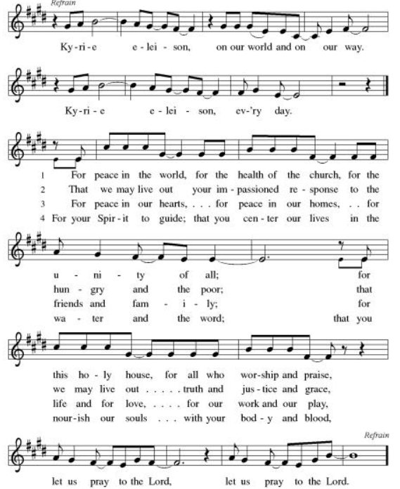

**Hymn of Praise: ELW Canticle of Praise: Glory to God (front of hymnal, pg. 185)

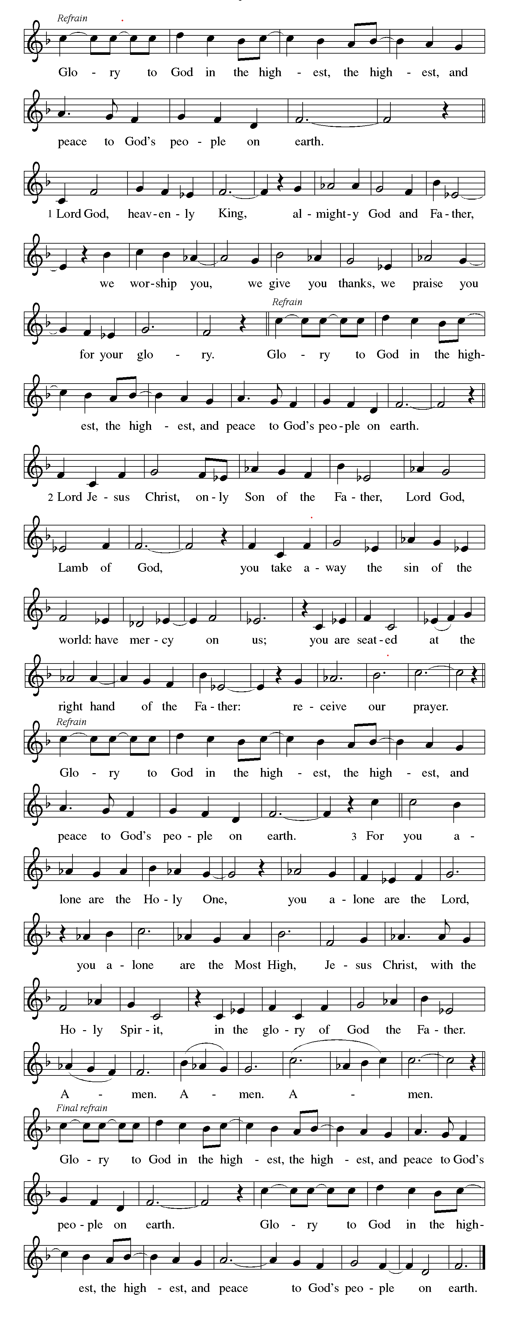

**Prayer of the Day

God, you call us to follow where you lead. Sometimes we know what path we are being called to follow; other times we do not. Empower us to faithfully answer your call. We pray this in Jesus' name. Amen.

Reading: Call of Abraham - Genesis 12:1-9

¹God said to Abram, “Leave your country, your people, and the home of your parents, and go to a place I will show you. ²I will make of you a great people. I will bless you and make your name so great that it will be used in blessings. ³I will bless those who bless you, and I will curse those who curse you. And all the people on the face of the earth will be blessed through you.”

⁴Abram, who was 75 years old when he left Haran, began the journey as God had instructed, and his nephew Lot went with them. ⁵Abram took Sarai, his spouse, Lot, all their possessions, and all the dependents they acquired in Haran, and set out for Canaan.

When they arrived in Canaan, ⁶Abram and his family traveled through the land until they arrived at the sacred place at Shechem and came to the oak grove of Moreh. The Canaanites occupied the land at that time.

⁷God appeared to Abram and said, “I will give this land to your descendants.” Abram built an altar where God appeared to him. ⁸Then they moved off toward the hill country east of Bethel and set up camp, with Bethel toward the sea and Ai to the east. Abram built an altar to God and invoked the Name of God.

⁹After that they traveled in stages to the Negev.

Word of God, Word of Life
Thanks be to God

**Gospel Acclamation
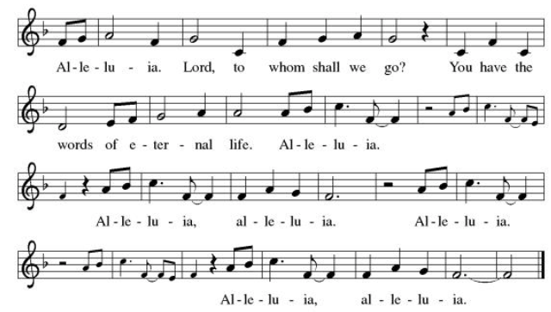

Announcement of the Gospel
Glory to you, O Lord.
Gospel: Matthew 28:19-20

²⁸[Jesus said,] “Go, therefore, and make disciples of all the nations. Baptize them in the name of Abba God, and of the Only Begotten, and of the Holy Spirit. ²⁰Teach them to carry out everything I have commanded you. And Know that I am with you always, even until the end of the world!”

The Gospel of the Lord.
Praise to you, O Christ.

Sermon “pending”, Carla Deubner

Hymn of the Day We Walk By Faith ELW #635

**Affirmation of Faith – Immigrant’s Creed by Jose Luis Casal

I believe in Almighty God, who guided the people in exile and in exodus, the God of Joseph in Egypt and Daniel in Babylon, the God of foreigners and immigrants.

I believe in Jesus Christ, a displaced Galilean, who was born away from his people and his home, who fled his country with his parents when his life was in danger. When he returned to his own country he suffered under the oppression of Pontius Pilate, the servant of a foreign power. Jesus was persecuted, beaten, tortured, and unjustly condemned to death. But on the third day Jesus rose from the dead, not as a scorned foreigner but to offer us citizenship in God’s kingdom.

I believe in the Holy Spirit, the eternal immigrant from God’s kingdom among us, who speaks all languages, lives in all countries, and reunites all races.

I believe that the Church is the secure home for foreigners and for all believers. I believe that the communion of saints begins when we embrace all God’s people in all their diversity. I believe in forgiveness, which makes us all equal before God, and in reconciliation, which heals our brokenness. I believe that in the Resurrection God will unite us as one people in which all are distinct and all are alike at the same time. I believe in life eternal, in which no one will be foreigner but all will be citizens of the kingdom where God reigns forever and ever. Amen.

**Prayers of Intercession

Holy God, our prayers rise to you like the wings of a dove. We call upon your name, and we ask that you hear us.
Reminded of God’s gracious and abundant love, we offer our prayers, confident that God hears us.
Hold your church accountable for our unwillingness to share your good news and our anger at your generosity to others. Nourish us by your grace to be witnesses to your love. Hear us, O God.
Your mercy is great.
Guide scientists and researchers studying responses to the climate crisis so that all your creation may inspire us to give thanks for your great goodness. Hear us, O God.
Your mercy is great.
Show employers the benefits of equal pay standards for all their employees. Reconcile conflicts between employees. Fill places of employment with camaraderie, and bring an end to employment disparity. Hear us, O God.
Your mercy is great.
Encourage any who cannot work or who cannot work a full day with the truth that their value comes from your everlasting love for them. Provide for those who are injured, ill, and for all in any need especially Monty & Marie, Paul, Helen, Linda, Kay, Becky H., Jim & Jan, Melian, Becky W., David, William & family, Judy, Peter & Carrie, Barbara & Donna, Brad & Chris, Drake, Bill & Sandy, Betsy and the people of Spokane, Washington, Hawaii, Indonesia, El Salvador, Honduras, Nicaragua, Nepal, and Tibet. Hear us, O God.
Your mercy is great.
Strengthen all those in this congregation whose labor serves the needs of others in the community. especially Inspire all in this congregation to support community endeavors with our time and talents. Hear us, O God.
Your mercy is great.
Pave a way to justice, drown the forces of oppression, bring peace on earth. Give leaders the will to turn from war and violence. Especially we pray for the people of Cuba, Venezuela, Iran, Sudan, Gaza, Israel, and Ukraine. When people must flee their homes, guide them to safety. Comfort those living with deep trauma, anxiety, or fear; all those who serve people in need, and accompany all those who care for people in harm’s way. We also lift up Jim’s grandson, Dylan, who is deployed, and Sharon’s great nephew, Taylor, who is serving in the military. Hear us, O God.
Your mercy is great.
Comfort us with the promise of the resurrection as we remember all our loved ones whose desire to be with Jesus is fulfilled. Hear us, O God.
Your mercy is great.
Grant the prayers we have offered, what we have forgotten to ask, and whatever else you see that we need. We ask this in Jesus’ name.
Amen.

Good and loving God, we give everyone we have prayed for into your care. Amen.

** Sharing of the Peace

**Offering is brought forward

** Offertory Response Take Oh, Take Me As I Am ELW #814
** Offertory Prayer

Good and loving God, everything that we have and everything that we are comes from you.
We respond in gratitude, offering up to you our gifts of our money, our time, and our
talents. We dedicate these gifts to your service. In Jesus’ name we pray, amen.

**LORD’S PRAYER
Our Father in heaven,
hallowed be your name,
your kingdom come,
your will be done,
on earth as in heaven.
Give us today our daily bread.
Forgive us our sins
as we forgive those
who sin against us.
Save us from the time of trial
and deliver us from evil.
For the kingdom, the power,
and the glory are yours,
now and forever. Amen.

** Sending Song Lord Jesus, You Shall Be My Song (verse 1) ELW #808

** Blessing

** Closing Hymn The Church of Christ, In Every Age ELW #729

**Dismissal

Go In Peace! Serve Your Neighbor!
THANKS BE TO GOD!

+ + + + + +

Setting 08 from the Evangelical Lutheran Worship are under copyright and used with permission under One License #733618-A. Specific copyright information as listed in bulletin, the Prayers of Intercession are under copyright and are used with permission under Augsburg Fortress Liturgy License #SB155933. All other liturgy written by Sarah Pierce.

Weekly Attendance
Week of September 13: 24

******************************************************************************************

Next Week:
18th Sunday after Pentecost:
Exodus 14:5-7, 10-14, 21-29; 15:20-21
Matthew 2:13-15

Calendar of Events

This Week
September 20 | Pastor’s vacation September 09-September 20th  God’s Work. Our Hands.

Upcoming Events

September 23 | Bell Practice 6:30 pm
September 27 | Celebration 5th year Anniversary of Pastor’s Ordination
September 30 | Bell Practice 6:30 pm
October 03 | Blessing of the Animals
October 04 | Wear Your Work-clothes to Church - Work Day
October 11 | Zoo after services
October 14 | Council Meeting 6:30 pm
October 25 | Reformation Sunday
November 01 | All Saints Sunday  Celebration of Gifts  Service for the Healing of the World
November 11 | Council Meeting 6:30 pm
November 15 | Congregational Meeting
November 25 | Thanksgiving Eve Service 7:00 pm  Pie Night
November 26 - 27 | Thanksgiving - Office Closed
December 6 | Advent Dinner after worship
December 19 | Council Meeting 6:30pm

SYNOD CONFIRMATION

As announced during the recent conference gatherings and synod assembly, the Central States Synod is putting together synod-wide confirmation. Details are in the works, but here are the basics. . .

  - Classes will run from September 3 through April 15. We will meet via Zoom from 6:30 – 7:45 pm on the 1st & 3rd Thursdays.
  - We will be on a two-year cycle. One year will be a Catechism year, and one will be a Bible year. We will be starting this fall with the Catechism year.
  - Anyone of any age can participate. (It's not just for students)
  - Each student will receive a Confirmation Kit containing items that will be used throughout the year.
  - There will be a weekly homework assignment.
  - Participants will be connected via GroupMe. Parents will need to give permission for this.
  - There will be some in-person retreats and/or camps offered along the way to connect in person with the other students.
  

As we prepare, we are hosting orientation meetings for parents, pastoral leaders, and students. We will talk about expectations, logistics, and answer your questions. If you are thinking of participating in the synod confirmation, please join us for one of two sessions, to be held on August 13 and August 20 at 6:30. Ask Pastor Sarah for the link or go to
https://www.css-elca.org/workshops#confirmation to register.

******************************************************************************************
BLUE SPRINGS COMMUNITY SERVICE LEAGUE is very appreciative of your continued support of your neighbor.

Birthdays
September 7 - Evie Soetmelk
September 23 – Phil Gross
September 24 – Gordon Wiltse

Altar Guild – n/a
Reader –
Greeter – Donna Taylor
Usher -
Tech – Gary Antes

Prayer Requests
Monty & Marie Health Concerns (March 04)
Paul Health Concerns (May 31)
Mary Health Concerns (May 15)
James & Family Health Concerns (September 11)
William and Family Health Concerns (September 25)
Becky H Health Concerns (October 28)
David Health Concerns (November 18)
Becky W Health Concerns (November 18)
Judy Health Issues (December 16)
Kay (Sara’s cousin) Health Concerns (July 15)
Sharon Health Concerns (October 22)
Michael Health Concerns (October 22)
Peter and Carrie Health Concerns (November 26)
Melian Health Concerns (November 16)
RJ Health Concerns (November 17)
Barbara Health Concerns (December 30)
Helen Health Concerns (February 25)
Chris Health Concerns (June 09)
Drake Issues (August 11)
Bill & Sandy Health Issues (August 12)
Betsy Surgery Sept. 17th (September 2)

Merciful God, your justice and mercy are without limits. Bring courage and resilience to those who resist tyranny with their words and their bodies. Strengthen those who fight for justice in your name across the country, and around the world.

Please pray for the people of Venezuela & Iran, Sudan, Gaza, Ukraine, Israel, Cuba, Iran and Palestine.
Please pray for the Homeless.
Please pray for legal & illegal immigrants & those seeking asylum or citizenship

