All Saints Lutheran Church, ELCA
421 SW 19th St. Blue Springs, Missouri 64015 816-229-3633
Pastor Sarah Pierce Spierce.aslcpastor@gmail.com
allsaintslc64015@gmail.com https://aslcbs.org/

Sunday, January 25, 2026

Third Sunday of Epiphany

You are absolutely invited into this sacred space. We welcome all who are seeking God’s love and grace. All Saints recognizes that we are all unique and beloved children of God. We celebrate and give thanks for the many diverse gifts that God has given us. We affirm the sacredness of people of all sexual orientations, gender identities, and gender expressions. We affirm the sacredness of all those who have experienced exclusion because of race, ability, age, or culture. We are committed to working towards anti-racism in ourselves and our community. We affirm the sacredness of all those who wrestle with addiction, physical or mental health, imprisonment, socio-economic circumstances, or anything that too often divides us. We believe that through our openness we all grow in our faith through Christ’s teaching to love one another as God loves us. We need each other and our sincere hope is by being in community together, we will experience God’s presence in new and real ways.

The offering plate is by the main door to the sanctuary for your convenience.

We practice open communion at All Saints Lutheran Church. What does that mean? It means that if you believe and trust that Christ offers his body and blood For You, you are welcome at the table. At All Saints, we believe that Christ invites all people to the feast. “Come to the banquet for all is now ready.”

**Stand as you are comfortable

Prelude

Announcements

** Affirmation of Baptism

God prepares a way for us, a path through the desert. In our baptisms, Jesus calls us to follow that path, and we receive the gift of the Holy Spirit, empowering us to answer Jesus’ call. But sometimes, we forget the gift of forgiveness and unending love that we have been given, and we need to be reminded.

Jesus, sometimes we forget to listen to your call. We forget about the power of our baptisms. Sometimes, we get distracted with other things and forget to place you first. We ask that you help us to turn back to you when we turn away. We ask you to help us recenter our lives on you, so that we remember the power of our baptisms. We pray that we can feel your presence in our lives.

We ask you to receive our prayers and to be with us, today and forever. We pray that your presence shines through us to those who most need to see it.
Let your light so shine before others that they may see your good work and glorify God in heaven.

Holy and loving God, we thank you for the gift of forgiveness. We thank you for the gift of your unconditional love.

Holy and loving Jesus, we thank you for the gift of the baptism which frees us from the power of sin and death, for all time. We thank you for showing us how to live in that freedom.

Holy and loving Spirit, we thank you for infusing us with your presence. Empower us to live out our baptismal call to proclaim Christ through word and deed, to care for others and for the world, and to work for justice and peace. Amen.

**Entrance Hymn Borning Cry ELW#732

**Greeting
The grace of our Lord Jesus Christ, the love of God,
and the communion of the Holy Spirit be with you all.
And also with you.

**Kyrie
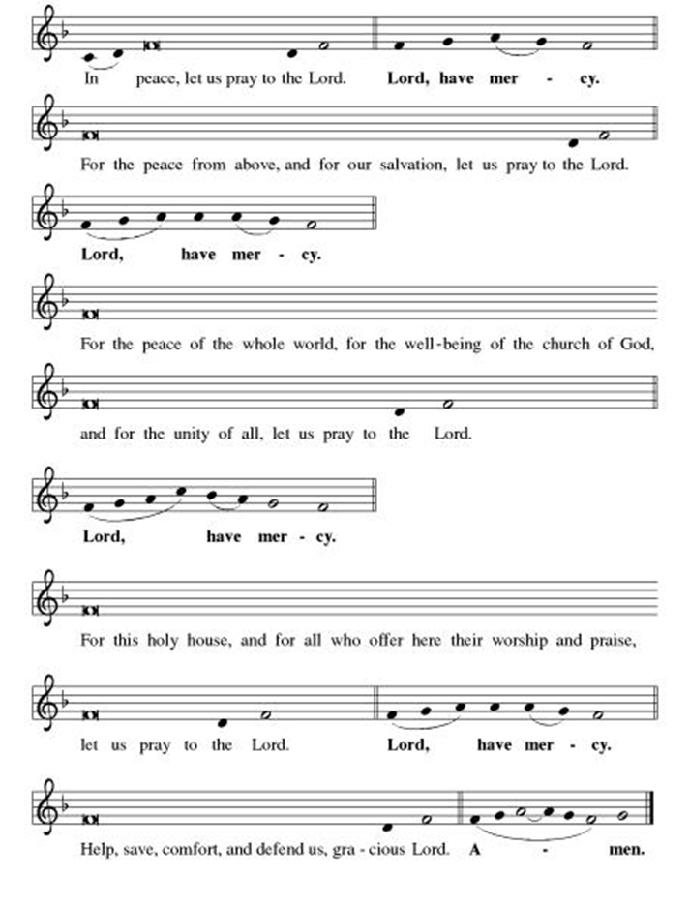
**This is the Feast
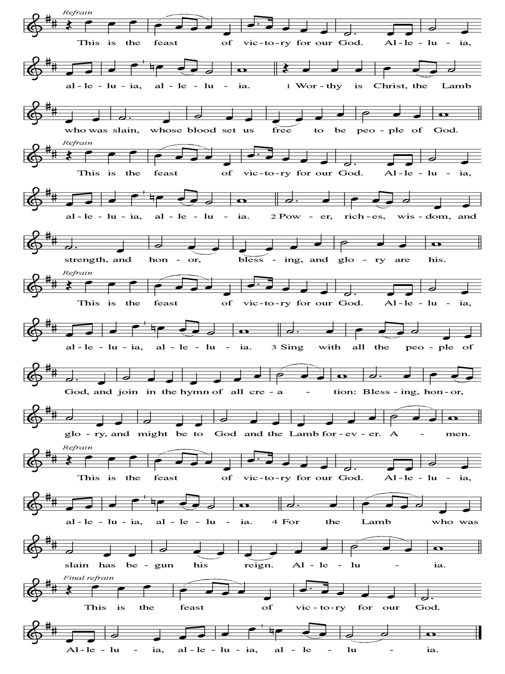
**Prayer of the Day
Loving God, you bring us to new life in our baptisms and inspire us with the Spirit. Empower us to do the work you call us to do: loving our neighbors and caring for those who are in need. We pray this in Jesus’ name. Amen.

Reading: Psalm 139:13-18

¹³You created my inmost being
and stitched me together in my mother’s womb.
¹⁴For all these mysteries I thank you—
for the wonder of myself,
for the wonder of your works—
my soul knows it well.
¹⁵My frame was not hidden from you
while I was being made in that secret place,
knitted together in the depths of the earth;
¹⁶your eyes saw my body even there.
All of my days
were written in your book,
all of them planned
before even the first of them came to be.
¹⁷How precious your thoughts are to me, O God!
How impossible to number them!
¹⁸I could no more count them
than I could count the sand.
But suppose I could?
You would still be with me!

The Word of God, Word of Life
Thanks be to God

**Gospel Acclamation

**Alleluia
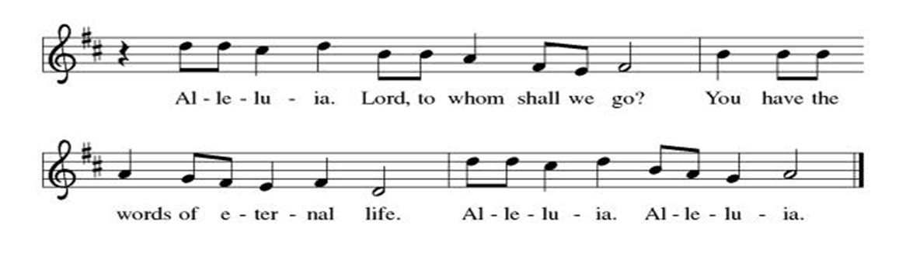
Announcement of the Gospel
Glory to you, O Lord.

Gospel: John 3:1-21

¹A certain Pharisee named Nicodemus, a member of the Sanhedrin, ²came to Jesus at night. “Rabbi,” he said, “we know you’re a teacher come from God, for no one can perform the signs and wonders you do, unless by the power of God.”

³Jesus gave Nicodemus this answer:
“The truth of the matter is,
unless one is born from above,
one cannot see the kingdom of God.”

⁴Nicodemus said, “How can an adult be born a second time? I can’t go back into my mother’s womb to be born again!”

⁵Jesus replied: “The truth of the matter is,
no one can enter God’s kingdom
without being born of water and the Spirit.
⁶What is born of the flesh is flesh;
what is born of the Spirit is Spirit.
⁷So don’t be surprised when I tell you that
you must be born from above.
⁸The wind blows where it will.
You hear the sound it makes,
but you don’t know where it comes from
or where it goes.
So it is with everyone
who is born of the Spirit.”

⁹“How can this be possible?” asked Nicodemus.

¹⁰Jesus replied, “You’re a teacher of Israel, and you still don’t understand these matters?

¹¹“The truth of the matter is,
we’re talking about what we know;
we’re testifying about what we’ve seen—
yet you don’t accept our testimony.
¹²If you don’t believe
when I tell you about earthly things,
how will you believe
when I tell you about heavenly things?
¹³No one has gone up to heaven
except the One who came down from heaven—
the Chosen One.
¹⁴As Moses lifted up the serpent in the desert,
so the Chosen One must be lifted up,
¹⁵so that everyone who believes in the Chosen One
might have eternal life.
¹⁶Yes, God so loved the world
as to give the Only Begotten One,
that whoever believes may not die,
but have eternal life.
¹⁷God sent the Only Begotten into the world
not to condemn the world,
but that through the Only Begotten
the world might be saved.
¹⁸Whoever believes in the Only Begotten avoids judgment,
but whoever doesn’t believe is judged already
for not believing in the name
of the Only Begotten of God.
¹⁹On these grounds is sentence pronounced:
that though the light came into the world,
people showed they preferred darkness to the light
because their deeds were evil.
²⁰Indeed, people who do wrong hate the light and avoid it,
for fear their actions will be exposed;
²¹but people who live by the truth
come out into the light,
so that it may be plainly seen
that what they do is done in God.”

The Gospel of the Lord.
Praise to you, O Christ.

Sermon Deacon Dave Mareske

Hymn of the Day The Church of Christ, in Every Age ELW#729

**Affirmation of Faith – Immigrant’s Creed by Jose Luis Casal

I believe in Almighty God, who guided the people in exile and in exodus, the God of Joseph in Egypt and Daniel in Babylon, the God of foreigners and immigrants.

I believe in Jesus Christ, a displaced Galilean, who was born away from his people and his home, who fled his country with his parents when his life was in danger. When he returned to his own country he suffered under the oppression of Pontius Pilate, the servant of a foreign power. Jesus was persecuted, beaten, tortured, and unjustly condemned to death. But on the third day Jesus rose from the dead, not as a scorned foreigner but to offer us citizenship in God’s kingdom.

I believe in the Holy Spirit, the eternal immigrant from God’s kingdom among us, who speaks all languages, lives in all countries, and reunites all races.

I believe that the Church is the secure home for foreigners and for all believers. I believe that the communion of saints begins when we embrace all God’s people in all their diversity. I believe in forgiveness, which makes us all equal before God, and in reconciliation, which heals our brokenness. I believe that in the Resurrection God will unite us as one people in which all are distinct and all are alike at the same time. I believe in life eternal, in which no one will be foreigner but all will be citizens of the kingdom where God reigns forever and ever. Amen.

**Prayers of Intercession

Jesus, you came to live with us on earth so that we would know you love us no matter what. Listen to the prayers we lift to you.

Holy One, you entrust the message of the cross and the mission of the gospel to the church in every land. Guide the newly baptized and deepen the faith of all who follow Christ. Merciful God,
receive our prayer.
Holy Creator, you lavish creation with splendor, and we praise you for the gift of life. Teach us to live as wise stewards, sharing the earth’s resources with all inhabitants of this garden planet. Merciful God,
receive our prayer.
Holy Judge, your power is love, and you judge the nations by the measure of Christ. Free any who are unjustly accused or wrongly condemned. We pray for those in authority. Merciful God,
receive our prayer.
Holy Lover, you care for vulnerable young children, frail elders, and any who are sick especially Monty, Paul, Linda, Betty F., Kay, Becky H., Jim & Jan, Melian, Becky W., David, William & family, Helen, Larry & Judy, Otto, Kevin, Peter & Carrie, Barbara & Donna, families in our community who endure hunger, and our beloved for whom death is near. We pray for all who are affected by natural disasters. Provide for their needs and relieve their suffering. Merciful God,
receive our prayer.
Holy Giver, you gather, forgive, and shape us as disciples of Christ. Nurture in us a spirit of patience and respect, that we may love one another as you love us. Merciful God,
receive our prayer.
Pave a way to justice, drown the forces of oppression, bring peace on earth. Give leaders the will to turn from war and violence. Especially we pray for the people of Venezuela, Sudan, Gaza, Israel, and Ukraine, and for Jim’s grandson Dylan, who is deployed. When people must flee their homes, guide them to safety. Comfort those living with deep trauma, anxiety, or fear; all those who serve people in need, and accompany all those who care for people in harm’s way. Merciful God,
receive our prayer.
We pray for people who rise up against injustice. Bring courage and resilience to those who resist tyranny with their words and their bodies. Strengthen those who fight for justice in your name across the country, and around the world. Protect and sustain immigrants and refugees and all who work with them, that your kingdom, without borders and without walls, may truly come on earth as it is in heaven. We pray for all victims of gun violence or kidnapping, especially those who are targeted out of hate or fear. Embolden us to holy outrage and empower us to speak our truth of love and justice. Merciful God,
receive our prayer.
We lift up all who teach and all who learn. Thank you for teachers who share their knowledge and wisdom. Bless the students in our midst. Especially we remember Evie, in kindergarten; Addison, in high school; and Tyler, Zach, Katie and Katy, in college. Bless Janet and Lisa as they teach. Merciful God,
receive our prayer.
Holy Savior, you free us from the power of death. Lead and guide us until we come at last into the communion of all your saints in light. Merciful God,
receive our prayer.

Loving God, because you lived among us, we know that you hear our prayers and hold close all for whom we pray. Amen

** Sharing of the Peace

**Offering is brought forward

** Offertory Response Let Us Talents and Tongues Employ (V. 1) ELW#674

**Offertory Prayer
God of abundance, with thanks, we return to you the gifts you have given us so freely. Bless these offerings of our time, our talents, and our treasure. Shape us to be your hands and feet. Use our gifts to shower each other, our communities, and the world with your loving kindness. All this we ask in Jesus’ name. Amen.

**Dialogue
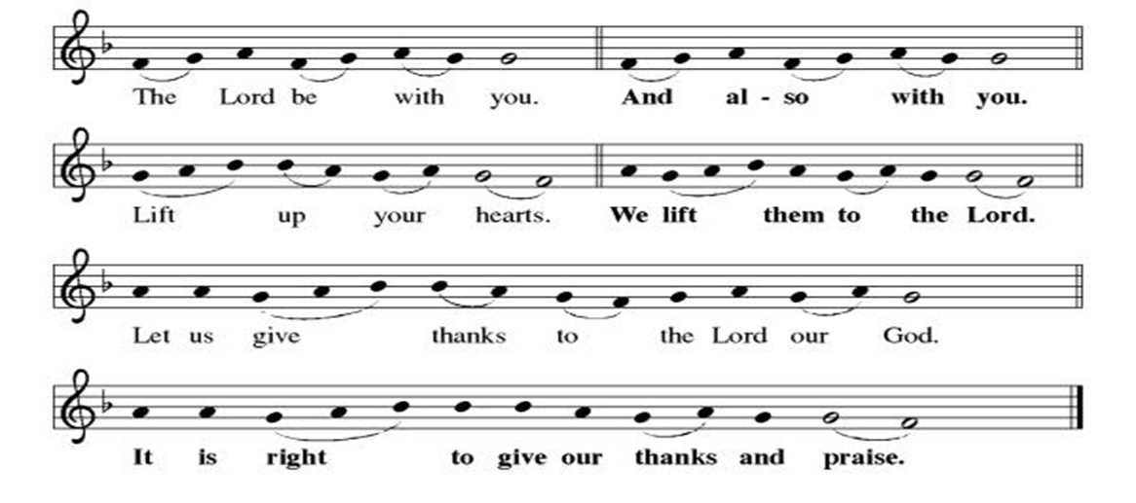

**Preface: From the beginning of time…this hymn of praise:

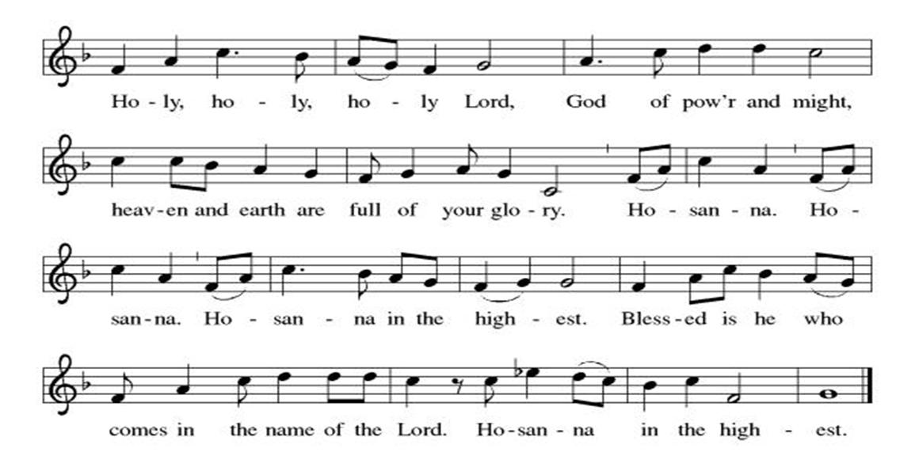
** Thanksgiving at the Table

**LORD’S PRAYER
Our Father in heaven,
hallowed be your name,
your kingdom come,
your will be done,
on earth as in heaven.
Give us today our daily bread.
Forgive us our sins
as we forgive those
who sin against us.
Save us from the time of trial
and deliver us from evil.
For the kingdom, the power,
and the glory are yours,
now and forever. Amen.

Invitation to Communion

Communion Hymn Here is Bread ELW #483

**Post-communion prayer

Holy One, Human and Divine, we give you thanks for the life-giving invitation to gather at your table and be fed. Strengthen us now for your service, and send us out from this place renewed in our commitment to love you and serve each other and all of creation. Send your Spirit upon us, so that we can proclaim your blessings to a world that hungers to receive them. All this we ask in your name, the one who is, who was, and who is to come. Amen.

**Sending Song

Listen, God Is Calling (refrain, V. 1, refrain) ELW#513

**Benediction

**Closing Hymn God Loved the World ELW#323

**Dismissal

Go in peace. Share the good news!
THANKS BE TO GOD!

+ + + + + +

Hymns from the Evangelical Lutheran Worship are under copyright and used with permission under One License #733618-A. ELW setting #3 the Prayers of Intercession are under copyright and are used with permission under Augsburg Fortress Liturgy License #SB155933. All other liturgy written by Sarah Pierce.

Weekly Attendance

Week of January 18
28

Next Week:
Fourth Sunday after Epiphany

The Color of the day is Green
Psalm 42 1-3
John 4:1-42

Calendar of Events
Today
- Dave Mareske Preaches
- Coffee with Council
Upcoming Week

February 04 | Paint Party Fundraiser
February 05 | Zoom Presentation: ELCA Social Statement
February 08 | Souper Bowl for CSL  Special Offering for Hollis
February 11 | Church Council Meeting 6:30 pm
February 12 | BSCT Bingo Event
February 15 | Pre-Lent Ice Cream Social after Church
February 18 | Ash Wednesday  God’s Global Barn yard begins February 18-April 05
February 22 | Coffee with Council
March 04 | Paint Party Fundraiser
March 15 | Church Council Meeting 6:30 pm
March 22 | Coffee with Council
March 25 | All Saints hosting Mid-Week Lenten Service
March 29 | Palm Sunday
April 01 | Paint Party Fundraiser
April 02 | Maundy Thursday
April 05 | Easter Sunday
April 06 | Church Council Meeting 6:30 pm
April 26 | Coffee with Council
May 06 | Paint Party Fundraiser
May 10 | Mother’s Day
May 13 | Church Council Meeting 6:30 pm
May 17 | Congregational Meeting
May 24 | Pentecost
May 25 | Memorial Day
June 03 | Paint Party Fundraiser
June 19 | Juneteenth Office Closed
July 01 | Paint Party Fundraiser
July 04 | Independence Day
July 26 | Coffee with Council  Celebrate Niel’s Birthday (July 28)
Note: 2006 paint party fundraisers: Feb. 4, March 4, April 1, May 6, June 3, July 1, Aug. 5, Sept. 2, Oct. 7, Nov. 4, Dec. 2
Note: Theater group church use: auditions Feb. 6&7, 6:30-9:30; callbacks Feb. 8, 1-5; rehearsals MWF & Saturday, Feb.16-April 18, MWF 6:30-9:30 and Saturdays 12-4.
**All Saints no longer has a source to reuse old greeting cards.
*****************************************************************************************
BLUE SPRINGS COMMUNITY SERVICE LEAGUE is very appreciative of your continued support of your neighbor.
*****************************************************************************************
The Central States Synod and Kansas Interfaith Action present “We the People: a virtual series on faith & public life”

- Thursday, February 05 6:30pm: “Diving Into the ELCA Social Statement on Faith and Civic Life” with Dr. Jim Brandt

We will join all of these sessions from the sanctuary via Zoom.

January 28
Altar Guild- Sara Meyers
Lector – Tonya Hamilton
Greeter – Donna Taylor
Tech – Gary Antes

Prayer Requests
Monty Health Concerns (May 15)
Paul Health Concerns (May 31)
Mary Health Concerns (May 15)
James & Family Health Concerns (September 11)
Betty F (Sara’s friend) Health Concerns (July 15)
William and Family Health Concerns (September 25)
Becky H Health Concerns (October 28)
David Health Concerns (November 18)
Becky W Health Concerns (November 18)
Larr & Judy Health Issues (December 16)
Helen Health Issues (January 14)
Otto Health Concerns (July 15)
Kay (Sara’s cousin) Health Concerns (July 15)
Kevin Health Concerns (October 01)
Fred Health Concerns (October 22)
Sharon Health Concerns (October 22)
Michael Health Concerns (October 22)
Peter and Carrie Health Concerns (November 26)
Melian Health Concerns (November 16)
RJ Health Concerns (November 17)
Barbara Health Concerns (December 30)

Merciful God, your justice and mercy are without limits. Bring courage and resilience to those who resist tyranny with their words and their bodies. Strengthen those who fight for justice in your name across the country, and around the world.

Please pray for the people of Venezuela, Sudan, Gaza, Ukraine, Israel, Iran and Palestine.
Please pray for the Homeless.
Please pray for legal & illegal immigrants & those seeking asylum or citizenship

