All Saints Lutheran Church, ELCA
421 SW 19th St. Blue Springs, Missouri 64015 816-229-3633
Pastor Sarah Pierce Spierce.aslcpastor@gmail.com
allsaintslc64015@gmail.com https://aslcbs.org/

Sunday, August 09, 2026

Eleventh Sunday after Pentecost

You are absolutely invited into this sacred space. We welcome all who are seeking God’s love and grace. All Saints recognizes that we are all unique and beloved children of God. We celebrate and give thanks for the many diverse gifts that God has given us. We affirm the sacredness of people of all sexual orientations, gender identities, and gender expressions. We affirm the sacredness of all those who have experienced exclusion because of race, ability, age, or culture. We are committed to working towards anti-racism in ourselves and our community. We affirm the sacredness of all those who wrestle with addiction, physical or mental health, imprisonment, socio-economic circumstances, or anything that too often divides us. We believe that through our openness we all grow in our faith through Christ’s teaching to love one another as God loves us. We need each other and our sincere hope is by being in community together, we will experience God’s presence in new and real ways.

The offering plate is by the main door to the sanctuary for your convenience.

We practice open communion at All Saints Lutheran Church. What does that mean? It means that if you believe and trust that Christ offers his body and blood For You, you are welcome at the table. At All Saints, we believe that Christ invites all people to the feast. “Come to the banquet for all is now ready.”

**Stand as you are comfortable

Note: Bold Print: Congregational Statements

Prelude

Announcements

Baptismal Sunday
August 02-Pam Meek
August 08-Pastor Sarah

** Confession and Forgiveness

The God that we worship is complex, multi-faceted, a single God made up of three Persons. When we try to understand the fullness of God, we fail. But God knows us and loves us and wants to be in relationship with us, so God is constantly finding new ways to be present with us. But sometimes, we fall short in our awareness. When that happens, we find that we have turned away from God to the idols of our own making.

Let us confess our sins together, as a community.

God of All the Cosmos,
Sometimes we try to make you small.
We try to put you in a box,
confine you to our way of understanding.
God, sometimes we misunderstand what you tell us.
Inspire us, Holy Spirit, to remember that you are beyond definition.
Help us to remember that you cannot be made small.
Help us to think deeply about who you are
and to respect and honor other people’s experiences of you.
Beloved in Christ, the God who walks beside you
is the same God who brings peace passing all understanding.
The Spirit who inspires your knowledge of the presence of God
is the same Spirit who moves over the waters of creation.
The Christ who hears your prayers
is the same Christ + who defeated death for the forgiveness of all sin, for all time.
Be at peace, for your sins are forgiven.

Amen.

**Entrance Hymn My Hope Is Built On Nothing Less ELW#597

**Greeting
The grace of our Lord Jesus Christ, the love of God,
and the communion of the Holy Spirit be with you all.
And also with you.

**Kyrie ELW 513
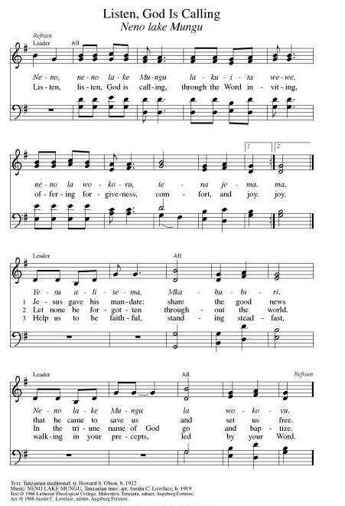
**Hymn of Praise ELW 866
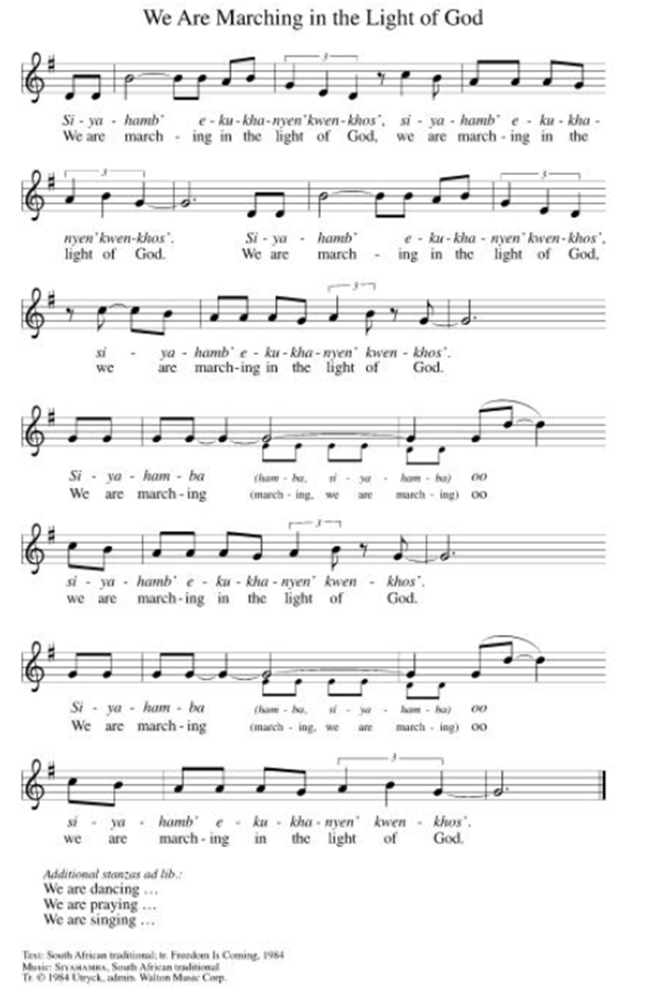

**Prayer of the Day
God, you have given us the gift of the Word that creates and saves us. You have given us the gift of words, which bind us together in community. When words are used to harm, help us to find words that reconcile us to each other. We pray this in Jesus’ name. Amen.

Reading: Psalm 34:1-10

¹I will bless my God always;
praise will continually be on my lips!
²My soul will boast about God –
let the oppressed hear it and be glad!
³Glorify God with me,
and let us exalt God’s Name together!
⁴I sought God, who answered me
and freed me from all my fears.
⁵Those who look to God are radiant,
and their faces are never covered with shame.
⁶The poor called out; God heard
and saved them from all their troubles.
⁷The angel of God encamps around those
who revere God, and rescues them.
⁸Taste and see how good God is!
Happiness comes to those who take refuge in God.
⁹Holy people of God, revere your God –
for those who stand in awe of God lack nothing.
¹⁰The young lion may grow weak and hungry,
but those who seek God will lack no good thing.

Word of God, Word of Life
Thanks be to God

**Gospel Acclamation ELW 519
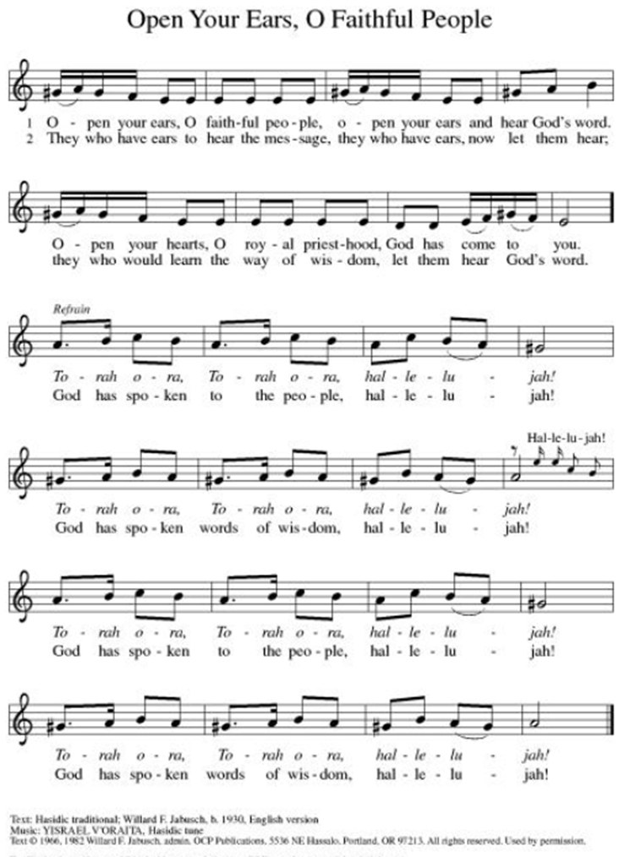
Announcement of the Gospel
Glory to you, O Lord.

Gospel: Matthew 18:15-20

¹⁵[Jesus said,] “If your sibling should commit some wrong against you, go and point out the error, but keep it between the two of you. If they listen to you, you have won a loved one back; ¹⁶if not, try again, but take one or two others with you, so that every case may stand on the word of two or three witnesses. ¹⁷If your sibling refuses to listen to them, refer the matter to the church. If they ignore even the church, then treat that sibling as you would a Gentile or a tax collector.

¹⁸“The truth is, whatever you declare bound on earth will be bound in heaven, and whatever you declare loosed on earth will be loosed in heaven.

¹⁹“Again I tell you, if two of you on earth join in agreement to pray for anything whatsoever, it will be granted you by my Abba God in heaven. ²⁰Where two or three are gathered in my name, I am there in their midst.”

The Gospel of the Lord.
Praise to you, O Christ.

Sermon

Hymn of the Day Draw Us in the Spirit’s Tether ELW#470

**Affirmation of Faith – Immigrant’s Creed by Jose Luis Casal

I believe in Almighty God, who guided the people in exile and in exodus, the God of Joseph in Egypt and Daniel in Babylon, the God of foreigners and immigrants.

I believe in Jesus Christ, a displaced Galilean, who was born away from his people and his home, who fled his country with his parents when his life was in danger. When he returned to his own country he suffered under the oppression of Pontius Pilate, the servant of a foreign power. Jesus was persecuted, beaten, tortured, and unjustly condemned to death. But on the third day Jesus rose from the dead, not as a scorned foreigner but to offer us citizenship in God’s kingdom.

I believe in the Holy Spirit, the eternal immigrant from God’s kingdom among us, who speaks all languages, lives in all countries, and reunites all races.

I believe that the Church is the secure home for foreigners and for all believers. I believe that the communion of saints begins when we embrace all God’s people in all their diversity. I believe in forgiveness, which makes us all equal before God, and in reconciliation, which heals our brokenness. I believe that in the Resurrection God will unite us as one people in which all are distinct and all are alike at the same time. I believe in life eternal, in which no one will be foreigner but all will be citizens of the kingdom where God reigns forever and ever. Amen.

Affirmation of Baptism

People of God, you have made a public profession of your faith. Do you intend to continue in the covenant God made with you in your baptism:
To live together as God’s faithful people with all the body of Christ;
To listen to the Word preached and taught, and to answer Jesus’ invitation to the Table;
To proclaim the good news: that in Christ, we are set free to love and serve our neighbor, through our words and our actions; To serve our neighbors in our community and around the world, striving always to follow Jesus’ example to the best of our abilities;
And to work for God’s justice and the peace that is beyond our understanding, throughout creation?

I do, and I ask God to help and guide me.

People of God, do you promise to support and pray for one another in your life in Christ?

We do, and we ask God to help and guide us.

Let us pray. Loving God, through water and the Holy Spirit you give us new birth, cleanse us from sin, and raise us to eternal life. Stir up in all your people the gift of your Holy Spirit: the spirit of wisdom and understanding, the spirit of counsel and strength, the spirit of knowledge and the reverence for our God, that we delight in your presence now and forever.
Amen.

**Prayers of Intercession

Holy God, our prayers rise to you like the wings of a dove. We call upon your name, and we ask that you hear us.

For believers around the world who stream to your holy mountain, that all be united in faith and harmony in the body of Christ. Let your church on earth be a witness to the beloved community of your heavenly kingdom. Merciful God,
receive our prayer.
For your wondrous creation, that it thrives and flourishes as you intend. Raise up wise stewards to defend the natural world against carelessness and destruction. Safeguard endangered species and their habitats. Merciful God,
receive our prayer.
For the nations of the world and all in authority, that they heed the cry of the outcast and ensure care for the most vulnerable. Give wisdom to leaders of countries, congregations, and communities, that they lead and serve justly. Merciful God,
receive our prayer.
For all who are lonely, grieving, or struggling with chronic pain, that they find comfort, community, and hope. Send relief to all who struggle with illness of any kind especially for Monty & Marie, Paul, Helen, Linda, Kay, Becky H., Jim & Jan, Melian, Becky W., David, William & family, Judy, Peter & Carrie, Barbara & Donna, Brad & Chris, and the people of Spokane, Washington. Merciful God,
receive our prayer.
For this congregation, for visitors and those new to this faith community, that all may recognize the presence of Christ in each new face. Draw this community together in love and strengthen it in unwavering faith. Merciful God,
receive our prayer.
Pave a way to justice, drown the forces of oppression, bring peace on earth. Give leaders the will to turn from war and violence. Especially we pray for the people of Cuba, Venezuela, Iran, Sudan, Gaza, Israel, and Ukraine. When people must flee their homes, guide them to safety. Comfort those living with deep trauma, anxiety, or fear; all those who serve people in need, and accompany all those who care for people in harm’s way. We also lift up Jim’s grandson, Dylan, who is deployed, and Sharon’s great nephew, Taylor, who is serving in the military. Merciful God,
receive our prayer.
We pray for people who rise up against injustice. Bring courage and resilience to those who resist tyranny with their words and their bodies. Strengthen those who fight for justice in your name across the country, and around the world. Protect and sustain immigrants and refugees and all who work with them, that your kingdom, without borders and without walls, may truly come on earth as it is in heaven. We pray for all victims of gun violence or kidnapping. Embolden us to holy outrage and empower us to speak our truth of love and justice. Merciful God,
receive our prayer.
For the saints before us whose work is done, that their faithful example continues to direct your church. May their witness remind us that your gifts and calling are irrevocable, whether in life or death. Merciful God,
receive our prayer.

Good and loving God, we give everyone we have prayed for into your care. Amen.

** Sharing of the Peace

**Offering is brought forward

** Offertory Response ELW486

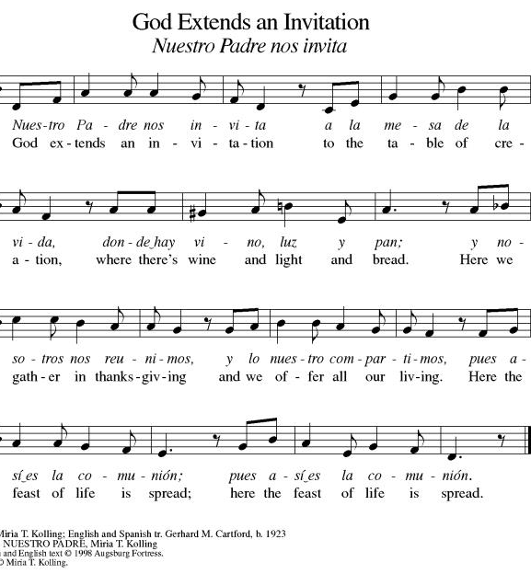

**Offertory Prayer
Jesus, all that we have and all that we are comes from you. Thank you for the gifts you have given us. Receive these gifts – our money, our service, our time – which we give in gratitude for all that we have received from you. Amen.

Dialogue
Christ is with you!
And also with you!
Lift up your hearts in joyful praise!
We lift them up to God in joy!

**Preface: We give thanks and praise to God...this hymn of praise:
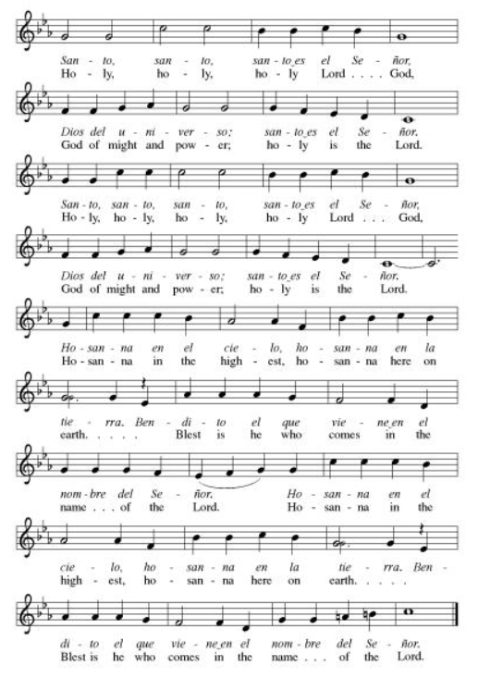
**Words of Institution

**LORD’S PRAYER
You are invited during this Pentecost season to pray whichever version feels most comfortable on your lips and in your soul. A separate sheet is available with alternate versions, should you be interested. Or, you are invited to use one of these:
Our Father in heaven, Our Father, who art in heaven,
hallowed be your name, hallowed be thy name,
your kingdom come, thy kingdom come,
your will be done, thy will be done,
on earth as in heaven. on earth as it is in heaven.
Give us today our daily bread. Give us this day our daily bread;
Forgive us our sins and forgive us our trespasses
as we forgive those as we forgive those
who sin against us. who trespass against us;
Save us from the time of trial and lead us not into temptation,
and deliver us from evil. but deliver us from evil.
For the kingdom, the power, For thine is the kingdom,
and the glory are yours, and the power, and the glory,
now and forever. Amen. forever and ever. Amen.

Invitation to Communion

Communion Hymn One Bread, One Body ELW#496

**Sending Song ELW 535

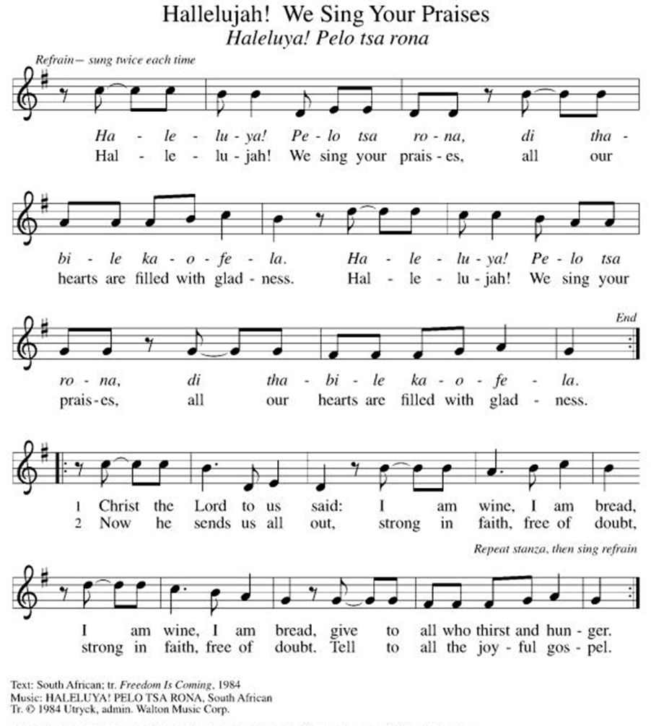

**Prayer After Communion
Holy God, you love us so much that you transformed an act of destruction into an act that gives new life. Thank you for the renewal we receive at your Table, as you send us out from this place into the world. Strengthen us for your service. In Jesus’ name we pray. Amen.

**Blessing

**Closing Hymn O God, Our Help in Ages Past ELW#632

**Dismissal
Empowered by the Spirit, may you go in peace to share the gospel!
THANKS BE TO GOD!

+ + + + + +

Setting 07 and hymns from the Evangelical Lutheran Worship are under copyright and used with permission under One License #733618-A. Specific copyright information as listed in bulletin, the Prayers of Intercession are under copyright and are used with permission under Augsburg Fortress Liturgy License #SB155933. All other liturgy written by Sarah Pierce.

Weekly Attendance
Week of August 02:
25
******************************************************************************************

Next Week:
12th Sunday after Pentecost:
Exodus 19:1-6; 20:1-2
Matthew 22:34-40

John 4:1-14
The color of the day is Green

Calendar of Events

Today
- Baptismal Sunday

This Week
August 11 | Creative Friends 1:00 pm

Upcoming Events

August 18 | Creative Friends 1:00 pm
August 19 | Council Meeting 6:30
August 20 | Newsletter Deadline
August 22 | Project Comfort 9:00 am-Noon
August 23 | Coffee with Council
August 25 | Creative Friends 1:00 pm
August 30 | Fifth Sunday Conversation
September 09 | Bell’s Practice 6:30 pm
September 13 | God’s Work. Our Hands.
September 23 | Council Meeting 6:30 pm
September 27 | Celebration 5th year Anniversary of Pastor’s Ordination
October 03 | Blessing of Animals
October 25 | Reformation Sunday
November 01 | Healing for World
November 25 | Pie Night 7:00 pm
November 26  November 27 | Thanksgiving - Office Closed

SYNOD CONFIRMATION

As announced during the recent conference gatherings and synod assembly, the Central States Synod is putting together synod-wide confirmation. Details are in the works, but here are the basics. . .

  - Classes will run from September 3 through April 15. We will meet via Zoom from 6:30 – 7:45 pm on the 1st & 3rd Thursdays.
  - We will be on a two-year cycle. One year will be a Catechism year, and one will be a Bible year. We will be starting this fall with the Catechism year.
  - Anyone of any age can participate. (It's not just for students)
  - Each student will receive a Confirmation Kit containing items that will be used throughout the year.
  - There will be a weekly homework assignment.
  - Participants will be connected via GroupMe. Parents will need to give permission for this.
  - There will be some in-person retreats and/or camps offered along the way to connect in person with the other students.
  

As we prepare, we are hosting orientation meetings for parents, pastoral leaders, and students. We will talk about expectations, logistics, and answer your questions. If you are thinking of participating in the synod confirmation, please join us for one of two sessions, to be held on August 13 and August 20 at 6:30. Ask Pastor Sarah for the link or go to
https://www.css-elca.org/workshops#confirmation to register.

******************************************************************************************

Pastor Sarah Questions:

Questions for Reflection and Discussion

- As I discuss in my sermon, this text is the standard for church discipline: verses 15-17 are even required to be in ELCA church constitutions in paragraph C.15.01, the first paragraph on church discipline. Bonhoeffer uses this text in part of his discussion on church discipline as well, in his book “Discipleship,” calling churches to use this structure. But as one commentator I read this week pointed out, that takes this text a little out of its context. What happens when we place it in between the parable of the lost sheep, in which the shepherd leaves the 99 to look for the one that has strayed, and Peter’s question about how many times he must forgive his sibling (7?), and Jesus’ reply (70 times 7)?
- The entirety of Matthew chapter 18 is basically a playbook on how to be the church: center the vulnerable and weak, don’t put roadblocks in people’s way to faith, try to bring people back into the fold when they wander away, this morning’s text, Peter and Jesus’ discussion about forgiveness, and the parable of the unforgiving servant, which Jesus uses to demonstrate God’s unrelenting focus on the importance of forgiveness.
- The practice in this text creates safeguards for both the offender (the one who sins against their sibling or their community) and the community. For the offender, it safeguards them against the embarrassment of having their sins brought to light if it’s not needed, as well as the hasty action of any sort of “mob mentality.” For the community, it provides a process to address serious issues that arise. This, I’m sure, is why it is included in the congregational constitution, although that drives eventually to what we need to do if we need to relieve someone of membership. The goal here is clearly reconciliation, as Jesus was focused on outreach to Gentiles and tax collectors.
- Binding and loosing: commentator Mark Allen Powell wrote in “Matthew: An Interpretation Bible Commentary” that “it is now widely recognized that the terms bind and loose were used in rabbinic interpretations of the law to designate whether or not a specific scriptural admonition was applicable for a given circumstance.” He goes on to cite examples such as whether the law forbidding work on the Sabbath applied to travel since travel is work (binding it), or whether it should be loosed regarding travel for certain circumstances (like to go to a sick person’s bedside to heal them, since healing the sick was allowed on the Sabbath). These were common discussions among the Pharisees around the time Matthew’s Gospel was being written, and so Matthew’s original audience would have understood this. Jesus is acting like a rabbi in this context.

******************************************************************************************
BLUE SPRINGS COMMUNITY SERVICE LEAGUE is very appreciative of your continued support of your neighbor.
Birthdays
August 09-Matthew Girkin
August 11-Heather Antes
August 14-Donna Taylor

August 09
Altar Guild – Sara Meyers
Reader – Tonya Namilton
Greeter – Donna Taylor
Usher-Paul Blixrud
Tech – Gary Antes

Prayer Requests
Monty & Marie Health Concerns (March 04)
Paul Health Concerns (May 31)
Mary Health Concerns (May 15)
James & Family Health Concerns (September 11)
Betty F (Sara’s friend) Health Concerns (July 15)
William and Family Health Concerns (September 25)
Becky H Health Concerns (October 28)
David Health Concerns (November 18)
Becky W Health Concerns (November 18)
Judy Health Issues (December 16)
Kay (Sara’s cousin) Health Concerns (July 15)
Sharon Health Concerns (October 22)
Michael Health Concerns (October 22)
Peter and Carrie Health Concerns (November 26)
Melian Health Concerns (November 16)
RJ Health Concerns (November 17)
Barbara Health Concerns (December 30)
Helen Health Concerns (February 25)
Val (Tonya’s sister) Health Concerns (February 18)
Chris Health Concerns (June 09)

Merciful God, your justice and mercy are without limits. Bring courage and resilience to those who resist tyranny with their words and their bodies. Strengthen those who fight for justice in your name across the country, and around the world.

Please pray for the people of Venezuela & Iran, Sudan, Gaza, Ukraine, Israel, Cuba, Iran and Palestine.
Please pray for the Homeless.
Please pray for legal & illegal immigrants & those seeking asylum or citizenship

