**All Saints Lutheran Church, ELCA**

**421 SW 19th St. Blue Springs, Missouri 64015 816-229-3633**

**Pastor Sarah Pierce** Spierce.aslcpastor@gmail.com

[allsaintslc64015@gmail.com](mailto:allsaintslc64015@gmail.com) <https://aslcbs.org/>

## Sunday, June 29, 2025

## Third Sunday after Pentecost

## *You are absolutely invited into this sacred space.  We welcome all who are seeking God’s love and grace.  All Saints recognizes that we are all unique and beloved children of God.  We celebrate and give thanks for the many diverse gifts that God has given us.  We affirm the sacredness of people of all sexual orientations, gender identities, and gender expressions.  We affirm the sacredness of all those who have experienced exclusion because of race, ability, age, or culture. We are committed to working towards anti-racism in ourselves and our community. We affirm the sacredness of all those who wrestle with addiction, physical or mental health, imprisonment, socio-economic circumstances, or anything that too often divides us.  We believe that through our openness we all grow in our faith through Christ’s teaching to love one another as God loves us.  We need each other and our sincere hope is by being in community together, we will experience God’s presence in new and real ways.*

*The offering plate is by the main door to the sanctuary for your convenience.*

*We practice open communion at All Saints Lutheran Church. What does that mean? It means that if you believe and trust that Christ offers his body and blood For You, you are welcome at the table. At All Saints, we believe that Christ invites all people to the feast. “Come to the banquet for all is now ready.”*

***\*\*Stand as you are comfortable***

***Prelude***

***Announcements***

**\*\* Confession and Forgiveness**

Siblings in Christ, as we gather in this place, let us confess our sins together in the ancient words of the people:

**O God, have mercy on me!**

**Because of your love and your great compassion, wipe away my faults;**

**wash me clean of my guilt;**

**purify me of my sin.**

**For I am aware of my faults,**

**and have my sin constantly in mind.**

**I sinned against you alone,**

**and did what is evil in your sight.**

**You are just when you pass sentence on me,**

**blameless when you give judgment.**

**I was born in sin, conceived in sin -**

**yet you want truth to live in my innermost being.**

**Teach me your wisdom!**

**Bless God, my soul!**

**All that is in me, bless God’s holy name!**

**Bless God, my soul,**

**and remember all God’s kindness!**

The One who forgives all your sins is the One who heals all your disease;

the One + who ransoms your life from the Pit is the One who crowns you with love and tenderness.

God’s love lasts from age to age for those who revere them,

as does God’s goodness to our children’s children,

and to those who cling to the faith of Christ.

**Amen.**

***\*\*Entrance Hymn* We Pray for Peace (Tune: FINLANDIA “Be Still, My Soul”)**

**We pray for peace, O God of love and justice,**

**as once again, we face a time of war.**

**The meek and humble try – amid the crisis –**

**to love and build, to nurture and restore.**

**May leaders hear the truth the prophets teach us –**

**that gifts of peace are well worth struggling for.**

**We pray for peace, O Christ who calmed the waters –**

**who stilled the storm, who stilled disciples’ fears.**

**You spoke with love and with amazing power;**

**be with us now when trouble is so near.**

**May leaders see the miracle you offer –**

**that words and deeds can calm the nations here.**

**We pray for peace, O Spirit here among us;**

**your love emboldens, judges and restrains.**

**Take any hate and acts of impulse from us;**

**make leaders wise, amid competing claims.**

**May we seek peace, O God of love and justice;**

**may love and mercy be our highest aims.**

*Copyright 2022 by Carolyn Winfrey Gillette. All Rights reserved. Permission is given for free use of this hymn, including online.*

***\*\*Greeting***

The grace of our Lord Jesus Christ, the love of God,

and the communion of the Holy Spirit be with you all.

**And also with you.**

**\*\*Kyrie**

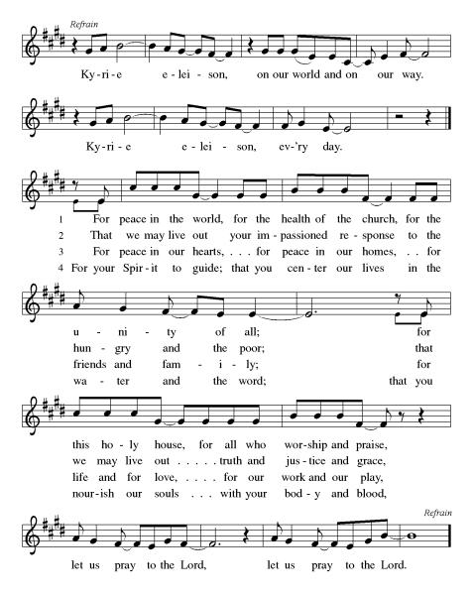

***\*\*Prayer of the Day***

**Holy and eternal God, you know what we need, even before we say it. And yet you call us to worship you and to pray. Use our worship and our prayer to strengthen us for your service, and to keep our faith healthy and alive. In Jesus’ name we pray. Amen.**

***Reading:*** **Leviticus 9:1-11, 22-24**

1On the eighth day, Moses summoned Aaron and his heirs and the clan leaders of Israel, 2and said, “Take a young, unblemished calf as a purification offering, and an unblemished ram for a burnt offering, and present them to God. 3Then tell the Israelites to take a male goat for a purification offering, and a yearling calf and a yearling lamb, both unblemished, for a burnt offering, 4and an ox and a ram for a fellowship sacrifice to be offered to God, together with a grain offering mixed with oil. For today God will appear to you!”

5They brought what Moses had commanded to the front of the Tent of Meeting, and the whole community gathered and stood before God. 6Moses said, “God commanded these things so that God’s glory might appear to you.”

7Then Moses said to Aaron, “Approach the altar and sacrifice your purification offering and your burnt offering, to make atonement for yourself and for the people. Then sacrifice the offerings of the people, to make atonement for them, as God commands.”

8Aaron approached the altar and slaughtered the calf as the purification offering of the high priest. 9Aaron’s heirs presented the blood to Aaron, who dipped a finger in the blood and put it on the horns of the altar; the remainder he poured out at the base of the altar. 10Aaron burned on the altar the fat, the kidneys, and the covering of the liver from the purification offering, as God had commanded Moses. 11But he burned the meat and the skin outside the camp.

22Aaron raised his hands toward the people to bless them, and when the purification offering, the burnt offering and the communal offering had been sacrificed, he stepped down 23and entered the tent of meeting with Moses. When they came out, they blessed the congregation, and the glory of God appeared before all the people. 24A tongue of flame shot out from the presence of God and consumed the burnt offering and the fat on the altar. And when all the people witnessed this, they shouted for joy and fell on their faces.

Word of God, Word of Life

**Thanks be to God**

***\*\*Gospel Acclamation***

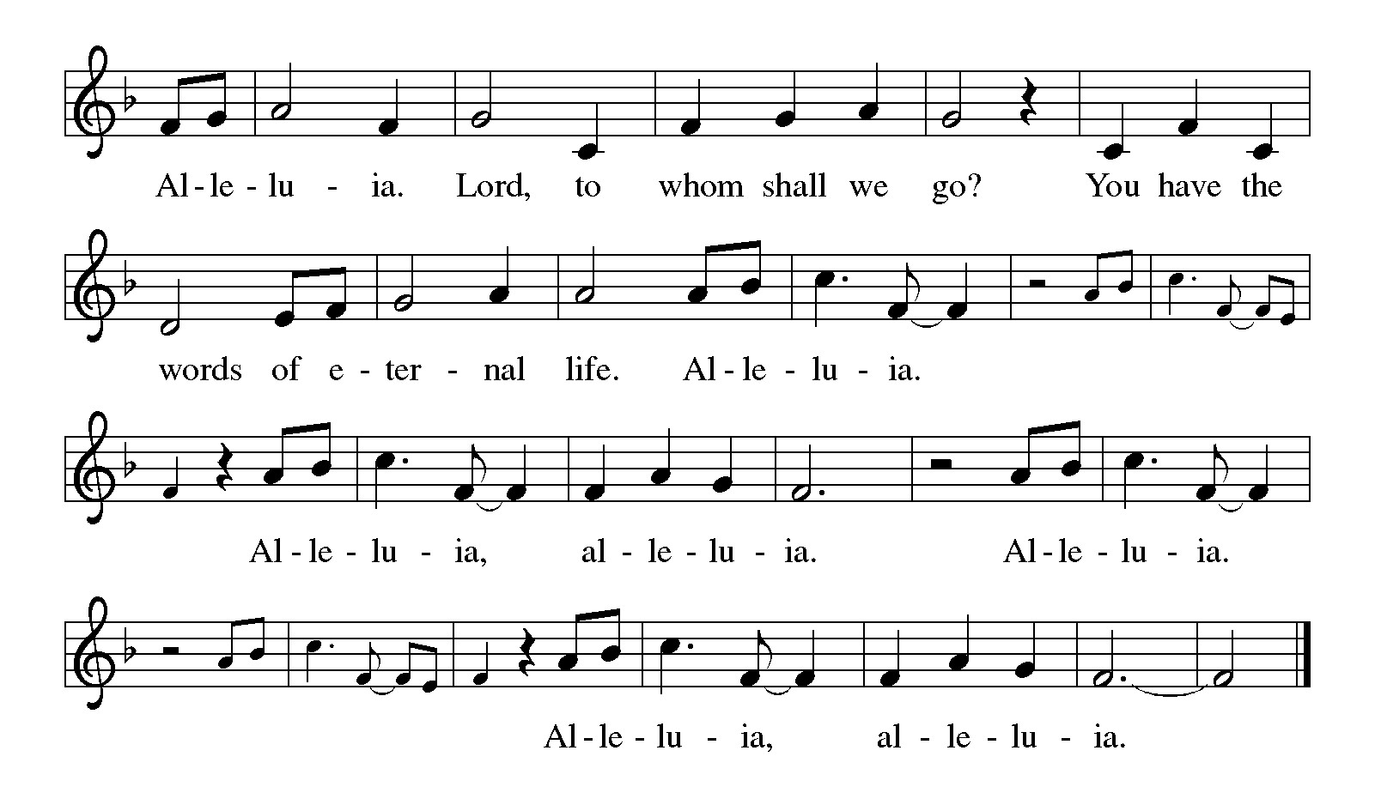

*Announcement of the Gospel*

**Glory to you, O Lord.**

***Gospel:* Matthew 6:7-15**

7[Jesus said,] “And when you pray, don’t babble like the Gentiles. They think God will hear them if they use a lot of words. 8Don’t imitate them. Your God knows what you need before you ask for it. 9This is how you are to pray:

‘Abba God in heaven,

hallowed be your name!

10May your reign come;

may your will be done on earth as it is in heaven:

11give us today

the bread of Tomorrow.

12And forgive us our debts,

as we hereby forgive those

who are indebted to us.

13Don’t put us to the test,

but free us from evil.’

14 “If you forgive the faults of others, Abba God will forgive you yours. 15If you don’t forgive others, neither will Abba God forgive you.

The Gospel of the Lord.

**Praise to you, O Christ.**

**Sermon "Fifth Sunday Conversation: Worship"**

***Hymn of the Day* What a Friend We Have in Jesus ELW#742**

\*\***Affirmation of Faith – Immigrant’s Creed by Jose Luis Casal**

**I believe in Almighty God, who guided the people in exile and in exodus, the God of Joseph in Egypt and Daniel in Babylon, the God of foreigners and immigrants.**

**I believe in Jesus Christ, a displaced Galilean, who was born away from his people and his home, who fled his country with his parents when his life was in danger. When he returned to his own country he suffered under the oppression of Pontius Pilate, the servant of a foreign power. Jesus was persecuted, beaten, tortured, and unjustly condemned to death. But on the third day Jesus rose from the dead, not as a scorned foreigner but to offer us citizenship in God’s kingdom.**

**I believe in the Holy Spirit, the eternal immigrant from God’s kingdom among us, who speaks all languages, lives in all countries, and reunites all races.**

**I believe that the Church is the secure home for foreigners and for all believers. I believe that the communion of saints begins when we embrace all God’s people in all their diversity. I believe in forgiveness, which makes us all equal before God, and in reconciliation, which heals our brokenness. I believe that in the Resurrection God will unite us as one people in which all are distinct and all are alike at the same time. I believe in life eternal, in which no one will be foreigner but all will be citizens of the kingdom where God reigns forever and ever. Amen.**

***\*\*Prayers of Intercession***

**God of Love, hear the prayers that we lift before you. Hold close to you all those for whom we pray.**

Guide your church, O God. Anoint us for service and make us messengers of your peace. Emboldened by the witness of Christians throughout history, send us to proclaim your reign come near. God of grace,

**hear our prayer.**

Protect this world, O God. Watch over fields and fruit trees, foxes and birds, the pleasant land beneath us and the sun and moon above. Keep us mindful of the rich inheritance you have given us in the natural world. God of grace,

**hear our prayer.**

Counsel our leaders, O God. Make them steadfast in seeking justice and unable to be shaken as they pursue peace. Lead them by your Spirit to listen and respond to the people they govern. God of grace,

**hear our prayer.**

Uphold all who suffer, O God. Give refuge to those of us who know rejection, and shelter to those of us who have nowhere to lay our heads. Bring any who are sick into your healing presence especially Monty, Paul, Linda, Betty F, Carla, Becky H., Becky W., David, William and family, Helen, Larry, Stephen, Jennifer, Otto, families in our community who endure hunger, and our beloved for whom death is near. Embrace all who are far from home or estranged from loved ones, and all who live with regret. Embolden your people to offer and to seek forgiveness. May all who weep now sing songs of joy again. Wipe away every tear. Lift up all who have been bowed low by circumstances or internal strife. Bring to wholeness those who cry out to you in need. Give perseverance to each of us living with mental illness, and shield us from discrimination due to race, class, gender, or any other human distinction. Give all your fullness of joy. God of grace,

**hear our prayer.**

Set free this assembly, O God. Grow your Spirit’s fruits within us and within our congregation’s ministries. Set our faces always on you, that we might live in the freedom to which you have called us. God of grace,

**hear our prayer.**

We pray for the nations. Pave a way to justice, drown the forces of oppression, bring peace on earth. Give leaders the will to turn from war and violence. Especially we pray for the people of Gaza, Israel, Iran, and Ukraine. When people must flee their homes, guide them to safety. Comfort those living with deep trauma, anxiety, or fear; all those who serve people in need, and accompany all those who care in harm’s way.

God of grace,

**hear our prayer.**

We pray for people who rise up against injustice. Bring courage and resilience to those who resist tyranny with their words and their bodies. Strengthen those who fight for justice in your name in Los Angeles, across the country, and around the world. Protect and sustain immigrants and refugees and all who work with them, that your kingdom, without borders and without walls, may truly come on earth as it is in heaven. We pray for all victims of gun violence, especially those who are targeted out of hate or fear. Comfort and sustain Minnesota Senator John and Yvette Hoffman, the victim at the Salt Lake City protest, and the family of the Minnesota Representative Melissa and Mark Hortman, especially their children. Embolden us to holy outrage and empower us to speak our truth of love and justice, God of grace,

**Your mercy is great.**

**Good and loving God, we give everyone we have prayed for into your care. Amen.**

*\*\** ***Sharing of the Peace***

### *\*\*Offering is brought forward*

### *\*\** *Offertory Response*

**Create in Me ELW#186**

### *\*\*Offertory Prayer*

**Holy God, we return to you with thanks the first fruits of what you have given us: our time, our talents and interests, and our money. Use these gifts to your service and for your ministry in this place. We pray this in Jesus’ name. Amen.**

**Dialogue**

Thank you God, for you are good!

**Your love is everlasting!**

You alone perform such great marvels.

**Your love is everlasting!**

Your wisdom made the heavens.

**Your love is everlasting!**

You spread the land out over the waters.

**Your love is everlasting!**

You made the great lights:

**Your love is everlasting!**

The sun to govern the day, moon and stars to govern the night.

**Your love is everlasting!**

**\*\*Preface:** Since the earliest days of the covenant…this hymn of praise:

**\*\*Holy, Holy, Holy**

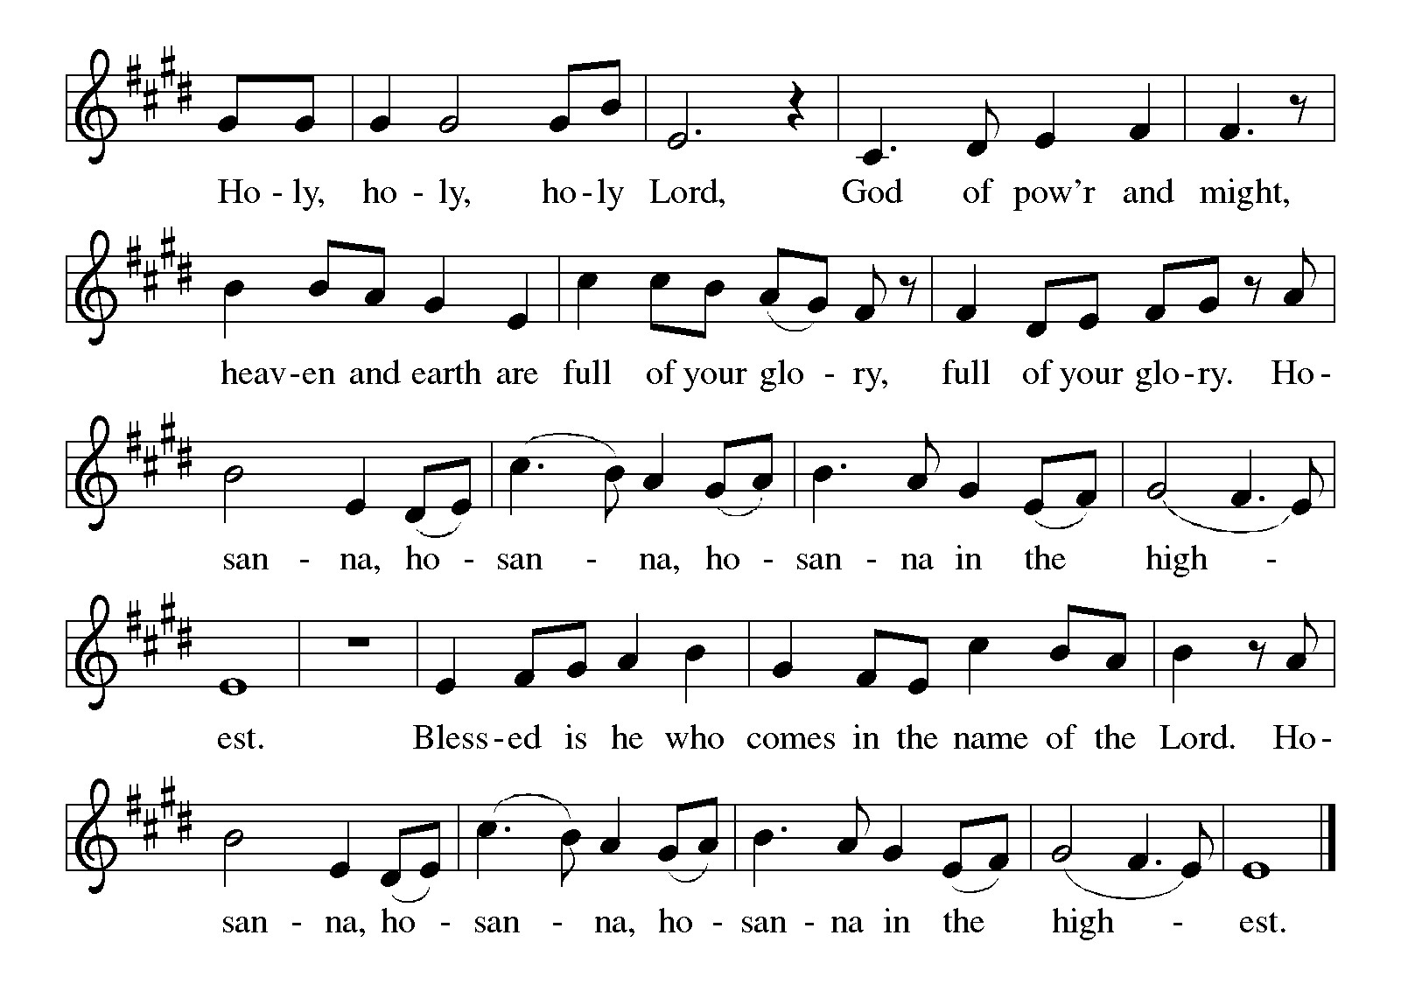

***\*\*Words of Institution***

**\*\*LORD’S PRAYER**

**Our Father, who art in heaven,**

**hallowed be thy name,**

**thy kingdom come,**

**thy will be done,**

**on earth as it is in heaven.**

**Give us this day our daily bread;**

**and forgive us our trespasses,**

**as we forgive those**

**who trespass against us;**

**and lead us not into temptation,**

**but deliver us from evil.**

**For thine is the kingdom,**

**and the power, and the glory,**

**forever and ever. Amen.**

***Invitation to Communion***

# ***Communion Hymn The King of Love My Shepherd Is ELW#502***

### *\*\*Sending Song*

### *Praise to you, O God of Mercy ELW#208*

### *\*\*Prayer After Communion*

**Grafted onto the tree of faith and grounded in our baptisms, we have been fed by the Word and at the Table. Now send us out to share the joy of Christ with all whom we encounter. Amen.**

### *\*\*Blessing*

### *\*\*Closing Hymn Blessed Assurance ELW#*638

### 

### *\*\*Dismissal*

Go in peace to serve Christ and the world!

**THANKS BE TO GOD!**

### + + + + + +

*Setting 8 liturgy are under copyright and used with permission under One License #733618-A. Specific copyright information as listed in bulletin, the Prayers of Intercession are under copyright and are used with permission under Augsburg Fortress Liturgy License #SB155933. All other liturgy written by Sarah Pierce.*

*Confession and Forgiveness based on Psalm 51:1-6 and Psalm 103:104, 17-18 (adapted). Dialog based on Psalm 136:1, 4-8. Thanksgiving based on Psalm 100 (adapted). Benediction based on 1 Thessalonians 5:16-24 (adapted).*

**Weekly Attendance**

***Week of June 22***

***20***

*\*\*\*\*\*\*\*\*\*\*\*\*\*\*\*\*\*\*\*\*\*\*\*\*\*\*\*\*\*\*\*\*\*\*\*\*\*\*\*\*\*\*\*\*\*\*\*\*\*\*\*\*\*\*\*\*\*\*\*\*\*\*\*\*\*\*\*\*\*\*\*\*\*\*\*\*\*\*\*\*\*\*\*\*\*\*\*\*\*\**

**Calendar of Events**

***Today***

* ***Adult Bible Study***
* ***Fifth Sunday of Conversation***

***This Week***

|  |  |
| --- | --- |
| ***July 01*** | ***Creative Friends 1:00 pm*** |
| ***July 04*** | ***Independence Day-Office Closed*** |

***Upcoming Events***

|  |  |
| --- | --- |
| ***July 06*** | ***Blessing of CSL Contributions*** |
| ***July 08*** | ***Creative Friends 1:00 pm*** |
| ***July 13*** | ***Baptismal Birthdays*** |
| ***July 13*** | ***Installation of Church Council/Ice Cream Social after Worship/Photo OP*** |
| ***July 15*** | ***Creative Friends 1:00 pm*** |
| ***July 16*** | ***Council Meeting 6:30 pm*** |
| ***July 27*** | ***Coffee with Council*** |
| ***August 09*** | ***BS Back to School Bingo 1:00 p -3:00 pm*** |
| ***August 13*** | ***Council Meeting 6:30 pm*** |
| ***September 07*** | ***God’s Work. Our Hands*** |
| ***September 14*** | ***Council Meeting 6:30 pm after Worship*** |
| ***October 04*** | ***Blessing of Animals TBA*** |

****************************************************************************************

The book of Leviticus has kind of a bad reputation. We often think of it as being excessively rules-based, really strict, with regulations that don’t really apply to us any longer in our modern world. So much so that it seems like Leviticus has two purposes in modern Christianity – either to be ignored and set aside, or to have verses pulled out of context to be used to condemn others. But neither of those are a fair treatment of Leviticus. When we dive into it, we discover a text that we can wrestle with and learn from. A text that has much to teach us about faithfulness to God and to each other.

We will be exploring this book in a **7-part sermon series** this summer, starting on **Holy Trinity Sunday.**

* **June 29: Worship (5th Sunday Conversation)**
* **July 06: Purification**
* **July 13: Holiness Code part 1**
* **July 20: Holiness Code part 2**
* **July 27: Sabbath/Conclusion**

**\*\*\*\*\*\*\*\*\*\*\*\*\*\*\*\*\*\*\*\*\*\*\*\*\*\*\*\*\*\*\*\*\*\*\*\*\*\*\*\*\*\*\*\*\*\*\*\*\*\*\*\*\*\*\*\*\*\*\*\*\*\*\*\*\*\*\*\*\*\*\*\*\*\*\***

**“The New Colossus” by Emma Lazarus (1849-1887)**

Not like the brazen giant of Greek fame,  
With conquering limbs astride from land to land;  
Here at our sea-washed, sunset gates shall stand  
A mighty woman with a torch, whose flame  
Is the imprisoned lightning, and her name  
Mother of Exiles. From her beacon-hand  
Glows world-wide welcome; her mild eyes command  
The air-bridged harbor that twin cities frame.  
“Keep, ancient lands, your storied pomp!” cries she  
With silent lips. “Give me your tired, your poor,  
Your huddled masses yearning to breathe free,  
The wretched refuse of your teeming shore.  
Send these, the homeless, tempest-tost to me,  
I lift my lamp beside the golden door!”

*(poets.org)*

This poem was written by Lazarus in 1883 as part of the fund-raising efforts for a base for the Statue of Liberty. It is cast on a plaque that is mounted on the inside of the base of the statue. Lazarus was an activist and advocate for Jewish refugees fleeing from Russian pogroms in the 1800s, and wrote the poem as a way to express empathy for Russian Jewish refugees to the US.

The statue was intended to be a symbol of republican (anti-imperialist) values; however, Lazarus’ poem gave it a new purpose, turning it into a symbol of welcome for immigrants and refugees at the front door of the country. *(Wikipedia article on “The New Colossus”)*

*\*\*\*\*\*\*\*\*\*\*\*\*\*\*\*\*\*\*\*\*\*\*\*\*\*\*\*\*\*\*\*\*\*\*\*\*\*\*\*\*\*\*\*\*\*\*\*\*\*\*\*\*\*\*\*\*\*\*\*\*\*\*\*\*\*\*\*\*\*\*\*\*\*\*\*\*\*\*\*\*\*\*\*\*\*\*\*\*\**

*You may recall that there has been an announcement in the bulletin over the past year directing you to Lutheran Immigration and Refugee Services (LIRS) if you wish to support the people of Ukraine. LIRS has changed its name to Global Refuge and can be found at* ***globalrefuge.org****. Although their name has changed, their mission remains the same: to assist and support refugees in the United States and around the world. Visit their website to see all the ways you can support this important work.*

**\*\*\*\*\*\*\*\*\*\*\*\*\*\*\*\*\*\*\*\*\*\*\*\*\*\*\*\*\*\*\*\*\*\*\*\*\*\*\*\*\*\*\*\*\*\*\*\*\*\*\*\*\*\*\*\*\*\*\*\*\*\*\*\*\*\*\*\*\*\*\*\*\*\*\*\*\*\*\*\*\*\*\*\*\*\*\*\*\***

**BLUE SPRINGS COMMUNITY SERVICE LEAGUE** *is very appreciative of your continued support of your neighbor.*

*\*\*\*\*\*\*\*\*\*\*\*\*\*\*\*\*\*\*\*\*\*\*\*\*\*\*\*\*\*\*\*\*\*\*\*\*\*\*\*\*\*\*\*\*\*\*\*\*\*\*\*\*\*\*\*\*\*\*\*\*\*\*\*\*\*\*\*\*\*\*\*\*\*\*\*\*\*\*\*\*\*\*\*\*\*\*\*\*\*\**

**Questions for Reflection and Discussion**

1. Looking back to last week, you may remember that I briefly mentioned in my sermon that there were different sacrifices required for priests, for the community as a whole, for the ruler, and for ordinary people. I spent more time on freewill sacrifices, sacrifices for unintentional sin, and sacrifices for intentional sin. In the first four verses of Leviticus 9, we see some of these differences in required sacrifices between the societal roles, as well as the differences between sin sacrifices and freewill sacrifices. All were required when the people came together to worship, for this first service when God would appear to them. Why do you think this was?
2. We read in verse 6: “God commanded these things so that God’s glory might appear to you.” Again in verse 7: “…as God commands.” In verse 10: “…as God had commanded Moses.” And verse 21 says the same thing: “Aaron elevated [these specific portions of the sacrifice] before God, as Moses commanded.” Why the emphasis on command?
3. Verse 23 notes specifically that the glory of God appears before “all the people.” This is the same glory that appeared at Sinai and filled the Tabernacle, and now is seen again during worship. It’s a promise of God’s presence, but also God’s acceptance of the offering and of the priestly ministry. What does this mean for their covenant and for their journey? We obviously don’t do sacrifice any more (thank goodness!) or see tongues of flame consume things from the altar (again, thank goodness! Think what it would do to our insurance premiums!) but is there anything you can think of that might be comparable in our worship?
4. Why is worship important? Especially with what’s going on in the world?
5. Why is the prayer of Jesus important? Especially with what’s going on in the world?
6. Look at verse 10 of Matthew’s reading and compare it to the version of the Prayer of Jesus that we will pray during the communion liturgy. Look at where the line breaks are. Do you think the editors of the Inclusive Bible made the second line of this verse appear this way on purpose? Why?

***\*\*\*\*\*\*\*\*\*\*\*\*\*\*\*\*\*\*\*\*\*\*\*\*\*\*\*\*\*\*\*\*\*\*\*\*\*\*\*\*\*\*\*\*\*\*\*\*\*\*\*\*\*\*\*\*\*\*\*\*\*\*\*\*\*\*\*\*\*\*\*\*\*\*\*\*\*\*\*\*\*\*\*\*\*\****

***Greeter –*** **June 29*-******Donna Taylor***

***Usher –* June 29*-Paul Blixrud***

***Altar Guild-* June 29-Sara Meyers**

***Tech-* June 29*-Gary Antes***

**Prayer Requests**

***Monty Health Concerns (May 15)***

*Paul Health Concerns (May 31)*

*Mary Health Concerns (May 15)*

*Carla (Pr. George’s wife) Health Concerns (June 26)*

*James & Family Health Concerns (September 11)*

*Betty F (Sara’s friend) Health Concerns (September 23)*

*William and Family Health Concerns (September 25)*

*Becky H Health Concerns (October 28)*

*David Health Concerns (November 18)*

*Becky W Health Concerns (November 18)*

*Larry Health Issues (December 16)*

*Helen Health Issues (January 14)*

*Stephen Health Concerns (February 27)*

*Jennifer Health Concerns (February 27)*

*Otto Health Concerns (April 23)*

***Merciful God, your justice and mercy are without limits. Bring courage and resilience to those who resist tyranny with their words and their bodies. Strengthen those who fight for justice in your name in Los Angeles, across the country, and around the world.***

***Please pray for the people of Gaza, Ukraine, Israel, Iran and Palestine.***

***Please pray for the people of the Sudan.***

***Please pray for the Homeless.***

***Please pray for legal & illegal immigrants & those seeking asylum or citizenship.***