All Saints Lutheran Church, ELCA
421 SW 19th St. Blue Springs, Missouri 64015 816-229-3633
Pastor Sarah Pierce Spierce.aslcpastor@gmail.com
allsaintslc64015@gmail.com https://aslcbs.org/

Sunday, November 23, 2025

Reign of Christ Sunday

You are absolutely invited into this sacred space. We welcome all who are seeking God’s love and grace. All Saints recognizes that we are all unique and beloved children of God. We celebrate and give thanks for the many diverse gifts that God has given us. We affirm the sacredness of people of all sexual orientations, gender identities, and gender expressions. We affirm the sacredness of all those who have experienced exclusion because of race, ability, age, or culture. We are committed to working towards anti-racism in ourselves and our community. We affirm the sacredness of all those who wrestle with addiction, physical or mental health, imprisonment, socio-economic circumstances, or anything that too often divides us. We believe that through our openness we all grow in our faith through Christ’s teaching to love one another as God loves us. We need each other and our sincere hope is by being in community together, we will experience God’s presence in new and real ways.

The offering plate is by the main door to the sanctuary for your convenience.

We practice open communion at All Saints Lutheran Church. What does that mean? It means that if you believe and trust that Christ offers his body and blood For You, you are welcome at the table. At All Saints, we believe that Christ invites all people to the feast. You don’t have to be a member of All Saints; you don’t even have to be Lutheran. “Come to the banquet for all is now ready.”

**Stand as you are comfortable

Prelude

Announcements

Lighting of the Advent Wreath

We gather together as God’s people, a people who have hope even when it seems all hope is lost. A people who believe that God is with us, even in the midst of a doubt-filled world. To believe that God is with us, no matter what, can sometimes feel like the most audacious thing in the world. It flies in the face of every message that the world sends. And yet…

Light the first candle

We believe. We hope. We know, deeper than knowing, that God is with us. And so we look for Jesus, the one chosen by God to be God-Among-Us.

Come, Jesus. We await the radical love and justice that you bring to all people and to all of creation.

**Remembrance of Baptism

Advent is a time of waiting. We prepare for the birth of our Savior, the Christ Child, into whose death and resurrection we are baptized. In our home in the northern half of the world, it is a time when the world grows colder and darker. And because we are baptized into Christ’s death and resurrection, we know the darkness is a holy time. A time to draw near to Jesus. To be reminded that you love the darkness as much as you love the light.

As we prepare for the coming of our Savior, in whose name we are baptized, let’s remember the promises that bind us to Jesus and each other.

Together, we reaffirm our baptismal promises:
To live together as God’s faithful people with all the body of Christ;
To listen to the Word preached and taught, and to answer Jesus’ invitation to the Table;
To proclaim the good news: that in Christ, we are set free to love and serve our neighbor, through our words and our actions;
To serve our neighbors in our community and around the world, striving always to follow Jesus’ example to the best of our abilities;
And to work for God’s justice and the peace that is beyond our understanding, throughout creation.

Siblings in Christ, we await the coming of the messiah, and we rejoice in the reign of God in our midst. Through the waters of baptism and the Holy Spirit, who moved across the dark waters of creation, you are a part of the body of Christ + forever.
Amen.

**Entrance Hymn Come, Thou Almighty King ELW #408

**Greeting
The grace of our Lord Jesus Christ, the love of God,
and the communion of the Holy Spirit be with you all.
And also with you.

**Kyrie: Creator of the Stars of Night ELW #245
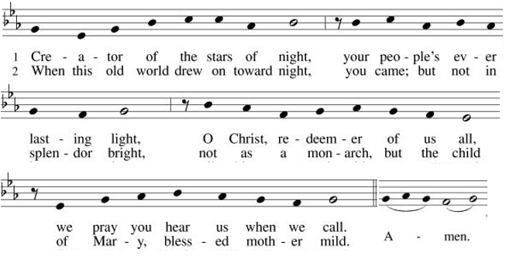

**Hymn of Praise: Rejoice, Rejoice, Believers ELW #244
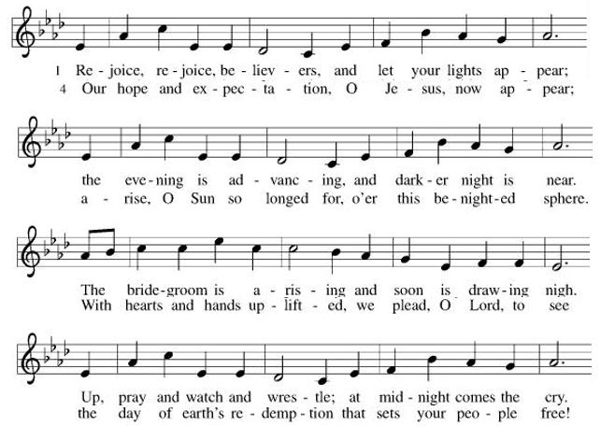
**Prayer of the Day

Jesus, you are always with us. You call us to support and encourage one another and to help spread your hope and peace, even when it is hard to find. Help us to flourish, even when life is challenging. We pray this in your name. Amen.

Reading: Psalm 137: 1-6; Jeremiah 29:1, 4-14

Psalm 137:1-6

¹By the rivers of Babylon
we sat and wept, remembering Zion.
²On the willows there
we hung up our harps.
³For there our captors taunted us to sing our songs,
our tormentors demanded songs of joy:
“Sing us one of the songs of Zion!”
⁴But how could we sing a song of God
in a foreign land?
⁵If I forget you, Jerusalem,
may my right hand forget its skill!
⁶May my tongue stick to the roof of my mouth
if I ever forget you,
if I ever stop considering Jerusalem
my greatest joy.

Jeremiah 29:1, 4-14

¹Jeremiah sent a letter from Jerusalem to Babylon to the surviving elders among the exiles, to the priests, the prophets, and all the other people Nebuchadnezzar had deported.

⁴“Thus says God the All-Powerful One, the God of Israel, to all the exiles I deported from Jerusalem to Babylon: ⁵Build houses to live in. Plant gardens and eat what they grow. ⁶Marry and raise children. Find spouses for your children, that they may bear children of their own. Multiply while you are there. Do not decrease. ⁷Rather, seek the peace and the prosperity of the city to which I exiled you. Pray to God for it, for if it prospers, you will prosper. ⁸This is what our God, the God of Israel, says: Do not let the diviners and prophets among you deceive you. Don’t listen to the dreams they dream, ⁹for they lie when they prophesy in my Name. I did not send them, declares God.

¹⁰“Thus says God: Only when the seventy years granted to Babylon are over will I visit you and fulfill my promise to bring you back to this place. ¹¹I alone know my purpose for you, says God, my purpose for your prosperity and my purpose not to harm you, my purpose to give you hope with a future in it. ¹²At that time you will call upon me and come and pray to me, and I will listen to you. ¹³You will seek me and find me when you seek me wholeheartedly. ¹⁴I will let you find me, says God, and I will restore your fortunes. And I will gather you from all the nations and all the places to which I banished you, says God, and restore you to the place from which I carried you into exile.”

Word of God, Word of Life.
Thanks be to God!

**Gospel Acclamation: He Came Down ELW #253



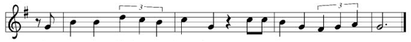

Announcement of the Gospel
Glory to you, O Lord.

Gospel: John 14:27

²⁷[Jesus said,] “Peace I leave with you;
my peace I give to you;
but the kind of peace I give you
is not like the world’s peace.
Don’t let your hearts be distressed;
don’t be fearful.”

The Gospel of the Lord.
Praise to you, O Christ!

Sermon “Flourishing in Exile”

Hymn of the Day Evening and Morning ELW#761

**Affirmation of Faith – Immigrant’s Creed by Jose Luis Casal

I believe in Almighty God, who guided the people in exile and in exodus, the God of Joseph in Egypt and Daniel in Babylon, the God of foreigners and immigrants.

I believe in Jesus Christ, a displaced Galilean, who was born away from his people and his home, who fled his country with his parents when his life was in danger. When he returned to his own country he suffered under the oppression of Pontius Pilate, the servant of a foreign power. Jesus was persecuted, beaten, tortured, and unjustly condemned to death. But on the third day Jesus rose from the dead, not as a scorned foreigner but to offer us citizenship in God’s kingdom.

I believe in the Holy Spirit, the eternal immigrant from God’s kingdom among us, who speaks all languages, lives in all countries, and reunites all races.

I believe that the Church is the secure home for foreigners and for all believers. I believe that the communion of saints begins when we embrace all God’s people in all their diversity. I believe in forgiveness, which makes us all equal before God, and in reconciliation, which heals our brokenness. I believe that in the Resurrection God will unite us as one people in which all are distinct and all are alike at the same time. I believe in life eternal, in which no one will be foreigner but all will be citizens of the kingdom where God reigns forever and ever. Amen.

**Prayers of Intercession

God of Love, hear the prayers that we lift before you. Hold close to you all those for whom we pray.

We pray for the church in the world, its leaders, and its mission to share the good news of healing and restoration. Inspire us to embody the beloved community in ways that faithfully witness to the Holy Spirit. Hear us, O God.
Your mercy is great.
We pray for the trembling mountains and glad streams of creation. Preserve and renew your coastlines, deep seas, forests, and grasslands. Guide all who tend flocks or care for creatures of all kinds. Hear us, O God.
Your mercy is great.
We pray for leaders and advocates in government, civic life, and public safety. Support equity across the globe, and heal division with accountability and truth. Hear us, O God.
Your mercy is great.
We pray for any who are hungry, living in poverty or desperation, weary in body or spirit, or sick, especially Monty, Paul, Linda, Betty F., Kay, Becky H., Jim & Jan, Becky W., David, William and family, Helen, Larry, Otto, Kevin, families in our community who endure hunger, and our beloved for whom death is near. Comfort all in need of your tender care. Hear us, O God.
Your mercy is great.
We pray for this part of the body of Christ gathered around word and sacrament. Bring us into authentic community where all ages are valued and experience God’s faithfulness together. Hear us, O God.
Your mercy is great.
We pray for migrants and refugees who set out, not knowing where they go. Provide shelter, sustenance, protection from harm, and welcome. Bless the work of Global Refuge and other support and advocacy programs. Hear us, O God.
Your mercy is great.
We pray for the nations. Pave a way to justice, drown the forces of oppression, bring peace on earth. Give leaders the will to turn from war and violence. Especially we pray for the people of Sudan, Gaza, Israel, and Ukraine, and for Jim’s grandson Dylan, who is deployed in Oman. When people must flee their homes, guide them to safety. Comfort those living with deep trauma, anxiety, or fear; all those who serve people in need, and accompany all those who care for people in harm’s way. Hear us, O God.
Your mercy is great.
We pray for people who rise up against injustice. Bring courage and resilience to those who resist tyranny with their words and their bodies. Strengthen those who fight for justice in your name across the country, and around the world. Protect and sustain immigrants and refugees and all who work with them, that your kingdom, without borders and without walls, may truly come on earth as it is in heaven. We pray for all victims of gun violence or kidnapping, especially those who are targeted out of hate or fear. Embolden us to holy outrage and empower us to speak our truth of love and justice. Hear us, O God.
Your mercy is great.
We lift up all who teach and all who learn. Thank you for teachers who share their knowledge and wisdom. Bless the students in our midst. Especially we remember Evie, in kindergarten; Addison, in high school; and Tyler, Zach, Katie and Katy, in college. Bless Janet and Lisa as they teach. Hear us, O God.
Your mercy is great.
We give thanks for all who have died in faith. May we remember them faithfully until we are gathered with you in the paradise you promise. Hear us, O God.
Your mercy is great.

Good and loving God, we give everyone we have prayed for into your care. Amen.

** Sharing of the Peace

**Offering is brought forward

** Offertory Response Creator of the Stars of Night ELW#245

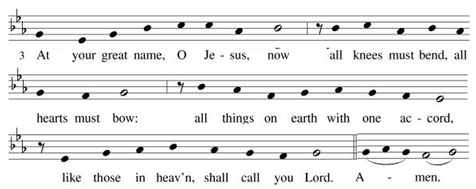

**Offertory Prayer
Almighty God, we give you thanks for all that you have given us. In return, we offer up these gifts of our skills, our time, and our money, which are a token of our offering to you. Help us to be good stewards of all that you have given us. We pray this in the name of Jesus, our Savior. Amen.

**Dialogue
Jesus has prepared a sacred meal for us.
We await your coming, Jesus.

All are welcome at your table. You call, and we respond with joy.
We await your coming, Jesus.

**Preface: In hope and patience… this hymn of praise:

**Sanctus: Prepare the Royal Highway ELW #264
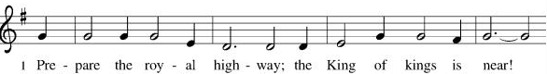
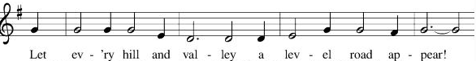
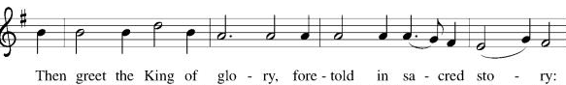
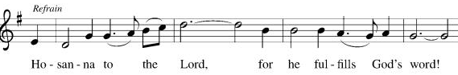
**Words of Institution

**LORD’S PRAYER

Our Father, who art in heaven,
hallowed be thy name,
thy kingdom come,
thy will be done,
on earth as it is in heaven.
Give us this day our daily bread;
and forgive us our trespasses,
as we forgive those
who trespass against us;
and lead us not into temptation,
but deliver us from evil.
For thine is the kingdom,
and the power, and the glory,
forever and ever. Amen.

Invitation to Communion

Communion Hymn We Place Upon Your Table, Lord ELW#467

**Sending Song Awake, Awake, and Greet the New Morn ELW#242

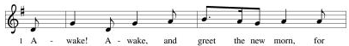

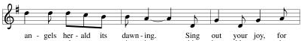

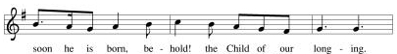

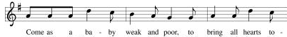

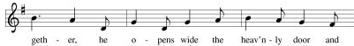

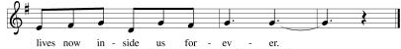

**Prayer After Communion

Gracious God, when we participate in this holy meal, we are connected to all who believe throughout the world. We are connected through faith, through your presence and through your mission to share your grace with all we meet. Amen.

**Blessing

**Closing Hymn Praise, My Soul, the King of Heaven ELW#865

**Dismissal

Go in peace to serve Christ and the world!

THANKS BE TO GOD!

+ + + + + +
Setting 10 liturgy is under copyright and used with permission under One License #733618-A. The Prayers of Intercession are under copyright and are used with permission under Augsburg Fortress Liturgy License #SB155933. All other liturgy written by Sarah Pierce.

***********************************************************************************************************
Weekly Attendance

Week of November 9

30

******************************************************************************************

Calendar of Events
Today

- Bag up quilts for MLM and doll/quilt/book bags for CSL toy drive

This Week
- November 25: Creative Friends
- November 26: Thanksgiving Eve worship 7:00 pm
- November 29: Decorate for Advent 9:00 am

Upcoming Events
December 2 | Creative Friends
December 3 | Pastor Sarah out of the office
December 3 | Bells rehearsal 6:30pm
December 4 | Pastor Sarah in the office
December 07 | Advent Dinner after Worship
December 9 | Creative Friends
December 10 | Council Meeting 6:30 pm
December 16 | Creative Friends
December 17 | Bells rehearsal 6:30pm
December 21 | Bells play during worship
December 23 | Creative Friends
December 24 | Christmas Eve worship 7:00pm
January 14, 2026 | Council Meeting 6:30 pm
February 15 | Pre-Lent Ice Cream Social after church
February 18 | Ash Wednesday
March 29 | Palm Sunday
April 05 | Easter Sunday

*****************************************************************************************
BLUE SPRINGS COMMUNITY SERVICE LEAGUE is very appreciative of your continued support of your neighbor.
Our special offering to the CSL food bank totaled $1395! Thank you for your generosity to help feed the hungry in our community!
*****************************************************************************************
Traci has suggested we do a mini school supply drive (paper, pens and pencils, notebooks, etc.) for middle and high school students transitioning to new classes in the second semester. We would like to collect these supplies in November and December, donating to CSL in mid- to late-December.
******************************************************************************************
Questions for Reflection and Discussion from Pastor Sarah
- Jeremiah 29:11 is one of the most well-known verses in the Bible. It gets pulled out of context all the time to be used as a word of hope on its own. And it’s powerful! One thing that’s often lost when it’s pulled out of context is that the “you” is plural, not singular: “I alone know my purpose for y’all, says God, my purpose for y’all’s prosperity and my purpose not to harm y’all, my purpose to give y’all hope with a future in it.”
- The verse is much more powerful in context! Then you get the full scope of what the hope is that God is promising: they’ve been forced into exile, but now they’re being instructed to build lives. The verbs in verses 5-7 are all active, action-y verbs: build, plant, eat, marry, raise, find, multiply, seek, pray. These are all things you do when you’re creating a future that’s centered on God.
- Contrast this with the verses from psalm 137, which are about the same event – the destruction of Jerusalem and the exile to Babylon. Psalm 137 has a very different tone to it; it is full of despair, rather than hope.
- One of the things I thought about when writing my sermon (the road not taken) was all of the people who are being exiled in our world right now. We could talk about the ongoing conflict in Gaza that doesn’t ever seem to end, as the two sides can’t come to an agreement for a lasting cease-fire, since Israel won’t accept a Palestinian state and Palestine won’t accept anything less. We could talk about the civil war in Sudan and the genocide that’s happening there. We could talk about what’s happening here in our own country as people are being detained and deported for having brown skin. But this word of hope seemed to call for something much, much closer to home, something we will all experience.
- Have you ever felt exiled from life? Like things just weren’t normal anymore and maybe never would again, and there were whole swathes of people around you who just didn’t get it, or didn’t even know what was going on? What helped you find your “new normal?”

**************************************************************************************
Birthdays:
Gary Antes November 29
Zach Antes November 29

November 16
Altar Guild – Sara Meyers
Communion Assistant – Flavia Via
Lector – Tonya Hamilton
Greeter – Donna Taylor
Tech – Gary Antes

Prayer Requests
Monty Health Concerns (May 15)
Paul Health Concerns (May 31)
Mary Health Concerns (May 15)
James & Family Health Concerns (September 11)
Betty F (Sara’s friend) Health Concerns (July 15)
William and Family Health Concerns (September 25)
Becky H Health Concerns (October 28)
David Health Concerns (November 18)
Becky W Health Concerns (November 18)
Larry Health Issues (December 16)
Helen Health Issues (January 14)
Otto Health Concerns (July 15)
Kay (Sara’s cousin) Health Concerns (July 15)
Kevin Health Concerns (October 01)
Fred Health Concerns (October 22)
Sharon Health Concerns (October 22)
Michael Health Concerns (October 22)

Merciful God, your justice and mercy are without limits. Bring courage and resilience to those who resist tyranny with their words and their bodies. Strengthen those who fight for justice in your name across the country, and around the world.

Please pray for the people of Sudan, Gaza, Ukraine, Israel, Iran and Palestine.
Please pray for the people of Jamaica and Cuba.
Please pray for the Homeless.
Please pray for legal & illegal immigrants & those seeking asylum or citizenship.

