All Saints Lutheran Church, ELCA
421 SW 19th St. Blue Springs, Missouri 64015 816-229-3633
Pastor Sarah Pierce Spierce.aslcpastor@gmail.com
allsaintslc64015@gmail.com https://aslcbs.org/

Sunday, March 22, 2026

Fifth Sunday of Lent

You are absolutely invited into this sacred space. We welcome all who are seeking God’s love and grace. All Saints recognizes that we are all unique and beloved children of God. We celebrate and give thanks for the many diverse gifts that God has given us. We affirm the sacredness of people of all sexual orientations, gender identities, and gender expressions. We affirm the sacredness of all those who have experienced exclusion because of race, ability, age, or culture. We are committed to working towards anti-racism in ourselves and our community. We affirm the sacredness of all those who wrestle with addiction, physical or mental health, imprisonment, socio-economic circumstances, or anything that too often divides us. We believe that through our openness we all grow in our faith through Christ’s teaching to love one another as God loves us. We need each other and our sincere hope is by being in community together, we will experience God’s presence in new and real ways.

The offering plate is by the main door to the sanctuary for your convenience.

We practice open communion at All Saints Lutheran Church. What does that mean? It means that if you believe and trust that Christ offers his body and blood For You, you are welcome at the table. At All Saints, we believe that Christ invites all people to the feast. “Come to the banquet for all is now ready.”

**Stand as you are comfortable

Prelude

Bells play: Jesus the Very Thought of You

Announcements

** Confession and Forgiveness
Siblings in Christ, as beings created in the image of God, we are created to be in relationship with God, with each other, and with all of creation, and to experience the joy of that relationship. But because we sin against God, against each other, and against creation, these relationships are fractured.

Jesus asks us as his followers to live in such a way that we resist anything that threatens to tempt us away from our love and service to God and each other. Made bold by the Holy Spirit, let us confess together the sins which turn us away from God and from each other. I invite you to spend a few moments in silent reflection, bringing your sin before you to God as an offering of repentance.

Holy God, Who loves and forgives us,
we confess to you and to each other,
before all the faithful of every time and place,
that we are guilty of sin,
and we cannot free ourselves
from that prison.
We have sinned against you and each other
By what we have thought,
By what we have said,
And by the things we have done
And the things we should have done and did not do.
We have not loved you with our whole beings.
We have not loved each other and this world as you intend that we should.
We have not forgiven those who have harmed us, with the fullness of forgiveness that you offer us.
Restore us, Holy God. Do not hold onto your anger against us.
Hear us, Holy God, for your forgiveness and mercy know no limits.

Holy God, show us the work of your saving hands
That we may be signs to the world of the power of your forgiveness.
By the suffering and death of our Savior, your Beloved,
Renew in us the sure knowledge that we, with all your children, will be resurrected with him.

Holy and Eternal God, in all goodness and mercy, forgives us of our sins through the life, death, and resurrection of Jesus Christ +, who redeems us, and the power of the Holy Spirit, who sustains us in faith and hope.

**Entrance Hymn O, Worship the King ELW#842

**Greeting
The grace of our Lord Jesus Christ, the love of God,
and the communion of the Holy Spirit be with you all.
And also with you.

**Kyrie
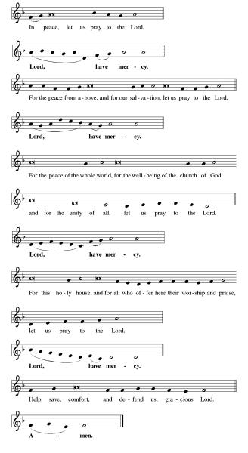

**Glory to God
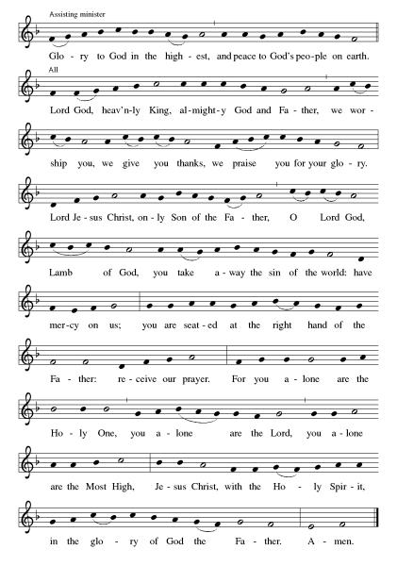

**Prayer of the Day
Loving God, you fill our senses with the abundance of your love for us. Wash us in your grace and help us to remember that you have promised us abundant life, so that we are bold to share your love with the world. In Jesus’ name. Amen.

Bells play: O Master Let Me Walk With You

Reading: Psalm 45:6-8

⁶God has enthroned you forever and ever,
and your royal scepter is a rod of justice.
⁷And because you love justice and hate corruption,
God, your God, has set you above your companions
and anointed you with the oil of gladness.
⁸Your robes are all fragrant with myrrh, aloes and cassia.
Stringed instruments entertain you in ivory palaces.

Word of God, Word of Life
Thanks be to God

**Lenten Acclamation
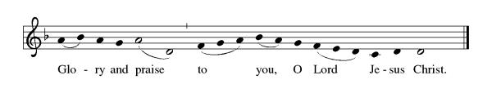

Announcement of the Gospel
Glory to you, O Lord.

Gospel: John 12:1-8

¹Six days before Passover, Jesus went to Bethany, the village of Lazarus, whom Jesus had raised from the dead. ²There they gave a banquet in Jesus’ honor, at which Martha served. Lazarus was one of those at the table. ³Mary brought a pound of costly ointment, pure nard, and anointed the feet of Jesus, wiping them with her hair. The house was full of the scent of the ointment.

⁴Judas Iscariot, one of the disciples – the one who was to betray Jesus – protested, ⁵“Why wasn’t this ointment sold? It could have brought nearly a year’s wages, and the money been given to poor people!” ⁶Judas didn’t say this because he was concerned for poor people, but because he was a thief. He was in charge of the common fund and would help himself to it.

⁷So Jesus replied, “Leave her alone. She did this in preparation for my burial. ⁸You have poor people with you always. But you won’t always have me.”

⁹Meanwhile a large crowd heard that Jesus was there and came to see not only Jesus, but also Lazarus, whom he raised from the dead. ¹⁰So the chief priests planned to kill Lazarus as well, ¹¹since it was because of him that many of the people were leaving them and believing in Jesus.

The Gospel of the Lord.
Praise to you, O Christ.

Sermon "Abundance of Love"

Hymn of the Day Jesus, the Very Thought of You ELW#754

**Affirmation of Faith – Immigrant’s Creed by Jose Luis Casal
I believe in Almighty God, who guided the people in exile and in exodus, the God of Joseph in Egypt and Daniel in Babylon, the God of foreigners and immigrants.

I believe in Jesus Christ, a displaced Galilean, who was born away from his people and his home, who fled his country with his parents when his life was in danger. When he returned to his own country he suffered under the oppression of Pontius Pilate, the servant of a foreign power. Jesus was persecuted, beaten, tortured, and unjustly condemned to death. But on the third day Jesus rose from the dead, not as a scorned foreigner but to offer us citizenship in God’s kingdom.

I believe in the Holy Spirit, the eternal immigrant from God’s kingdom among us, who speaks all languages, lives in all countries, and reunites all races.

I believe that the Church is the secure home for foreigners and for all believers. I believe that the communion of saints begins when we embrace all God’s people in all their diversity. I believe in forgiveness, which makes us all equal before God, and in reconciliation, which heals our brokenness. I believe that in the Resurrection God will unite us as one people in which all are distinct and all are alike at the same time. I believe in life eternal, in which no one will be foreigner but all will be citizens of the kingdom where God reigns forever and ever. Amen.

**Prayers of Intercession

Jesus, you came to live with us on earth so that we would know you love us no matter what. Listen to the prayers we lift to you.

We pray for the church. Grant life and peace to all who gather in your name. Breathe into us so that we may share your message of forgiveness, hope, and love. Hear us, O God.
Your mercy is great.
We pray for creation. Renew landscapes that have dried up, prosper the work of those who restore homes and habitats after natural disasters, and sustain places where biodiversity thrives. Hear us, O God.
Your mercy is great.
We pray for the nations. Unbind leaders trapped by fear to act boldly for justice, free all who live in places of war and violence, and guide refugees and asylum seekers to safety. Hear us, O God.
Your mercy is great.
We pray for all people in need. Take away the stone of poverty that weighs down so many. Console any who weep and heal all who are sick especially Monty & Marie, Paul, Helen, Linda, Betty F., Kay, Becky H., Jim & Jan, Melian, Becky W., David, Val, William & family, Judy, Kevin, Peter & Carrie, Barbara & Donna, families in our community who endure hunger, and our beloved for whom death is near. Hear us, O God.
Your mercy is great.
We pray for this assembly. Ready the hearts and spirits of all preparing to be baptized. Deepen our wonder at the mystery of your resurrection and life. Hear us, O God.
Your mercy is great.
Pave a way to justice, drown the forces of oppression, bring peace on earth. Give leaders the will to turn from war and violence. Especially we pray for the people of Venezuela, Iran, Sudan, Gaza, Israel, and Ukraine. When people must flee their homes, guide them to safety. Comfort those living with deep trauma, anxiety, or fear; all those who serve people in need, and accompany all those who care for people in harm’s way. We also lift up Jim’s grandson Dylan, who is deployed, and Sharon’s great nephew, Taylor, who is deployed in the Middle East. Hear us, O God
Your mercy is great.
We pray for people who rise up against injustice. Bring courage and resilience to those who resist tyranny with their words and their bodies. Strengthen those who fight for justice in your name across the country, and around the world. Protect and sustain immigrants and refugees and all who work with them, that your kingdom, without borders and without walls, may truly come on earth as it is in heaven. We pray for all victims of gun violence or kidnapping, especially those who are targeted out of hate or fear. Embolden us to holy outrage and empower us to speak our truth of love and justice. Hear us, O God.
Your mercy is great.
We lift up all who teach and all who learn. Thank you for teachers who share their knowledge and wisdom. Bless the students in our midst. Especially we remember Evie, in kindergarten; Addison, in high school; and Tyler, Zach, Katie and Katy, in college. Bless Janet, Carla, and Lisa as they teach. Hear us, O God.
Your mercy is great.
We offer our thanksgiving for all people who have died in faith. Give us faith to trust in your power to redeem and save, and bring us up from our graves to life in you. Hear us, O God.
Your mercy is great.

Loving God, because you lived among us, we know that you hear our prayers and hold close all for whom we pray. Amen

** Sharing of the Peace

**Offering is brought forward

** Offertory Response Let Us Talents and Tongues Employ (V. 1) ELW#674

**Offertory Prayer

Good and loving God, we give to you these offerings of our time, our talents, and our money, for the work of your people in this place, as we seek to follow your Son. Prepare our hearts and minds to come to your Table, as you feed us with the life-giving body and blood of your son Jesus Christ, through whom we receive the gift of eternal life.

Amen.

** Thanksgiving at the Table
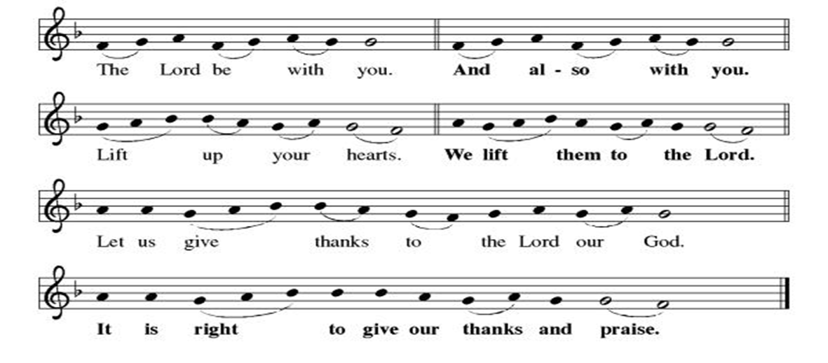

**Preface: We give you thanks, Holy God… this hymn of praise:
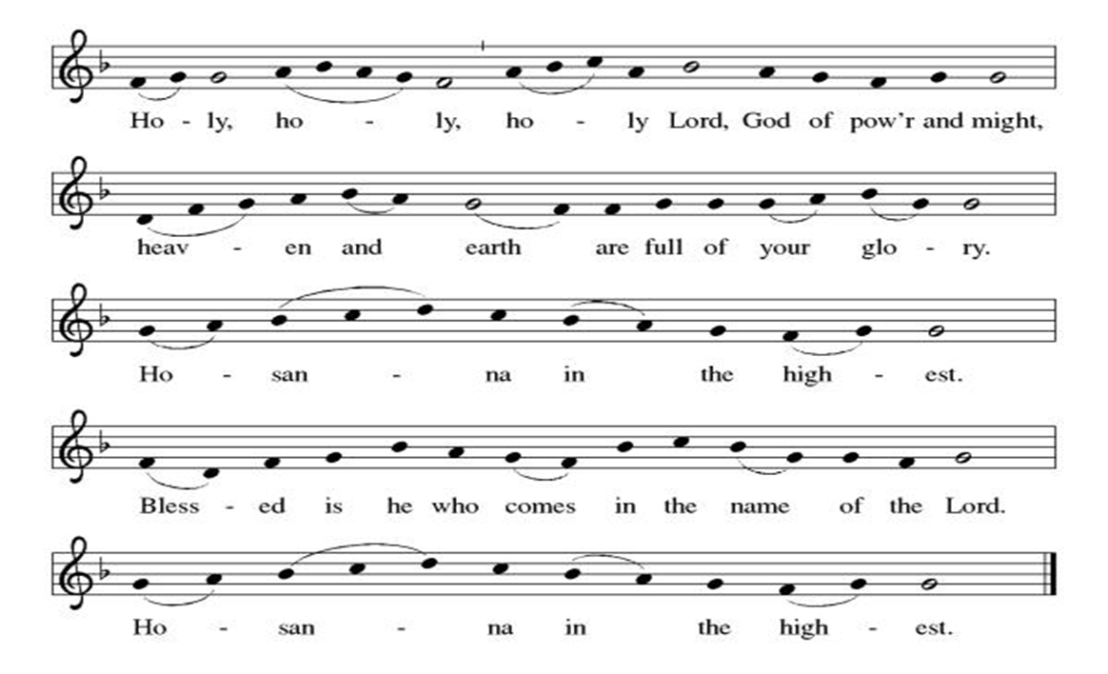
**LORD’S PRAYER
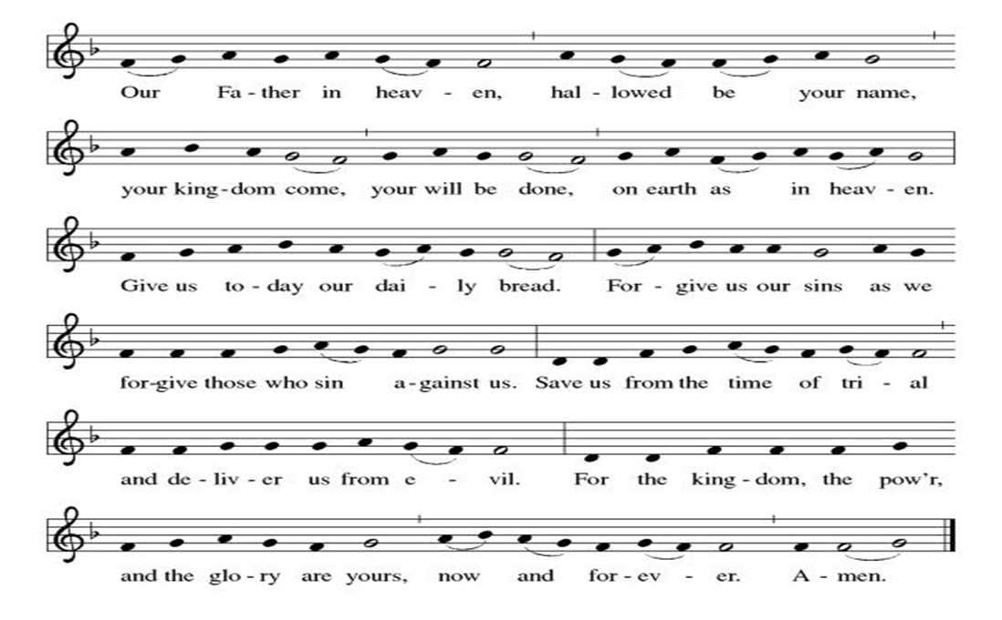

Invitation to Communion

Communion Hymn In the Cross of Christ I Glory ELW#324

**Post-communion prayer

Holy and Eternal God, we have been fed at your Table with the goodness of our Savior. Send us out, emboldened to share the good news of your promise of forgiveness and eternal life. Strengthen our resolve to respond to the needs of our neighbors and to care for your world. Amen.

Healing of Nations

**Benediction

**Dismissal

Go in peace. Serve in Love!
Thanks be to God!

+ + + + + +
Hymns from the Evangelical Lutheran Worship are under copyright and used with permission under One License #733618-A. ELW setting #5 the Prayers of Intercession are under copyright and are used with permission under Augsburg Fortress Liturgy License #SB155933. All other liturgy written by Sarah Pierce.

Weekly Attendance

Week of March 15
24
Next Week:
Palm Sunday

The Color of the day is Purple
Psalm 24
John Processional Gospel John 12:12-18
John Passion Gospel John 131-38, 18:1-19:42

Calendar of Events
Today
- Bells play: Jesus the Very Thought of You & O Master Let Me Walk With You
- Coffee with Council
Upcoming Week
- Bells
- Creative Friends
- Project Comfort
- March 25: Worship at All Saints Lutheran; Rev. Dr. Andrew Florio preaching

March 24 | Creative Friends
March 24 | Bells Practice
March 28 | Project Comfort
March 29 | Palm Sunday  Work Day wear your work clothes
March 31 | Bells Practice
April 01 | Paint Party Fundraiser
April 02 | Maundy Thursday  Worship 7:00 pm
April 03 | Good Friday Office Closed  Service at 7:00 pm
April 04 | Easter Vigil 7:45 pm
April 05 | Easter Sunday  Bells play “My Lord What A Morning” & “We Will Glorify”  Easter Brunch after service
April 08 | Church Council Meeting 6:30 pm
April 12 | View Christian Nationalism part1
April 15 | Bells Practice
April 22 | Bells Practice
April 26 | Coffee with Council
April 29 | Bells Practice
May 03 | View Christian Nationalism part 2
May 06 | Paint Party Fundraiser
May 10 | Mother’s Day
May 13 | Church Council Meeting 6:30 pm
May 17 | Congregational Meeting after worship
May 24 | Pentecost
May 25 | Memorial Day
June 03 | Paint Party Fundraiser
June 07 | View Christian Nationalism part 3  Ice Cream Social
June 19 | Juneteenth Office Closed
June 28 | Coffee with Council
July 01 | Paint Party Fundraiser
July 04 | Independence Day
July 26 | Coffee with Council  Celebrate Niel’s Birthday (July 28)
September 13 | God’s Work. Our Hands.
Note: 2026 paint party fundraisers: Feb. 4, March 4, April 1, May 6, June 3, July 1, Aug. 5, Sept. 2, Oct. 7, Nov. 4, Dec. 2
Note: Theater group church use: auditions Feb. 6 &7, 6:30-9:30; callbacks Feb. 8, 1-5; rehearsals MWF & Saturday, Feb.16-April 18, MWF 6:30-9:30 and Saturdays 12-4.

As we have done for many years now, we will join together with our ecumenical siblings in Christ to worship together during Lent. We will gather for a meal at 5:30, with worship beginning at about 6:40. As in years past, the offerings will go to Community Services League. Here is the schedule:

- March 25: Worship at All Saints Lutheran; Rev. Dr. Andrew Florio preaching

Our theme this year is Reconciliation.

Pastor Sarah Questions:

- We find ourselves back where we were last Sunday: at the home of Lazarus, Mary, and Martha. But now Lazarus is fully back to life, seated next to Jesus at the banquet. What role does everyone play? Why do you think Jesus stopped back at Bethany on his way to Jerusalem?
- In verse 3, we’re told that Mary brought a pound of pure nard to anoint the feet for Jesus. (The Greek word for pure has the same root as the word for faith/trust.) This anointing is a sign of abundance, even before we find out how much the nard costs! It’s also a sign of the love and care that Mary shows Jesus. Her loose hair is merely a symbol of her grief, nothing more. It’s meant to signal to us that she knows she’s preparing him for burial.
- Judas is called out as a thief in verse 6; remember back to chapter 10, the “Good Shepherd” discourse, when Jesus says in verse 10: “The thief comes only to steal and slaughter and destroy.” We’re being told in no uncertain terms who Judas is.
- Contrast Mary and Judas. Mary clearly has an abiding relationship with Jesus; we know from the last chapter that she and her family are beloved of Jesus, and they love him. And now we see her performing an act of service and care for him. Clearly, she is a believer, possibly even in a way she wasn’t before. She is demonstrating that with her anointing. Judas, on the other hand, is distancing himself from Jesus by choosing to criticize not only her act of love and service, but he’s being pretty hypocritical about it since he doesn’t actually subscribe to what he’s saying.
- What does it mean that Lazarus’ resurrection bookends this text? Does it foreshadow Jesus’ resurrection? Does Mary’s anointing foreshadow Jesus’ death and/or his washing of the disciples’ feet for you?
- The second sentence of verse 3, “The house was full of the scent of the ointment,” was evocative for me as I began to construct my sermon. It reminds me of the ways our senses can seem to fill up every space in our minds and hearts, reminding us or bringing us back to certain events or significant moments in our lives. Are there such moments or events that you can think of that are associated with certain scents?

******************************************************************************************
BLUE SPRINGS COMMUNITY SERVICE LEAGUE is very appreciative of your continued support of your neighbor.
*****************************************************************************************
March 22
Altar Guild – Sara Meyers
Lector – Tonya Hamilton
Greeter – Donna Taylor
Tech – Gary Antes

Prayer Requests
Monty & Marie Health Concerns (Maech 04)
Paul Health Concerns (May 31)
Mary Health Concerns (May 15)
James & Family Health Concerns (September 11)
Betty F (Sara’s friend) Health Concerns (July 15)
William and Family Health Concerns (September 25)
Becky H Health Concerns (October 28)
David Health Concerns (November 18)
Becky W Health Concerns (November 18)
Judy Health Issues (December 16)
Kay (Sara’s cousin) Health Concerns (July 15)
Kevin Health Concerns (October 01)
Fred Health Concerns (October 22)
Sharon Health Concerns (October 22)
Michael Health Concerns (October 22)
Peter and Carrie Health Concerns (November 26)
Melian Health Concerns (November 16)
RJ Health Concerns (November 17)
Barbara Health Concerns (December 30)
Helen Health Concerns (February 25)
Val (Tonya’s sister) Health Concerns (February 18)

Merciful God, your justice and mercy are without limits. Bring courage and resilience to those who resist tyranny with their words and their bodies. Strengthen those who fight for justice in your name across the country, and around the world.

Please pray for the people of Venezuela & Iran, Sudan, Gaza, Ukraine, Israel, Iran and Palestine.
Please pray for the Homeless.
Please pray for legal & illegal immigrants & those seeking asylum or citizenship

