All Saints Lutheran Church, ELCA
421 SW 19th St. Blue Springs, Missouri 64015 816-229-3633
Pastor Sarah Pierce Spierce.aslcpastor@gmail.com
allsaintslc64015@gmail.com https://aslcbs.org/

Sunday, July 19, 2026

Eighth Sunday after Pentecost

You are absolutely invited into this sacred space. We welcome all who are seeking God’s love and grace. All Saints recognizes that we are all unique and beloved children of God. We celebrate and give thanks for the many diverse gifts that God has given us. We affirm the sacredness of people of all sexual orientations, gender identities, and gender expressions. We affirm the sacredness of all those who have experienced exclusion because of race, ability, age, or culture. We are committed to working towards anti-racism in ourselves and our community. We affirm the sacredness of all those who wrestle with addiction, physical or mental health, imprisonment, socio-economic circumstances, or anything that too often divides us. We believe that through our openness we all grow in our faith through Christ’s teaching to love one another as God loves us. We need each other and our sincere hope is by being in community together, we will experience God’s presence in new and real ways.

The offering plate is by the main door to the sanctuary for your convenience.

We practice open communion at All Saints Lutheran Church. What does that mean? It means that if you believe and trust that Christ offers his body and blood For You, you are welcome at the table. At All Saints, we believe that Christ invites all people to the feast. “Come to the banquet for all is now ready.”

**Stand as you are comfortable
Note: Bold Print: Congregational Statements

Prelude

Announcements

** Confession and Forgiveness

The God that we worship is complex, multi-faceted, a single God made up of three Persons. When we try to understand the fullness of God, we fail. But God knows us and loves us and wants to be in relationship with us, so God is constantly finding new ways to be present with us. But sometimes, we fall short in our awareness. When that happens, we find that we have turned away from God to the idols of our own making.

Let us confess our sins together, as a community.

God of All the Cosmos,
Sometimes we try to make you small.
We try to put you in a box,
confine you to our way of understanding.
God, sometimes we misunderstand what you tell us.
Inspire us, Holy Spirit, to remember that you are beyond definition.
Help us to remember that you cannot be made small.
Help us to think deeply about who you are
and to respect and honor other people’s experiences of you.

Beloved in Christ, the God who walks beside you
is the same God who brings peace passing all understanding.
The Spirit who inspires your knowledge of the presence of God
is the same Spirit who moves over the waters of creation.
The Christ who hears your prayers
is the same Christ + who defeated death for the forgiveness of all sin, for all time.
Be at peace, for your sins are forgiven.

Amen.

**Entrance Hymn Come Thou Fount of Every Blessing ELW#807

**Greeting
The grace of our Lord Jesus Christ, the love of God,
and the communion of the Holy Spirit be with you all.
And also with you.

**Kyrie ELW 513
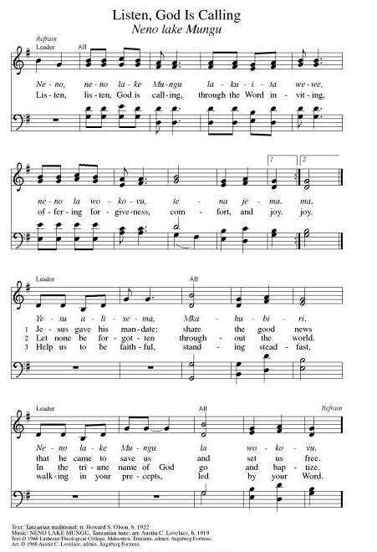
**Hymn of Praise ELW 866
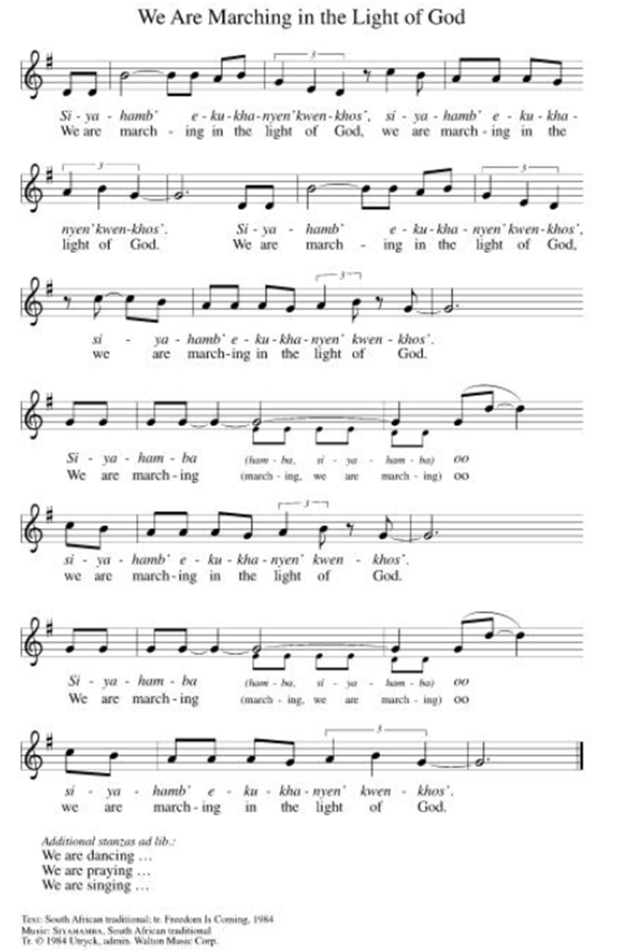

**Prayer of the Day
Loving God, you claim us through our baptisms, making us part of the Body of Christ. You bring us together to dwell in you and send us out again. Empower us so that everything we do becomes an act of worship and thanksgiving. We pray this in Jesus’ name. Amen.

Reading: Psalm 84

¹How I love your dwelling place,
my God, God of Hosts!
²How my soul yearns and pines
for your courts, O my God!
My heart and my flesh sing for
joy to you, the living God.
³The sparrow has found its home at last,
the swallow a nest for its young –
on your altars, God of Hosts,
my Sovereign, my God!
⁴Happiness belongs to those who live in your house
and can praise you all day long;
⁵and happy the pilgrims who find refuge in you
as they set their hearts on the Ascents!
⁶As they go through the Valley of the Weeper,
they make it a place of springs,
clothed in blessings by the early rains.
⁷From there they make their way from village to village,
until each one appears before God in Zion.
⁸My God, God of Hosts, hear my prayer;
Listen, O God of our ancestors!

⁹O God, our shield, show us your favor
and look upon the face of your Anointed –
¹⁰for a single day in your courts
is worth more than a thousand anywhere else;
better to be a humble doorkeeper in God’s house
than to live richly in the tents of the corrupt.
¹¹For you, Our God, are a battlement and shield,
bestowing grace and glory; God withholds nothing good
from those whose walk is blameless.
¹²Our God, God of Hosts,
happy are those who put their trust in you!

Word of God, Word of Life
Thanks be to God

Reading: Romans 6:1-11

¹What can we say, then? Should we go on sinning so that grace might abound? ²Of course not! We’re dead to sin, so how can we continue to live in it?

³Don’t you know that when we were baptized into Christ Jesus, we were baptized into Christ’s death? ⁴We’ve been buried with Jesus through baptism, and we joined with Jesus in death, so that as Christ was raised from the dead by God’s glory, we too might live a new life.

⁵For if we have been united with Christ in the likeness of Christ’s death, we will also be united with Christ in the likeness of Christ’s resurrection. ⁶We must realize that our former selves have been crucified with Christ to make the body of sin and failure completely powerless, to free us from slavery to sin: ⁷for when people die, they have finished with sin.

⁸But we believe that, having died with Christ, we will also live with Christ – ⁹knwoing that Christ, having been raised from the dead, will never die again: death is now powerless over our Savior. ¹⁰When Christ died, Christ died to sin, once for all, so that the life Christ lives is now life in God. ¹¹In this way, you too must consider yourselves to be dead to sin – but alive to God in Christ Jesus.

Word of God, Word of Life
Thanks be to God

**Gospel Acclamation ELW 519
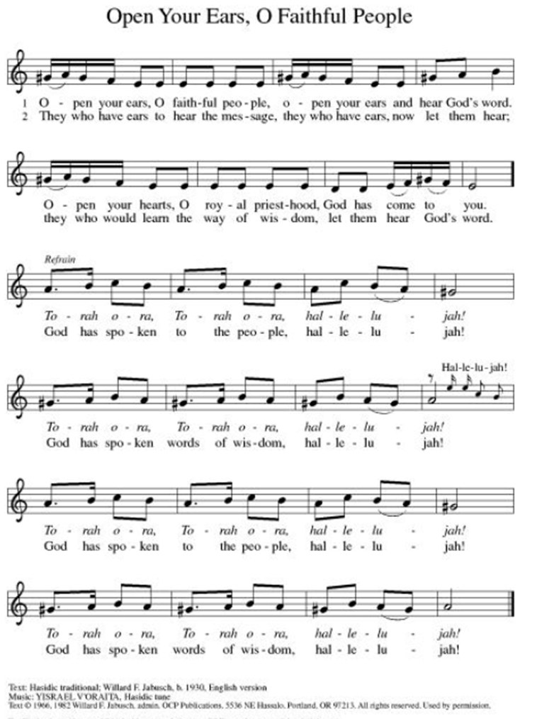

Announcement of the Gospel
Glory to you, O Lord.

Gospel: Luke 24:45-53

⁴⁵Then Jesus opened [the disciples’] minds to the understanding of the scriptures, ⁴⁶saying, “That is why the scriptures say that the Messiah must suffer and rise from the dead on the third day. ⁴⁷In the Messiah’s name, repentance for the forgiveness of sins will be preached to all nations, beginning at Jerusalem. ⁴⁸You are witnesses of all this.

⁴⁹ “Take note: I am sending forth what Abba God has promised to you. Remain here in the city until you are clothed with the power from on high.”

⁵⁰Then Jesus took them to the outskirts of Bethany, and with upraised hands blessed the disciples. ⁵¹While blessing them, the savior left them and was carried up to heaven. ⁵²The disciples worshiped the risen Christ and returned to Jerusalem full of joy. ⁵³They were found in the Temple constantly, speaking the praises of God.

The Gospel of the Lord.
Praise to you, O Christ.

Sermon "Dwelling Place"

Hymn of the Day Crashing Waters at Creation ELW#455

**Affirmation of Faith – Immigrant’s Creed by Jose Luis Casal

I believe in Almighty God, who guided the people in exile and in exodus, the God of Joseph in Egypt and Daniel in Babylon, the God of foreigners and immigrants.

I believe in Jesus Christ, a displaced Galilean, who was born away from his people and his home, who fled his country with his parents when his life was in danger. When he returned to his own country he suffered under the oppression of Pontius Pilate, the servant of a foreign power. Jesus was persecuted, beaten, tortured, and unjustly condemned to death. But on the third day Jesus rose from the dead, not as a scorned foreigner but to offer us citizenship in God’s kingdom.

I believe in the Holy Spirit, the eternal immigrant from God’s kingdom among us, who speaks all languages, lives in all countries, and reunites all races.

I believe that the Church is the secure home for foreigners and for all believers. I believe that the communion of saints begins when we embrace all God’s people in all their diversity. I believe in forgiveness, which makes us all equal before God, and in reconciliation, which heals our brokenness. I believe that in the Resurrection God will unite us as one people in which all are distinct and all are alike at the same time. I believe in life eternal, in which no one will be foreigner but all will be citizens of the kingdom where God reigns forever and ever. Amen.

Affirmation of Baptism

People of God, you have made a public profession of your faith. Do you intend to continue in the covenant God made with you in your baptism:
To live together as God’s faithful people with all the body of Christ;
To listen to the Word preached and taught, and to answer Jesus’ invitation to the Table;
To proclaim the good news: that in Christ, we are set free to love and serve our neighbor, through our words and our actions;
To serve our neighbors in our community and around the world, striving always to follow Jesus’ example to the best of our abilities;
And to work for God’s justice and the peace that is beyond our understanding, throughout creation?

I do, and I ask God to help and guide me.

People of God, do you promise to support and pray for one another in your life in Christ?

We do, and we ask God to help and guide us.

Let us pray. Loving God, through water and the Holy Spirit you give us new birth, cleanse us from sin, and raise us to eternal life. Stir up in all your people the gift of your Holy Spirit: the spirit of wisdom and understanding, the spirit of counsel and strength, the spirit of knowledge and the reverence for our God, that we may delight in your presence now and forever.
Amen.

**Prayers of Intercession

Holy God, our prayers rise to you like the wings of a dove. We call upon your name, and we ask that you hear us.

God our source, protect your church from those who sow division. Where we trade grace for judgment, restore us, and where we get lost among the complexities of life, guide us. God of grace,
hear our prayer.
God our creator, sustain creation in places not easily seen; the depths of oceans, microscopic plants and animals, galaxies beyond our own. May we share earth’s dedication to hope for what we do not yet see. God of grace,
hear our prayer.
God our soil, we yearn to live on your lands and waters with justice and in righteousness. Renew the hearts of all in authority, that our leaders guide wisely toward the flourishing of all. God of grace,
hear our prayer.
God our rock, be a source of constancy for those whose lives have been uprooted by war, eviction, global climate change, unemployment, harassment, false witness to their character, or illness or injury. We pray especially for Monty & Marie, Paul, Helen, Linda, Betty F., Kay, Becky H., Jim & Jan, Melian, Becky W., David, Val, William & family, Judy, Peter & Carrie, Barbara & Donna, and Brad & Chris. We lift up families in our community who endure hunger, and our beloved for whom death is near. God of grace,
hear our prayer.
God our teacher, guide and provide for all summer camp staff and campers, daycare professionals, librarians, summer school educators and coaches, teachers preparing for the coming academic year, and youth becoming first-time babysitters. God of grace,
hear our prayer.
Pave a way to justice, drown the forces of oppression, bring peace on earth. Give leaders the will to turn from war and violence. Especially we pray for the people of Cuba, Venezuela, Iran, Sudan, Gaza, Israel, and Ukraine. When people must flee their homes, guide them to safety. Comfort those living with deep trauma, anxiety, or fear; all those who serve people in need, and accompany all those who care for people in harm’s way. We also lift up Jim’s grandson, Dylan, who is deployed, and Sharon’s great nephew, Taylor, who is serving in the military. God of grace,
hear our prayer.
We pray for people who rise up against injustice. Bring courage and resilience to those who resist tyranny with their words and their bodies. Strengthen those who fight for justice in your name across the country, and around the world. Protect and sustain immigrants and refugees and all who work with them, that your kingdom, without borders and without walls, may truly come on earth as it is in heaven. We pray for all victims of gun violence or kidnapping. Embolden us to holy outrage and empower us to speak our truth of love and justice. God of grace,
hear our prayer
God our hope, the message of your salvation is planted among us in all times and places. We give you thanks for the witness of all the saints who shine like the sun in your presence. God of grace,
hear our prayer.

Good and loving God, we give everyone we have prayed for into your care. Amen.

** Sharing of the Peace

**Offering is brought forward

** Offertory Response ELW486

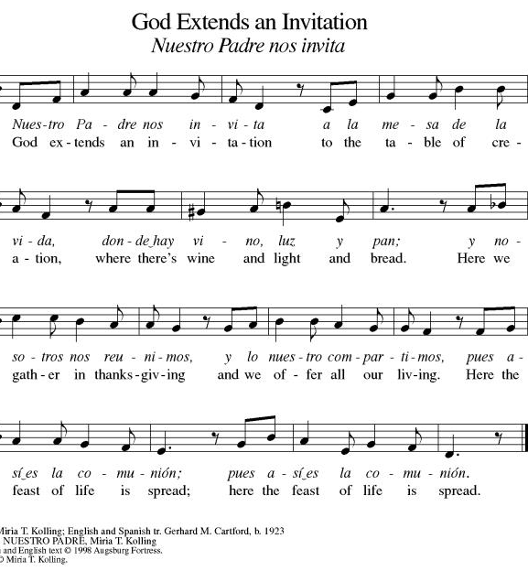
**Offertory Prayer
Jesus, all that we have and all that we are comes from you. Thank you for the gifts you have given us. Receive these gifts – our money, our service, our time – which we give in gratitude for all that we have received from you. Amen.

Dialogue
Christ is with you!
And also with you!
Lift up your hearts in joyful praise!
We lift them up to God in joy!

**Preface: We give thanks and praise to God...this hymn of praise:
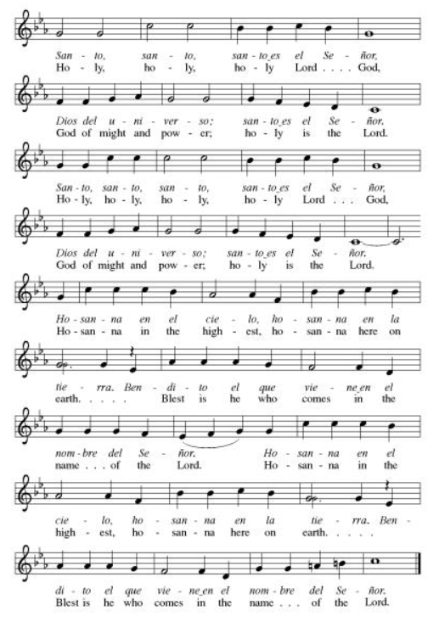
**Words of Institution

**LORD’S PRAYER
You are invited during this Pentecost season to pray whichever version feels most comfortable on your lips and in your soul. A separate sheet is available with alternate versions, should you be interested. Or, you are invited to use one of these:
Our Father in heaven, Our Father, who art in heaven,
hallowed be your name, hallowed be thy name,
your kingdom come, thy kingdom come,
your will be done, thy will be done,
on earth as in heaven. on earth as it is in heaven.
Give us today our daily bread. Give us this day our daily bread;
Forgive us our sins and forgive us our trespasses
as we forgive those as we forgive those
who sin against us. who trespass against us;
Save us from the time of trial and lead us not into temptation,
and deliver us from evil. but deliver us from evil.
For the kingdom, the power, For thine is the kingdom,
and the glory are yours, and the power, and the glory,
now and forever. Amen. forever and ever. Amen.

Invitation to Communion

Communion Hymn Let Us Break Bread Together ELW#471

**Sending Song ELW 535

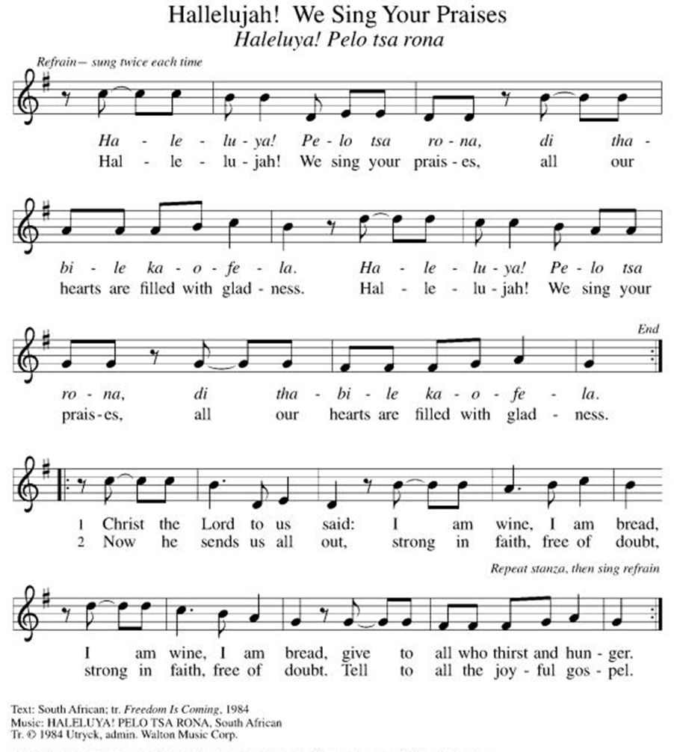

**Prayer After Communion
Holy God, you love us so much that you transformed an act of destruction into an act that gives new life. Thank you for the renewal we receive at your Table, as you send us out from this place into the world. Strengthen us for your service. In Jesus’ name we pray. Amen.

**Blessing

**Closing Hymn On Our Way Rejoicing ELW#537

**Dismissal

Empowered by the Spirit, may you go in peace to share the gospel!
THANKS BE TO GOD!

+ + + + + +

Setting 07 and hymns from the Evangelical Lutheran Worship are under copyright and used with permission under One License #733618-A. Specific copyright information as listed in bulletin, the Prayers of Intercession are under copyright and are used with permission under Augsburg Fortress Liturgy License #SB155933. All other liturgy written by Sarah Pierce.
Weekly Attendance

Week of July 12:
24
******************************************************************************************

Next Week:
9th Sunday after Pentecost:
Psalm 65
1 Corinthians 11:17-34a
Luke 6:20-26

John 4:1-14
The color of the day is Green

Calendar of Events

Today
- Adult Bible Study

This Week
July 20 | Newsletter Deadline
July 21 | Creative Friends
July 25 | Project Comfort

Upcoming Events

July 26 | Coffee with Council  Celebrate Niel’s Birthday (July 28)
July 28 | Creative Friends
August 19 | Council Meeting 6:30
September 13 | God’s Work. Our Hands.
September 23 | Council Meeting 6:30 pm
September 27 | Celebration 5th year Anniversary of Pastor’s Ordination

Note: 2026 paint party fundraisers: Aug. 5, Sept. 2, Oct. 7, Nov. 4, Dec. 2

SYNOD CONFIRMATION

As announced during the recent conference gatherings and synod assembly, the Central States Synod is putting together synod-wide confirmation. Details are in the works, but here are the basics. . .

  - Classes will run from September 3 through April 15. We will meet via Zoom from 6:30 – 7:45 pm on the 1st & 3rd Thursdays.
  - We will be on a two-year cycle. One year will be a Catechism year, and one will be a Bible year. We will be starting this fall with the Catechism year.
  - Anyone of any age can participate. (It's not just for students)
  - Each student will receive a Confirmation Kit containing items that will be used throughout the year.
  - There will be a weekly homework assignment.
  - Participants will be connected via GroupMe. Parents will need to give permission for this.
  - There will be some in-person retreats and/or camps offered along the way to connect in person with the other students.
  

As we prepare, we are hosting orientation meetings for parents, pastoral leaders, and students. We will talk about expectations, logistics, and answer your questions. If you are thinking of participating in the synod confirmation, please join us for one of two sessions, to be held on August 13 and August 20 at 6:30. Ask Pastor Sarah for the link or go to
https://www.css-elca.org/workshops#confirmation to register.

******************************************************************************************

Pastor Sarah Questions:

Questions for Reflection and Discussion

- Psalm 84 is not one that we can interpret to be specifically about baptism, but it’s very much about place, as Psalm 46 was last week. What does that have to do with baptism?
- One of the commentaries I read said about Psalm 84 that this psalm holds together our yearning for God and our longing to be in a place because God’s presence is there, which means that faith takes the form of movement: we go toward God. How do we move toward God through worship? In our daily lives?
- Bonhoeffer, in talking about this psalm (and other worship psalms), talks about sacrifice: he says that Jesus has already offered the perfect worship by perfecting sacrifice in his own voluntary death on the cross, so all we can do is sacrifice through praise and thanksgiving, and through living our life the way God wants us to, until our entire lives become worship.
- What connection do you see between Psalm 84 and Romans 6?
- Paul says in verse 4 that we were buried with Jesus in baptism and died with Jesus so that as Jesus was resurrected, we can be too. This is a pretty countercultural view on dealing with sin – much more common (both then and today) is the “carrot and stick” approach, to offer rewards for good behavior, punishment for bad behavior, which is pretty much the exact opposite of grace. But Paul is saying that method can’t change our hearts, can’t make us “repent” (or find a new way of understanding, as we talked about last week); only love can do that.
- After the end of this week’s reading in verse 11, Paul goes on to juxtapose slavery and freedom. For Paul, freedom is never individual (free will, as we think of it) but is always expressed through a relationship with something bigger than us. Something that we want to belong to, that gives us the freedom to love and to care for others and to worship God. He sees us as always existing in the mode of belonging. What do you think about that? Do we always “belong” somehow, to something? Whether it’s to our families, to our careers, to God, either to something that “owns” us or to something or someone that we want to give our allegiance to?

******************************************************************************************
BLUE SPRINGS COMMUNITY SERVICE LEAGUE is very appreciative of your continued support of your neighbor.
Birthdays
July 24-Judy Williams

July 12
Reader – Carla Deubner
Altar Guild – Anne Lee & Paul Blixrud
Greeter – Donna Taylor
Usher-Paul Blixrud
Tech – Gary Antes

Prayer Requests
Monty & Marie Health Concerns (March 04)
Paul Health Concerns (May 31)
Mary Health Concerns (May 15)
James & Family Health Concerns (September 11)
Betty F (Sara’s friend) Health Concerns (July 15)
William and Family Health Concerns (September 25)
Becky H Health Concerns (October 28)
David Health Concerns (November 18)
Becky W Health Concerns (November 18)
Judy Health Issues (December 16)
Kay (Sara’s cousin) Health Concerns (July 15)
Sharon Health Concerns (October 22)
Michael Health Concerns (October 22)
Peter and Carrie Health Concerns (November 26)
Melian Health Concerns (November 16)
RJ Health Concerns (November 17)
Barbara Health Concerns (December 30)
Helen Health Concerns (February 25)
Val (Tonya’s sister) Health Concerns (February 18)
Chris Health Concerns (June 09)

Merciful God, your justice and mercy are without limits. Bring courage and resilience to those who resist tyranny with their words and their bodies. Strengthen those who fight for justice in your name across the country, and around the world.

Please pray for the people of Venezuela & Iran, Sudan, Gaza, Ukraine, Israel, Cuba, Iran and Palestine.
Please pray for the Homeless.
Please pray for legal & illegal immigrants & those seeking asylum or citizenship

