All Saints Lutheran Church, ELCA
421 SW 19th St. Blue Springs, Missouri 64015 816-229-3633
Pastor Sarah Pierce Spierce.aslcpastor@gmail.com
allsaintslc64015@gmail.com https://aslcbs.org/

Sunday, October 4, 2026

Nineteenth Sunday after Pentecost

You are absolutely invited into this sacred space. We welcome all who are seeking God’s love and grace. All Saints recognizes that we are all unique and beloved children of God. We celebrate and give thanks for the many diverse gifts that God has given us. We affirm the sacredness of people of all sexual orientations, gender identities, and gender expressions. We affirm the sacredness of all those who have experienced exclusion because of race, ability, age, or culture. We are committed to working towards anti-racism in ourselves and our community. We affirm the sacredness of all those who wrestle with addiction, physical or mental health, imprisonment, socio-economic circumstances, or anything that too often divides us. We believe that through our openness we all grow in our faith through Christ’s teaching to love one another as God loves us. We need each other and our sincere hope is by being in community together, we will experience God’s presence in new and real ways.
The offering plate is by the main door to the sanctuary for your convenience.
We practice open communion at All Saints Lutheran Church. What does that mean? It means that if you believe and trust that Christ offers his body and blood For You, you are welcome at the table. At All Saints, we believe that Christ invites all people to the feast. “Come to the banquet for all is now ready.”
**Stand as you are comfortable
Note: Bold Print - Congregational Statements

Prelude
Announcements

** Confession and Forgiveness
God who created the heavens, the earth, and all that exists, sometimes we feel small when we
stand before you. But we trust that you see and hear us when we come before you.
Let us take a moment to draw near to God.
Holy God,
You always listen to us when we pray.
Forgive us when we forget to center our lives around you.
Forgive us when we turn away, distracted by other things that delight or distress us.
Forgive us when we sin against you, scorning the promises you have made to us.
Help us remember that you are always the solid foundation on which we stand.
Remind us, your children, to turn back to you.

Beloved children of God, the Spirit moves among us, bringing comfort and renewal. Our
Creator, the Source of all that is good and holy, is making all things new. And in Jesus, our
Savior +, we find the promise of forgiveness and mercy.
Amen.

**Entrance Hymn Light Dawns on a Weary World ELW # 726

**Greeting
The grace of our Lord Jesus Christ, the love of God,
and the communion of the Holy Spirit be with you all.
And also with you.
**Kyrie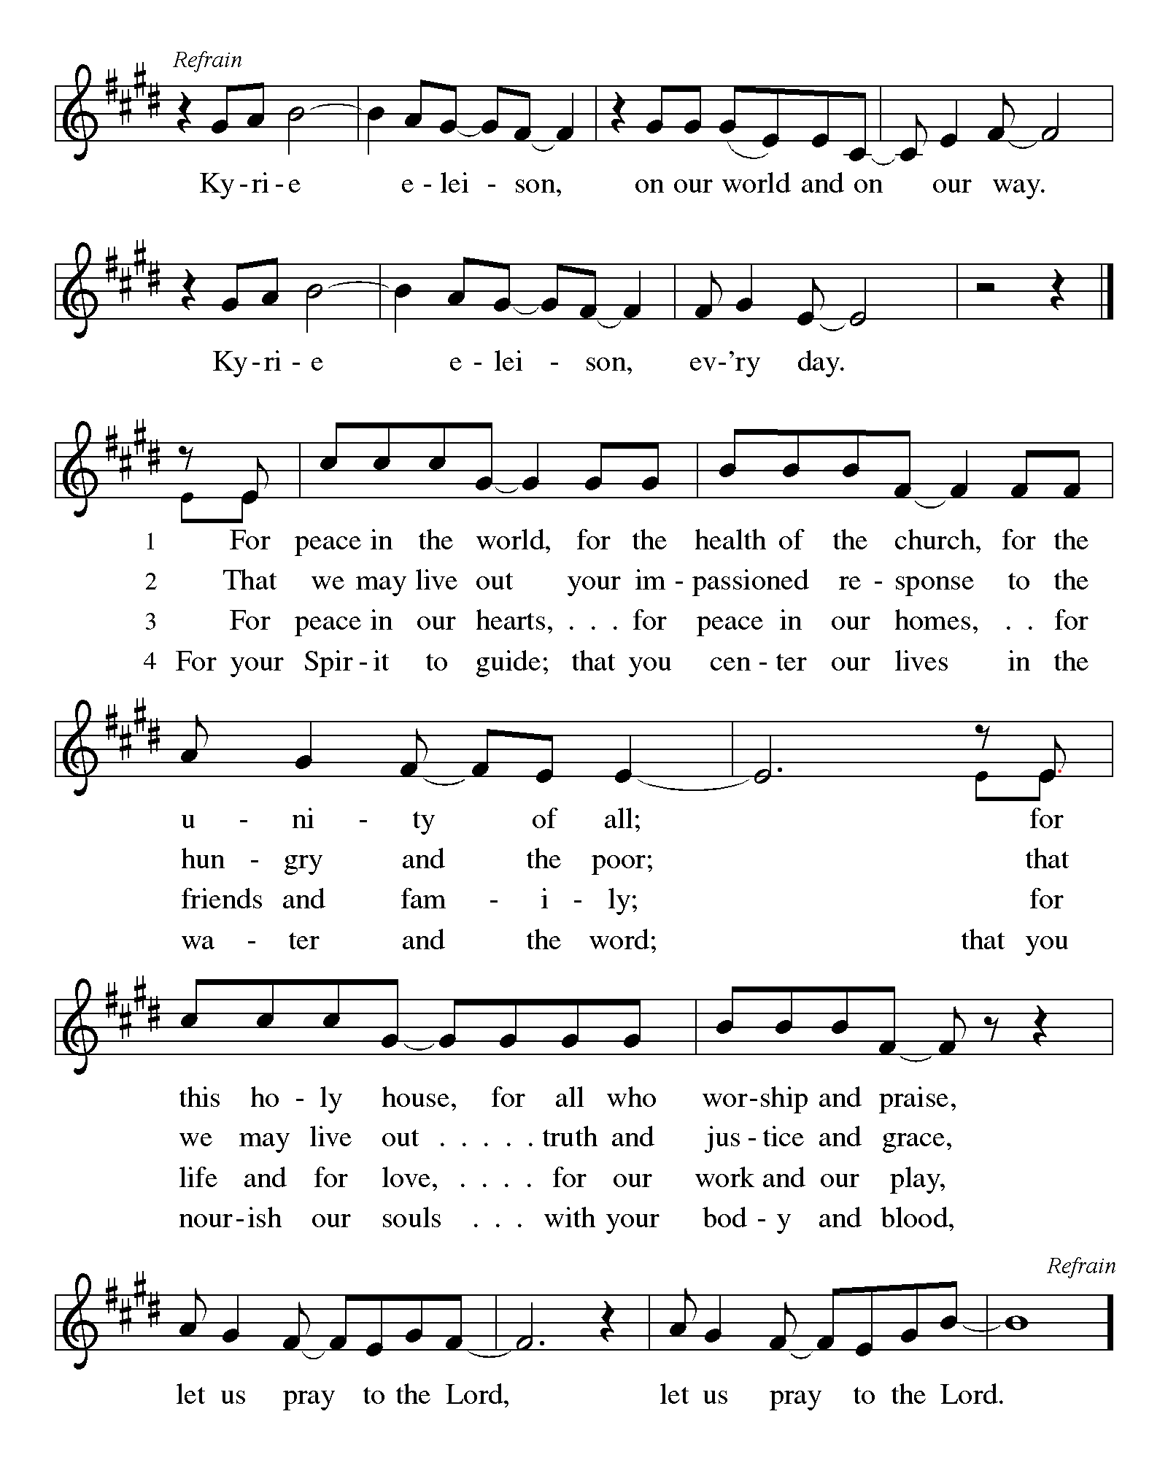
**Hymn of Praise:
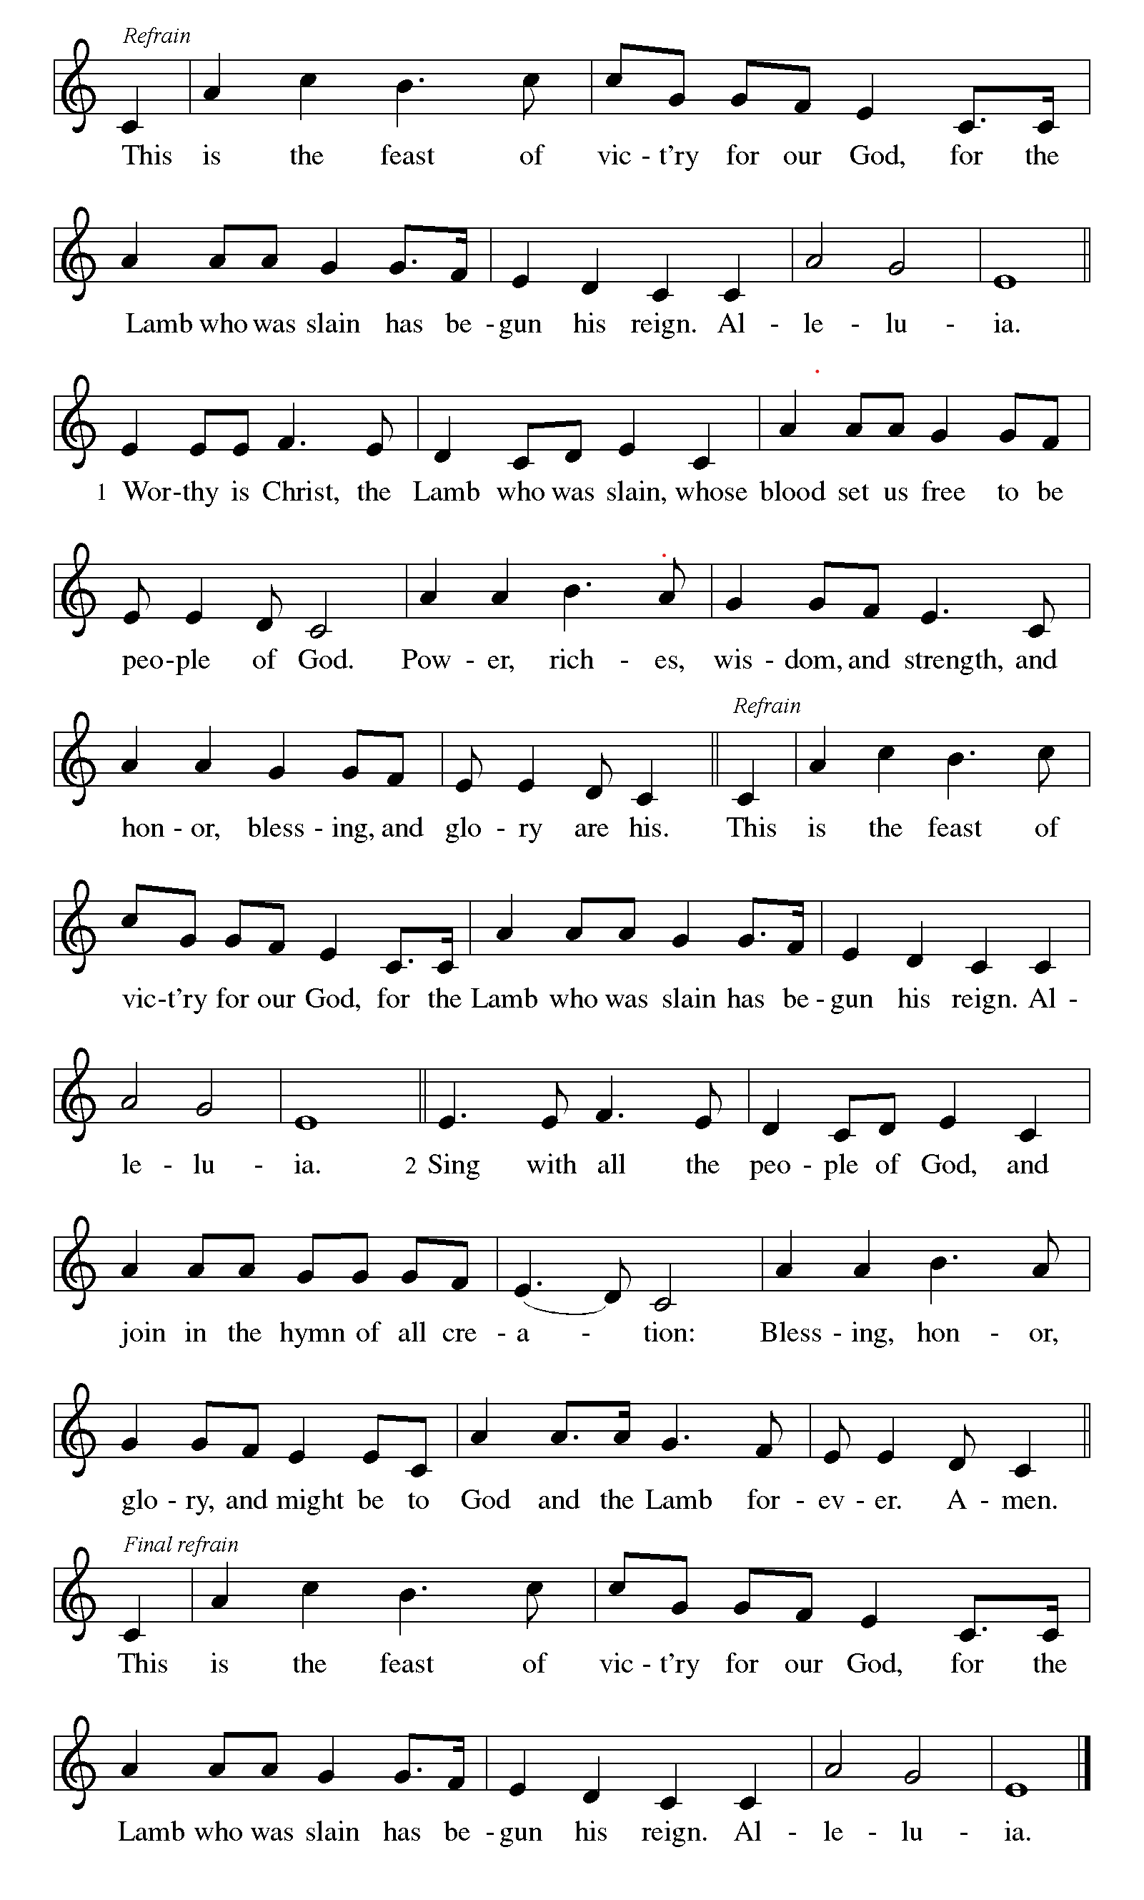
**Prayer of the Day
Holy God, the universe naturally tends towards chaos. You help define its order. Empower us to order our lives toward your desires for creation. Strengthen our faith and give us the courage to follow where you lead us. We pray this in Jesus’ name. Amen.

Reading: Exodus 14:5-31; 15:20-21
⁵When the ruler of Egypt learned that the people had fled, he and his followers changed in their feelings toward them. “What have we done,” they exclaimed, “allowing the Israelites to leave our service?” ⁶So Pharaoh ordered the chariots harnessed and with an army of ⁷600 of the best chariots and all the other chariots in Egypt, with warriors on them, ⁸pursued the Israelites even as they made their triumphant escape. ^{9The} Egyptians gave chase—the whole army, with horses, chariots, and charioteers—and caught up with them as they lay encamped by the sea, at Pi-hahiroth, facing Baal-zephon.
¹⁰As Pharaoh drew near, the Israelites looked back and saw the Egyptians pursuing them, and cried out in terror to God. ¹¹They turned on Moses, asking, “Were there no graves in Egypt that you must lead us out to die in the desert? What have you done to us? Why did you bring us out of Egypt? ¹²Didn’t we tell you in Egypt, ‘Leave us alone. Let us serve the Egyptians’? It would have been better to work for the Egyptians than to die here in the desert!”
¹³But Moses told the people, “Don’t be afraid! Stand your ground, and you will see the victory God will win for you today. Though you see Egypt today, you will never see it again. ¹⁴God will do the fighting for you; you have only to keep still!”
¹⁵Then God said to Moses, “Why are you crying out to me? Tell the Israelites to march on. ¹⁶And you, lift up your staff and stretch out your hand over the sea, and split the sea in two, that the Israelites may pass through it on dry land. ¹⁷I will make the hearts of the Egyptians so stubborn that they will come in after you, and I will glorify myself at the expense of Pharaoh and all the army, chariots and charioteers. ¹⁸The Egyptians will know that I am God, when I glorify myself over Pharaoh and his chariots and charioteers.”
¹⁹Then the angel of God, who was leading the Israelites, moved to their rear—the pillar of cloud left the front of their number and took up position behind them, ²⁰between the Israelites and the Egyptians. All during the night the cloud provided light to one side and darkness to the other side, so that there was no contact between them.
²¹Then Moses stretched his hand over the sea, and God swept the sea with a strong east wind throughout the night and so turned it into dry land. When the water was thus divided, ²²the Israelites marched into the midst of the sea on dry land, with the water walled up on their right and on their left.
²³The Egyptians followed in pursuit; all Pharaoh’s horses and chariots and charioteers went after them into the midst of the sea. ²⁴At dawn, God looked down upon the Egyptian forces from the column of fiery cloud, and threw the army into confusion and panic, ²⁵clogging their chariot wheels so that they could hardly turn. The Egyptians turned to flee from the Israelites, saying, “Their God fights for them against us!”
²⁶Then God told Moses, “Stretch out your hand over the sea, and let the water flow back upon the Egyptians, over their chariots and their charioteers.” ²⁷So at sunrise, Moses stretched out his hand over the sea, and the waters rolled back in. As the Egyptians fled, God hurled them into its midst. ²⁸As the water flowed back, covering the chariots and the charioteers—Pharaoh’s whole army, who had followed the Israelites into the sea—not one of them survived. ²⁹But the Israelites passed through, walking dry-shod in the sea, with the water like a wall, on their right and on their left. ³⁰Thus God saved Israel on that day from the power of Egypt. When Israel saw the Egyptians lying dead on the seashore ³¹and beheld the great power that God had shown against them, the people held God in awe; and put their faith in God and in Moses, God’s trusted servant.
^{15:20}Then Aaron’s sister, the prophet Miriam, picked up a tambourine, and all the women, followed her, dancing, with tambourines,
²¹while Miriam sang:
“Sing to God
who has triumphed gloriously,
who has flung horse and rider
into the sea!”
Word of God, Word of Life
Thanks be to God
**Gospel Acclamation
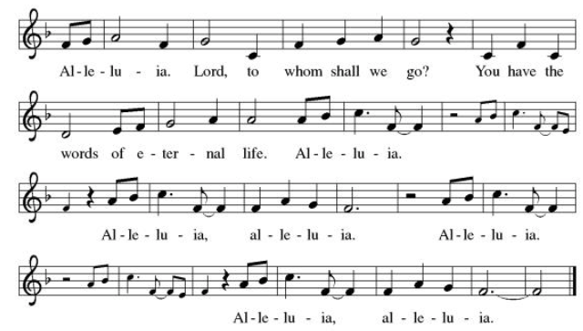
Announcement of the Gospel
Glory to you, O Lord.

Gospel: Matthew 2:13-15

¹³After the astrologers had left, the angel of God suddenly appeared in a dream to Joseph with the
command, “Get up, take the child and his mother and flee to Egypt. Stay there until I tell you
otherwise. Herod is searching for the child to destroy him.” ¹⁴Joseph got up, awakened Jesus and
Mary, and they left that night for Egypt. ¹⁵They stayed there until the death of Herod, to fulfill
what God had said through the prophet: “Out of Egypt I have called my Own.”

The Gospel of the Lord.
Praise to you, O Christ.

Sermon "Chaos and Creation"

Hymn of the Day Eternal Father Strong to Save ELW # 756

**Affirmation of Faith – Immigrant’s Creed by Jose Luis Casal
I believe in Almighty God, who guided the people in exile and in exodus, the God of Joseph in Egypt and Daniel in Babylon, the God of foreigners and immigrants.

I believe in Jesus Christ, a displaced Galilean, who was born away from his people and his home, who fled his country with his parents when his life was in danger. When he returned to his own country he suffered under the oppression of Pontius Pilate, the servant of a foreign power. Jesus was persecuted, beaten, tortured, and unjustly condemned to death. But on the third day Jesus rose from the dead, not as a scorned foreigner but to offer us citizenship in God’s kingdom.

I believe in the Holy Spirit, the eternal immigrant from God’s kingdom among us, who speaks all languages, lives in all countries, and reunites all races.
I believe that the Church is the secure home for foreigners and for all believers. I believe that the communion of saints begins when we embrace all God’s people in all their diversity. I believe in forgiveness, which makes us all equal before God, and in reconciliation, which heals our brokenness. I believe that in the Resurrection God will unite us as one people in which all are distinct and all are alike at the same time. I believe in life eternal, in which no one will be foreigner but all will be citizens of the kingdom where God reigns forever and ever. Amen.

**Prayers of Intercession

Holy God, our prayers rise to you like the wings of a dove. We call upon your name, and we ask that you hear us.

Hold your church accountable for our unwillingness to share your good news and our anger at your generosity to others. Nourish us by your grace to be witnesses to your love. Hear us, O God.
Your mercy is great.
Guide scientists and researchers studying responses to the climate crisis so that all your creation may inspire us to give thanks for your great goodness. Hear us, O God.
Your mercy is great.
Show employers the benefits of equal pay standards for all their employees. Reconcile conflicts between employees. Fill places of employment with camaraderie, and bring an end to employment disparity. Hear us, O God.
Your mercy is great.
Encourage any who cannot work or who cannot work a full day with the truth that their value comes from your everlasting love for them. Provide for those who are injured, ill, and for all in any need especially Monty & Marie, Paul, Helen, Linda, Kay, Becky H., Jim & Jan, Melian, Becky W., David, William & family, Judy, Peter & Carrie, Barbara & Donna, Brad & Chris, Drake, Bill & Sandy, Betsy, Jean, Jim McDonald, Howard & Sara and the people of Spokane, Washington, Hawaii, Indonesia, El Salvador, Honduras, Nicaragua, Nepal, and Tibet. Hear us, O God.
Your mercy is great.
Strengthen all those in this congregation whose labor serves the needs of others in the community. especially Inspire all in this congregation to support community endeavors with our time and talents. Hear us, O God.
Your mercy is great.
Pave a way to justice, drown the forces of oppression, bring peace on earth. Give leaders the will to turn from war and violence. Especially we pray for the people of Cuba, Venezuela, Iran, Sudan, Gaza, Israel, and Ukraine. When people must flee their homes, guide them to safety. Comfort those living with deep trauma, anxiety, or fear; all those who serve people in need, and accompany all those who care for people in harm’s way. We also lift up Jim’s grandson, Dylan, who is deployed, and Sharon’s great nephew, Taylor, who is serving in the military. Hear us, O God.
Your mercy is great.
We lift up all who teach and all who learn. Thank you for teachers who share their knowledge and wisdom. Bless the students in our midst. Especially we remember Evie, in Elementary school; Addison, in high school; and Tyler and Zack, in college. Bless Lisa and Carla as they teach. Hear us, O God.
Your mercy is great.
Comfort us with the promise of the resurrection as we remember all our loved ones whose desire to be with Jesus is fulfilled. Hear us, O God.
Your mercy is great.

Good and loving God, we give everyone we have prayed for into your care. Amen.

** Sharing of the Peace

**Offering is brought forward

** Offertory Response Take Oh, Take Me As I Am ELW # 814

Blessing of CSL Gifts

** Offertory Prayer
Good and loving God, everything that we have and everything that we are comes from you.
We respond in gratitude, offering up to you our gifts of our money, our time, and our
talents. We dedicate these gifts to your service. In Jesus’ name we pray, amen.

Dialogue
Christ is with you!
And also with you!
Lift up your hearts in joyful praise!
We lift them up to God in joy!

**Preface: Since the earliest days of the covenant…this hymn of praise: 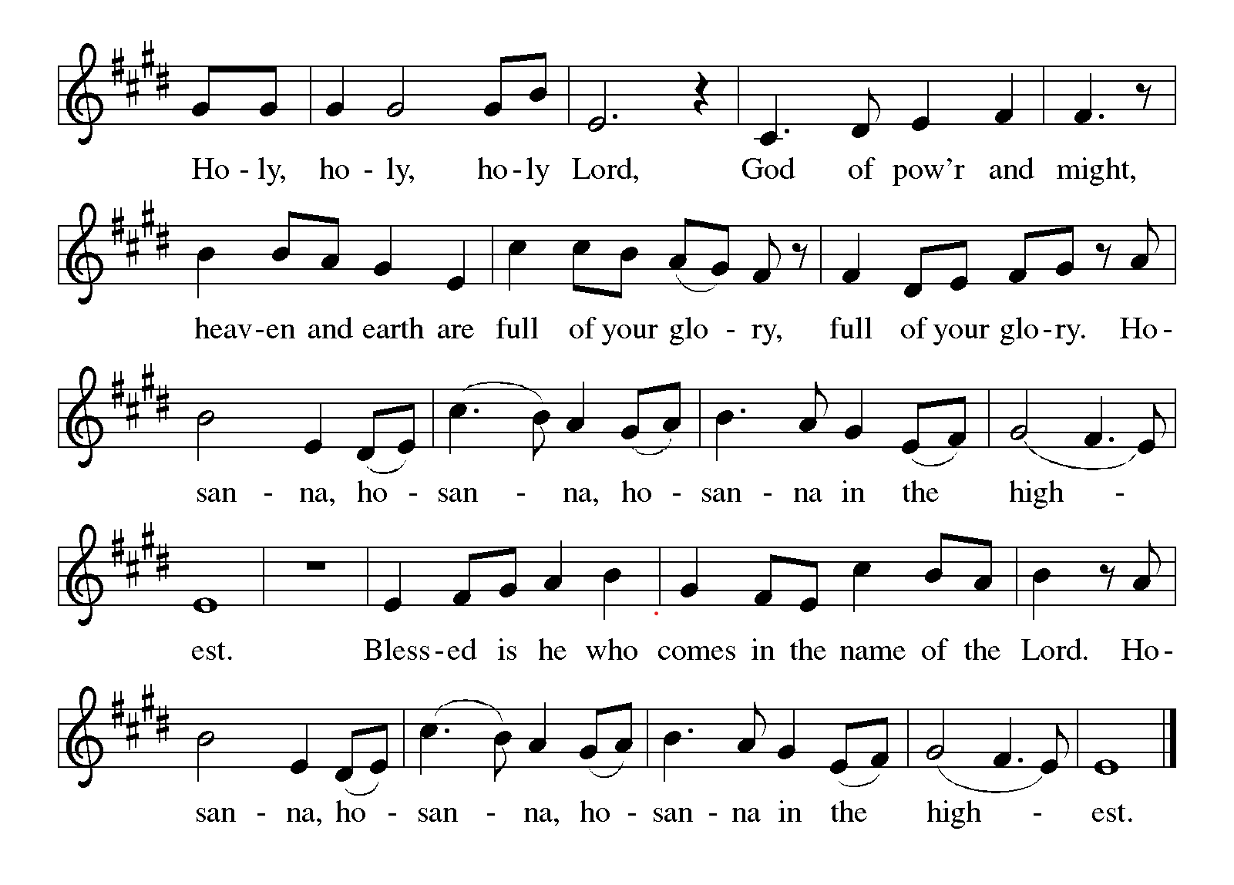
**words of institution

**LORD’S PRAYER

Our Father in heaven,
hallowed be your name,
your kingdom come,
your will be done,
on earth as in heaven.
Give us today our daily bread.
Forgive us our sins
as we forgive those
who sin against us.
Save us from the time of trial
and deliver us from evil.
For the kingdom, the power,
and the glory are yours,
now and forever. Amen.

Invitation to Communion

Communion Hymn I received the Living God ELW # 477

**Prayer After Communion

Abiding God, you call us then feed and nurture us. Now you send us out in the world you created with a purpose: to love our neighbors and care for those who need us. Strengthen us to do your work. In Jesus’ name we pray, amen.

** Sending Song Lord Jesus, You Shall Be My Song (verse 1) ELW # 808

** Blessing

** Closing Hymn All Creatures Worship God Most High ELW #835

**Dismissal

Go In Peace! Serve Your Neighbor!
THANKS BE TO GOD!

+ + + + + +

Setting 08 from the Evangelical Lutheran Worship are under copyright and used with permission under One License #733618-A. Specific copyright information as listed in bulletin, the Prayers of Intercession are under copyright and are used with permission under Augsburg Fortress Liturgy License #SB155933. All other liturgy written by Sarah Pierce.
******************************************************************************************

Weekly Attendance
Week of September 27: 35

Next Week:
20th Sunday after Pentecost:
Exodus 19:3-7; 20:1-17;
Deuteronomy 32:10-18
Matthew 5:17

Calendar of Events

Today
- Blessings of CSL

This Week
October 04 | Wear Your Work-clothes to Church - Work Day

Upcoming Events

October 11 | Zoo after services
October 14 | Council Meeting 6:30 pm
October 25 | Reformation Sunday
November 01 | All Saints Sunday  Celebration of Gifts  Service for the Healing of the World
November 11 | Council Meeting 6:30 pm
November 15 | Congregational Meeting, after worship
November 25 | Thanksgiving Eve Service 7:00 pm  Pie Night
November 26 - 27 | Thanksgiving - Office Closed
December 6 | Advent Dinner, after worship
December 19 | Council Meeting 6:30pm

******************************************************************************************
BLUE SPRINGS COMMUNITY SERVICE LEAGUE is very appreciative of your continued support of your neighbor.

Birthdays
Pam Meek 10/05
Anne Lee 10/09

October 04
Altar Guild –
Reader – Carla Deubnar
Greeter – Donna Taylor
Usher - Paul Blixrud
Tech – Gary Antes

Prayer Requests
Monty & Marie Health Concerns (March 04)
Paul Health Concerns (May 31)
Mary Health Concerns (May 15)
James & Family Health Concerns (September 11)
William and Family Health Concerns (September 25)
Becky H Health Concerns (October 28)
David Health Concerns (November 18)
Becky W Health Concerns (November 18)
Judy Health Issues (December 16)
Kay (Sara’s cousin) Health Concerns (July 15)
Sharon Health Concerns (October 22)
Michael Health Concerns (October 22)
Peter and Carrie Health Concerns (November 26)
Melian Health Concerns (November 16)
RJ Health Concerns (November 17)
Barbara Health Concerns (December 30)
Helen Health Concerns (February 25)
Chris Health Concerns (June 09)
Drake Issues (August 11)
Bill & Sandy Health Issues (August 12)
Betsy Surgery Sept. 17th (September 2)
Jim Health Concerns (September 29)
Howard & Sarah Health Concerns (September 29)
Jean Health Concerns (September 29)

Merciful God, your justice and mercy are without limits. Bring courage and resilience to those who resist tyranny with their words and their bodies. Strengthen those who fight for justice in your name across the country, and around the world.

Please pray for the people of Venezuela & Iran, Sudan, Gaza, Ukraine, Israel, Cuba, Iran and Palestine.
Please pray for the Homeless.
Please pray for legal & illegal immigrants & those seeking asylum or citizenship

