**All Saints Lutheran Church, ELCA**

**421 SW 19th St. Blue Springs, Missouri 64015 816-229-3633**

**Pastor Sarah Pierce** Spierce.aslcpastor@gmail.com

[allsaintslc64015@gmail.com](mailto:allsaintslc64015@gmail.com) <https://aslcbs.org/>

## Sunday, August 17, 2025

## Tenth Sunday after Pentecost

## *You are absolutely invited into this sacred space.  We welcome all who are seeking God’s love and grace.  All Saints recognizes that we are all unique and beloved children of God.  We celebrate and give thanks for the many diverse gifts that God has given us.  We affirm the sacredness of people of all sexual orientations, gender identities, and gender expressions.  We affirm the sacredness of all those who have experienced exclusion because of race, ability, age, or culture. We are committed to working towards anti-racism in ourselves and our community. We affirm the sacredness of all those who wrestle with addiction, physical or mental health, imprisonment, socio-economic circumstances, or anything that too often divides us.  We believe that through our openness we all grow in our faith through Christ’s teaching to love one another as God loves us.  We need each other and our sincere hope is by being in community together, we will experience God’s presence in new and real ways.*

*The offering plate is by the main door to the sanctuary for your convenience.*

*We practice open communion at All Saints Lutheran Church. What does that mean? It means that if you believe and trust that Christ offers his body and blood For You, you are welcome at the table. At All Saints, we believe that Christ invites all people to the feast. “Come to the banquet for all is now ready.”*

***\*\*Stand as you are comfortable***

***Prelude***

***Announcements***

**\*\* Confession and Forgiveness**

As with Esther and Mordecai, in times of uncertainty and challenge, we seek Your

divine wisdom to guide our hearts and minds.

**When we try to figure things out on our own and forget to go to you for clarity**

**and discernment, forgive us, O God.**

**When we lose trust in you because times are so difficult, painful and scary, help us trust you. Remember us, O God, in our time of need. Give us courage when we need it. Help us listen for your voice amidst the chaos. Shine your light on our path and lead us to choices that honor you and bring peace to the world.**

God remains faithful at all times and in all places. Even when we turn our backs on God, God never abandons us. God always forgives our sins + and gives us the strength and courage to start again.

**Amen.**

***\*\*Entrance Hymn Oh, Worship the King ELW #842***

***\*\*Greeting***

The grace of our Lord Jesus Christ, the love of God,

and the communion of the Holy Spirit be with you all.

**And also with you.**

**\*\*Kyrie**

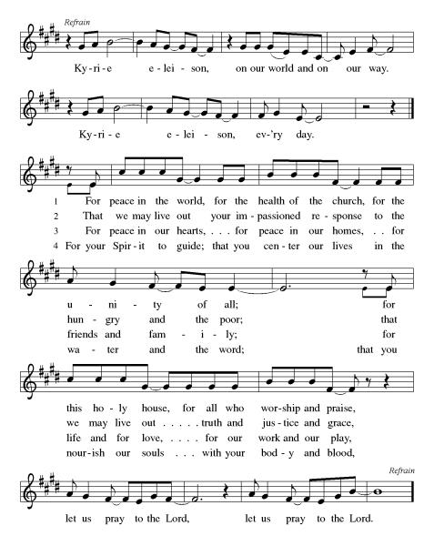

***\*\*Prayer of the Day***

**Holy God,**

**Grant us the courage to stand firm in truth and justice. Strengthen our hearts to speak boldly against injustice and to uphold righteousness in a world that often wavers. May we be guided by Your wisdom and love, empowering us to be beacons of hope and integrity. Help us to act with compassion and unwavering faith. Amen.**

***Reading:*** **Esther 2:19-22; 3:1-5, 8-10, 13a, 4:1-4, 10, 11b-17**

19Even after Esther had been transferred to the second harem along with the others, she continued to keep her heritage and her parentage secret, in respect of Mordecai’s wishes, whose instructions she continued to follow in the same way she did when she was under his care.

20During this time, Mordecai was a member of the Sovereign’s Gate, 21 and two rebels, Bigthan and Teresh, who were royal eunuchs belonging to the Guardians of the Threshold, hatched a plot to kill Ahasuerus. 22Mordecai heard about the plot and informed Esther, who, on Mordecai’s instruction, told Ahasuerus. 23The matter was investigated and proven true, and the two schemers were sent to the gallows. The matter was then recorded in the Annals in the presence of Ahasuerus.

3:1Not long after this happened, Ahasuerus selected Haman ben-Hammedatha, from the land of Agag, for promotion in rank and status above all the other members of the court and officers of the state, 2and proclaimed that all the members of the Ruler’s Gate must bow down and prostrate themselves before Haman.

Mordecai, however, refused to bow or prostrate himself. 3The other members of the court asked him every day, “Why do you defy the imperial command?” 4But Mordecai did not listen to them, so they reported the matter to Haman, hoping to see if Mordecai would continue this behavior, since they knew that he was Jewish.

5When Haman saw for himself that Mordecai would not bow down and prostrate himself before him, he became enraged.

8Haman then sought an audience with Ahasuerus. He said, “These are a people who remain unassimilated into our ways, and they are scattered throughout the empire in all the provinces. Their laws are not like those of the other peoples and they disregard the imperial decrees. It is not in your interest, therefore, to tolerate them. 9If the sovereign would order their destruction, I am willing to give 375 tons of silver to royal tax collectors to fill the royal treasury.”

10Ahasuerus removed his signet ring and handed it to Haman ben-Hammedatha the Agagite, oppressor of the Jewish people. 11“Keep your money!” Ahasuerus said, “You may deal with those people any way you want.”

13aThe letters were then sent by runners to every province in the empire, ordering the destruction, slaughter and annihilation of the Jewish people—old and young, women, men and children—together with the seizure of their property.

4:1When Mordecai heard about the decree, he ripped his tunic and put on sackcloth and ashes. Then, he paraded through the city, sounding loud and bitter shrieks, 2until he arrived at the front door of the Sovereign’s Gate, though he was stopped there because no one was permitted to enter wearing sackcloth and ashes. 3The same thing happened in every province—no sooner had the imperial decree been read than every Jewish person in the province began mourning, fasting, weeping and wailing, and many of them put on sackcloth and ashes.

4When Esther’s attendants told her what was happening, she was overwhelmed with grief. She sent out clothes for Mordecai to wear instead of sackcloth, but he refused to wear them.

10[Esther said] to Mordecai: 11“I have not been summoned to the sovereign for the last thirty days.”

12When Mordecai heard Esther’s reply, he wrote back the following response: 13“Don’t fool yourself into thinking that, just because you are in the imperial palace, you will be the only Jewish person to escape. 14If you insist on remaining silent at this time, vindication and liberation will come to our people through another source, but both you and your family will surely die. Who’s to say? — you may have come into the royal court for just this moment.”

15So Esther sent a message to Mordecai: 16“Bring together all the Jewish people in Susa now and fast for me. Do not eat or drink, day and night, for three days. After that, I will go to the sovereign in defiance of the law. If I die, I die.”

17Mordecai went and carried out all of Esther’s instructions.

Word of God, Word of Life

**Thanks be to God**

**Sermon Pastor Sami**

***Hymn of the Day*  *God of Grace and God of Glory* ELW#7*05***

\*\***Affirmation of Faith – Immigrant’s Creed by Jose Luis Casal**

**I believe in Almighty God, who guided the people in exile and in exodus, the God of Joseph in Egypt and Daniel in Babylon, the God of foreigners and immigrants.**

**I believe in Jesus Christ, a displaced Galilean, who was born away from his people and his home, who fled his country with his parents when his life was in danger. When he returned to his own country he suffered under the oppression of Pontius Pilate, the servant of a foreign power. Jesus was persecuted, beaten, tortured, and unjustly condemned to death. But on the third day Jesus rose from the dead, not as a scorned foreigner but to offer us citizenship in God’s kingdom.**

**I believe in the Holy Spirit, the eternal immigrant from God’s kingdom among us, who speaks all languages, lives in all countries, and reunites all races.**

**I believe that the Church is the secure home for foreigners and for all believers. I believe that the communion of saints begins when we embrace all God’s people in all their diversity. I believe in forgiveness, which makes us all equal before God, and in reconciliation, which heals our brokenness. I believe that in the Resurrection God will unite us as one people in which all are distinct and all are alike at the same time. I believe in life eternal, in which no one will be foreigner but all will be citizens of the kingdom where God reigns forever and ever. Amen.**

***\*\*Prayers of Intercession***

**God of Love, hear the prayers that we lift before you. Hold close to you all those for whom we pray.**

Raise up faithful leaders for your church around the world. Inspire global missionaries with a spirit of accompaniment, as they walk alongside our partners in the gospel in solidarity, interdependence, and mutuality. Hear us, O God.

**Your mercy is great.**

Safeguard rivers and lakes from pollution. Sustain the work of conservationists, policy makers, and advocacy groups seeking to protect fresh water sources. Hear us, O God.

**Your mercy is great.**

Bridge divisions across partisan lines. Strengthen cooperative efforts among lawmakers who enact policies that protect our neighbors who are most vulnerable. Hear us, O God.

**Your mercy is great.**

Embrace all who suffer in isolation: for those who are incarcerated or detained, those who are fleeing from unsafe environments, and those who are sick or homebound especially Monty, Paul, Linda, Betty F., Kay, Becky H., Jim & Jan, Becky W., David, William and family, Helen, Larry, Jennifer, Otto, families in our community who endure hunger, and our beloved for whom death is near. Carry your people when grief is heavy, and lift burdens of shame and self-doubt. Provide protection and aid to children who are unsafe and undernourished while on summer break. Bring honor to any who experience slander and evil intent or are discredited by others. Assure all who are afraid or experiencing great uncertainty that your promises are sure. Reassure them of your care in all times and places. Hear us, O God.

**Your mercy is great.**

Guide the leaders of this congregation. In these late summer weeks, inspire their planning for a new program year ahead. Kindle in us a spirit of collaboration and support for their work. Hear us, O God.

**Your mercy is great.**

Calm the fears of migrants and refugees who set out, not knowing where they go. Provide shelter, sustenance, protection from harm, and welcome. Bless the work of Global Refuge and other means of support and advocacy. Hear us, O God of grace,

**hear our prayer.**

We pray for the nations. Pave a way to justice, drown the forces of oppression, bring peace on earth. Give leaders the will to turn from war and violence. Especially we pray for the people of Gaza, Israel, and Ukraine, and for Jim’s grandson Dylan, who is deployed in Oman. When people must flee their homes, guide them to safety. Comfort those living with deep trauma, anxiety, or fear; all those who serve people in need, and accompany all those who care for people in harm’s way. Hear us, O God of grace,

**hear our prayer.**

We pray for people who rise up against injustice. Bring courage and resilience to those who resist tyranny with their words and their bodies. Strengthen those who fight for justice in your name across the country, and around the world. Protect and sustain immigrants and refugees and all who work with them, that your kingdom, without borders and without walls, may truly come on earth as it is in heaven. We pray for all victims of gun violence or kidnapping, especially those who are targeted out of hate or fear us. Embolden us to holy outrage and empower us to speak our truth of love and justice, Hear us, O God.

**hear our prayer.**

God of learning, we lift up all who teach and all who learn. Thank you for teachers who share their knowledge and wisdom. Bless the students in our midst. Especially we remember Evie who starts kindergarten this year and Tyler who will be starting college this year, Addison, Sophomore in High School, Zach and Katy in college also. We remember Suelyn who is doing continuing education, Janet and Lisa, as they teach. Hear us, O God.

**hear our prayer.**

With thanksgiving, we remember the cloud of witnesses who surround us. By the example of their faith, enable us to run with perseverance the race set before us, until that day when we join their unending praise. Hear us, O God.

**hear our prayer.**

**Good and loving God, we give everyone we have prayed for into your care. Amen.**

*\*\** ***Sharing of the Peace***

### *\*\*Offering is brought forward*

### *\*\** *Offertory Response*

**Create in Me ELW#186**

### *\*\*Offertory Prayer*

**Holy God, we return to you with gratitude the gifts you have given us. Use them to your service and for your ministry in this place. We pray this in Jesus’ name. Amen.**

**Thanksgiving at the Table**

Thank you God, for you are good!

Your love is everlasting!

**You alone perform such great marvels.**

**Your love is everlasting!**

Your wisdom made the heavens.

Your love is everlasting!

**You spread the land out over the waters.**

**Your love is everlasting!**

You made the great lights:

Your love is everlasting!

**The sun to govern the day, moon and stars to govern the night.**

**Your love is everlasting!**

**\*\*Preface:** O God, you called your servant Esther……..all creation as we sing:

**\*\*Holy, Holy, Holy**

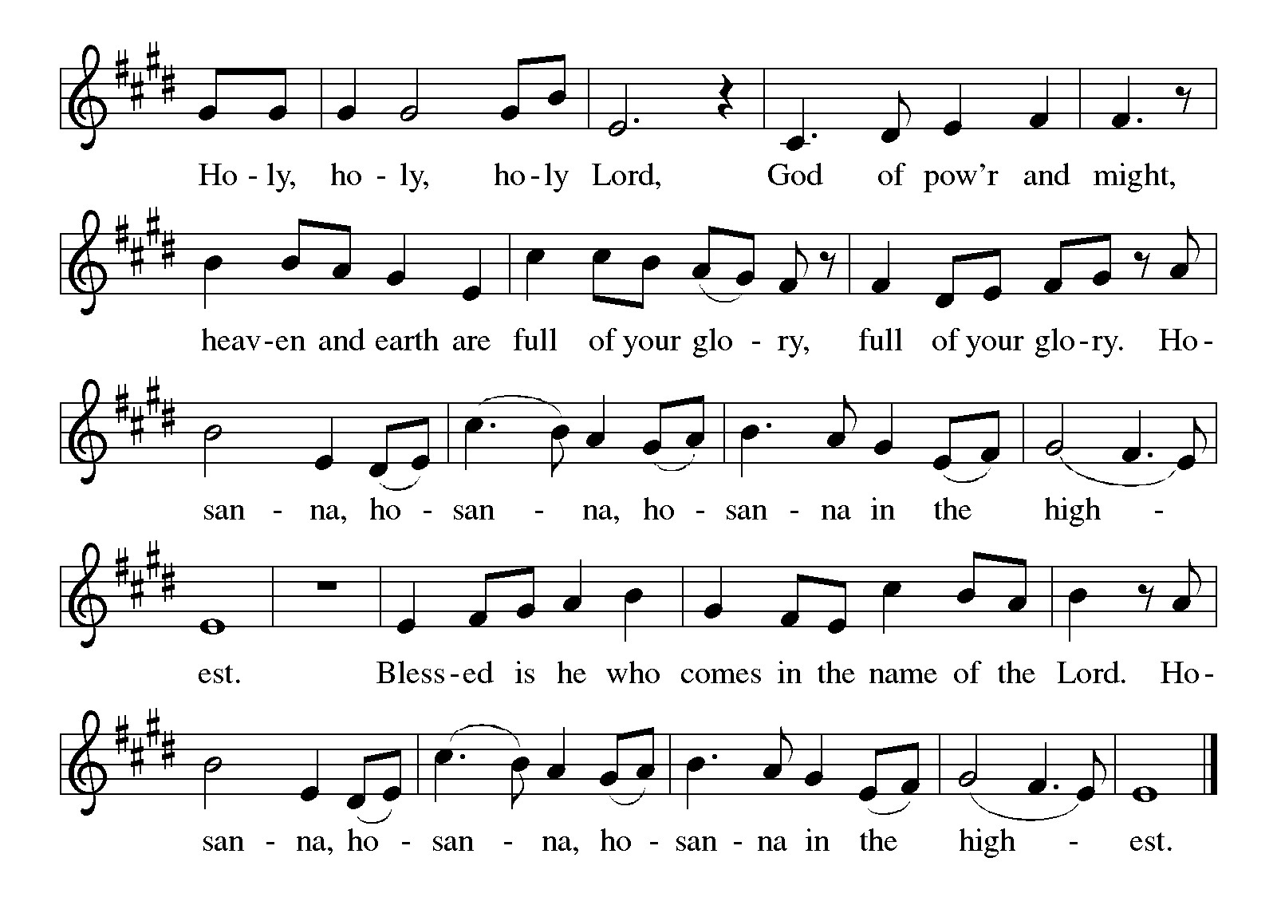

***\*\*Words of Institution***

**\*\*LORD’S PRAYER**

**Our Father, who art in heaven,**

**hallowed be thy name,**

**thy kingdom come,**

**thy will be done,**

**on earth as it is in heaven.**

**Give us this day our daily bread;**

**and forgive us our trespasses,**

**as we forgive those**

**who trespass against us;**

**and lead us not into temptation,**

**but deliver us from evil.**

**For thine is the kingdom,**

**and the power, and the glory,**

**forever and ever. Amen.**

***Invitation to Communion***

# ***Communion Hymn I Receive the Living God ELW#477***

### *\*\*Sending Song*

### *Praise to you, O God of Mercy ELW#208*

### *\*\*Prayer After Communion*

**Grafted onto the tree of faith and grounded in the promise of your faithful mercy, we have been fed by the Word and at the Table. Now send us out to share the joy of Christ with all whom we encounter. Amen.**

### *\*\*Blessing*

***\*\*Closing Hymn******God Be With You Till We Meet Again******ELW#536***

### 

### *\*\*Dismissal*

Go in peace to serve Christ and the world!

**THANKS BE TO GOD!**

### + + + + + +

*Setting 8 liturgy are under copyright and used with permission under One License #733618-A. Specific copyright information as listed in bulletin, the Prayers of Intercession are under copyright and are used with permission under Augsburg Fortress Liturgy License #SB155933. All other liturgy written by Sarah Pierce and Sami Pfalzgraf.*

*Dialog based on Psalm 136:1, 4-8. Thanksgiving based on Psalm 100 (adapted).*

*\*\*\*\*\*\*\*\*\*\*\*\*\*\*\*\*\*\*\*\*\*\*\*\*\*\*\*\*\*\*\*\*\*\*\*\*\*\*\*\*\*\*\*\*\*\*\*\*\*\*\*\*\*\*\*\*\*\*\*\*\*\*\*\*\*\*\*\*\*\*\*\*\*\*\*\*\*\*\*\*\*\*\*\*\*\*\*\*\*\*\*\*\*\*\*\*\*\*\*\*\*\*\*\*\*\*\**

**Weekly Attendance**

***Week of August 10***

***26***

*\*\*\*\*\*\*\*\*\*\*\*\*\*\*\*\*\*\*\*\*\*\*\*\*\*\*\*\*\*\*\*\*\*\*\*\*\*\*\*\*\*\*\*\*\*\*\*\*\*\*\*\*\*\*\*\*\*\*\*\*\*\*\*\*\*\*\*\*\*\*\*\*\*\*\*\*\*\*\*\*\*\*\*\*\*\*\*\*\*\**

**Calendar of Events**

***Today***

* ***Adult Bible Study***
* ***Sign up Sheet***

***This Week***

|  |  |
| --- | --- |
| ***August 19*** | ***Creative Friends 1:30 pm*** |
| ***August 20*** | ***Newsletter Deadline*** |
| ***August 23*** | ***Project Comfort 9:00 am-Noon*** |

***Upcoming Events***

|  |  |
| --- | --- |
| ***August 24*** | ***Pot Luck after Worship*** |
| ***August 26*** | ***Creative Friends 1:30 pm*** |
| ***August 28*** | ***Coffee with Council*** |
| ***August 31*** | ***Fifth Sunday Conversation*** |
| ***September 07*** | ***God’s Work. Our Hands/Zoo after Worship*** |
| ***September 14*** | ***Council Meeting 6:30 pm after Worship*** |
| ***September 17- September 21*** | ***Pastor Sarah Vacation*** |
| ***September 22-23*** | ***Blue Springs Theatre 7:00 pm-9:00 pm*** |
| ***September 29-October 01*** | ***Blue Springs Theatre 7:00 pm-9:00 pm*** |
| ***September 28*** | ***Bishop Installation/Atonement Lutheran Church 5:00 pm Overland Park*** |
| ***October 04*** | ***Blessing of Animals TBA*** |
| ***October 12*** | ***Fall Work Day*** |
|  |  |
|  |  |

* **August 24: Joint sermon! Pastor Sarah and Pastor Sami will both be at ASLC to preach together! We'll be exploring courage and strength as Esther and Mordecai work together to find justice.**
* **August 31: Pastor Sarah will be at ASLC for our 5th Sunday Conversation as we wrap up the book of Esther, talking about the power of stories to help us work through our desire for justice that looks like vengeance, when God's justice looks more like mercy.**

****************************************************************************************

*You may recall that there has been an announcement in the bulletin over the past year directing you to Lutheran Immigration and Refugee Services (LIRS) if you wish to support the people of Ukraine. LIRS has changed its name to Global Refuge and can be found at* ***globalrefuge.org****. Although their name has changed, their mission remains the same: to assist and support refugees in the United States and around the world. Visit their website to see all the ways you can support this important work.*

**\*\*\*\*\*\*\*\*\*\*\*\*\*\*\*\*\*\*\*\*\*\*\*\*\*\*\*\*\*\*\*\*\*\*\*\*\*\*\*\*\*\*\*\*\*\*\*\*\*\*\*\*\*\*\*\*\*\*\*\*\*\*\*\*\*\*\*\*\*\*\*\*\*\*\*\*\*\*\*\*\*\*\*\*\*\*\*\*\***

**BLUE SPRINGS COMMUNITY SERVICE LEAGUE** *is very appreciative of your continued support of your neighbor.*

*\*\*\*\*\*\*\*\*\*\*\*\*\*\*\*\*\*\*\*\*\*\*\*\*\*\*\*\*\*\*\*\*\*\*\*\*\*\*\*\*\*\*\*\*\*\*\*\*\*\*\*\*\*\*\*\*\*\*\*\*\*\*\*\*\*\*\*\*\*\*\*\*\*\*\*\*\*\*\*\*\*\*\*\*\*\*\*\*\*\**

**Questions for Reflection and Discussion from Pastor Sami**

1. The history of Haman is given in the reading. Why? What does it matter? Ah, when the writers give us specific information such as this, it’s a red flag that this is something important. If we read Esther 2:5, we discover Mordecai is the “son of Jair son of Shimei son of Kish, a Benjaminite.” Kish is the father of King Saul. Haman is decided from Agag, King of the Amalekites, who were perennial enemies of Israel. The conflict between Haman and Mordecai mirrors the conflict between Amalekites and Israel.
2. Mordecai overhears a plot by the eunuchs to assassinate the king. Why do you think Esther and Mordecai care if the king dies? They have made the best out of a difficult situation. Esther and Mordecai were exiles. Throughout this reading, we see Esther and Mordecai are captives. Esther may be queen, and Mordecai may be sitting in a position of some responsibility at the king’s gate, they are both under duress because they are exiles.
3. Pastor Sarah talked in her sermon last week that wisdom is shown in NOT overreacting to situations and not acting extremely. King Ahasuerus was not wise and now we see Haman is not either. He overreacts to Mordecai not bowing to him by wanting to kill him and the entire Jewish population. We see Haman is not a wise character. How does Esther react in this story? Is she wise?
4. The people who cast Pur were seeking a lucky day, as indicated by the lots, for the purpose in hand. A lot was cast for each day of the month, and for each month in the year, and in some way or other one day and one mouth were indicated as the most favorable. The notion of lucky and unlucky days seems to have been prevalent in the East in early times. Haman casts pur to discover the day of the genocide of the Jewish people in Persia. Why do you think he casts pur for that and not asking for the king’s decree to make his plans a reality?
5. It’s interesting the Jewish people were given an entire year to plan and strive to save themselves before the day of their impending death. Could this have been an act of God?

***\*\*\*\*\*\*\*\*\*\*\*\*\*\*\*\*\*\*\*\*\*\*\*\*\*\*\*\*\*\*\*\*\*\*\*\*\*\*\*\*\*\*\*\*\*\*\*\*\*\*\*\*\*\*\*\*\*\*\*\*\*\*\*\*\*\*\*\*\*\*\*\*\*\*\*\*\*\*\*\*\*\*\*\*\*\****

***Greeter –*** **August 17*-******Donna Taylor***

***Usher –* August 17*-Paul Blixrud***

***Altar Guild-* August 17- *Anne Lee & Paul Blixrud***

***Tech-* August 17*-Gary Antes***

**Prayer Requests**

***Monty Health Concerns (May 15)***

*Paul Health Concerns (May 31)*

*Mary Health Concerns (May 15)*

*James & Family Health Concerns (September 11)*

*Betty F (Sara’s friend) Health Concerns (July 15)*

*William and Family Health Concerns (September 25)*

*Becky H Health Concerns (October 28)*

*David Health Concerns (November 18)*

*Becky W Health Concerns (November 18)*

*Larry Health Issues (December 16)*

*Helen Health Issues (January 14)*

*Jennifer Health Concerns (February 27)*

*Otto Health Concerns (July 15)*

*Kay (Sara’s cousin) Health Concerns (**July 15)*

***Merciful God, your justice and mercy are without limits. Bring courage and resilience to those who resist tyranny with their words and their bodies. Strengthen those who fight for justice in your name in Los Angeles, across the country, and around the world.***

***Please pray for the people of Gaza, Ukraine, Israel, Iran and Palestine.***

***Please pray for the people of the Sudan.***

***Please pray for the Homeless.***

***Please pray for legal & illegal immigrants & those seeking asylum or citizenship.***