**All Saints Lutheran Church, ELCA**

**421 SW 19th St. Blue Springs, Missouri 64015 816-229-3633**

**Pastor Sarah Pierce** Spierce.aslcpastor@gmail.com

[allsaintslc64015@gmail.com](mailto:allsaintslc64015@gmail.com) <https://aslcbs.org/>

## Sunday, September 08, 2024

## The Sixteenth Sunday of Pentecost

## God’s Work, Our Hands Sunday

## *You are absolutely invited into this sacred space.  We welcome all who are seeking God’s love and grace.  All Saints recognizes that we are all unique and beloved children of God.  We celebrate and give thanks for the many diverse gifts that God has given us.  We affirm the sacredness of people of all sexual orientations, gender identities, and gender expressions.  We affirm the sacredness of all those who have experienced exclusion because of race, ability, age, or culture. We are committed to working towards anti-racism in ourselves and our community. We affirm the sacredness of all those who wrestle with addiction, physical or mental health, imprisonment, socio-economic circumstances, or anything that too often divides us.  We believe that through our openness we all grow in our faith through Christ’s teaching to love one another as God loves us.  We need each other and our sincere hope is by being in community together, we will experience God’s presence in new and real ways.*

*The offering plate is by the main door to the sanctuary for your convenience.*

*We practice open communion at All Saints Lutheran Church. What does that mean? It means that if you believe and trust that Christ offers his body and blood For You, you are welcome at the table. At All Saints, we believe that Christ invites all people to the feast. “Come to the banquet for all is now ready.”*

***\*\*Stand as you are comfortable***

***Prelude***

***Announcements***

***\*\** Confession and Forgiveness**

Siblings in Christ, we love because God first loved us. But sometimes we forget what it means to love because God loves us, and so we confess our sins together, to remind ourselves and each other what it means to be God’s beloved children.

**Loving God,**

**we know that you love us and in thankful response,**

**we love our siblings in Christ and our neighbors.**

**But sometimes, we forget that people who disagree with us are our neighbors.**

**Sometimes, we forget that we can say and do harmful things to our siblings in Christ**

**who say and do harmful things to us,**

**all in your name.**

**Merciful God,**

**help us to remember that living in love means following your commandments.**

**Help us to remember that following your commandments means loving you above all else,**

**and loving and caring for our neighbors as ourselves.**

**Empower us to speak your truth in love when we should,**

**to listen in love when we can,**

**and to walk away when we must.**

Beloved children of God, even in difficult seasons, the Spirit is always accompanying us on our journey. And in our savior Jesus Christ +, your sins are forgiven.

**Amen.**

***\*\*Entrance Hymn The God of Abraham Praise ELW#*831**

***\*\*Greeting***

The grace of our Lord Jesus Christ, the love of God,

and the communion of the Holy Spirit be with you all.

**And also with you.**

***\*\*Kyrie***



***\*\*Glory to God***

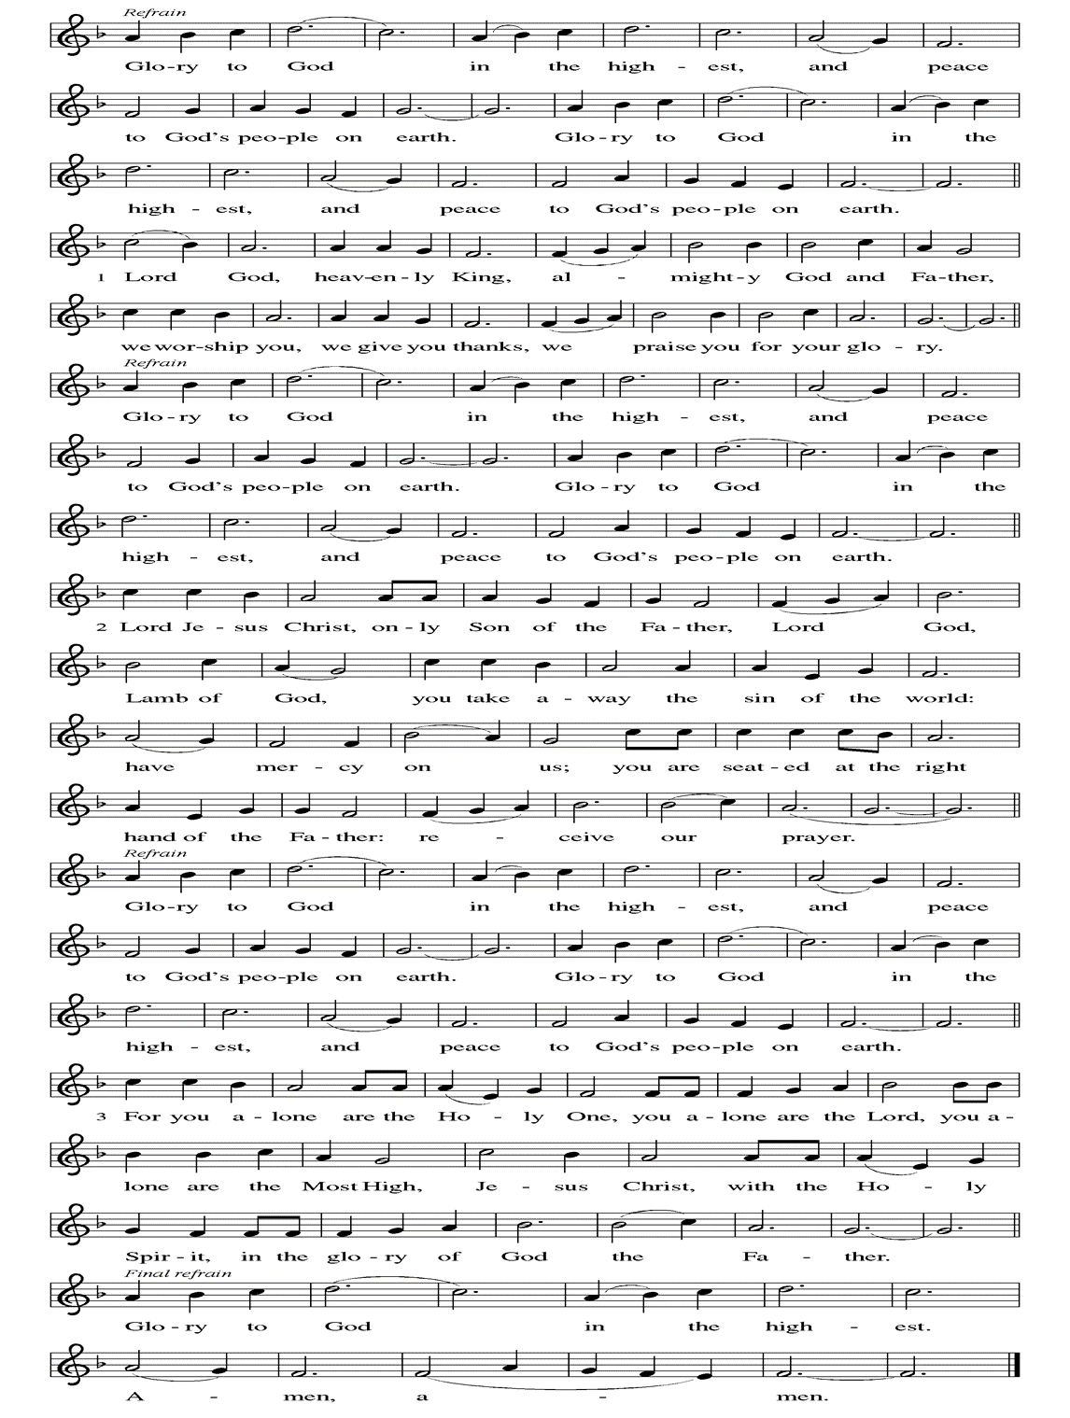

***\*\*Prayer of the Day***

**Creator God, thank you for entrusting us with your creation. Empower us to care for and protect this world and each other as you would, and grant us the wisdom and courage to make decisions that are in line with your love for us and the world. In Jesus’ name we pray. Amen.**

***Reading:*** **Genesis 2:4b-9, 15-22a, 25; 3:1-8**

4bAt the time when God made the heavens and the earth, 5there was still no wild bush on the earth nor had any wild plant sprung up, for God had not yet sent rain to the earth, and there was no human being to till the soil. 6Instead, a flow of water would well up from the ground and irrigate the soil.

7So God fashioned an earth creature out of the clay of the earth, and blew into its nostrils the breath of life. And the earth creature became a living being.

8God planted a garden to the east, in Eden – “Land of Pleasure” – and placed in it the earth creature that had been made. 9Then God caused every kind of tree, enticing to look at and good to eat, to spring from the soil. In the center of the garden was the Tree of Life, and the Tree of the Knowledge of Good and Evil.

15Then God took the earth creature and settled it in the garden of Eden so that it might cultivate and care for the land. 16God commanded the earth creature,

“You may eat as much as you like

from any of the trees in the garden –

except the Tree of

the Knowledge of Good and Evil.

You must not eat from that tree,

for on the day you eat from that tree,

that is the day you will die – yes, die.”

18Then God said, “It is not good for the earth creature to be alone. I will make a fitting companion for it.” 19So from the soil God formed all the various wild beasts and all the birds of the air, and brought them to the earth creature to be named. Whatever the earth creature called each one, that became its name. 20The earth creature gave names to all the cattle, all the birds of the air, and all the wild animals.

But none of them proved to be a fitting companion, 21so God made the earth creature fall into a deep sleep, and while it slept, God divided the earth creature in two, then closed up the flesh from its side. 22God then fashioned the two halves into male and female, and presented them to one another.

25Now the woman and the man were both naked, though they were not ashamed. 3:1The snake was even more naked: the most cunning of all the animals that God had made.

The snake asked the woman, “Did God really tell you not to eat from the trees in the garden?”

2The woman answered the snake, **“We may eat fruit from all the other trees in the garden. 3But of the fruit from the tree in the middle of the garden, God said, ‘Don’t eat it and don’t touch it, or you will die.’”**

4The snake said to the woman, “Die? You won’t die! 5God knows well that on the day that you eat it, your eyes will be opened and you will be like gods, knowing good and evil!”

6The woman knew that the tree was enticing to the eye, and now saw that the fruit was good to eat—that it was desirable for the knowledge it could give. So she took some of its fruit and ate it. She gave some also to the man beside her, and he ate it.

7Then the eyes of both of them were opened, and they realized that they were naked. So they sewed fig leaves together and made loincloths for themselves.

8When they heard the sound of God walking in the garden in the cool of the evening, the man and the woman hid from God’s presence among the trees of the garden.

The Word of the Lord

**Thanks be to God**

***\*\*Gospel Acclamation***

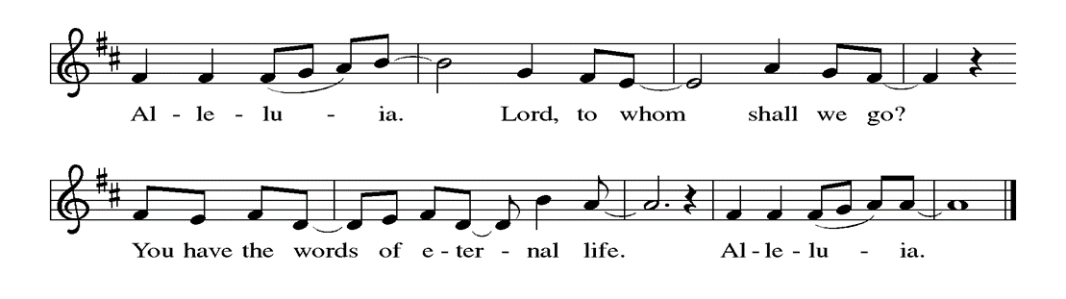

*Announcement of the Gospel*

**Glory to you, O Lord.**

***Gospel:* Luke 11:4**

4[Jesus said,] “Forgive us our sins,

for we too forgive everyone who sins against us;

and don’t let us be subjected to the Test.”

The Gospel of the Lord.

**Praise to you, O Christ.**

**Sermon "The Choices We Make"**

***Hymn of the Day* Creating God, Your Fingers Trace ELW#684**

**\*\*Blessing of Hands for Ministry**

We are called to proclaim the good news:

**God is at work!**

This good news is not left in some history long ago or a place far away:

**God is at work in the world still today!**

In us and through us, God is glorified in our work.

When we offer a helping hand, God is praised.

When we share of our abundance, God is known in the world.

**God is at work in us!**

In our service today and in our daily lives,

let us live out what God has called us to in baptism.

**God is at work through our hands!**

**\*\* A New Creed (from the United Church of Canada)**

**We are not alone,  
we live in God's world.  
   
We believe in God:  
who has created and is creating,  
who has come in Jesus,  
the Word made flesh,   
to reconcile and make new,  
who works in us and others by the Spirit.  
We trust in God.  
   
We are called to be the Church:  
to celebrate God's presence,  
to live with respect in Creation,  
to love and serve others,  
to seek justice and resist evil,  
to proclaim Jesus, crucified and risen,  
our judge and our hope.   
​  
In life, in death, in life beyond death,  
God is with us.  
We are not alone.**  
**Thanks be to God.**

### *\*\*Prayers of Intercession*

**God of Love, hear the prayers that we lift before you. Hold close to you all those for whom we pray.**

God of love, send us out filled with your love and life. Be known in our daily living, that your love may be known through our proclamation. God, we pray,

**open our hands in love.**

God of creation, remind us to be good stewards of your diverse and beautiful world. God, we pray,

**open our hands in love.**

God of peace, fill the hearts of those who rule, govern and lead. Give them and us compassion to guide the peoples of this world in the ways of truth, justice, equity and peace. God, we pray,

**open our hands in love.**

God of healing, visit those who yearn for your wholeness, especially those whose names and needs we lift up now especially Monty, Paul, Linda, Meagan, Matt, Pastor Sarah, Elaine, Pete, David, Carla (Pastor George’s wife), Richard and Dee, families in our community who endure hunger, those who seek asylum or citizenship, and our beloved for whom death is near. Encourage all those who bear another’s burdens. Give wisdom and perseverance to all who work in health care professions. God, we pray,

**open our hands in love.**

God of service, give us strength and humility. In our service to those near and far, whose needs are visible or invisible, may we find you in the faces of our neighbors. God, we pray,

**open our hands in love.**

God of learning, we ask your blessings upon all of the students and professors in our congregation. Bless Evie as she begins preschool; Tyler and Addison in high school; Matthew, Zachary, Katy, Kimberly, and Katie in college; and Sue Lyn, who is pursuing continuing education. And bless Janet and Lisa as they continue their work as educators. God, we pray,

**Open our hands in love.**

Everlasting God, support us in this life. As we remember those who have gone before as examples of faithful living and honor those whose faith was known only to you, inspire us to follow their example of baptismal life until we join with them in worship. God, we pray,

**open our hands in love.**

**Good and loving God, we give everyone we have prayed for into your care. Amen.**

*\*\** ***Sharing of the Peace***

### *\*\*Offering is brought forward*

### *\*\** *Offertory Response*

### As the Grains of Wheat (Refrain Only) ELW #465

### *\*\*Offertory Prayer*

**Holy God, thank you for all that you have given us: the breath of life, forgiveness of sins, and our faith in you. Thank you for inspiring us to use our time, our talents, and our treasure to your service, and accept these gifts that we give you in thanksgiving for all you have done for us. We pray this in the name of Jesus, our savior. Amen.**

**\*\* *The Great Thanksgiving***

The God of Love is with you.

**And also with you!**

Give thanks to God, who is good,

**Whose loving kindness endures forever.**

***\*\*Preface:*** We are in a difficult season… this hymn of praise:

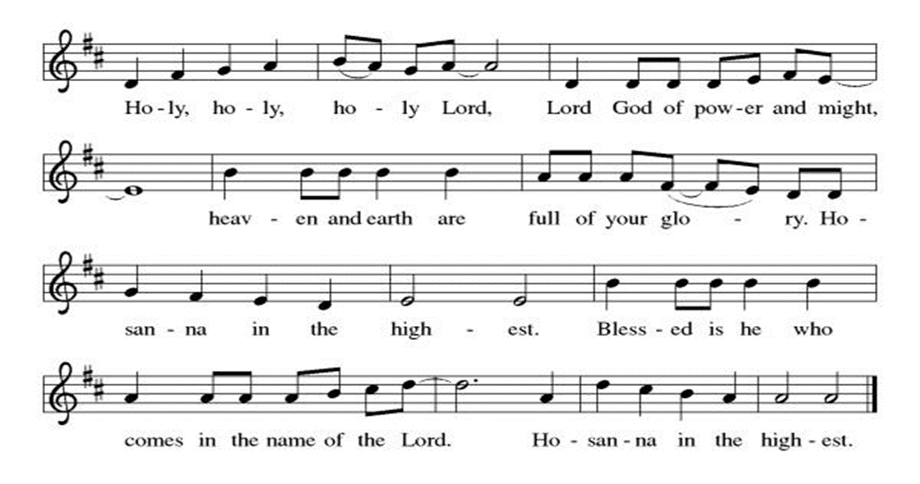

***\*\*Words of Institution***

**\*\*LORD’S PRAYER**

**Our Father in heaven,**

**hallowed be your name,**

**your kingdom come,**

**your will be done,**

**on earth as in heaven.**

**Give us today our daily bread.**

**Forgive us our sins**

**as we forgive those**

**who sin against us.**

**Save us from the time of trial**

**and deliver us from evil.**

**For the kingdom, the power,**

**and the glory are yours,**

**now and forever. Amen.**

***Invitation to Communion***

### *Communion Hymn Morning Has Broken ELW #*556

### 

### *\*\*Sending Song*

### *Now, Lord ELW#200*

### *\*\*Prayer After Communion*

**Good and loving God, thank you for being present with us as we hear your Word and are fed at your Table. We know that you are with us as we go out into the world to do the work that you have called us to. Empower us with your Spirit to love and serve our neighbors, following the example that you set for us in Jesus, our Savior. Amen.**

### *\*\*Blessing*

### *\*\*Closing Hymn Go, My Children, with My Blessing ELW#*543

### 

### *\*\*Dismissal*

Go in peace. Serve in Love.

**THANKS BE TO GOD!**

### + + + + + +

*Hymns from Setting 6 and the Evangelical Lutheran Worship are under copyright and used with permission under One License #733618-A. Specific copyright information as listed in bulletin, the Prayers of Intercession are under copyright and are used with permission under Augsburg Fortress Liturgy License #SB155933. All other liturgy written by Sarah Pierce.*

**Weekly Attendance**

***Week of September 01***

***20***

*\*\*\*\*\*\*\*\*\*\*\*\*\*\*\*\*\*\*\*\*\*\*\*\*\*\*\*\*\*\*\*\*\*\*\*\*\*\*\*\*\*\*\*\*\*\*\*\*\*\*\*\*\*\*\*\*\*\*\*\*\*\*\*\*\*\*\*\*\*\*\*\*\*\*\*\*\*\*\*\*\*\*\*\*\*\*\*\*\*\**

**Calendar of Events**

***Today***

* ***God’s Work, Our Hands-Zoo***

***Sept 02 through Oct 07 & 09-Mon-Thurs-BS Theatre Group 6:30 pm- 9:30 pm***

***Sept 10-Creative Friends 1:00 pm***

***Sept 11-Council Meeting 6:30 pm***

***Sept 14-Men’s Breakfast 8:00 am IHOP***

***Sept 17-Creative Friends 1:00 pm***

***Sept 18 through Sept 22-Pastor Sarah’s Vacation***

***Sept 18-Bell Practice 6:30 pm***

***Sept 24-Creative Friends 1:00 pm***

***Sept 25-Bell Choir Practice 6:30 pm***

***Sept 28-Project Comfort 9:00 am-Noon***

***Oct 02-Bell practice 6:30 pm***

***Oct 05 through Oct 13-Jean’s Vacation***

***Oct 06-Fall Day Clean up***

***Oct 09-Council Meeting 6:30 pm***

***Oct 13-Rain Date Fall Day***

***Oct 14-Columbus Day-Office Closed***

***Oct 14 through 17- Pastor Sarah’s Fall Theological Conference***

***Oct 27-Congregational Meal, Film & Pledge after Services***

***Nov 05-Election Day\*\*\*\****

***Nov 11-Veteran's Day-Office Closed***

***Nov 17-Congregational Meeting***

*You may recall that there has been an announcement in the bulletin over the past year directing you to Lutheran Immigration and Refugee Services (LIRS) if you wish to support the people of Ukraine. LIRS has changed its name to Global Refuge and can be found at* ***globalrefuge.org****. Although their name has changed, their mission remains the same: to assist and support refugees in the United States and around the world. Visit their website to see all the ways you can support this important work.*

***Bishop Candea reminds us that as followers of Christ, we are to pray for and support the most vulnerable among us. She pointed out that right now, the most vulnerable people in the world are the women, children, and elderly people living in the Gaza Strip.***

***All members are welcome to attend regularly scheduled council meetings. Additionally, the Council would like to remind you that the most recent Council reports and minutes are available on the bulletin board in the narthex.***

**\*\*\*\*\*\*\*\*\*\*\*\*\*\*\*\*\*\*\*\*\*\*\*\*\*\*\*\*\*\*\*\*\*\*\*\*\*\*\*\*\*\*\*\*\*\*\*\*\*\*\*\*\*\*\*\*\*\*\*\*\*\*\*\*\*\*\*\*\*\*\*\*\*\*\*\*\*\*\*\*\*\*\*\*\*\*\*\*\***

**BLUE SPRINGS COMMUNITY SERVICE LEAGUE** *is very appreciative of your continued support of your neighbor.*

*\*\*\*\*\*\*\*\*\*\*\*\*\*\*\*\*\*\*\*\*\*\*\*\*\*\*\*\*\*\*\*\*\*\*\*\*\*\*\*\*\*\*\*\*\*\*\*\*\*\*\*\*\*\*\*\*\*\*\*\*\*\*\*\*\*\*\*\*\*\*\*\*\*\*\*\*\*\*\*\*\*\*\*\*\*\*\*\*\*\**

**Questions for Reflection and Discussion**

1. We can’t really talk about this text without addressing the elephant in the room: the historical interpretation of chapter 3 as an indictment of women as the originators of sin. But if we go back to the text, there’s no basis for that interpretation. Yes, Eve is the one having the conversation with the snake, but she did not receive the directive from God not to eat of the Tree of the Knowledge of Good and Evil – Adam did. And when the snake asks the woman, “Did God really tell you not to eat from the trees?” the pronoun is plural. “Did God really tell y’all…?” And Adam is right there with her the whole time, not disagreeing, and eating the apple himself.
2. Now that we have that out of the way…I mention the word in my sermon, because it’s the easiest way to describe it, but to call the action of eating the apple “sin” is a little anachronistic. It might be better to call it “disobedience” or “rebellion.” The concept of sin isn’t introduced in the Bible until chapter 4, when God rejects Cain’s offering and says in verse 7, “…sin is a demon haunting your doorway, and it wants you – but you can conquer it.” But if we define sin as turning away from God, then the actions in chapter 3 seem to fit the bill. What are your thoughts on this?
3. I spend some time in my sermon talking about the way chapter 1 informs our reading of chapter 2. There’s one other place that I want to lift up, which didn’t really fit into the flow of my sermon. In chapter 2 verse 18, we read, “Then God said, “It is not good for the earth creature to be alone.” Contrast this with all of the times that creation was called “good” in chapter 1. We are created to be in community, to support and care for one another.
4. This story is often called “Creation and the Fall,” although it’s sometimes called “Creation and the Rebellion.” What would you title it?
5. Contrast Adam and Eve’s nakedness in chapter 2 verse 25 with chapter 3 verse 7. What has changed?

***Greeter***

***Sept 08 Donna Taylor***

***Altar Guild***

***Sept 08 Mary Ann Gross***

***Usher***

***Sept 08***  ***Paul Blixrud***

***Reader***

***Sept 08 Betsy Reese***

***Tech***

***Sept 08 Gary Antes***

**Prayer Requests**

***Monty Health Concerns (May 15)***

*Paul Health Concerns (May 31)*

*Meagan Health Concerns (April 15)*

*Pastor Sarah Health Concerns (October 03)*

*Matt Health Concerns (November 06)*

*Elaine Health Concerns (January 23)*

*Pete Health Concerns (February 05)*

*David Health Concerns (March 23)*

*Mary Health Concerns (May 15)*

*Dee Health Concerns (May 21)*

*Carla (Pr. George’s wife) Health Concerns (June 26)*

*Richard Health Concerns (August 12)*

***Please pray for the people of Haiti, Ukraine, Israel and Palestine.***

***Please pray for the people of the Sudan.***

***Please pray for the people that have been impacted by the Hurricanes in the Caribbean and the Atlantic.***

***Please pray for the Homeless.***